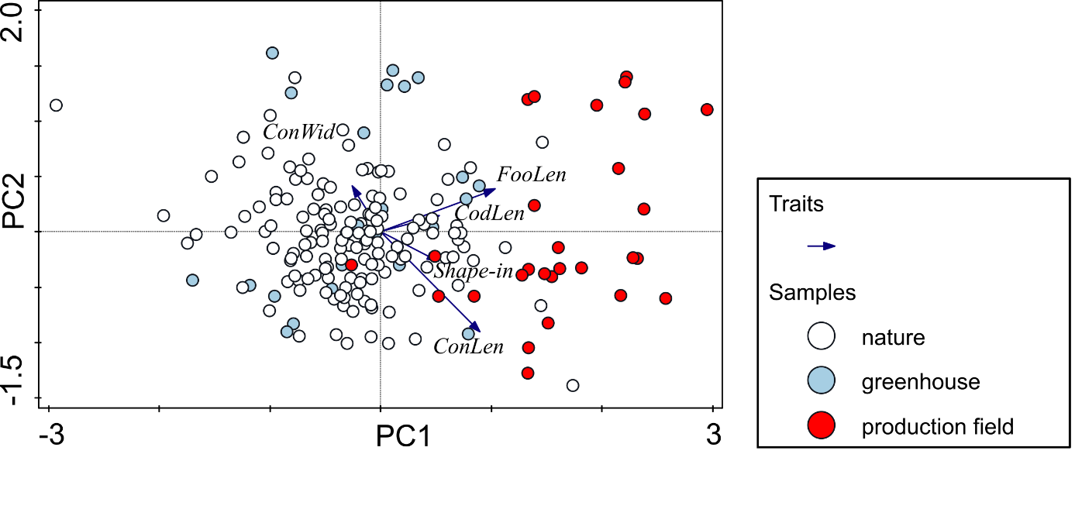

Supplementary material 4 - Figure 8. PCA of the whole LPM data set with a passive projection of collection places of Lactuca host species. ConWid – conidia width, ConLen – conidia length, FooLen – foot-cell length, CodLen – conidiophore length, Shape-in – shape-index.

