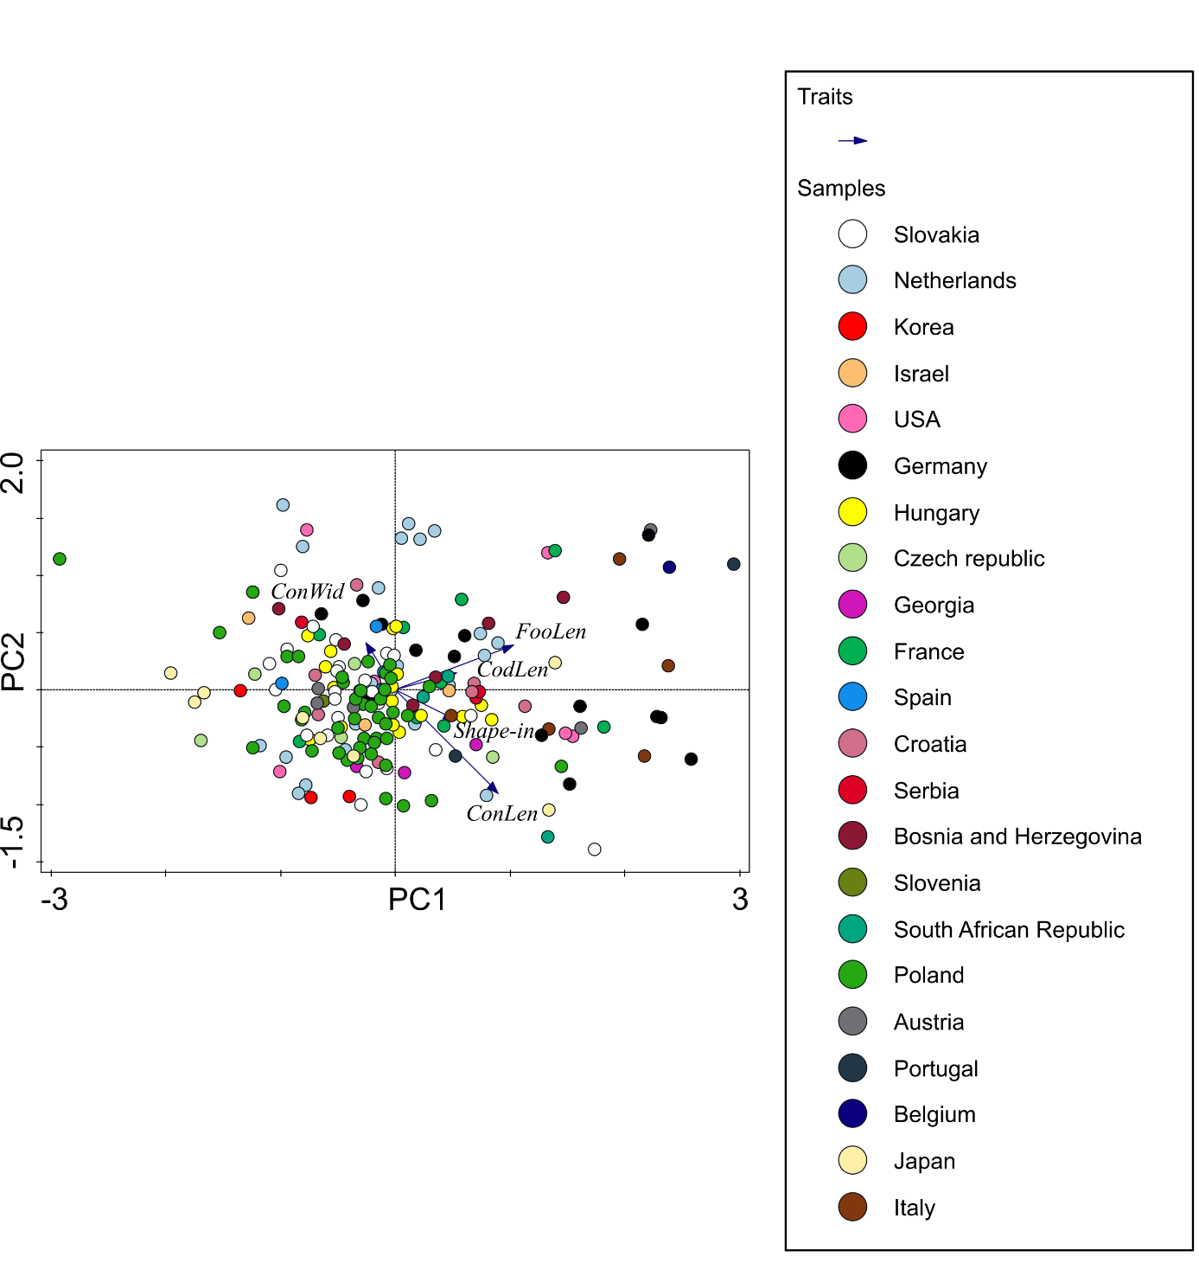

Supplementary material 5 - Figure 9. PCA of the whole LPM data set with a passive projection of the geographic origin of lettuce powdery mildew samples. ConWid – conidia width, ConLen – conidia length, FooLen – foot-cell length, CodLen – conidiophore length, Shape-in – shape-index.

