Why National and International Legitimacy Beliefs Are Linked:
Social Trust as an Antecedent Factor

Online appendix

Table of contents

Appendix A. Wording of survey questions

Appendix B: Descriptive statistics

Appendix C: Causal mediation analysis

Appendix D: Robustness checks

Appendix A. Wording of survey questions

Questions are presented in the order they appear in the questionnaire.

Intro-text
This survey is conducted by researchers at Stockholm University in Sweden.
The purpose of the survey is to get your opinion on politics in your country and the world. There are no right or wrong answers to the questions; we are interested in your opinion.

Single choice
How often do you watch the news on television, radio, printed newspapers or the Internet?
- Frequently
- Occasionally
- Never
- Don’t know

Single choice
When you get together with friends, how often would you say you discuss political matters?
- Frequently
- Occasionally
- Never
- Don’t know

Single choice, scale 0-10
Generally speaking, would you say that most people can be trusted, or that you can’t be too careful in dealing with people?
- You can’t be too careful

- Most people can be trusted
- Don’t know

Single choice, scale 0-10
Now let’s turn to a few questions about your opinion on politics.
In politics, people sometimes talk of “left” and “right”. How would you place your views on this scale?
- Left

- Right
- Don’t know

Single choice, dichotomous
Please think of what you recently have heard or read of the [country] government. Do you agree or disagree with the following statements?
- The [country] government is doing a good job.
- The way in which the [country] government makes decisions is democratic.
Agree
Disagree
Don’t know

Matrix, scale 1-4. Single choice, scale 0-10
How much confidence do you have in the [country] government?
- No confidence at all

- Complete confidence
- Don’t know

Single choice, scale 0-10. Question only asked in member states of the institution.
How much confidence do you personally have in the [international institution]?
- No confidence at all

- Complete confidence
- Don’t know

Ranking 1-4
Some people feel that they belong to a larger group that includes people in their own country, their continent or the world as a whole.
Please rank your feeling of belonging from 1 to 4, where 1 refers to the group to which you belong most of all, and 4 refers to the group to which you belong least of all.

Germany:
Bundesland
Germany
Europe
The world as a whole
Don’t know

UK:
Region
United Kingdom
Europe
The world as a whole
Don’t know

US:
State
US
North America
The world as a whole
Don’t know

Background variable delivered by Yougov panel: gender, age, and education

Germany: Education
[educ_neu] {single} Welchen höchsten Schulabschluss haben Sie?
<1> Noch in schulischer Ausbildung
<2> Haupt-(Volks-)schulabschluss
<3> Realschul- oder gleichwertiger Abschluss (POS, Mittlere Reife)
<4> Abitur, Fachhochschulreife
<5> Ohne Schulabschluss
<777> keine Angabe

<1> Keinen Abschluss
<2> Noch in Ausbildung
<3> Noch im Studium
<4> Lehre oder vergleichbarer Abschluss
<5> Universitäts- oder Fachhochschulabschluss
<777> keine Angabe

US: education
[educ] {single varlabel="Education"} What is the highest level of education you have completed?
<1/"No HS"> Did not graduate from high school
<2> High school graduate
<3/"Some college"> Some college, but no degree (yet)
<4/"2-year"> 2-year college degree
<5/"4-year"> 4-year college degree
<6/"Post-grad"> Postgraduate degree (MA, MBA, MD, JD, PhD, etc.)

UK: education
[profile_education_level] {single varlabel="Education qualification (highest attained)"} What is the highest educational or work-related qualification you have?
<1> No formal qualifications
<2> Youth training certificate/skillseekers
<3> Recognised trade apprenticeship completed
<4> Clerical and commercial
<5> City & Guilds certificate
<6> City & Guilds certificate - advanced
<7> ONC
<8> CSE grades 2-5
<9> CSE grade 1, GCE O level, GCSE, School Certificate
<10> Scottish Ordinary/ Lower Certificate
<11> GCE A level or Higher Certificate
<12> Scottish Higher Certificate
<13> Nursing qualification (eg SEN, SRN, SCM, RGN)
<14> Teaching qualification (not degree)
<15> University diploma
<16> University or CNAA first degree (eg BA, B.Sc, B.Ed)
<17> University or CNAA higher degree (eg M.Sc, Ph.D)
<18> Other technical, professional or higher qualification
<19> Don't know
<20> Prefer not to say

[profile_education_level_regrouped] {single varlabel="education_level_regrouped"} What is the highest educational or work-related qualification you have?
<1> Degree or above
<2> GCSE or equivalent
<3> A-level or equivalent
<4> Other
<5> No qualifications

Appendix B. Descriptive statistics

Table B1. Descriptive statistics
 | Min. | Mean | Max. | Std. dev. | N
International confidence | 0 | 3.860 | 10 | 2.470 | 6085
National confidence | 0 | 4.240 | 10 | 2.690 | 6076
Social trust | 0 | 4.880 | 10 | 2.490 | 6039
Political interest | 1 | 1.460 | 3 | 0.680 | 6025
Media exposure | 0 | 1.730 | 2 | 0.480 | 6066
Cosmopolitan identity | 0 | 0.380 | 2 | 0.730 | 6085
Performance satisfaction | 0 | 0.470 | 1 | 0.500 | 5680
Democracy satisfaction | 0 | 0.410 | 1 | 0.490 | 5808
Age | 18 | 46.88 | 86 | 15.25 | 6085
Gender | 0 | 0.470 | 1 | 0.500 | 6085
Education | 1 | 3.090 | 4 | 0.830 | 6012

Table B2. Correlation matrix
 | 1. | 2. | 3. | 4. | 5. | 6. | 7. | 8. | 9. | 10.
1. National confidence | 1.000
2. Social trust | 0.248 | 1.000
3. Education | 0.036 | 0.080 | 1.000
4. Political interest | -0.030 | -0.050 | -0.023 | 1.000
5. Media exposure | 0.103 | 0.146 | 0.085 | -0.040 | 1.000
6. Cosmopolitan identity | -0.069 | 0.003 | 0.069 | 0.060 | -0.062 | 1.000
7. Performance satisfaction | 0.615 | 0.158 | -0.033 | -0.062 | 0.037 | -0.064 | 1.000
8. Democracy satisfaction | 0.704 | 0.098 | -0.017 | -0.004 | 0.051 | -0.049 | 0.566 | 1.000
9. Age | 0.034 | 0.126 | -0.051 | 0.009 | 0.284 | -0.120 | 0.000 | -0.002 | 1.000
10. Gender | 0.009 | -0.028 | -0.050 | -0.022 | -0.134 | -0.010 | 0.047 | 0.011 | 0.012 | 1.000
Notes: N=5470.

Appendix C. Causal mediation analysis

We detail the numerical results used for Figure 3 below. Nonparametric bootstrap confidence intervals obtained with the percentile method. 1000 simulations for each analysis.

Pooled country sample

Estimate 95% CI Lower 95% CI Upper p-value
ACME 0.605 0.517 0.706 0
ADE 1.422 1.179 1.675 0
Total Effect 2.026 1.781 2.286 0
Prop. Mediated 0.298 0.249 0.359 0

Sample Size Used: 5496

UK

Estimate 95% CI Lower 95% CI Upper p-value
ACME 0.1183 0.0574 0.2076 0
ADE 1.8710 1.4378 2.3090 0
Total Effect 1.9893 1.5442 2.4209 0
Prop. Mediated 0.0594 0.0284 0.1057 0

Sample Size Used: 1936

US

Estimate 95% CI Lower 95% CI Upper p-value
ACME 1.373 1.063 1.699 0.00
ADE 0.585 0.078 1.170 0.02
Total Effect 1.958 1.470 2.522 0.00
Prop. Mediated 0.701 0.518 0.947 0.00

Sample Size Used: 1377

Germany

Estimate 95% CI Lower 95% CI Upper p-value
ACME 0.972 0.771 1.163 0
ADE 0.944 0.557 1.336 0
Total Effect 1.916 1.525 2.294 0
Prop. Mediated 0.507 0.401 0.650 0

Sample Size Used: 2178

Appendix D. Robustness checks

Table D1. Replication of Table 2 controlling for a potential effect of international on national confidence
 | Model 1 | Model 2 | Model 3 | Model 4
 | All countries | UK | Germany | US
International confidence (equation (1))
National confidence | 0.39 | 0.19 | 0.49 | 0.57**
 | (0.32) | (0.27) | (0.27) | (0.21)
Social trust | 0.14** | 0.20*** | 0.10* | -0.03
 | (0.05) | (0.03) | (0.05) | (0.06)
Cosmopolitan identity | 0.32*** | 0.11 | 0.24* | 0.44***
 | (0.07) | (0.14) | (0.11) | (0.09)
Performance satisfaction | 0.29 | 0.56 | 0.28 | 0.03
 | (0.50) | (0.48) | (0.52) | (0.19)
Democracy satisfaction | 0.18 | -0.33 | 0.28 | 0.86
 | (0.93) | (0.87) | (0.71) | (0.59)
Political interest | 0.05 | -0.05 | 0.06 | 0.19
 | (0.05) | (0.07) | (0.07) | (0.10)
Media exposure | -0.10 | -0.24 | 0.32*** | -0.26
 | (0.14) | (0.17) | (0.10) | (0.18)
Age | -0.01*** | -0.00 | -0.02*** | -0.03***
 | (0.00) | (0.00) | (0.00) | (0.01)
Gender | 0.20** | -0.04 | 0.13 | 0.52***
 | (0.06) | (0.12) | (0.09) | (0.15)
Education | -0.02 | 0.03 | 0.11 | -0.06
 | (0.07) | (0.08) | (0.07) | (0.09)
Country fixed effects | Yes | No | No | No
National confidence (equation (2))
International confidence | -0.48* | -2.77 | -1.69 | 0.43***
 | (0.21) | (3.84) | (1.02) | (0.13)
Social trust | 0.24*** | 0.64 | 0.52* | 0.19***
 | (0.05) | (0.82) | (0.20) | (0.04)
Performance satisfaction | 1.94*** | 4.19 | 3.93** | 0.41*
 | (0.21) | (3.45) | (1.25) | (0.18)
Democracy satisfaction | 3.46*** | 4.07*** | 5.23*** | 1.31***
 | (0.29) | (1.17) | (1.57) | (0.37)
Political interest | 0.02 | -0.12 | 0.19 | -0.11
 | (0.09) | (0.28) | (0.18) | (0.13)
Media exposure | 0.47** | 0.09 | 0.77 | 0.54*
 | (0.16) | (0.70) | (0.44) | (0.23)
Age | -0.01 | -0.01 | -0.03 | 0.01
 | (0.00) | (0.02) | (0.02) | (0.01)
Gender | 0.13 | 0.23 | -0.03 | -0.17
 | (0.09) | (0.32) | (0.20) | (0.18)
Education | 0.21*** | 0.37 | 0.12 | 0.22*
 | (0.06) | (0.31) | (0.18) | (0.09)
Country fixed effects | Yes | No | No | No
Overall R-squared | 42.22% | 26.10% | -0.09%ª | 67.77%
N | 5470 | 1933 | 2176 | 1361
Notes: Structural equation analysis using design weights. Unstandardized coefficients, with standard errors in parentheses. * p<.05, ** p<.01, *** p<.001. A constant is included in each equation, but not reported here. ª The negative overall R² for Model 3 is due to the negative R² for the second equation, indicating a worsening of model fit in explaining variation in national confidence. The R² for the first equation is 44.63%.

Table D2. Replication of Table 2 considering potential effect of quality of domestic political institutions on social trust
 | Model 1 |  |  | Model 2 |  | Model 3 | Model 4
 | All countries |  |  | UK |  | Germany | US
International confidence (equation (1))
National confidence | 0.39*** | 0.19*** |  |  | 0.49*** |  | 0.57***
 | (0.03) | (0.06) |  |  | (0.04) |  | (0.05)
Social trust | 0.14*** | 0.20*** |  |  | 0.10*** |  | -0.03
 | (0.02) | (0.04) |  |  | (0.03) |  | (0.04)
Cosmopolitan identity | 0.32*** | 0.11 |  |  | 0.24** |  | 0.44***
 | (0.07) | (0.14) |  |  | (0.09) |  | (0.12)
Performance satisfaction | 0.29* | 0.56* |  |  | 0.28 |  | 0.03
 | (0.13) | (0.22) |  |  | (0.18) |  | (0.21)
Democracy satisfaction | 0.18 | -0.33 |  |  | 0.28 |  | 0.86***
 | (0.14) | (0.27) |  |  | (0.19) |  | (0.24)
Political interest | 0.05 | -0.05 |  |  | 0.06 |  | 0.19
 | (0.07) | (0.11) |  |  | (0.10) |  | (0.13)
Media exposure | -0.10 | -0.24 |  |  | 0.32* |  | -0.26
 | (0.10) | (0.19) |  |  | (0.14) |  | (0.16)
Age | -0.01*** | -0.00 |  |  | -0.02*** |  | -0.03***
 | (0.00) | (0.01) |  |  | (0.00) |  | (0.01)
Gender | 0.20* | -0.04 |  |  | 0.13 |  | 0.52**
 | (0.10) | (0.16) |  |  | (0.12) |  | (0.19)
Education | -0.02 | 0.03 |  |  | 0.11 |  | -0.06
 | (0.06) | (0.08) |  |  | (0.10) |  | (0.10)
Country fixed effects | Yes |  | No |  | No |  | No
National confidence (equation (1))
Social trust | 0.14*** | 0.05 |  |  | 0.19*** |  | 0.23**
 | (0.03) | (0.03) |  |  | (0.03) |  | (0.09)
Performance satisfaction | 1.53*** | 1.73*** |  |  | 1.91*** |  | 0.56
 | (0.13) | (0.18) |  |  | (0.17) |  | (0.33)
Democracy satisfaction | 2.85*** | 3.27*** |  |  | 2.64*** |  | 2.28***
 | (0.14) | (0.18) |  |  | (0.17) |  | (0.40)
Political interest | -0.01 | -0.00 |  |  | 0.04 |  | -0.04
 | (0.11) | (0.11) |  |  | (0.12) |  | (0.28)
Media exposure | 0.44 | 0.53** |  |  | 0.13 |  | 0.59
 | (0.23) | (0.19) |  |  | (0.17) |  | (0.54)
Age | 0.00 | -0.00 |  |  | 0.00 |  | -0.00
 | (0.00) | (0.01) |  |  | (0.01) |  | (0.01)
Gender | 0.03 | 0.24 |  |  | -0.14 |  | 0.09
 | (0.12) | (0.15) |  |  | (0.14) |  | (0.33)
Education | 0.18* | 0.18* |  |  | -0.04 |  | 0.27
 | (0.08) | (0.09) |  |  | (0.11) |  | (0.21)
Country fixed effects | Yes | No |  |  | No |  | No
Social trust equation
Performance satisfaction | 0.79*** | 0.69* |  |  | 1.01*** |  | 0.59
 | (0.17) | (0.28) |  |  | (0.24) |  | (0.38)
Democracy satisfaction | 0.08 | -0.38 |  |  | 0.33 |  | 0.76
 | (0.17) | (0.28) |  |  | (0.24) |  | (0.42)
Overall R-squared | 56.72% |  | 66.90% |  | 64.18% |  | 38.78%
N | 5470 | 1933 |  |  | 2176 |  | 1361
Notes: Structural equation analysis using design weights. Unstandardized coefficients, with standard errors in parentheses. * p<.05, ** p<.01, *** p<.001. A constant is included in each equation, but not reported here.

Table D3. Replication of Table 2 including fixed effects for international institutions
 | Model 1 | Model 2 | Model 3 | Model 4
 | All countries | UK | Germany | US
International confidence (equation (1))
National confidence | 0.39*** | 0.19*** | 0.49*** | 0.57***
 | (0.03) | (0.06) | (0.04) | (0.05)
Social trust | 0.14*** | 0.20*** | 0.10*** | -0.03
 | (0.02) | (0.04) | (0.03) | (0.04)
Cosmopolitan identity | 0.32*** | 0.10 | 0.23** | 0.44***
 | (0.07) | (0.14) | (0.09) | (0.12)
Performance satisfaction | 0.28* | 0.56* | 0.27 | 0.02
 | (0.13) | (0.22) | (0.18) | (0.21)
Democracy satisfaction | 0.18 | -0.33 | 0.27 | 0.86***
 | (0.14) | (0.27) | (0.19) | (0.24)
Political interest | 0.05 | -0.04 | 0.06 | 0.19
 | (0.07) | (0.11) | (0.10) | (0.13)
Media exposure | -0.09 | -0.25 | 0.31* | -0.25
 | (0.10) | (0.19) | (0.14) | (0.16)
Age | -0.01*** | -0.00 | -0.02*** | -0.03***
 | (0.00) | (0.01) | (0.00) | (0.01)
Gender | 0.20* | -0.03 | 0.12 | 0.51**
 | (0.10) | (0.16) | (0.12) | (0.19)
Education | -0.02 | 0.03 | 0.12 | -0.06
 | (0.06) | (0.08) | (0.10) | (0.10)
Country fixed effects | Yes | No | No | no
Institution fixed effects | Yes | Yes | Yes | Yes
National confidence (equation (1))
Social trust | 0.14*** | 0.05 | 0.19*** | 0.23**
 | (0.03) | (0.03) | (0.03) | (0.09)
Performance satisfaction | 1.53*** | 1.73*** | 1.91*** | 0.56
 | (0.13) | (0.18) | (0.17) | (0.33)
Democracy satisfaction | 2.85*** | 3.27*** | 2.64*** | 2.28***
 | (0.14) | (0.18) | (0.17) | (0.40)
Political interest | -0.01 | -0.00 | 0.04 | -0.04
 | (0.11) | (0.11) | (0.12) | (0.28)
Media exposure | 0.44 | 0.53** | 0.13 | 0.59
 | (0.23) | (0.19) | (0.17) | (0.54)
Age | 0.00 | -0.00 | 0.00 | -0.00
 | (0.00) | (0.01) | (0.01) | (0.01)
Gender | 0.03 | 0.24 | -0.14 | 0.09
 | (0.12) | (0.15) | (0.14) | (0.33)
Education | 0.18* | 0.18* | -0.04 | 0.27
 | (0.08) | (0.09) | (0.11) | (0.21)
Country fixed effects | Yes | No | No | No
Overall R-squared | 57.18% | 69.51% | 58.49% | 41.65%
N | 5470 | 1933 | 2176 | 1361
Notes: Structural equation analysis using design weights. Unstandardized coefficients, with standard errors in parentheses. * p<.05, ** p<.01, *** p<.001. A constant is included in each equation, but not reported here.
Table D4. Robustness check using World Values Survey data – United Nations, 1999-2004
 | Model 1 | Model 2 | Model 3 | Model 4
Dependent variable: United Nations confidence
National confidence | 1.97*** | 1.96*** | 2.04*** | 2.07***
 | (0.05) | (0.05) | (0.05) | (0.06)
Social trust |  | 1.09*** | 1.09*** | 1.10***
 |  | (0.02) | (0.02) | (0.02)
Cosmopolitan identity | 1.21*** | 1.22*** | 1.22*** | 1.23***
 | (0.03) | (0.03) | (0.03) | (0.03)
Age | 1.00*** | 1.00*** | 0.99*** | 0.99***
 | (0.00) | (0.00) | (0.00) | (0.00)
Gender | 0.99 | 0.99 | 1.00 | 1.00
 | (0.02) | (0.02) | (0.02) | (0.02)
Education | 1.03*** | 1.03***
 | (0.01) | (0.01)
Political interest (self-reported) |  |  | 1.12***
 |  |  | (0.02)
National confidence * Political interest (self-reported) |  |  | 0.97*
 |  |  | (0.02)
Political interest |  |  |  | 1.14***
 |  |  |  | (0.03)
National confidence * Political interest |  |  |  | 0.94***
 |  |  |  | (0.02)
Country fixed effects | Yes | Yes | Yes | Yes
Cut 1 | –2.77*** | –2.69*** | –2.69*** | –2.69***
 | (0.08) | (0.08) | (0.09) | (0.09)
Cut 2 | –1.11*** | –1.02*** | –1.02*** | –1.02***
 | (0.08) | (0.08) | (0.09) | (0.09)
Cut 3 | 1.15*** | 1.23*** | 1.24*** | 1.24***
 | (0.08) | (0.09) | (0.09) | (0.09)
Dependent variable: national confidence
Social trust |  | 1.33*** | 1.29*** | 1.32***
 |  | (0.03) | (0.03) | (0.03)
Age | 1.01*** | 1.01*** | 1.01*** | 1.01***
 | (0.00) | (0.00) | (0.00) | (0.00)
Gender | 1.00 | 1.00 | 1.05* | 1.00
 | (0.02) | (0.02) | (0.02) | (0.02)
Education | 0.96*** | 0.96***
 | (0.01) | (0.01)
Political interest (self-reported) |  |  | 1.16***
 |  |  | (0.01)
Political interest |  |  |  | 0.97*
 |  |  |  | (0.01)
Country fixed effects | Yes | Yes | Yes | Yes
Cut 1 | –1.50*** | –1.46*** | –1.12*** | –1.31***
 | (0.08) | (0.08) | (0.07) | (0.07)
Cut 2 | 0.31*** | 0.35*** | 0.72*** | 0.52***
 | (0.08) | (0.08) | (0.07) | (0.07)
Cut 3 | 2.42*** | 2.47*** | 2.86*** | 2.66***
 | (0.12) | (0.12) | (0.10) | (0.10)
N | 67572 | 64974 | 61557 | 61164
Log Likelihood | –147710 | –141972.8 | –136909.1 | –136181.7
Bayesian Information Criterion | 296665.5 | 285208.8 | 275075.3 | 273619.8
Notes: Structural equation analysis using ordered logistic regression on the basis of data from 47 countries. Using sampling weights and country fixed effects. Odds ratios, with standard errors in parentheses. These European countries were European Union member states at the time of the survey data collection. * p<.05, ** p<.01, *** p<.001
Operationalization:
- Confidence: ‘I am going to name a number of organizations. For each one, could you tell me how much confidence you have in them: is it a great deal of confidence (3), quite a lot of confidence (2), not very much confidence (1) or none at all (0)? United Nations; The government’
- Social trust: ’Generally speaking, would you say that most people can be trusted or that you need to be very careful in dealing with people? Most people can be trusted (1), can’t be too careful (0).’
- Cosmopolitan identity: ‘To which of these geographical groups would you say you belong first of all? Locality (1), region (2), country (3), continent (4), world (5)?’
- Education: 9-point indicator (highest level of education, ISCED-coding).
- Political interest (self-reported): ‘How interested would you say you are in politics? Very interested (3), Somewhat interested (2), Not very interested (1), Not at all interested (0)’
- Political interest: ‘When you get together with your friends, would you say you Political interest political matters frequently, occasionally or never? Frequently (2), occasionally (1) or never (0)?’
Table D5. Robustness check using World Values Survey data – European Union, 1999-2004
 | Model 1 | Model 2 | Model 3 | Model 4
Dependent variable: European Union confidence
National confidence | 2.78*** | 2.73*** | 2.53*** | 2.80***
 | (0.14) | (0.14) | (0.23) | (0.24)
Cosmopolitan identity | 1.45*** | 1.45*** | 1.46*** | 1.48***
 | (0.11) | (0.11) | (0.11) | (0.11)
Age | 0.99*** | 0.99*** | 0.99*** | 0.99***
 | (0.00) | (0.00) | (0.00) | (0.00)
Gender | 1.01 | 1.01 | 1.01 | 0.99
 | (0.06) | (0.06) | (0.06) | (0.06)
Social trust |  | 1.23** | 1.24** | 1.25***
 |  | (0.08) | (0.08) | (0.08)
Education | 1.04* | 1.03*
 | (0.01) | (0.02)
Political interest (self-reported) |  |  | 1.04
 |  |  | (0.06)
National confidence * Political interest (self-reported) |  |  | 1.05
 |  |  | (0.05)
Political interest |  |  |  | 1.00
 |  |  |  | (0.09)
National confidence * Political interest |  |  |  | 0.98
 |  |  |  | (0.07)
Country fixed effects | Yes | Yes | Yes | Yes
Cut 1 | –1.47*** | –1.45*** | –1.59*** | –1.59***
 | (0.14) | (0.15) | (0.16) | (0.16)
Cut 2 | 0.88*** | 0.90*** | 0.76*** | 0.76***
 | (0.14) | (0.15) | (0.16) | (0.16)
Cut 3 | 3.87*** | 3.87*** | 3.73*** | 3.73***
 | (0.17) | (0.17) | (0.18) | (0.18)
Dependent variable: national confidence
Age | 1.01*** | 1.01*** | 1.01*** | 1.01***
 | (0.00) | (0.00) | (0.00) | (0.00)
Gender | 1.05 | 1.05 | 1.09 | 1.03
 | (0.05) | (0.05) | (0.06) | (0.05)
Social trust |  | 1.46*** | 1.39*** | 1.42***
 |  | (0.08) | (0.08) | (0.08)
Education | 0.96** | 0.96***
 | (0.01) | (0.01)
Political interest (self-reported) |  |  | 1.08*
 |  |  | (0.04)
Political interest |  |  |  | 0.86***
 |  |  |  | (0.04)
Country fixed effects | Yes | Yes | Yes | Yes
Cut 1 | –1.15*** | –1.12*** | –0.81*** | –0.95***
 | (0.12) | (0.13) | (0.11) | (0.11)
Cut 2 | 0.92*** | 0.95*** | 1.26*** | 1.12***
 | (0.12) | (0.13) | (0.11) | (0.11)
Cut 3 | 2.85*** | 2.89*** | 3.21*** | 3.07***
 | (0.14) | (0.14) | (0.12) | (0.12)
N | 5357 | 5186 | 5168 | 5149
Log Likelihood | –10464.62 | –10134.07 | –10128.37 | –10114.02
Bayesian Information Criterion | 21092.39 | 20447.77 | 20436.36 | 20407.68
Notes: Structural equation analysis using ordered logistic regression on the basis of data from four countries. These countries were European Union member states at the time of the survey data collection.Using sampling weights and country fixed effects. Odds ratios, with standard errors in parentheses. * p<.05, ** p<.01, *** p<.001
Operationalization:
- Confidence: ‘I am going to name a number of organizations. For each one, could you tell me how much confidence you have in them: is it a great deal of confidence (3), quite a lot of confidence (2), not very much confidence (1) or none at all (0)? United Nations; The government’
- Social trust: ’Generally speaking, would you say that most people can be trusted or that you need to be very careful in dealing with people? Most people can be trusted (1), can’t be too careful (0).’
- Cosmopolitan identity: ‘To which of these geographical groups would you say you belong first of all? Locality (1), region (2), country (3), continent (4), world (5)?’
- Education: 9-point indicator (highest level of education, ISCED-coding).
- Political interest (self-reported): ‘How interested would you say you are in politics? Very interested (3), Somewhat interested (2), Not very interested (1), Not at all interested (0)’
- Political interest: ‘When you get together with your friends, would you say you Political interest political matters frequently, occasionally or never? Frequently (2), occasionally (1) or never (0)?’
Table D6. Robustness check using European Social Survey data – United Nations, 2014
 | Model 1 | Model 2 | Model 3 | Model 4
Dependent variable: United Nations trust
National confidence | 0.52*** | 0.49*** | 0.57*** | 0.52***
 | (0.01) | (0.01) | (0.01) | (0.01)
Age | –0.01*** | –0.01*** | –0.01*** | –0.01***
 | (0.00) | (0.00) | (0.00) | (0.00)
Gender | 0.11*** | 0.12*** | 0.13*** | 0.12***
 | (0.03) | (0.03) | (0.03) | (0.03)
Social trust |  | 0.10*** | 0.09*** | 0.10***
 |  | (0.01) | (0.01) | (0.01)
Education | 0.01 | –0.01
 | (0.01) | (0.01)
Political interest (self-reported) |  |  | 0.35***
 |  |  | (0.03)
National confidence * Political interest (self-reported) |  |  | –0.06***
 |  |  | (0.01)
Media exposure |  |  |  | 0.10***
 |  |  |  | (0.02)
National confidence * Media exposure |  |  |  | –0.02***
 |  |  |  | (0.00)
Country fixed effects | Yes | Yes | Yes | Yes
Constant | 2.34*** | 2.03*** | 1.58*** | 1.84***
 | (0.09) | (0.09) | (0.10) | (0.10)
Dependent variable: national trust
Age | –0.01*** | –0.01*** | –0.01*** | –0.01***
 | (0.00) | (0.00) | (0.00) | (0.00)
Gender | –0.22*** | –0.18*** | –0.08** | –0.17***
 | (0.03) | (0.03) | (0.03) | (0.03)
Social trust |  | 0.29*** | 0.28*** | 0.31***
 |  | (0.01) | (0.01) | (0.01)
Education | 0.22*** | 0.14***
 | (0.01) | (0.01)
Political interest (self-reported) |  |  | 0.44***
 |  |  | (0.02)
Media exposure |  |  |  | 0.08***
 |  |  |  | (0.01)
Country fixed effects | Yes | Yes | Yes | Yes
Constant | 4.62*** | 3.33*** | 3.19*** | 3.68***
 | (0.10) | (0.10) | (0.10) | (0.10)
var(e.trustun) | 4.55*** | 4.51*** | 4.49*** | 4.47***
_cons | (0.04) | (0.04) | (0.04) | (0.04)
var(e.trustparl) | 5.73*** | 5.33*** | 5.22*** | 5.29***
_cons | (0.04) | (0.04) | (0.04) | (0.04)
N | 39035 | 38982 | 39117 | 37110
Log Likelihood | –168113.7 | –166375.4 | –166500.5 | –158302.4
Bayesian Information Criterion | 336766.6 | 333311 | 333572 | 317172.9
Notes: Structural equation analysis using nonlinear least squares using 21 countries. Using sampling weights and country fixed effects. Unstandardized coefficients, with standard errors in parentheses. These European countries were European Union member states at the time of the survey data collection. * p<.05, ** p<.01, *** p<.001
Operationalization:
- Trust: ‘Using this card, please tell me on a score of 0-10 how much you personally trust each of the institutions I read out. 0 means you do not trust an institution at all, and 10 means you have complete trust. Firstly, …[country]’s parliament; the European Parliament; the United Nations’
- Social trust: Using this card, generally speaking, would you say that most people can be trusted, or that you can’t be too careful in dealing with people? Please tell me on a score of 0 to 10, where 0 means you can’t be too careful and 10 means that most people can be trusted.
- Education: 6-point indicator (highest level of education, ISCED-coding).
- Political interest (self-reported): ‘How interested would you say you are in politics? Very interested (3), Quite interested (2), Hardly interested (1), Not at all interested (0)’
- Media exposure: ‘And again on an average weekday, how much of your time watching television is spent watching news or programmes about politics and current affairs? No time at all (0), Less than 1⁄2 hour (1), 1⁄2 hour to 1 hour (2), More than 1 hour, up to 1 1⁄2 hours (3), More than 1 1⁄2 hours, up to 2 hours (4), More than 2 hours, up to 2 1⁄2 hours (5), More than 2 1⁄2 hours, up to 3 hours (6), More than 3 hours (7)’
Table D7. Robustness check using European Social Survey data – European Parliament, 2014
 | Model 1 | Model 2 | Model 3 | Model 4
Dependent variable: European Parl. trust
National confidence | 0.60*** | 0.58*** | 0.64*** | 0.61***
 | (0.01) | (0.01) | (0.01) | (0.01)
Age | –0.02*** | –0.02*** | –0.02*** | –0.02***
 | (0.00) | (0.00) | (0.00) | (0.00)
Gender | 0.29*** | 0.30*** | 0.30*** | 0.32***
 | (0.02) | (0.02) | (0.02) | (0.02)
Social trust |  | 0.08*** | 0.08*** | 0.08***
 |  | (0.01) | (0.01) | (0.01)
Education | –0.02* | –0.04***
 | (0.01) | (0.01)
Political interest (self-reported) |  |  | 0.20***
 |  |  | (0.03)
National confidence * Political interest (self-reported) |  |  | –0.04***
 |  |  | (0.01)
Media exposure |  |  |  | 0.09***
 |  |  |  | (0.02)
National confidence * Media exposure |  |  |  | –0.02***
 |  |  |  | (0.00)
Constant | 1.20*** | 0.93*** | 0.55*** | 0.67***
 | (0.08) | (0.08) | (0.09) | (0.09)
Dependent variable: national trust
Age | –0.01*** | –0.01*** | –0.01*** | –0.01***
 | (0.00) | (0.00) | (0.00) | (0.00)
Gender | –0.22*** | –0.18*** | –0.08** | –0.17***
 | (0.03) | (0.03) | (0.03) | (0.03)
Social trust | 0.29*** | 0.29*** | 0.31***
 | (0.01) | (0.01) | (0.01)
Education | 0.22*** | 0.14***
 | (0.01) | (0.01)
Political interest (self-reported)
Media exposure
Constant | 4.62*** | 3.33*** | 3.19*** | 3.68***
 | (0.10) | (0.10) | (0.10) | (0.10)
var(e.International confidence) | 3.89*** | 3.87*** | 3.86*** | 3.86***
_cons | (0.04) | (0.04) | (0.04) | (0.04)
var(e.National confidence) | 5.73*** | 5.33*** | 5.22*** | 5.29***
_cons | (0.04) | (0.04) | (0.04) | (0.04)
N | 39035 | 38982 | 39117 | 37110
Log Likelihood | –164988.3 | –163251.1 | –163262 | –154975
Bayesian Information Criterion | 330515.8 | 327062.5 | 327095.1 | 310518.3
Notes: Structural equation analysis using nonlinear least squares using data from 21 European countries. Using sampling weights and country fixed effects. Unstandardized coefficients, with standard errors in parentheses. These European countries were European Union member states at the time of the survey data collection. * p<.05, ** p<.01, *** p<.001
Operationalization:
- Trust: ‘Using this card, please tell me on a score of 0-10 how much you personally trust each of the institutions I read out. 0 means you do not trust an institution at all, and 10 means you have complete trust. Firstly, …[country]’s parliament; the European Parliament; the United Nations’
- Social trust: Using this card, generally speaking, would you say that most people can be trusted, or that you can’t be too careful in dealing with people? Please tell me on a score of 0 to 10, where 0 means you can’t be too careful and 10 means that most people can be trusted.
- Education: 6-point indicator (highest level of education, ISCED-coding).
- Political interest (self-reported): ‘How interested would you say you are in politics? Very interested (3), Quite interested (2), Hardly interested (1), Not at all interested (0)’
- Media exposure: ‘And again on an average weekday, how much of your time watching television is spent watching news or programmes about politics and current affairs? No time at all (0), Less than 1⁄2 hour (1), 1⁄2 hour to 1 hour (2), More than 1 hour, up to 1 1⁄2 hours (3), More than 1 1⁄2 hours, up to 2 hours (4), More than 2 hours, up to 2 1⁄2 hours (5), More than 2 1⁄2 hours, up to 3 hours (6), More than 3 hours (7)’
Figure D1. Marginal effect of national on international confidence, at levels of political interest (self-reported), United Nations, 1999–2004
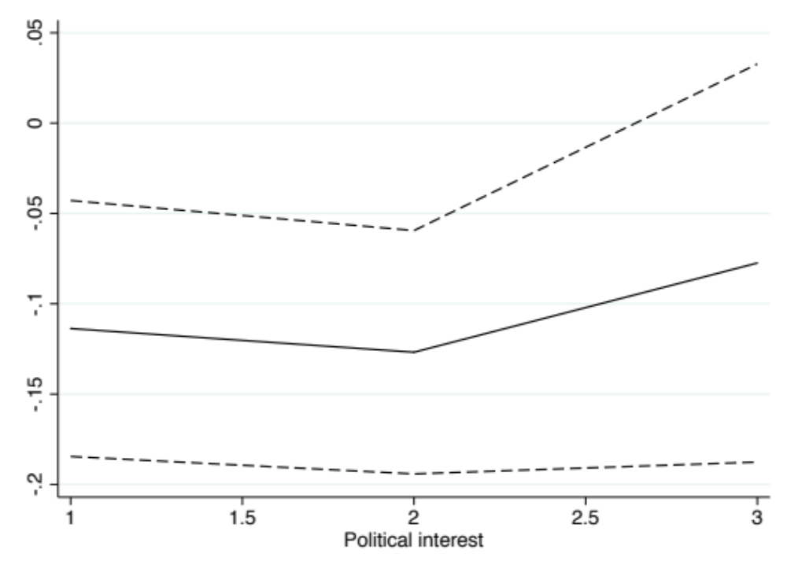
Notes: Based on estimations in model 3 in Table D4 in this appendix. Solid line depicts the marginal effect on the dependent variable, expressed in odds ratios. Dashed lines depict the 95% confidence intervals of the marginal effect. When the confidence intervals overlap with zero, the marginal effect is not statistically significant.

Figure D2. Marginal effect of national on international confidence, at levels of political interest, United Nations, 1999-2004
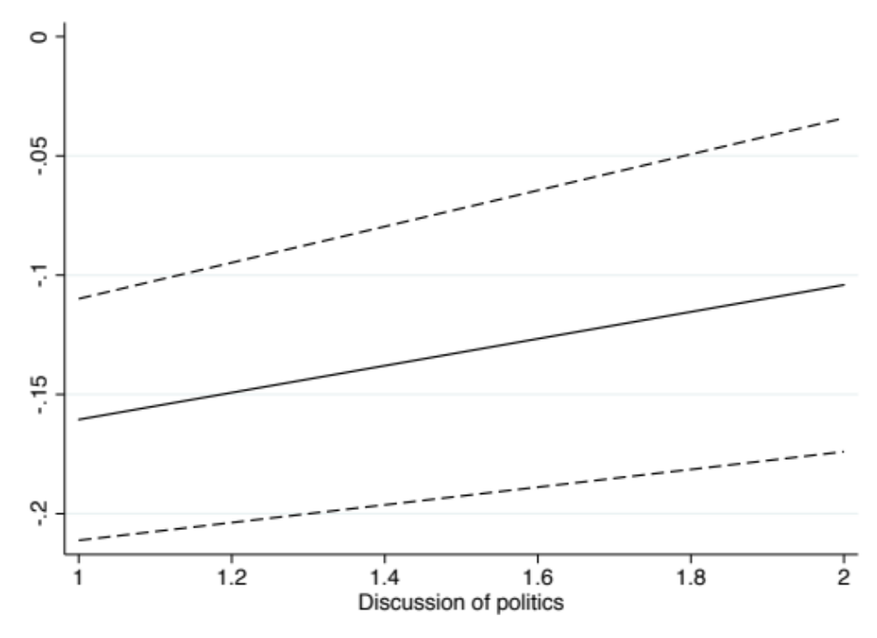
Notes: Based on estimations in model 4 in Table D4 in this appendix. Solid line depicts the marginal effect on the dependent variable, expressed in odds ratios. Dashed lines depict the 95% confidence intervals of the marginal effect. When the confidence intervals overlap with zero, the marginal effect is not statistically significant.

Figure D3. Marginal effect of national on international confidence, at levels of political interest (self-reported), United Nations, 2014
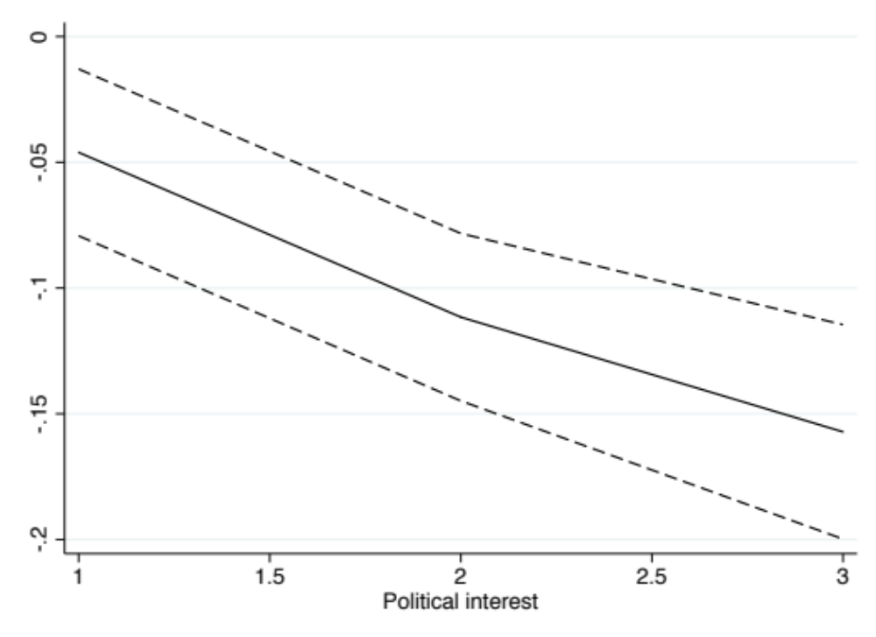
Notes: Based on estimations in model 3 in Table D6 in this appendix. Solid line depicts the marginal effect on the dependent variable, expressed in odds ratios. Dashed lines depict the 95% confidence intervals of the marginal effect. When the confidence intervals overlap with zero, the marginal effect is not statistically significant.

Figure D4. Marginal effect of national on international confidence, at levels of media consumption, United Nations, 2014
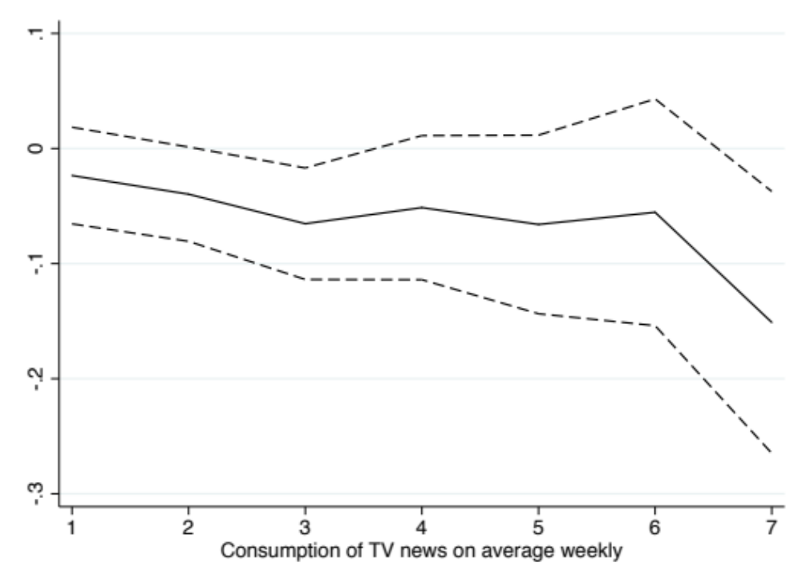
Notes: Based on estimations in model 4 in Table D6 in this appendix. Solid line depicts the marginal effect on the dependent variable, expressed in odds ratios. Dashed lines depict the 95% confidence intervals of the marginal effect. When the confidence intervals overlap with zero, the marginal effect is not statistically significant.

Figure D5. Marginal effect of national on international confidence, at levels of political interest (self-reported), European Parliament, 2014
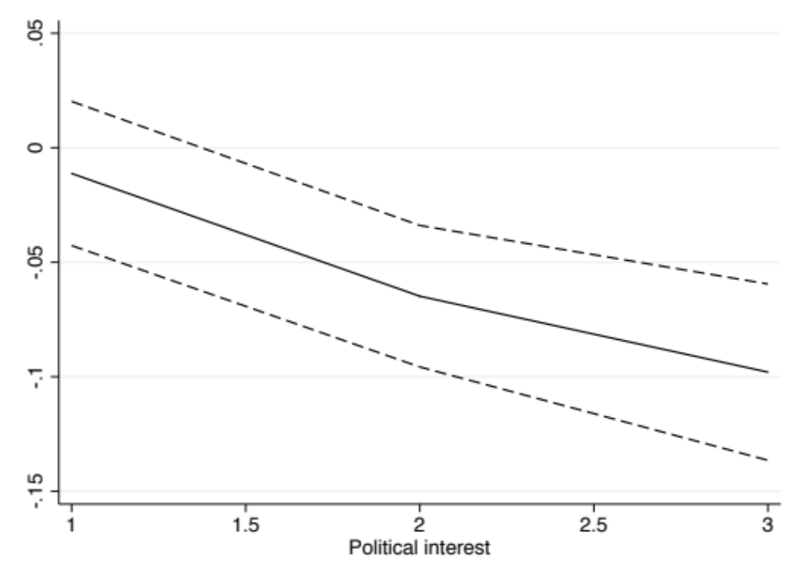
Notes: Based on estimations in model 3 in Table D7 in this appendix. Solid line depicts the marginal effect on the dependent variable, expressed in odds ratios. Dashed lines depict the 95% confidence intervals of the marginal effect. When the confidence intervals overlap with zero, the marginal effect is not statistically significant.

Figure D6. Marginal effect of national on international confidence, at levels of media exposure, European Parliament, 2014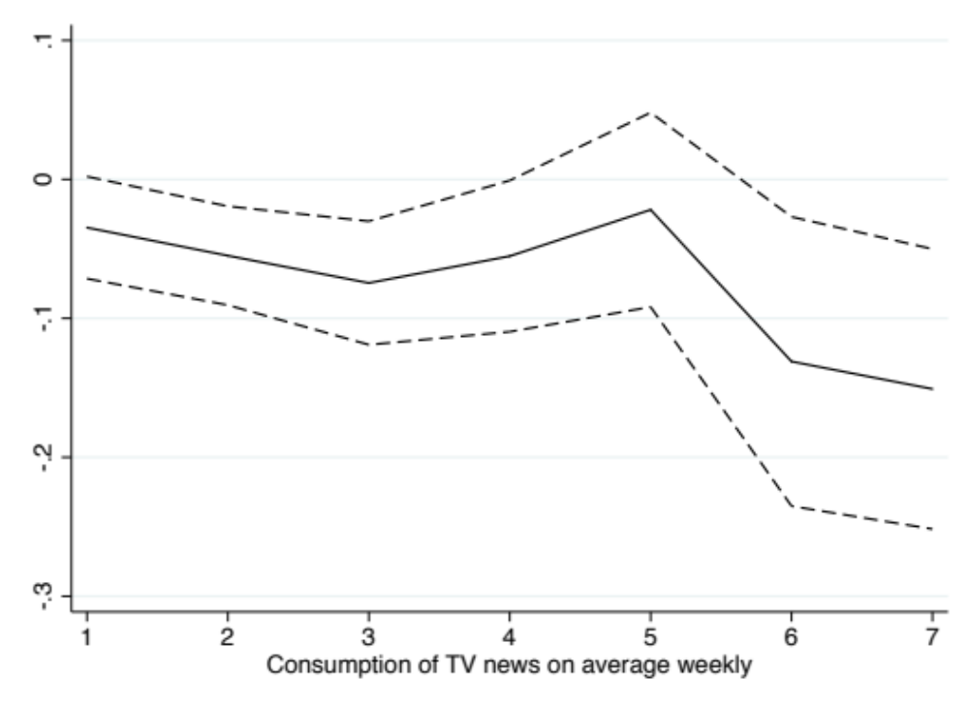

Notes: Based on estimations in model 4 in Table D7 in this appendix. Solid line depicts the marginal effect on the dependent variable, expressed in odds ratios. Dashed lines depict the 95% confidence intervals of the marginal effect. When the confidence intervals overlap with zero, the marginal effect is not statistically significant.

