Appendix

A.1. Formal transparency
A.2. Impact of upcoming elections (Hypothesis 2a)
A.3. Euroscepticism metrics (H2b)
A.4. Council formations (H2c)
A.5. Collinearity test
A.6. Transparency culture
A.7. Regional country allocations (for the Council Presidency control variable)
A.8. Agenda items
A.9. Time series considerations
A.10. European Parliament
A.11 Logistic and zero-inflated Poisson regressions
A.12. Semester granularity
A.13. Overdispersion tests for the Poisson regressions
A.14. Interrupted time series
A.15. Single transparency variable
A.16. Financial crisis

A.1. Formal transparency

The formal transparency measure is based on changes in formal transparency rules (reviewed in article section 3) that obligated the Council to publish documents (e.g., minutes) and livestream meetings. These formal changes are the 1995 Guardian judgment, the 2001 Council transparency regulation, and the 2009 Lisbon Treaty. Accordingly, the measure is a cardinal variable with a value of 1 from 1990 to 19 October 1995, a value of 2 until 30 May 2001, 3 until 1 December 2009, and 4 after that. Separately, we also modeled these effects using three discrete binary treatments (i.e., as interrupted time series), one for each of the transparency changes (see A.14.).
In addition to these important legal changes, the Council also voluntarily committed to greater transparency. Among these pledges, the 2006 “Overall Policy on Transparency” committed the Council to holding more public debates on legislative items. To evaluate the significance of this policy, we first constructed versions of our models in which the original formal transparency indicator was replaced with an enhanced indicator containing an additional transparency increment in June 2006 (the date of the relevant European Council meeting). The statistical significance of this new indicator was no worse than that of our original independent variable, but nor was it better (p < 0.001 in both cases). Similar results were observed when the revised transparency metric was substituted into models 2 and 3 – with one notable exception: the strength and significance of our de facto transparency measure (reflecting the number of delegations in attendance) decreased when regressed alongside the 2006-inclusive indicator. In a separate test, we employed a binary variable (alongside the original formal transparency measure) corresponding to the 2006 guidance. This variable fared less well; when included alongside either or both of the original transparency variables (formal and/or de facto) the model preferred the original(s), and the significance of the new indicator ranged from p = 0.24 to 0.90.
These null results are unsurprising given the context of the policy. The Council’s 2006 rules of procedure grant broad discretion regarding the public accessibility of legislative debates, stipulating that legislative debates should be open “unless, on a case-by-case basis, the Council or Coreper decides otherwise” (Art. 8; Paragraph 1c). Our qualitative research confirms that the Council made ample use of this discretion. Only fifty percent of all legislative debates that were supposed to be open per “2006 policy” were indeed made public. This selective approach suggests that legislative debates remained closed on sensitive matters and generated minimal impact on governmental demands for alternative confidential venues. Such patterns suggest the effects of the 2006 policy may have been transient, aligning with the observation by Hillebrandt et. al. (2014, 15) of a post-2006 transparency fatigue.
A.2. Impact of upcoming elections (H2a)

We extrapolated data from the Comparative Manifesto Project (https://wzb.eu/en/research/dynamics-of-political-systems/center-for-civil-society-research/projects/the-manifesto-project) relating to EU elections dating back to the beginning of our dataset. In addition to an overall count of upcoming elections at each point in time, we ran regressions against the number of upcoming "big" elections (i.e., those occurring in Germany, Italy, France, or the UK), the number of upcoming "close" elections (in which the winning party received less than five percent more votes than the runner-up), and whether it was a Eurosceptic election (in which the winning party’s manifesto was coded as Eurosceptic by the Manifesto Project). When regressed in sequence, the counts pertaining to the closely contested elections were more statistically significant (see below), and these significances further improved (to p = 0.002 and 0.06) when the date variable is omitted from the regressions.
Although these results are not as compelling as the Euroscepticism results, they hint that uncertainty surrounding elections may be a contributing factor in the decision to deliberate over meals on such occasions. We included the “big close” indicator in Model 3; it also bears mention that none of the election treatments substantially reduced the effects of the main independent variables in that model.

Table A.2.: Upcoming election measures (n = 2336; df = 2333)
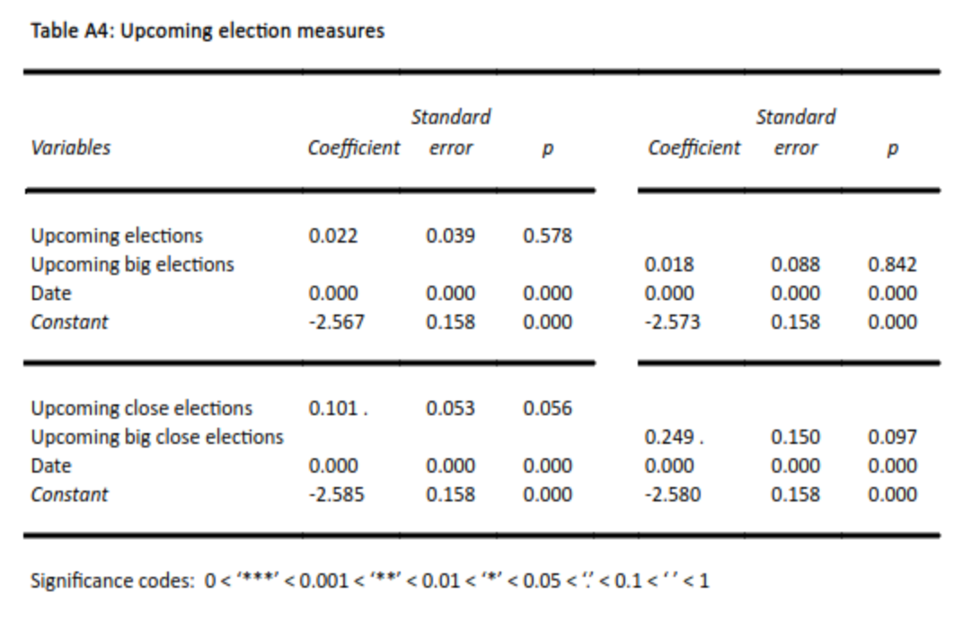
A.3. Euroscepticism metrics (H2b)

The measure of Euroscepticism used in this paper is the percentage of member states in which more citizens believe the EU to be detrimental than beneficial. Other metrics are available (including positive or negative “image” of the EU, or whether EU membership is believed to be good or bad), as are other methodologies (for instance a population-weighted percentage of member states, or an aggregated differential of the Eurosceptic percentages). However, we elected to use the “detrimental” metric on the assumption that it is particularly likely to be reflected at the political level in the Council, and we used unweighted rather than weighted percentage-differences, in accordance with findings from Thomson (2011) about the intergovernmental balance of power within the Council.

A.4. Council formations (H2c)

The Council of the EU is a single legal entity with ten configurations: Agriculture and Fisheries (AGRIFISH); Competitiveness (COMPET); Economic and Financial Affairs (ECOFIN); Environment (ENVI); Employment, Social Policy, Health and Consumer Affairs (EPSCO); Education, Youth, Culture and Sport (EYCS); Foreign Affairs (FAC); General Affairs (GAC); Justice and Home Affairs (JHA); Transport, Telecommunication and Energy (TTE). As the EU grew in size and importance, the number of formations proliferated, until in 2002 the Council limited itself to ten. The then General Affairs and External Relations Council (GAERC) was split into two configurations, the General Affairs Council and the Foreign Affairs Council.
In testing Hypothesis 2c, we ran a model (Model 4, see section 6) excluding the meetings of the Justice and Home Affairs; Education, Youth, Culture and Sport; and Foreign Affairs Council / GAERC formations that are less subject to interest group lobbying than formations pertaining to single market issues.
Note that there is a distinction between the expected frequency of meal breaks from one formation to the next, and the strength of the relationship between transparency and meals within each formation. Testing for the former measure reveals that JHA, GAERC/FAC, and ECOFIN have the highest baseline propensities for recorded meal breaks, with break frequencies higher than 40% in all cases. The latter measure speaks more directly to the theory we are trying to test, and hence informs the construction of Model 4. In this model we compare the results of our main (Council formation agnostic) models, with a regression run against only the formations that are likelier to negotiate matters relating to the single market. These results show a stronger correlation between transparency and recorded meal breaks for the latter group, in support of Hypothesis 2c. However, it is also the case that two of the three non-single market relevant Council formations (JHA and GAERC, listed above) are two of the three formations that are most likely to record meal breaks overall, which hints at a difference between the baseline appetite for breaks within each formation, and the sensitivity of each formation to changes in transparency.

Graph A.4.: Recorded meals per Council configuration, 1990-2019, annual granularity
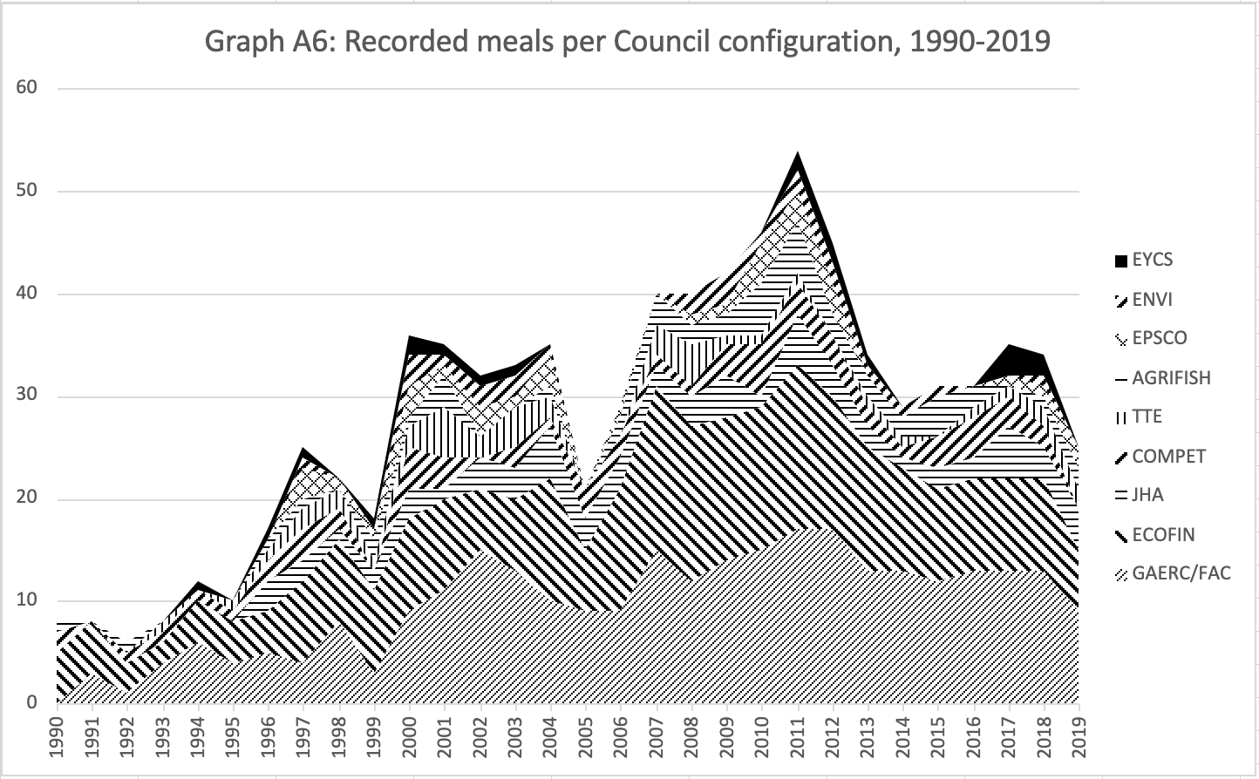
A.5. Collinearity test

The correlation grid reveals some evidence of collinearity between formal and de facto transparency. Neither variable is mechanistically derived from the other, but their level of correlation does raise the question of whether an indirect causal relationship exists, or whether the two measures are jointly motivated by an omitted variable. Intuitively, one possibility is that EU enlargement tends to produce increases in formal transparency; but the putative mechanism that would underpin such a relationship is not clear or obvious enough to warrant the removal of either variable from our regressions.

Table A.5. Correlation grid for primary independent and control variables
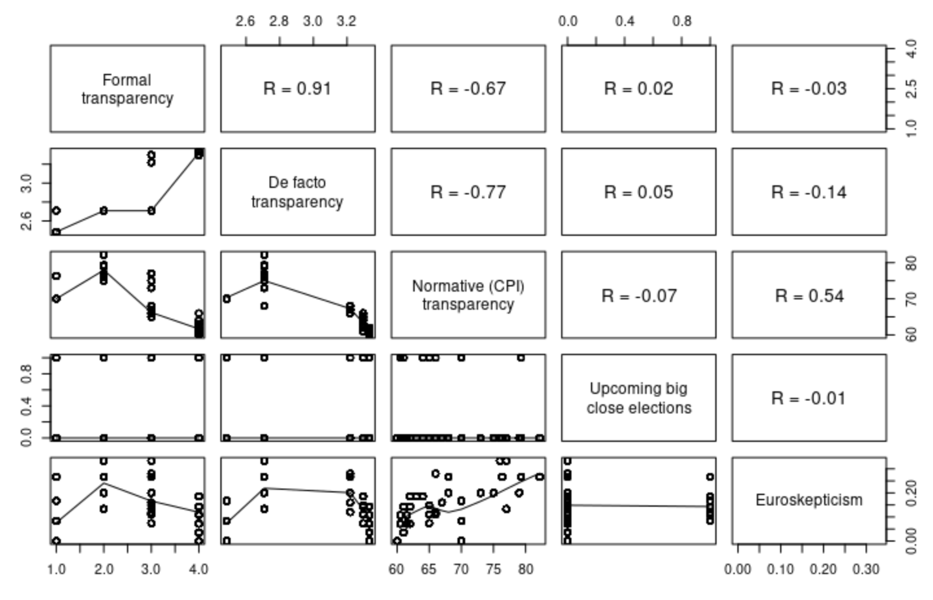

A.6. Transparency culture

To account for the possibility that “transparency cultures” might be transmitted to the Council through the evolving national composition of its membership, we sought external, national-level measures of transparency to use as controls. The relative merits of different transparency indicators have received attention in the literature, and we considered metrics described by Hollyer et al. (2014), Alt et al., (2014), Fisman and Miguel (2007), and Williams (2015).
However, most were constrained either in time (unavailable for recent years), in location (unavailable for all member states), or in scope (e.g., dealing only with financial disclosures), and we therefore elected to use the CPI index published by Transparency International in view of its longstanding usage in studies of transparency and corruption. (Note that CPI is not perfect either as it only started in 1995; accordingly, we have extrapolated backwards for the years 1990-1994.) For the sake of comparison, we also include results from Williams’ Quality of Government Transparency measure below, though note that this metric was not calculated for the final third of the time span under consideration.

Table A.6. P-value comparison of cultural transparency measures (CPI vs QoG; n = 2336; df = 2330)
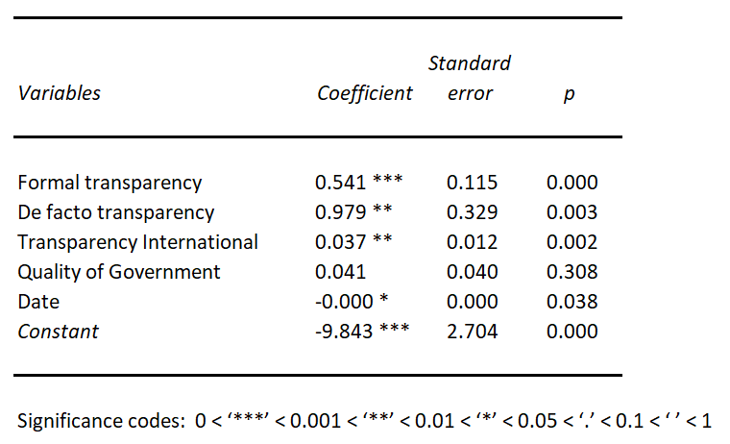
A.7. Regional country allocations (for the Council Presidency control variable)

Northern = Denmark, Sweden, Finland; Western = Austria, Belgium, France, Germany, Ireland, Luxembourg, Netherlands, United Kingdom; Southern = Cyprus, Greece, Italy, Malta, Portugal, Spain; Central and Eastern European (CEE) = Bulgaria, Czechia, Estonia, Hungary, Latvia, Lithuania, Poland, Romania, Slovakia, Slovenia. No Croatian presidencies in this (pre-2020) dataset.
The foregoing regional categorizations were tested sequentially in Model 2, in which we subject Hypothesis 1 to a battery of robustness checks. We elected to group member states by region, rather than regress them individually, as the latter would result in small-n samples, particularly in the later years, as more countries joined the EU.

Table A.7.: Northern Council Presidencies

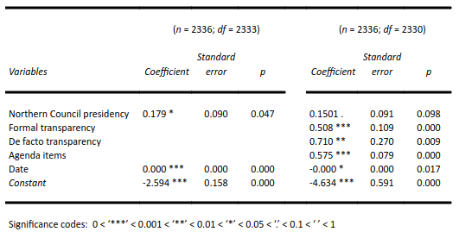
A.8. Agenda items

The dependent variable in this study is the incidence of meal breaks recorded by the Council Secretariat. Although it is customary to adjourn for lunch, the Council Secretariat only makes an official note of these breaks when they deem the attendant discussions to be of public interest. As a result, the dependent variable measures not the occurrence of informal meal breaks per se, but more specifically informal meal breaks that the ministers used to discuss EU affairs (thereby excluding breaks that were solely used for sustenance). Since lunch breaks are an integral part of each Council meeting, there is little risk that governments manipulate the agenda to create opportunities for lunch breaks (“post-treatment bias”).
To control for the number of sensitive items that governments must deal with in each Council session, we collected data on the number of agenda items per session. Considering that several sensitive items could in principle be discussed during the same meal break, we use the natural log of agenda items, to account for the fact that the relationship between the chances of encountering a sensitive item and the use of meal breaks is nonlinear.

A.9. Time series considerations

As our dataset is a time-series, and certain of our variables are – broadly speaking – increasing over time, we ran checks to assess the influence of time and to remove its effects from our analysis. To test for stationarity, we ran an augmented Dickey-Fuller (ADF) test against the meal count data, and its test statistic (-10.14) and p-value (<0.01) did not provide conclusive evidence of non-stationarity. However, a similar test applied to aggregated (semester-level) meal data did suggest non-stationarity (with p = 0.9025).
To check for auto-correlation we plotted (using the acf function implemented in the tseries R package) lagged auto-correlation, i.e., meal counts compared to lagged meal counts, against degrees of lag. These results did indicate a positive auto-correlation that tailed into negative territory about a third of the way through our time series; a partial auto-correlation (pacf) test also indicated temporary (and erratic) levels of auto-correlation at small degrees of lag; and an acf plot using differenced meal counts (our dependent variable less its value at T-1), suggested that our dataset’s first order difference is not auto-correlated.
It is important to note that non-stationarity and/or first-order auto-correlation are entirely compatible with the hypotheses we are testing, as most of our independent variables also increase with time. Indeed, we would expect their non-stationarities to be transmitted to our dependent variables; the question is how to remove their time-driven components from our regressions. To do this we tested the inclusion of a lagged dependent variable on the right side of our equations, however the statistical significances of these tests (for example p = 0.476 in Model 1) suggested that this is an insufficient way of accounting for the non-stationarity that we observe. This is not surprising given the inconclusive results of our initial stationarity tests, and given that our dataset consists of a lengthy set of low, countable numbers with a mode (most common value) of 0. (This feature of our dataset also prevented us from regressing against the differenced meal counts, as negative numbers are incompatible with Poisson regressions.) We therefore elected to use time as an independent variable on the left side of our equations, and in this approach the significance of the control variable, across all models, was much improved.

A.10. European Parliament

A concern regarding our measure of the power of the European Parliament was its correlation (0.95) with our formal transparency metric. However, the latter yielded stronger and more statistically significant results, both in side-by-side modelling (below) and in the multivariate models that we ran (where the EP’s statistical significance weakened to 0.095). For this reason, we elected to use the formal transparency metric in most models so as not to overload them with duplicative indicators.

Table A10: P-value comparison of Formal Transparency and EP Power (n = 2336; df = 2332)
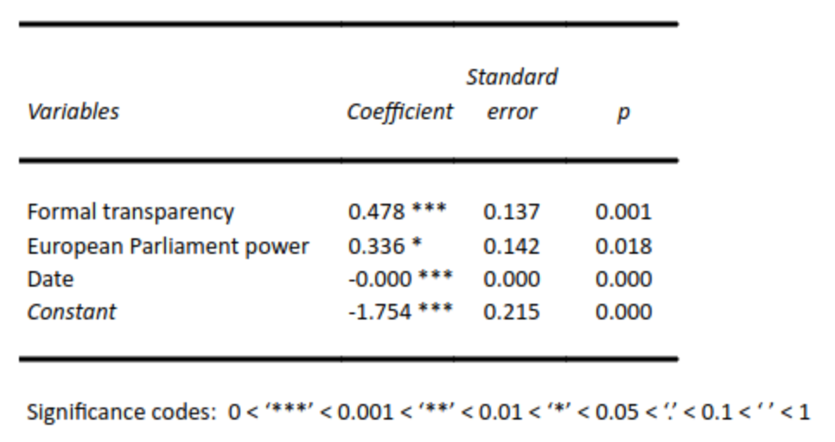

A.11 Logistic and Zero-inflated Poisson regressions

Per section 6, we chiefly employ standard Poisson regressions in which the dependent variable is the number of recorded breaks in each session. For the sake of robustness, however, we also run logistic (logit) regressions that consider whether each session had a recorded break or not (i.e., a binary rather than countable dependent variable). These results were mixed, as the below table illustrates, with some independent variables increasing and other decreasing in explanatory power.

Table A.11.1.: Logistic regression; DV indicates whether a break occurred or not
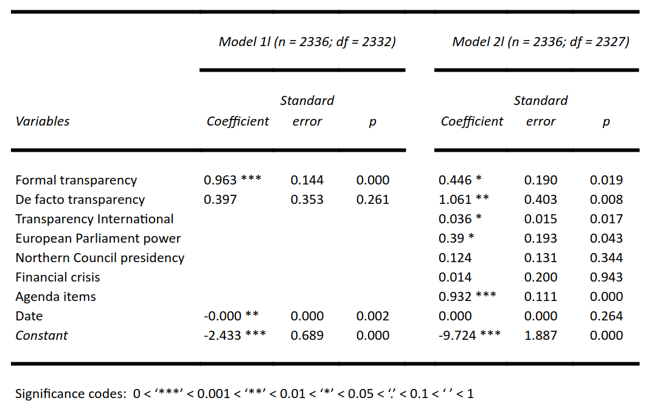
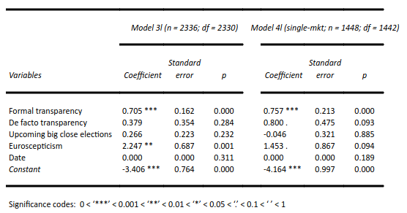
A concern with this approach is that if ministers have more cause to deliberate in secret, and this prompts them to take more breaks, then this may entail more than one break in a given session. Since switching to a binary variable runs the risk of dampening or even concealing this effect, we opted to continue with Poisson regressions for the analysis in the paper.
Another family of regressions to consider is Zero-inflated Poisson, which is often employed when a set of observations contains numerous “zeroes” (as indeed ours does). The purpose of Zero-inflated Poisson is to distinguish between “true zeroes” (driven by the independent variables of interest) and zeroes that might be motivated by some other structural factor. Amongst our array of independent variables the most likely candidate for this latter effect would be the count of agenda items per meeting, and so we run a model that first uses that count to predict whether each session breaks at all (a binomial), and then uses the transparency variables to predict the number of breaks in sessions where at least one break does occur. This model indicates that the variables in the two halves of the zero-inflated regression structure are indeed statistically significant, but they are not more significant than in the original model, in which both the agenda items and the transparency variables are regressed as predictors of the same (non-binary) outcome. The sensitivity of these models to regressor scaling and to correlation prevented us from running a more extensive battery of tests, and in any case we could not discern an intuitive reason why, within the zero-break sessions, some would be structurally different from others; hence we opted not to use Zero-inflated Poisson for the models described in the paper.

Table A.11.2.: Zero-inflated model (n = 2336; log-likelihood = -1653 on 4 df)
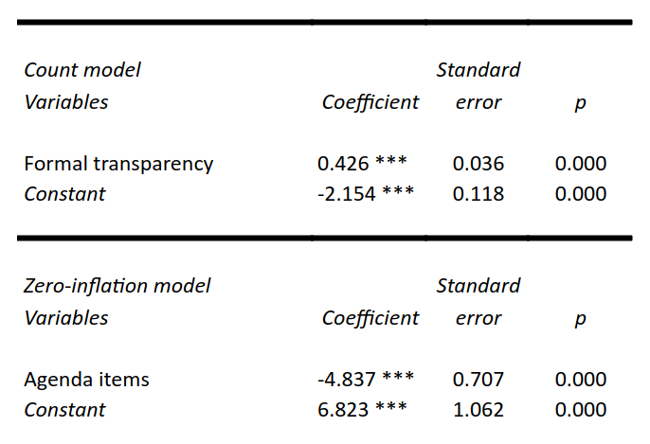

A.12. Semester granularity

Although our dependent variable (along with the agenda control) is captured at session-level granularity, several of our independent variables and controls are observed less frequently. Elections occur erratically throughout the year, the Council Presidency rotates with each new EU semester, certain measures of transparency and Euroscepticism are recorded annually, and the political events that drive EU expansion and transparency reform are less frequent still. To round out our analysis, we run additional models at semester granularity, as this is the most granular level at which the above variables can be expressed or approximated. To calculate the semester-level averages we sum the total number of meal breaks in each semester, and then divide each sum by the number of sessions in the same semester, with agenda items added as an optional control variable. In contrast to alternative approaches, e.g. weighting each average by a control variable, this approach allows for the most consistent comparison with the session-level methodology.

Table A.12.: Semester-level results
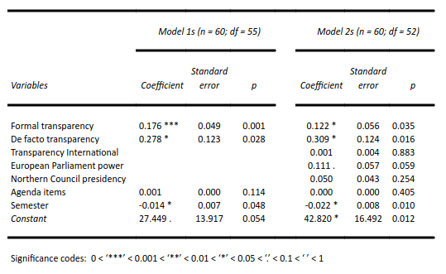

In the main, these results corroborate the key findings from the paper. We include them here for robustness, however for the other models in the paper we continue to employ session granularity. This is because semester-level analysis omits variation from one session to the next, effectively precludes election-level analysis, and partially misrepresents the timing of key intra-year events including the EU’s Eastern enlargement and formal transparency increases.
Due to the mismatch between the granularities of the variables, it should be noted that there is a degree of heteroskedasticity in the residuals of variables such as the transparency indicators, and hence standard errors may be understated in the models at session granularity; the coefficients themselves are not affected by this phenomenon.
A.13. Overdispersion tests for the Poisson regressions

We test for overdispersion in order to assess whether negative binomial regressions would be more appropriate than Poisson, however the meal count data are found not to be overdispersed in any of the relevant models. The overall variance of the number of recorded meals in each session (σ² = 0.31) is just under the mean (µ = 0.36), for a quotient of 0.86, and for each of the models we run, the residual deviance is lower than the number of degrees of freedom.

Table A.13.: Overdispersion tests

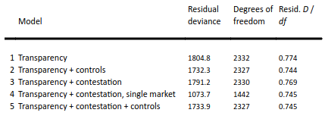

A.14. Interrupted time series

As mentioned in section 6 and A.1., we also ran models examining the effects of each discrete change in formal transparency. This “interrupted time series” approach utilizes a binary treatment variable to represent each transparency increment, as well as an interaction term that measures whether these transparency changes, in conjunction with time, combine to set the observed meal frequencies on a different, statistically significant trend. The binary treatment results corroborate our main (multi-increment) regression results and also permit enquiry into the relative significances of the individual transparency enhancements.

Table A.14.: Interrupted time series: binary treatment plus interaction term
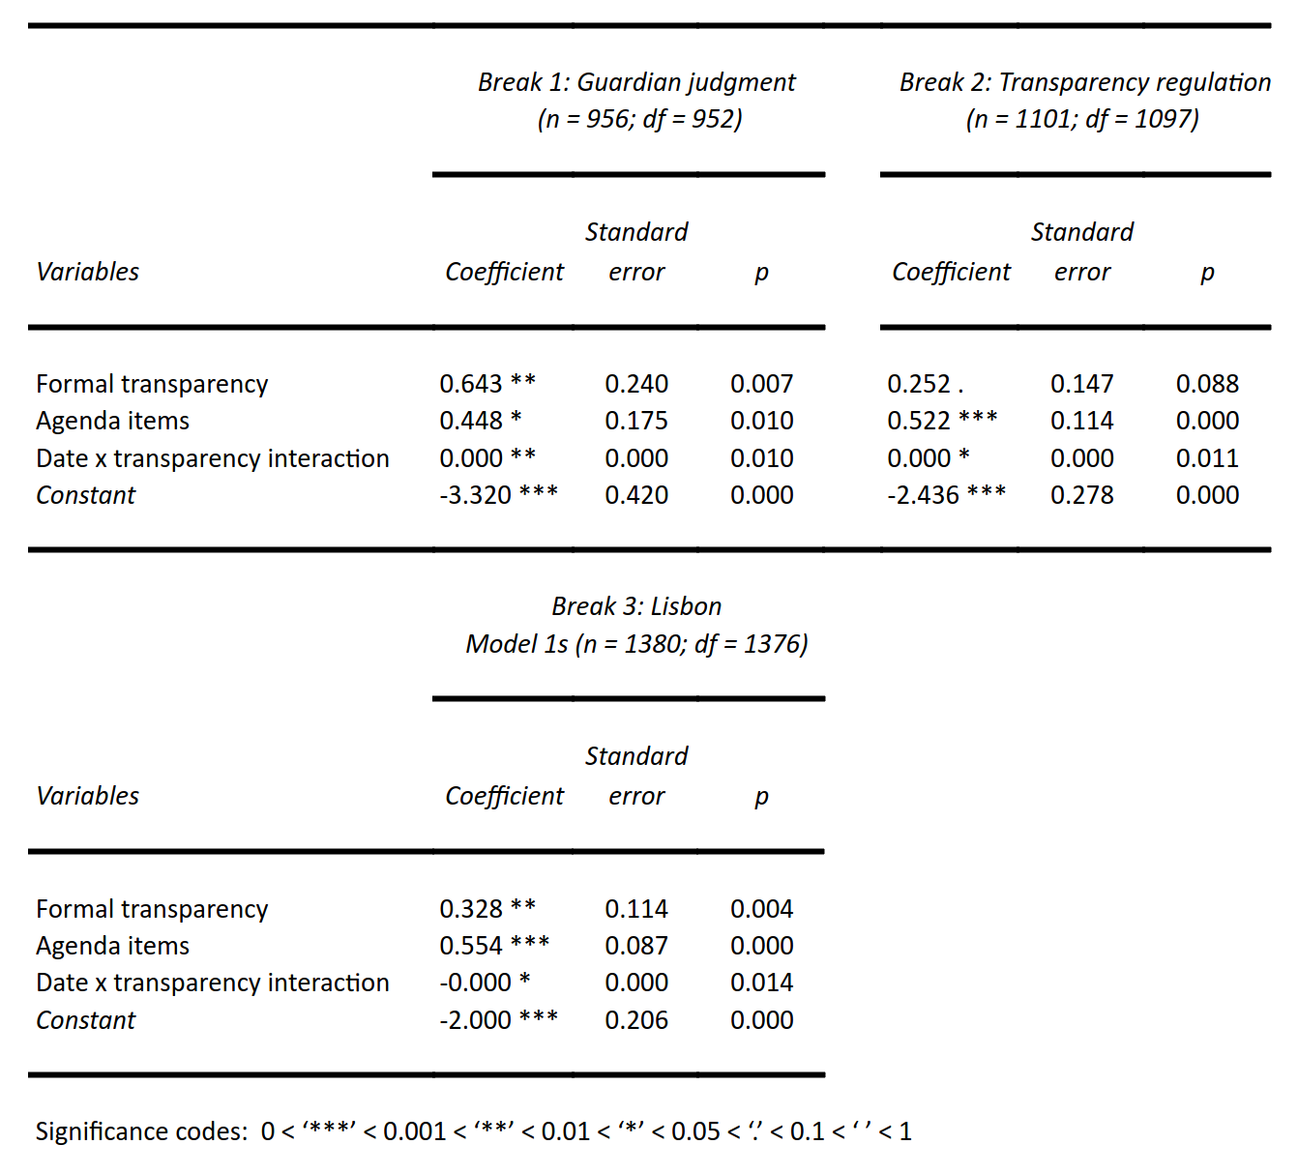

A.15. Single transparency variable
As mentioned at the conclusion of the robustness checks section, the following is a version of the original transparency model omitting de facto transparency (and therefore according more weight to formal transparency).

Table A.15.: Comparison of Model 1 with a single transparency variable model
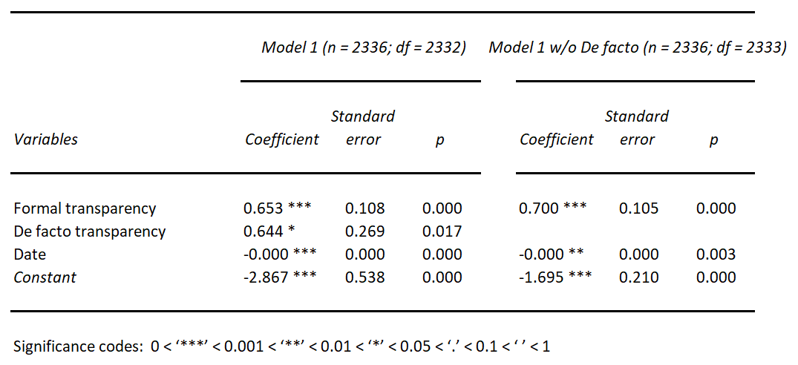

A.16. Financial crisis
As mentioned in the robustness checks section, the following table compares Model 2 to an alternative version that utilizes a more expansive definition of the Euro area financial crisis. In the original specification this variable activated from May, 2010 through July, 2012; the alternate runs from 15 September, 2008 (the collapse of Lehman) to 1 July, 2013. This suggests it is possible to discern an effect following from the financial crisis, however the results are not as robust as those of our transparency variables.

Table A.16.: Model 2 using an expanded specification of the financial crisis variable
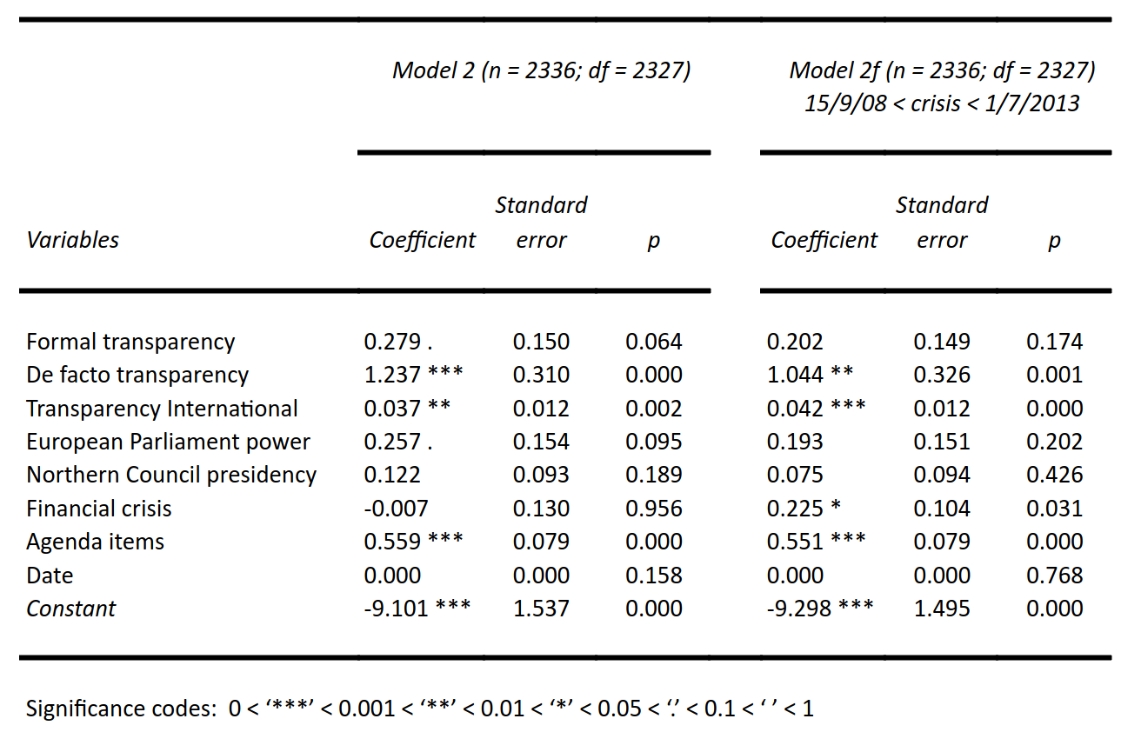

References
Alt, J., Lassen, D. D., & Wehner, J. (2014). It isn’t just about Greece: Domestic politics, transparency and fiscal gimmickry in Europe. British Journal of Political Science, 44(4), 707–716.
Council of the EU (2008). Sixth annual report of the Council on the implementation of regulation 1049/2001 of the European Parliament and of the Council of 30 May 2001 regarding public access to European Parliament, Council and Commission documents. 8475/08, 16 April 2008.
Cross, J.P., & Boelstad, J. (2015). Openness and censorship in the European Union: An interrupted time-series analysis. European Union Politics 16(2), 216-240.
Fisman, R., & Miguel, E. (2007). Corruption, Norms, and Legal Enforcement: Evidence from Diplomatic Parking Tickets. The Journal of Political Economy, 115(6), 1020-1048.
Hillebrandt, M., Curtin, D., & Meijer, A. (2014). Transparency in the EU Council of Ministers: An Institutional Analysis. European Law Journal, 20(1), 1–20.
Hollyer, J. R., Rosendorff, B. P., & Vreeland, J. R. (2014). Measuring transparency. Political Analysis, 22(4), 413–434.
Thomson, R. (2011). Resolving controversy in the European Union: Legislative decision-making before and after enlargement. Cambridge University Press.
Williams, A. (2015). A global index of information transparency and accountability. Journal of Comparative Economics, 43(3), 804–824.

The average share of public debates on legislative items was 21 percent before 2006, 17 percent during the Austrian presidency in the first half of 2006, and after rising to 76 percent during the Finnish presidency in the second half of 2006, it dropped again by 26 percent to an average share of 50 percent of legislative debates in 2007 (Council of the EU 2008, fn 27). Note that the data refers to public debates on legislative items rather than to entire Council sessions. The Council Secretariat was unable to provide data for 2008-2009.

