Appendix (Online Appendix, not intended for publication)
A1 Instructions
A1.1 General Instructions
A1.2 Instructions for the first part of the experiment
A1.3 Instructions for the second part of the experiment
A1.4 Instructions for the third part of the experiment
A2 Comprehension Tests
A2.1 Comprehension Test before part 1
A2.2 Comprehension Tests before part 3
A3 Additional information on ex-post questionnaire
A4 Regressions
A4.1 Regression results: Prefilling of deductions with controls (corresponds to Table 3)
A4.2 Regression results: Prefilling of deductions (with variable “evader”)
A4.3 Regression results: Disallowing the deductibility (with variable “evader”)
A4.4 Regression results: Limiting the deductibility (with variable “evader”)

A1 Instructions
Appendix A1 includes the translated instructions (from German). All participants received the general instructions in print (A1.1). Before the experiment was executed, the participants received the instructions for the first part of the experiment (A1.2). The instructions for the second part (decision on donation) were displayed on the computer screen (A1.3). After that, participants received the instructions for the third part of the experiment in print (A1.4).
A1.1 General Instructions
Thank you very much for participating in this experimental study. For your participation, you will receive a lump sum of 4 Euros.
The experimental study consists of one experiment, in which you have the possibility to earn money, and a questionnaire at the end of the study. The amount of money you earn depends on your decisions in the experiment and on chance. The instructions explain to you how you can influence the amount of money you earn in this study with your decisions.
It is important that you understand the instructions. Hence, please do not hesitate to ask any questions. If you have a question, please raise your hand. We will then come to you to answer your question. Please do not ask your question loudly. You may write on the instructions and highlight them. Please do not take the instructions home, but return them to us at the end of the study.
The analysis of the experiment will be anonymous. We will on no account link your name to the data collected in the experiment. You will not get to know the identity of any other participant, neither before, nor after the experiment. Likewise, the other participants will not get to know your identity. At the end of the experiment, you will have to sign a receipt to confirm the payments you received. This receipt will only be used for accounting purposes.
We would like to point out that you are not allowed to communicate with other participants or leave your seat throughout the whole experiment. Please make sure to switch off your mobile phone.
The calculator, the pen and the notepad that are lying in front of you may be used.
The currency used in the experiment is ECU, where 100 ECU equal 1 Euro.
At the end of this experimental study, you will receive your payout privately and in cash. Your total payout consists of your payout of the experiment and the lump sum of 4 Euros for your participation.
The instructions for the experiment will be handed out shortly.

A1.2 Instructions for the first part of the experiment
Procedure of the experiment
The experiment consists of three parts:
- In part 1, you solve puzzle tasks and thereby generate income.
- In part 2, you make a decision about a donation.
- In part 3, you fill out a tax return. Based on the tax return, a tax will be determined. The tax amount is among others dependent on your income.
In the beginning of each part, you will receive instructions which describe the respective part of the experiment.
The payout that you will receive at the end of the experiment is dependent on your decisions and statements in the parts 1 to 3.
Credit account
During the experiment, you receive a personal credit account on which your payout relevant amounts will be posted on during the experiment. Your account balance will be displayed to you after each part of the experiment.
Your account balance at the end of the experiment determines your personal payout of the experiment. For this purpose, your account balance will be converted to Euros and added to your lump sum of 4 Euros for your participation and your payouts of the comprehension tests.
General information
Comprehension Test
Prior to part 1 and 3, respectively, you will be asked to do a comprehension test on your computer. The comprehension test consists of different blocks of questions. Each question block consists of up to four questions. For answering those questions correctly, you will receive an additional payout. The following applies:
If you answer all questions of a question block …
- … correctly on the first try, you will receive 1 Euro.
- … correctly on the second try, you will receive 0.50 Euro.
- … correctly on the third or on more tries, you will receive 0 Euro.
Questionnaire
After the experiment, you will be asked to answer a couple of questions on your computer. Please answer the questions thoroughly as they contain important information for us.
General Advice
The used program separates decimal places with a point and not with a comma (e.g. “2.5” instead of “2,5”).

Part 1: Generate Income
Puzzle Task
The first part of the experiment consists of a mathematical puzzle task. The screen of your computer will display a puzzle with a matrix of 12 numbers. From this matrix, you should select the two numbers that add up to 10. In each matrix with 12 numbers, there are only 2 numbers that exactly add up to 10. All numbers have two decimal places.
The screen with the matrix looks as follows:
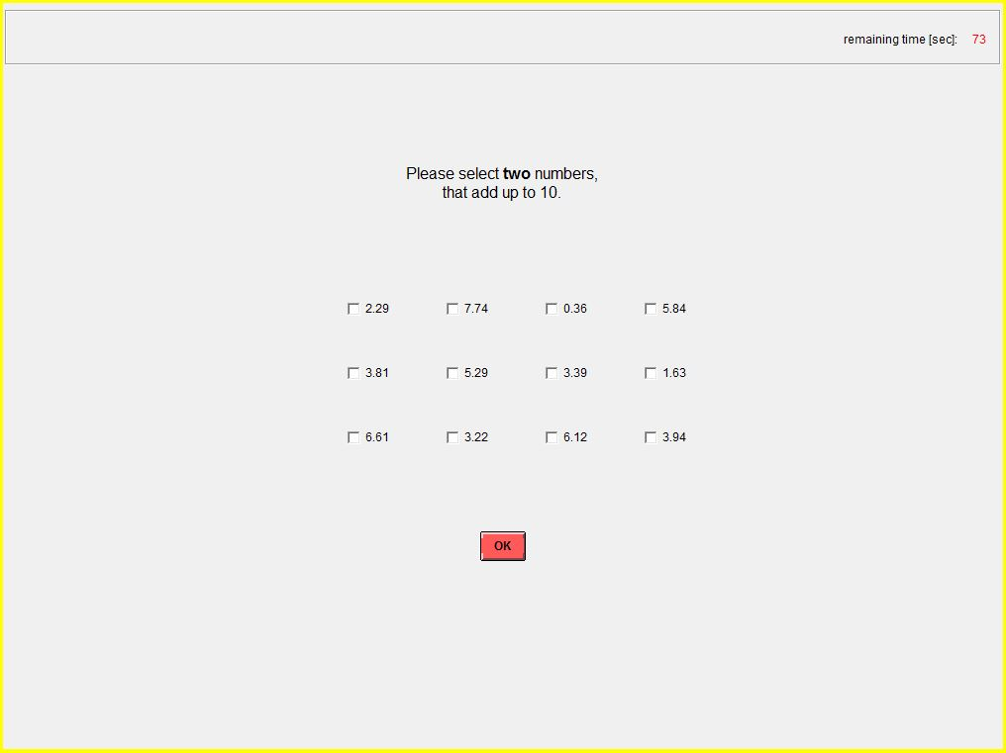

Part 1 consists of one non-payout relevant practice round and 4 payout relevant rounds. In each round, you have 3 minutes time to solve as many mathematical puzzles as you like. A maximum of 20 puzzles can be solved correctly in each round. After each round, you have a break of 1 minute before the next round starts.
Your earned income depends on the number of puzzles you solved correctly. For each puzzle that you solved correctly, you receive an income of 93 ECU. For each puzzle that you solved incorrectly, you receive an income of 0 ECU. Your income in each round is calculated as follows:
Earned income per round = number of correctly solved puzzles in the respective round x 93 ECU
If you solve every puzzle correctly in one round, you will consequently earn 1,860 ECU in that round. After each round, your number of correctly solved puzzles and the resulting income earned in that round will be displayed to you.

Social Insurance Contribution
A fictitious social insurance contribution of 22.6% of your income will be retained. This amount will be deducted automatically and not paid out to you.

Simplifying the puzzle task
In order to simplify the puzzle task, you can reduce the number of selectable numbers so that you can recognize the right combination among the remaining numbers quicker.
Removing numbers involves costs. The costs are:
- “Remove 1 number”: 37 ECU per round
- “Remove 2 numbers”: 142 ECU per round
- “Remove 3 numbers”: 299 ECU per round
Of course you can also choose not to remove any numbers (“Remove no numbers”). Thus, you do not have costs.
At the beginning of each round, you decide how many numbers you want to remove. Your decision applies for all puzzles in that round. The costs incur once per round and are deducted automatically from your income at the end of the round. In the following round you can make a new decision if you want to remove numbers.
On the reverse side of these instructions, you can find examples for all 4 options.
Please note that it is not possible to remove numbers in the practice round.

General overview and notepad
At the end of the first part, your total income of all 4 rounds, the total amount of retained social insurance contributions and your total costs to simplify the puzzle tasks will be displayed to you in a general overview.
You will need these information when you fill out the tax return in part 3. Hence, please write down these information on the notepad at your place.
Please do not return the notepad to us, but take it home or throw it in trash.

Credit account
After part 1 of the experiment, your total income, which you generated in the 4 rounds of the puzzle task, will be posted on your credit account while the total amount of social insurance contributions and the costs for simplifying the puzzle task will be deducted.
„no numbers removed“  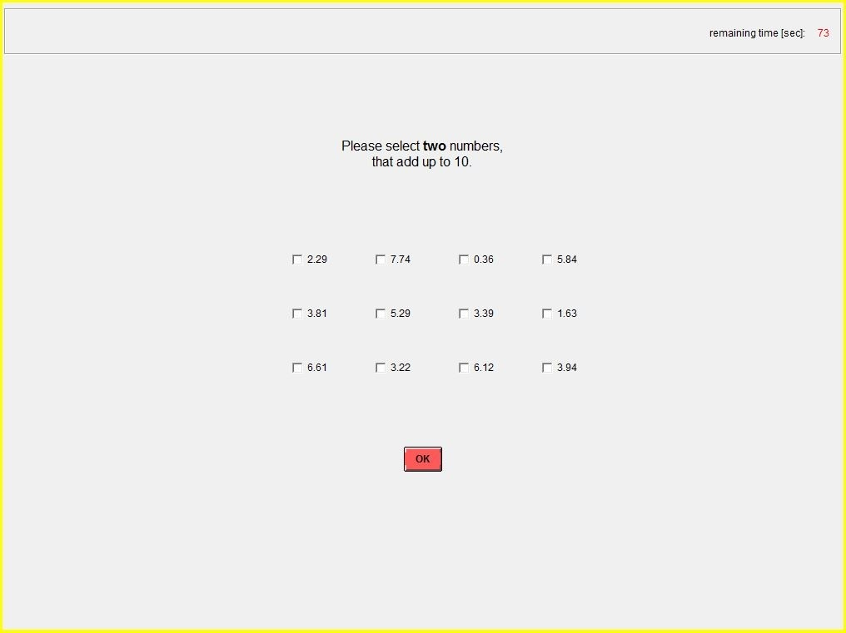 | „1 number removed“  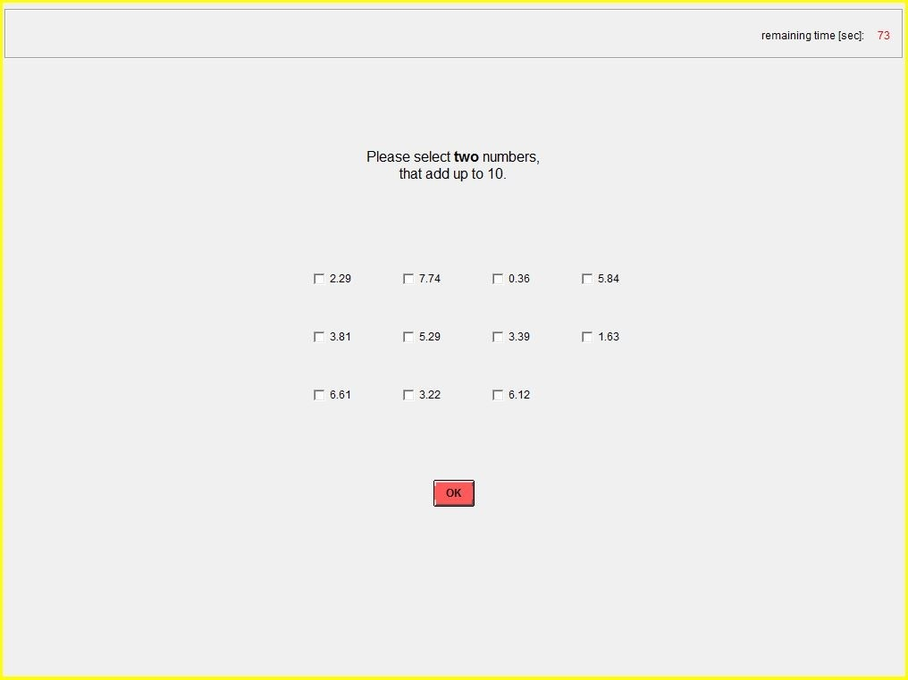
„2 numbers removed“  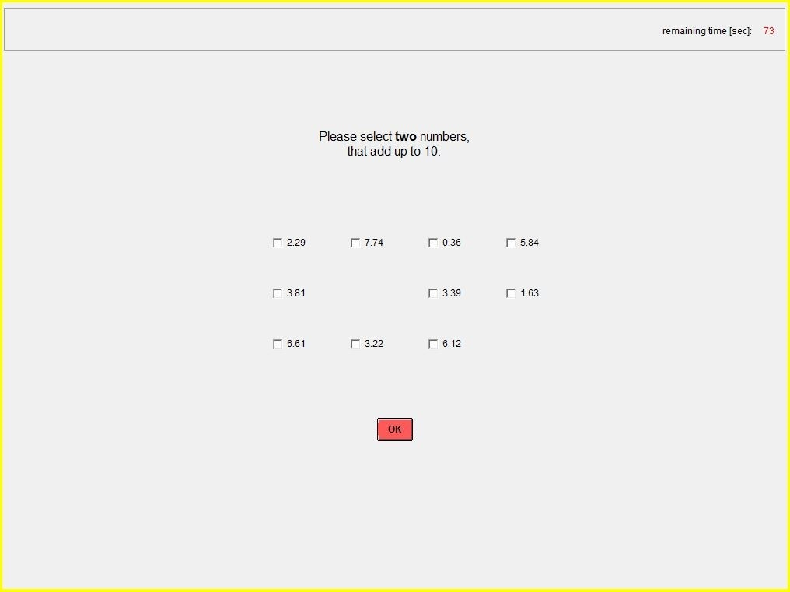 | „3 numbers removed“  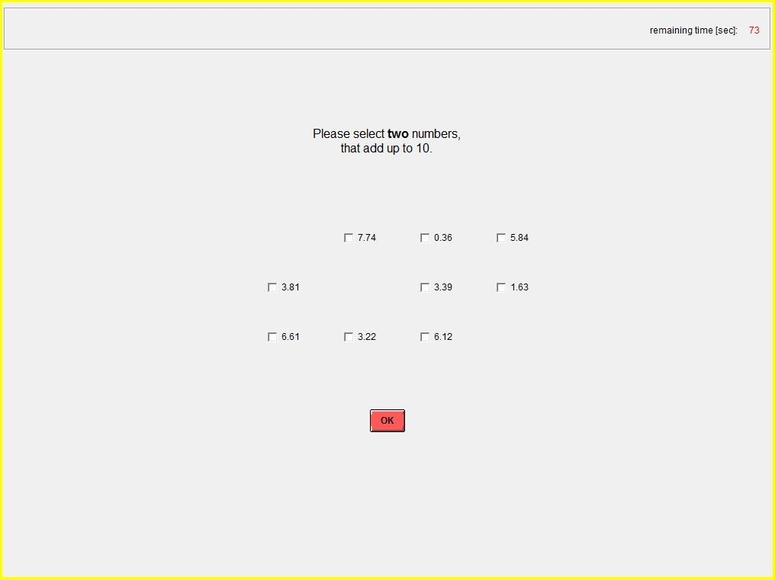
A1.3 Instructions for the second part of the experiment
Part 2: Donation decision
In part 2 of the experiment, you have the possibility to donate part of your income.
The computer program will show you various charitable organizations. You may choose one or more organizations. If you choose more than one organization, your donation will be split equally between these organizations. If you do not choose any organization, the computer program will randomly choose one organization.
After the execution of the experimental study, the donations will be transferred from the chair of Behavioral Accounting/Taxation/Finance (Prof. Dr. Martin Fochmann) to the respective organizations. You may later receive proof for these transactions on demand.
Once again, please note the amount that you donated on your notepad for part 3.
Credit account
After part 2, the amount that you donated will be deducted from your credit account.

A1.4 Instructions for the third part of the experiment
Part 3: Filling out the tax return
Tax return
For this study, you now have to complete a fictional tax return in order that a fictional tax can be determined. This means that in part 3, you shall declare the expenses you had in part 1 and 2.
With your tax return, a declared taxable income will be determined, which depends on your total income of the puzzle task (part 1) and on your declaration of expenses in the following.
The tax rate is 40% on the declared taxable income and will automatically be retained. The tax revenue stays at the University of Cologne.
[Treatments: 4i, 4i prefilled, 4i limited-deductibility]
The declared taxable income is determined according to the following scheme:
Total income of the puzzle task (part 1)
– declared amount of social insurance contributions from part 1
– declared total costs for the simplification of the puzzle tasks from part 1
– declared donation from part 2
– declared commuting allowance
= declared taxable income

[Treatment 3i]
The declared taxable income is determined according to the following scheme:
Total income of the puzzle task (part 1)
– declared amount of social insurance contributions from part 1
– declared total costs for the simplification of the puzzle tasks from part 1
– declared donation from part 2
= declared taxable income

[Treatment 2i]
The declared taxable income is determined according to the following scheme:
Total income of the puzzle task (part 1)
– declared amount of social insurance contributions from part 1
– declared total costs for the simplification of the puzzle tasks from part 1
= declared taxable income

The total income of the puzzle task is prefilled by the computer and cannot be changed.
Your task is to complete the [Treatments: 4i, 4i prefilled, 4i limited-deductibility: 4; Treatment 3i: 3; Treatment 2i: 2] expense form fields. Based on your declared expenses, the declared taxable income is determined, which is the basis for the tax calculation. Your declared expenses can be smaller, equal to or larger than your actual expenses.
Please keep in mind to always enter the total expenses in the form fields and not for example the expenses of one particular round of the puzzle task.
[Treatments: 4i, 4i prefilled, 4i limited-deductibility]
One exception to this is the commuting allowance. The commuting allowance compensates the costs for your way from your apartment to the experimental laboratory. For this purpose, please enter the shortest way from your apartment to the experimental laboratory (only one-way). Please bring up to a round figure. The computer will then automatically calculate the deductible amount for the commuting allowance. For every declared kilometer, the commuting allowance is [Treatment 4i, 4i prefilled: 30; Treatment 4i limited-deductibility: 10] ECU. You are allowed to use an app (e.g. Google Maps) on your smartphone to find out the distance in kilometers. The maximum of declarable kilometers is 50.

[Treatment 4i prefilled]
The 4 expense form fields are prefilled by the computer. The prefilled form fields might deviate from your actual expenses. Please check the prefilled expense form fields in your tax return.
After filling out all the [Treatments: 4i, 4i prefilled, 4i limited-deductibility: 4; Treatment 3i: 3; Treatment 2i: 2] expense form fields, you can press the button “submit tax return” to submit your tax return. After submitting your tax return, you cannot make any changes.
Before you submit your tax return, you can also press the button “calculate tax”. Then, your declared taxable income and the resulting tax will be displayed on your screen. If you want to change your declarations, you can press the button “change tax return”. You can press “calculate tax” and “change tax return” as often as you want until you are done with your tax return. When you want to submit your tax return, press the button “submit tax return”.
Please keep in mind that your declared expenses must not result in a negative taxable income.
Tax Payment
The payable tax is 40% of your declared taxable income.
Tax = 0.40 x declared taxable income
Audit of the tax return
With a probability of 30%, your tax return will be audited, checking if your declared expenses in the tax return coincide with your actual expenses. If your tax return is audited and the declared expenses do not coincide with your actual expenses, you have to pay a fine. The fine is twice the amount of the not-payed tax.
Not-payed tax = 0.40 x (actual taxable income – declared taxable income)
Fine = 2 x not-payed tax
If the audit comes to the conclusion that you payed too much taxes (because your declared expenses are smaller than your actual expenses), the amount which was payed too much will be refunded. In this case, no fine applies.
Your personal payout from the experiment
After submitting your tax return in part 3, the resulting tax burden of the tax return is deducted from your credit account. If your tax return is audited and the declared taxable income does not coincide with the actually taxable income, the resulting fine is deducted from your credit account as well. If you receive a tax refund, it will be posted on your account.
Your account balance at the end of the experiment is your personal payout from the experiment. Therefore, your payout is determined as follows:
Your payout =
total earned income from the puzzle task (part 1)
– actual total social insurance contributions from part 1
– actual total expenses for the simplification of puzzle tasks from part 1
– actual donation from part 2
– payable tax determined based on the declared taxable income from part 3
– possible fine
+ possible tax refund
Please keep in mind that your declarations in the tax return only affect the payable tax (and possibly the fine or tax refund). The amount of your total income, the amount of social insurance contributions, the amount of expenses to simplify the puzzle tasks or the amount of your donation are not affected.
The payout will be converted to Euros and added to your lump sum of 4 Euro for your participation and your payouts from the comprehension tests. The resulting amount of money will afterwards be paid out to you in cash.

A2 Comprehension Tests
A2.1 Comprehension Test before part 1
1.1 How many payout relevant rounds has the first part of the experiment?
1.2 Which amount (in ECU) do you earn for every correctly solved puzzle?
1.3 Which statement is correct?
- One round of the puzzle task consists of one puzzle and takes 3 minutes.
- One round of the puzzle task consists of maximal 20 puzzles and takes 3 minutes.
- One round of the puzzle task consists of infinitely many puzzles and takes 3 minutes.
1.4 Which statement is correct? In order to simplify the puzzle task, you can delete irrelevant numbers …
- … You can decide on it at the beginning of each single round. Thus, costs can incur in every round.
- … You can decide on it at the beginning of each single round. There are no costs.
- … You decide on it at the beginning of the experiment for the entire experiment. Thus, costs can incur only once.
- … You decide on it at the beginning of the experiment for the entire experiment. There are no costs.

A2.2 Comprehension Tests before part 3
[Treatment 4i, 4i prefilled, 4i limited-deductibility]
1.1 Regarding the commuting allowance, which statement is correct?
- The declared kilometers do not affect the declared taxable income.
- For every declared kilometer, the declared taxable income is reduced by 1 ECU.
- For every declared kilometer, the declared taxable income is reduced by [Treatment 4i, 4i prefilled: 30; Treatment 4i limited-deductibility: 10] ECU.
1.2 Is it possible that your declared expenses in the tax return deviate from your actual expenses (i.e. that they are lower or higher)?
- Yes.
- No.
1.3 Which of the following statements regarding the calculation of the tax is correct?
- The tax amounts to 40% of the actual income.
- The tax amounts to 40% of the declared taxable income.
1.4 What is the probability (in percent) of an audit of your tax return?

2.1 Do your declarations in the tax return affect your actual earned income from the puzzle task?
- Yes.
- No.
2.2 Do your declarations in the tax return affect the actual amount of your social insurance contribution or the actual amount of your costs to simplify the puzzle task or the actual amount of your donation [not Treatment 2i]?
- Yes.
- No.
2.3 Your declarations in the tax return solely affect the amount of tax (and possibly the fine or the tax refund) and not on other matters?
- Yes.
- No.

3.1 For a person who wants to pay the correct amount of taxes, it applies that:
- Declared expenses < actual expenses.
- Declared expenses > actual expenses.
- Declared expenses = actual expenses.
3.2 For a person who wants to pay less taxes than the correct amount of taxes, it applies that:
- Declared expenses < actual expenses.
- Declared expenses > actual expenses.
- Declared expenses = actual expenses.
3.3 For a person who wants to pay more taxes than the correct amount of taxes, it applies that:
- Declared expenses < actual expenses.
- Declared expenses > actual expenses.
- Declared expenses = actual expenses.
3.4 Do your declarations in the tax return affect your personal payout from this experiment?
- Yes, because they affect the amount of taxes to be paid.
- No.
A3 Additional information on ex-post questionnaire
At the end of the experiment (but before participants learn their final payoffs), participants are asked to answer a questionnaire. In particular, the following variables are collected: “age” (in years), “risk attitude” (obtained from the SOEP survey and gives the subject’s self-reported general willingness to take a risk, measured on an 11-point scale where 0 = not willing to take risk and 10 = highly willing to take risk), “female” (female = 1, 0 otherwise), “economics” (1 if the participant experienced more than one lecture economics, 0 otherwise), “tax experience” (1 if the participant states that she ever completed a tax declaration in the past, 0 otherwise), “tax morale” (adapted question from the World Values Survey: “How do you evaluate the following statement?: Cheating on tax if you have the chance...”, answers were given on a 10-point Likert scale from “…is always justifiable” = 0 to “…is never justifiable” = 9), “fairness” (perceived fairness of tax and control system, measured on an 11-point scale where 0 = low perceived fairness of tax and control system and 10 = high perceived fairness of tax and control system), “decision complexity” (measures how complex a participant perceived the tax-related decisions in the experiment, 11-point scale from 0 = low perceived decision complexity to 10 = high perceived decision complexity), “monthly income” (monthly income in Euro after fixed costs such as rent), and “joy”, “anger”, “fear” and “guilt” (each variable measures the level of joy/anger/fear/guilt felt by an individual during the experiment, 11-point scale from 0 = felt no joy/anger/fear/guilt during experiment to 10 = felt high joy/anger/fear/guilt during experiment).

A4 Regressions

A4.1 Regression results: Prefilling of deductions with controls (corresponds to Table 3)
 | Treatment 4i vs 4i prefilled
Dependent variable | Over-deductions | Over-deductions | Over-deductions | Over-deductions | Total over-deductions
 | Model 1 | Model 2 | Model 3 | Model 4 | Model 5
 | Item 1 | Item 2 | Item 3 | Item 4 | All items
Treatment 4i prefilled | -124.43 | -49.67 | 33.34 | -338.69** | -479.47**
 | (80.54) | (65.46) | (55.08) | (158.57) | (212.78)
Age | -14.38 | -8.59 | -4.18 | 4.62 | -22.52
 | (8.93) | (7.26) | (6.11) | (17.58) | (23.60)
Risk attitude | 8.30 | 1.50 | 12.63 | 10.13 | 32.56
 | (17.74) | (14.42) | (12.13) | (34.92) | (46.86)
Female | -82.53 | -19.20 | -20.12 | 37.67 | -84.18
 | (90.22) | (73.33) | (61.70) | (177.62) | (238.35)
Tax experience | 129.30 | -14.91 | 11.64 | -40.37 | 85.66
 | (86.91) | (70.64) | (59.43) | (171.11) | (229.61)
Tax morale | 7.83 | -4.11 | -7.28 | -7.23 | -10.79
 | (17.61) | (14.31) | (12.04) | (34.67) | (46.52)
Economics | -38.93 | 2.90 | -28.02 | -55.88 | -119.93
 | (79.96) | (64.99) | (54.68) | (157.43) | (211.26)
Decision complexity | 14.58 | -3.63 | -5.03 | -81.99** | -76.06*
 | (17.20) | (13.98) | (11.76) | (33.86) | (45.44)
Monthly income | -0.15 | 0.35* | 0.28* | -0.18 | 0.30
 | (0.22) | (0.18) | (0.15) | (0.44) | (0.59)
Fairness | -9.75 | -4.13 | -7.63 | 18.07 | -3.43
 | (18.56) | (15.09) | (12.69) | (36.55) | (49.04)
Joy | 14.92 | -14.20 | -5.94 | -9.45 | -14.68
 | (16.97) | (13.79) | (11.61) | (33.41) | (44.84)
Anger | -13.21 | -6.07 | -15.52 | -11.54 | -46.33
 | (16.54) | (13.44) | (11.31) | (32.56) | (43.69)
Fear | -18.72 | 1.99 | -3.89 | -8.30 | -28.92
 | (17.62) | (14.32) | (12.05) | (34.68) | (46.54)
Guilt | 33.30* | -16.23 | 28.91** | -11.84 | 34.14
 | (18.38) | (14.94) | (12.57) | (36.19) | (48.56)
Constant | 408.89 | 342.36 | 202.07 | 862.37 | 1,815.69**
 | (335.26) | (272.50) | (229.27) | (660.07) | (885.74)
No. of observations/subjects | 78 | 78 | 78 | 78 | 78
R-squared | 0.196 | 0.145 | 0.182 | 0.221 | 0.209
Note: This table shows the same regression results as presented in Table 4, but with all controls displayed. The results of linear regression models are presented with either overdeductions or total overdeductions as dependent variables (regression coefficients, standard errors in parentheses). Number of observations is determined by the number of subjects participated in the respective treatments. *** p<0.01, ** p<0.05, * p<0.1

A4.2 Regression results: Prefilling of deductions (with variable “evader”)

 | Treatment 4i vs 4i prefilled
Dependent variable | Evader | Evader | Evader | Evader
 | Model 1 | Model 2 | Model 3 | Model 4
 | Item 1 | Item 2 | Item 3 | Item 4
Treatment 4i prefilled | -0.78 | -166.03 | -0.05 | -1.00*
 | (1.20) | (0.00) | (0.70) | (0.55)
Constant | -4.83 | 532.99 | 1.53 | 1.20
 | (6.78) | (0.00) | (3.73) | (2.33)
Controls | Yes | Yes | Yes | Yes
No. of observations/subjects | 78 | 78 | 78 | 78
R-squared | 0.1135 | 0.1135 | 0.1135 | 0.1135
Note: In this table, the results of logistic regression models are presented with evader as dependent variable (regression coefficients, standard errors in parentheses). Number of observations is determined by the number of subjects participated in the respective treatments. *** p<0.01, ** p<0.05, * p<0.1

A4.3 Regression results: Disallowing the deductibility (with variable “evader”)

 | Treatment 4i vs 3i |  |  | Treatment 3i vs 2i
Dependent variable | Evader | Evader | Evader | Evader | Evader
 | Model 1 | Model 2 | Model 3 | Model 4 | Model 5
 | Item 1 | Item 2 | Item 3 | Item 1 | Item 2
Treatment 3i | 1.80 | -0.37 | 1.33**
 | (3.66) | (1.32) | (0.65)
Treatment 2i |  |  |  | 3.16** | 3.18***
 |  |  |  | (1.25) | (1.23)
Constant | 7.79 | -1.03 | -3.33 | 0.92 | 1.93
 | (13.91) | (7.91) | (2.71) | (3.74) | (3.05)
Controls | Yes | Yes | Yes | Yes | Yes
No. of observations/subjects | 82 | 82 | 82 | 77 | 77
R-squared | 0.3650 | 0.3650 | 0.3650 | 0.3650 | 0.3650
Note: In this table, the results of logistic regression models are presented with evader as dependent variable (regression coefficients, standard errors in parentheses). Number of observations is determined by the number of subjects participated in the respective treatments. *** p<0.01, ** p<0.05, * p<0.1

A4.4 Regression results: Limiting the deductibility (with variable “evader”)

 | Treatment 4i vs 4i limited-deductibility
Dependent variable | Evader | Evader | Evader | Evader
 | Model 1 | Model 2 | Model 3 | Model 4
 | Item 1 | Item 2 | Item 3 | Item 4
Treatment 4i limited-deductibility | 0.73 | 0.90 | 0.33 | -0.94
 | (1.47) | (1.30) | (0.77) | (0.62)
Constant | 7.07 | 8.22 | 4.36 | 4.52
 | (12.62) | (7.26) | (4.26) | (2.89)
Controls | Yes | Yes | Yes | Yes
No. of observations/subjects | 75 | 75 | 75 | 75
R-squared | 0.0072 | 0.0107 | 0.1028 | 0.0967
Note: In this table, the results of linear regression models are presented with evader as dependent variables (regression coefficients, standard errors in parentheses). Number of observations is determined by the number of subjects participated in the respective treatments. *** p<0.01, ** p<0.05, * p<0.1

