The Moderating Role of CEO Sustainability Reporting Style in the Relationship between Sustainability Reporting, Sustainability Performance, and Cost of Equity

Appendix

Content:
Appendix 1: Measuring the Quality of Sustainability Reporting
Appendix 2: CEOs’ Style of Sustainability Reporting Control Variables
Appendix 3: Further Analyses and Robustness Tests
Appendix 4: Result Tables and Figures of Additional Tests
Appendix 4 Tables:
Appendix 4 Table 1: CEO-Fixed Effects Estimation with the AKM Method 14
Appendix 4 Table 2: Sustainability Reporting and CEO Turnovers 16
Appendix 4 Table 3: Sustainability Reporting and CEO Turnovers with Interaction Term 18
Appendix 4 Table 4: CEO-Fixed Effects Estimation Using Only CEOs from the Internal Pool 20
Appendix 4 Table 5: CEO-Fixed Effects Estimation Excluding CEOs from Identified Endogenous Turnover Events 22
Appendix 4 Table 6: Cost of Equity and CEO-Fixed Effects – Random Score Weighting 24
Appendix 4 Table 7: CEO-Fixed Effects Estimation Using SR# 25

Appendix 4 Figures:
Appendix 4 Figure 1: Marginal Effect of SP on COEC Depending on SR and CFO-Fixed Effects 27
Appendix 4 Figure 2: Marginal Effect of SP on COEC Depending on SR Reporting Levels (Above and Below Annual Median) and CEO-Fixed Effects 28
Appendix 4 Figure 3: Marginal Effect of SP on COEC Depending on SR and CEO-Fixed Effects –Non Complex Companies 29
Appendix 4 Figure 4: Marginal Effect of SP on COEC Depending on SR and CEO-Fixed Effects – Complex Companies 30
Appendix 4 Figure 5: Marginal Effect of SP on COEC Depending on SR and CEO-Fixed Effects – Normative CSR 31
Appendix 4 Figure 6: Marginal Effect of SP on COEC Depending on SR and CEO-Fixed Effects – Synthesized CEO within Sample Switches 32
Appendix 4 Figure 7: Marginal Effect of SP on COEC Depending on SR and CEO-Fixed Effects – Excluding CEOs from Identified Endogenous Turnover Events 33
Appendix 1: Measuring the Quality of Sustainability Reporting
In the following, we outline the five elements of our constructed score and link them to previous literature. The sustainability report is the core instrument that firms use to disclose their sustainability performance (Lu, Shailer, and Yu 2017), which we capture with the first sustainability reporting score (SR) element (SRS 1 Separate Sustainability Report (Section)). Previous empirical findings indicate that these standalone reports may have multiple beneficial effects, e.g., better analyst forecast accuracy (Dhaliwal, Radhakrishnan, Tsang, and Yang 2012) and more efficient use of cash (Lu et al. 2017).
Severe methodological criticisms of the GRI guidelines notwithstanding (Boiral and Henri 2017; Fonseca, McAllister, and Fitzpatrick 2014; Moneva, Archel, and Correa 2006), they are often used as a proxy for the level and sometimes even the quality of sustainability reporting, either by applying the original guidelines or by developing an adjusted index based on the GRI guidelines (Clarkson, Li, Richardson, and Vasvari 2008; Clarkson, Fang, Li, and Richardson 2013; Kaspereit and Lopatta 2016; Plumlee, Brown, Hayes, and Marshall 2015; Skouloudis, Evangelinos, and Kourmousis 2010). Hence, our second item SRS2 GRI Report Guidelines takes into account whether a firm’s report is prepared in line with GRI requirements.
Recent studies also indicate that integrated reporting, e.g., combined financial/non-financial disclosures (Lozano and Huisingh 2011), is value-relevant to investors as it gives them a holistic picture of a firm’s overall performance (Kolk 2003; Reimsbach, Hahn, and Gürtürk 2018). Consequently, we also include SRS3 Integrated MD&A.
Firms can reduce the dilemmas they face in their attempts to act in a socially responsible manner by engaging in a dialogue with their stakeholders (Nielsen and Thomsen 2007), which in turn may improve their (future) sustainability performance. Engaging with its stakeholders may also increase a firm’s legitimacy (Golob and Bartlett 2007), which in itself has economic value (Janney, Dess, and Forlani 2009) and may also eventually lead to better access to legislators (Werner 2015). Hence, SRS4 Stakeholder Engagement indicates whether companies explain how they engage with their stakeholders.
Companies may either report on their sustainability activities only in their home country or globally. As sustainability reports that detail a firm’s global activities are expected to be more informative for investors than those with a solely national scope, we integrate SRS5 Global Activities, which indicates whether a sustainability report has a global scope (Sobczak and Coelho Martins 2010).

Appendix 2: CEOs’ Style of Sustainability Reporting Control Variables
Here, we would like to outline our control variable set and explain the motivation behind including the control variables chosen. We build on Dhaliwal, Li, Tsang, and Yang (2011). For instance, we control for sustainability performance (SP) as better-performing companies are more likely to voluntarily publish information about their performance Dye (1985). As each item of the Asset4 sustainability performance score is adjusted for relative industry performance, we recognize the across-industry differences of sustainability performance on the individual item level. We refrain from using the KLD performance indicator as done by Dhaliwal et al. (2011) because it is a raw measurement that does not account for relative industry performance. Sustainability reporting is positively associated with company size (SIZE) (Deegan and Gordon 1996; Marshall, Brown, and Plumlee 2001; Prado-Lorenzo, Rodríguez-Domínguez, Gallego-Álvarez, and García-Sánchez 2009) and profitability (ROA) (Dhaliwal et al. 2011; Marshall et al. 2001), which is why we control for these factors as well. As companies with low liquidity and high financing needs are more likely to improve their voluntary (sustainability) reporting quality (Clarkson et al. 2008; Dhaliwal et al. 2011; Frankel, McNichols, and Wilson 1995), we control for a company’s share liquidity (LIQUIDITY) as well as for the net issuance of long-term debt and shares in a period (FIN). We also include earnings quality (EM) to control for a possible correlation between sustainability reporting and general disclosure policies as well as the financial transparency of a company (Dhaliwal et al. 2011).
Prior literature suggests that voluntary financial and non-financial disclosures are used as substitutes (Dhaliwal, Li, Tsang, and Yang 2014). We control for this substitutional relationship and include MFCAST, which indicates whether a firm has issued at least one management forecast in a year. As leverage affects debt holders’ demand for disclosures and thereby increases agency costs (Jensen and Meckling 1976), we control for leverage with LEV. We also control for market-to-book ratio (MTB) because prior literature has found a positive relationship between market-to-book ratio and sustainability disclosures (Prado-Lorenzo et al. 2009).
Firms with higher cost of equity are expected to improve their quality of sustainability reporting to lower their cost of equity (Dhaliwal et al. 2014). We estimate the cost of equity (COEC) for each company at the end of June of each year following the approach outlined in Hou, van Dijk, and Zhang (2012) and take the mean value of five distinct cost of equity estimates, using both actual earnings numbers, as well as analyst forecasts (for an comprehensive explanation of the five different cost of equity measures, see El Ghoul, Guedhami, Kwok, and Mishra (2011) as well as Hou et al. (2012)). These are the Claus and Thomas (2001) model, the Gebhardt, Lee, and Swaminathan (2001) model, the Gordon and Gordon (1997) model, the MPEG/ Easton (2004) model, as well as the Ohlson and Juetter-Nauroth (2005) model. Focusing on ex-ante implied cost of equity allows us to use a larger sample size, as we can rely more on cross-sectional variation across companies than on realized ex-post returns and explicit cost of equity (Chava 2014). As globally operating companies may face stronger pressure to engage in (and report on) sustainability activities, we also integrate GLOBAL to indicate whether a firm reports foreign income (Dhaliwal et al. 2011). As an inverse measure for market competition, we integrate the Herfindahl-Hirschman index (HHI) (Dhaliwal et al. 2011). Additionally, to control for the impact of time-variant CEO characteristics in the decision-making process, we include the CEO’s age (CEOAGE) and tenure (CEOTEN), as well as their prior experience as a CFO (CFOEXP) in the company they currently serve (Bochkay, Chychyla, and Nanda 2019; Matsunaga and Yeung 2008). Further, we add whether a company receives external assurance on its sustainability reporting (EXTERNALSSURANCE) and whether a company has signed the United Nations Global Compact (GLOBALCOMPACT). We include these two variables because the first appears to be at the intersection of sustainability performance and reporting (Steinmeier and Stich 2019), and the second could be perceived as another indicator of sustainability performance (Cetindamar 2007).
Further, we control for governance measures regarding the CEO and the board composition, as CEOs’ power on a board might also influence the decision-making process. Hence, we include a proxy for CEO centricity (CEO_POWER) following Bauer, Fang, and Pittman (2021), and (CEO_DCHAIR), a dummy for CEO duality (Song and Wan 2019). Moreover, we add board characteristics such as the percentage of outside directors monitoring the CEO (BOARD_INDEPENDENT) (Jo and Harjoto 2011), the sustainability expertise and voice by a chief sustainability officer (CSO) (Fu, Tang, and Chen 2020; Gallego-Álvarez and Pucheta-Martínez 2020) and BOARD_GENDER_DIV, the female share on the board (Adams and Ferreira 2009; Melero 2011). As compensation incentives might also influence executives in their decision making, we also add controls for (1) whether compensation is tied to a sustainability target (BOARD_CSR_COMP) (Tsang, Wang, Liu, and Yu 2021), and as investments in sustainability often pay off in the long term, (2) whether the compensation incentivizes management to reflect the longer-term performance of the company by utilizing the maximum time horizon in years for the director’s targets to receive full compensation (BOARD_LT_COMP) (Mahoney and Thorne 2005).

Appendix 3: Further Analyses and Robustness Tests
CEO-Fixed Effects and Sustainability Reporting
Our main results suggest that the capital market sets a marginal increase in sustainability performance as a function of the individual CEOs with their high (low) fixed effects on sustainability reporting only for certain levels of sustainability reporting. Therefore, in this appendix, we further analyze how the level of sustainability reporting moderates sustainability performance on the next period’s cost of equity relationship for high (low) CEO-fixed effects. First, building on our results for Hypothesis 2a, we specifically examine CEOs from the top tercile (i.e., CEOs that increase sustainability reporting relative to the baseline level of sustainability reporting) and how the relationship between sustainability performance and next-period cost of equity is moderated by a sustainability reporting level that is below the annual sample median. Our results suggest that for CEOs with a high CEO-fixed effect on sustainability reporting (relative to the company-specific baseline level), the capital market perceives this fixed effect as a negative signal in evaluating a marginal increase in sustainability performance given the sustainability reporting level is below the annual median (see Appendix 4 Figure 2). Alternatively, this could also be explained by the findings of Epstein and Schneider (2008). Their study suggests that potentially bad signals are responded to more strongly than positive signals when the underlying information quality is poor. In our case, if sustainability-related information still conveys ambiguous signals (i.e., if the level of reporting is not sufficient), increases in sustainability performance might be perceived as opportunistic and negatively related to firm value (Cahan, Villiers, Jeter, Naiker, and van Staden 2016).
Second, to complement our results with regard to Hypothesis 2b, we examine CEOs belonging to the bottom tercile (i.e., CEOs who reduce sustainability reporting relative to baseline levels of sustainability reporting) and how the relationship between sustainability performance and next period’s cost of equity is moderated by a sustainability reporting level that is above the annual sample median. Complementing this, our results for the top tercile show that CEOs initiating a decline in sustainability reporting are interpreted as a positive signal when assessing a marginal increase in sustainability performance if a company has a disclosure level that is above the annual median. Our results suggest that an increase in sustainability performance is more likely to be interpreted as a positive signal when the CEO has a low CEO-fixed effect on sustainability reporting, as then the value of a marginal increase in sustainability reflects the true value or a positive outlook for the firm (Lys, Naughton, and Wang 2015).
Our analysis related to low reporting levels may also suggest that investors sometimes have difficulties assessing the value of sustainability activities when the quality of reporting is insufficient and the resulting circumstances may be overly complex. Since there is an independent relationship between corporate complexity, information environment, and voluntary disclosures (Guay, Samuels, and Taylor 2016), we additionally test whether corporate complexity, in general, makes it difficult for investors to incorporate the additional information provided by CEO-fixed effects into their assessment of future risks. To this end, we split our sample by the median number of geographic (business) segments. Our results show a significant relationship between sustainability activities and their impact on next period’s cost of equity, moderated by CEO-fixed effects and the level of reporting only for companies with low complexity (i.e., with number of geographic (business) segments below the sample median) (see Appendix 4 Figure 3). Regarding firms with a high complexity (i.e., firms with geographic (business) segments above the sample median) our results do not show any significant ranges (see Appendix 4 Figure 4). This is consistent with previous literature suggesting that information attributes such as complexity need to be taken into account when analyzing how information is processed by the capital market (e.g., in analyst forecasts) (Plumlee 2003) and that investors do not fully respond to published information if it is considered too complex (You and Zhang 2009).
CEO Style and Normative versus Legal Sustainability Activities
Prior literature distinguishes between sustainability activities that are legally required (legal) and those implemented on a voluntary basis (normative) (Harjoto and Jo 2015). To better understand which specific elements are moderated by CEOs’ sustainability reporting style, we follow prior research and distinguish between these two types using sustainability strengths and concerns data from KLD. We argue that relatively good performance in normative activities should drive reporting on it, motivated by the argument that companies need to disclose information about their strengths and activities. By contrast, relatively negative performance on legal sustainability activities (which tends to be composed of concerns) leads to an increase in reporting, as companies feel the need to somehow take a stand. Thus, for our first model, we expect a positive (negative) relationship between normative (legal) sustainability activities and sustainability reporting. Regarding the results for our second model, we expect the overall relationship on signaling to be driven more by normative sustainability activities than by legal sustainability activities. We base this on our assumption that CEOs’ style is mainly driven by their social values, and we, thus, expect that signaling is of primary importance when it comes to normative sustainability activities and the evaluation thereof.
To test our prediction, we follow Harjoto and Jo (2015) and replicate their measures of normative and legal sustainability activities (our sample, after including KLD sustainability strengths and concerns data, consists of 6,191 observations). We replace our Asset4 measure of sustainability performance with the normative (legal) sustainability performance measure and rerun our analysis for both normative and legal sustainability performance separately. Regarding our first model, we obtain, as expected, a significant positive (0.140, p-val <0.05) (negative (-0.115, p-val <0.05)) coefficient for normative (legal) sustainability performance on sustainability reporting in the next period. In our second model, we only find a significant relationship between normative sustainability activities and next-period cost of equity moderated by sustainability reporting and a CEO-fixed effects (see Appendix 4 Figure 5), consistent with our reasoning that CEOs’ sustainability reporting style is particularly important to investors when assessing normative sustainability activities. Then again, we fail to find a significant coefficient for legal sustainability performance, which we expected as well.
Robustness Tests
In this section, we conduct a battery of additional tests and analyses to verify and extend our main findings. First, we address the concern highlighted by Fee, Hadlock, and Pierce (2013) concerning to the use of F-tests to test the significance of a large set of individual effects in the absence of very strong assumptions about the error term. Similar to them, we run a placebo test where we created artificial switches within the sample and assign each CEO-to-CEO mover who switches or leaves the sample to a different company within the sample. We repeat the random assignment 100 times and perform the first and second steps of the analysis using these synthetic samples. Concerning our first step, the two-sided Vuong test for a non-zero difference of the two models’ explanatory power shows that the real-fixed effects significantly outperforms the placebo-fixed effects. Hereby, the average Z-statistic equals 6.04 (significant at the 1 percent level). In our second step of the analysis, we find no significant coefficient of the calibrated placebo terciles on the sustainability performance on the next period’s future cost of equity relationship, suggesting that the CEO-fixed effects identified in our main analysis indeed send a relevant signal to the capital market (see Appendix 4 Figure 6).
Then again, in the theoretical framework and in interpreting the results, we argue that CEOs’ sustainability reporting styles shape the sustainability reporting of a company. An alternative explanation is that companies choose CEOs based on their style of sustainability reporting. Following this interpretation, managers do not shape a company through their specific style, but rather are chosen because of their specific style (Bertrand and Schoar 2003). Companies strategically planning to increase their sustainability reporting quality may select a CEO who matches their preferences. However, since we are interested in the signal about the motives of corporate sustainability engagement that is conveyed by CEOs to investors and is based on publicly available information, it should make no difference to investors and their perception whether the signal reflects only the personal style of values or the underlying selection process as well. Contradicting this alternative interpretation, for the case of sustainability performance, Cronqvist and Yu (2017) find no strong evidence for an endogenous selection procedure of CEOs, suggesting it is indeed the CEO’s impact that matters and that it is unlikely that CEOs are primarily hired for reasons linked to sustainability.
To test that it is CEO imprint rather than the CEO selection process that shapes the CEO-fixed effects in the case of sustainability reporting, we follow the argument by Kesner and Dalton (1994) that companies seeking a policy change are more likely to select a CEO from outside the company as internal candidates share the corporate identity and support the company’s reporting practice to a larger degree. We, therefore, restrict the sample to those CEOs who were selected from an internal pool, i.e., who previously held another position within the same firm. We rerun Models (1a) and (1b) and again apply the firm cluster-robust Vuong test for equal (superior) model fit. We still find a significant explanatory power of CEOs in terms of across-firm differences in sustainability reporting, suggesting that it is the CEO-specific imprint rather than the CEO selection process that drives the CEO-fixed effects (see Appendix 4 Table 4). Additionally, we follow the approach of Fee et al. (2013) and distinguish between endogenous and exogenous CEO turnovers. We hand-collect the information on endogenous and exogenous turnover events as outlined by Fee et al. (2013). We then rerun our Models (1a) and (1b) on a restricted sample from which we exclude all CEOs that are likely to be endogenously selected, as in this case CEO-fixed effects are more likely shaped by the selection process. Similar to our test above, we still find significant explanatory power of CEOs for cross-firm differences in sustainability reporting suggesting our results are not mainly driven by endogenous CEO selection (see Appendix 4 Table 5 and Appendix 4 Figure 7).
Next, we ensure that our results are robust to the construction of our sustainability reporting score. In our main analysis, all five items are equally weighted (e.g., 1/5). This weight is arbitrary to some extent as there is no obvious reason why the score items should not be weighted differently (e.g., stronger weighting of integrated management discussion and analysis (MD&A)). To ensure that our results are not sensitive to the construction of the score, we also assign the weights randomly. Hereby, we generate groups of five random numbers derived from uniformly distributed random variates over the interval 0 and 1 as item weights and repeat this procedure 100 times. As a result, we obtain 100 different versions of our sustainability reporting score and rerun our main analysis for each of these score versions. In all 100 runs, we find a higher explanatory power (significant at the 1 percent level) in explaining firm-level sustainability reporting quality for the model including CEO-fixed effects compared to the model without. The Vuong test Z-statistic varies from 9.89 to 12.51 with a mean of 12.51, a median of 12.57, and a standard deviation of 0.58. Looking at the results of our second model, we also find considerably stable results for the marginal relationship of sustainability reporting on cost of equity depending on CEO-fixed effects and sustainability performance. All mean values for our variables of interest as well as the overall model fit are qualitatively similar to our main regression results (see Appendix 4 Table 6).
Further, we apply an alternative definition of our sustainability reporting score and define SR# as the sum of all five indicator variables that comprise SR (i.e., SR# ranges from zero to five). The explanatory power of CEO fixed effects on the modified sustainability reporting score SR# is also comparable to the results with the primary sustainability reporting measure SR (see Appendix 4 Table 7). Hence, modifying the sustainability reporting score does not affect the previously identified importance of CEOs in explaining across-firm and over-time differences in the quality of sustainability reporting.
Additionally, we address the validity of our sustainability reporting score directly by comparing it with the sustainability reports themselves. Specifically, we hand-collect sustainability reports released by the companies in our sample and perform a correlation analysis to validate our score versus the total length of the company’s released report. We document a significant positive correlation (0.36) between our sustainability reporting score (measuring both quality and scope) and the length of the sustainability report.
Finally, to ensure that the estimated fixed effects are associated with the individual reporting elements, we regress the CEO-fixed effects on the individual reporting elements in an additional test. For all five individual report elements, the coefficient on the CEO-fixed effects is significant and positive. For some of the elements, this effect is, in fact, larger: SRS1 (Separate Sustainability Report (Section)) (0.398, p<0.01), SRS4 (Stakeholder Engagement) (0.381, p<0.01), and SRS5 (Global Activities) (0.486, p<0.01). However, the effect is also positive for the other two elements SRS2 (GRI Reporting Guidelines) (0.145, p<0.05) and SRS3 (Integrated MD&A) (0.053, p<0.05), showing that CEO-fixed effects indeed influence each of the individual elements.

Appendix 4: Result Tables and Figures of Additional Tests
Appendix 4 Table 1: CEO-Fixed Effects Estimation with the AKM Method
Dependent Variable:  SR_{i,t+1} | (1)
SP_{i,t} | 0.667***
 | (0.029)
SIZE_{i,t} | 0.024***
 | (0.006)
LIQUIDITY_{i,t} | -0.002
 | (0.002)
FIN_{i,t} | -0.025
 | (0.016)
ROA_{i,t} | -0.053
 | (0.038)
HHI_{i,t} | 0.039
 | (0.149)
EM_{i,t} | 0.003
 | (0.025)
MFCAST_{i,t} | 0.000
 | (0.010)
LEV_{i,t} | 0.028
 | (0.031)
MTB_{i,t} | -0.000
 | (0.001)
COEC_{i,t} | 0.052
 | (0.081)
GLOBAL_{i,t} | 0.017
 | (0.013)
${CEOTEN}_{i,k,t}$ | 0.019***
 | (0.006)
${CEOAGE}_{k,t}$ | 0.093
 | (0.074)
${CFOEXP}_{i,k}$ | 0.000
 | (0.000)
${CLOBALCOMPACT}_{i,t}$ | 0.017
 | (0.013)
${EXTERNALASSURANCE}_{i,t}$ | 0.039***
 | (0.010)
CEO_POWER_{i,k,t} | 0.067*
 | (0.039)
CSO_{i,t} | 0.014
 | (0.014)
CEO_DCHAIR_{i,t} | 0.012
 | (0.010)
BOARD_CSR_COMP_{i,t} | -0.026***
 | (0.008)
BOARD_LT_COMP_{i,t} | -0.007***
 | (0.002)
BOARD_GENDER_DIV_{i,t} | -0.001**
 | (0.000)
BOARD_INDEPENDENT_{i,t} | -0.000
 | (0.000)
Observations | 7,149
R-squared within | 0.3944
Firm FE | YES
Time FE | YES
CEO FE | YES
F-test that CEO and firm effects are equal to zero: F (1764,5818)=7.27***
F-test that CEO effects are equal to zero: F (1747,5818)=7.09***
F-test that firm effects are equal to zero: F (17,5818)=13.02***
This table presents the regression results for Model (1b) using the AKM method. All variables are as defined in Table 3. Asterisks indicate significance levels with: *** p<0.01, ** p<0.05, and * p<0.1. Standard errors are reported in parentheses below.

Appendix 4 Table 2: Sustainability Reporting and CEO Turnovers
Dependent Variable:  SR_{i,t+1} | (1) | (2) | (3)
CEOTURNO1_{i,t} | 0.000
 | (0.011)
CEOTURNO2_{i,t} |  | -0.001
 |  | (0.006)
CEOTURNO3_{i,t} |  |  | -0.001
 |  |  | (0.005)
SP_{i,t} | 0.791*** | 0.791*** | 0.791***
 | (0.045) | (0.045) | (0.045)
SIZE_{i,t} | 0.031*** | 0.031*** | 0.031***
 | (0.009) | (0.009) | (0.009)
LIQUIDITY_{i,t} | -0.002 | -0.002 | -0.002
 | (0.004) | (0.004) | (0.004)
FIN_{i,t} | -0.016 | -0.016 | -0.016
 | (0.018) | (0.018) | (0.018)
ROA_{i,t} | -0.091* | -0.091* | -0.091*
 | (0.049) | (0.049) | (0.049)
HHI_{i,t} | 0.076 | 0.076 | 0.076
 | (0.263) | (0.264) | (0.264)
EM_{i,t} | -0.013 | -0.013 | -0.013
 | (0.023) | (0.023) | (0.023)
MFCAST_{i,t} | -0.009 | -0.009 | -0.009
 | (0.017) | (0.017) | (0.017)
LEV_{i,t} | 0.024 | 0.024 | 0.024
 | (0.050) | (0.050) | (0.049)
MTB_{i,t} | 0.000 | 0.000 | 0.000
 | (0.001) | (0.001) | (0.001)
COEC_{i,t} | 0.164 | 0.164 | 0.164
 | (0.103) | (0.103) | (0.103)
GLOBAL_{i,t} | 0.005 | 0.005 | 0.005
 | (0.008) | (0.005) | (0.005)
${CEOTEN}_{i,k,t}$ | -0.087 | -0.087 | -0.087
 | (0.054) | (0.053) | (0.053)
${CEOAGE}_{k,t}$ | 0.011 | 0.011 | 0.011
 | (0.019) | (0.019) | (0.019)
${CFOEXP}_{i,k}$ | -0.006 | -0.006 | -0.006
 | (0.019) | (0.019) | (0.019)
${CLOBALCOMPACT}_{i,t}$ | 0.011 | 0.011 | 0.011
 | (0.024) | (0.024) | (0.024)
${EXTERNALASSURANCE}_{i,t}$ | 0.051*** | 0.051*** | 0.051***
 | (0.016) | (0.016) | (0.016)
CEO_POWER_{i,k,t} | 0.027 | 0.027 | 0.027
 | (0.046) | (0.046) | (0.045)
CSO_{i,t} | 0.048*** | 0.048*** | 0.048***
 | (0.018) | (0.018) | (0.018)
CEO_DCHAIR_{i,t} | 0.007 | 0.007 | 0.007
 | (0.014) | (0.014) | (0.014)
BOARD_CSR_COMP_{i,t} | -0.027* | -0.027* | -0.027*
 | (0.014) | (0.014) | (0.014)
BOARD_LT_COMP_{i,t} | -0.008** | -0.008** | -0.008**
 | (0.003) | (0.003) | (0.003)
BOARD_GENDER_DIV_{i,t} | -0.001 | -0.001 | -0.001
 | (0.001) | (0.001) | (0.001)
BOARD_INDEPENDENT_{i,t} | -0.000 | -0.000 | -0.000
 | (0.000) | (0.000) | (0.000)
CONSTANT | -0.147 | -0.147 | -0.147
 | (0.221) | (0.218) | (0.218)
Observations | 7,149 | 7,149 | 7,149
Adjusted R-squared | 0.493 | 0.493 | 0.493
Firm FE | YES | YES | YES
Time FE | YES | YES | YES
This table presents the regression results for Model (1a) plus indicator variables for CEO turnovers. Column 1 presents the results for CEOTURNO1, an indicator variable that equals 1 if a new CEO has been appointed in the current period. Column 2 with CEOTURNO2 includes CEO turnovers in the last period and column 3 with CEOTURNO3 includes CEO turnovers in the second-to-last period. All other variables are as defined in Table 3. Asterisks indicate significance levels with: *** p<0.01, ** p<0.05, and * p<0.1. Standard errors are reported in parentheses below.

Appendix 4 Table 3: Sustainability Reporting and CEO Turnovers with Interaction Term
Dependent Variable:  SR_{i,t+1} | (1) | (2) | (3)
CEOTURNO1_{i,t} | -0.005
 | (0.015)
CEOTURNO1_{i,t} * SP_{i,t} | 0.014
 | (0.027)
CEOTURNO2_{i,t} |  | 0.008
 |  | (0.013)
CEOTURNO2_{i,t} * SP_{i,t} |  | -0.021
 |  | (0.027)
CEOTURNO3_{i,t} |  |  | 0.004
 |  |  | (0.011)
CEOTURNO3_{i,t} * SP_{i,t} |  |  | -0.010
 |  |  | (0.023)
SP_{i,t} | 0.790*** | 0.794*** | 0.793***
 | (0.044) | (0.045) | (0.045)
SIZE_{i,t} | 0.031*** | 0.031*** | 0.031***
 | (0.009) | (0.009) | (0.009)
LIQUIDITY_{i,t} | -0.002 | -0.002 | -0.002
 | (0.004) | (0.004) | (0.004)
FIN_{i,t} | -0.016 | -0.016 | -0.016
 | (0.018) | (0.018) | (0.018)
ROA_{i,t} | -0.091* | -0.091* | -0.091*
 | (0.049) | (0.049) | (0.049)
HHI_{i,t} | 0.075 | 0.076 | 0.076
 | (0.263) | (0.264) | (0.264)
EM_{i,t} | -0.013 | -0.013 | -0.013
 | (0.023) | (0.023) | (0.023)
MFCAST_{i,t} | -0.009 | -0.008 | -0.008
 | (0.017) | (0.017) | (0.017)
LEV_{i,t} | 0.024 | 0.024 | 0.024
 | (0.050) | (0.050) | (0.050)
MTB_{i,t} | 0.000 | 0.000 | 0.000
 | (0.001) | (0.001) | (0.001)
COEC_{i,t} | 0.165 | 0.163 | 0.164
 | (0.102) | (0.102) | (0.102)
GLOBAL_{i,t} | 0.005 | 0.005 | 0.005
 | (0.008) | (0.005) | (0.005)
${CEOTEN}_{i,k,t}$ | -0.087 | -0.087 | -0.087
 | (0.054) | (0.053) | (0.053)
${CEOAGE}_{k,t}$ | 0.011 | 0.011 | 0.011
 | (0.019) | (0.019) | (0.019)
${CFOEXP}_{i,k}$ | -0.006 | -0.006 | -0.006
 | (0.019) | (0.019) | (0.019)
${CLOBALCOMPACT}_{i,t}$ | 0.011 | 0.011 | 0.011
 | (0.024) | (0.024) | (0.024)
${EXTERNALASSURANCE}_{i,t}$ | 0.051*** | 0.051*** | 0.051***
 | (0.016) | (0.016) | (0.016)
CEO_POWER_{i,k,t} | 0.027 | 0.026 | 0.027
 | (0.046) | (0.046) | (0.046)
CSO_{i,t} | 0.048*** | 0.048*** | 0.048***
 | (0.018) | (0.018) | (0.018)
CEO_DCHAIR_{i,t} | 0.007 | 0.007 | 0.007
 | (0.014) | (0.014) | (0.014)
BOARD_CSR_COMP_{i,t} | -0.027* | -0.027* | -0.027*
 | (0.014) | (0.014) | (0.014)
BOARD_LT_COMP_{i,t} | -0.008** | -0.008** | -0.008**
 | (0.003) | (0.003) | (0.003)
BOARD_GENDER_DIV_{i,t} | -0.001 | -0.001 | -0.001
 | (0.001) | (0.001) | (0.001)
BOARD_INDEPENDENT_{i,t} | -0.000 | -0.000 | -0.000
 | (0.000) | (0.000) | (0.000)
CONSTANT | -0.148 | -0.148 | -0.147
 | (0.221) | (0.218) | (0.218)
Observations | 7,149 | 7,149 | 7,149
Adjusted R-squared | 0.493 | 0.493 | 0.493
Firm FE | YES | YES | YES
Time FE | YES | YES | YES
This table presents the regression results for Model (1a) plus indicator variables for CEO turnovers. Beside the main effect of CEOTURNO already included in the regressions displayed in Appendix 4 Table 2, all three regressions in this table interact CEOTURNO also with the current period’s sustainability performance SP to control for potential interaction effects. Column 1 presents the results for CEOTURNO1, an indicator variable that equals 1 if a new CEO has been appointed in the current period. Column 2 with CEOTURNO2 includes CEO turnovers in the last period and Column 3 with CEOTURNO3 includes CEO turnover in the second-to-last period. All other variables are as defined in Table 3. Asterisks indicate significance levels with: *** p<0.01, ** p<0.05, and * p<0.1. Standard errors are reported in parentheses below.

Appendix 4 Table 4: CEO-Fixed Effects Estimation Using Only CEOs from the Internal Pool
Dependent Variable:  SR_{i,t+1} | (1) | (2)
Panel A: Regression results
VARIABLES
SP_{i,t} | 0.816*** | 0.671***
 | (0.053) | (0.060)
SIZE_{i,t} | 0.031*** | 0.015
 | (0.011) | (0.012)
LIQUIDITY_{i,t} | -0.003 | -0.003
 | (0.004) | (0.005)
FIN_{i,t} | -0.018 | -0.038
 | (0.023) | (0.024)
ROA_{i,t} | -0.120* | -0.029
 | (0.062) | (0.060)
HHI_{i,t} | 0.089 | -0.090
 | (0.298) | (0.355)
EM_{i,t} | -0.003 | 0.017
 | (0.029) | (0.029)
MFCAST_{i,t} | -0.027 | -0.028*
 | (0.023) | (0.017)
LEV_{i,t} | 0.015 | 0.006
 | (0.062) | (0.063)
MTB_{i,t} | 0.001 | 0.001
 | (0.001) | (0.001)
COEC_{i,t} | 0.137 | 0.059
 | (0.120) | (0.113)
GLOBAL_{i,t} | 0.004 | 0.016
 | (0.007) | (0.014)
${CEOTEN}_{ik,,t}$ | -0.094 | 0.083
 | (0.072) | (0.127)
${CEOAGE}_{k,t}$ | 0.013 | 0.026
 | (0.021) | (0.021)
${CFOEXP}_{i,k}$ | -0.004 | 0.079***
 | (0.023) | (0.027)
${CLOBALCOMPACT}_{it,}$ | 0.013 | 0.008
 | (0.027) | (0.034)
${EXTERNALASSURANCE}_{i,t}$ | 0.035* | 0.022
 | (0.018) | (0.018)
CEO_POWER_{i,k,t} | -0.007 | 0.086
 | (0.060) | (0.064)
CSO_{i,t} | 0.036** | 0.014
 | (0.016) | (0.019)
CEO_DCHAIR_{i,t} | 0.009 | 0.023
 | (0.017) | (0.020)
BOARD_CSR_COMP_{i,t} | -0.024 | -0.028
 | (0.017) | (0.018)
BOARD_LT_COMP_{i,t} | -0.007 | -0.008*
 | (0.004) | (0.004)
BOARD_GENDER_DIV_{i,t} | -0.000 | -0.001
 | (0.001) | (0.001)
BOARD_INDEPENDENT_{i,t} | -0.000 | -0.001
 | (0.001) | (0.001)
CONSTANT | -0.089 | -0.648
 | (0.304) | (0.485)
Observations | 5,251 | 5,251
Adjusted R-squared | 0.494 | 0.611
Firm FE | YES | YES
Time FE | YES | YES
CEO FE | NO | YES
Panel B: Cluster-robust Vuong test
Vuong Z-Statistic: 10.917***
p-Value: 0.000 (***)
Panel A presents the regression results for Model (1a) without CEO-fixed effects (Column 1) and Model (1b) with CEO-fixed effects (Column 2). The sample includes all CEOs from the internal pool. All variables are as defined in Table 3. Panel B shows the test statistics for the Vuong test using firm-clustered standard errors with H0: Model (1a) and Model (1b) are equally close to the true specification and H1: Model (1b) is closer to the true specification than Model (1a). Asterisks indicate significance levels with: *** p<0.01, ** p<0.05, and * p<0.1. Standard errors are reported in parentheses below.

Appendix 4 Table 5: CEO-Fixed Effects Estimation Excluding CEOs from Identified Endogenous Turnover Events
Dependent Variable:  SR_{i,t+1} | (1) | (2)
Panel A: Regression results
VARIABLES
SP_{i,t} | 0.798*** | 0.671***
 | (0.046) | (0.052)
SIZE_{i,t} | 0.034*** | 0.024**
 | (0.009) | (0.010)
LIQUIDITY_{i,t} | -0.002 | -0.003
 | (0.004) | (0.004)
FIN_{i,t} | -0.010 | -0.021
 | (0.018) | (0.019)
ROA_{i,t} | -0.098* | -0.066
 | (0.050) | (0.049)
HHI_{i,t} | 0.164 | 0.032
 | (0.263) | (0.326)
EM_{i,t} | -0.014 | 0.002
 | (0.024) | (0.024)
MFCAST_{i,t} | -0.008 | 0.003
 | (0.017) | (0.016)
LEV_{i,t} | 0.038 | 0.025
 | (0.049) | (0.048)
MTB_{i,t} | -0.000 | -0.000
 | (0.001) | (0.001)
COEC_{i,t} | 0.179* | 0.067
 | (0.106) | (0.099)
GLOBAL_{i,t} | 0.003 | 0.019*
 | (0.005) | (0.011)
${CEOTEN}_{i,k,t}$ | -0.061 | 0.122
 | (0.054) | (0.098)
${CEOAGE}_{k,t}$ | 0.017 | 0.016
 | (0.020) | (0.018)
${CFOEXP}_{i,k}$ | -0.007 | -0.003
 | (0.020) | (0.032)
${CLOBALCOMPACT}_{i,t,}$ | 0.008 | 0.008
 | (0.025) | (0.029)
${EXTERNALASSURANCE}_{i,t}$ | 0.049*** | 0.038**
 | (0.016) | (0.017)
CEO_POWER_{i,k,t} | 0.007 | 0.032
 | (0.045) | (0.050)
CSO_{i,t} | 0.050*** | 0.015
 | (0.019) | (0.019)
CEO_DCHAIR_{i,t} | 0.010 | 0.021
 | (0.014) | (0.018)
BOARD_CSR_COMP_{i,t} | -0.030** | -0.032**
 | (0.014) | (0.015)
BOARD_LT_COMP_{i,t} | -0.009*** | -0.008**
 | (0.003) | (0.004)
BOARD_GENDER_DIV_{i,t} | -0.001 | -0.001*
 | (0.001) | (0.001)
BOARD_INDEPENDENT_{i,t} | -0.000 | -0.000
 | (0.000) | (0.000)
CONSTANT | -0.286 | -0.856**
 | (0.220) | (0.385)
Observations | 6,925 | 6,925
Adjusted R-squared | 0.493 | 0.617
Firm FE | YES | YES
Time FE | YES | YES
CEO FE | NO | YES
Panel B: Cluster-robust Vuong test
Vuong Z-Statistic: 12.273***
p-Value: 0.000 (***)
Panel A presents the regression results for Model (1a) without CEO fixed effects (Column 1) and Model (1b) with CEO fixed effects (Column 2). The sample excludes all CEOs appointed after an identified endogenous turnover event. All variables are as defined in Table 3. Panel B shows the test statistics for the Vuong test using firm-clustered standard errors with H0: Model (1a) and Model (1b) are equally close to the true specification and H1: Model (1b) is closer to the true specification than Model (1a). Asterisks indicate significance levels with: *** p<0.01, ** p<0.05, and * p<0.1. Standard errors are reported in parentheses below.

Appendix 4 Table 6: Cost of Equity and CEO-Fixed Effects – Random Score Weighting
Dependent Variable:  COEC_{i,t+1} |  | (1) |  | (2)
VARIABLES |  | (Mean) Coefficient |  | T-value
CEOFE_{i,t} |  | 0.000 |  | 0.264
SR_{i,t} |  | 0.058*** |  | 68.500
SP_{i,t} |  | 0.003** |  | 3.020
CEOFE_{i,t} * SR_{i,t} |  | -0.019*** |  | -50.330
CEOFE_{i,t} * SP_{i,t} |  | 0.004*** |  | 8.565
SP_{i,t} * SR_{i,t} |  | -0.087*** |  | -56.534
CEOFE_{i,t} *SR_{i,t}* SP_{i,t} |  | 0.027*** |  | 36.845
Obervations (in each regression) |  | 7,149
(Mean) R-squared |  | 0.625
Number of Regressions |  | 100
Firm FE |  | YES
Time FE |  | YES
Controls |  | YES
This table reports average coefficients estimated with 100 different weights for the composition of SR for Model (2). Column 1 presents the mean effects of CEO-fixed effects on next period’s cost of equity. All variables are as defined in Table 3. Asterisks indicate significance levels with: *** p<0.01, ** p<0.05, and * p<0.1. The t-statistic reported is equal to the average coefficient divided by its standard error.

Appendix 4 Table 7: CEO-Fixed Effects Estimation Using SR#
Dependent Variable:  SR#_{i,t+1} | (1) | (2)
Panel A: Regression results
VARIABLES
SP_{i,t} | 3.648*** | 3.064***
 | (0.214) | (0.244)
SIZE_{i,t} | 0.148*** | 0.135***
 | (0.041) | (0.045)
LIQUIDITY_{i,t} | -0.006 | -0.008
 | (0.018) | (0.019)
FIN_{i,t} | -0.048 | -0.078
 | (0.085) | (0.088)
ROA_{i,t} | -0.425* | -0.234
 | (0.228) | (0.234)
HHI_{i,t} | -0.177 | 0.131
 | (1.188) | (1.449)
EM_{i,t} | -0.031 | 0.023
 | (0.110) | (0.110)
MFCAST_{i,t} | 0.019 | 0.063
 | (0.073) | (0.066)
LEV_{i,t} | 0.179 | 0.117
 | (0.232) | (0.228)
MTB_{i,t} | -0.002 | -0.002
 | (0.003) | (0.004)
COEC_{i,t} | 0.749 | 0.166
 | (0.489) | (0.466)
GLOBAL_{i,t} | 0.026 | 0.069
 | (0.024) | (0.051)
${CEOTEN}_{i,k,t}$ | -0.346 | 0.314
 | (0.243) | (0.416)
${CEOAGE}_{k,t}$ | 0.021 | 0.035
 | (0.087) | (0.079)
${CFOEXP}_{i,k}$ | -0.047 | 0.059
 | (0.095) | (0.142)
${CLOBALCOMPACT}_{i,t}$ | 0.121 | 0.140
 | (0.119) | (0.141)
${EXTERNALASSURANCE}_{i,t}$ | 0.396*** | 0.314***
 | (0.075) | (0.085)
CEO_POWER_{i,k,t} | 0.051 | 0.263
 | (0.211) | (0.239)
CSO_{i,t} | 0.271*** | 0.108
 | (0.093) | (0.089)
CEO_DCHAIR_{i,t} | 0.024 | 0.058
 | (0.065) | (0.085)
BOARD_CSR_COMP_{i,t} | -0.103 | -0.082
 | (0.069) | (0.073)
BOARD_LT_COMP_{i,t} | -0.031** | -0.015
 | (0.016) | (0.018)
BOARD_GENDER_DIV_{i,t} | -0.003 | -0.004
 | (0.003) | (0.003)
BOARD_INDEPENDENT_{i,t} | -0.003 | -0.003
 | (0.002) | (0.002)
CONSTANT | -0.906 | -3.320**
 | (0.985) | (1.636)
Observations | 7,149 | 7,149
Adjusted R-squared | 0.487 | 0.608
Firm FE | YES | YES
Time FE | YES | YES
CEO FE | NO | YES
Panel B: Cluster-robust Vuong test
Vuong Z-Statistic: 12.952
p-Value: 0.000 (***)
Panel A presents the regression results for Model (1a) without CEO-fixed effects (Column 1) and Model (1b) with CEO-fixed effects (Column 2). All variables are as defined in Table 3. Panel B shows the test statistics for the Vuong test using firm-clustered standard errors with H0: Model (1a) and Model (1b) are equally close to the true specification and H1: Model (1b) is closer to the true specification than Model (1a). Asterisks indicate significance levels with: *** p<0.01, ** p<0.05, and * p<0.1. Standard errors are reported in parentheses below. SR# is defined as the sum of all five indicator variables that comprise SR.

Appendix 4 Figure 1: Marginal Effect of SP on COEC Depending on SR and CFO-Fixed Effects
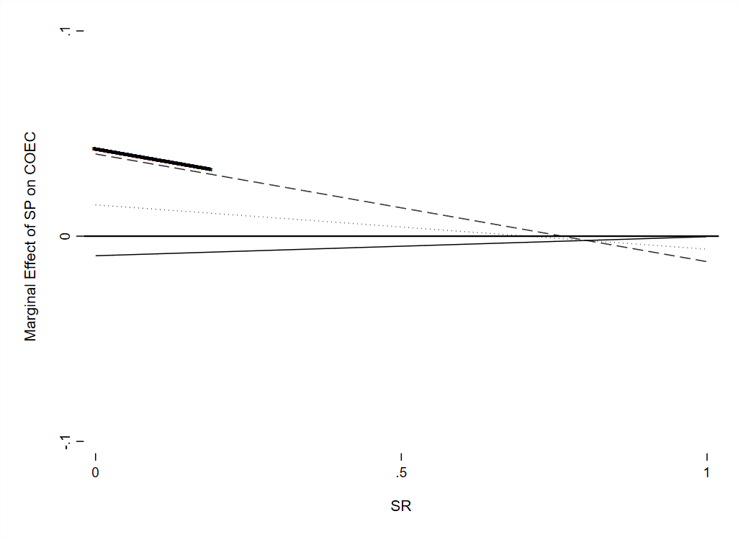

This figure shows the marginal effect of sustainability performance (SP) on the next period’s cost of equity (COEC) depending on CFO-fixed effects (CFOFE) and sustainability reporting (SR). The dashed (dotted, full) lines indicate the marginal effect of sustainability performance on the next period’s equity depending on sustainability reporting levels for firms with a CFO from the bottom (middle, top) CFO-fixed effect tercile. Values of sustainability reporting levels and CFO-fixed effect terciles for which we find a significant marginal effect of sustainability performance on the next period’s cost of equity at the 10 percent significance level are indicated with a bold line above the respective variables’ value combinations.
Appendix 4 Figure 2: Marginal Effect of SP on COEC Depending on SR Reporting Levels (Above and Below Annual Median) and CEO-Fixed Effects

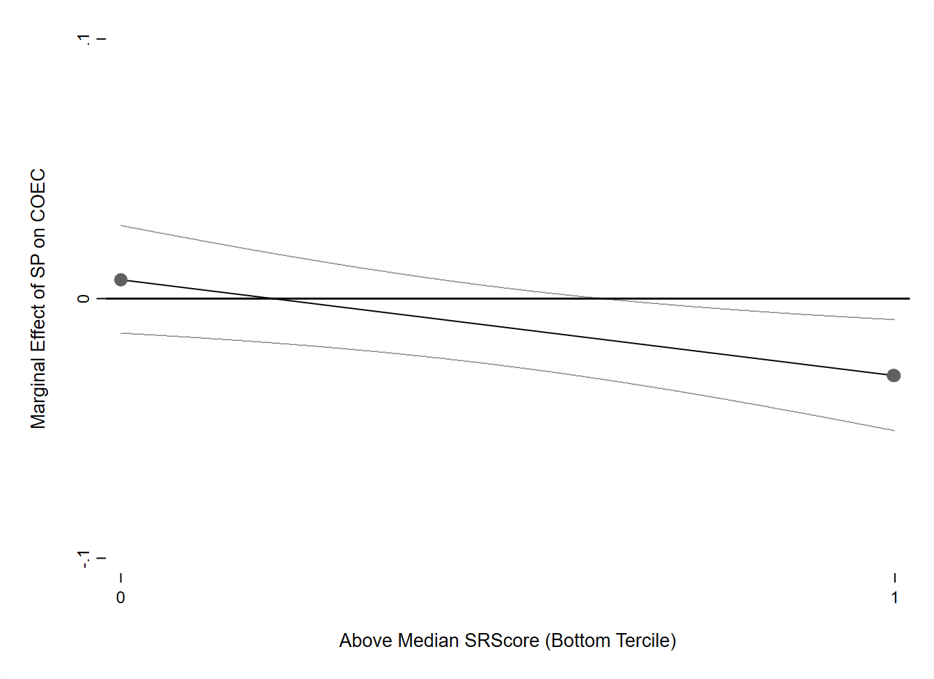
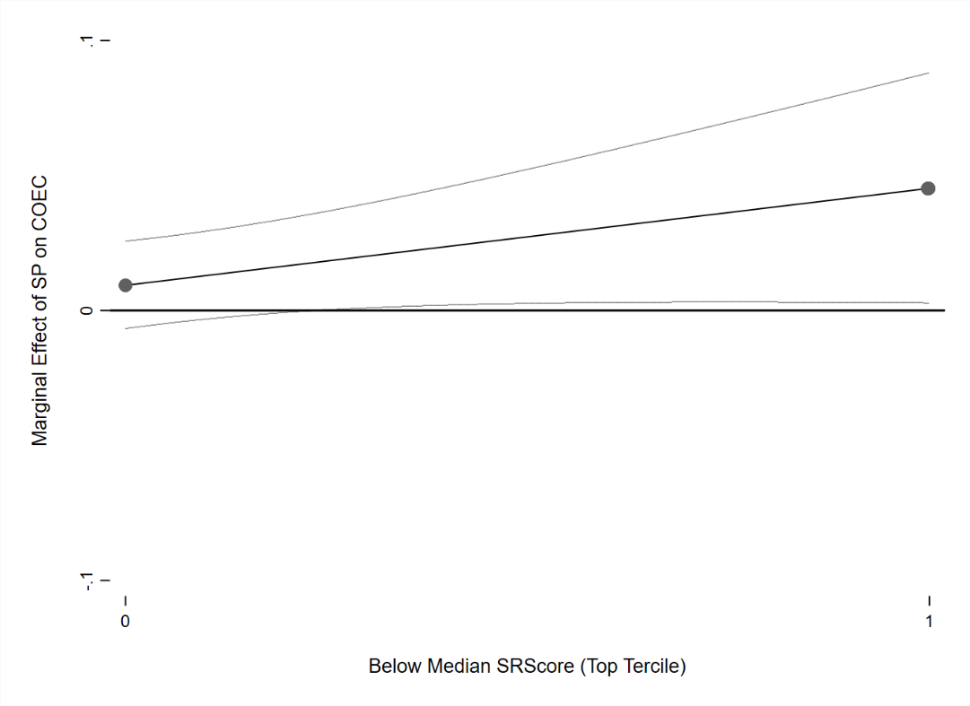

This figure shows the marginal effect of sustainability performance (SP) on next period’s cost of equity (COEC) depending on CEO-fixed effects (CEOFE) as well as the level of sustainability reporting (SR). The left graph shows the relationship between SP on next period’s CEOC for the CEOs assigned to the top tercile depending on whether a company has a sustainability reporting level below the median reporting level in the current year. The right graph shows the relationship between SP on next period’s CEOC for the CEOs assigned to the bottom tercile depending on whether a company has a SR reporting level above the median reporting level in the current year. Significant marginal effect of sustainability performance on next period’s cost of equity at the 10 percent significance level are indicated by the confidence intervals shown by the grey lines.

Appendix 4 Figure 3: Marginal Effect of SP on COEC Depending on SR and CEO-Fixed Effects –Non Complex Companies

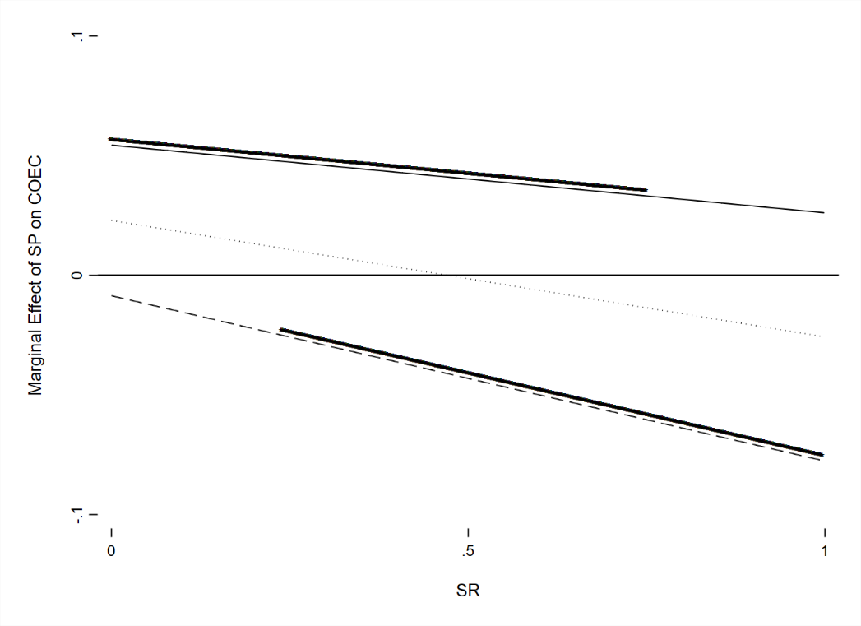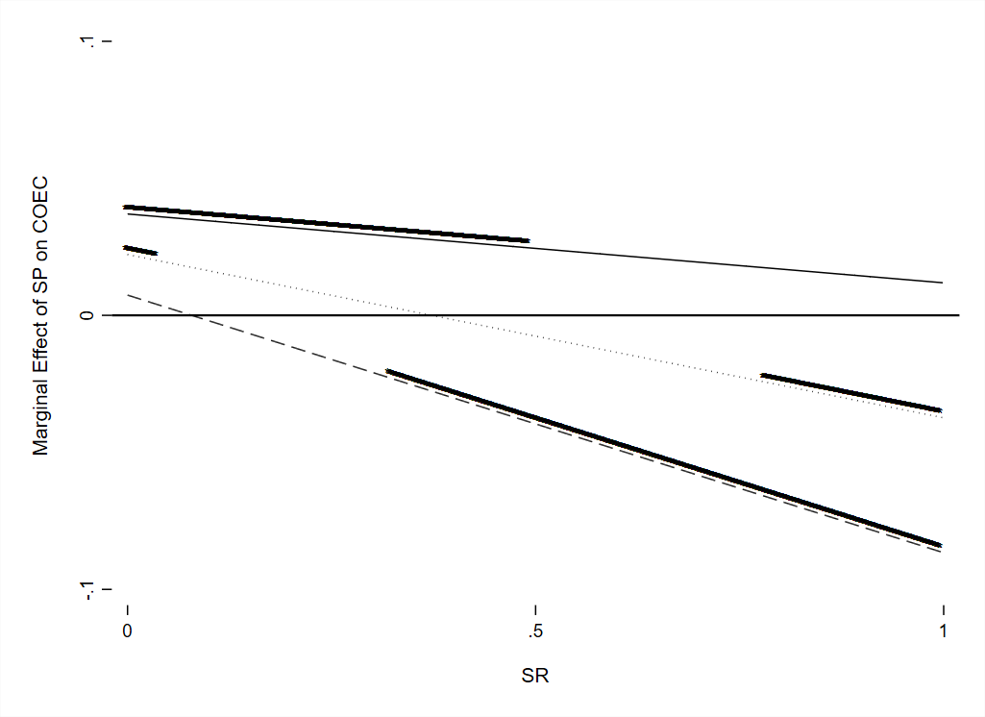
This figure shows the marginal effect of sustainability performance (SP) on next period’s cost of equity (COEC) depending on CEO-fixed effects (CEOFE) as well as sustainability reporting (SR). The dashed (dotted, full) lines indicate the marginal effect of sustainability performance on next period’s equity depending on sustainability reporting levels for firms with a CEO from the bottom (middle, top) CEO-fixed effect tercile. Values of sustainability reporting levels and CEO-fixed effect terciles for which we find a significant marginal effect of sustainability performance on next period’s cost of equity at the 10 percent significance level are indicated with a bold line positioned above the respective variables’ value combinations. The graph left (right) includes only firms with a number in geographical (business) segments below the sample median.

Appendix 4 Figure 4: Marginal Effect of SP on COEC Depending on SR and CEO-Fixed Effects – Complex Companies
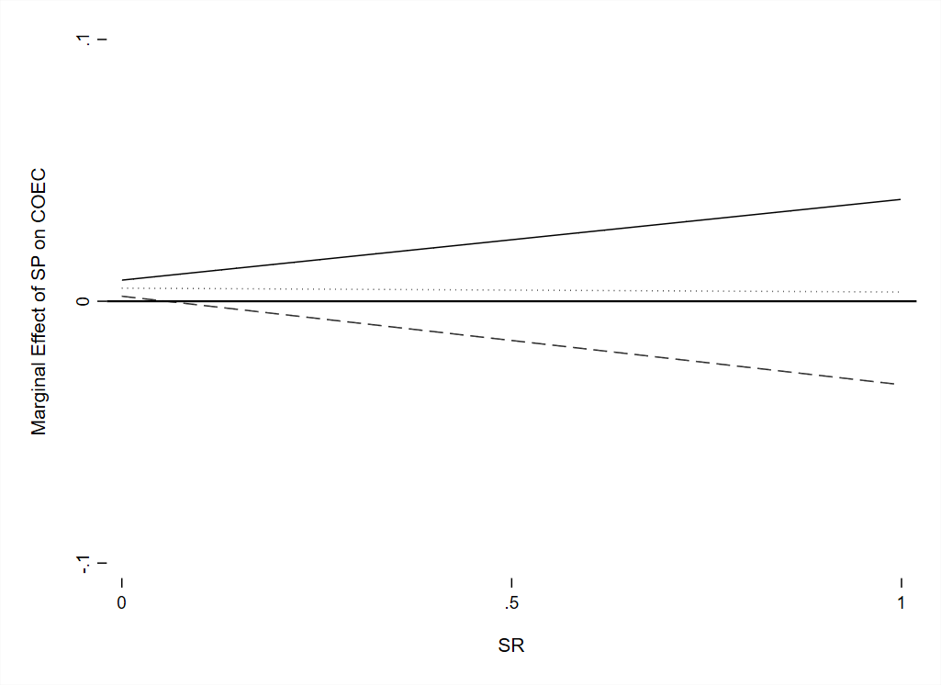
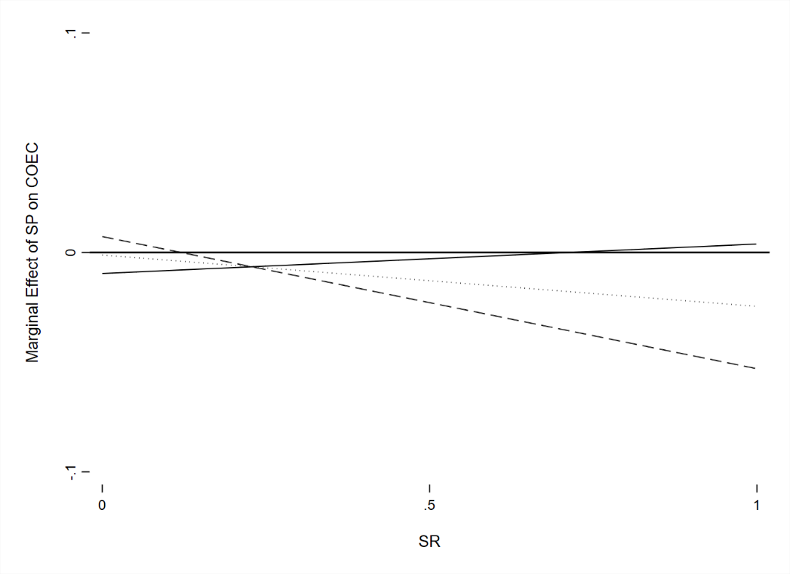
This figure shows the marginal effect of sustainability performance (SP) on next period’s cost of equity (COEC) depending on CEO-fixed effects (CEOFE) as well as sustainability reporting (SR). The dashed (dotted, full) lines indicate the marginal effect of sustainability performance on next period’s equity depending on sustainability reporting levels for firms with a CEO from the bottom (middle, top) CEO-fixed effect tercile. Values of sustainability reporting levels and CEO-fixed effect terciles for which we find a significant marginal effect of sustainability performance on next period’s cost of equity at the 10 percent significance level are indicated with a bold line positioned above the respective variables’ value combinations. The graph left (right) includes only firms with a number in geographic (business) segments above the sample median.

Appendix 4 Figure 5: Marginal Effect of SP on COEC Depending on SR and CEO-Fixed Effects – Normative CSR

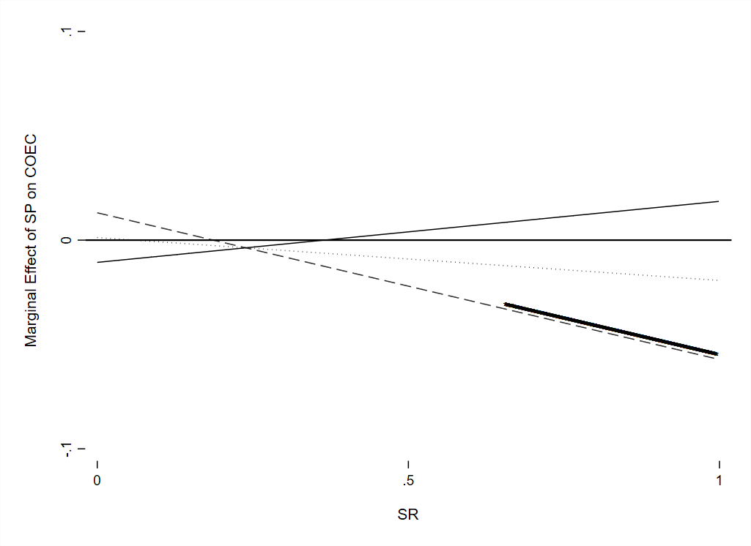

This figure shows the marginal effect of sustainability performance (SP), in this case normative sustainability activities according to Harjoto and Jo (2015), on the next period’s cost of equity (COEC) depending on CEO-fixed effects (CEOFE) and sustainability reporting (SR). The dashed (dotted, full) lines indicate the marginal effect of sustainability performance on the next period’s equity depending on sustainability reporting levels for firms with a CEO from the bottom (middle, top) CEO-fixed effect tercile. Values of sustainability reporting levels and CEO-fixed effect terciles for which we find a significant marginal effect of sustainability performance on the next period’s cost of equity at the 10 percent significance level are indicated with a bold line above the respective variables’ value combinations.
Appendix 4 Figure 6: Marginal Effect of SP on COEC Depending on SR and CEO-Fixed Effects – Synthesized CEO within Sample Switches
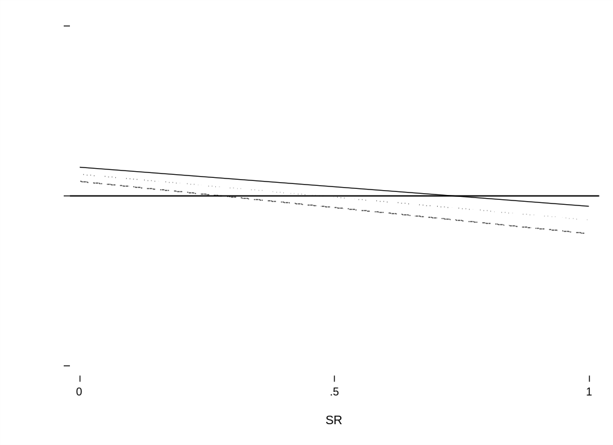
This figure shows the average marginal effect of sustainability performance (SP), on the next period’s cost of equity (COEC) depending on synthesized CEO-fixed effects (CEOFE) and sustainability reporting (SR). CEOFE are estimated on a sample with synthesized CEO within sample switches. The random allocation was performed 100 times, the effect displayed are the mean effects from each random estimation. The dashed (dotted, full) lines indicate the marginal effect of sustainability performance on the next period’s equity depending on sustainability reporting levels for firms with a CEO from the bottom (middle, top) CEO-fixed effect tercile. Values of sustainability reporting levels and CEO-fixed effect terciles for which we find an on average significant marginal effect of sustainability performance on the next period’s cost of equity at the 10 percent significance level are indicated with a bold line above the respective variables’ value combinations.
Appendix 4 Figure 7: Marginal Effect of SP on COEC Depending on SR and CEO-Fixed Effects – Excluding CEOs from Identified Endogenous Turnover Events

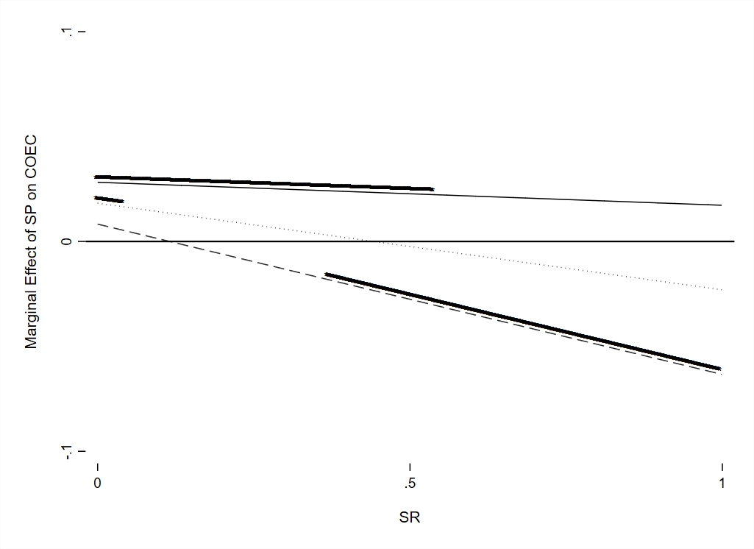
This figure shows the marginal effect of sustainability performance (SP), on the next period’s cost of equity (COEC) depending on CEO-fixed effects (CEOFE) and sustainability reporting (SR). CEOFE are estimated on a sample excluding all CEOs appointed after an identified endogenous turnover event. The dashed (dotted, full) lines indicate the marginal effect of sustainability performance on the next period’s equity depending on sustainability reporting levels for firms with a CEO from the bottom (middle, top) CEO-fixed effect tercile. Values of sustainability reporting levels and CEO-fixed effect terciles for which we find a significant marginal effect of sustainability performance on the next period’s cost of equity at the 10 percent significance level are indicated with a bold line above the respective variables’ value combinations.

Bibliography
Adams, R. B., and D. Ferreira. 2009. Women in the boardroom and their impact on governance and performance. Journal of Financial Economics 94 (2): 291–309. doi: 10.1016/j.jfineco.2008.10.007.
Bauer, A. M., X. Fang, and J. A. Pittman. 2021. The importance of IRS enforcement to stock price crash risk: The role of CEO power and incentives. The Accounting Review 96 (4): 81–109. doi: 10.2308/TAR-2018-0375.
Bertrand, M., and A. Schoar. 2003. Managing with style: The effect of managers on firm policies. The Quarterly Journal of Economics 118 (4): 1169–208. doi: 10.1162/003355303322552775.
Bochkay, K., R. Chychyla, and D. Nanda. 2019. Dynamics of CEO disclosure style. The Accounting Review 94 (4): 103–40. doi: 10.2308/accr-52281.
Boiral, O., and J.-F. Henri. 2017. Is sustainability performance comparable? A study of GRI reports of mining organizations. Business & Society 56 (2): 283–317. doi: 10.1177/0007650315576134.
Brambor, T., W. R. Clark, and M. Golder. 2006. Understanding interaction models: Improving empirical analyses. Political Analysis 14 (1): 63–82. doi: 10.1093/pan/mpi014.
Cahan, S. F., C. de Villiers, D. C. Jeter, V. Naiker, and C. J. van Staden. 2016. Are CSR disclosures value relevant? Cross-country evidence. European Accounting Review 25 (3): 579–611. doi: 10.1080/09638180.2015.1064009.
Cetindamar, D. 2007. Corporate social responsibility practices and environmentally responsible behavior: The case of the United Nations global compact. Journal of Business Ethics 76 (2): 163–76. doi: 10.1007/s10551-006-9265-4.
Chava, S. 2014. Environmental externalities and cost of capital. Management Science 60 (9): 2223–47. doi: 10.1287/mnsc.2013.1863.
Clarkson, P. M., X. Fang, Y. Li, and G. Richardson. 2013. The relevance of environmental disclosures: Are such disclosures incrementally informative? Journal of Accounting and Public Policy 32 (5): 410–31. doi: 10.1016/j.jaccpubpol.2013.06.008.
Clarkson, P. M., Y. Li, G. D. Richardson, and F. P. Vasvari. 2008. Revisiting the relation between environmental performance and environmental disclosure: An empirical analysis. Accounting, Organizations and Society 33 (4-5): 303–27. doi: 10.1016/j.aos.2007.05.003.
Claus, J., and J. Thomas. 2001. Equity premia as low as three percent? Evidence from analysts’ earnings forecasts for domestic and international stock markets. The Journal of Finance 56 (5): 1629–66. doi: 10.1111/0022-1082.00384.
Cronqvist, H., and F. Yu. 2017. Shaped by their daughters: Executives, female socialization, and corporate social responsibility. Journal of Financial Economics 126 (3): 543–62. doi: 10.1016/j.jfineco.2017.09.003.
Deegan, C., and B. Gordon. 1996. A study of the environmental disclosure practices of Australian corporations. Accounting and Business Research 26 (3): 187–99. doi: 10.1080/00014788.1996.9729510.
Dhaliwal, D. S., O. Z. Li, A. Tsang, and Y. G. Yang. 2011. Voluntary nonfinancial disclosure and the cost of equity capital: The initiation of corporate social responsibility reporting. The Accounting Review 86 (1): 59–100. doi: 10.2308/accr.00000005.
Dhaliwal, D. S., O. Z. Li, A. Tsang, and Y. G. Yang. 2014. Corporate social responsibility disclosure and the cost of equity capital: The roles of stakeholder orientation and financial transparency. Journal of Accounting and Public Policy 33 (4): 328–55. doi: 10.1016/j.jaccpubpol.2014.04.006.
Dhaliwal, D. S., S. Radhakrishnan, A. Tsang, and Y. G. Yang. 2012. Nonfinancial disclosure and analyst forecast accuracy: International evidence on corporate social responsibility disclosure. The Accounting Review 87 (3): 723–59. doi: 10.2308/accr-10218.
Dye, R. A. 1985. Disclosure of nonproprietary information. Journal of Accounting Research 23 (1): 123–45. doi: 10.2307/2490910.
Easton, P. D. 2004. PE ratios, PEG ratios, and estimating the implied expected rate of return on equity capital. The Accounting Review 79 (1): 73–95. doi: 10.2308/accr.2004.79.1.73.
El Ghoul, S., O. Guedhami, C. C. Kwok, and D. R. Mishra. 2011. Does corporate social responsibility affect the cost of capital? Journal of Banking & Finance 35 (9): 2388–406. doi: 10.1016/j.jbankfin.2011.02.007.
Epstein, L. G., and M. Schneider. 2008. Ambiguity, information quality, and asset pricing. The Journal of Finance 63 (1): 197–228. doi: 10.1111/j.1540-6261.2008.01314.x.
Fee, C. E., C. J. Hadlock, and J. R. Pierce. 2013. Managers with and without style: Evidence using exogenous variation. The Review of Financial Studies 26 (3): 567–601. doi: 10.1093/rfs/hhs131.
Fonseca, A., M. L. McAllister, and P. Fitzpatrick. 2014. Sustainability reporting among mining corporations: a constructive critique of the GRI approach. Journal of Cleaner Production 84: 70–83. doi: 10.1016/j.jclepro.2012.11.050.
Frankel, R., M. McNichols, and P. G. Wilson. 1995. Discretionary disclosure and external financing. The Accounting Review 70 (1): 135–50.
Fu, R., Y. Tang, and G. Chen. 2020. Chief sustainability officers and corporate social (Ir)responsibility. Strategic Management Journal 41 (4): 656–80. doi: 10.1002/smj.3113.
Gallego-Álvarez, I., and M. C. Pucheta-Martínez. 2020. Corporate social responsibility reporting and corporate governance mechanisms: An international outlook from emerging countries. Business Strategy & Development 3 (1): 77–97. doi: 10.1002/bsd2.80.
Gebhardt, W. R., C. M. C. Lee, and B. Swaminathan. 2001. Toward an implied cost of capital. Journal of Accounting Research 39 (1): 135–76. doi: 10.1111/1475-679X.00007.
Golob, U., and J. L. Bartlett. 2007. Communicating about corporate social responsibility: A comparative study of CSR reporting in Australia and Slovenia. Public Relations Review 33 (1): 1–9. doi: 10.1016/j.pubrev.2006.11.001.
Gordon, J. R., and M. J. Gordon. 1997. The finite horizon expected return model. Financial Analysts Journal 53 (3): 52–61. doi: 10.2469/faj.v53.n3.2084.
Guay, W., D. Samuels, and D. Taylor. 2016. Guiding through the fog: Financial statement complexity and voluntary disclosure. Journal of Accounting and Economics 62 (2-3): 234–69. doi: 10.1016/j.jacceco.2016.09.001.
Harjoto, M. A., and H. Jo. 2015. Legal vs. normative CSR: Differential impact on analyst dispersion, stock return volatility, cost of capital, and firm value. Journal of Business Ethics 128 (1): 1–21. doi: 10.1007/s10551-014-2082-2.
Hou, K., M. A. van Dijk, and Y. Zhang. 2012. The implied cost of capital: A new approach. Journal of Accounting and Economics 53 (3): 504–26. doi: 10.1016/j.jacceco.2011.12.001.
Janney, J. J., G. Dess, and V. Forlani. 2009. Glass houses? Market reactions to firms joining the UN Global Compact. Journal of Business Ethics 90 (3): 407–23. doi: 10.1007/s10551-009-0052-x.
Jensen, M. C., and W. H. Meckling. 1976. Theory of the firm: Managerial behavior, agency costs and ownership structure. Journal of Financial Economics 3 (4): 305–60. doi: 10.1016/0304-405X(76)90026-X.
Jo, H., and M. A. Harjoto. 2011. Corporate governance and firm value: The impact of corporate social responsibility. Journal of Business Ethics 103 (3): 351–83. doi: 10.1007/s10551-011-0869-y.
Kaspereit, T., and K. Lopatta. 2016. The value relevance of SAM’s corporate sustainability ranking and GRI sustainability reporting in the European stock markets. Business Ethics: A European Review 25 (1): 1–24. doi: 10.1111/beer.12079.
Kesner, I. F., and D. R. Dalton. 1994. Top management turnover and CEO succession: An investigation of the effects of turnovers on performance. Journal of Management Studies 31 (5): 701–13. doi: 10.1111/j.1467-6486.1994.tb00635.x.
Kolk, A. 2003. Trends in sustainability reporting by the Fortune Global 250. Business Strategy and the Environment 12 (5): 279–91. doi: 10.1002/bse.370.
Lozano, R., and D. Huisingh. 2011. Inter-linking issues and dimensions in sustainability reporting. Journal of Cleaner Production 19 (2-3): 99–107. doi: 10.1016/j.jclepro.2010.01.004.
Lu, L. Y., G. Shailer, and Y. Yu. 2017. Corporate social responsibility disclosure and the value of cash holdings. European Accounting Review 26 (4): 729–53. doi: 10.1080/09638180.2016.1187074.
Lys, T., J. P. Naughton, and C. Wang. 2015. Signaling through corporate accountability reporting. Journal of Accounting and Economics 60 (1): 56–72. doi: 10.1016/j.jacceco.2015.03.001.
Mahoney, L. S., and L. Thorne. 2005. Corporate social responsibility and long-term compensation: Evidence from Canada. Journal of Business Ethics 57 (3): 241–53. doi: 10.1007/s10551-004-5367-z.
Marshall, R. S., D. Brown, and M. Plumlee. 2001. ‘Negotiated’ transparency? Corporate citizenship engagement and environmental disclosure. The Journal of Corporate Citizenship (28): 43–60.
Matsunaga, S. R., and E. Yeung. 2008. Evidence on the impact of a CEO’s financial experience on the quality of the firm’s financial reports and disclosures. Working Paper. Available at: https://papers.ssrn.com/sol3/papers.cfm?abstract_id=1014097. Accessed January 31, 2021.
Melero, E. 2011. Are workplaces with many women in management run differently? Journal of Business Research 64 (4): 385–93. doi: 10.1016/j.jbusres.2010.01.009.
Moneva, J. M., P. Archel, and C. Correa. 2006. GRI and the camouflaging of corporate unsustainability. Accounting Forum 30 (2): 121–37. doi: 10.1016/j.accfor.2006.02.001.
Nielsen, A. E., and C. Thomsen. 2007. Reporting CSR – what and how to say it? Corporate Communications: An International Journal 12 (1): 25–40. doi: 10.1108/13563280710723732.
Ohlson, J. A., and B. E. Juetter-Nauroth. 2005. Expected EPS and EPS growth as determinants of value. Review of Accounting Studies 10: 349–65.
Plumlee, M., D. Brown, R. M. Hayes, and R. S. Marshall. 2015. Voluntary environmental disclosure quality and firm value: Further evidence. Journal of Accounting and Public Policy 34 (4): 336–61. doi: 10.1016/j.jaccpubpol.2015.04.004.
Plumlee, M. A. 2003. The effect of information complexity on analysts’ use of that information. The Accounting Review 78 (1): 275–96. doi: 10.2308/accr.2003.78.1.275.
Prado-Lorenzo, J.-M., L. Rodríguez-Domínguez, I. Gallego-Álvarez, and I.-M. García-Sánchez. 2009. Factors influencing the disclosure of greenhouse gas emissions in companies world‐wide. Management Decision 47 (7): 1133–57. doi: 10.1108/00251740910978340.
Reimsbach, D., R. Hahn, and A. Gürtürk. 2018. Integrated reporting and assurance of sustainability information: An experimental study on professional investors’ information processing. European Accounting Review 27 (3): 559–81. doi: 10.1080/09638180.2016.1273787.
Skouloudis, A., K. Evangelinos, and F. Kourmousis. 2010. Assessing non-financial reports according to the global reporting initiative guidelines: Evidence from Greece. Journal of Cleaner Production 18 (5): 426–38. doi: 10.1016/j.jclepro.2009.11.015.
Sobczak, A., and L. Coelho Martins. 2010. The impact and interplay of national and global CSR discourses: Insights from France and Brazil. Corporate Governance: The international journal of business in society 10 (4): 445–55. doi: 10.1108/14720701011069678.
Song, W.-L., and K.-M. Wan. 2019. Does CEO compensation reflect managerial ability or managerial power? Evidence from the compensation of powerful CEOs. Journal of Corporate Finance 56: 1–14. doi: 10.1016/j.jcorpfin.2018.11.009.
Steinmeier, M., and M. Stich. 2019. Does sustainability assurance improve managerial investment decisions? European Accounting Review 28 (1): 177–209. doi: 10.1080/09638180.2017.1412337.
Tsang, A., K. T. Wang, S. Liu, and L. Yu. 2021. Integrating corporate social responsibility criteria into executive compensation and firm innovation: International evidence. Journal of Corporate Finance 70: 102070. doi: 10.1016/j.jcorpfin.2021.102070.
Werner, T. 2015. Gaining access by doing good: The effect of sociopolitical reputation on firm participation in public policy making. Management Science 61 (8): 1989–2011. doi: 10.1287/mnsc.2014.2092.
You, H., and X. Zhang. 2009. Financial reporting complexity and investor underreaction to 10-K information. Review of Accounting Studies 14 (4): 559–86. doi: 10.1007/s11142-008-9083-2.

The sustainability performance score also consists of items that capture sustainability reporting, as the sustainability reporting score items are also included in the sustainability performance score. However, we believe that this overlap should not be an issue for two reasons. First, it affects only five out of 178 sustainability performance items. Second, even assuming that the overlap between both scores affects our results to a limited extent, it would only cause an upwards bias of the coefficients’ standard errors due to multicollinearity (Brambor, Clark, and Golder 2006).
Interestingly, we find that legal sustainability activities relate primarily to concerns (20 concern vs. 2 strength items, whereas normative sustainability activities captures mostly strengths (41 strength vs. 17 concern items).
Our mean values are consistent with those reported in their study (normative sustainability activities: 0.087 (our sample) vs. 0.098 (Harjoto and Jo, 2015) and legal sustainability activities: -0.064 vs. -0.150).
Due to the restricted availability, especially in the years before 2010, we were only able to identify 774 reports. For this reason we refrain from including these reports/related proxy into our main analysis.

