ONLINE SUPPLEMENTARY MATERIAL
[Instructions translated from original language. The first and the last parts of the instructions were identical in each treatment. Only the middle part differed between treatments. In order to make the instructions for all treatments easily comprehensible without being overly redundant, we start with the first part of the instructions, followed by two versions of the middle part and end with the last part of the instructions. The first version of the middle part contains the respective instructions for both No-Whistle treatments and the second version for both Whistle treatments.]
[First part of the instructions:]

Instructions

Welcome to this Experiment!
You will now participate in an experiment that is financed by the [research institute of the first author]. From now on, we ask you to keep quiet and remain seated in front of your computers. You are not allowed to talk or communicate with other participants during the experiment. Please turn off your mobile devices.
The following instructions describe the experiment and explain how your decisions affect your earnings. Please read the instructions carefully until the end! Issues that might be unclear at the beginning of the instructions are explained in detail in later parts. If you have any questions after reading the instructions or during the experiment, please raise your hand and wait for an experimenter to come to you. All of your decisions during the experiment will be treated in an anonymous manner.
Throughout this experiment all your earnings will be calculated in ECU (Experimental Currency Units). At the end of the experiment, the total amount of ECU you have earned will be converted to euro at the following rate:
100 ECU = 1.00 euro
In addition to the earnings from your decisions, you will receive a show-up fee in the amount of 2.50 euro for arriving at our lab on time [at the lab in City 2: 4.00 euro]. At the end of the experiment, the total amount of money that you have earned (= your earnings + show-up fee) will be paid out to you privately in cash (i.e., none of the other participants will know your total earnings).
Preliminary notes about the experiment
The experiment consists of a total of 10 rounds. Each round follows the same procedure. Prior to round 1, all participants will be divided at random into groups of three. In each group, each member receives a unique membership number in his or her own group: either “1”, “2” or “3”. Each participant remains in the same group in all 10 rounds and always keeps his or her membership number. Except for the membership number, no participant’s identity will be revealed to any other group member.

[In the following begins the middle part of the instructions. We start with the middle part for both No-Whistle treatments, followed by the middle part for both Whistle treatments. In the former, we provide the instructions for the No-Whistle (B: 150) treatment and indicate differences in the No-Whistle (B: 100 or 150) treatment in italics. In the latter, we provide the instructions for the mild punishment treatment and italicize differences in the strong punishment treatment.]

[Middle part for both No-Whistle treatments:]

The Decision Situation
In each round, each participant makes a decision between alternative A and alternative B.

Alternative A:
A participant who chooses alternative A receives 100 ECU in the respective round.

Alternative B:
A participant who chooses alternative B receives 150 ECU in the respective round.
[A participant who chooses alternative B receives either 100 ECU or 150 ECU in the respective round. Whether the participant receives 100 ECU or 150 ECU depends on a random drawing (more on this later).]

Procedure of a Round
- Make a decision: At the beginning of each round, each participant makes a decision between alternative A and alternative B.
- Feedback about decisions of group members: Once all participants made their decision in a round, all participants are informed about the decisions of their respective group members. This means that each participant will see the decisions of both other group members in the current round on his or her monitor (see screen shot at the end of the instructions).
- Feedback at the end of a round: Afterwards, each participant sees his or her own earnings in the current round on his or her monitor. This concludes the current round.

Your Earnings in a Round

Alternative A:
If you chose alternative A, your earnings in the current round are 100 ECU.

Alternative B:
If you chose alternative B, your earnings in the current round are 150 ECU.
[If you chose alternative B, the computer determines at random whether your earnings in the current round are 100 ECU or 150 ECU. Both earnings are equally likely. This means that the chance to receive 150 ECU is 50%. Of course, the computer executes the random drawing in each round anew in which you chose alternative B. (For illustration: If you chose alternative B in a round, it is as if the computer flips a coin. If the coin shows “heads”, your earnings in this round are 100 ECU. If the coin shows “tails”, your earnings in this round are 150 ECU.)]

[Middle part for both Whistle treatments:]

The Decision Situation
In each round, each participant makes a decision between alternative A and alternative B.

Alternative A:
A participant who chooses alternative A receives 100 ECU in the respective round.

Alternative B:
A participant who chooses alternative B receives either 100 ECU or 150 ECU in the respective round. Whether the participant receives 100 ECU or 150 ECU depends on whether he or she is reported by his or her other group members. In this case, a random drawing determines the earnings in the respective round (more on this later).
[A participant who chooses alternative B receives either 25 ECU or 150 ECU in the respective round. Whether the participant receives 25 ECU or 150 ECU depends on whether he or she is reported by his or her other group members (more on this later).]

Procedure of a Round
- Make a decision: At the beginning of each round, each participant makes a decision between alternative A and alternative B.
- Feedback about decisions of group members: Once all participants made their decision in a round, all participants are informed about the decisions of their respective group members. This means that each participant will see the decisions of both other group members in the current round on his or her monitor.
- Reporting group members: Each member of your group who chose alternative B in the current round can be reported. If you want to report one of your group members, you tick the checkbox next to the respective member (see screen shot at the end of the instructions). Reporting a group member generates costs of 10 ECU. If you report both of your group members in a round, the costs of reporting amount to 20 ECU in this round. Group members who chose alternative A cannot be reported.
- Feedback at the end of a round: Afterwards, each participant sees his or her own earnings in the current round on his or her monitor and whether he or she was reported by the other group members, if he or she chose alternative B. This concludes the current round. Note: If you were reported by either one or both of your group members, you will only be informed that you were reported. You will neither be informed by whom nor by how many of your group members you were reported.

Your Earnings in a Round

Alternative A:
If you chose alternative A, your earnings in the current round are 100 ECU.

Alternative B:
If you chose alternative B, your earnings in the current round depend on whether you were reported by your group members in this round.
  - If none of your group members reported you, your earnings in the current round are 150 ECU.
  - If at least one of your group members reported you, the computer determines at random whether your earnings in the current round are 100 ECU or 150 ECU. Both earnings are equally likely. This means that the chance to receive 150 ECU is 50%, no matter whether you were reported by only one or by both of your group members. Of course, the computer executes the random drawing in each round anew in which you chose alternative B and were reported by at least one of your group members. (For illustration: If you chose alternative B in a round and were reported by at least one of your group members, it is as if the computer flips a coin. If the coin shows “heads”, your earnings in this round are 100 ECU. If the coin shows “tails”, your earnings in this round are 150 ECU.)
[b. If at least one of your group members reported you, your earnings in the current round are 25 ECU, no matter whether you were reported by only one or by both of your group members.]
If you reported any of your group members in the current round, the costs for reporting are subtracted from your round earnings. If you reported one member of your group, 10 ECU are subtracted from your earnings in the current round. If you reported both members of your group, 20 ECU are subtracted from your earnings in the current round.

[Last part of the instructions:]

Your Total Earnings
At the end of the experiment, your individual earnings from all 10 rounds will be summed up. However, there is a possibility that your entire group, including yourself, loses all earnings from all 10 rounds. Every time a member of your group chooses alternative B, there is a probability of 0.003 (= a risk of 0.3%) that all members of your group lose all their earnings from all rounds.
At the end of the experiment, the computer will count how often alternative B was chosen in your group throughout all 10 rounds. For each instance that one of the members of your group chose alternative B, the computer will determine at random whether or not the earnings in your group will be lost. In each random drawing, the risk of losing all earnings is 0.3%. All members of your group lose all their earnings as soon as one of these random drawings comes to this conclusion. (For illustration: Each random drawing is as if the computer draws a ball from an urn containing a total of 1000 balls. 997 of those balls are green and 3 balls are red. If the color of the randomly drawn ball is red, all earnings in your group will be lost.)

Example 1: If all members in your group chose alternative A in all 10 rounds, there will be no random drawing for your group. All accumulated earnings in group, therefore, will not be lost with certainty.
Example 2: If one member in your group chose alternative B in all 10 rounds and both other members always chose alternative A, the random drawing will be executed 10 times for your group. All earnings from all rounds in your group will be lost, as soon as one of these random drawings comes to this conclusion.
Example 3: If all members in your group chose alternative B in all 10 rounds, the random draw- ing will be executed 30 times for your group. All earnings from all rounds in your group will be lost, as soon as one of these random drawings comes to this conclusion.
Before the experiment begins, we kindly ask you to answer a few comprehension questions. As soon as all the participants answered those questions correctly, we will start the experiment.

Please keep quiet and remain seated during the entire experiment. If you have any questions, please raise your hand. Click on “OK” if you have finished reading the instructions.

[Screen shot at the end of instructions in both No-Whistle treatments:]

Example screen shot regarding the feedback about the decisions of group members:
In this example, we are in round 1 and we see a screen shot from the perspective of group member 1. All group members have made their decisions between alternative A and alternative B in the current round. In this example, group member 2 has chosen alternative A and group member 3 has chosen alternative B.
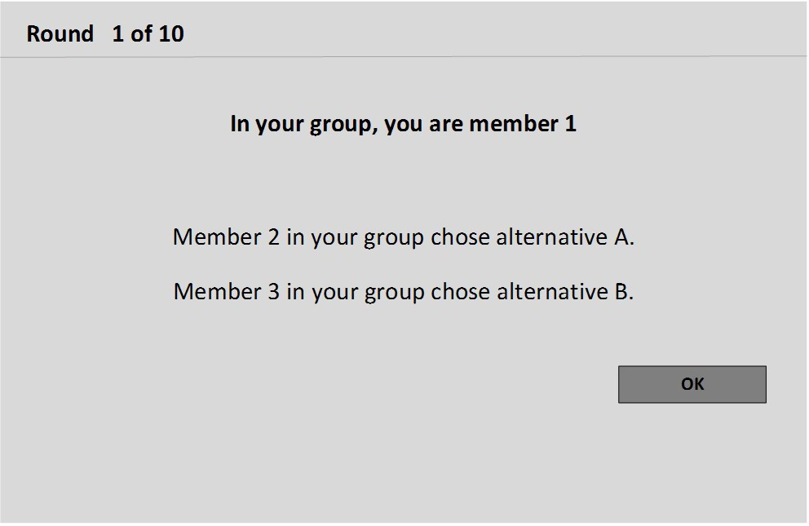

[Screen shot at the end of instructions in both Whistle treatments:]

Example screen shot regarding the feedback about the decisions and reporting of group members:
In this example, we are in round 1 and we see a screen shot from the perspective of group member 1. All group members have made their decisions between alternative A and alternative B in the current round. Because group member 2 has chosen alternative A in this example, this group member cannot be reported (there is no checkbox next to this member). Group member 3 has chosen alternative B and therefore can be reported (there is a checkbox next to this member). In this example, group member 1 decided to report group member 3 and therefore ticked the respective checkbox. For reporting group member 3, 10 ECU are subtracted from group member 1’s current round earnings.
