Web Appendix A. Specific examples of studies that were included or excluded from this review
Category | Example | Classification | Reason for classification
A. – Global study without European contextualization | Contractor, Kundu, & Hsu (2003) analyzed the relationship between multinationality and performance in global service firms. While some European firms were included in the study, most were headquartered in the United States, and no discussion was made of European institutional or market factors. | Excluded | Europe appears only as part of a global sample, and the focus and theoretical framework of the study are universal rather than contextual.
B. – Empirical emphasis on European MNEs and context | Gupta & Govindarajan (2000) examined knowledge flows within MNEs. Their sample consisted of subsidiaries in the United States, Japan, and Europe, with 46% of these being European MNEs. However, this study did not explicitly address institutional, regulatory, or cultural factors in Europe. Instead, the theoretical framework and interpretation focused on generalizable mechanisms of knowledge transfer within MNEs. | Excluded | Despite the significant presence of European subsidiaries in the sample, the analysis and theoretical discussion of this study were not directly linked to the European context. Therefore, this study was not classified as a Europe-focused study according to our contextual screening criteria.
C. – European data with partially contextual insights | Barkema & Drogendijk (2007) investigated internationalization paths and learning patterns of European firms. While the theoretical framework (gradual internationalization, experiential learning) is broadly generalizable, the empirical design and interpretation focused on the European business environment, including the continent’s institutional complexity and market diversity. | Included | While the theoretical model of this study is universal, the empirical focus and interpretation are centered on European firms. The study provides meaningful contextual insights into how Europe’s heterogeneous institutional environment impacts the internationalization process of firms. Thus, while conceptually general, its substantive contributions are closely tied to the European context, warranting its inclusion in this review.

Web Appendix B. Research contexts
 | Intra-European | Outward (Extra-European) | Inward (Extra-European) | Other | Total
Europe | 11 | 18 | 20 | 12 | 61
Western Europe | 3 | 4 | 5 | 2 | 14
Eastern Europe | 1 | 0 | 1 | 2 | 4
Central Europe | 0 | 0 | 2 | 0 | 2
CEE | 8 | 2 | 11 | 1 | 22
Nordic countries | 1 | 2 | 0 | 0 | 3
The UK | 0 | 2 | 2 | 1 | 5
Austria | 0 | 1 | 2 | 0 | 3
Bulgaria | 0 | 0 | 1 | 0 | 1
Czech Republic | 0 | 0 | 1 | 1 | 2
France | 0 | 0 | 0 | 2 | 2
Germany | 0 | 5 | 3 | 2 | 10
Greece | 0 | 1 | 0 | 0 | 1
Hungary | 1 | 1 | 1 | 1 | 4
Italy | 0 | 1 | 1 | 0 | 2
Lithuania | 0 | 1 | 0 | 0 | 1
Netherlands | 0 | 1 | 0 | 1 | 2
Norway | 0 | 2 | 1 | 0 | 3
Poland | 1 | 1 | 1 | 1 | 4
Slovenia | 0 | 0 | 1 | 1 | 2
Sweden | 0 | 2 | 1 | 0 | 3
Switzerland | 0 | 1 | 2 | 0 | 3
Türkiye | 0 | 0 | 1 | 0 | 1
Ukraine | 0 | 0 | 1 | 0 | 1
European business school | 0 | 0 | 0 | 1 | 1

The research contexts reported in Web Appendix B were identified through a thorough review of each individual paper. For all included studies, the geographical context of the previous studies was carefully identified based on the data, case studies, and descriptions of the countries and regions analyzed. The relevant countries or regions were then manually noted and categorized into four directional categories: Intra-European, Outward, Inward, and Other. When a study included multiple countries, each country was recorded individually. For example, if a paper analyzed France, Austria, and Switzerland, all three countries were entered into the corresponding directional category. Regional designations such as “Nordic countries,” “Western Europe,” and “CEE” were retained as independent categories only when explicitly used by the authors and were not automatically disaggregated into their constituent countries. Similarly, country-level contexts such as Germany, Italy, and Poland were maintained as separate entries and not aggregated into broader regional categories. The category “Europe” was used only when studies explicitly mentioned Europe as the research context. It was not inferred from the presence of individual European countries or derived from more general terms like “European.” Therefore, if a single article examined multiple regions, it could contribute to multiple context categories. After manually coding all articles in this manner, frequencies were tallied to produce the figures reported in Web Appendix B.

Web Appendix C. Theory-topic network
The theory–topic network provides a descriptive visual overview of recurring linkages between theories and research topics across the reviewed studies. To enhance interpretability, the visualization focuses on the most frequently used theoretical perspectives. The network was constructed using standard Python-based tools (Matplotlib, Pandas, and NetworkX), with nodes representing theories and topics and edges indicating the relative strength of their associations.
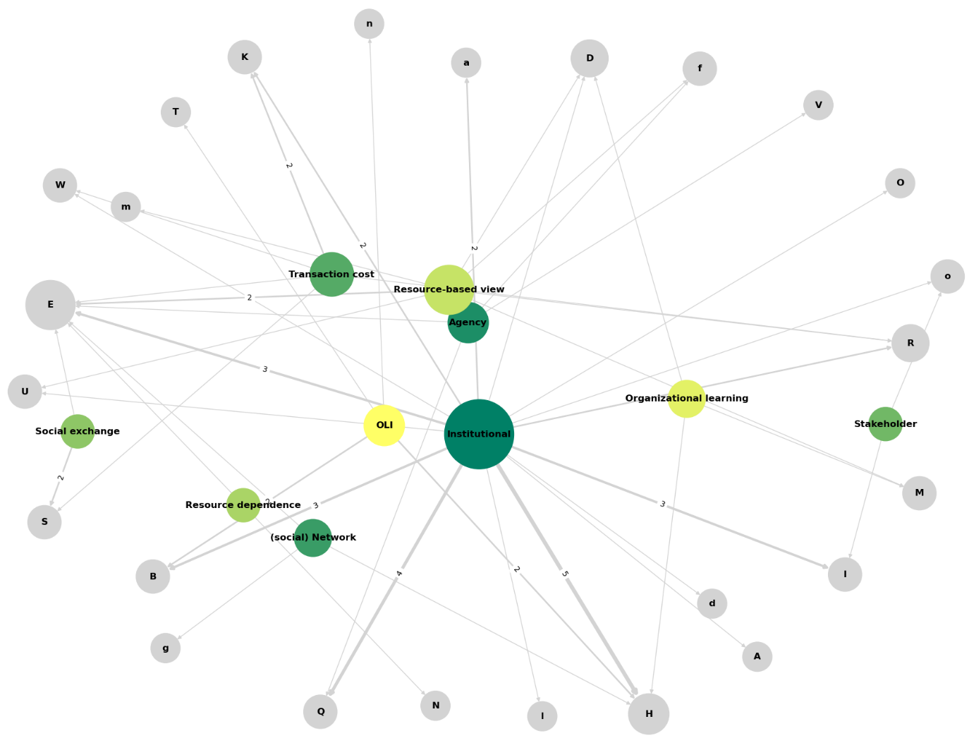
Web Appendix D. Methods and data sources
The Figure below shows the research methods and data sources used in empirical studies conducted on IB in Europe and IB from 2000 to 2023. The majority of these studies were quantitative (N = 85; 73.91%), with over half relying on secondary data (N = 45) and 38 using survey data. In contrast, qualitative studies were less common (N = 17; 14.78%), with interviews being the domiant approach (N = 12). Triangulation—combining multiple methods to reduce bias—remained underutilized, employed in only 5.22% of studies (N = 6). The remaining 6.09% (N = 8) included commentary or conceptual articles. Overall, the findings suggest a continued preference for statistical approaches in research on IB in Europe.
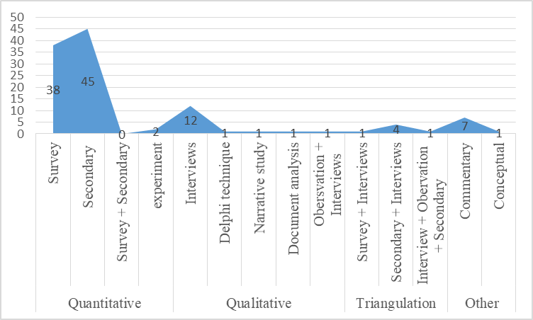

Web Appendix E. Keyword network and time-series weight changes
From the 555 initially retrieved co-occurring keywords, 433 formed a connected network and were retained for analysis. Figures below present the resulting keyword network and time-series weight changes, highlighting both emerging and established themes.

Diagram of the keyword co-occurrence analysis  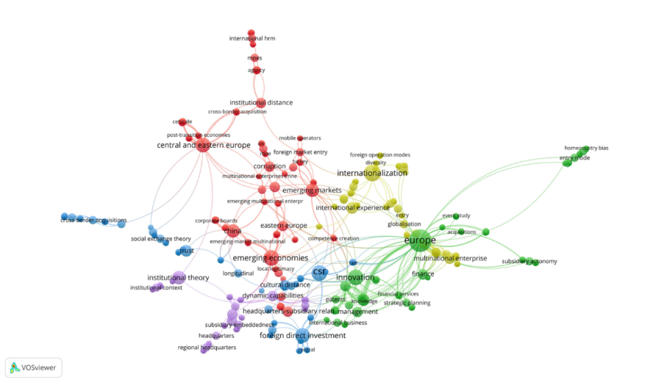  Notes: Cluster 1 (yellow), Cluster 2 (blue), Cluster 3 (red), Cluster 4 (purple), Cluster 5 (green) | Overlay diagram of the keywords co-occurrence analysis by year  