Facile electrodeposition of nickel- and cobalt-based metal oxides as bifunctional electrocatalysts for alkaline water splitting
Jose Antonio Fontes de Carvalho Ribeiro Rodrigues, Thomaz de Oliveira Barros, João Victor Madureira Correia Moraes, Rajendran Suresh Babu*, Ana Lucia Ferreira de Barros
Laboratory of Experimental and Applied Physics, Centro Federal de Educação Tecnológica Celso Suckow da Fonseca, Av. Maracanã Campus 229, Rio de Janeiro, Brazil

Supporting Information
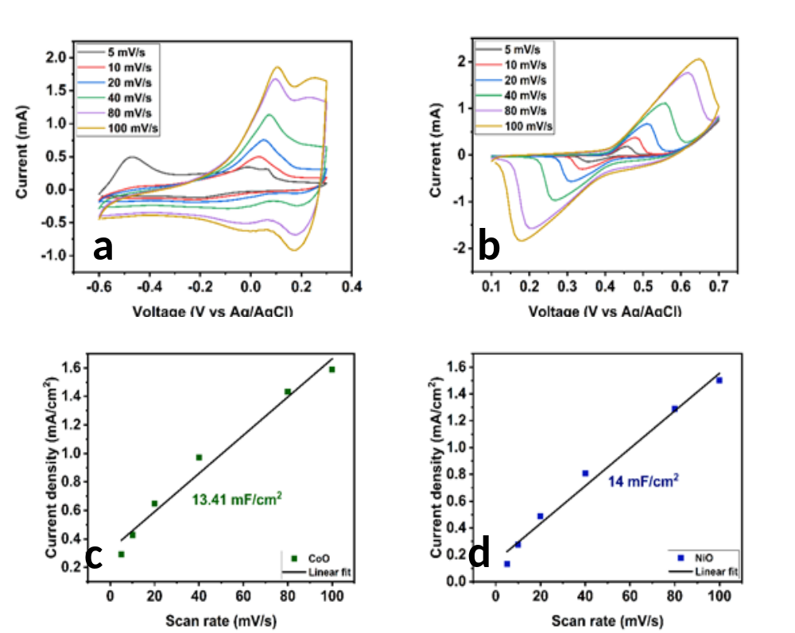

Figure S1. CV curves of (a) CoO/NP and (b) NiO/NP recorded in the non-faradaic region at different scan rates in 1.0 M KOH. (c,d) Linear plots of capacitive current density (Δj = (ja − jc)/2) versus scan rate; the slope gives the double-layer capacitance (Cdl) used to estimate ECSA

