Supplementary material
Fig. S1. Intensity map for the 2 December 2020 Thiva shallow event. Source: ITSAK (http://shakemaps.itsak.gr/auth2020xqsq/intensity.html).
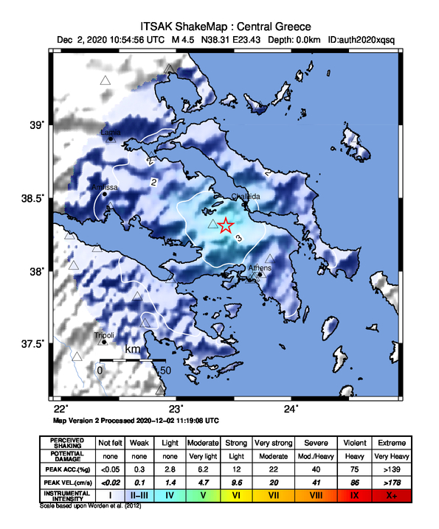

Fig. S2 Scattered plots and histograms showing the trade-offs and uncertainties of source parameters of the non-linear inversion; red points indicate the optimal values and the black curves are showing the Gaussian fit. To estimate the uncertainties of the uniform-slip models, an empirical approach was followed; by adding realistic noise to the interferograms: a non-linear inversion was applied again beginning from the configuration of the optimum parameters. We repeated this procedure 100 times and gathered results that represent the uncertainties and trade-offs of the parameters.
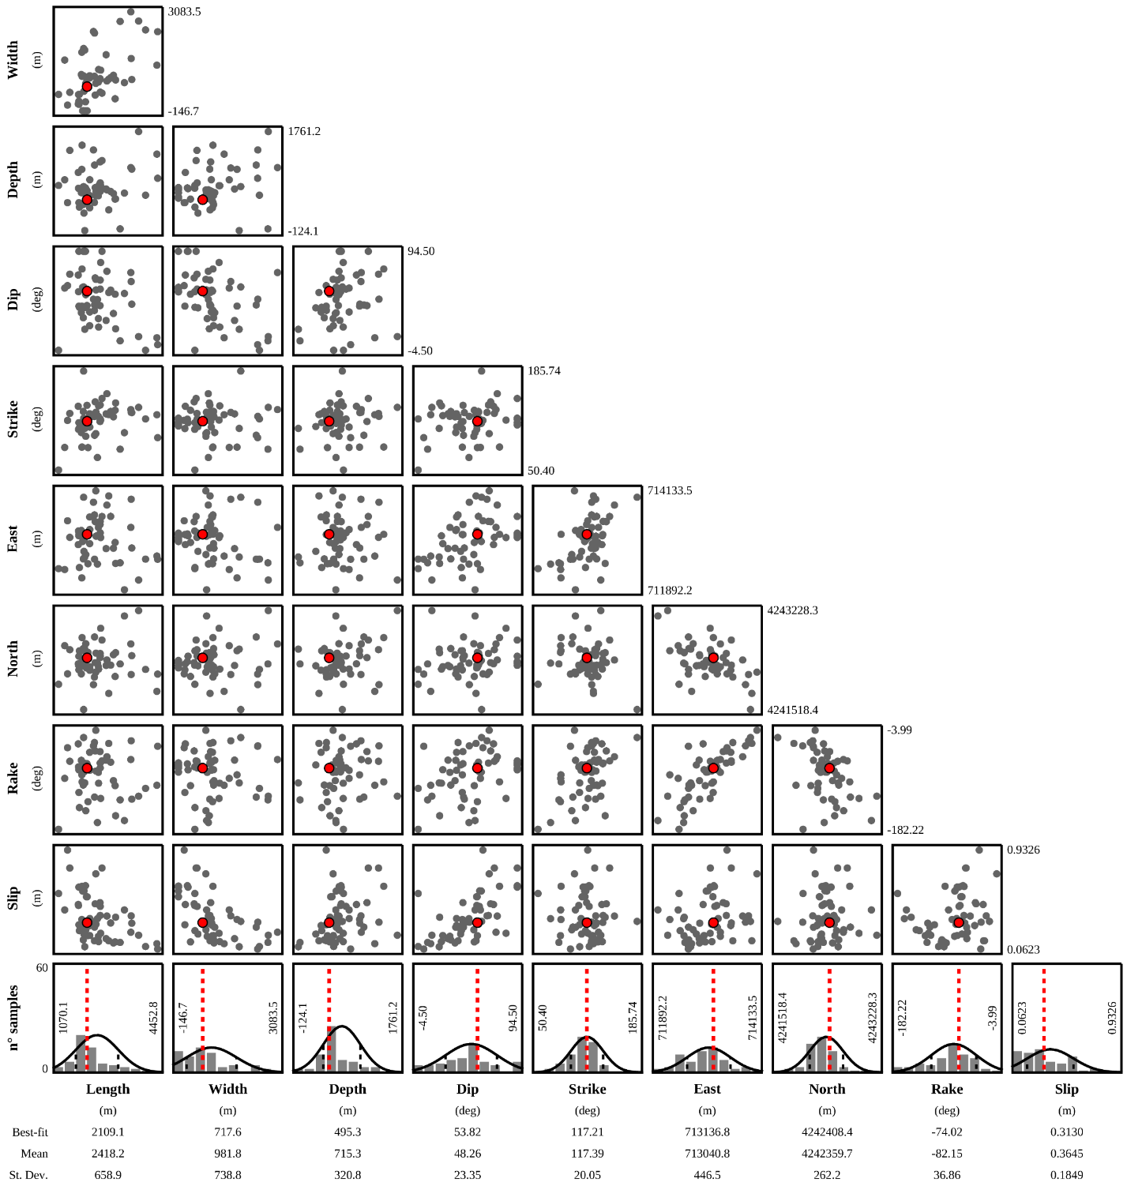

Fig. S3 Observed data (left), modelled (center) and residuals (right) of the InSAR non-linear inversion assuming uniform slip. Magenta lines and white rectangle represent the tectonic framework by NOAFaults v4.0 database (Ganas, 2022) and retrieved plain fault, respectively.
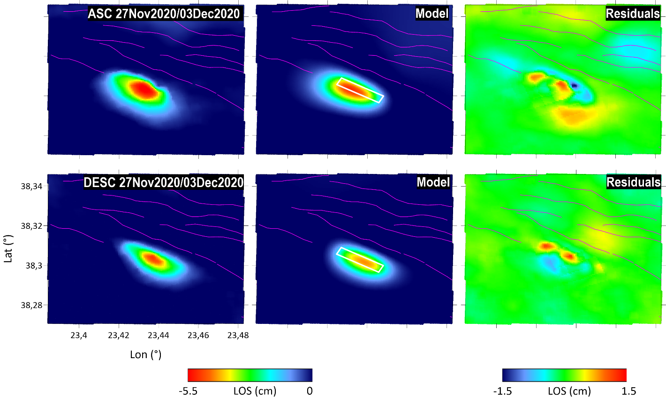

Fig. S4. Map displaying the available stations (green triangles) and those selected on the basis of the epicentral distance and of the SNR (blue triangles). The red star identifies the epicenter of the event.
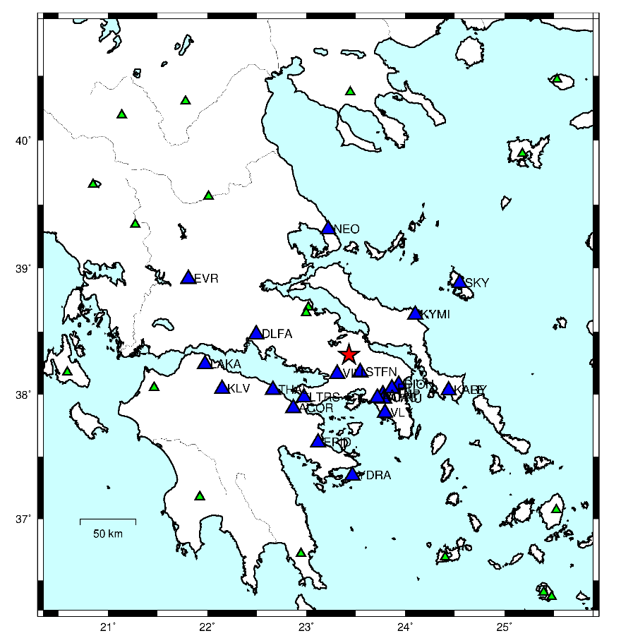
Fig. S5 Three component waveforms in m/s recorded at station EPID belonging to the Hellenic Seismological Network (HUSN), University of Athens, Seismological Laboratory (HA) located at about 85 km south from the earthquake’s epicentre.

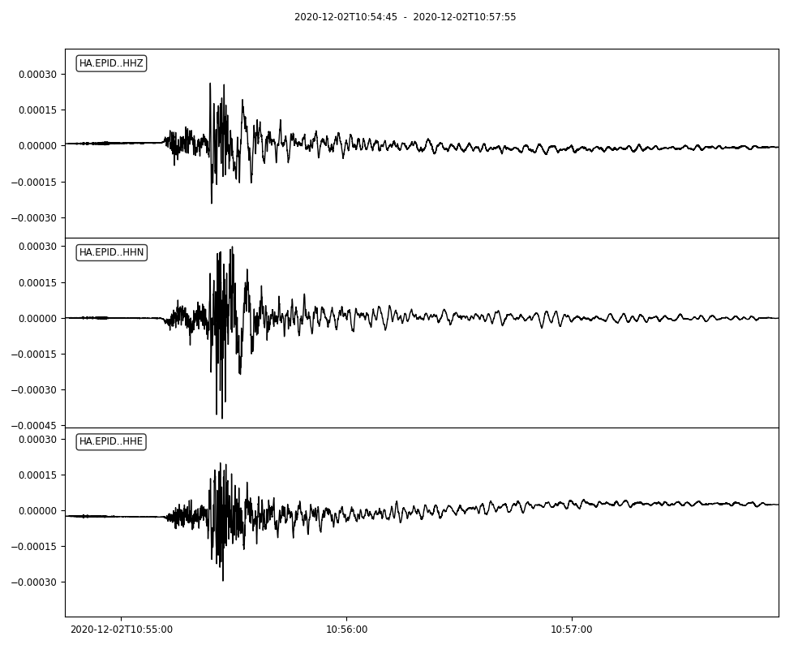

Fig. S6 Three component waveforms in m/s recorded at station KALE belonging to the Hellenic Seismological Network (HUSN), University of Athens, Seismological Laboratory (HA) located at about 92 km west from the earthquake’s epicenter.

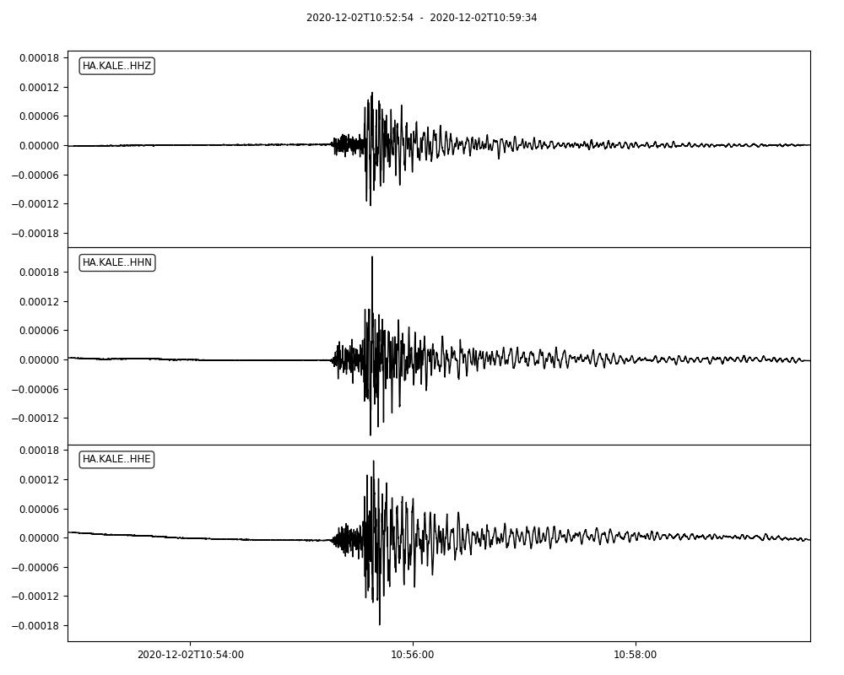

Fig. S7 Three component waveforms in m/s recorded at station KYMI belonging to the Hellenic Seismological Network (HUSN), National Observatory of Athens (HL) located at about 65 km east from the earthquake’s epicenter.
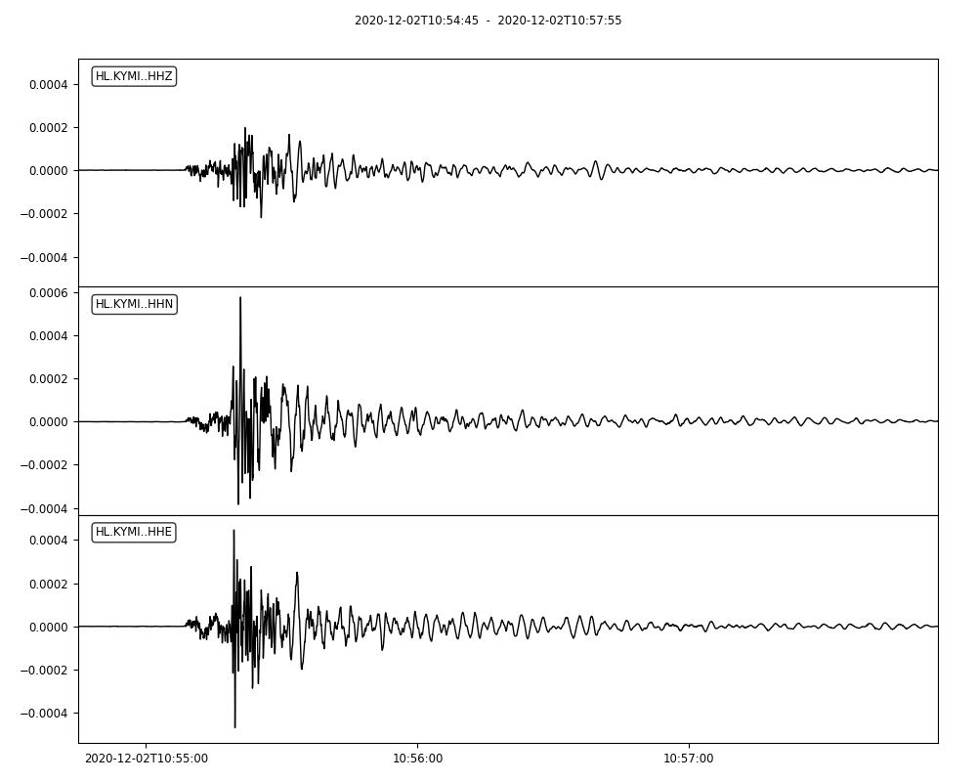

Fig. S8 Three component accelerograms in m/s² recorded at station NOAC belonging to the Hellenic Seismological Network (HUSN), National Observatory of Athens (HL) located at about 45 km south from the earthquake’s epicenter.

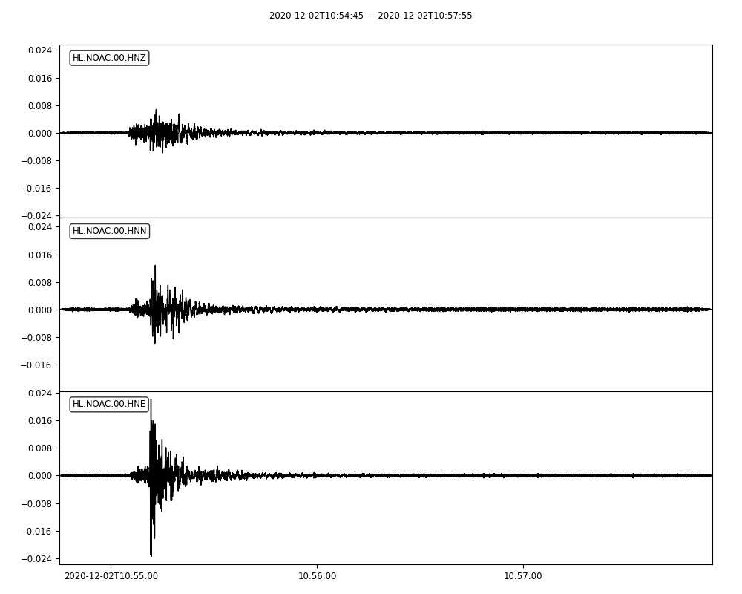

Fig. S9. NNE-SSW cross-section at a high-angle to the Asopos rift showing main fault planes accommodating crustal extension. The solid lines depict normal fault planes dipping 60° while the dashed lines with 50°, respectively. The profile line is shown in black on the map (right panel).

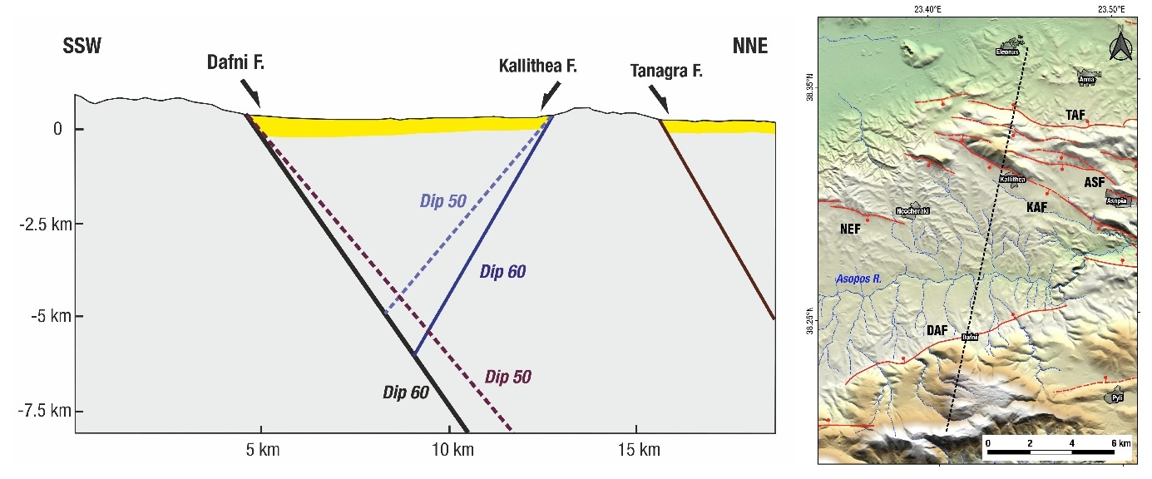

Fig. S10 Results of the linear modelling obtained by fixing the fault geometric parameters to coincide with those of the Kallithea fault (see table S1): (left) Modelled slip distribution over the known Kallithea fault plane for the 60-degree dipping case. Right) Observed data (left), modelled (center) and residuals (right) with respect to the InSAR data; it is evident that, with this fixed geometry, the 60-degree fault model is unable to fit the data well (compare with Fig. 7).

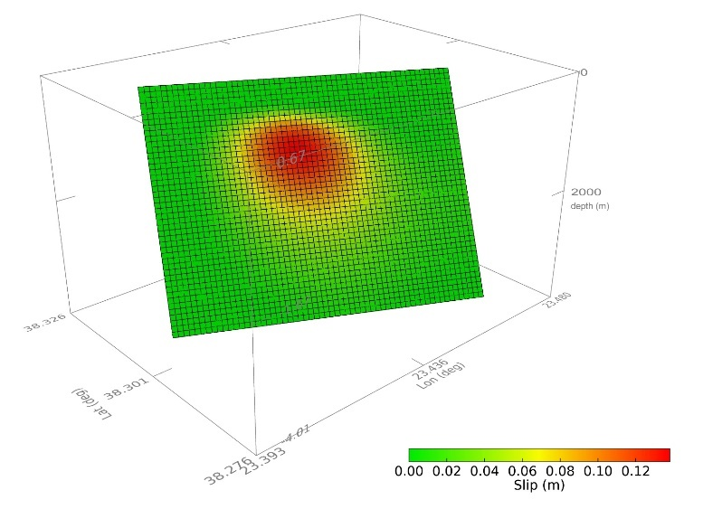
(a)

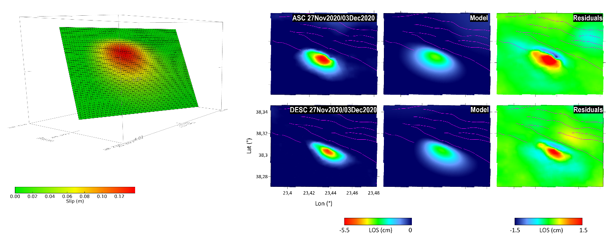

Table S1. List of fixed fault parameters used for performing the linear modelling of the slip distribution over the known Kallithea fault for a 60° dipping scenario (see Fig. S10 for results) ; note that depth of -320 m means that the modelled fault plane reaches the surface however, the effective modelled slipped area is the one depicted in Fig. S10 (a and b). Note that the fault top in this model coincides with location F in Fig. 10.

Center of the Top fault LON [deg] | 23.441165
Center of the Top fault LAT [deg] | 38.312228
Azimuth - strike [deg] | 114.0
Depth of Top fault edge [m] | -320.0, (reaching the surface)
Rake [deg] | -90.00
Dip [deg] | 60.00
Depth of the max slip [m] | 1137.0
Maximum slip [m] | 0.138

