Supporting information
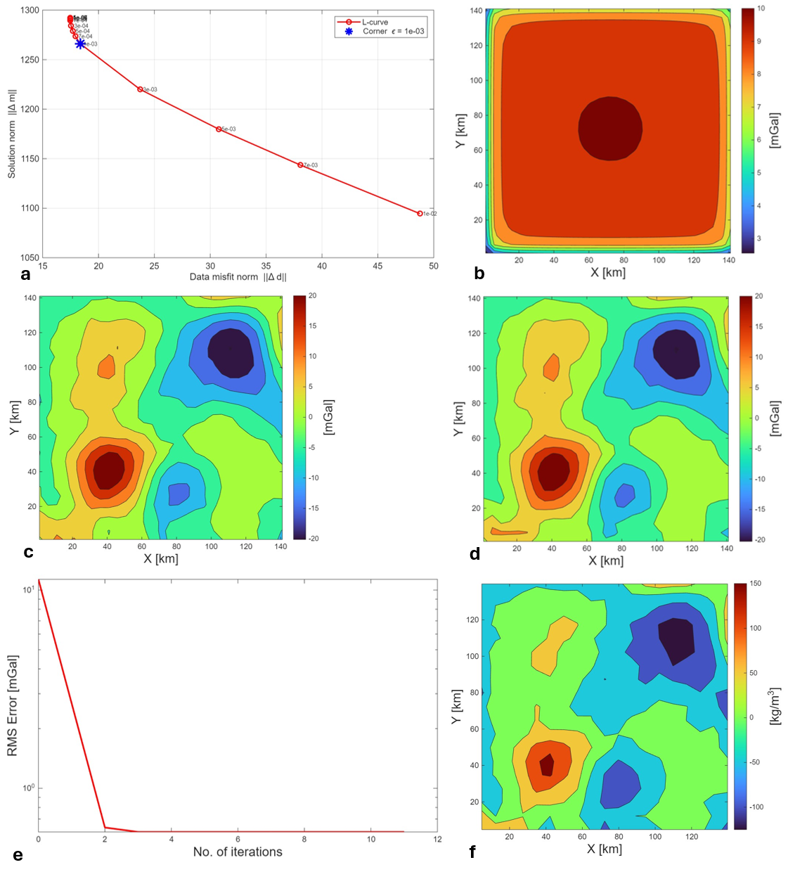
Fig. S1. Inversion results using GLSQ method (a) L-curve analysis, (b) Data calculated on initial model (spatially constant model), (c) Measured data, (d) Data calculated after inversion, (e) Data misfit, and (f) Inverted model.

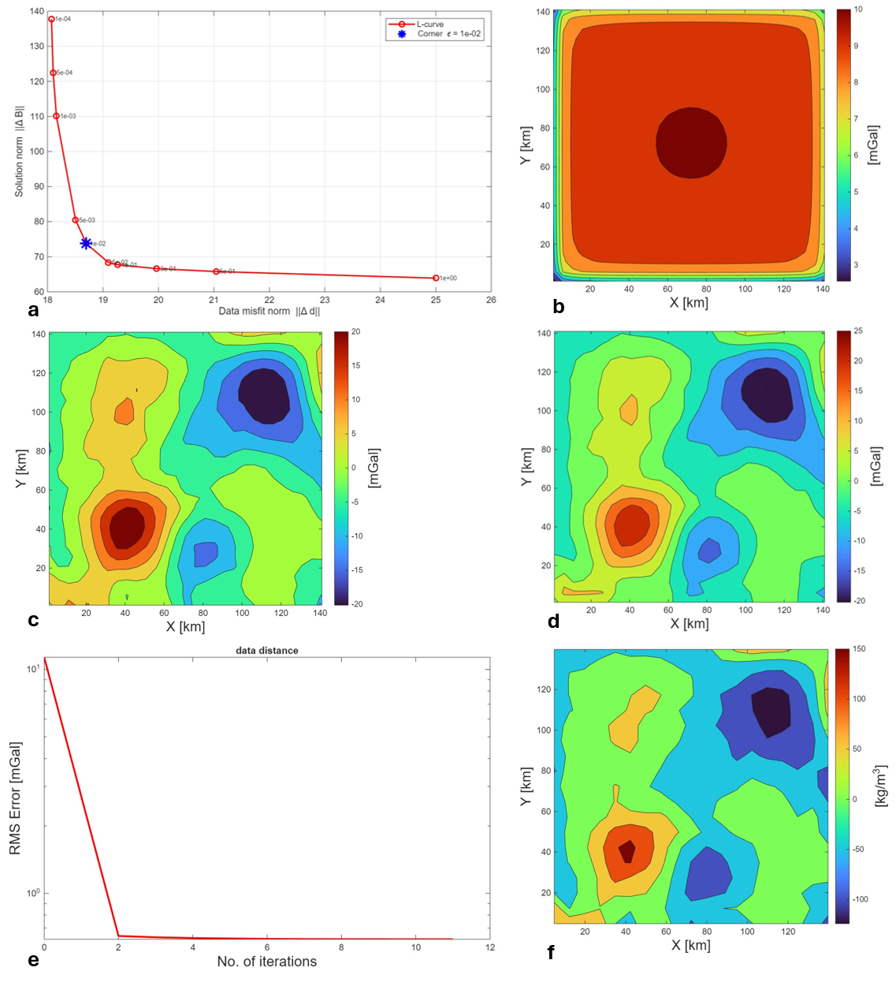
Fig. S2. Inversion results using SEb-GLSQ method (a) L-curve analysis, (b) Data calculated on initial model (spatially constant model), (c) Measured data, (d) Data calculated after inversion, (e) Data misfit, and (f) Inverted model.

