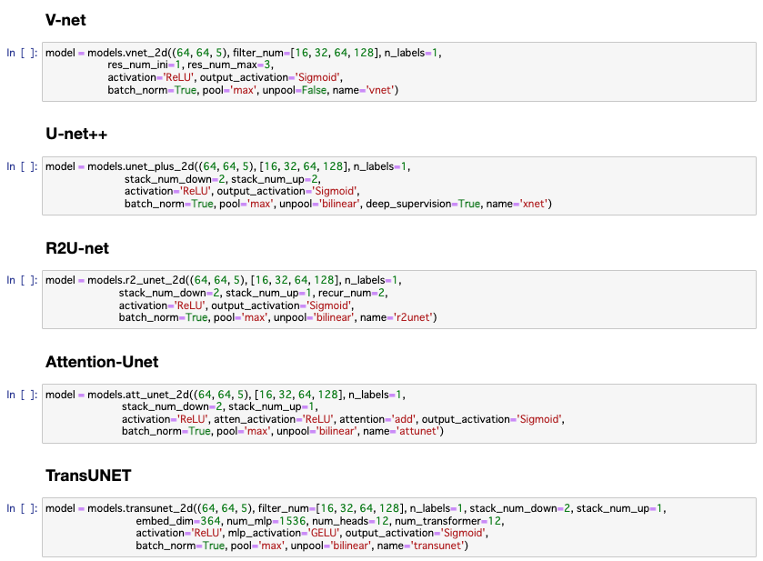
Supplementary Figure S1: Hyper-parameter configurations for all comparison deep-learning models.

