Journal name: Japanese Journal of Radiology

Title: Correlation of Tumor Maximum Standardized Uptake Value from ¹⁸F-BPA PET and Boron Neutron Capture Therapy Tumor Dose with Treatment Outcomes in Head and Neck Cancer: A Retrospective Analysis

Yuki Yoshino ^{a,b,c*}, Satoshi Takeno ^{a,b}, Teruhito Aihara ^{a,d}, Kayako Isohashi ^{e}, Naonori Hu ^{a,f}, Yasukazu Kanai ^{a,g}, Akinori Sasaki ª, Mai Nojiri ª, Tetsuya Terada ^{d}, Shinichi Haginomori ^{d}, Keiji Nihei ^{a,b}, Koji Ono ^{a,g}

ª Kansai BNCT Medical Center, Osaka Medical and Pharmaceutical University, Osaka, Japan
^{b} Department of Radiation Oncology, Osaka Medical and Pharmaceutical University, Osaka, Japan
^{c} Department of Radiology, Kyoto Prefectural University of Medicine, Kyoto, Japan
^{d} Department of Otorhinolaryngology – Head and Neck Surgery, Osaka Medical and Pharmaceutical University, Osaka, Japan
^{e} Department of Radiology, Graduate School of Medicine, The University of Osaka, Osaka, Japan
^{f} Institute for Integrated Radiation and Nuclear Science, Kyoto University, Kyoto, Japan
^{g} BNCT Joint Clinical Institute, Osaka Medical and Pharmaceutical University, Osaka, Japan

*Corresponding Author:
Email: yuki.yoshino@ompu.ac.jp

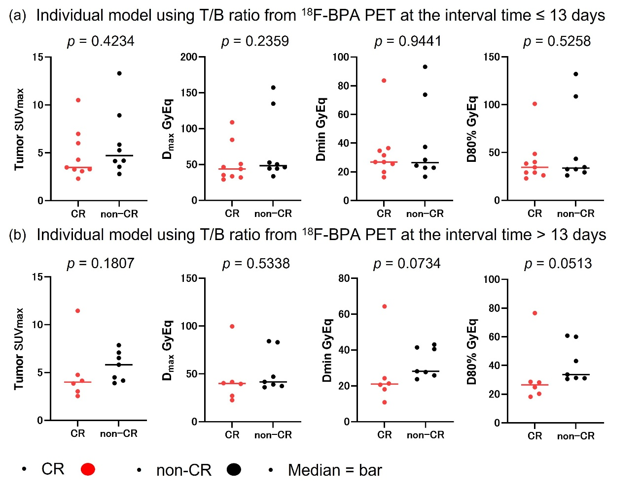
Online Resource 1. Comparison between the CR and non-CR groups using a two-sided Mann–Whitney U test (individual model). The interval time refers to the number of days between ¹⁸F-BPA and BNCT. (a) Comparison of tumor SUVmax, Dmin, Dmax, and D80% for duration time ≤ 13 days. (b) Comparison of tumor SUVmax, Dmin, Dmax, and D80% for interval time > 13 days.
Abbreviations: CR = complete response; Dmax = the maximum dose of the tumor; Dmin = the minimum dose of the tumor; D_{80%} = dose received by 80% of the tumor volume; SUVmax = maximum standardized uptake value.

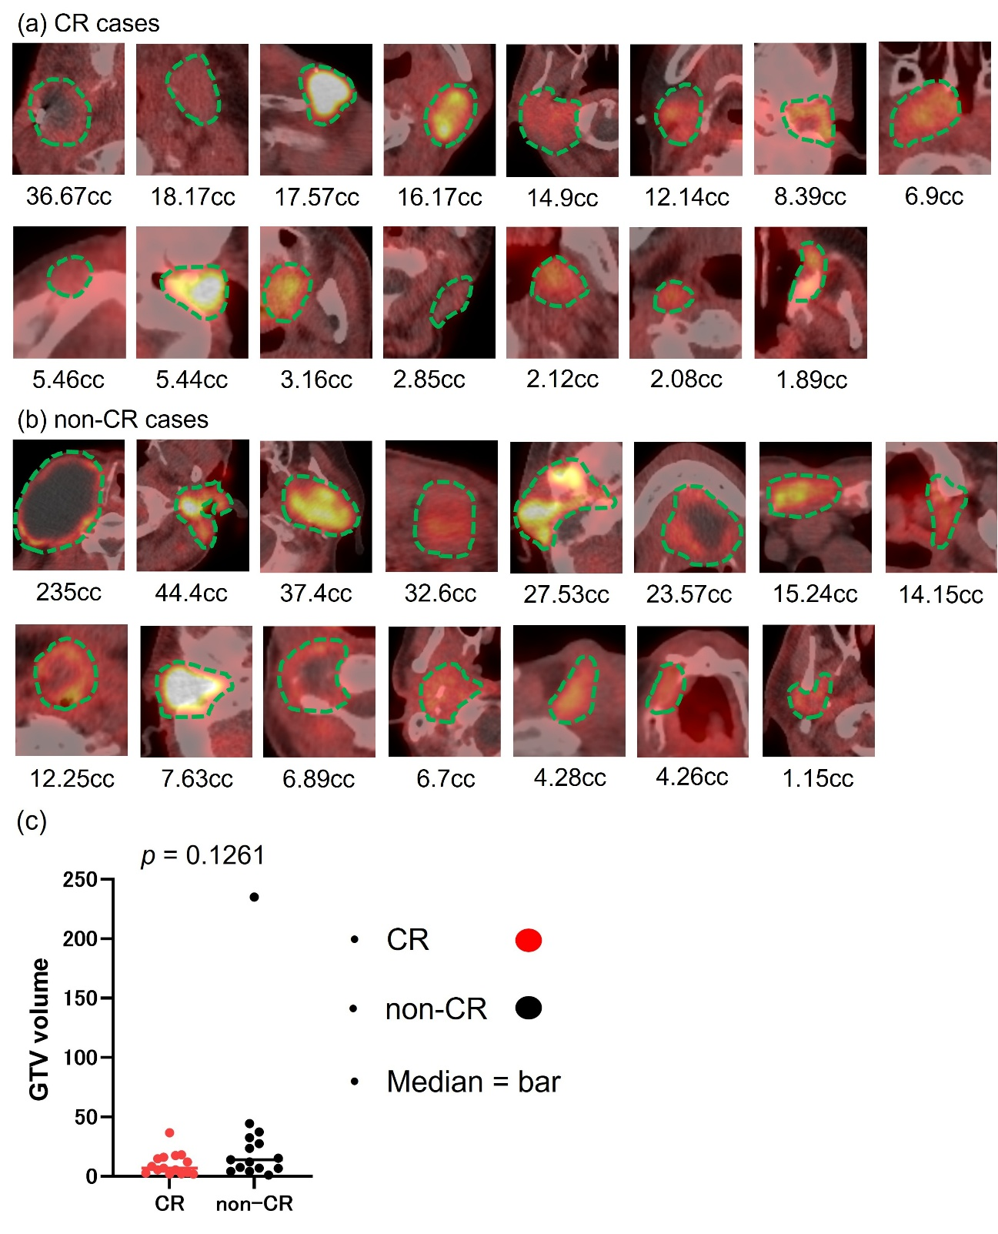Online Resource 2. Tumor images of ¹⁸F-BPA PET/CT before BNCT with GTV volumes. The area outlined in green indicates the tumor. The higher the brightness, the more ¹⁸F-BPA accumulates. (a) All CR cases. (b) All non-CR cases. (c) Comparison of GTV volumes between the CR group and non-CR group using a two-sided Mann–Whitney U test.
Abbreviations: ¹⁸F-BPA PET/CT = fluorine-18-labeled 4-borono-L-phenylalanine positron emission tomography/computed tomography; CR = complete response; GTV = gross tumor volume; BNCT = boron neutron capture therapy.

