Supplementary Table S1. Diagnostic performance of combinations of bone marrow hyperattenuation and other CT findings for fracture detection in the cortical disruption–negative group
 | Reader 1 | Reader 2 | Reader 3 | Median
BMH or soft tissue hematoma (n = 57)
Sensitivity | 90.5 (69.6–98.8) | 95.2 (76.2–99.9) | 100 (83.9–100) | 95.2
Specificity | 77.8 (60.8–89.9) | 86.1 (70.5–95.3) | 61.1 (43.5–76.9) | 77.8
PPV | 70.4 (49.8–86.2) | 80.0 (59.3–93.2) | 60.0 (42.1–76.1) | 70.4
NPV | 93.3 (77.9–99.2) | 96.9 (83.8–99.9) | 100 (84.6–100) | 96.9
Accuracy | 82.5 (70.1–91.3) | 89.5 (78.5–96.0) | 75.4 (62.2–85.9) | 82.5
BMH or CT capsular sign (n = 52)*
Sensitivity | 100 (82.4–100) | 100 (82.4–100) | 100 (82.4–100) | 100
Specificity | 75.8 (57.7–88.9) | 78.8 (61.1–91.0) | 72.7 (54.5–86.7) | 75.8
PPV | 70.4 (49.8–86.2) | 73.1 (52.2–88.4) | 67.9 (47.6–84.1) | 70.4
NPV | 100 (86.3–100) | 100 (86.8–100) | 100 (85.8–100) | 100
Accuracy | 84.6 (71.9–93.1) | 86.5 (74.2–94.4) | 82.7 (69.7–91.8) | 84.6
BMH or lipohemarthrosis (n = 57)
Sensitivity | 90.5 (69.6–98.8) | 95.2 (76.2–99.9) | 95.2 (76.2–99.9) | 95.2
Specificity | 97.2 (85.5–99.9) | 80.6 (64.0–91.8) | 97.2 (85.5–99.9) | 97.2
PPV | 95.0 (75.1–99.9) | 74.1 (53.7–88.9) | 95.2 (76.2–99.9) | 95.0
NPV | 94.6 (81.8–99.3) | 96.7 (82.8–99.9) | 97.2 (85.5–99.9) | 96.7
Accuracy | 94.7 (85.4–98.9) | 86.0 (74.2–93.7) | 96.5 (87.9–99.6) | 94.7
BMH or any other CT finding (n = 52)*†
Sensitivity | 100 (82.4–100) | 100 (82.4–100) | 100 (82.4–100) | 100
Specificity | 72.7 (54.5–86.7) | 63.6 (45.1–79.6) | 54.5 (36.4–71.9) | 63.6
PPV | 67.9 (47.6–84.1) | 61.3 (42.2–78.2) | 55.9 (37.9–72.8) | 61.3
NPV | 100 (85.8–100) | 100 (83.9–100) | 100 (81.5–100) | 100
Accuracy | 82.7 (69.7–91.8) | 76.9 (63.2–87.5) | 71.2 (56.9–82.9) | 76.9
BMH and soft tissue hematoma (n = 57)
Sensitivity | 42.9 (21.8–66.0) | 71.4 (47.8–88.7) | 66.7 (43.0–85.4) | 66.7
Specificity | 100 (90.3–100) | 100 (90.3–100) | 100 (90.3–100) | 100
PPV | 100 (66.4–100) | 100 (78.2–100) | 100 (76.8–100) | 100
NPV | 75.0 (60.4–86.4) | 85.7 (71.5–94.6) | 83.7 (69.3–93.2) | 83.7
Accuracy | 78.9 (66.1–88.6) | 89.5 (78.5–96.0) | 87.7 (76.3–94.9) | 87.7
BMH and CT capsular sign (n = 52)*
Sensitivity | 42.1 (20.3–66.5) | 36.8 (16.3–61.6) | 47.4 (24.4–71.1) | 42.1
Specificity | 97.0 (84.2–99.9) | 100 (89.4–100) | 100 (89.4–100) | 100
PPV | 88.9 (51.8–99.7) | 100 (59.0–100) | 100 (66.4–100) | 100
NPV | 74.4 (58.8–86.5) | 73.3 (58.1–85.4) | 76.7 (61.4–88.2) | 74.4
Accuracy | 76.9 (63.2–87.5) | 76.9 (63.2–87.5) | 80.8 (67.5–90.4) | 76.9
BMH and lipohemarthrosis (n = 57)
Sensitivity | 9.5 (1.2–30.4) | 9.5 (1.2–30.4) | 9.5 (1.2–30.4) | 9.5
Specificity | 100 (90.3–100) | 100 (90.3–100) | 100 (90.3–100) | 100
PPV | 100 (15.8–100) | 100 (15.8–100) | 100 (15.8–100) | 100
NPV | 65.5 (51.4–77.8) | 65.5 (51.4–77.8) | 65.5 (51.4–77.8) | 65.5
Accuracy | 66.7 (52.9–78.6) | 66.7 (52.9–78.6) | 66.7 (52.9–78.6) | 66.7
BMH, soft tissue hematoma, and CT capsular sign (n = 52)*
Sensitivity | 26.3 (9.1–51.2) | 31.6 (12.6–56.6) | 36.8 (16.3–61.6) | 31.6
Specificity | 100 (89.4–100) | 100 (89.4–100) | 100 (89.4–100) | 100
PPV | 100 (47.8–100) | 100 (54.1–100) | 100 (59.0–100) | 100
NPV | 70.2 (55.1–82.7) | 71.7 (56.5–84.0) | 73.3 (58.1–85.4) | 71.7
Accuracy | 73.1 (59.0–84.4) | 75.0 (61.1–86.0) | 76.9 (63.2–87.5) | 75.0
BMH, soft tissue hematoma, and lipohemarthrosis (n = 57)
Sensitivity | 4.8 (0.1–23.8) | 4.8 (0.1–23.8) | 4.8 (0.1–23.8) | 4.8
Specificity | 100 (90.3–100) | 100 (90.3–100) | 100 (90.3–100) | 100
PPV | 100 (2.5–100) | 100 (2.5–100) | 100 (2.5–100) | 100
NPV | 64.3 (50.4–76.6) | 64.3 (50.4–76.6) | 64.3 (50.4–76.6) | 64.3
Accuracy | 64.9 (51.1–77.1) | 64.9 (51.1–77.1) | 64.9 (51.1–77.1) | 64.9
BMH, CT capsular sign, and lipohemarthrosis (n = 52)*
Sensitivity | 10.5 (1.3–33.1) | 10.5 (1.3–33.1) | 10.5 (1.3–33.1) | 10.5
Specificity | 100 (89.4–100) | 100 (89.4–100) | 100 (89.4–100) | 100
PPV | 100 (15.8–100) | 100 (15.8–100) | 100 (15.8–100) | 100
NPV | 66.0 (51.2–78.8) | 66.0 (51.2–78.8) | 66.0 (51.2–78.8) | 66.0
Accuracy | 67.3 (52.9–79.7) | 67.3 (52.9–79.7) | 67.3 (52.9–79.7) | 67.3
BMH, soft tissue hematoma, CT capsular sign, and lipohemarthrosis (n = 52)*
Sensitivity | 5.3 (0.1–26.0) | 5.3 (0.1–26.0) | 5.3 (0.1–26.0) | 5.3
Specificity | 100 (89.4–100) | 100 (89.4–100) | 100 (89.4–100) | 100
PPV | 100 (2.5–100) | 100 (2.5–100) | 100 (2.5–100) | 100
NPV | 64.7 (50.1–77.6) | 64.7 (50.1–77.6) | 64.7 (50.1–77.6) | 64.7
Accuracy | 65.4 (50.9–78.0) | 65.4 (50.9–78.0) | 65.4 (50.9–78.0) | 65.4
BMH and any other CT finding (n = 52)*‡
Sensitivity | 63.2 (38.4–83.7) | 78.9 (54.4–93.9) | 78.9 (54.4–93.9) | 78.9
Specificity | 97.0 (84.2–99.9) | 100 (89.4–100) | 100 (89.4–100) | 100
PPV | 92.3 (64.0–99.8) | 100 (78.2–100) | 100 (78.2–100) | 100
NPV | 82.1 (66.5–92.5) | 89.2 (74.6–97.0) | 89.2 (74.6–97.0) | 89.2
Accuracy | 84.6 (71.9–93.1) | 92.3 (81.5–97.9) | 92.3 (81.5–97.9) | 92.3
BMH = bone marrow hyperattenuation, NPV = negative predictive value, PPV = positive predictive value.
Data are presented as percentage (95% confidence interval), calculated using the Clopper–Pearson exact method.
*For combinations including the CT capsular sign, patients in whom the contralateral hip joint capsule could not be evaluated were excluded.
† “BMH or any other CT finding” was considered positive when BMH or any of the following findings was positive: soft tissue hematoma, the CT capsular sign, or lipohemarthrosis.
‡ “BMH and any other CT finding” was considered positive when both BMH and at least one of the following findings was positive: soft tissue hematoma, the CT capsular sign, or lipohemarthrosis.

Supplementary Fig. S1 Example of false-negative bone marrow hyperattenuation assessment in the cortical disruption–negative group.
(a) Initial coronal CT image of the symptomatic right femur obtained 2 days after the injury shows no definite cortical disruption. A subtle area of increased attenuation can be seen within the femoral neck marrow (white arrow), but the finding is equivocal, and all three readers interpreted this case as bone marrow hyperattenuation–negative.
(b) Coronal CT image of the contralateral femur is shown for comparison.
(c) Follow-up coronal CT image obtained 5 days later shows a displaced right femoral neck fracture (black arrow).

Supplementary Fig. S2 Example of false-positive assessment of intertrochanteric extension in a suspected isolated greater trochanter fracture.
(a) Coronal CT image shows a fracture of the greater trochanter (black arrow) and an apparent area of increased attenuation extending from the fracture site into the intertrochanteric region (white arrow). The apparent hyperattenuation reaches the calcar femorale (arrowhead). The contralateral femur could not be used for comparison because of an implant (not shown).
(b) Coronal T1-weighted MRI shows a hypointense fracture line with surrounding bone marrow edema confined to <50% of the intertrochanteric line (white arrow).

Supplementary Fig. S1 Example of false-negative bone marrow hyperattenuation assessment in the cortical disruption–negative group.
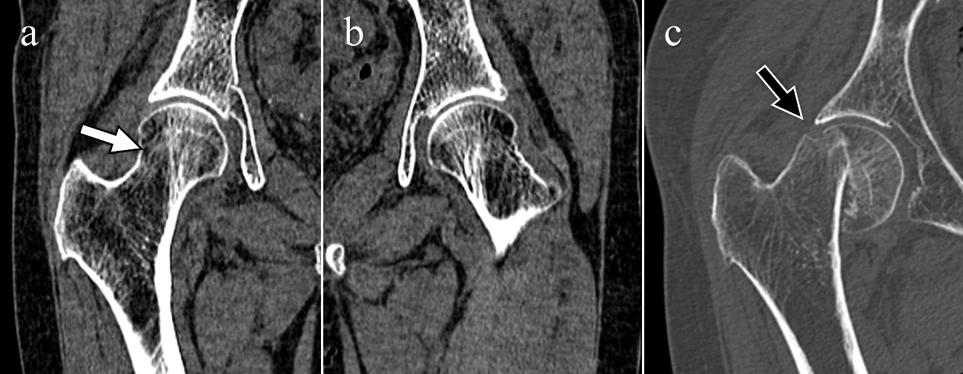

Supplementary Fig. S2 Example of false-positive assessment of intertrochanteric extension in a suspected isolated greater trochanter fracture.
