Supplementary Figure 1. Rebleeding Rates Across the Included Studies

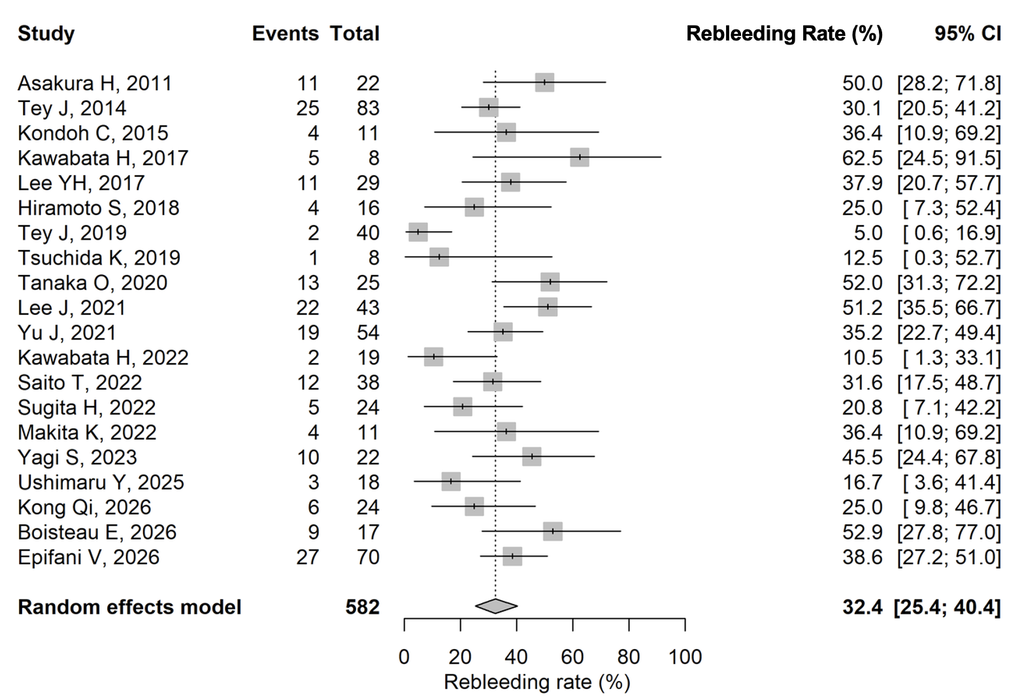Forest plot of rebleeding rates across the included studies. Each square represents the estimated rebleeding rate for an individual study, with a size proportional to the study weight. The horizontal lines indicate 95% confidence intervals. The pooled estimate was calculated using a random-effects model. The pooled rebleeding rate was 32.4%.

