Supplementary figure 1. The association between Clavien-Dindo classification and disease-free survival

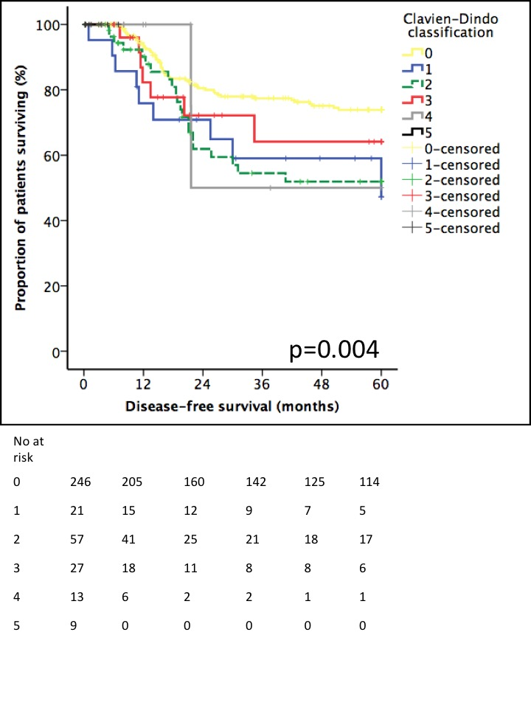

Supplementary figure 2. The association between Clavien-Dindo classification and overall survival

