Supplementary Figure 1. Proportion meta-analysis of the prevalence of low health literacy in EU Member States by self-reported comprehension items.

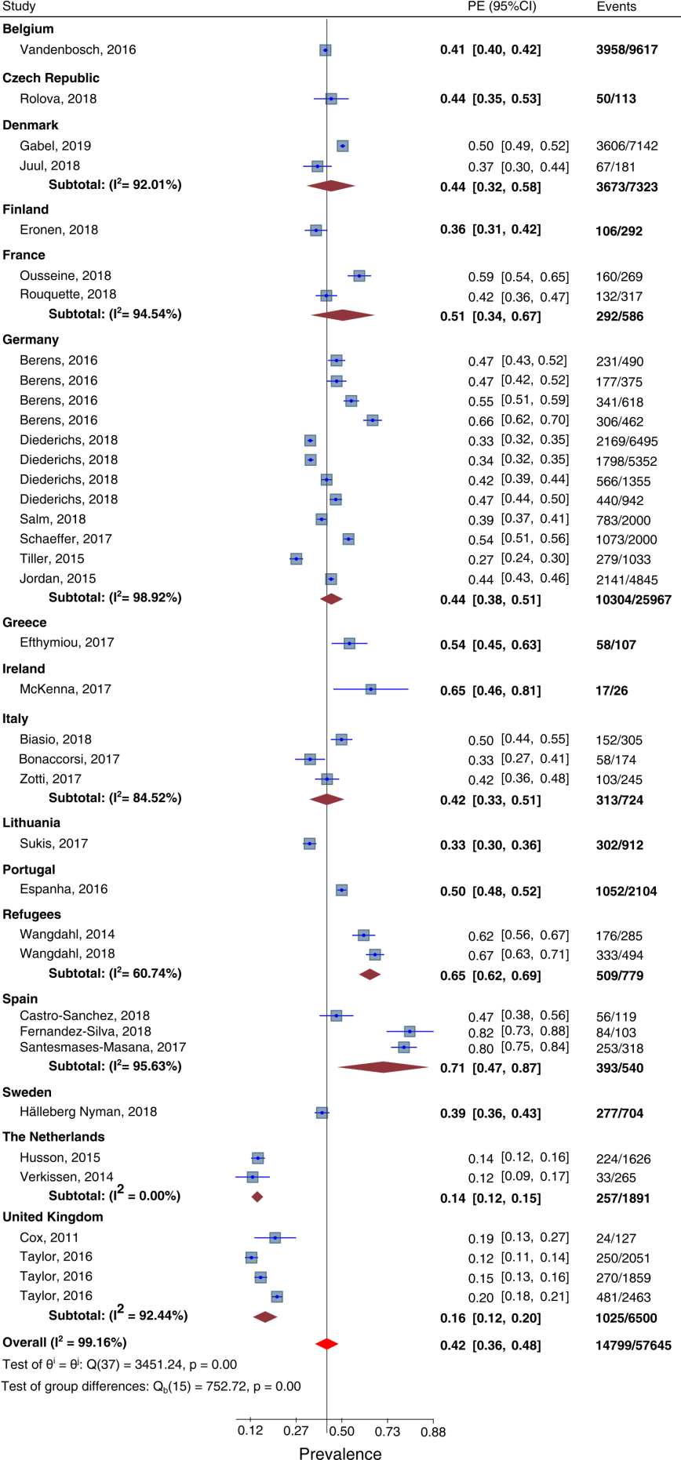

Supplementary Figure 2. Proportion meta-analysis of the prevalence of low health literacy in EU Member States by reading or numeracy comprehension items.

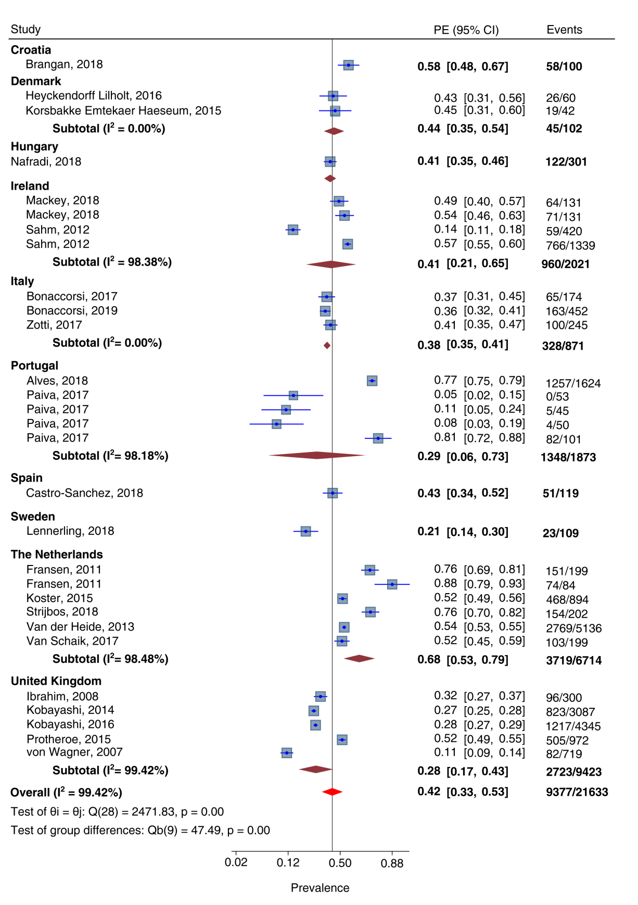

Supplementary Figure 3. Proportion meta-analysis of the prevalence of low health literacy in EU Member States by word recognition items.

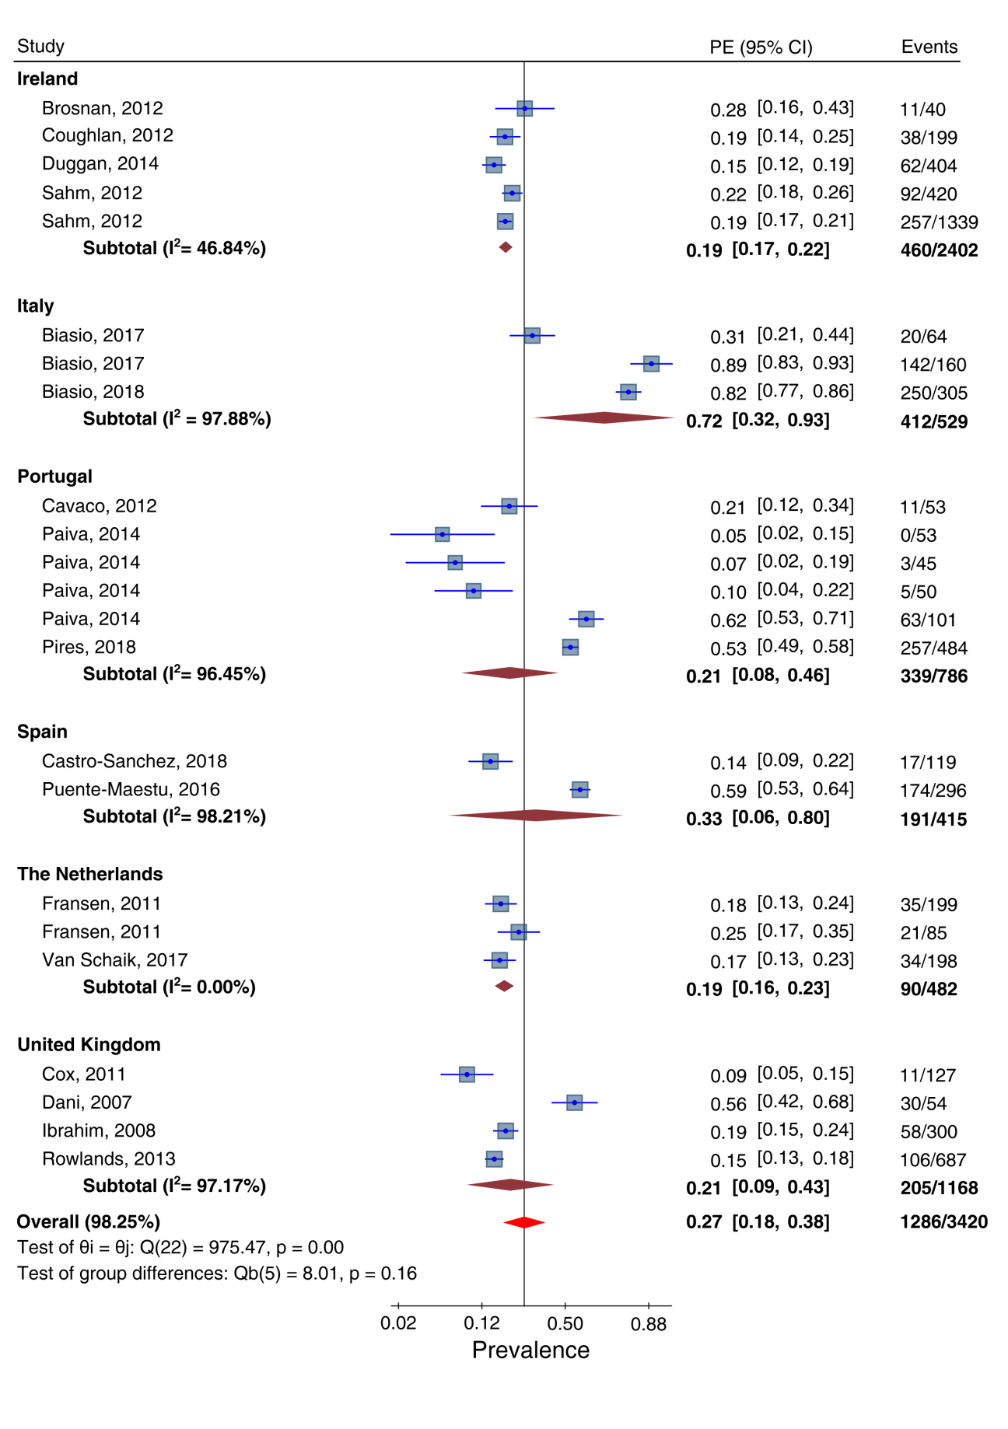

Supplementary Figure 4. Proportion meta-analysis of the prevalence of low health literacy in EU Member States by mixed method.

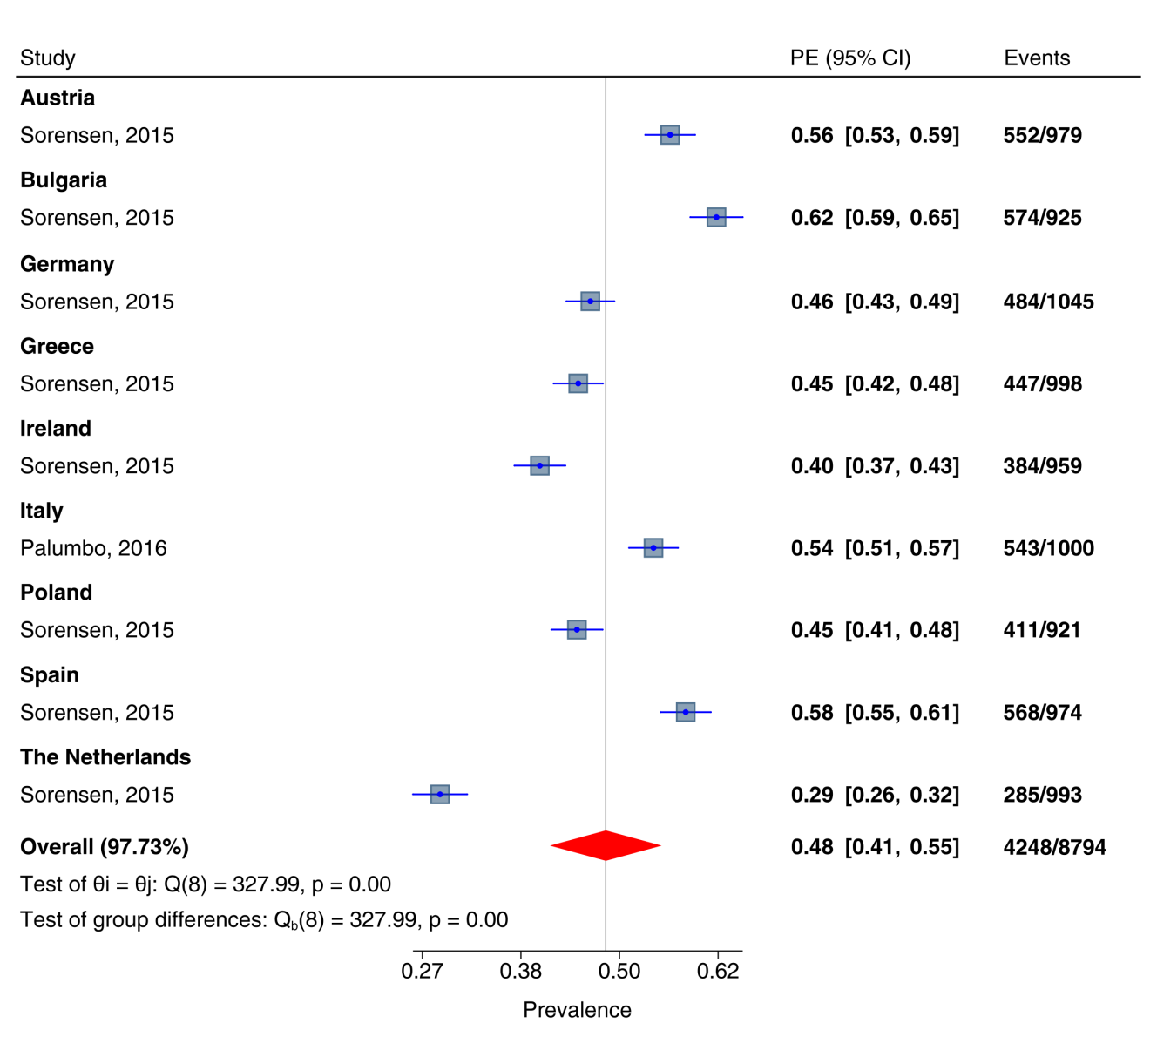

Appendices

Supplementary Table 1. Search strategies used in the systematic review.

(“health literacy”[Title/Abstract]) AND (((evaluat*[Title/Abstract]) OR measure*[Title/Abstract]) OR assess*[Title/Abstract])  Filter: Publication date from 2000/01/01 | PubMed
health:ab AND literacy:ab AND (evaluat*:ab OR measure*:ab OR assess*:ab) AND [embase]/lim AND [2000-2019]/py | Embase
(“health literacy”) AND (((evaluat*) OR measure*) OR assess*) for title/abstract/keywords  Limit: after 2000 | Scopus

Supplementary Table 2. Cut-off scores, number of items and characteristics of the health literacy tools that were applied to estimate the prevalence of low health literacy (HL).

Tool | Cut-off score for low HL | N. of items | Characteristics of the tool
BSAIT | ≤ 64/72 | 72 | 72 reading comprehension items
HALS | ≤ 275/500 | 191 | 191 health-related literacy tasks
HLS-EU-Q16 | ≤ 33/50 or ≤ 12/16 | 16 | 16 comprehension items
HLS-EU-Q47 | ≤ 33/50 | 47 | 47 comprehension items
HLS-EU-Q86 | ≤ 33/50 | 86 | 47 comprehension items  7 literacy and numeracy items  16 social determinant items  16 lifestyle questions and self-reported questions on health services use
IALS tool | < 4/4 | 4 | 4 reading comprehension questions
METER | ≤ 34/40 | 70 | 40 reading comprehension medical terms
METER | ≤ 18/30 | 70 | 30 reading comprehension non-medical terms
NVS | ≤ 3/6 | 6 | 6 reading comprehension and numeracy items
REALM | ≤ 60/66 | 66 | 66 reading comprehension and pronunciation medical terms
S-FHL | answering sometimes, often, or always for one or more items | 5 | 5 items on functional skills
SAHLPA-23 | ≤ 19/23 | 23 | 23 reading comprehension medical terms
SAHLSA-50 | ≤ 37/50 | 50 | 50 reading comprehension medical terms
SBSQ single item | answering somewhat, a little, or not at all | 1 | answering to “how confident are you filling out medical forms by yourself?”
SILS | > 2 | 1 | answering to “how often do you need to have someone help when you read instructions, pamphlets, or other written material from your doctor or pharmacy?”
TOFHLA-short | ≤ 66/100 | 40 | 36 reading comprehension items  4 numeracy items
TOFHLA | ≤ 74/100 | 67 | 50 reading comprehension items  17 numeracy items
BSAIT: Basic Skill Assessment Initial Test. HALS: Health Activities Literacy Scale. HLS-EU-Q: European Health Literacy Survey Questionnaire. IALS: International Adult Literacy Survey. METER: Medical Term Recognition Test. NVS: Newest Vital Sign. REALM: Rapid Estimate of Adult Literacy in Medicine. S-FHL: Scale for Functional Health Literacy. SAHLPA: Short Assessment of Health Literacy in Portuguese Adults. SAHLSA: Short Assessment of Health Literacy for Spanish Adults. SBSQ: Set of Brief Screening Questions. SILS: Single Item Literacy Screener. TOFHLA: Test of Functional Health Literacy in Adults.

Supplementary Table 3. Full list of articles included in the proportion meta-analysis quantifying the prevalence of low health literacy in European Union Member States.

First Author,  year | Country | Tool | Target population | Mean or median  age | Prevalence (n/N) | Quality assessment  (Newcastle Ottawa Scale)
 |  |  |  |  |  | S | C | O | Final score
Alves, 2018 | Portugal | NVS | General population |  | 1257/1624 | 5 | 2 | 3 | 10
Berens, 2016 | Germany | HLS-EU-Q47 | General population | 15-29 | 177/375 | 4 | 2 | 2 | 8
 |  |  |  | 30-45 | 231/490
 |  |  |  | 46-64 | 341/618
 |  |  |  | 65-99 | 306/462
Biasio, 2017 | Italy | METER | General population, medical students | 21.7 | 20/64 | 2 | 0 | 3 | 5
Biasio, 2017 | Italy | METER | General population,  non-medical students | 24.3 | 142/160
Biasio, 2018 | Italy | METER | General population | 53.9 | 250/305 | 4 | 0 | 2 | 6
Biasio, 2018 | Italy | SILS | General population | 53.9 | 152/305
Bonaccorsi, 2017 | Italy | SILS | General population | 51 | 58/174 | 4 | 2 | 3 | 9
Bonaccorsi, 2017 | Italy | NVS | General population | 51 | 65/174
Bonaccorsi, 2019 | Italy | NVS | General population | 53.3 | 163/452 | 4 | 2 | 3 | 9
Brangan, 2018 | Croatia | NVS | General population | 63.5 | 58/100 | 4 | 0 | 3 | 7
Brosnan, 2012 | Ireland | REALM | Chronic disease patients | 38 | 11/40 | 3 | 0 | 2 | 5
Castro-Sanchez, 2018 | Spain | NVS | General population | 32.3 | 51/119 | 5 | 2 | 3 | 10
Castro-Sanchez, 2018 | Spain | SAHLSA-50 | General population | 32.3 | 17/119
Castro-Sanchez, 2018 | Spain | SILS | General population | 32.3 | 56/119
Cavaco, 2012 | Portugal | SAHLSA-50 | General population | 51 | 11/53 | 2 | 0 | 2 | 4
Coughlan, 2012 | Ireland | REALM | General population | 61.5 | 38/199 | 4 | 0 | 3 | 7
Cox, 2011 | United Kingdom | SBSQ single item | Oncology patients | 64 | 24/127 | 5 | 0 | 2 | 7
Cox, 2011 | United Kingdom | REALM | Oncology patients | 64 | 11/127
Dani, 2007 | United Kingdom | REALM | General population | 67 | 30/54 | 5 | 0 | 2 | 7
Diederichs, 2018 | Germany | HLS-EU-Q16 | Chronic disease patients, males | 58.6 | 566/1355 | 4 | 2 | 2 | 8
Diederichs, 2018 | Germany | HLS-EU-Q16 | General population, males | 58.6 | 1798/5352
Diederichs, 2018 | Germany | HLS-EU-Q16 | General population, females | 60.1 | 2169/6495
Diederichs, 2018 | Germany | HLS-EU-Q16 | Chronic disease patients, females | 60.1 | 440/942
Duggan, 2014 | Ireland | REALM | General population | 31.2 | 62/404 | 5 | 2 | 3 | 10
Efthymiou, 2017 | Greece | HLS-EU-Q16 | General population |  | 58/107 | 4 | 0 | 1 | 5
Eronen, 2018 | Finland | HLS-EU-Q16 | General population | 75 | 106/292 | 4 | 2 | 2 | 8
Espanha, 2016 | Portugal | HLS-EU-Q47 | General population |  | 1052/2104 | 5 | 0 | 1 | 6
Fernandez-Silva, 2018 | Spain | HLS-EU-Q47 | Chronic disease patients | 65.4 | 84/103 | 4 | 2 | 2 | 8
Fransen, 2011 | The Netherlands | REALM | Chronic disease patients, diabetes type 2 | 59.7 | 21/85 | 4 | 0 | 2 | 6
Fransen, 2011 | The Netherlands | REALM | Chronic disease patients, coronary artery diseases | 59.7 | 35/199
Fransen, 2011 | The Netherlands | NVS | Chronic disease patients, coronary artery diseases | 59.7 | 151/199
Fransen, 2011 | The Netherlands | NVS | Chronic disease patients, diabetes type 2 | 59.7 | 74/84
Gabel, 2019 | Denmark | HLS-EU-Q16 | General population | 63.5 | 3606/7142 | 5 | 2 | 2 | 9
Halleberg Nyman, 2018 | Sweden | S-FHL | General population | 47 | 277/704 | 4 | 0 | 2 | 6
Heyckendorff Lilholt, 2016 | Denmark | TOFHLA | Chronic disease patients | 70.1 | 26/60 | 3 | 2 | 3 | 8
Husson, 2015 | The Netherlands | SBSQ single item | Oncology patients | 70 | 224/1626 | 5 | 2 | 2 | 9
Ibrahim, 2008 | United Kingdom | BSAIT | Chronic disease patients | 64 | 96/300 | 3 | 0 | 3 | 6
Ibrahim, 2008 | United Kingdom | REALM | Chronic disease patients | 64 | 58/58
Jordan, 2015 | Germany | HLS-EU-Q16 | General population |  | 2141/4845 | 4 | 2 | 2 | 8
Juul, 2018 | Denmark | HLS-EU-Q16 | Chronic disease patients | 64 | 67/181 | 3 | 2 | 2 | 7
Kobayashi, 2014 | United Kingdom | IALS | General population | 67.5 | 823/3087 | 4 | 2 | 3 | 9
Kobayashi, 2016 | United Kingdom | IALS | General population | 63.3 | 1217/4345 | 4 | 2 | 3 | 9
Korsbakke Emtekaer Haeseum, 2015 | Denmark | TOFHLA | Chronic disease patients | 68.7 | 19/42 | 4 | 0 | 2 | 6
Koster, 2015 | The Netherlands | NVS | General population | 56.3 | 468/894 | 4 | 2 | 3 | 9
Lennerling, 2018 | Sweden | NVS | Chronic disease patients | 53.5 | 23/109 | 4 | 0 | 3 | 7
Mackey, 2018 | Ireland | NVS | General population, chronic pain group | 48.5 | 71/131 | 5 | 2 | 3 | 10
Mackey, 2018 | Ireland | NVS | General population, control group | 49.8 | 64/131
McKenna, 2017 | Ireland | HLS-EU-Q47 | General population | 59 | 17/26 | 3 | 0 | 2 | 5
Nafradi, 2018 | Hungary | NVS | General population | 46.5 | 122/301 | 3 | 2 | 3 | 8
Ousseine, 2018 | France | SILS | Chronic disease patients | 70 | 160/269 | 4 | 2 | 2 | 8
Paiva, 2014 | Portugal | METER | General population, physicians | 32.3 | 0/53 | 4 | 2 | 3 | 9
Paiva, 2014 | Portugal | METER | General population, health researchers | 29.6 | 3/45
Paiva, 2014 | Portugal | METER | General population,  other researchers | 43.8 | 5/50
Paiva, 2014 | Portugal | METER | General population | 45.6 | 63/101
Paiva, 2017 | Portugal | NVS | General population, health researchers | 28 | 5/45 | 4 | 2 | 3 | 9
Paiva, 2017 | Portugal | NVS | General population,  other researchers | 48.5 | 4/50
Paiva, 2017 | Portugal | NVS | General population | 42 | 82/101
Paiva, 2017 | Portugal | NVS | General population, physicians | 30 | 0/53
Palumbo, 2016 | Italy | HLS-EU-Q86 | General population |  | 543/1000 | 5 | 1 | 3 | 9
Pires, 2018 | Portugal | SAHLSA-23 | General population | 38.7 | 257/484 | 4 | 2 | 3 | 9
Protheroe, 2015 | United Kingdom | NVS | General population | 48.7 | 505/972 | 4 | 2 | 3 | 9
Puente-Maestu, 2016 | Spain | SAHLSA-50 | Chronic disease patients | 68 | 174/296 | 4 | 2 | 3 | 9
Rolová, 2018 | Czech Republic | HLS-EU-Q47 | Chronic disease patients | 46.1 | 50/113 | 5 | 0 | 2 | 7
Rouquette, 2018 | France | HLS-EU-Q6 | General population | 53 | 234/ 317 | 3 | 0 | 2 | 5
Rouquette, 2018 | France | HLS-EU-Q16 | General population | 53 | 132/317
Rowlands, 2013 | United Kingdom | REALM | Chronic disease patients | 70 | 106/687 | 5 | 2 | 3 | 10
Sahm, 2012 | Ireland | REALM | General population,  from community and hospital |  | 257/1339 | 4 | 0 | 3 | 7
Sahm, 2012 | Ireland | TOFHLA-40 | General population,  from hospital |  | 59/420
Sahm, 2012 | Ireland | REALM | General population,  from hospital |  | 92/420
Sahm, 2012 | Ireland | NVS | General population,  from community and hospital |  | 766/1339
Salm, 2018 | Germany | HLS-EU-Q16 | General population | 59 | 783/2000 | 5 | 2 | 2 | 9
Santesmases-Masana, 2017 | Spain | HLS-EU-Q47 | Chronic disease patients | 77.9 | 253/318 | 4 | 2 | 2 | 8
Schaeffer, 2017 | Germany | HLS-EU-Q47 | General population |  | 1073/2000 | 4 | 2 | 2 | 8
Sorensen, 2015 | Austria | HLS-EU-Q86 | General population |  | 552/979 | 5 | 2 | 2 | 9
Sorensen, 2015 | Ireland | HLS-EU-Q86 | General population |  | 384/959
Sorensen, 2015 | Germany | HLS-EU-Q86 | General population |  | 484/1045
Sorensen, 2015 | The Netherlands | HLS-EU-Q86 | General population |  | 285/993
Sorensen, 2015 | Greece | HLS-EU-Q86 | General population |  | 447/998
Sorensen, 2015 | Poland | HLS-EU-Q86 | General population |  | 411/921
Sorensen, 2015 | Bulgaria | HLS-EU-Q86 | General population |  | 574/925
Sorensen, 2015 | Spain | HLS-EU-Q86 | General population |  | 568/974
Strijbos, 2018 | The Netherlands | NVS | Chronic disease patients | 69.9 | 154/202 | 4 | 2 | 3 | 9
Sukis, 2017 | Lithuania | HLS-EU-Q47 | General population | 25 | 302/912 | 4 | 2 | 2 | 8
Taylor, 2016 | United Kingdom | SILS | Chronic disease patients, kidney disease wait-listed | 50 | 270/1859 | 5 | 2 | 3 | 10
Taylor, 2016 | United Kingdom | SILS | Chronic disease patients, kidney disease incident dialysis | 58 | 481/2463
Taylor, 2016 | United Kingdom | SILS | Chronic disease patients, kidney disease incident transplant | 50 | 250/2051
Tiller, 2015 | Germany | HLS-EU-Q16 | General population | 69.9 | 279/1033 | 4 | 2 | 2 | 8
Van der Heide, 2013 | The Netherlands | HALS | General population | 46.7 | 2769/5136 | 4 | 2 | 2 | 8
Van Schaik, 2017 | The Netherlands | NVS | Chronic disease patients | 56 | 103/199 | 4 | 0 | 3 | 7
Van Schaik, 2017 | The Netherlands | REALM | Chronic disease patients | 56 | 34/198
Vandenbosch, 2016 | Belgium | HLS-EU-Q16 | General population | 55.8 | 3958/9617 | 5 | 2 | 2 | 9
Verkissen, 2014 | The Netherlands | SBSQ single item | Oncology patients | 62.8 | 33/265 | 4 | 2 | 2 | 8
Von Wagner, 2007 | United Kingdom | TOFHLA | General population | 47.6 | 82/719 | 5 | 2 | 3 | 10
Wangdahl, 2014 | Extra- EU Countries | HLS-EU-Q16 | Refugees |  | 176/285 | 3 | 2 | 2 | 7
Wangdahl, 2014 | Extra- EU Countries | S-FHL | Refugees |  | 316/396
Wangdahl, 2018 | Extra- EU Countries | HLS-EU-Q16 | Refugees |  | 333/494 | 3 | 2 | 2 | 7
Zotti, 2017 | Italy | NVS | Oncology patients | 54 | 100/245 | 4 | 0 | 3 | 7
Zotti, 2017 | Italy | SILS | Oncology patients | 54 | 103/245
S: Selection. C: Comparability. O: Outcome.
Tool (in alphabetic order). BSAIT: Basic skill Assessment Initial Test. HALS: Health Activities Literacy Scale. HLS-EU-Q: European Health Literacy Survey Questionnaire. IALS: International Adult Literacy Survey. METER: Medical Term Recognition Test. NVS: Newest Vital Sign. REALM: Rapid Estimate of Adult Literacy in Medicine. S-FHL: Scale for Functional Health Literacy. SAHLPA: Short Assessment of Health Literacy in Portuguese Adults. SAHLSA: Short Assessment of Health Literacy for Spanish Adults. SBSQ: Set of Brief Screening Questions. SILS: Single Item Literacy Screener TOFHLA: Test of Functional Health Literacy in Adults.

