APPENDIX

Appendix Figure 1. Trends in visits per FTE in cardiology, by randomization status

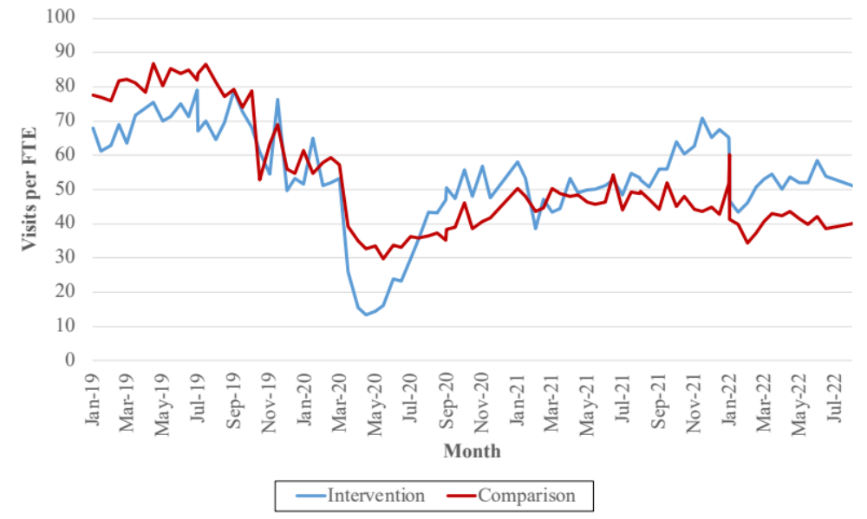

Appendix Figure 2. Trends in RVUs per FTE in cardiology, by randomization status

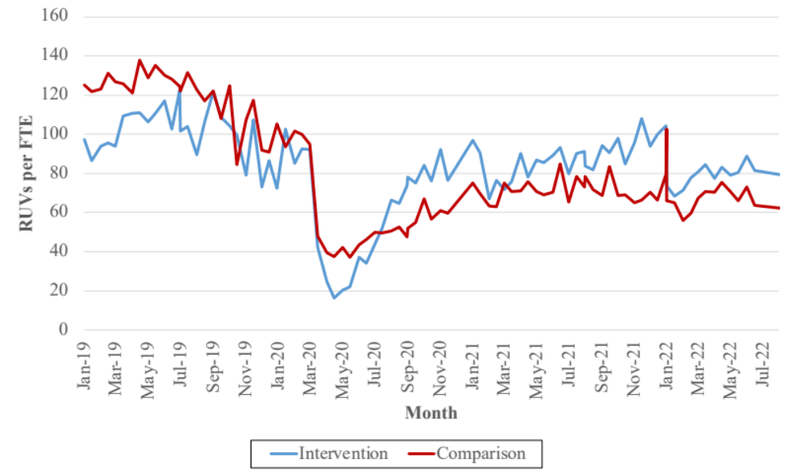
Appendix Figure 3. Trends in patients per day per provider in cardiology, by randomization status

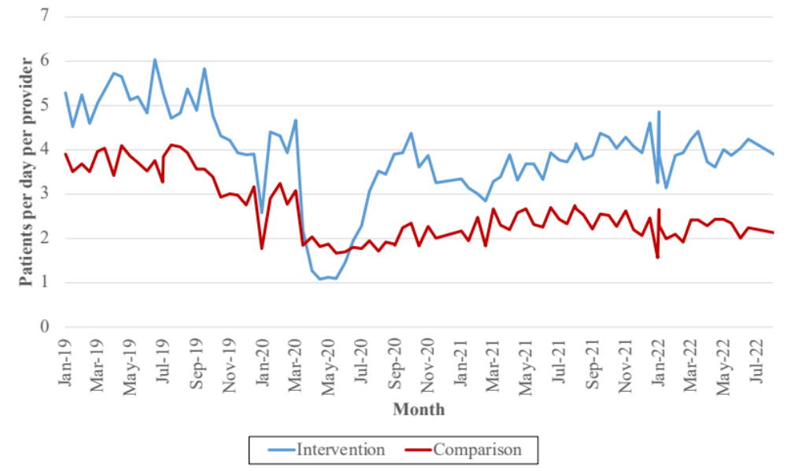

Appendix Figure 4. Trends in visits per FTE in orthopedics, by randomization status

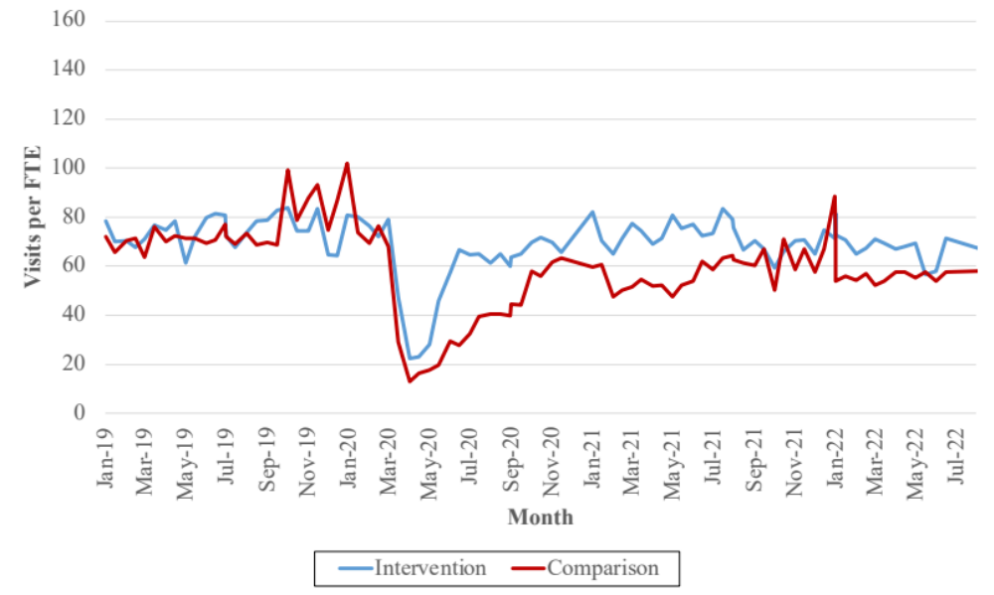
Appendix Figure 5. Trends in RVUs per FTE in orthopedics, by randomization status

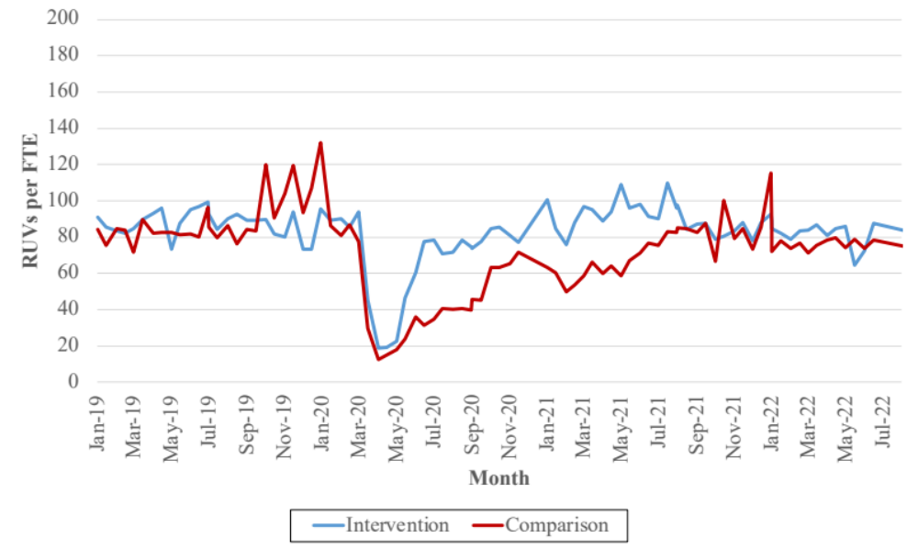

Appendix Figure 6. Trends in patients per day per provider in orthopedics, by randomization status

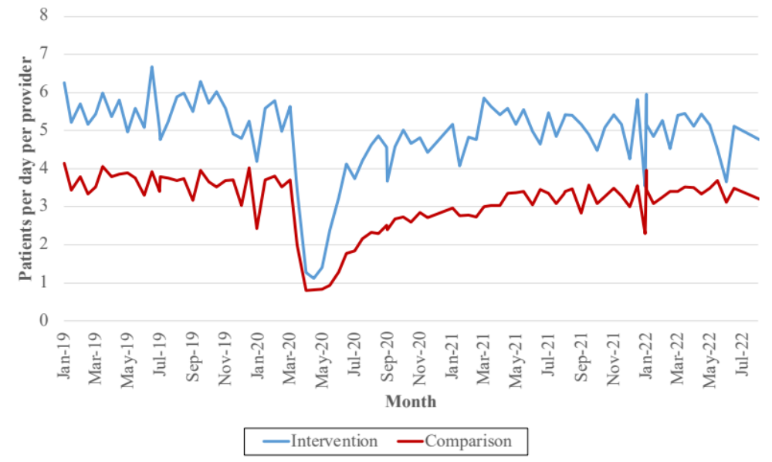
Appendix Figure 7. Trends in request to appointment day wait times in cardiology, by randomization status

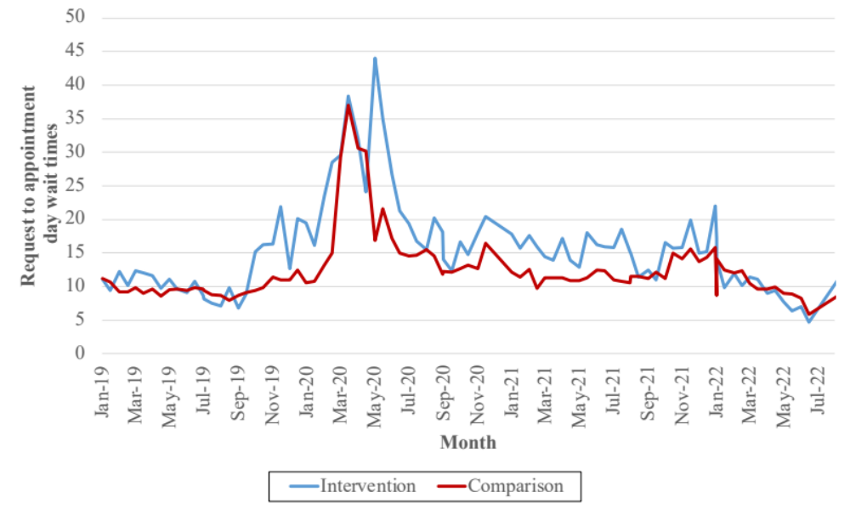

Appendix Figure 8. Trends in request to appointment made wait times in cardiology, by randomization status

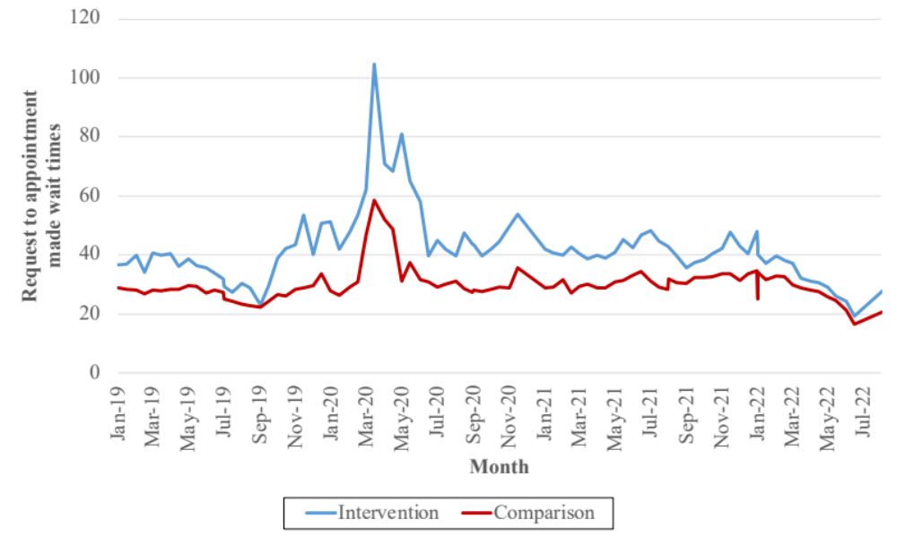
Appendix Figure 9. Trends in appointment made to appointment day wait times in cardiology, by randomization status

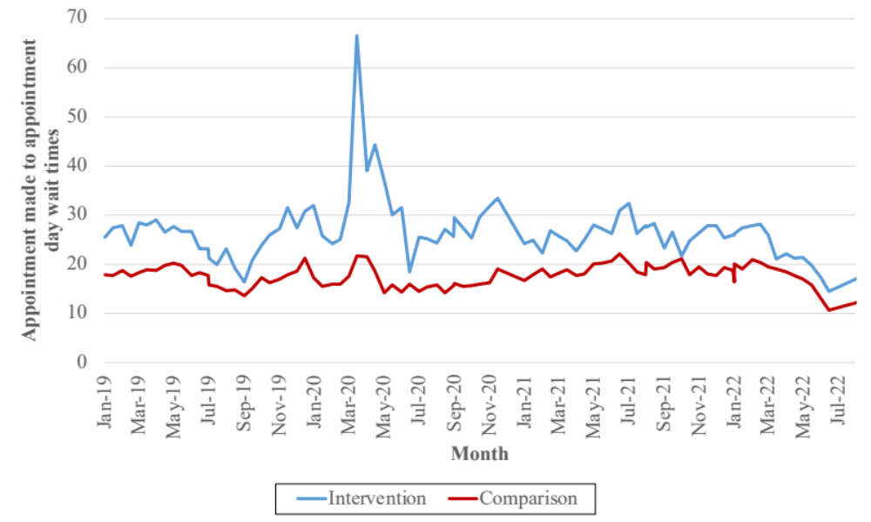

Appendix Figure 10. Trends in request to appointment day wait times in orthopedics, by randomization status

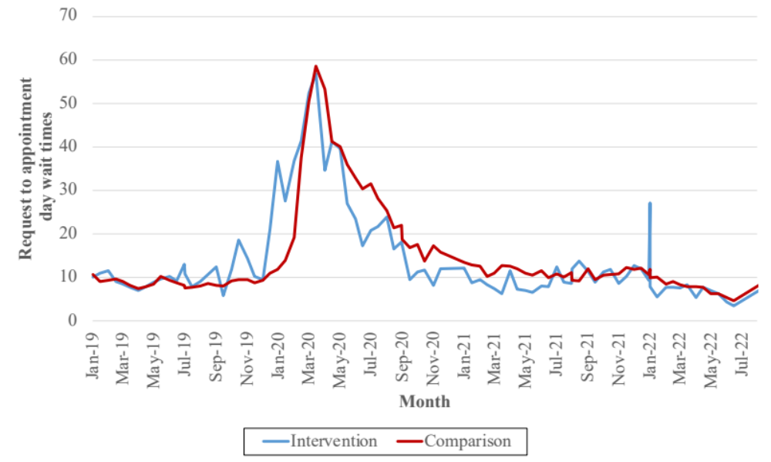
Appendix Figure 11. Trends in request to appointment made wait times in orthopedics, by randomization status

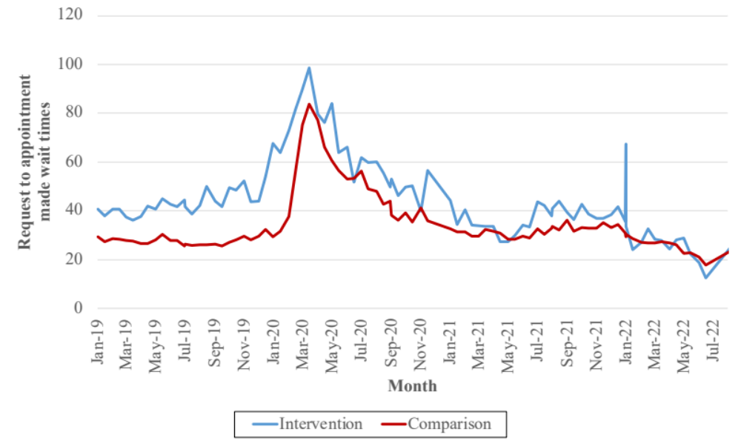

Appendix Figure 12. Trends in appointment made to appointment day wait times in orthopedics, by randomization status

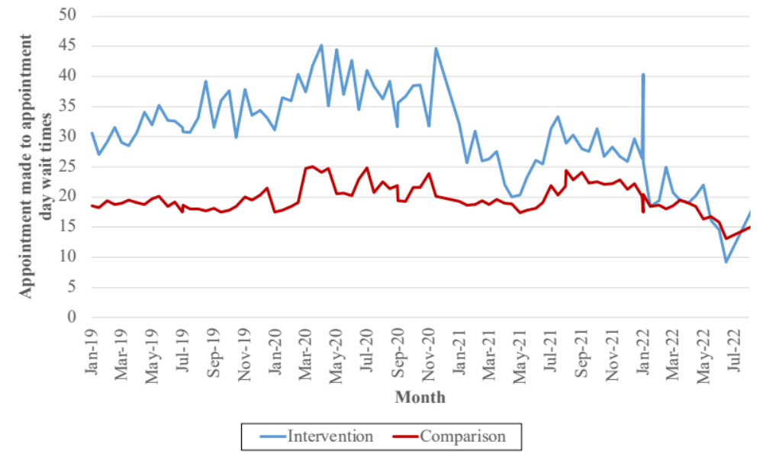
Appendix Figure 13. Trends in “It was easy to get my appointment” in cardiology, by randomization status

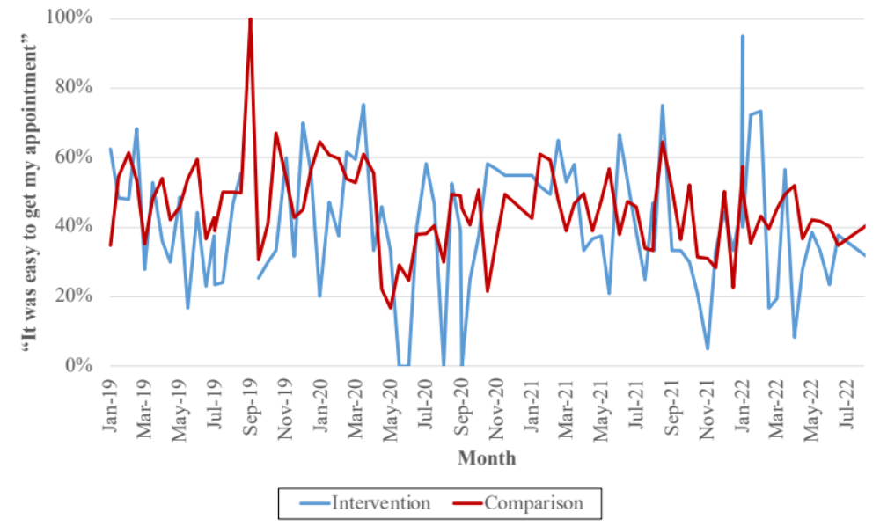

Appendix Figure 14. Trends in “I got my appointment on a date/time that worked for me” in cardiology, by randomization status

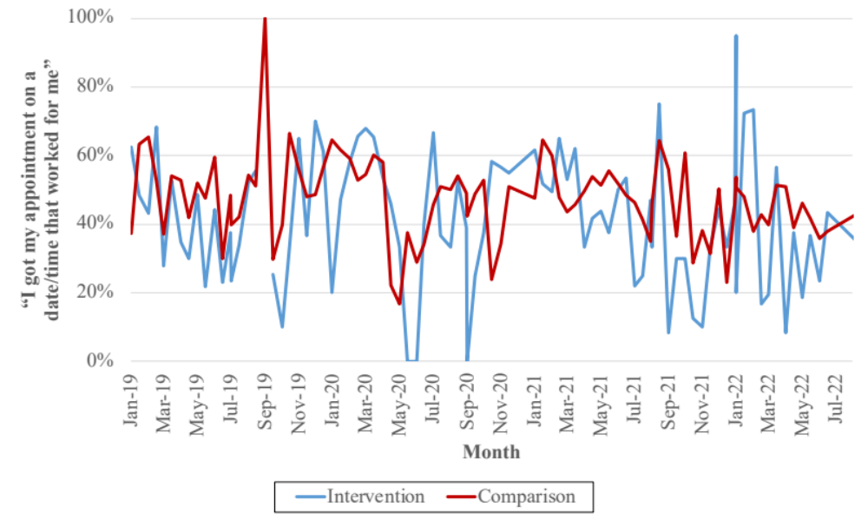
Appendix Figure 15. Trends in “After I checked in for my appointment, I knew what to expect” in cardiology, by randomization status

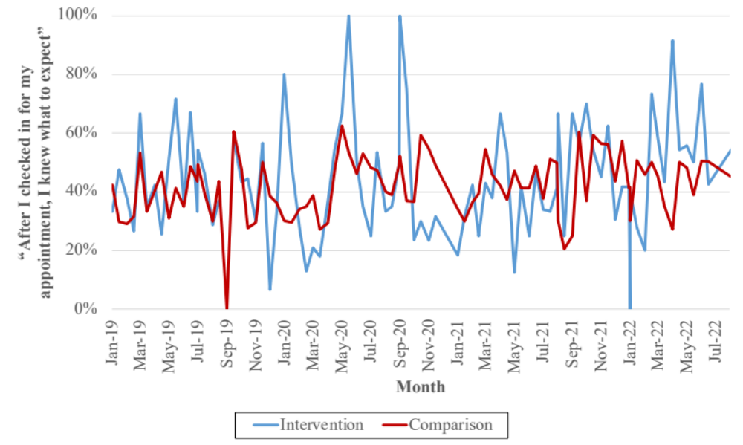

Appendix Figure 16. Trends in “My provider listened carefully to me” in cardiology, by randomization status

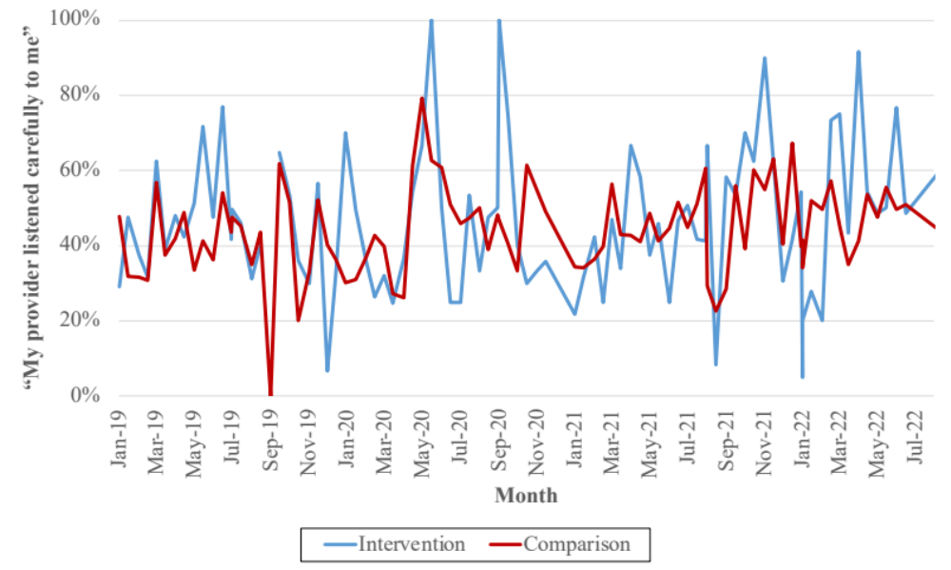
Appendix Figure 17. Trends in “My provider explained things in a way that I could understand” in cardiology, by randomization status

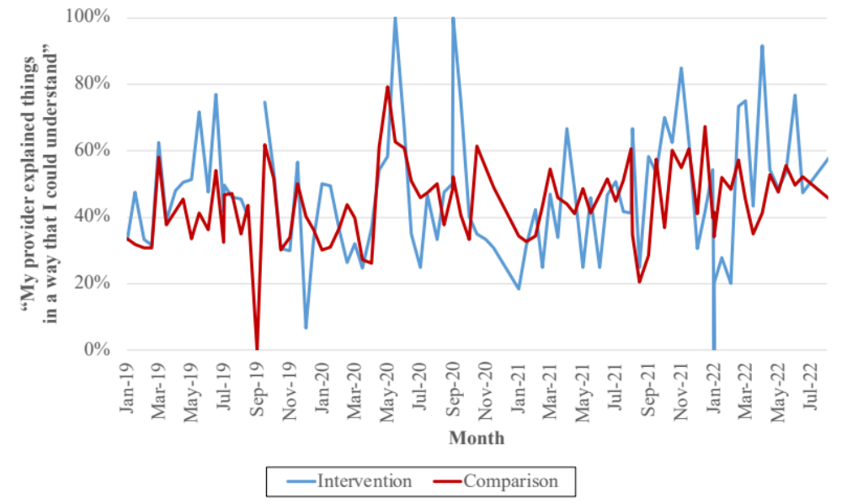

Appendix Figure 18. Trends in “I trust this clinic for my healthcare needs” in cardiology, by randomization status

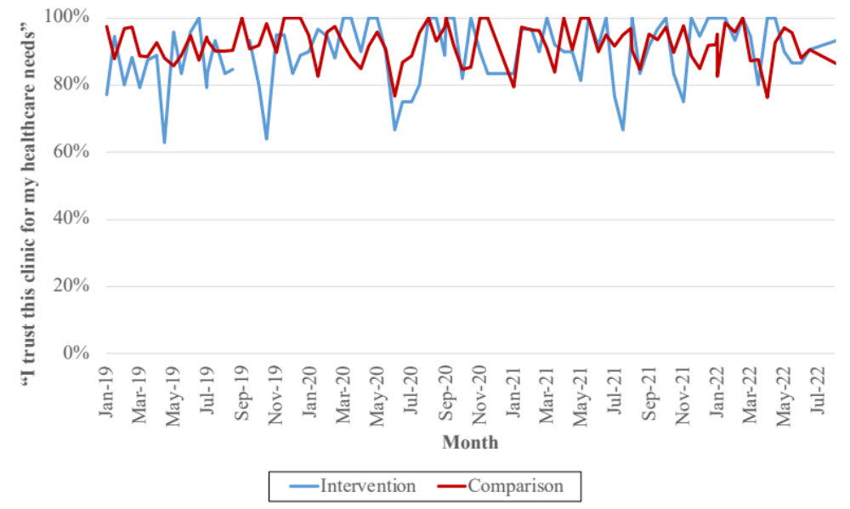
Appendix Figure 19. Trends in “It was easy to get my appointment” in cardiology, by randomization status

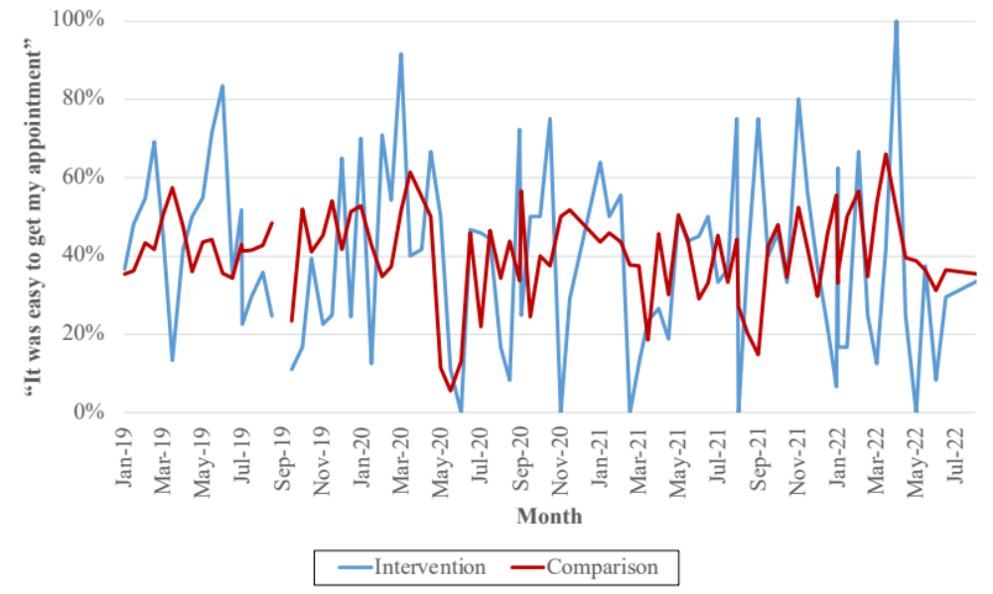

Appendix Figure 20. Trends in “I got my appointment on a date/time that worked for me” in cardiology, by randomization status

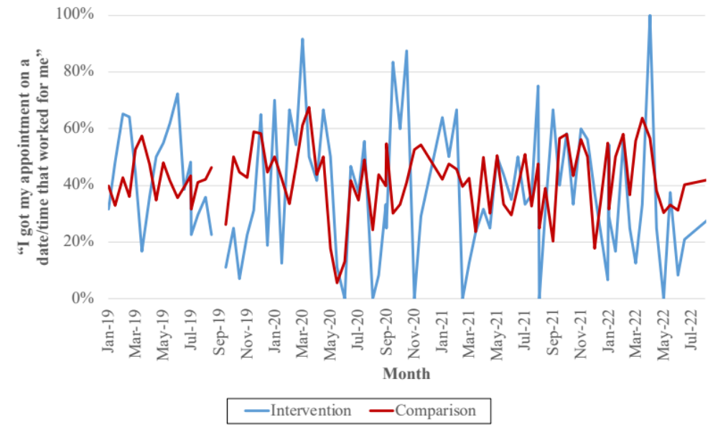
Appendix Figure 21. Trends in “After I checked in for my appointment, I knew what to expect” in cardiology, by randomization status

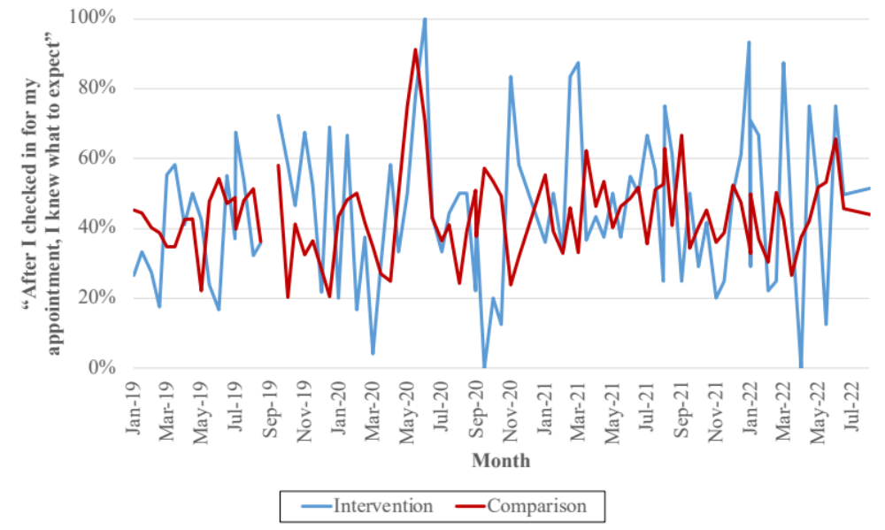

Appendix Figure 22. Trends in “My provider listened carefully to me” in cardiology, by randomization status

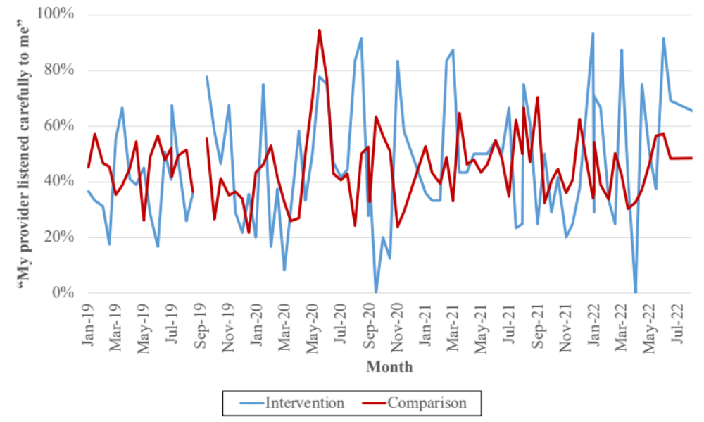
Appendix Figure 23. Trends in “My provider explained things in a way that I could understand” in cardiology, by randomization status

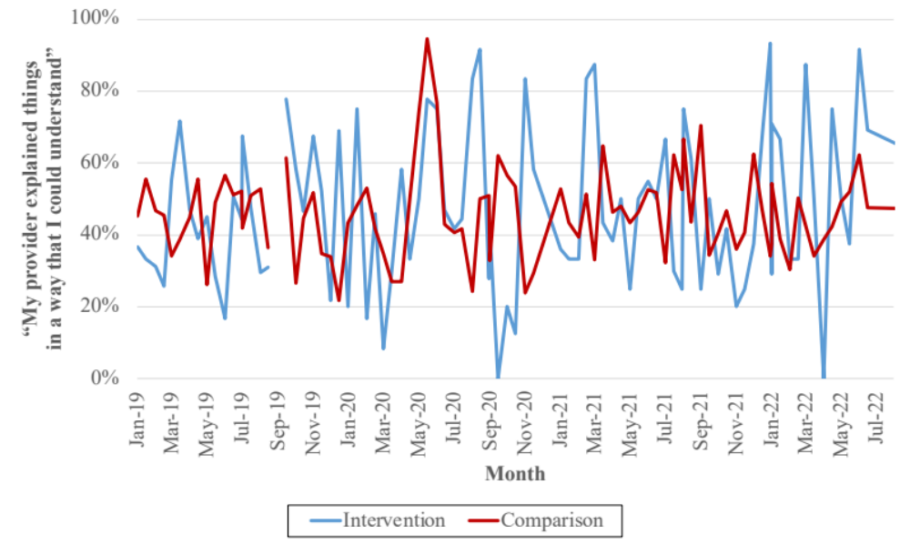

Appendix Figure 24. Trends in “I trust this clinic for my healthcare needs” in cardiology, by randomization status

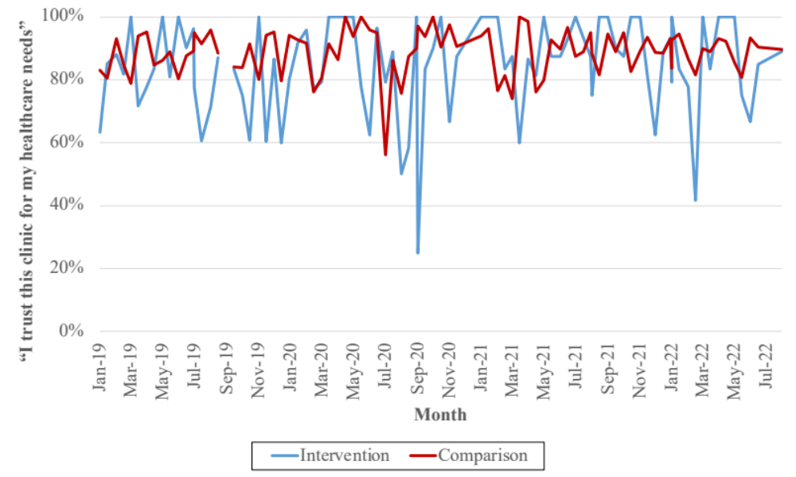

Appendix Table 1. Difference-in-differences regression results for provider productivity in cardiology

 | Unadjusted | Fully adjusted | Unadjusted | Fully adjusted | Unadjusted | Fully adjusted
Outcome  Covariate | Visits  per FTE | Visits  per FTE | RVUs  per FTE | RVUs  per FTE | Patients per day per provider | Patients per day per provider
Intervention | -3.305 | -44.109 | -52.297*** | -66.498 | 3.166*** | 4.845*
 | (3.395) | (38.760) | (5.191) | (56.515) | (0.235) | (2.296)
Pilot | -35.427*** | 127.518 | -56.682*** | 327.845 | -1.439** | -13.211
 | (8.209) | (183.718) | (11.033) | (329.584) | (0.437) | (12.846)
Intervention x Pilot | 15.219*** | 8.472** | 32.750*** | 25.173*** | 0.041 | -0.218
 | (2.401) | (2.723) | (3.722) | (4.139) | (0.142) | (0.176)
Proportion of |  | 30.649*** |  | 11.354 |  | 1.498***
enrollees over age 65 |  | (8.757) |  | (12.184) |  | (0.437)
Proportion of |  | 15.686* |  | -4.002 |  | 1.637***
enrollees age 35-65 |  | (7.768) |  | (10.364) |  | (0.410)
Proportion of enrollees |  | -21.285*** |  | -11.806 |  | -0.469
with priority status 7 or 8 |  | (5.420) |  | (6.889) |  | (0.242)
Zillow Home Value |  | -1.815 |  | -3.983 |  | 0.098
Index |  | (1.695) |  | (3.037) |  | (0.119)
Medicare Advantage |  | 5.300*** |  | 6.368*** |  | 0.166***
penetration |  | (1.010) |  | (1.282) |  | (0.048)
NOSOS risk score |  | -40.123 |  | -50.962 |  | 2.031
 |  | (35.593) |  | (56.618) |  | (2.141)
Proportion of Black |  | -1.544** |  | -1.582* |  | -0.016
enrollees |  | (0.527) |  | (0.704) |  | (0.026)
Proportion of |  | 1.572 |  | -2.273 |  | -0.065
American Indian enrollees |  | (1.513) |  | (2.060) |  | (0.062)
Proportion of Asian |  | 2.270 |  | -1.987 |  | 0.179**
enrollees |  | (1.473) |  | (1.853) |  | (0.065)
Proportion of Native |  | 2.556 |  | 5.756* |  | 0.177*
Hawaiian enrollees |  | (1.852) |  | (2.506) |  | (0.075)
Constant | 90.161*** | -1241.329 | 154.748*** | 809.793 | 4.097*** | -156.011***
 | (7.035) | (777.615) | (8.810) | (1162.959) | (0.361) | (43.311)
Clinic fixed effects | x | x | x | x | x | x
Pay period fixed effects | x | x | x | x | x | x
R-squared | 0.612 | 0.651 | 0.676 | 0.695 | 0.721 | 0.736
Observations | 1276 | 1276 | 1276 | 1276 | 1276 | 1276
Standard errors in parentheses.
* p<0.05, ** p<0.01, *** p<0.001

Appendix Table 2. Difference-in-differences regression results for provider productivity in orthopedics

 | Unadjusted | Fully adjusted | Unadjusted | Fully adjusted | Unadjusted | Fully adjusted
Outcome  Covariate | Visits  per FTE | Visits  per FTE | RVUs  per FTE | RVUs  per FTE | Patients per day per provider | Patients per day per provider
Intervention | 7.277* | -51.777 | 26.834*** | -43.746 | 2.735*** | 2.224
 | (3.377) | (34.816) | (4.555) | (46.111) | (0.137) | (1.214)
Pilot | -16.729** | -327.989 | -10.824 | -370.406 | -0.788** | -32.337*
 | (5.830) | (278.726) | (7.503) | (365.240) | (0.265) | (15.834)
Intervention x Pilot | 15.757*** | 12.504*** | 19.893*** | 17.263*** | 0.001 | 0.011
 | (3.135) | (3.734) | (4.093) | (5.012) | (0.129) | (0.140)
Proportion of |  | 21.993* |  | 19.725 |  | 0.271
enrollees over age 65 |  | (8.613) |  | (10.826) |  | (0.322)
Proportion of |  | -4.499 |  | -14.820 |  | 0.399
enrollees age 35-65 |  | (7.552) |  | (9.996) |  | (0.311)
Proportion of enrollees |  | -13.433* |  | -14.312* |  | -0.149
with priority status 7 or 8 |  | (5.267) |  | (6.067) |  | (0.168)
Zillow Home Value |  | 2.878 |  | 3.291 |  | 0.290*
Index |  | (2.565) |  | (3.356) |  | (0.145)
Medicare Advantage |  | -0.679 |  | -0.878 |  | -0.013
penetration |  | (0.586) |  | (0.765) |  | (0.030)
NOSOS risk score |  | 72.378* |  | 42.393 |  | -0.615
 |  | (34.396) |  | (48.855) |  | (1.543)
Proportion of Black |  | -1.021 |  | -1.250 |  | 0.015
enrollees |  | (0.806) |  | (1.129) |  | (0.023)
Proportion of |  | -4.573** |  | -5.869** |  | -0.086
American Indian enrollees |  | (1.658) |  | (2.050) |  | (0.045)
Proportion of Asian |  | 2.964 |  | 5.367* |  | -0.112*
enrollees |  | (1.542) |  | (2.216) |  | (0.054)
Proportion of Native |  | 8.026* |  | 11.870* |  | -0.140*
Hawaiian enrollees |  | (3.554) |  | (5.481) |  | (0.068)
Constant | 60.715*** | -1140.566 | 67.648*** | -626.400 | 2.921*** | -85.976*
 | (4.191) | (849.592) | (5.469) | (1120.180) | (0.185) | (40.563)
Clinic fixed effects | x | x | x | x | x | x
Pay period fixed effects | x | x | x | x | x | x
R-squared | 0.400 | 0.422 | 0.397 | 0.416 | 0.813 | 0.816
Observations | 1119 | 1119 | 1119 | 1119 | 1119 | 1119
Standard errors in parentheses.
* p<0.05, ** p<0.01, *** p<0.001

Appendix Table 3. Difference-in-differences regression results for wait times in cardiology

 | Unadjusted | Fully adjusted | Unadjusted | Fully adjusted | Unadjusted | Fully adjusted
Outcome  Covariate | Request to appointment day | Request to appointment day | Request to appointment made | Request to appointment made | Appointment made to appointment day | Appointment made to appointment day
Intervention | 11.696*** | -11.262 | 0.664 | -30.604** | 11.031*** | 19.341
 | (1.914) | (16.749) | (0.932) | (9.922) | (1.394) | (12.544)
Pilot | -14.586*** | 213.472 | -6.016*** | 101.781 | -8.570*** | 111.690
 | (2.960) | (141.704) | (1.507) | (59.828) | (2.124) | (110.197)
Intervention x Pilot | 0.650 | 0.912 | 0.822 | 0.581 | -0.171 | 0.330
 | (1.263) | (1.518) | (0.784) | (1.000) | (0.899) | (1.035)
Proportion of |  | -4.681 |  | 2.927 |  | -7.608*
enrollees over age 65 |  | (4.475) |  | (2.494) |  | (3.333)
Proportion of |  | -10.885** |  | -1.043 |  | -9.842**
enrollees age 35-65 |  | (3.956) |  | (2.131) |  | (3.124)
Proportion of enrollees |  | 0.100 |  | 0.392 |  | -0.292
with priority status 7 or 8 |  | (2.238) |  | (1.348) |  | (1.659)
Zillow Home Value |  | -2.112 |  | -1.030 |  | -1.082
Index |  | (1.303) |  | (0.551) |  | (1.014)
Medicare Advantage |  | 0.383 |  | 0.405* |  | -0.022
penetration |  | (0.318) |  | (0.184) |  | (0.232)
NOSOS risk score |  | 55.605*** |  | 13.254 |  | 42.351***
 |  | (15.928) |  | (8.376) |  | (12.219)
Proportion of Black |  | -1.468*** |  | 0.017 |  | -1.484***
enrollees |  | (0.267) |  | (0.160) |  | (0.204)
Proportion of |  | 0.549 |  | -0.309 |  | 0.858*
American Indian enrollees |  | (0.545) |  | (0.369) |  | (0.394)
Proportion of Asian |  | 1.174 |  | -0.449 |  | 1.624**
enrollees |  | (0.759) |  | (0.423) |  | (0.543)
Proportion of Native |  | 1.819* |  | 0.453 |  | 1.365*
Hawaiian enrollees |  | (0.820) |  | (0.514) |  | (0.561)
Constant | 25.219*** | 1119.785* | 8.602*** | 101.159 | 16.617*** | 1018.627**
 | (2.042) | (455.373) | (1.218) | (221.570) | (1.363) | (353.993)
Clinic fixed effects | x | x | x | x | x | x
Pay period fixed effects | x | x | x | x | x | x
R-squared | 0.478 | 0.506 | 0.469 | 0.488 | 0.408 | 0.456
Observations | 1280 | 1280 | 1280 | 1280 | 1280 | 1280
Standard errors in parentheses. Request to appointment day represents the total wait time, request to appointment made represents the time between request for an appointment and appointment creation, and appointment made to appointment day represents the time between appointment creation and appointment day.
* p<0.05, ** p<0.01, *** p<0.001

Appendix Table 4. Difference-in-differences regression results for wait times in orthopedics

 | Unadjusted | Fully adjusted | Unadjusted | Fully adjusted | Unadjusted | Fully adjusted
Outcome  Covariate | Request to appointment day | Request to appointment day | Request to appointment made | Request to appointment made | Appointment made to appointment day | Appointment made to appointment day
Intervention | 12.779*** | 90.815*** | 2.718* | 36.984*** | 10.061*** | 53.831***
 | (1.900) | (14.610) | (1.229) | (8.794) | (1.381) | (11.414)
Pilot | -13.311*** | 206.327 | -4.775*** | 41.814 | -8.536** | 164.513
 | (4.228) | (251.230) | (1.669) | (76.915) | (3.353) | (201.120)
Intervention x Pilot | -10.368*** | -8.545*** | -5.211*** | -2.808 | -5.158*** | -5.736***
 | (1.911) | (2.083) | (1.385) | (1.584) | (1.176) | (1.346)
Proportion of |  | -34.657*** |  | -17.087*** |  | -17.570***
enrollees over age 65 |  | (5.102) |  | (3.170) |  | (3.461)
Proportion of |  | -32.847*** |  | -10.215*** |  | -22.632***
enrollees age 35-65 |  | (4.138) |  | (2.273) |  | (3.156)
Proportion of enrollees |  | 13.493*** |  | 7.778*** |  | 5.715***
with priority status 7 or 8 |  | (2.582) |  | (1.795) |  | (1.636)
Zillow Home Value |  | -1.955 |  | -0.406 |  | -1.550
Index |  | (2.310) |  | (0.707) |  | (1.849)
Medicare Advantage |  | -0.972** |  | -0.351 |  | -0.621*
penetration |  | (0.338) |  | (0.194) |  | (0.252)
NOSOS risk score |  | 135.293*** |  | 42.960*** |  | 92.333***
 |  | (17.850) |  | (10.611) |  | (12.737)
Proportion of Black |  | -0.642 |  | -0.639* |  | -0.003
enrollees |  | (0.430) |  | (0.316) |  | (0.263)
Proportion of |  | 4.328*** |  | 3.808*** |  | 0.520
American Indian enrollees |  | (0.810) |  | (0.570) |  | (0.485)
Proportion of Asian |  | 8.167*** |  | 3.228*** |  | 4.940***
enrollees |  | (0.994) |  | (0.772) |  | (0.564)
Proportion of Native |  | 2.955* |  | 2.487** |  | 0.468
Hawaiian enrollees |  | (1.189) |  | (0.838) |  | (0.846)
Constant | 30.455*** | 3017.535*** | 8.247*** | 1098.142*** | 22.208*** | 1919.393***
 | (2.518) | (637.147) | (1.166) | (257.216) | (2.032) | (498.601)
Clinic fixed effects | x | x | x | x | x | x
Pay period fixed effects | x | x | x | x | x | x
R-squared | 0.625 | 0.687 | 0.429 | 0.487 | 0.637 | 0.686
Observations | 1119 | 1119 | 1119 | 1119 | 1119 | 1119
Standard errors in parentheses. Request to appointment day represents the total wait time, request to appointment made represents the time between request for an appointment and appointment creation, and appointment made to appointment day represents the time between appointment creation and appointment day.
* p<0.05, ** p<0.01, *** p<0.001
Appendix Table 5. Difference-in-differences regression results for patient satisfaction in cardiology
 | Unadjusted | Fully adjusted | Unadjusted | Fully adjusted | Unadjusted | Fully adjusted | Unadjusted | Fully adjusted | Unadjusted | Fully adjusted | Unadjusted | Fully adjusted
Outcome  Covariate | Easy | Easy | Time that worked | Time that worked | Knew what to expect | Knew what to expect | Listened carefully | Listened carefully | Explained things | Explained things | Trust | Trust
Intervention | -0.271*** | -0.389 | -0.270*** | -0.294 | 0.300*** | 0.562 | 0.275*** | 0.232 | 0.268*** | 0.118 | 0.004 | 0.046
 | (0.060) | (0.612) | (0.059) | (0.619) | (0.063) | (0.640) | (0.064) | (0.645) | (0.064) | (0.643) | (0.032) | (0.415)
Pilot | -0.104 | -0.308 | -0.070 | -3.767 | 0.078 | 6.031 | 0.090 | 4.273 | 0.178** | 4.225 | -0.029 | -1.046
 | (0.102) | (3.841) | (0.103) | (3.525) | (0.098) | (4.492) | (0.109) | (4.505) | (0.086) | (4.517) | (0.042) | (2.559)
Intervention | 0.052 | 0.040 | 0.030 | 0.008 | -0.030 | 0.011 | -0.032 | 0.001 | -0.039 | -0.004 | 0.054* | 0.068*
x Pilot | (0.042) | (0.049) | (0.042) | (0.049) | (0.044) | (0.051) | (0.043) | (0.051) | (0.044) | (0.051) | (0.027) | (0.031)
Proportion of |  | 0.095 |  | 0.152 |  | -0.252 |  | -0.180 |  | -0.162 |  | -0.146
enrollees over age 65 |  | (0.153) |  | (0.155) |  | (0.152) |  | (0.151) |  | (0.151) |  | (0.084)
Proportion of |  | 0.070 |  | 0.144 |  | -0.211 |  | -0.178 |  | -0.152 |  | -0.184*
enrollees age 35-65 |  | (0.135) |  | (0.139) |  | (0.135) |  | (0.133) |  | (0.133) |  | (0.082)
Proportion of |  | -0.064 |  | -0.095 |  | 0.131 |  | 0.100 |  | 0.095 |  | 0.038
enrollees with priority status 7 or 8 |  | (0.080) |  | (0.080) |  | (0.082) |  | (0.082) |  | (0.083) |  | (0.046)
Zillow Home |  | 0.003 |  | 0.035 |  | -0.055 |  | -0.039 |  | -0.037 |  | 0.009
Value Index |  | (0.035) |  | (0.032) |  | (0.041) |  | (0.041) |  | (0.041) |  | (0.023)
Medicare Advantage |  | -0.007 |  | 0.001 |  | -0.009 |  | -0.006 |  | -0.007 |  | -0.007
penetration |  | (0.014) |  | (0.013) |  | (0.013) |  | (0.014) |  | (0.014) |  | (0.007)
NOSOS risk score |  | 0.606 |  | 0.943 |  | -1.394* |  | -1.187 |  | -1.431* |  | -0.300
 |  | (0.721) |  | (0.719) |  | (0.709) |  | (0.721) |  | (0.716) |  | (0.371)
Proportion of Black |  | 0.005 |  | -0.002 |  | 0.004 |  | 0.004 |  | 0.002 |  | 0.006
enrollees |  | (0.010) |  | (0.010) |  | (0.011) |  | (0.011) |  | (0.011) |  | (0.007)
Proportion of |  | -0.016 |  | -0.006 |  | 0.005 |  | 0.007 |  | 0.003 |  | 0.019
American Indian enrollees |  | (0.024) |  | (0.024) |  | (0.025) |  | (0.025) |  | (0.025) |  | (0.016)
Proportion of Asian |  | -0.005 |  | -0.009 |  | 0.024 |  | 0.017 |  | 0.015 |  | 0.003
enrollees |  | (0.028) |  | (0.028) |  | (0.029) |  | (0.028) |  | (0.029) |  | (0.019)
Proportion of Native |  | 0.030 |  | -0.000 |  | -0.028 |  | -0.020 |  | -0.024 |  | 0.007
Hawaiian enrollees |  | (0.034) |  | (0.036) |  | (0.037) |  | (0.038) |  | (0.037) |  | (0.025)
Constant | 0.565*** | -6.371 | 0.590*** | -18.916 | 0.235** | 31.769* | 0.267** | 23.814 | 0.188* | 22.019 | 0.926*** | 13.024
 | (0.094) | (14.317) | (0.097) | (14.005) | (0.088) | (15.038) | (0.102) | (14.909) | (0.077) | (14.885) | (0.039) | (8.358)
Clinic fixed effects | x | x | x | x | x | x | x | x | x | x | x | x
Pay period fixed effects | x | x | x | x | x | x | x | x | x | x | x | x
R-squared | 0.131 | 0.135 | 0.136 | 0.140 | 0.113 | 0.121 | 0.125 | 0.132 | 0.126 | 0.132 | 0.127 | 0.139
Observations | 1106 | 1106 | 1106 | 1106 | 1106 | 1106 | 1106 | 1106 | 1106 | 1106 | 1106 | 1106
Standard errors in parentheses. Easy: “It was easy to get my appointment”, Time that worked: “I got my appointment on a date/time that worked for me”, Knew what was expected: “After I checked in for my appointment, I knew what to expect”, Listened carefully: “My provider listened carefully to me”, Explained things: “My provider explained things in a way that I could understand”, Trust: “I trust this clinic for my healthcare needs”.
* p<0.05, ** p<0.01, *** p<0.001

Appendix Table 6. Difference-in-differences regression results for patient satisfaction in orthopedics
 | Unadjusted | Fully adjusted | Unadjusted | Fully adjusted | Unadjusted | Fully adjusted | Unadjusted | Fully adjusted | Unadjusted | Fully adjusted | Unadjusted | Fully adjusted
Outcome  Covariate | Easy | Easy | Time that worked | Time that worked | Knew what to expect | Knew what to expect | Listened carefully | Listened carefully | Explained things | Explained things | Trust | Trust
Intervention | 0.081 | -0.767 | 0.099 | -0.681 | 0.008 | 0.701 | -0.005 | 0.568 | 0.003 | 0.442 | 0.188*** | 0.814*
 | (0.101) | (0.507) | (0.100) | (0.514) | (0.102) | (0.528) | (0.105) | (0.525) | (0.103) | (0.525) | (0.057) | (0.321)
Pilot | -0.016 | -3.220 | -0.038 | -3.282 | 0.053 | 9.281* | 0.107 | 3.746 | 0.106 | 5.935 | 0.087 | 0.230
 | (0.075) | (3.714) | (0.079) | (4.019) | (0.086) | (3.985) | (0.089) | (4.145) | (0.092) | (4.530) | (0.070) | (2.389)
Intervention | -0.016 | -0.002 | -0.019 | 0.012 | -0.002 | -0.054 | 0.045 | -0.002 | 0.021 | -0.010 | 0.015 | -0.042
x Pilot | (0.052) | (0.078) | (0.053) | (0.078) | (0.054) | (0.080) | (0.054) | (0.080) | (0.054) | (0.080) | (0.038) | (0.049)
Proportion of |  | 0.213 |  | 0.079 |  | -0.114 |  | -0.108 |  | -0.150 |  | 0.026
enrollees over age 65 |  | (0.136) |  | (0.133) |  | (0.138) |  | (0.138) |  | (0.138) |  | (0.083)
Proportion of |  | 0.178 |  | 0.046 |  | -0.075 |  | -0.065 |  | -0.099 |  | 0.007
enrollees age 35-65 |  | (0.117) |  | (0.115) |  | (0.117) |  | (0.120) |  | (0.119) |  | (0.075)
Proportion of |  | -0.073 |  | -0.019 |  | 0.038 |  | 0.049 |  | 0.076 |  | -0.035
enrollees with priority status 7 or 8 |  | (0.071) |  | (0.071) |  | (0.073) |  | (0.073) |  | (0.074) |  | (0.047)
Zillow Home |  | 0.030 |  | 0.031 |  | -0.084* |  | -0.033 |  | -0.054 |  | -0.001
Value Index |  | (0.034) |  | (0.037) |  | (0.036) |  | (0.038) |  | (0.042) |  | (0.022)
Medicare Advantage |  | -0.008 |  | -0.019 |  | 0.009 |  | 0.008 |  | 0.006 |  | 0.002
penetration |  | (0.012) |  | (0.012) |  | (0.013) |  | (0.013) |  | (0.013) |  | (0.007)
NOSOS risk score |  | -0.559 |  | -0.293 |  | 1.293 |  | 1.093 |  | 0.682 |  | 1.384*
 |  | (0.799) |  | (0.774) |  | (0.827) |  | (0.843) |  | (0.827) |  | (0.589)
Proportion of Black |  | 0.002 |  | 0.001 |  | -0.005 |  | -0.005 |  | -0.005 |  | 0.009
enrollees |  | (0.010) |  | (0.010) |  | (0.010) |  | (0.010) |  | (0.010) |  | (0.007)
Proportion of |  | -0.046 |  | -0.036 |  | 0.064* |  | 0.067* |  | 0.061* |  | 0.031
American Indian enrollees |  | (0.026) |  | (0.027) |  | (0.027) |  | (0.027) |  | (0.027) |  | (0.017)
Proportion of Asian |  | -0.051* |  | -0.012 |  | 0.002 |  | 0.011 |  | 0.007 |  | 0.001
enrollees |  | (0.023) |  | (0.023) |  | (0.024) |  | (0.024) |  | (0.024) |  | (0.016)
Proportion of Native |  | 0.013 |  | -0.016 |  | -0.005 |  | -0.029 |  | -0.027 |  | 0.030
Hawaiian enrollees |  | (0.038) |  | (0.039) |  | (0.038) |  | (0.039) |  | (0.038) |  | (0.025)
Constant | 0.336*** | -20.942 | 0.339*** | -10.552 | 0.304*** | 24.937* | 0.364*** | 12.873 | 0.372*** | 20.696 | 0.688*** | -1.646
 | (0.067) | (12.358) | (0.059) | (12.581) | (0.080) | (12.658) | (0.079) | (13.160) | (0.080) | (13.699) | (0.074) | (8.006)
Clinic fixed effects | x | x | x | x | x | x | x | x | x | x | x | x
Pay period fixed effects | x | x | x | x | x | x | x | x | x | x | x | x
R-squared | 0.113 | 0.126 | 0.136 | 0.143 | 0.121 | 0.133 | 0.113 | 0.126 | 0.111 | 0.122 | 0.158 | 0.172
Observations | 955 | 955 | 955 | 955 | 955 | 955 | 955 | 955 | 955 | 955 | 955 | 955
Standard errors in parentheses. Easy: “It was easy to get my appointment”, Time that worked: “I got my appointment on a date/time that worked for me”, Knew what was expected: “After I checked in for my appointment, I knew what to expect”, Listened carefully: “My provider listened carefully to me”, Explained things: “My provider explained things in a way that I could understand”, Trust: “I trust this clinic for my healthcare needs”.
* p<0.05, ** p<0.01, *** p<0.001

