Appendix:

Figure S1. Study Flow Chart.
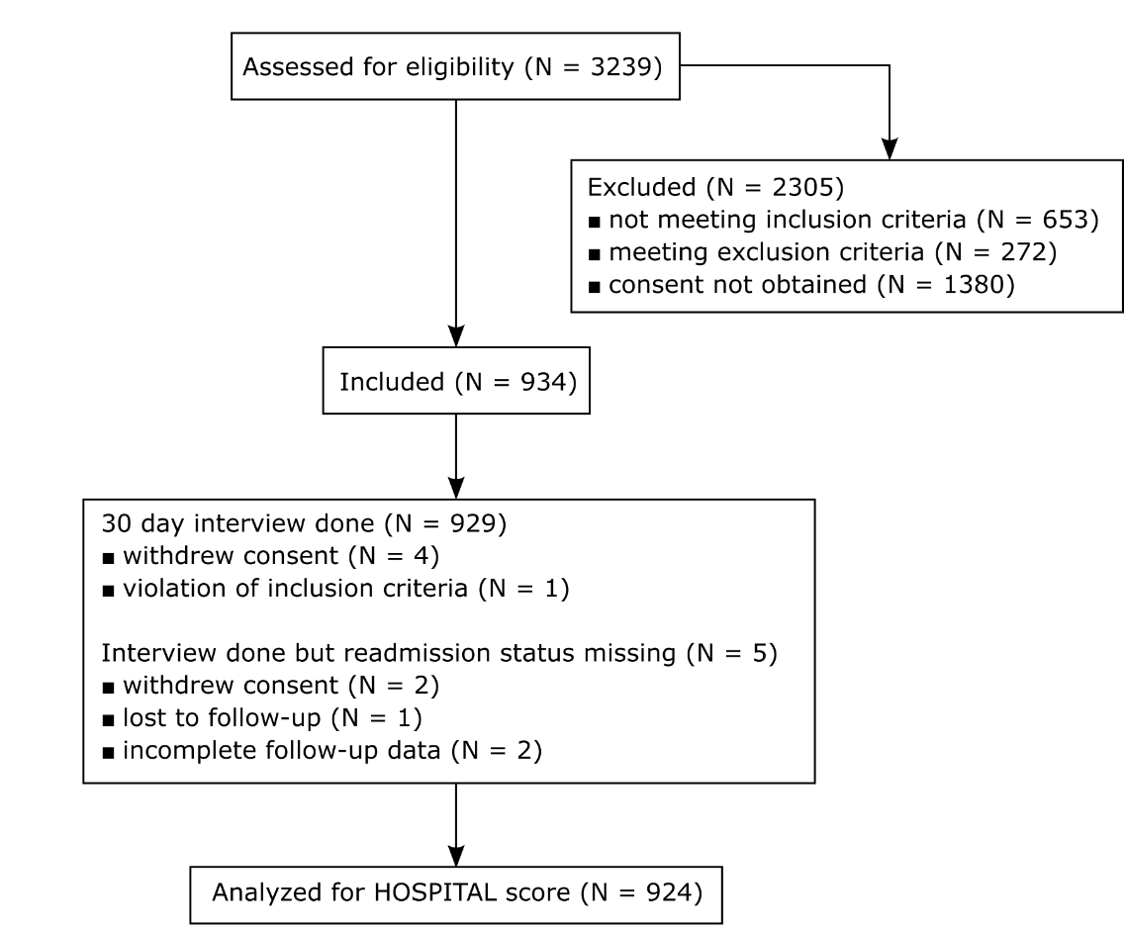

Table S2
Proportion and readmission rate per score points for the 3 versions of the HOSPITAL score.
HOSPITAL score | Original score |  |  | Simplified score with lab at discharge |  |  |  | Simplified score with lab at admission
HOSPITAL score | N | Readmission or deaths | Readmission rate (95% CI) | N | Readmission or deaths | Readmission rate (95% CI) | N |  | Readmission or deaths | Readmission rate (95% CI)
0 | 3 | 0 | 0.0% (0.0 to 56%) | 17 | 0 | 0.0% (0.0 to 18%) | 18 |  | 0 | 0.0% (0.0 to 18%)
1 | 169 | 9 | 5.3% (2.8 to 10%) | 310 | 23 | 7.4% (5.0 to 11%) | 287 |  | 23 | 8.0% (5.4 to 12%)
2 | 211 | 20 | 9.5% (6.2 to 14%) | 133 | 16 | 12% (7.5 to 19%) | 147 |  | 15 | 10% (6.3 to 16%)
3 | 131 | 16 | 12% (7.7 to 19%) | 153 | 13 | 8.5% (5.0 to 14%) | 160 |  | 13 | 8.1% (4.8 to 13%)
4 | 152 | 16 | 11% (6.6 to 16%) | 150 | 29 | 19% (14 to 26%) | 134 |  | 24 | 18% (12 to 25%)
5 | 112 | 25 | 22% (16 to 31%) | 51 | 15 | 29% (19 to 43%) | 79 |  | 21 | 27% (18 to 37%)
6 | 58 | 14 | 24% (15 to 37%) | 77 | 17 | 22% (14 to 33%) | 63 |  | 15 | 24% (15 to 36%)
7 | 58 | 14 | 24% (15 to 37%) | 18 | 5 | 28% (12 to 51%) | 19 |  | 8 | 42% (23 to 64%)
8 | 16 | 4 | 25% (10 to 49%) | 11 | 4 | 36% (15 to 65%) | 12 |  | 3 | 25% (8.9 to 53%)
9 | 10 | 4 | 40% (17 to 69%) | 2 | 0 | 0.0% (0.0 to 66%) | 3 |  | 0 | 0.0% (0.0 to 56%)
10 | 2 | 0 | 0.0% (0.0 to 66%) | 0 | 0 | n.d. | 1 |  | 0 | 0.0% (0.0 to 79%)
11 | 1 | 0 | 0.0% (0.0 to 79%) | 2 | 0 | 0.0% (0.0 to 66%) | 1 |  | 0 | 0.0% (0.0 to 79%)
12 | 1 | 0 | 0.0% (0.0 to 79%) | 0 | 0 | n.d. | 0 |  | 0 | n.d.
13 | 0 | 0 | n.d. | / | / | / | / |  | / | /
Overall | 924 | 122 | 13% (11 to 16%) | 924 | 122 | 13% (11 to 16%) | 924 |  | 122 | 13% (11 to 16%)

