Use of a risk assessment model for venous thromboembolism is associated with decreased prophylaxis
Tarini Gunaratne, MD¹, Rebecca Schulte, MPH², Stephanie Moss, MD³, Oleg Lisheba, MS,⁴ Michael B. Rothberg, MD, MPH⁵
Supplementary Materials

Supplementary Figure 1: Enrollment Flow Diagram

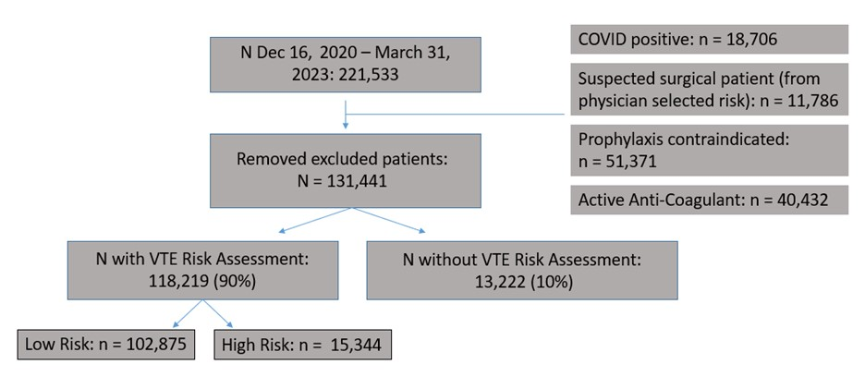

Supplementary Figure 2 – RAM usage over time at each of the study hospitals
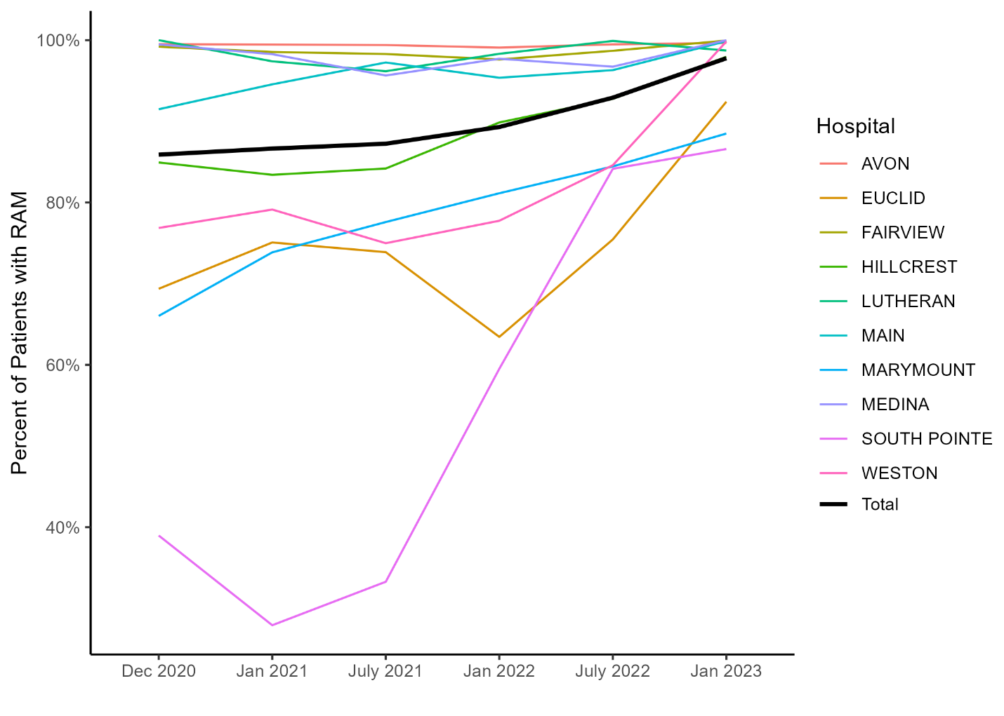
Supplementary Figure 3 – Physician RAM use vs physician prophylaxis ordering 