APPENDIX FIGURES

Appendix Figure 2 – Weekly ACP visits in 2020, by type

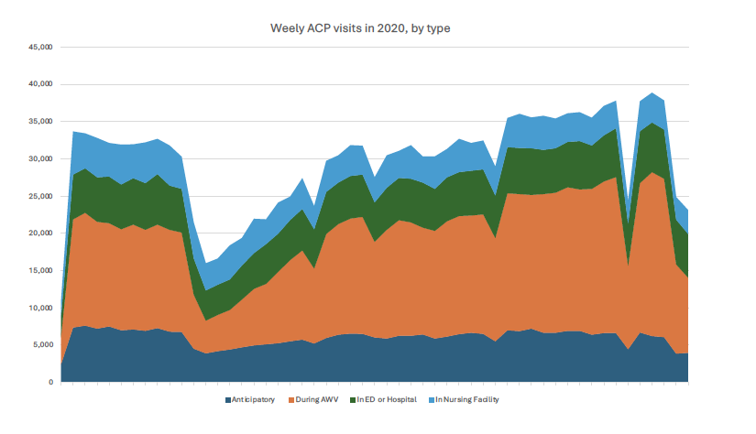

Appendix Figure 3a – Sensitivity analysis: Adding nursing facility ACP visits to anticipatory ACP visits

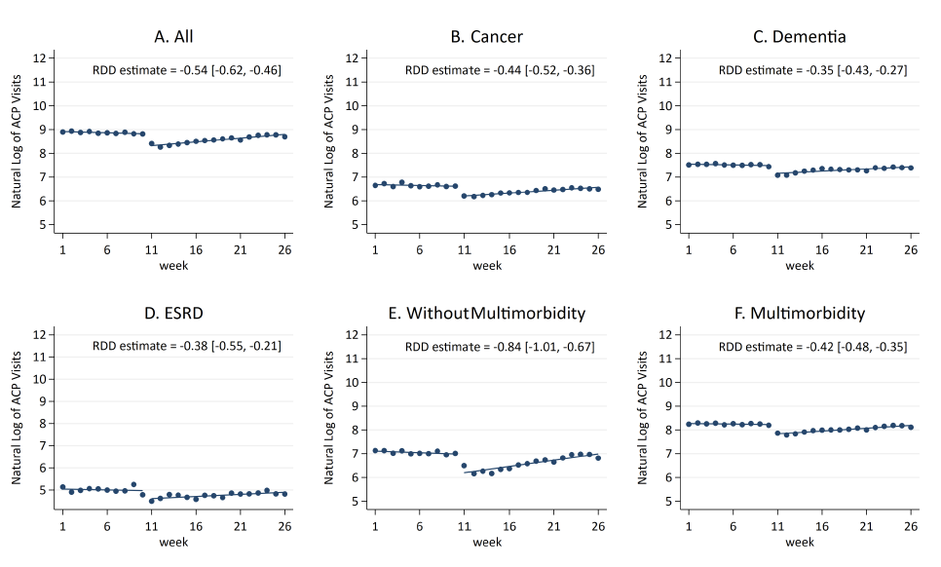
Appendix Figure 3b – Sensitivity analysis: Nursing home visits only

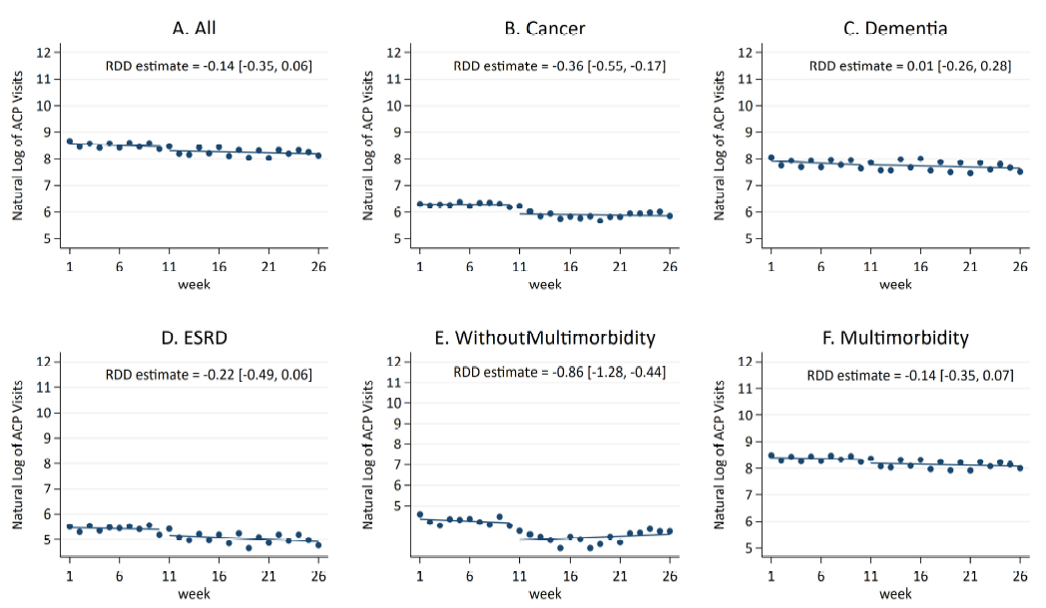

Appendix Figure 3c – Sensitivity analysis: Adding AWV ACP visits to anticipatory ACP visits
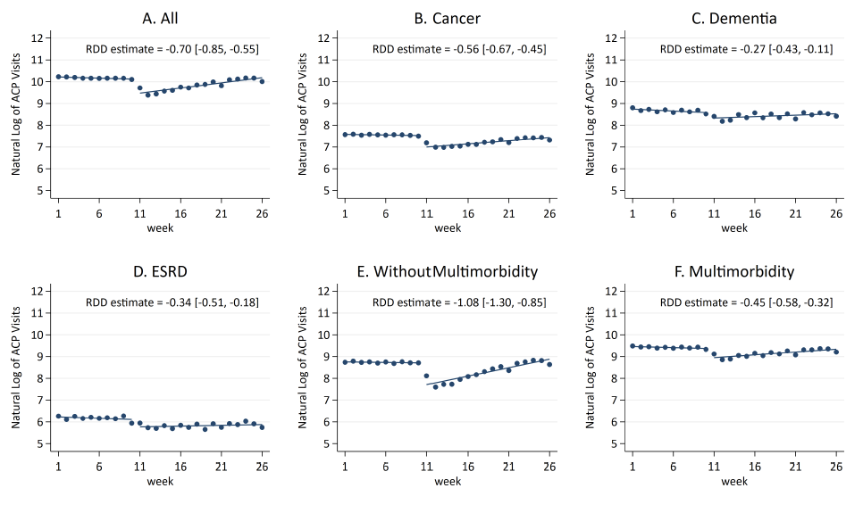

Appendix Figure 3d – Sensitivity analysis: ACP during AWV only
