Supplementary Materials to “Temporal Trends and Sociodemographic Differences in Telemedicine Utilization, 2019-2024”
Table of Contents
eTable 1. Face-to-face list of encounter types 3
eTable 2. Complete list of provider specialties 4
eTable 3. Study variables 5
eTable 4. Patient-level baseline characteristics 7
eTable 5. Odds ratios for diabetes visits 8
eTable 6. Odds ratios for MBD visits 10
eTable 7. Odds ratios for sleep awake disorder visits 12
eTable 8. Odds ratios for heart failure visits 14
eTable 9. Odds ratios for COPD visits 16
eTable 10. Odds ratios for CAD visits 18
eTable 11. Odds ratios for GI visits 20
eTable 12. Baseline characteristics for different health systems 22
eTable 13. Odds ratios with a finer age category 23
eTable 14. Odds ratios with the interaction term of MBD and race/ethnicity 25
eTable 15. Odds ratios with the interaction term of visit year and insurance within MBD visits 27
eTable 16. Crude odds ratios 29
eFigure 1. Temporal patterns for diabetes visits 31
eFigure 2. Temporal patterns for MBD visits 32
eFigure 3. Temporal patterns for sleep awake disorder visits 33
eFigure 4. Temporal patterns for heart failure visits 34
eFigure 5. Temporal patterns for COPD visits 35
eFigure 6. Temporal patterns for CAD visits 36
eFigure 7. Temporal patterns for GI visits 37

eTable 1. Face-to-face list of encounter types
Encounter Type | Encounter Type Name
2 | Walk-In
3 | Hospital Encounter
11 | Research Encounter
50 | Appointment
76 | Telemedicine
81 | Ophth Exam
91 | Home Care Visit
101 | Office Visit
108 | Immunization
120 | Endoscopy
200 | Allied Health Visit
436 | PT/OT/ST
438 | OBGYN Visit
441 | In Home Primary Care Encounter
449 | PEC Visit
450 | OBGYN SURGERY
452 | Out of Office Visit
600 | General Surgery
604 | Anticoagulation Therapy
610 | Infusion Visit
1003 | Procedure Visit
2523 | Hospice F2F Visit
32002 | Care Management
32003 | Virtual Visit
32006 | Psych Office Visit
32009 | Psych Allied Health
32012 | Procedure
32013 | Allied Health Visit (Non-Chargeable)
32030 | Telehealth
32032 | Psych Allied Health (Non-Chargeable)
304113 | Palliative Home Care Visit
304114 | CCBH Scheduled
304117 | Telemedicine (Non-Chargeable)
1650000002 | TXP Evaluation

eTable 2. Complete list of provider specialties
The provider specialties were categorized according to https://taxonomy.nucc.org/.
Provider Specialty Clusters
Anesthesiology
Behavioral Health & Social Service Providers
Chiropractic Providers
Critical Care
Dental Providers
Dermatology
Dietary & Nutritional Service Providers
Emergency Medicine
Eye and Vision Services Providers
Family Medicine
Hospice and Palliative Medicine
Hospitalist
Hospitals
Internal Medicine
Medical Genetics
Nuclear Medicine
Nursing Service Providers
Obstetrics & Gynecology
Ophthalmology
Other Service Providers
Pathology
Pediatrics
Pharmacy Service Providers
Physical Medicine & Rehabilitation
Physician Assistants & Advanced Practice Nursing Providers
Podiatric Medicine & Surgery Service Providers
Preventive Medicine
Psychiatry & Neurology
Radiology
Residential Treatment Facilities
Respiratory, Developmental, Rehabilitative and Restorative Service Providers
Sleep Medicine
Speech, Language and Hearing Service Providers
Sports Medicine
Surgery
Urology

eTable 3. Study variables
Variable | Functional form | Values | Detail
Outcome
Visit type | Indicator | Telemedicine/In-person visit | Based on the encounter type in eTable 1. The values “Telemedicine”, “Virtual visit”, “Telehealth”, and “Telemedicine (Non-Chargeable)” is telemedicine visit, otherwise is in-person visit.
Sociodemographic variables
Age (years) | 3 categories | < 40 years  40-64 years  ≥65 years | Age is defined as the integer of (date – birth date)/365.25.
Sex | Indicator | Male/Female | Based on records in the sex column.
Race/Ethnicity | 6 categories | NHW  NHB  Hispanic  AAPI  Multiple  Other/unknown | Based on records in the race and ethnicity columns.
Primary insurance plan | 4 categories | Commercial  Medicaid  Medicare  Self-Pay/Other | Based on the PlanFCName column. “Commercial” includes “Managed Care”, “Commercial”, “Blue Cross”, and “Blue Shield”; “Medicaid” includes “Medicaid”, “Medicaid (MA)”, and “Managed Medicaid”; “Medicare” includes “Medicare” and “Managed Medicare”; all others are categorized as “Self-Pay/Other”. For encounters with multiple insurance records on the same visit date, a hierarchy was applied to assign a single primary category: Medicare -> Managed Medicare -> Medicaid -> Medicaid (MA) -> Managed Medicaid -> Commercial -> Managed Care -> Blue Cross -> Blue Shield -> Self-Pay/Other.
Patient portal user | Indicator | Yes/No | Based on the MyPennMedicine_Activated column.
Marital Status | Indicator | Yes/No | Based on the Marital_status column.
Encounter category | 3 categories | Return patient visit  New patient visit  Other/Unkown | Based on the enc_cat column.
Median household income | 3 categories | <$50,000  $50,000 to $100,000  ≥$100,000 | Based on patients’ zip code and calculated using R package tidycensus.
Charlson Comorbidity Index score | 2 categories | <3  ≥3 | Based on diagnosis domain.
Distance from home to place of service | 3 categories | <5 miles  5 to 15 miles  ≥15 miles | Based on patients’ and place of service’s zip code and calculated using R package zipcodeR.
Provider specialty | 3 categories | Primary care  Specialty care  Unknown | Based on eTable 2. “Primary care” includes “Family Medicine”, “Internal Medicine”, “Pediatrics”; all others are categorized as “Specialty care”.
Other variables
Health conditions | 7 categories | Diabetes  MBD  Sleep disorder  Heart failure  COPD  CAD  GI | Codeset available at Github: https://github.com/Penncil/Telemedicine

eTable 4. Patient-level baseline characteristics
 | Telemedicine only (N=13,323) | In-person only (N=1,633,134) | Mixed use  (N=601,884) | Overall  (N=2,248,341)
Age Range, no. (%)
< 40 years | 6502 (48.8) | 579623 (35.5) | 189668 (31.5) | 775793 (34.5)
40-64 years | 4717 (35.4) | 600792 (36.8) | 231331 (38.4) | 836840 (37.2)
≥65 years | 2104 (15.8) | 452719 (27.7) | 180885 (30.1) | 635708 (28.3)
Sex, no. (%)
Female | 7981 (59.9) | 916095 (56.1) | 377794 (62.8) | 1301870 (57.9)
Male | 5342 (40.1) | 717039 (43.9) | 224090 (37.2) | 946471 (42.1)
Race/Ethnicity, no. (%)
Non-Hispanic White | 6662 (50.0) | 892989 (54.7) | 379322 (63.0) | 1278973 (56.9)
Non-Hispanic Black | 1540 (11.6) | 254425 (15.6) | 117376 (19.5) | 373341 (16.6)
Hispanic | 657 (4.9) | 94393 (5.8) | 30034 (5.0) | 125084 (5.6)
Asian | 583 (4.4) | 94011 (5.8) | 28222 (4.7) | 122816 (5.5)
Other/Unknown | 3881 (29.1) | 297316 (18.2) | 46930 (7.8) | 348127 (15.5)
Insurance Plan, no. (%)
Commercial | 5534 (41.5) | 681008 (41.7) | 312968 (52.0) | 999510 (44.5)
Medicaid | 994 (7.5) | 131779 (8.1) | 65015 (10.8) | 197788 (8.8)
Medicare | 1292 (9.7) | 304457 (18.6) | 155630 (25.9) | 461379 (20.5)
Self-Pay/Other | 5503 (41.3) | 515890 (31.6) | 68271 (11.3) | 589664 (26.2)
MyPennMedicine User, no. (%)
No | 4750 (35.7) | 769660 (47.1) | 83579 (13.9) | 857989 (38.2)
Yes | 8573 (64.3) | 863474 (52.9) | 518305 (86.1) | 1390352 (61.8)
Marital Status, no. (%)
Married | 5562 (41.7) | 724320 (44.4) | 310920 (51.7) | 1040802 (46.3)
Unmarried | 7761 (58.3) | 908814 (55.6) | 290964 (48.3) | 1207539 (53.7)
Median household income, no. (%)
<$50,000 | 1863 (14.0) | 250928 (15.4) | 103375 (17.2) | 356166 (15.8)
$50,000 to $100,000 | 8073 (60.6) | 804906 (49.3) | 295929 (49.2) | 1108908 (49.3)
≥$100,000 | 3387 (25.4) | 577300 (35.3) | 202580 (33.7) | 783267 (34.8)
Charlson Comorbidity Index score, no. (%)
<3 | 12822 (96.2) | 1411138 (86.4) | 398666 (66.2) | 1822626 (81.1)
≥3 | 501 (3.8) | 221996 (13.6) | 203218 (33.8) | 425715 (18.9)

eTable 5. Odds ratios for diabetes visits
Characteristics | Adjusted Odds Ratio (95% CI)
Visit Year
2020 | 6.13 (5.90-6.38)
2021 | 3.75 (3.59-3.92)
2022 | 1.40 (1.34-1.46)
2023 | 1.09 (1.04-1.13)
2024 | 1.00 [Reference]
Hospital
HUP | 1.00 [Reference]
CCH | 0.20 (0.18-0.21)
PMC | 0.51 (0.49-0.53)
PAH | 0.82 (0.79-0.86)
PPMC | 0.86 (0.83-0.89)
Age Range
< 40 years | 1.00 [Reference]
40-64 years | 0.68 (0.66-0.71)
≥65 years | 0.47 (0.44-0.49)
Sex
Female | 1.00 [Reference]
Male | 0.79 (0.77-0.81)
Race/Ethnicity
Non-Hispanic White | 1.00 [Reference]
Asian | 0.94 (0.89-0.99)
Hispanic | 0.88 (0.82-0.93)
Non-Hispanic Black | 0.92 (0.89-0.96)
Other/Unknown | 0.90 (0.85-0.94)
Insurance Plan
Commercial | 1.00 [Reference]
Medicaid | 1.17 (1.12-1.22)
Medicare | 1.07 (1.03-1.11)
Self-Pay/Other | 0.87 (0.82-0.92)
MyPennMedicine User
No | 1.00 [Reference]
Yes | 1.66 (1.60-1.73)
Marital Status
Married | 1.00 [Reference]
Unmarried | 0.96 (0.94-0.99)
Median household income
<$50,000 | 1.12 (1.08-1.16)
$50,000 to $100,000 | 1.00 [Reference]
≥$100,000 | 1.08 (1.04-1.11)
Charlson Comorbidity Index score
<3 | 1.00 [Reference]
≥3 | 0.80 (0.77-0.82)
Encounter Category
Return Patient Visit | 1.00 [Reference]
New Patient Visit | 0.39 (0.37-0.41)
Other/Unknown | -
Distance from Home to Place of Service
< 5 miles | 1.00 [Reference]
5 to 15 miles | 1.34 (1.30-1.38)
≥15 miles | 1.70 (1.64-1.76)
Provider Specialty
Primary Care | 0.93 (0.89-0.96)
Specialty Care | 1.00 [Reference]
Unknown | 0.25 (0.24-0.26)

eTable 6. Odds ratios for MBD visits
Characteristics | Adjusted Odds Ratio (95% CI)
Visit Year
2020 | 1.83 (1.79-1.86)
2021 | 2.09 (2.04-2.13)
2022 | 1.40 (1.37-1.42)
2023 | 1.09 (1.07-1.11)
2024 | 1.00 [Reference]
Hospital
HUP | 1.00 [Reference]
CCH | 0.12 (0.12-0.13)
PMC | 0.05 (0.05-0.05)
PAH | 0.05 (0.05-0.05)
PPMC | 0.19 (0.18-0.19)
Age Range
< 40 years | 1.00 [Reference]
40-64 years | 0.87 (0.86-0.88)
≥65 years | 0.70 (0.68-0.72)
Sex
Female | 1.00 [Reference]
Male | 0.90 (0.89-0.91)
Race/Ethnicity
Non-Hispanic White | 1.00 [Reference]
Asian | 1.04 (1.01-1.07)
Hispanic | 0.97 (0.95-1.00)
Non-Hispanic Black | 0.85 (0.84-0.87)
Other/Unknown | 1.14 (1.11-1.16)
Insurance Plan
Commercial | 1.00 [Reference]
Medicaid | 0.64 (0.63-0.65)
Medicare | 0.75 (0.73-0.77)
Self-Pay/Other | 0.81 (0.80-0.83)
MyPennMedicine User
No | 1.00 [Reference]
Yes | 3.17 (3.10-3.23)
Marital Status
Married | 1.00 [Reference]
Unmarried | 0.91 (0.89-0.92)
Median household income
<$50,000 | 1.07 (1.06-1.09)
$50,000 to $100,000 | 1.00 [Reference]
≥$100,000 | 0.87 (0.86-0.89)
Charlson Comorbidity Index score
<3 | 1.00 [Reference]
≥3 | 0.79 (0.78-0.80)
Encounter Category
Return Patient Visit | 1.00 [Reference]
New Patient Visit | 0.42 (0.41-0.43)
Other/Unknown | -
Distance from Home to Place of Service
< 5 miles | 1.00 [Reference]
5 to 15 miles | 0.96 (0.95-0.98)
≥15 miles | 1.40 (1.37-1.42)
Provider Specialty
Primary Care | 0.58 (0.57-0.60)
Specialty Care | 1.00 [Reference]
Unknown | 0.05 (0.05-0.05)

eTable 7. Odds ratios for sleep awake disorder visits
Characteristics | Adjusted Odds Ratio (95% CI)
Visit Year
2020 | 2.47 (2.39-2.57)
2021 | 2.32 (2.22-2.41)
2022 | 1.18 (1.14-1.22)
2023 | 0.96 (0.93-0.99)
2024 | 1.00 [Reference]
Hospital
HUP | 1.00 [Reference]
CCH | 0.15 (0.14-0.16)
PMC | 0.19 (0.18-0.20)
PAH | 0.56 (0.54-0.57)
PPMC | 0.42 (0.40-0.44)
Age Range
< 40 years | 1.00 [Reference]
40-64 years | 0.66 (0.64-0.68)
≥65 years | 0.54 (0.52-0.57)
Sex
Female | 1.00 [Reference]
Male | 0.76 (0.74-0.78)
Race/Ethnicity
Non-Hispanic White | 1.00 [Reference]
Asian | 1.13 (1.06-1.20)
Hispanic | 0.99 (0.94-1.05)
Non-Hispanic Black | 1.07 (1.04-1.11)
Other/Unknown | 0.98 (0.94-1.03)
Insurance Plan
Commercial | 1.00 [Reference]
Medicaid | 1.05 (1.01-1.09)
Medicare | 1.08 (1.04-1.12)
Self-Pay/Other | 0.84 (0.80-0.87)
MyPennMedicine User
No | 1.00 [Reference]
Yes | 2.50 (2.40-2.61)
Marital Status
Married | 1.00 [Reference]
Unmarried | 1.04 (1.01-1.06)
Median household income
<$50,000 | 1.34 (1.29-1.39)
$50,000 to $100,000 | 1.00 [Reference]
≥$100,000 | 1.06 (1.03-1.08)
Charlson Comorbidity Index score
<3 | 1.00 [Reference]
≥3 | 0.77 (0.75-0.80)
Encounter Category
Return Patient Visit | 1.00 [Reference]
New Patient Visit | 0.45 (0.43-0.46)
Other/Unknown | -
Distance from Home to Place of Service
< 5 miles | 1.00 [Reference]
5 to 15 miles | 1.00 (0.98-1.03)
≥15 miles | 1.47 (1.43-1.52)
Provider Specialty
Primary Care | 1.20 (1.15-1.25)
Specialty Care | 1.00 [Reference]
Unknown | -

eTable 8. Odds ratios for heart failure visits
Characteristics | Adjusted Odds Ratio (95% CI)
Visit Year
2020 | 9.06 (8.04-10.22)
2021 | 3.24 (2.81-3.73)
2022 | 1.29 (1.13-1.48)
2023 | 1.19 (1.04-1.36)
2024 | 1.00 [Reference]
Hospital
HUP | 1.00 [Reference]
CCH | 0.26 (0.19-0.35)
PMC | 0.42 (0.34-0.50)
PAH | 0.98 (0.87-1.10)
PPMC | 0.68 (0.63-0.74)
Age Range
< 40 years | 1.00 [Reference]
40-64 years | 0.89 (0.76-1.03)
≥65 years | 0.85 (0.72-1.00)
Sex
Female | 1.00 [Reference]
Male | 0.70 (0.65-0.75)
Race/Ethnicity
Non-Hispanic White | 1.00 [Reference]
Asian | 1.09 (0.85-1.40)
Hispanic | 0.89 (0.71-1.11)
Non-Hispanic Black | 1.00 (0.91-1.10)
Other/Unknown | 0.86 (0.72-1.01)
Insurance Plan
Commercial | 1.00 [Reference]
Medicaid | 1.23 (1.08-1.40)
Medicare | 1.10 (0.99-1.22)
Self-Pay/Other | 1.07 (0.91-1.27)
MyPennMedicine User
No | 1.00 [Reference]
Yes | 2.17 (1.07-1.28)
Marital Status
Married | 1.00 [Reference]
Unmarried | 0.97 (0.90-1.04)
Median household income
<$50,000 | 1.11 (1.00-1.23)
$50,000 to $100,000 | 1.00 [Reference]
≥$100,000 | 1.13 (1.04-1.24)
Charlson Comorbidity Index score
<3 | 1.00 [Reference]
≥3 | 0.71 (0.65-0.78)
Encounter Category
Return Patient Visit | 1.00 [Reference]
New Patient Visit | 0.40 (0.35-0.45)
Other/Unknown | -
Distance from Home to Place of Service
< 5 miles | 1.00 [Reference]
5 to 15 miles | 1.11 (1.01-1.22)
≥15 miles | 1.57 (1.42-1.73)
Provider Specialty
Primary Care | 2.65 (2.31-3.04)
Specialty Care | 1.00 [Reference]
Unknown | 0.27 (0.23-0.32)

eTable 9. Odds ratios for COPD visits
Characteristics | Adjusted Odds Ratio (95% CI)
Visit Year
2020 | 8.88 (7.69-10.25)
2021 | 5.00 (4.25-5.88)
2022 | 1.63 (1.40-1.90)
2023 | 1.09 (0.93-1.28)
2024 | 1.00 [Reference]
Hospital
HUP | 1.00 [Reference]
CCH | 0.44 (0.33-0.58)
PMC | 0.68 (0.58-0.80)
PAH | 1.29 (1.15-1.46)
PPMC | 1.08 (0.97-1.21)
Age Range
< 40 years | 1.00 [Reference]
40-64 years | 1.60 (0.77-3.30)
≥65 years | 1.26 (0.60-2.61)
Sex
Female | 1.00 [Reference]
Male | 0.77 (0.71-0.84)
Race/Ethnicity
Non-Hispanic White | 1.00 [Reference]
Asian | 0.93 (0.63-1.38)
Hispanic | 1.52 (1.13-2.04)
Non-Hispanic Black | 1.18 (1.05-1.33)
Other/Unknown | 0.87 (0.69-1.08)
Insurance Plan
Commercial | 1.00 [Reference]
Medicaid | 1.43 (1.21-1.69)
Medicare | 1.08 (0.94-1.25)
Self-Pay/Other | 1.32 (1.07-1.62)
MyPennMedicine User
No | 1.00 [Reference]
Yes | 1.35 (1.22-1.49)
Marital Status
Married | 1.00 [Reference]
Unmarried | 1.12 (1.02-1.22)
Median household income
<$50,000 | 1.16 (1.02-1.31)
$50,000 to $100,000 | 1.00 [Reference]
≥$100,000 | 1.06 (0.95-1.18)
Charlson Comorbidity Index score
<3 | 1.00 [Reference]
≥3 | 0.70 (0.63-0.77)
Encounter Category
Return Patient Visit | 1.00 [Reference]
New Patient Visit | 0.29 (0.25-0.34)
Other/Unknown | -
Distance from Home to Place of Service
< 5 miles | 1.00 [Reference]
5 to 15 miles | 0.88 (0.80-0.98)
≥15 miles | 1.49 (1.31-1.68)
Provider Specialty
Primary Care | 1.49 (1.30-1.71)
Specialty Care | 1.00 [Reference]
Unknown | -

eTable 10. Odds ratios for CAD visits
Characteristics | Adjusted Odds Ratio (95% CI)
Visit Year
2020 | 11.38 (10.12-12.80)
2021 | 4.31 (3.77-4.93)
2022 | 1.39 (1.21-1.59)
2023 | 1.04 (0.91-1.20)
2024 | 1.00 [Reference]
Hospital
HUP | 1.00 [Reference]
CCH | 0.31 (0.25-0.38)
PMC | 0.54 (0.47-0.62)
PAH | 1.02 (0.93-1.12)
PPMC | 0.55 (0.50-0.60)
Age Range
< 40 years | 1.00 [Reference]
40-64 years | 0.47 (0.35-0.63)
≥65 years | 0.40 (0.30-0.54)
Sex
Female | 1.00 [Reference]
Male | 0.84 (0.78-0.90)
Race/Ethnicity
Non-Hispanic White | 1.00 [Reference]
Asian | 1.11 (0.94-1.32)
Hispanic | 0.95 (0.76-1.19)
Non-Hispanic Black | 1.12 (1.00-1.26)
Other/Unknown | 0.98 (0.84-1.14)
Insurance Plan
Commercial | 1.00 [Reference]
Medicaid | 1.02 (0.86-1.21)
Medicare | 0.96 (0.87-1.07)
Self-Pay/Other | 0.96 (0.81-1.14)
MyPennMedicine User
No | 1.00 [Reference]
Yes | 1.39 (1.27-1.53)
Marital Status
Married | 1.00 [Reference]
Unmarried | 0.98 (0.91-1.06)
Median household income
<$50,000 | 1.10 (0.98-1.24)
$50,000 to $100,000 | 1.00 [Reference]
≥$100,000 | 1.04 (0.96-1.12)
Charlson Comorbidity Index score
<3 | 1.00 [Reference]
≥3 | 0.77 (0.71-0.84)
Encounter Category
Return Patient Visit | 1.00 [Reference]
New Patient Visit | 0.31 (0.28-0.35)
Other/Unknown | -
Distance from Home to Place of Service
< 5 miles | 1.00 [Reference]
5 to 15 miles | 1.15 (1.06-1.25)
≥15 miles | 1.72 (1.57-1.88)
Provider Specialty
Primary Care | 1.78 (1.57-2.03)
Specialty Care | 1.00 [Reference]
Unknown | 0.19 (0.15-0.24)

eTable 11. Odds ratios for GI visits
Characteristics | Adjusted Odds Ratio (95% CI)
Visit Year
2020 | 6.47 (6.27-6.68)
2021 | 4.43 (4.27-4.59)
2022 | 1.20 (1.15-1.24)
2023 | 0.96 (0.93-1.00)
2024 | 1.00 [Reference]
Hospital
HUP | 1.00 [Reference]
CCH | 0.14 (0.14-0.15)
PMC | 0.77 (0.74-0.80)
PAH | 1.03 (1.00-1.06)
PPMC | 0.82 (0.80-0.85)
Age Range
< 40 years | 1.00 [Reference]
40-64 years | 0.80 (0.78-0.82)
≥65 years | 0.62 (0.60-0.65)
Sex
Female | 1.00 [Reference]
Male | 0.79 (0.78-0.81)
Race/Ethnicity
Non-Hispanic White | 1.00 [Reference]
Asian | 0.79 (0.75-0.83)
Hispanic | 0.96 (0.91-1.01)
Non-Hispanic Black | 1.05 (1.02-1.08)
Other/Unknown | 0.87 (0.83-0.91)
Insurance Plan
Commercial | 1.00 [Reference]
Medicaid | 1.15 (1.11-1.19)
Medicare | 1.11 (1.08-1.15)
Self-Pay/Other | 0.97 (0.93-1.01)
MyPennMedicine User
No | 1.00 [Reference]
Yes | 1.53 (1.49-1.59)
Marital Status
Married | 1.00 [Reference]
Unmarried | 1.00 (0.98-1.02)
Median household income
<$50,000 | 1.09 (1.06-1.13)
$50,000 to $100,000 | 1.00 [Reference]
≥$100,000 | 1.00 (0.98-1.02)
Charlson Comorbidity Index score
<3 | 1.00 [Reference]
≥3 | 0.87 (0.85-0.89)
Encounter Category
Return Patient Visit | 1.00 [Reference]
New Patient Visit | 0.29 (0.29-0.30)
Other/Unknown | -
Distance from Home to Place of Service
< 5 miles | 1.00 [Reference]
5 to 15 miles | 1.12 (1.09-1.15)
≥15 miles | 1.44 (1.40-1.48)
Provider Specialty
Primary Care | 1.37 (1.32-1.41)
Specialty Care | 1.00 [Reference]
Unknown | -

eTable 12. Baseline characteristics for different health systems
 | HUP | CCH | PMC | PATH | PPMC
Patient level
No. of patients | 1,434,416 | 321,410 | 362,692 | 566,814 | 655,190
Age Range, no. (%)
< 40 years | 464688 (32.4) | 105772 (32.9) | 125075 (34.5) | 220162 (38.8) | 210692 (32.2)
40-64 years | 546076 (38.1) | 125959 (39.2) | 138314 (38.1) | 211777 (37.4) | 250574 (38.2)
≥65 years | 423652 (29.5) | 89679 (27.9) | 99303 (27.4) | 134875 (23.8) | 193924 (29.6)
Sex, no. (%)
Female | 841391 (58.7) | 188906 (58.8) | 212277 (58.5) | 353240 (62.3) | 379040 (57.9)
Male | 593025 (41.3) | 132504 (41.2) | 150415 (41.5) | 213574 (37.7) | 276150 (42.1)
Race/Ethnicity, no. (%)
Non-Hispanic White | 835215 (58.2) | 235856 (73.4) | 206036 (56.8) | 299442 (52.8) | 339057 (51.7)
Non-Hispanic Black | 252252 (17.6) | 24084 (7.5) | 29999 (8.3) | 149075 (26.3) | 187751 (28.7)
Hispanic | 56719 (4.0) | 25283 (7.9) | 28810 (7.9) | 33881 (6.0) | 29867 (4.6)
Asian | 60694 (4.2) | 11480 (3.6) | 42979 (11.9) | 29217 (5.2) | 30988 (4.7)
Other/Unknown | 229536 (16.0) | 24707 (7.7) | 54868 (15.1) | 55199 (9.7) | 67527 (10.3)
Insurance Plan, no. (%)
Commercial | 652787 (45.5) | 167922 (52.2) | 170600 (47.0) | 262162 (46.3) | 293732 (44.8)
Medicaid | 132500 (9.2) | 19953 (6.2) | 8693 (2.4) | 87258 (15.4) | 88024 (13.4)
Medicare | 317734 (22.2) | 66424 (20.7) | 67514 (18.6) | 115540 (20.4) | 161756 (24.7)
Self-Pay/Other | 331395 (23.1) | 67111 (20.9) | 115885 (32.0) | 101854 (18.0) | 111678 (17.0)
MyPennMedicine User, no. (%)
No | 451538 (31.5) | 109230 (34.0) | 166655 (45.9) | 136411 (24.1) | 165819 (25.3)
Yes | 982878 (68.5) | 212180 (66.0) | 196037 (54.1) | 430403 (75.9) | 489371 (74.7)
Marital Status, no. (%)
Married | 680622 (47.4) | 172760 (53.8) | 186678 (51.5) | 244392 (43.1) | 296270 (45.2)
Unmarried | 753794 (52.6) | 148650 (46.2) | 176014 (48.5) | 322422 (56.9) | 358920 (54.8)
Median household income, no. (%)
<$50,000 | 245512 (17.1) | 8459 (2.6) | 17095 (4.7) | 146673 (25.9) | 183628 (28.0)
$50,000 to $100,000 | 726547 (50.7) | 135622 (42.2) | 138195 (38.1) | 304837 (53.8) | 329473 (50.3)
≥$100,000 | 462357 (32.2) | 177329 (55.2) | 207402 (57.2) | 115304 (20.3) | 142089 (21.7)
Charlson Comorbidity Index score, no. (%)
<3 | 1109196 (77.3) | 240326 (74.8) | 304418 (83.9%) | 429255 (75.7) | 469087 (71.6)
≥3 | 325220 (22.7) | 81084 (25.2) | 58274 (16.1%) | 137559 (24.3) | 186103 (28.4)
Encounter level
No. of visits | 32,579,604 | 4,226,757 | 6,274,330 | 6,573,163 | 7,495,880
Provider Specialty, no. (%)
Primary Care | 1018325 (4.7) | 742919 (17.6) | 286469 (4.6) | 4529237 (68.9) | 727333 (9.7)
Specialty Care | 13250860 (61.4) | 1952245 (46.2) | 3340639 (53.2) | 1850588 (28.2) | 4287326 (57.2)
Unknown | 7310419 (33.9) | 1531593 (36.2) | 2647222 (42.2) | 4529237 (68.9) | 2481221 (33.1)
Encounter Category, no. (%)
Return Patient Visit | 11469560 (53.2) | 2199952 (52.0) | 3606593 (57.5) | 3610622 (54.9) | 4179677 (55.8)
New Patient Visit | 2291927 (10.6) | 240316 (5.7) | 341085 (5.4) | 792990 (12.1) | 857601 (11.4)
Other/Unknown | 7818117 (36.2) | 1786489 (42.3) | 2326652 (37.1) | 2169551 (33.0) | 2458602 (32.8)
Distance from Home to Place of Service, no. (%)
< 5 miles | 6864570 (31.8) | 1187567 (28.1) | 1699823 (27.1) | 3363906 (51.2) | 3675927 (49.0)
5 to 15 miles | 7570634 (35.1) | 2273204 (53.8) | 3139244 (50.0) | 2000170 (30.4) | 2265883 (30.2)
≥15 miles | 7144400 (33.1) | 765986 (18.1) | 1435263 (22.9) | 1209087 (18.4) | 1554070 (20.7)

eTable 13. Odds ratios with a finer age category
Characteristics | Adjusted Odds Ratio (95% CI)
Visit Year
2019 | 1.00 [Reference]
2020 | 17.87 (17.70-18.04)
2021 | 11.44 (11.33-11.55)
2022 | 8.12 (8.04-8.20)
2023 | 6.59 (6.53-6.66)
2024 | 6.23 (6.17-6.30)
Hospital
HUP | 1.00 [Reference]
CCH | 0.45 (0.44-0.45)
PMC | 1.18 (1.17-1.18)
PAH | 0.57 (0.57-0.58)
PPMC | 0.59 (0.58-0.59)
Age Range
< 40 years | 1.00 [Reference]
40-64 years | 0.67 (0.67-0.67)
65-74 years | 0.50 (0.50-0.51)
≥75 years | 0.41 (0.41-0.42)
Sex
Female | 1.00 [Reference]
Male | 0.90 (0.90-0.91)
Race/Ethnicity
Non-Hispanic White | 1.00 [Reference]
Asian | 0.82 (0.82-0.83)
Hispanic | 0.94 (0.93-0.94)
Non-Hispanic Black | 0.88 (0.88-0.88)
Other/Unknown | 0.96 (0.96-0.97)
Insurance Plan
Commercial | 1.00 [Reference]
Medicaid | 0.99 (0.99-1.00)
Medicare | 1.10 (1.09-1.11)
Self-Pay/Other | 1.14 (1.14-1.15)
MyPennMedicine User
No | 1.00 [Reference]
Yes | 1.42 (1.42-1.43)
Marital Status
Married | 1.00 [Reference]
Unmarried | 1.11 (1.10-1.11)
Median household income
<$50,000 | 1.06 (1.05-1.06)
$50,000 to $100,000 | 1.00 [Reference]
≥$100,000 | 0.92 (0.91-0.92)
Charlson Comorbidity Index score
<3 | 1.00 [Reference]
≥3 | 0.88 (0.87-0.88)
Encounter Category
Return Patient Visit | 1.00 [Reference]
New Patient Visit | 0.46 (0.46-0.47)
Other/Unknown | 0.27 (0.27-0.27)
Distance from Home to Place of Service
< 5 miles | 1.00 [Reference]
5 to 15 miles | 1.03 (1.03-1.04)
≥15 miles | 1.41 (1.40-1.41)
Provider Specialty
Primary Care | 1.23 (1.22-1.23)
Specialty Care | 1.00 [Reference]
Unknown | 0.06 (0.06-0.06)

eTable 14. Odds ratios with the interaction term of MBD and race/ethnicity
Characteristics | Adjusted Odds Ratio (95% CI)
Visit Year
2019 | 1.00 [Reference]
2020 | 18.59 (18.41-18.77)
2021 | 12.35 (12.23-12.47)
2022 | 8.30 (8.22-8.38)
2023 | 6.74 (6.67-6.80)
2024 | 6.38 (6.34-6.44)
Hospital
HUP | 1.00 [Reference]
CCH | 0.45 (0.45-0.46)
PMC | 1.10 (1.09-1.10)
PAH | 0.56 (0.56-0.56)
PPMC | 0.61 (0.61-0.61)
Age Range
< 40 years | 1.00 [Reference]
40-64 years | 0.71 (0.71-0.72)
≥65 years | 0.53 (0.53-0.54)
Sex
Female | 1.00 [Reference]
Male | 0.89 (0.88-0.89)
Race/Ethnicity
Non-Hispanic White | 1.00 [Reference]
Asian | 0.84 (0.84-0.85)
Hispanic | 1.02 (1.01-1.03)
Non-Hispanic Black | 0.98 (0.97-0.98)
Other/Unknown | 0.97 (0.97-0.98)
Insurance Plan
Commercial | 1.00 [Reference]
Medicaid | 0.93 (0.92-0.93)
Medicare | 1.04 (1.04-1.05)
Self-Pay/Other | 1.09 (1.08-1.09)
MyPennMedicine User
No | 1.00 [Reference]
Yes | 1.51 (1.51-1.52)
Marital Status
Married | 1.00 [Reference]
Unmarried | 1.04 (1.04-1.05)
Median household income
<$50,000 | 1.05 (1.04-1.05)
$50,000 to $100,000 | 1.00 [Reference]
≥$100,000 | 0.93 (0.93-0.93)
Charlson Comorbidity Index score
<3 | 1.00 [Reference]
≥3 | 0.90 (0.90-0.90)
Encounter Category
Return Patient Visit | 1.00 [Reference]
New Patient Visit | 0.50 (0.49-0.50)
Other/Unknown | 0.29 (0.29-0.29)
Distance from Home to Place of Service
< 5 miles | 1.00 [Reference]
5 to 15 miles | 1.07 (1.06-1.07)
≥15 miles | 1.48 (1.47-1.49)
Provider Specialty
Primary Care | 1.23 (1.23-1.24)
Specialty Care | 1.00 [Reference]
Unknown | 0.07 (0.07-0.07)
MBD × Race/Ethnicity
MBD (1)×Asian | 0.90 (0.87-0.91)
MBD (1)×Hispanic | 0.64 (0.62-0.65)
MBD (1)×Non-Hispanic Black | 0.61 (0.60-0.62)
MBD (1)×Other/Unknown | 0.95 (0.94-0.97)

eTable 15. Odds ratios with the interaction term of visit year and insurance within MBD visits
Characteristics | Adjusted Odds Ratio (95% CI)
Visit Year
2020 | 1.87 (1.81-1.92)
2021 | 2.32 (2.24-2.39)
2022 | 1.48 (1.44-1.52)
2023 | 1.10 (1.07-1.13)
2024 | 1.00 [Reference]
Hospital
HUP | 1.00 [Reference]
CCH | 0.12 (0.12-0.13)
PMC | 0.05 (0.05-0.05)
PAH | 0.05 (0.05-0.05)
PPMC | 0.19 (0.18-0.19)
Age Range
< 40 years | 1.00 [Reference]
40-64 years | 0.87 (0.85-0.88)
≥65 years | 0.71 (0.69-0.73)
Sex
Female | 1.00 [Reference]
Male | 0.90 (0.89-0.91)
Race/Ethnicity
Non-Hispanic White | 1.00 [Reference]
Asian | 1.04 (1.01-1.07)
Hispanic | 0.98 (0.95-1.00)
Non-Hispanic Black | 0.85 (0.84-0.87)
Other/Unknown | 1.13 (1.11-1.16)
Insurance Plan
Commercial | 1.00 [Reference]
Medicaid | 0.77 (0.74-0.80)
Medicare | 0.81 (0.78-0.84)
Self-Pay/Other | 0.79 (0.77-0.82)
MyPennMedicine User
No | 1.00 [Reference]
Yes | 3.19 (3.12-3.25)
Marital Status
Married | 1.00 [Reference]
Unmarried | 0.90 (0.89-0.92)
Median household income
<$50,000 | 1.08 (1.06-1.10)
$50,000 to $100,000 | 1.00 [Reference]
≥$100,000 | 0.87 (0.86-0.89)
Charlson Comorbidity Index score
<3 | 1.00 [Reference]
≥3 | 0.79 (0.78-0.81)
Encounter Category
Return Patient Visit | 1.00 [Reference]
New Patient Visit | 0.42 (0.41-0.43)
Other/Unknown | -
Distance from Home to Place of Service
< 5 miles | 1.00 [Reference]
5 to 15 miles | 0.96 (0.95-0.98)
≥15 miles | 1.40 (1.37-1.42)
Provider Specialty
Primary Care | 0.58 (0.57-0.60)
Specialty Care | 1.00 [Reference]
Unknown | 0.05 (0.05-0.05)
Visit Year × Insurance Plan
2020 × Medicaid | 0.75 (0.71-0.78)
2020 × Medicare | 1.01 (0.95-1.07)
2020 × Self-Pay/Other | 1.56 (1.45-1.68)
2021 × Medicaid | 0.61 (0.58-0.64)
2021 × Medicare | 0.82 (0.77-0.87)
2021 × Self-Pay/Other | 2.54 (2.31-2.80)
2022 × Medicaid | 0.84 (0.80-0.88)
2022 × Medicare | 0.86 (0.82-0.90)
2022 × Self-Pay/Other | 0.93 (0.88-0.97)
2023 × Medicaid | 1.02 (0.97-1.07)
2023 × Medicare | 0.93 (0.88-0.98)
2023 × Self-Pay/Other | 0.99 (0.95-1.04)

eTable 16. Crude odds ratios
Characteristics | Crude Odds Ratio (95% CI)
Visit Year
2019 | 1.00 [Reference]
2020 | 16.51 (16.35-16.66)
2021 | 10.14 (10.04-10.23)
2022 | 7.77 (7.70-7.85)
2023 | 6.53 (6.47-6.59)
2024 | 6.35 (6.28-6.41)
Hospital
HUP | 1.00 [Reference]
CCH | 0.39 (0.39-0.39)
PMC | 0.76 (0.75-0.76)
PAH | 0.68 (0.68-0.68)
PPMC | 0.61 (0.60-0.61)
Age Range
< 40 years | 1.00 [Reference]
40-64 years | 0.66 (0.65-0.66)
≥65 years | 0.44 (0.44-0.44)
Sex
Female | 1.00 [Reference]
Male | 0.84 (0.84-0.84)
Race/Ethnicity
Non-Hispanic White | 1.00 [Reference]
Asian | 0.88 (0.88-0.89)
Hispanic | 1.06 (1.06-1.07)
Non-Hispanic Black | 0.91 (0.91-0.92)
Other/Unknown | 1.05 (1.05-1.06)
Insurance Plan
Commercial | 1.00 [Reference]
Medicaid | 0.93 (0.93-0.93)
Medicare | 0.63 (0.62-0.63)
Self-Pay/Other | 0.79 (0.79-0.80)
MyPennMedicine User
No | 1.00 [Reference]
Yes | 1.80 (1.79-1.81)
Marital Status
Married | 1.00 [Reference]
Unmarried | 1.16 (1.16-1.16)
Median household income
<$50,000 | 0.95 (0.95-0.95)
$50,000 to $100,000 | 1.00 [Reference]
≥$100,000 | 0.90 (0.90-0.90)
Charlson Comorbidity Index score
<3 | 1.00 [Reference]
≥3 | 0.71 (0.71-0.71)
Encounter Category
Return Patient Visit | 1.00 [Reference]
New Patient Visit | 0.64 (0.63-0.64)
Other/Unknown | 0.18 (0.18-0.19)
Distance from Home to Place of Service
< 5 miles | 1.00 [Reference]
5 to 15 miles | 0.97 (0.97-0.98)
≥15 miles | 1.32 (1.31-1.32)
Provider Specialty
Primary Care | 1.19 (1.18-1.19)
Specialty Care | 1.00 [Reference]
Unknown | 0.06 (0.06-0.06)

eFigure 1. Temporal patterns for diabetes visits
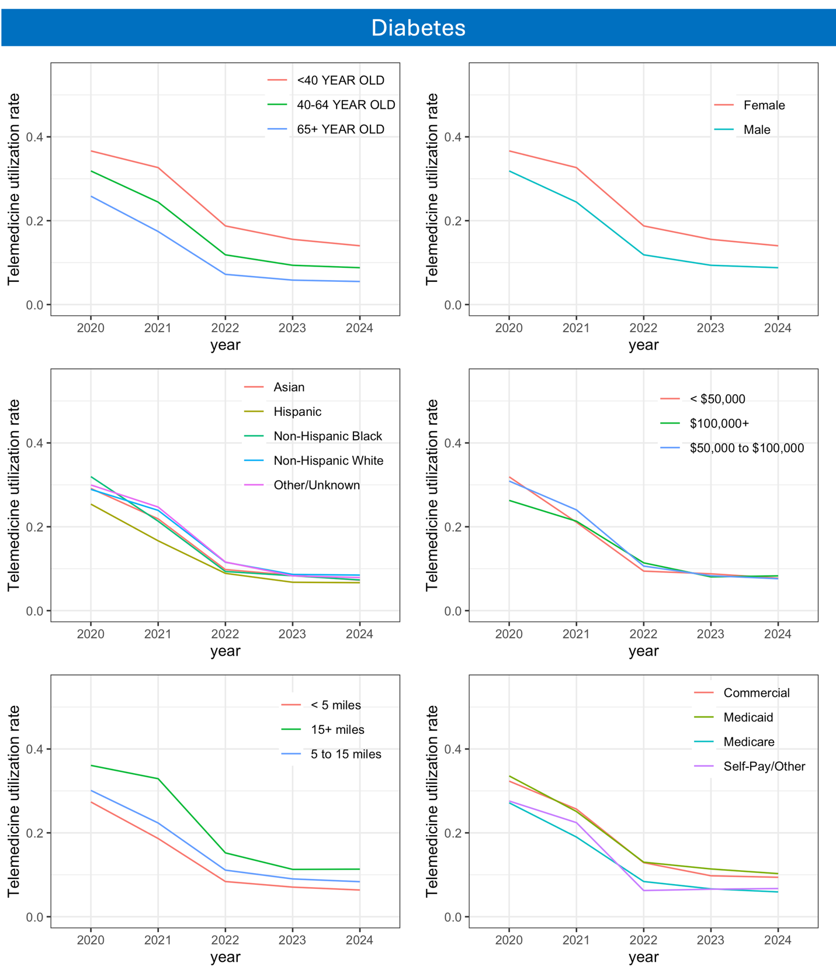

eFigure 2. Temporal patterns for MBD visits
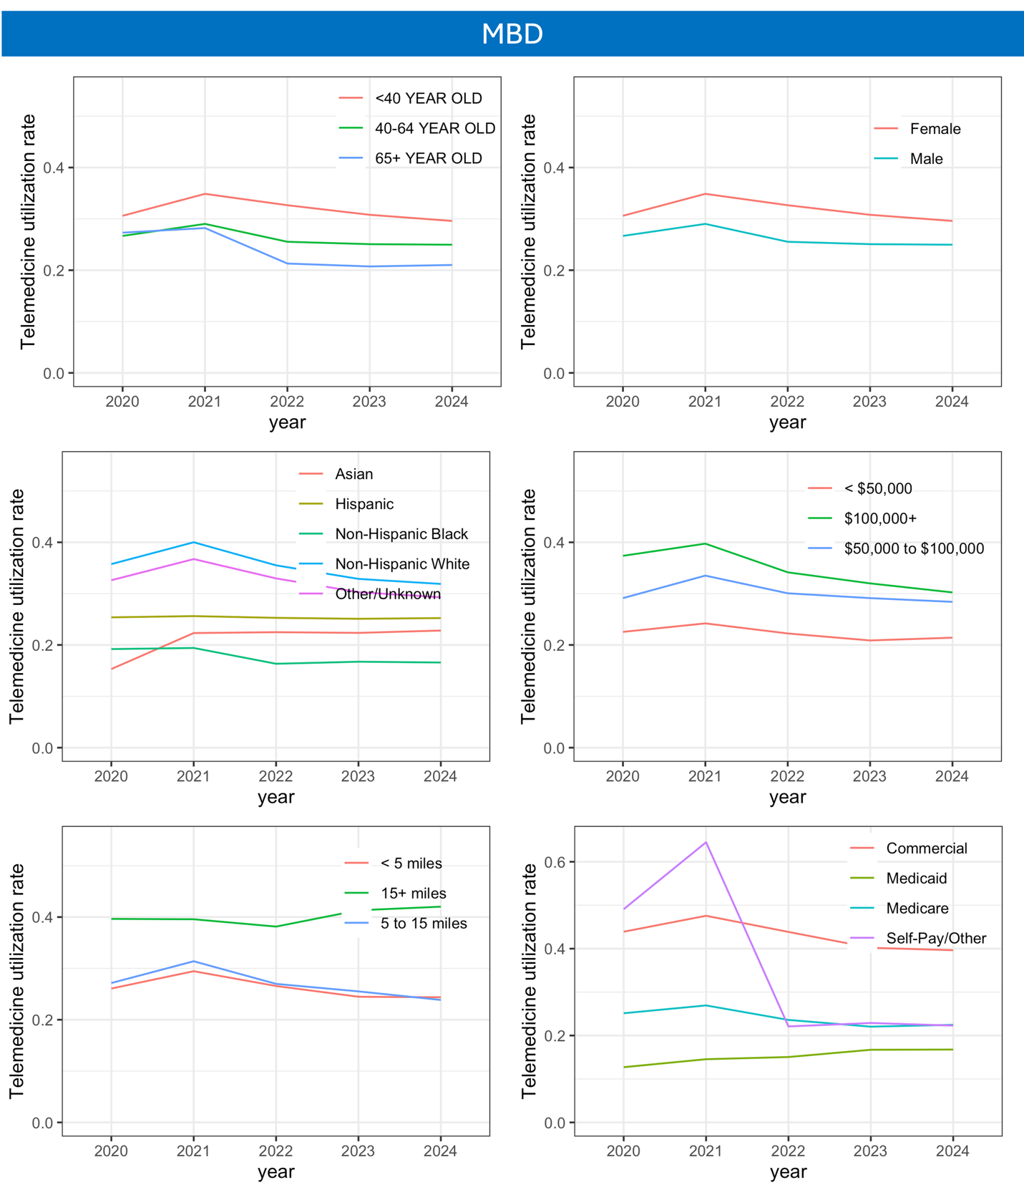

eFigure 3. Temporal patterns for sleep awake disorder visits
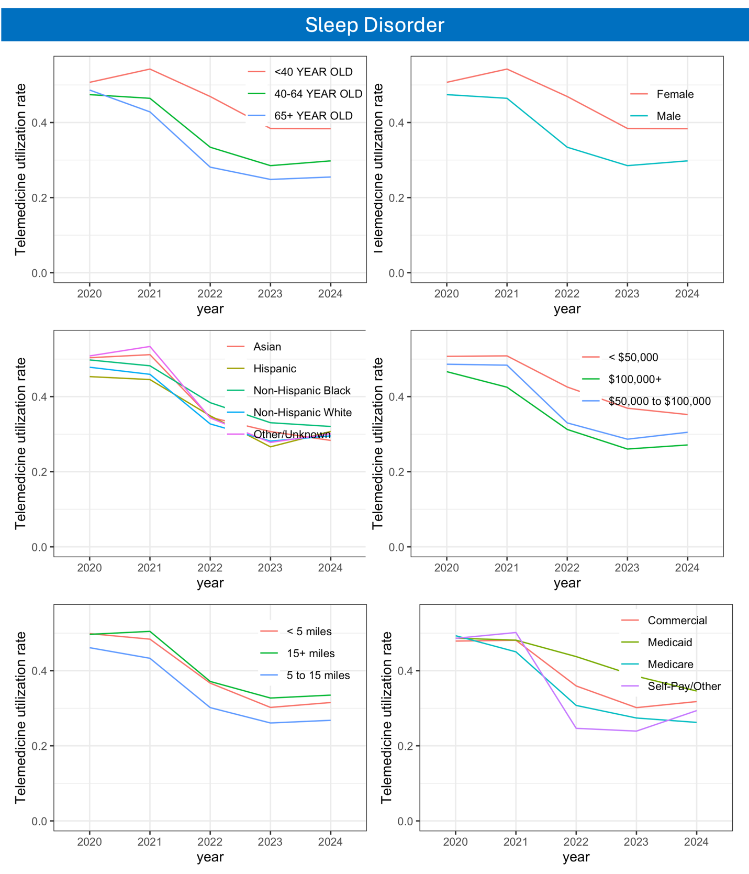

eFigure 4. Temporal patterns for heart failure visits
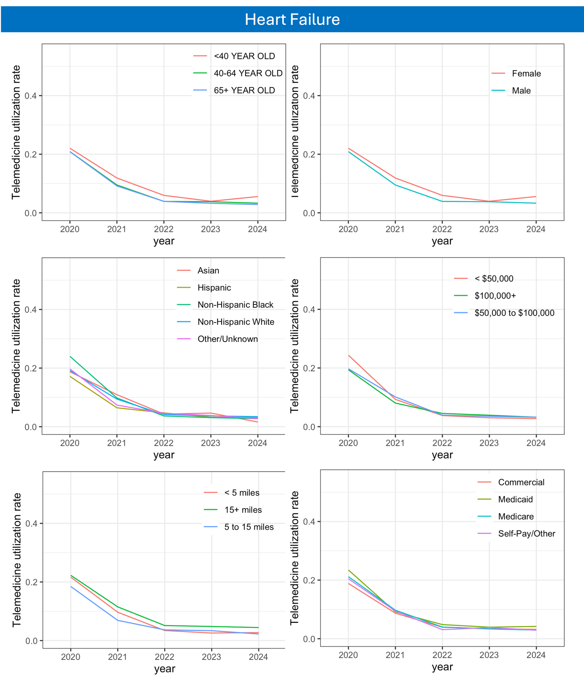

eFigure 5. Temporal patterns for COPD visits
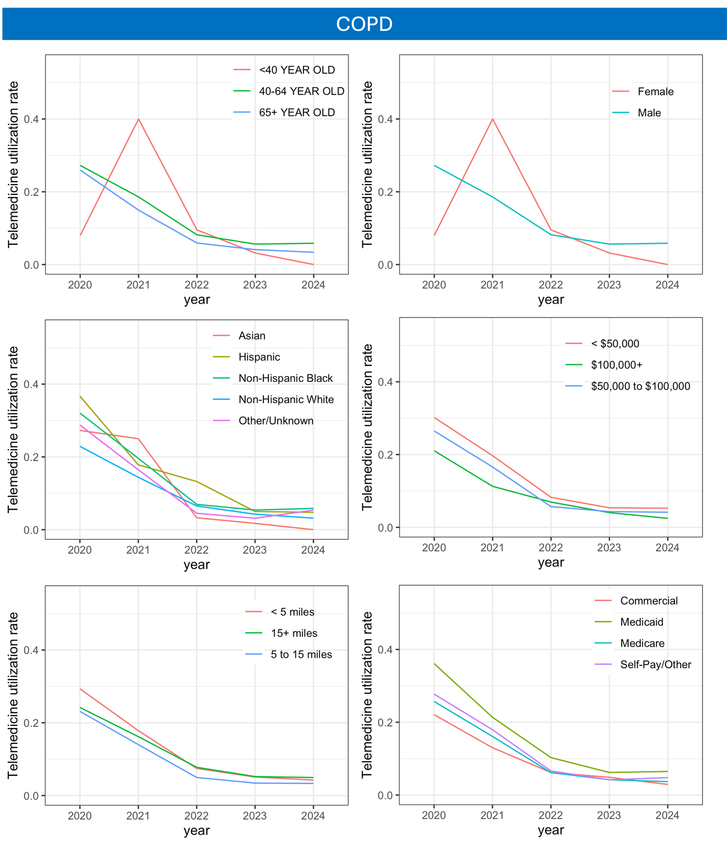

eFigure 6. Temporal patterns for CAD visits
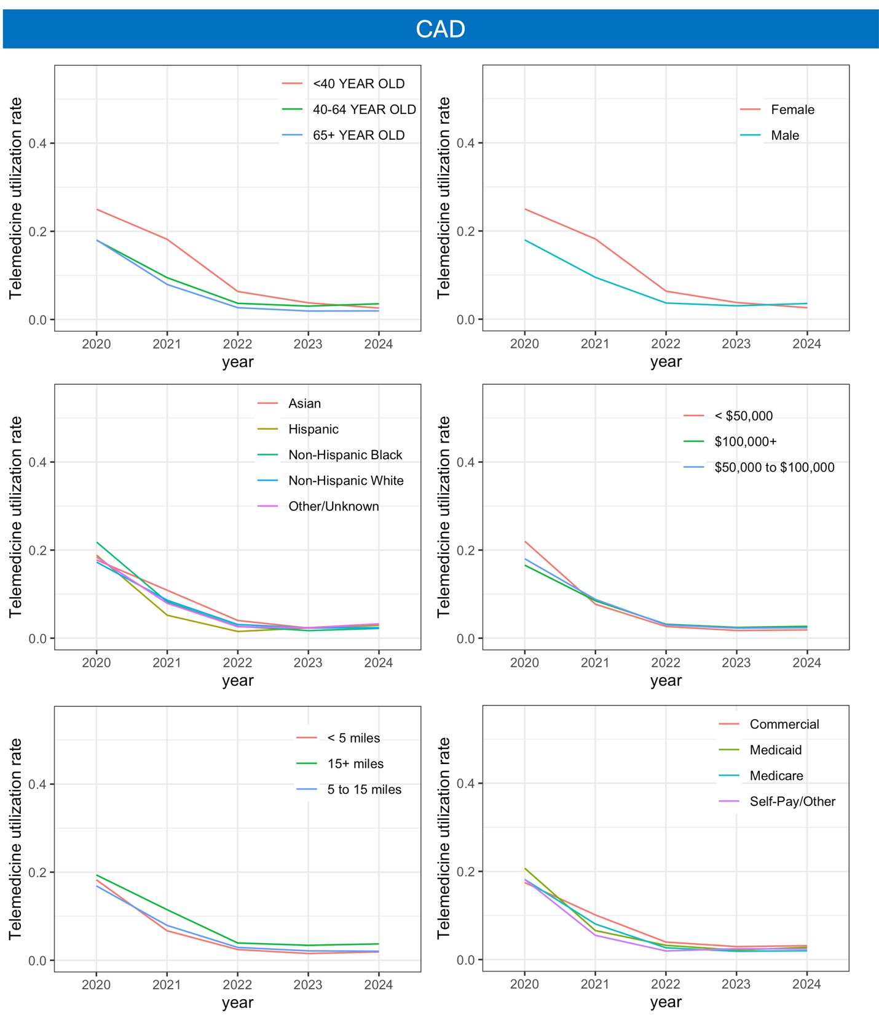

eFigure 7. Temporal patterns for GI visits
