Supplementary Appendix
Supplementary Appendix Table. HIIMS Frequently Asked Questions about Portal Uploaded Advance Directives
Question | Answer
How do we process Advance Directive documents that do not include HCAs? | - This is a Living Will. Accept the document as an Advance Directive Enduring.
How do we process End of Life DNR documents? | - Accept as an Advance Directive Enduring, if the patient signature and date are present, along with the two witness or notary signature(s) and date(s).
How should we process documents entitled Durable Power of Attorney? | - If the document is a Durable Power of Attorney for Health Care or a Power of Attorney for Health Care, process the document as an Advance Directive Enduring.  - If the document is a Financial Power of Attorney, deny the document. Reason: Invalid Form. Reason given to patient: Not an Advance Directive document.
Should we accept a document that outlines a person is resigning as a Health Care Agent? | - Yes. Accept the document as an Advance Directive Enduring.
How do we process records submitted that are not an Advance Directive, POLST, or Living Will? | - For Outside Records: Print/save off the documents and upload via ICAP. Deny the document. Reason: Invalid Form. Reason given to patient: Not an advance directive document. Include a note to explain that the submitted records will be uploaded into the UCLA chart.  - For Marriage License: Deny the document. Reason: Invalid Form. Reason given to patient: Not an advance directive document.
What should we do when the patient submits an Advance Directive as separate documents for each page? | - Print/save off the separate documents for each page, combine to a single file, and upload via ICAP. Deny the InBasket messages for each individual page. Reason: Invalid Form.
Do we deny an Advance Directive that is missing pages? | - Yes. Deny the document. Reason: Missing Documentation. Reason given to patient: Document is Missing Pages. Please re-submit document with all pages.
On an Advance Directive, the witnesses’ signatures on the document have no date. Should we accept it? | - Yes. Accept the document as an Advance Directive Enduring.
If we have a document that appears to contain all pages, signatures, and dates but it is very blurry and hard to read, what should we do? | - Deny the document. Reason: Illegible. Reason given to patient: Document is illegible or poor quality image. Please re-submit legible document.
What should we do when the patient submits a document that includes pages for a different patient? | - Deny the document. Reason: Contact name and document do not match. Reason given to patient: Document associated with an incorrect patient. Include a note to explain that the patient submitted documents for different people together, and they should re-submit the documents separately.
A patient submitted a POLST. The patient also submitted the names of individuals to include as Health Care Agents. Should we enter the individuals as Designated Surrogates? | - Yes. If there is no Advance Directive to support the individuals as Health Care Agents, they are Designated Surrogates.
In a POLST document, page 1 of 2 is complete. Page 2 is blank. Should we accept it? | - Yes. The second page is not required.
What should we do when the patient submits an Advance Directive with fillable fields, and the form is editable? | - First, make the document non-editable. (See outlined steps below). Upload the non-editable version to ICAP. Deny the InBasket messages for the fillable document. Reason: Invalid Form. Reason given to patient: Include a note to explain that the submitted document was editable. Therefore, a non-editable version has been uploaded into the UCLA chart.

Supplementary Appendix Figure 1. Modified Epic Advance Care Planning activity to facilitate advance care planning

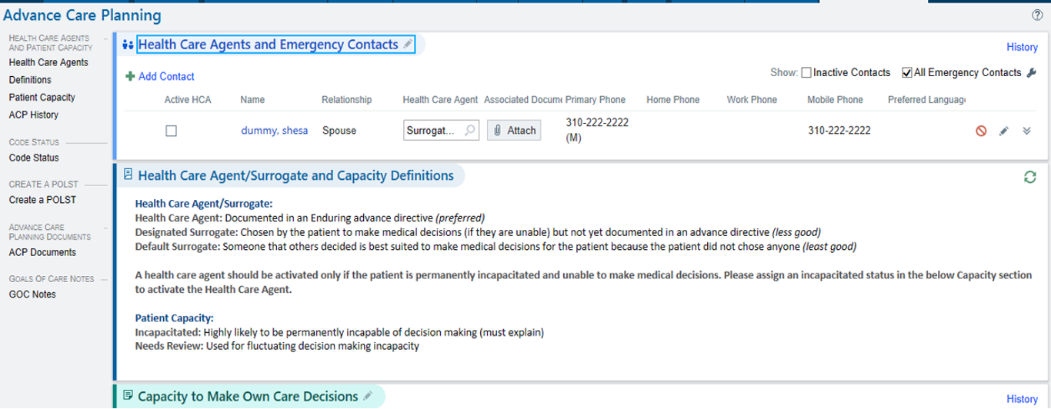

Supplementary Appendix Figure 2. Modified MyChart Advance Directive page including document and surrogate upload capability.



