Comparative effectiveness of current glucose-lowering medications in type 2 diabetes mellitus: emulation of a modified GRADE trial (Appendix)

Index

eMethods
eTable 1. Specification and Emulation of the Target Trial Using Real-World Claims Data
eTable 2. List of Component Medications in the Study Groups
eTable 3. Baseline Characteristics of Patients in the Four Study Groups Prior to Weighting for the Primary Outcome (HbA1c ≥7.0%) Analysis
eTable 4. Baseline Characteristics in the Propensity Score-Weighted Study Groups Used for the Primary Outcome (HbA1c ≥7.0%) Analysis
eTable 5. Selected Baseline Characteristics of Patients in the Four Study Groups Prior to Weighting for the Major Adverse Cardiovascular Event and Heart Failure Hospitalization (Secondary) And Hypoglycemia (Safety) Outcome Analysis
eTable 6. Selected Baseline Characteristics of Patients in the Four Study Groups Post Propensity Score-Weighting for the Major Adverse Cardiovascular Event and Heart Failure Hospitalization (Secondary) And Hypoglycemia (Safety) Outcome Analysis
eTable 7. Frequency of HbA1c Values Present in the 4 Study Groups in the Primary Outcome Analytic Cohort Over the Follow-up Period
eTable 8. Timing of HbA1c Test Ordered in Each Study Group with Stratification by Baseline HbA1c Level
eTable 9. Censoring Reasons for The Primary Outcome (HbA1c ≥7.0%) Analysis
eTable 10. Secondary outcomes in the propensity score-weighted cohorts
eTable 11. Hospitalization for Heart Failure Outcome (Primary Position)
eTable 12. Baseline Characteristics of Patients in the Cohorts With and Without At Least 1 HbA1c Value in the Follow-up Period Starting From 60 Days after Cohort Entry for the Primary Outcome (HbA1c ≥7.0%) Analysis
eTable 13. Primary Outcome (HbA1c ≥7.0%) in Contrast to GRADE Trial Results
eTable 14. Major Adverse Cardiovascular Events Outcome in Contrast to GRADE Trial Results
eTable 15. Hospitalization for Heart Failure Outcome in Contrast to GRADE Trial Results
eFigure 1. Study Design Diagram
eFigure 2. Patient Flowchart Diagram
eFigure 3. Cumulative Hazard Plot for Major Adverse Cardiovascular Events as a Secondary Outcome
eFigure 4. Cumulative Hazard Plot for Heart Failure Hospitalization (Any Position) as a Secondary Outcome
eFigure 5. Cumulative Hazard Plot for Heart Failure Hospitalization (Primary Position) as a Secondary Outcome
eFigures 6A-F. Forest Plots for Subgroup Analysis of the Primary Outcome (HbA1c ≥7.0%)
eFigure 7. Forest Plot Showing Findings of Primary and Sensitivity Analyses for Major Adverse Cardiovascular Events and Hospitalization for Heart Failure Outcome (Any Diagnosis Position)
eFigure 8. Forest Plot for the Glycemic Outcome Among Those with At Least 60 Days of Follow-up: A) Assuming Missing HbA1c Value as a Proxy for the Desired Glycemic Status (HbA1c <7.0%) and B) Missing Outcome Imputation
eFigure 9. Forest Plot for the Outcome of HbA1c Test Ordered Among Those With At Least 60 Days of Follow-up

eMethods

Details of Exclusion Criteria

Besides excluding patients whose HbA1c values were <6.0%, >9.0%, or missing in the 90 days prior to cohort entry date (CED), and those who received any combination of the study medications or glucagon-like peptide 1 receptor agonists (GLP-1RAs) indicated for obesity management (liraglutide 3mg and semaglutide 2.4mg) during the 365-day washout period, we also excluded those with ICD codes for a major cardiovascular event (defined as inpatient admission due to acute myocardial infarction (MI), prior MI, MI sequelae, acute coronary syndrome, unstable angina, stable angina, coronary atherosclerosis, coronary procedure, ischemic stroke, or peripheral artery disease) within 60 days of CED, New York Heart Association (NYHA) grade 3 or greater defined by at least 1 hospitalization for congestive heart failure (CHF) within 60 days of CED with more than 2 hospitalizations for CHF within 180 days of CED, and those with ≥3 hospitalization days (for any cause) within 30 days of CED. In accordance with the GRADE trial eligibility criteria,¹ those less than 30 years of age (and those whose age or gender information were missing on the cohort entry date) were also excluded, along with patients with any diagnoses of type 1 diabetes mellitus or secondary or gestational diabetes, prescription fills of other glucose-lowering medications (thiazolidinediones, meglitinides, sulfonylurea-1st generation, amylin analogs, alpha-glucosidase inhibitors, insulin, or tirzepatide), use of glucocorticoids or atypical antipsychotics, symptomatic hyperglycemia (in-patient or emergency department setting), pregnancy, end-stage renal disease, acute or chronic pancreatitis, liver cirrhosis, acute hepatitis, cancer including multiple endocrine neoplasia type 2, solid organ transplant, alcohol abuse/dependence, polycystic ovary syndrome, hemolytic anemia, acquired immunodeficiency syndrome (AIDS), nursing home admission, combined comorbidity score ≥10, or bariatric surgery in the 365 days prior to cohort entry.

Definitions of the Secondary Outcomes

The secondary outcomes were:

- Major adverse cardiovascular events (MACE) comprising

- non-fatal MI (identified by in-patient International Classification of Diseases [ICD]-9 410.xx [except 410.x2, subsequent episode of care] and ICD-10 I21.xx diagnosis codes at any position) OR
- non-fatal stroke (identified by in-patient ICD-9 430.xx, 431.xx, 433.x1, 434.x1, 436 and ICD-10 I60.xx, I61.xx, I63.xxx diagnosis codes at primary position) OR
- all-cause mortality

B) Hospitalization for heart failure (HHF) (identified by in-patient heart failure discharge diagnosis codes ICD-9 428, 428.0, 428.1, 428.2x, 428.3x, 428.4x, 428.9, 398.91, 402.01, 402.11, 402.91, 404.01, 404.11, 404.03, 404.13, 404.93, 404.91, and ICD-10 I09.81, I11.0, I13.0, I13.2, I50.1, I50.2x, I50.3x, I50.4x, I50.81x, I50.82, I50.83, I50.84, I50.89, I50.9)

The safety outcome was emergency visit or hospital admission for hypoglycemia identified by ICD-9 251.0, 251.1, 251.2, 962.3, and ICD-10 E10.64x, E11.641, E13.649, E15, T38.3Xx, E11.649, E13.641, E16.0, E16.1, E16.2 diagnosis codes at any position, inpatient or outpatient, with place of service as emergency rooms for emergency visit, and at primary position, inpatient, for hospital admission.

Covariates Used to Calculate Propensity Scores for Matching Weights

We included the following covariates, all assessed using administrative data or ICD codes, measured over 365 days prior to the cohort entry date, in the propensity score model:

A) Demographics: age (on cohort entry), gender, geographic region (i.e., Midwest, Northeast, South, West, others), race (i.e., non-Hispanic White, non-Hispanic Asian, non-Hispanic Black, Hispanic, and unknown/missing),
B) Lifestyle: obesity (different levels defined by diagnosis codes), smoking status, drug dependence (including opiates, cannabis, cocaine, amphetamine, hallucinogens, and anti-depressants)
C) Burden of comorbidities: combined comorbidity score,² frailty score³
D) Diabetes-related parameters: baseline glycated hemoglobin (HbA1c%), hypoglycemia, hyperglycemia
E) Diabetes complication: Diabetic retinopathy, diabetes with other ophthalmic manifestations, diabetic neuropathy, diabetic nephropathy, diabetic foot, diabetes with other complications, erectile dysfunction
F) Cardiovascular comorbidities: MI (acute/prior/sequelae), angina (unstable/stable), coronary atherosclerosis, congestive heart failure, ischemic stroke, peripheral arterial disease, diabetes with peripheral circulatory disorders, cardiomyopathy, cardiac valve disorder, atrial fibrillation
G) Kidney comorbidities: chronic kidney disease (categorized as stage 1-2, stage 3-4, and unspecified), acute kidney injury, hypertensive nephropathy, proteinuria, urinary tract infection, miscellaneous renal disease, kidney or urinary stone disease
H) Other comorbidities: liver diseases, metabolic dysfunction-associated steatohepatitis or steatotic liver disease, pneumonia, chronic obstructive pulmonary disease (COPD), dementia, hyperlipidemia, hypertension, transient ischemic attack, edema, obstructive sleep apnea, osteoarthritis, osteoporosis, fractures, falls, hypothyroidism, depression, anxiety or sleep disorder, coronavirus disease-2019 (COVID-19)
I) Non-study medications: renin angiotensin aldosterone inhibitors (angiotensin II receptor blockers and angiotensin-converting-enzyme inhibitors), beta blockers, calcium channel blockers, heart failure medications (digoxin, sacubitril/valsartan), thiazides, loop diuretics, mineralocorticoid receptor antagonists, nitrates, other antihypertensives, COPD/asthma medications (beta 2 agonist inhalant, anticholinergic inhalant, glucocorticoid inhalant), osteoporosis medications, statins, other lipid-lowering drugs, anticoagulants, antiplatelets, opioids, gabapentinoids, antidepressants, benzodiazepines, other anxiolytics or hypnotics, dementia medications (memantine, tacrine, rivastigmine, galantamine, and donepezil)
J) Health care utilization: number of hospitalizations, number of emergency department visits, number of outpatient visits, number of visits to endocrinologist, number of visits to cardiologist, number of visits to internist, number of visits to nephrologist, number of HbA1c tests ordered
K) Measure of socioeconomic status: ratio of brand vs. generic medications
L) Cohort entry year

Calculation of Average Standardized Mean Difference (SMD)
To achieve and assess baseline balance across the four study groups, we applied propensity score matching weights and calculated the standardized mean differences (SMDs) for each covariate. For each baseline covariate, the SMD was computed between the groups and then averaged across all four groups to obtain an average SMD per covariate. These average SMD values were compared against a threshold of 0.10, with values below this threshold indicating likely no important imbalance.

eTable 1. Specification and Emulation of the Target Trial Using Real-World Claims Data

Protocol component | Target trial specification | Target trial emulation using  real-world claims data
Aim | To compare the efficacy and safety of sodium-glucose cotransporter-2 inhibitors (SGLT-2is), sulfonylureas (SUs), glucagon-like peptide 1 receptor agonists (GLP-1RAs), and dipeptidyl peptidase-4 inhibitors (DPP-4is) in a 4-way comparison. | Same as target trial.
Eligibility | Adults with continuous enrollment (≥365 days) in database, who are at least 30 years old with at least one diagnosis code for type 2 diabetes mellitus (T2DM) in the past 365 days, who use metformin on trial entry, and had a HbA1c between 6% and 9%. See eMethods, Details of exclusion criteria, for the complete list of exclusion criteria. | Same as target trial.
Treatment strategies | 1. Initiate SGLT-2is  2. Initiate SUs  3. Initiate GLP-1RAs  4. Initiate DPP-4is | Same as target trial.
Treatment assignment | Randomized, non-blinded. Patients are randomly assigned to any of the 4 treatment strategies | Non-blinded and assumed to be randomized within levels of an extensive list of baseline covariates. Patients are assigned to treatment based on filled prescriptions.
Follow-up start | At assignment | 60-days after cohort entry (i.e., first dispensation of the study medication)
Follow-up end | First occurrence of safety/efficacy outcome, death, or loss to follow-up, administrative end of follow-up (end of study period), treatment addition or switching, occurrence of bariatric surgery. | For all the outcomes, follow-up ended at the first occurrence of the outcome of interest, a switch to or addition of any other glucose-lowering medication classes, bariatric surgery, death, end of data, end of the study period (August 31, 2023), 365 days after cohort entry, or disenrollment.
Outcome | Primary outcome: HbA1c ≥7.0%.  Secondary outcomes: major adverse cardiovascular events (MACE) (comprising non-fatal myocardial infarction, non-fatal stroke, or all-cause mortality), and heart failure hospitalization; hypoglycemia. | Same as target trial.
Protocol component | Target trial specification | Target trial emulation using  real-world claims data
Causal contrast | Per protocol effect (effect of receiving the treatment as stated in the protocol), assuming medications are continued as stated in the protocol until treatment addition or switching. | Observational analogue of per-protocol effect.
Statistical analysis | Estimates of incidence rates and hazard ratios comparing the treatment groups, under the assumption that loss to follow-up did not introduce bias. | Adjustment of baseline confounding via propensity score matching weights followed by calculation of incidence rates differences and hazard ratios via weighted Cox proportional hazards models, under the assumption that loss to follow-up did not introduce bias.

eTable 2. List of Component Medications in the Study Groups

Medication class | Medicines
Sodium-glucose co-transporter-2 inhibitors (SGLT-2is) | canagliflozin, dapagliflozin, empagliflozin, ertugliflozin
Sulfonylureas (SUs) | glipizide, glyburide, glimepiride
Glucagon-like peptide 1 receptor agonists (GLP-1RAs) | liraglutide, semaglutide, albiglutide, dulaglutide, exenatide, lixisenatide
Dipeptidyl peptidase-4 inhibitors (DPP-4is) | alogliptin, linagliptin, saxagliptin, sitagliptin

eTable 3. Baseline Characteristics of Patients in the Four Study Groups Prior to Propensity Score Weighting - Primary Outcome (HbA1c ≥7.0%) Analysisª

Characteristics (n (%)) | SGLT-2i  (N=5489) | SU  (N=11148) | GLP-1RA  (N=3617) | DPP-4i  (N=5069) | Average SMD
Demographics
Age (mean (SD)) (years) | 64.10 (11.16) | 67.01 (10.55) | 61.02 (11.08) | 66.13 (11.09) | 0.30
Female | 2292 (41.8) | 5117 (45.9) | 2022 (55.9) | 2475 (48.8) | 0.15
Race
White | 3322 (60.5) | 6380 (57.2) | 2384 (65.9) | 2732 (53.9) | 0.20
Black | 520 (9.5) | 1093 (9.8) | 407 (11.3) | 504 (9.9) | 0.20
Hispanic | 458 (8.3) | 934 (8.4) | 128 (3.5) | 589 (11.6) | 0.20
Asian | 872 (15.9) | 2077 (18.6) | 509 (14.1) | 982 (19.4) | 0.20
Unknown | 317 (5.8) | 664 (6.0) | 189 (5.2) | 262 (5.2) | 0.20
Region
Northeast | 645 (11.8) | 1080 (9.7) | 336 (9.3) | 619 (12.2) | 0.16
Midwest | 819 (14.9) | 1726 (15.5) | 559 (15.5) | 598 (11.8) | 0.16
South | 2672 (48.7) | 5162 (46.3) | 1958 (54.1) | 2335 (46.1) | 0.16
West | 1352 (24.6) | 3175 (28.5) | 762 (21.1) | 1513 (29.8) | 0.16
Body Mass Index (BMI)
Underweight/normal (<25 kg/m²) | 150 (2.7) | 371 (3.3) | 30 (0.8) | 186 (3.7) | 0.35
Overweight (25 - 29.9 kg/m²) | 496 (9.0) | 1024 (9.2) | 194 (5.4) | 512 (10.1) | 0.35
Obesity (30 - 39.9 kg/m²) | 548 (10.0) | 902 (8.1) | 305 (8.4) | 427 (8.4) | 0.35
Severe obesity (≥40 kg/m²) | 632 (11.5) | 989 (8.9) | 769 (21.3) | 374 (7.4) | 0.35
Unspecified Obesity | 981 (17.9) | 1579 (14.2) | 991 (27.4) | 741 (14.6) | 0.35
Unknown/missing | 2682 (48.9) | 6283 (56.4) | 1328 (36.7) | 2829 (55.8) | 0.35
Risk behaviors
Drug abuse or dependence | 76 (1.4) | 193 (1.7) | 67 (1.9) | 81 (1.6) | 0.02
Smoking | 838 (15.3) | 1780 (16.0) | 627 (17.3) | 689 (13.6) | 0.06
Burden of comorbidities
Combined comorbidity score (mean (SD)) | 1.12 (1.82) | 1.17 (1.86) | 1.03 (1.64) | 1.13 (1.84) | 0.04
Frailty score (mean (SD)) | 0.14 (0.04) | 0.14 (0.04) | 0.14 (0.04) | 0.14 (0.04) | 0.04
Frailty score categories
Robust (<0.10) | 521 (9.8) | 1018 (9.4) | 342 (9.7) | 482 (9.8) | 0.04
Pre-frail (0.10-0.19) | 4471 (83.7) | 8957 (82.6) | 2892 (82.1) | 4052 (82.3) | 0.04
Frail (≥0.20) | 349 (6.5) | 866 (8.0) | 287 (8.2) | 390 (7.9) | 0.04
Diabetes-related parameters
Baseline HbA1c % (mean (SD)) | 7.50 (0.74) | 7.66 (0.74) | 7.33 (0.81) | 7.54 (0.72) | 0.23
Baseline HbA1c %
Quartile 1 (6.0 - 7.0) | 1566 (28.5) | 2345 (21.0) | 1491 (41.2) | 1296 (25.6) | 0.25
Quartile 2 (7.1 - 7.6) | 1588 (28.9) | 3081 (27.6) | 857 (23.7) | 1565 (30.9) | 0.25
Quartile 3 (7.7 - 8.1) | 981 (17.9) | 2082 (18.7) | 481 (13.3) | 882 (17.4) | 0.25
Quartile 4 (8.2 - 9.0) | 1354 (24.7) | 3640 (32.7) | 788 (21.8) | 1326 (26.2) | 0.25
Hypoglycemia | 996 (18.1) | 1802 (16.2) | 660 (18.2) | 812 (16.0) | 0.04
Hyperglycemia (with HHS/DKA) | 2055 (37.4) | 3632 (32.6) | 1400 (38.7) | 1662 (32.8) | 0.08
Cardiovascular comorbidities
MI (acute/old/sequelae) | 205 (3.7) | 328 (2.9) | 78 (2.2) | 113 (2.2) | 0.05
Angina (unstable/stable) | 325 (5.9) | 515 (4.6) | 139 (3.8) | 213 (4.2) | 0.05
Coronary atherosclerosis (with procedure) | 1031 (18.8) | 1655 (14.8) | 452 (12.5) | 677 (13.4) | 0.09
Characteristics (n (%)) | SGLT-2i  (N=5489) | SU  (N=11148) | GLP-1RA  (N=3617) | DPP-4i  (N=5069) | Average SMD
Cardiovascular comorbidities
Congestive heart failure | 355 (6.5) | 567 (5.1) | 165 (4.6) | 251 (5.0) | 0.04
Ischemic stroke | 294 (5.4) | 597 (5.4) | 162 (4.5) | 281 (5.5) | 0.02
Diabetes with peripheral circulatory disorders | 626 (11.4) | 1212 (10.9) | 295 (8.2) | 492 (9.7) | 0.06
Peripheral artery disease | 371 (6.8) | 851 (7.6) | 167 (4.6) | 356 (7.0) | 0.07
Cardiomyopathy | 170 (3.1) | 245 (2.2) | 66 (1.8) | 106 (2.1) | 0.04
Valve disorders | 423 (7.7) | 736 (6.6) | 209 (5.8) | 340 (6.7) | 0.04
Atrial fibrillation | 372 (6.8) | 710 (6.4) | 172 (4.8) | 265 (5.2) | 0.05
Kidney comorbidities
CKD Stage 1-2 | 330 (6.0) | 742 (6.7) | 164 (4.5) | 315 (6.2) | 0.05
CKD Stage 3-4 | 523 (9.5) | 1323 (11.9) | 226 (6.2) | 587 (11.6) | 0.11
CKD unspecified | 128 (2.3) | 267 (2.4) | 72 (2.0) | 132 (2.6) | 0.02
eGFR (mean (SD))^{b} | 84.49 (18.37) | 80.82 (19.57) | 86.14 (18.35) | 82.46 (18.95) | 0.16
Acute kidney injury | 72 (1.3) | 171 (1.5) | 38 (1.1) | 81 (1.6) | 0.03
Hypertensive nephropathy | 374 (6.8) | 886 (7.9) | 176 (4.9) | 343 (6.8) | 0.06
Proteinuria | 336 (6.1) | 563 (5.1) | 163 (4.5) | 280 (5.5) | 0.04
Diabetic nephropathy | 956 (17.4) | 2100 (18.8) | 449 (12.4) | 910 (18.0) | 0.09
Miscellaneous renal disease | 306 (5.6) | 731 (6.6) | 186 (5.1) | 337 (6.6) | 0.04
Kidney and urinary stone disease | 176 (3.2) | 349 (3.1) | 158 (4.4) | 184 (3.6) | 0.04
Other comorbidities
Liver disease | 143 (2.6) | 256 (2.3) | 78 (2.2) | 119 (2.3) | 0.02
MASH/MAFLD | 368 (6.7) | 573 (5.1) | 346 (9.6) | 318 (6.3) | 0.09
Pneumonia | 78 (1.4) | 163 (1.5) | 60 (1.7) | 49 (1.0) | 0.03
COPD | 340 (6.2) | 819 (7.3) | 224 (6.2) | 339 (6.7) | 0.03
Dementia | 81 (1.5) | 233 (2.1) | 40 (1.1) | 120 (2.4) | 0.06
Hyperlipidemia | 4797 (87.4) | 9584 (86.0) | 3051 (84.4) | 4429 (87.4) | 0.05
Hypertension | 4455 (81.2) | 9061 (81.3) | 2872 (79.4) | 4075 (80.4) | 0.03
Transient ischemic attack | 60 (1.1) | 131 (1.2) | 29 (0.8) | 47 (0.9) | 0.02
Edema | 324 (5.9) | 596 (5.3) | 235 (6.5) | 268 (5.3) | 0.03
Diabetic retinopathy | 316 (5.8) | 769 (6.9) | 165 (4.6) | 346 (6.8) | 0.06
Diabetes with other ophthalmic manifestations | 452 (8.2) | 968 (8.7) | 186 (5.1) | 456 (9.0) | 0.08
Diabetic neuropathy | 849 (15.5) | 2115 (19.0) | 577 (16.0) | 933 (18.4) | 0.06
Diabetic foot  (with infection or amputation of lower limb) | 168 (3.1) | 384 (3.4) | 125 (3.5) | 140 (2.8) | 0.02
Erectile dysfunction | 275 (5.0) | 479 (4.3) | 171 (4.7) | 207 (4.1) | 0.03
Diabetes with other complications | 375 (6.8) | 725 (6.5) | 247 (6.8) | 322 (6.4) | 0.01
COVID-19 | 175 (3.2) | 182 (1.6) | 174 (4.8) | 71 (1.4) | 0.12
Obstructive sleep apnea | 887 (16.2) | 1326 (11.9) | 924 (25.5) | 594 (11.7) | 0.20
Osteoarthritis | 894 (16.3) | 1784 (16.0) | 665 (18.4) | 833 (16.4) | 0.03
Osteoporosis without fractures | 227 (4.1) | 490 (4.4) | 134 (3.7) | 292 (5.8) | 0.05
Fractures | 55 (1.0) | 115 (1.0) | 39 (1.1) | 47 (0.9) | 0.01
Falls | 150 (2.7) | 315 (2.8) | 110 (3.0) | 161 (3.2) | 0.02
Hypothyroidism | 951 (17.3) | 2011 (18.0) | 787 (21.8) | 1011 (19.9) | 0.06
Depression | 675 (12.3) | 1345 (12.1) | 649 (17.9) | 573 (11.3) | 0.10
Anxiety and sleep disorders | 928 (16.9) | 1680 (15.1) | 888 (24.6) | 798 (15.7) | 0.13
Characteristics (n (%)) | SGLT-2i  (N=5489) | SU  (N=11148) | GLP-1RA  (N=3617) | DPP-4i  (N=5069) | Average SMD
Non-study medications
Renin angiotensin aldosterone inhibitors^{c} | 4083 (74.4) | 8509 (76.3) | 2646 (73.2) | 3795 (74.9) | 0.04
Beta blockers | 1883 (34.3) | 3794 (34.0) | 1089 (30.1) | 1623 (32.0) | 0.05
Calcium channel blockers | 1540 (28.1) | 3331 (29.9) | 939 (26.0) | 1444 (28.5) | 0.05
Heart failure medications (digoxin/Entresto) | 114 (2.1) | 146 (1.3) | 24 (0.7) | 69 (1.4) | 0.06
Thiazides | 826 (15.0) | 1692 (15.2) | 649 (17.9) | 714 (14.1) | 0.05
Loop diuretics | 414 (7.5) | 844 (7.6) | 314 (8.7) | 336 (6.6) | 0.04
Mineralocorticoid | 193 (3.5) | 260 (2.3) | 133 (3.7) | 101 (2.0) | 0.06
Nitrates | 233 (4.2) | 398 (3.6) | 115 (3.2) | 160 (3.2) | 0.03
Other anti-hypertensives | 252 (4.6) | 614 (5.5) | 146 (4.0) | 239 (4.7) | 0.04
COPD/Asthma medications | 612 (11.1) | 1141 (10.2) | 511 (14.1) | 603 (11.9) | 0.06
Antiosteoporosis | 154 (2.8) | 384 (3.4) | 83 (2.3) | 236 (4.7) | 0.07
Statins | 4535 (82.6) | 8864 (79.5) | 2854 (78.9) | 4071 (80.3) | 0.05
Other lipid medications (including PCSK9is) | 792 (14.4) | 1405 (12.6) | 475 (13.1) | 753 (14.9) | 0.04
Anticoagulants (oral) | 370 (6.7) | 651 (5.8) | 210 (5.8) | 249 (4.9) | 0.04
Antiplatelet | 467 (8.5) | 773 (6.9) | 197 (5.4) | 323 (6.4) | 0.06
Opioids | 977 (17.8) | 2244 (20.1) | 782 (21.6) | 1016 (20.0) | 0.05
Gabapentin | 552 (10.1) | 1326 (11.9) | 485 (13.4) | 538 (10.6) | 0.06
Antidepressants | 1215 (22.1) | 2383 (21.4) | 1210 (33.5) | 1080 (21.3) | 0.14
Benzodiazepines | 469 (8.5) | 1056 (9.5) | 411 (11.4) | 491 (9.7) | 0.05
Anxiolytics hypnotics | 291 (5.3) | 508 (4.6) | 297 (8.2) | 245 (4.8) | 0.08
Dementia medicines | 50 (0.9) | 158 (1.4) | 16 (0.4) | 96 (1.9) | 0.08
Healthcare utilization
Hospitalizations | 178 (3.2) | 356 (3.2) | 92 (2.5) | 137 (2.7) | 0.03
Emergency department visits | 954 (17.4) | 1826 (16.4) | 684 (18.9) | 881 (17.4) | 0.03
Office visits | 5481 (99.9) | 11122 (99.8) | 3613 (99.9) | 5056 (99.7) | 0.02
Endocrine visits | 431 (7.9) | 482 (4.3) | 390 (10.8) | 371 (7.3) | 0.13
Cardiologist visits | 1539 (28.0) | 2777 (24.9) | 907 (25.1) | 1254 (24.7) | 0.04
Internists visit | 5254 (95.7) | 10722 (96.2) | 3400 (94.0) | 4897 (96.6) | 0.07
Nephrologist | 228 (4.2) | 504 (4.5) | 99 (2.7) | 292 (5.8) | 0.08
Number of HbA1c tests ordered (mean (SD)) | 2.68 (1.01) | 2.68 (1.01) | 2.65 (0.96) | 2.70 (1.02) | 0.03
Socioeconomic status parameters (mean (SD))
Ratio of brand/generic medicines | 1.02 (0.05) | 1.02 (0.05) | 1.02 (0.05) | 1.02 (0.06) | 0.04
Cohort entry year
2014 | 122 (2.2) | 759 (6.8) | 83 (2.3) | 494 (9.7) | 0.57
2015 | 235 (4.3) | 995 (8.9) | 98 (2.7) | 437 (8.6) | 0.57
2016 | 261 (4.8) | 1183 (10.6) | 122 (3.4) | 606 (12.0) | 0.57
2017 | 365 (6.6) | 1430 (12.8) | 203 (5.6) | 668 (13.2) | 0.57
2018 | 388 (7.1) | 1269 (11.4) | 217 (6.0) | 587 (11.6) | 0.57
2019 | 602 (11.0) | 1345 (12.1) | 378 (10.5) | 593 (11.7) | 0.57
2020 | 742 (13.5) | 1380 (12.4) | 479 (13.2) | 615 (12.1) | 0.57
2021 | 1441 (26.3) | 1756 (15.8) | 1012 (28.0) | 694 (13.7) | 0.57
2022 | 1333 (24.3) | 1031 (9.2) | 1025 (28.3) | 375 (7.4) | 0.57
Abbreviations: BMI, body mass index; CKD, chronic kidney disease; COPD, chronic obstructive pulmonary disease; COVID-19, coronavirus disease-19; DKA, diabetic ketoacidosis; DPP-4i, dipeptidyl peptidase-4 inhibitor; eGFR, estimated glomerular filtration rate; GLP-1RA, glucagon-like peptide-1 receptor agonist; HbA1c, hemoglobin A1c; HHS, hyperosmolar hyperglycemic state; MI, myocardial infarction; MASH/MASLD, metabolic dysfunction-associated steatohepatitis/metabolic dysfunction-associated steatotic liver disease; PCSK9is, proprotein convertase subtilisin/kexin type 9 inhibitors; SD, standard deviation; SGLT-2i, sodium-glucose cotransporter-2 inhibitor; SMD, standardized mean difference; SU, sulfonylurea
ªThose with at least 60 days follow-up after cohort entry with ≥1 HbA1c value in the follow-up period (after 60 days of cohort entry)
^{b}Missing: 13% for SGLT2-is, 14.8% for SUs, 15.8% for GLP-1RAs, and 11.2% for DPP-4is; not included in propensity score
^{c}Includes angiotensin-converting enzyme inhibitors (ACEis) and angiotensin II receptor blockers (ARBs)
eTable 4. Baseline Characteristics of Patients in the Four Study Groups after Propensity Score Weighting- Primary Outcome (HbA1c ≥7.0%) Analysisª

Characteristics (n (%)) | SGLT-2i  (N=2065) | SU  (N=2015) | GLP-1RA  (N=2006) | DPP-4i  (N=2006) | Average SMD
Demographics
Age (mean (SD)) (years) | 63.00 (11.04) | 63.29 (11.34) | 63.24 (10.51) | 63.53 (11.52) | 0.02
Female | 1076 (52.1) | 1027 (51.0) | 1010 (50.3) | 1069 (53.3) | 0.03
Race
White | 1295 (62.7) | 1256 (62.3) | 1266 (63.1) | 1241 (61.9) | 0.03
Black | 219 (10.6) | 214 (10.6) | 212 (10.6) | 228 (11.4) | 0.03
Hispanic | 101 (4.9) | 107 (5.3) | 103 (5.1) | 108 (5.4) | 0.03
Asian | 341 (16.5) | 332 (16.5) | 320 (15.9) | 324 (16.2) | 0.03
Unknown/missing | 109 (5.3) | 106 (5.3) | 106 (5.3) | 105 (5.2) | 0.03
Region
Northeast | 214 (10.3) | 199 (9.9) | 199 (9.9) | 204 (10.2) | 0.02
Midwest | 299 (14.5) | 284 (14.1) | 282 (14.0) | 289 (14.4) | 0.02
South | 1069 (51.8) | 1055 (52.4) | 1046 (52.2) | 1050 (52.3) | 0.02
West | 483 (23.4) | 476 (23.6) | 478 (23.8) | 463 (23.1) | 0.02
Body Mass Index (BMI)
Underweight/normal (< 25 kg/m²) | 27 (1.3) | 29 (1.5) | 28 (1.4) | 29 (1.4) | 0.02
Overweight (25 - 29.9 kg/m²) | 155 (7.5) | 156 (7.7) | 146 (7.3) | 139 (6.9) | 0.02
Obese (30 - 39.9 kg/m²) | 194 (9.4) | 197 (9.8) | 189 (9.4) | 187 (9.3) | 0.02
Morbid obese (≥ 40 kg/m²) | 277 (13.4) | 260 (12.9) | 262 (13.0) | 262 (13.1) | 0.02
Unspecified Obesity | 445 (21.5) | 432 (21.5) | 439 (21.9) | 433 (21.6) | 0.02
Unknown/missing | 967 (46.8) | 942 (46.7) | 941 (46.9) | 956 (47.7) | 0.02
Risk behaviors
Drug abuse or dependence | 37 (1.8) | 34 (1.7) | 34 (1.7) | 32 (1.6) | 0.01
Smoking | 321 (15.5) | 313 (15.6) | 323 (16.1) | 300 (14.9) | 0.02
Burden of comorbidities
Combined comorbidity score (mean (SD)) | 0.96 (1.68) | 1.03 (1.68) | 1.07 (1.70) | 0.99 (1.70) | 0.04
Frailty score (mean (SD)) | 0.14 (0.04) | 0.14 (0.04) | 0.14 (0.04) | 0.14 (0.04) | 0.02
Frailty score categories
Robust (<0.10) | 186 (9.3) | 196 (10.0) | 200 (10.2) | 207 (10.6) | 0.03
Pre-frail (0.10-0.19) | 1685 (83.9) | 1619 (82.6) | 1608 (82.4) | 1609 (82.5) | 0.03
Frail (≥0.20) | 137 (6.8) | 145 (7.4) | 144 (7.4) | 135 (6.9) | 0.03
Diabetes-related parameters
Baseline HbA1c % (mean (SD)) | 7.47 (0.76) | 7.48 (0.76) | 7.51 (0.78) | 7.48 (0.76) | 0.03
Baseline HbA1c %
Quartile 1 (6.0 - 7.0) | 651 (31.5) | 601 (29.8) | 583 (29.1) | 637 (31.8) | 0.04
Quartile 2 (7.1 - 7.6) | 565 (27.3) | 578 (28.7) | 568 (28.3) | 539 (26.8) | 0.04
Quartile 3 (7.7 - 8.1) | 332 (16.1) | 324 (16.1) | 323 (16.1) | 308 (15.4) | 0.04
Quartile 4 (8.2 - 9.0) | 517 (25.1) | 511 (25.3) | 532 (26.5) | 522 (26.0) | 0.04
Hypoglycemia | 98 (4.7) | 93 (4.6) | 99 (4.9) | 92 (4.6) | 0.01
Hyperglycemia (with HHS/DKA) | 365 (17.6) | 376 (18.7) | 358 (17.8) | 354 (17.7) | 0.01
Cardiovascular comorbidities
MI (acute/old/sequelae) | 42 (2.1) | 43 (2.1) | 47 (2.3) | 42 (2.1) | 0.01
Angina (unstable/stable) | 75 (3.6) | 76 (3.8) | 78 (3.9) | 83 (4.2) | 0.01
Coronary atherosclerosis (with procedure) | 262 (12.7) | 254 (12.6) | 256 (12.8) | 247 (12.3) | 0.01
Congestive heart failure | 87 (4.2) | 95 (4.7) | 101 (5.0) | 91 (4.5) | 0.02
Ischemic stroke | 98 (4.8) | 101 (5.0) | 100 (5.0) | 99 (5.0) | 0.01
Characteristics (n (%)) | SGLT-2i  (N=2065) | SU  (N=2015) | GLP-1RA  (N=2006) | DPP-4i  (N=2006) | Average SMD
Cardiovascular comorbidities
Diabetes with peripheral circulatory disorders | 176 (8.5) | 182 (9.0) | 173 (8.6) | 174 (8.7) | 0.01
Peripheral artery disease | 111 (5.4) | 111 (5.5) | 113 (5.6) | 108 (5.4) | 0.01
Cardiomyopathy | 36 (1.7) | 43 (2.1) | 44 (2.2) | 31 (1.6) | 0.03
Valve disorders | 127 (6.1) | 121 (6.0) | 123 (6.1) | 125 (6.2) | 0.01
Atrial fibrillation | 94 (4.6) | 104 (5.1) | 106 (5.3) | 93 (4.6) | 0.02
Kidney comorbidities
CKD Stage 1-2 | 99 (4.8) | 96 (4.8) | 108 (5.4) | 99 (4.9) | 0.02
CKD Stage 3-4 | 154 (7.5) | 160 (7.9) | 171 (8.5) | 152 (7.6) | 0.02
CKD unspecified | 44 (2.1) | 42 (2.1) | 44 (2.2) | 46 (2.3) | 0.01
eGFR (mean (SD))^{b} | 85.81 (18.11) | 84.45 (19.73) | 84.23 (18.47) | 84.67 (18.83) | 0.05
Acute kidney injury | 25 (1.2) | 22 (1.1) | 24 (1.2) | 26 (1.3) | 0.01
Hypertensive nephropathy | 114 (5.5) | 113 (5.6) | 119 (5.9) | 109 (5.4) | 0.01
Proteinuria | 94 (4.6) | 93 (4.6) | 100 (5.0) | 96 (4.8) | 0.01
Diabetic nephropathy | 285 (13.8) | 285 (14.1) | 292 (14.6) | 277 (13.8) | 0.01
Miscellaneous renal disease | 111 (5.4) | 111 (5.5) | 118 (5.9) | 106 (5.3) | 0.01
Kidney and urinary stone | 76 (3.7) | 82 (4.1) | 79 (3.9) | 73 (3.6) | 0.01
Other comorbidities
Liver disease | 47 (2.3) | 42 (2.1) | 41 (2.0) | 43 (2.2) | 0.01
MASH/MASLD | 156 (7.5) | 158 (7.9) | 164 (8.2) | 152 (7.6) | 0.01
Pneumonia | 28 (1.4) | 26 (1.3) | 28 (1.4) | 20 (1.0) | 0.02
COPD | 124 (6.0) | 128 (6.4) | 130 (6.5) | 119 (5.9) | 0.01
Dementia | 24 (1.2) | 28 (1.4) | 26 (1.3) | 29 (1.4) | 0.01
Hyperlipidemia | 1787 (86.5) | 1737 (86.2) | 1722 (85.8) | 1716 (85.5) | 0.02
Hypertension | 1640 (79.4) | 1613 (80.0) | 1613 (80.4) | 1592 (79.4) | 0.02
Transient ischemic attack | 17 (0.8) | 18 (0.9) | 19 (0.9) | 18 (0.9) | 0.01
Edema | 115 (5.6) | 115 (5.7) | 106 (5.3) | 115 (5.8) | 0.01
Diabetic retinopathy | 104 (5.0) | 108 (5.4) | 111 (5.5) | 108 (5.4) | 0.01
Diabetes with other ophthalmic manifestations | 120 (5.8) | 127 (6.3) | 132 (6.6) | 128 (6.4) | 0.02
Diabetic neuropathy | 338 (16.4) | 329 (16.3) | 346 (17.3) | 344 (17.1) | 0.02
Diabetic foot  (with infection or amputation of lower limb) | 59 (2.9) | 58 (2.9) | 55 (2.7) | 61 (3.0) | 0.01
Erectile dysfunction | 140 (6.8) | 134 (6.7) | 145 (7.2) | 135 (6.7) | 0.01
Diabetes with other complications | 754 (36.5) | 762 (37.8) | 777 (38.7) | 750 (37.4) | 0.03
COVID-19 | 60 (2.9) | 60 (3.0) | 54 (2.7) | 57 (2.8) | 0.01
Obstructive sleep apnea | 378 (18.3) | 356 (17.7) | 368 (18.3) | 351 (17.5) | 0.01
Osteoarthritis | 360 (17.4) | 353 (17.5) | 351 (17.5) | 343 (17.1) | 0.01
Osteoporosis without fractures | 87 (4.2) | 84 (4.2) | 83 (4.1) | 91 (4.6) | 0.01
Fractures | 21 (1.0) | 18 (0.9) | 20 (1.0) | 22 (1.1) | 0.01
Falls | 60 (2.9) | 61 (3.0) | 61 (3.0) | 69 (3.4) | 0.02
Hypothyroidism | 421 (20.4) | 404 (20.0) | 406 (20.3) | 410 (20.4) | 0.01
Depression | 296 (14.3) | 294 (14.6) | 286 (14.2) | 276 (13.8) | 0.01
Anxiety and sleep disorders | 417 (20.2) | 405 (20.1) | 399 (19.9) | 375 (18.7) | 0.02
Non-study medications
Renin angiotensin aldosterone inhibitors^{c} | 1530 (74.1) | 1497 (74.3) | 1505 (75.0) | 1482 (73.9) | 0.01
Beta blockers | 621 (30.1) | 619 (30.7) | 617 (30.8) | 607 (30.2) | 0.01
Calcium channel blockers | 548 (26.5) | 544 (27.0) | 558 (27.8) | 534 (26.6) | 0.02
Heart failure medications (digoxin/Entresto) | 16 (0.8) | 16 (0.8) | 17 (0.8) | 16 (0.8) | 0.00
Thiazides | 336 (16.3) | 321 (15.9) | 320 (16.0) | 342 (17.1) | 0.02
Loop diuretics | 147 (7.1) | 143 (7.1) | 146 (7.3) | 147 (7.3) | 0.01
Mineralocorticoid | 48 (2.3) | 49 (2.4) | 55 (2.7) | 55 (2.8) | 0.02
Nitrates | 64 (3.1) | 63 (3.1) | 66 (3.3) | 61 (3.0) | 0.01
Characteristics (n (%)) | SGLT-2i  (N=2065) | SU  (N=2015) | GLP-1RA  (N=2006) | DPP-4i  (N=2006) | Average SMD
Non-study medications
Other anti-hypertensives | 84 (4.1) | 82 (4.1) | 86 (4.3) | 90 (4.5) | 0.01
COPD/Asthma medications | 267 (12.9) | 267 (13.3) | 261 (13.0) | 255 (12.7) | 0.01
Antiosteoporosis | 64 (3.1) | 59 (2.9) | 57 (2.8) | 61 (3.1) | 0.01
Statins | 1653 (80.1) | 1622 (80.5) | 1610 (80.2) | 1612 (80.3) | 0.01
Other lipid medications (including PCSK9i) | 285 (13.8) | 280 (13.9) | 275 (13.7) | 285 (14.2) | 0.01
Anticoagulants (oral) | 105 (5.1) | 112 (5.6) | 114 (5.7) | 109 (5.4) | 0.01
Antiplatelet | 123 (5.9) | 122 (6.0) | 116 (5.8) | 108 (5.4) | 0.02
Opioids | 414 (20.0) | 414 (20.6) | 421 (21.0) | 411 (20.5) | 0.01
Gabapentin | 236 (11.4) | 244 (12.1) | 245 (12.2) | 231 (11.5) | 0.02
Antidepressants | 564 (27.3) | 546 (27.1) | 554 (27.6) | 527 (26.3) | 0.02
Benzodiazepines | 212 (10.3) | 209 (10.3) | 205 (10.2) | 215 (10.7) | 0.01
Anxiolytics hypnotics | 132 (6.4) | 130 (6.4) | 136 (6.8) | 123 (6.1) | 0.01
Dementia medicines | 12 (0.6) | 16 (0.8) | 15 (0.7) | 14 (0.7) | 0.01
Healthcare utilization
Hospitalizations | 49 (2.4) | 55 (2.7) | 59 (2.9) | 48 (2.4) | 0.02
Emergency department visits | 378 (18.3) | 363 (18.0) | 374 (18.7) | 352 (17.6) | 0.02
Office visits | 2061 (99.8) | 2011 (99.8) | 2002 (99.8) | 2003 (99.9) | 0.01
Endocrine visits | 185 (8.9) | 177 (8.8) | 186 (9.3) | 181 (9.0) | 0.01
Cardiologist visits | 506 (24.5) | 498 (24.7) | 505 (25.2) | 483 (24.1) | 0.01
Internists visit | 1972 (95.5) | 1919 (95.2) | 1907 (95.1) | 1912 (95.3) | 0.01
Nephrologist | 67 (3.3) | 64 (3.2) | 75 (3.7) | 71 (3.5) | 0.02
Number of HbA1c tests ordered (mean (SD)) | 2.66 (1.00) | 2.66 (0.99) | 2.67 (0.98) | 2.68 (1.02) | 0.01
Socioeconomic status parameter (mean (SD))
Ratio of brand/generic medicines | 1.02 (0.05) | 1.02 (0.05) | 1.02 (0.05) | 1.02 (0.05) | 0.02
Cohort entry year
2014 | 81 (3.9) | 66 (3.3) | 71 (3.5) | 71 (3.5) | 0.06
2015 | 100 (4.9) | 82 (4.1) | 88 (4.4) | 90 (4.5) | 0.06
2016 | 112 (5.4) | 105 (5.2) | 108 (5.4) | 113 (5.6) | 0.06
2017 | 189 (9.2) | 157 (7.8) | 171 (8.5) | 174 (8.7) | 0.06
2018 | 191 (9.2) | 173 (8.6) | 186 (9.3) | 177 (8.8) | 0.06
2019 | 272 (13.2) | 255 (12.6) | 265 (13.2) | 268 (13.3) | 0.06
2020 | 308 (14.9) | 335 (16.6) | 324 (16.1) | 301 (15.0) | 0.06
2021 | 482 (23.3) | 516 (25.6) | 493 (24.6) | 485 (24.2) | 0.06
2022 | 330 (16.0) | 326 (16.2) | 300 (15.0) | 328 (16.3) | 0.06
Abbreviations: BMI, body mass index; CKD, chronic kidney disease; COPD, chronic obstructive pulmonary disease; COVID-19, coronavirus disease-19; DKA, diabetic ketoacidosis; DPP-4i, dipeptidyl peptidase-4 inhibitor; eGFR, estimated glomerular filtration rate; GLP-1RA, glucagon-like peptide-1 receptor agonist; HbA1c, hemoglobin A1c; HHS, hyperosmolar hyperglycemic state; MI, myocardial infarction; MASH/MASLD, metabolic dysfunction-associated steatohepatitis/metabolic dysfunction-associated steatotic liver disease; PCSK9is, proprotein convertase subtilisin/kexin type 9 inhibitors; SD, standard deviation; SGLT-2i, sodium-glucose cotransporter-2 inhibitor; SMD, standardized mean difference; SU, sulfonylurea
ªThose with at least 60 days follow-up after cohort entry with ≥1 HbA1c value in the follow-up period (after 60 days of cohort entry)
^{b}Missing: 12.5% for SGLT2-is, 15.5% for SUs, 14.4% for GLP-1RAs, and 14.4% for DPP-4is; not included in propensity score
^{c}Includes angiotensin-converting enzyme inhibitors (ACEis) and angiotensin II receptor blockers (ARBs)

eTable 5. Selected Baseline Characteristics of Patients in the Four Study Groups Prior to Propensity Score Weighting - Secondary Outcome Analysisª

Characteristics (n (%)) | SGLT-2i  (N=7123) | SU  (N=14019) | GLP-1RA  (N=4648) | DPP-4i  (N=6656) | Average SMD
Demographics
Age (mean (SD)) (years) | 63.62 (11.30) | 66.54 (10.80) | 60.50 (11.23) | 65.82 (11.35) | 0.30
Female | 2997 (42.1) | 6443 (46.0) | 2604 (56.0) | 3251 (48.8) | 0.15
Burden of comorbidities
Combined comorbidity score (mean (SD)) | 1.12 (1.83) | 1.16 (1.87) | 1.03 (1.64) | 1.15 (1.87) | 0.04
Frailty score (mean (SD)) | 0.14 (0.04) | 0.14 (0.04) | 0.14 (0.04) | 0.14 (0.04) | 0.04
Frailty score categories
Robust (<0.10) | 673 (9.4) | 1270 (9.1) | 437 (9.4) | 605 (9.1) | 0.15
Pre-frail (0.10-0.19) | 5974 (83.9) | 11618 (82.9) | 3841 (82.6) | 5508 (82.8) | 0.15
Frail (≥0.20) | 476 (6.7) | 1131 (8.1) | 370 (8.0) | 543 (8.2) | 0.15
Diabetes-related parameters
Baseline HbA1c % (mean (SD)) | 7.52 (0.75) | 7.67 (0.74) | 7.35 (0.81) | 7.55 (0.73) | 0.22
Baseline HbA1c %
Quartile 1 (6.0 - 7.0) | 2002 (28.1) | 2975 (21.2) | 1861 (40.0) | 1684 (25.3) | 0.24
Quartile 2 (7.1 - 7.6) | 2002 (28.1) | 3806 (27.1) | 1115 (24.0) | 2005 (30.1) | 0.24
Quartile 3 (7.7 - 8.1) | 1279 (18.0) | 2628 (18.7) | 624 (13.4) | 1182 (17.8) | 0.24
Quartile 4 (8.2 - 9.0) | 1840 (25.8) | 4610 (32.9) | 1048 (22.5) | 1785 (26.8) | 0.24
Hypoglycemia | 1245 (17.5) | 2270 (16.2) | 828 (17.8) | 1031 (15.5) | 0.04
Hyperglycemia (with HHS/DKA) | 2679 (37.6) | 4638 (33.1) | 1813 (39.0) | 2192 (32.9) | 0.08
Cardiovascular comorbidities
MI (acute/old/sequelae) | 256 (3.6) | 418 (3.0) | 101 (2.2) | 160 (2.4) | 0.05
Angina (unstable/stable) | 438 (6.1) | 659 (4.7) | 181 (3.9) | 290 (4.4) | 0.06
Coronary atherosclerosis (with procedure) | 1295 (18.2) | 2065 (14.7) | 558 (12.0) | 918 (13.8) | 0.09
Congestive heart failure | 461 (6.5) | 731 (5.2) | 210 (4.5) | 344 (5.2) | 0.04
Ischemic stroke | 372 (5.2) | 753 (5.4) | 194 (4.2) | 370 (5.6) | 0.03
Diabetes with peripheral circulatory disorders | 784 (11.0) | 1487 (10.6) | 388 (8.3) | 656 (9.9) | 0.05
Hyperlipidemia | 6176 (86.7) | 12004 (85.6) | 3909 (84.1) | 5789 (87.0) | 0.05
Hypertension | 5743 (80.6) | 11386 (81.2) | 3664 (78.8) | 5367 (80.6) | 0.03
Kidney comorbidities
CKD Stage 1-2 | 406 (5.7) | 889 (6.3) | 201 (4.3) | 385 (5.8) | 0.05
CKD Stage 3-4 | 661 (9.3) | 1631 (11.6) | 289 (6.2) | 755 (11.3) | 0.11
Diabetic nephropathy | 1173 (16.5) | 2567 (18.3) | 552 (11.9) | 1164 (17.5) | 0.10
Other comorbidities
Diabetic retinopathy | 412 (5.8) | 933 (6.7) | 213 (4.6) | 451 (6.8) | 0.05
Diabetic neuropathy | 1134 (15.9) | 2615 (18.7) | 751 (16.2) | 1200 (18.0) | 0.04
Diabetes with other complications | 494 (6.9) | 923 (6.6) | 331 (7.1) | 430 (6.5) | 0.02
MASH/MASLD | 486 (6.8) | 717 (5.1) | 448 (9.6) | 426 (6.4) | 0.09
Obstructive sleep apnea | 1167 (16.4) | 1687 (12.0) | 1166 (25.1) | 786 (11.8) | 0.20
Osteoarthritis | 1167 (16.4) | 2246 (16.0) | 852 (18.3) | 1104 (16.6) | 0.03
Hypothyroidism | 1236 (17.4) | 2475 (17.7) | 999 (21.5) | 1295 (19.5) | 0.06
Non-study medications
Renin angiotensin aldosterone inhibitors^{b} | 5295 (74.3) | 10668 (76.1) | 3378 (72.7) | 4977 (74.8) | 0.04
Beta blockers | 2432 (34.1) | 4723 (33.7) | 1364 (29.3) | 2145 (32.2) | 0.06
Calcium channel blockers | 2018 (28.3) | 4171 (29.8) | 1163 (25.0) | 1907 (28.7) | 0.05
Thiazides | 1070 (15.0) | 2133 (15.2) | 813 (17.5) | 950 (14.3) | 0.05
Loop diuretics | 529 (7.4) | 1061 (7.6) | 390 (8.4) | 471 (7.1) | 0.03
Characteristics (n (%)) | SGLT-2i  (N=7123) | SU  (N=14019) | GLP-1RA  (N=4648) | DPP-4i  (N=6656) | Average SMD
Non-study medications
Mineralocorticoids | 249 (3.5) | 330 (2.4) | 162 (3.5) | 144 (2.2) | 0.05
Statins | 5859 (82.3) | 11072 (79.0) | 3634 (78.2) | 5298 (79.6) | 0.05
Opioids | 1304 (18.3) | 2860 (20.4) | 1011 (21.8) | 1380 (20.7) | 0.04
Gabapentinoids | 779 (10.9) | 1676 (12.0) | 620 (13.3) | 707 (10.6) | 0.05
Healthcare utilization
Hospitalizations | 239 (3.4) | 470 (3.4) | 123 (2.6) | 213 (3.2) | 0.02
Emergency department visits | 1283 (18.0) | 2379 (17.0) | 913 (19.6) | 1223 (18.4) | 0.04
Endocrine visits | 560 (7.9) | 607 (4.3) | 510 (11.0) | 470 (7.1) | 0.13
Cardiologist visits | 1980 (27.8) | 3482 (24.8) | 1157 (24.9) | 1673 (25.1) | 0.04
Number of HbA1c tests ordered (mean (SD)) | 2.64 (1.00) | 2.64 (1.01) | 2.63 (0.96) | 2.68 (1.01) | 0.03
Cohort entry year
2014 | 167 (2.3) | 976 (7.0) | 105 (2.3) | 657 (9.9) | 0.55
2015 | 311 (4.4) | 1212 (8.6) | 127 (2.7) | 573 (8.6) | 0.55
2016 | 348 (4.9) | 1459 (10.4) | 164 (3.5) | 778 (11.7) | 0.55
2017 | 479 (6.7) | 1748 (12.5) | 265 (5.7) | 872 (13.1) | 0.55
2018 | 520 (7.3) | 1630 (11.6) | 295 (6.3) | 799 (12.0) | 0.55
2019 | 803 (11.3) | 1703 (12.1) | 483 (10.4) | 742 (11.1) | 0.55
2020 | 995 (14.0) | 1791 (12.8) | 634 (13.6) | 808 (12.1) | 0.55
2021 | 1873 (26.3) | 2190 (15.6) | 1299 (27.9) | 933 (14.0) | 0.55
2022 | 1627 (22.8) | 1310 (9.3) | 1276 (27.5) | 494 (7.4) | 0.55
Abbreviations: CKD, chronic kidney disease; DKA, diabetic ketoacidosis; DPP-4i, dipeptidyl peptidase-4 inhibitor; GLP-1RA, glucagon-like peptide-1 receptor agonist; HbA1c, hemoglobin A1c; HHS, hyperosmolar hyperglycemic state; MI, myocardial infarction; MASH/MASLD, metabolic dysfunction-associated steatohepatitis/metabolic dysfunction-associated steatotic liver disease; SD, standard deviation; SGLT-2i, sodium-glucose cotransporter-2 inhibitor; SMD, standardized mean difference; SU, sulfonylurea
ªLarger than the primary analytic cohort since it is not censored for having at least 60 days of follow-up after cohort entry
^{b}Includes angiotensin-converting enzyme inhibitors (ACEis) and angiotensin II receptor blockers (ARBs)

eTable 6. Selected Baseline Characteristics of Patients in the Four Study Groups After Propensity Score Weighting - Secondary Outcome Analysisª

Characteristics (n (%)) | SGLT-2i  (N=2747) | SU  (N=2679) | GLP-1RA  (N=2670) | DPP-4i  (N=2675) | Average SMD
Demographics
Age (mean (SD)) (years) | 62.53 (11.21) | 62.81 (11.49) | 62.80 (10.66) | 63.12 (11.72) | 0.03
Female | 1435 (52.2) | 1376 (51.4) | 1370 (51.3) | 1424 (53.2) | 0.02
Burden of comorbidities
Combined comorbidity score (mean (SD)) | 0.98 (1.68) | 1.03 (1.70) | 1.07 (1.70) | 1.01 (1.71) | 0.03
Frailty score (mean (SD)) | 0.14 (0.04) | 0.14 (0.04) | 0.14 (0.04) | 0.14 (0.04) | 0.02
Frailty score categories
Robust (<0.10) | 243 (8.8) | 259 (9.7) | 252 (9.5) | 265 (9.9) | 0.02
Pre-frail (0.10-0.19) | 2315 (84.3) | 2222 (82.9) | 2217 (83.0) | 2225 (83.2) | 0.02
Frail (≥0.20) | 189 (6.9) | 198 (7.4) | 200 (7.5) | 185 (6.9) | 0.02
Diabetes-related parameters
Baseline HbA1c % (mean (SD)) | 7.48 (0.76) | 7.50 (0.76) | 7.52 (0.78) | 7.49 (0.76) | 0.03
Baseline HbA1c %
Quartile 1 (6.0 - 7.0) | 854 (31.1) | 791 (29.5) | 765 (28.7) | 831 (31.0) | 0.04
Quartile 2 (7.1 - 7.6) | 748 (27.2) | 754 (28.1) | 740 (27.7) | 715 (26.7) | 0.04
Quartile 3 (7.7 - 8.1) | 443 (16.1) | 431 (16.1) | 439 (16.4) | 425 (15.9) | 0.04
Quartile 4 (8.2 - 9.0) | 702 (25.6) | 703 (26.2) | 726 (27.2) | 705 (26.3) | 0.04
Hypoglycemia | 129 (4.7) | 126 (4.7) | 129 (4.8) | 121 (4.5) | 0.01
Hyperglycemia (with HHS/DKA) | 475 (17.3) | 485 (18.1) | 466 (17.4) | 462 (17.3) | 0.01
Cardiovascular comorbidities
MI (acute/old/sequelae) | 59 (2.2) | 59 (2.2) | 65 (2.4) | 57 (2.1) | 0.01
Angina (unstable/stable) | 100 (3.6) | 105 (3.9) | 111 (4.2) | 112 (4.2) | 0.02
Coronary atherosclerosis (with procedure) | 347 (12.6) | 337 (12.6) | 340 (12.7) | 334 (12.5) | 0.00
Congestive heart failure | 118 (4.3) | 125 (4.7) | 135 (5.0) | 123 (4.6) | 0.02
Ischemic stroke | 128 (4.7) | 127 (4.7) | 131 (4.9) | 127 (4.8) | 0.01
Diabetes with peripheral circulatory disorders | 236 (8.6) | 246 (9.2) | 235 (8.8) | 240 (9.0) | 0.01
Hyperlipidemia | 2366 (86.1) | 2294 (85.6) | 2284 (85.5) | 2283 (85.3) | 0.01
Hypertension | 2175 (79.2) | 2139 (79.8) | 2144 (80.3) | 2122 (79.3) | 0.02
Kidney comorbidities
CKD Stage 1-2 | 123 (4.5) | 124 (4.6) | 138 (5.2) | 129 (4.8) | 0.02
CKD Stage 3-4 | 206 (7.5) | 209 (7.8) | 225 (8.4) | 209 (7.8) | 0.02
Diabetic nephropathy | 364 (13.3) | 369 (13.8) | 383 (14.3) | 365 (13.6) | 0.02
Other comorbidities
Diabetic retinopathy | 139 (5.0) | 142 (5.3) | 147 (5.5) | 146 (5.4) | 0.01
Diabetic neuropathy | 450 (16.4) | 444 (16.6) | 464 (17.4) | 463 (17.3) | 0.02
Diabetes with other complications | 1018 (37.1) | 1023 (38.2) | 1044 (39.1) | 1008 (37.7) | 0.02
MASH/MASLD | 213 (7.8) | 214 (8.0) | 225 (8.4) | 210 (7.9) | 0.01
Obstructive sleep apnea | 496 (18.0) | 474 (17.7) | 495 (18.5) | 470 (17.6) | 0.01
Osteoarthritis | 480 (17.5) | 476 (17.8) | 476 (17.8) | 458 (17.1) | 0.01
Hypothyroidism | 552 (20.1) | 528 (19.7) | 539 (20.2) | 537 (20.1) | 0.01
Non-study medications
Renin angiotensin aldosterone inhibitors^{b} | 2025 (73.7) | 1984 (74.1) | 1996 (74.7) | 1974 (73.8) | 0.01
Beta blockers | 821 (29.9) | 814 (30.4) | 814 (30.5) | 807 (30.1) | 0.01
Calcium channel blockers | 718 (26.1) | 719 (26.9) | 734 (27.5) | 701 (26.2) | 0.02
Thiazides | 448 (16.3) | 432 (16.1) | 436 (16.3) | 453 (16.9) | 0.01
Loop diuretics | 197 (7.2) | 191 (7.1) | 201 (7.5) | 198 (7.4) | 0.01
Characteristics (n (%)) | SGLT-2i  (N=2747) | SU  (N=2679) | GLP-1RA  (N=2670) | DPP-4i  (N=2675) | Average SMD
Non-study medications
Mineralocorticoids | 69 (2.5) | 69 (2.6) | 75 (2.8) | 75 (2.8) | 0.01
Statins | 2186 (79.6) | 2138 (79.8) | 2126 (79.6) | 2123 (79.3) | 0.01
Opioids | 561 (20.4) | 563 (21.0) | 575 (21.5) | 552 (20.6) | 0.02
Gabapentinoids | 324 (11.8) | 324 (12.1) | 328 (12.3) | 309 (11.5) | 0.01
Healthcare utilization
Hospitalizations | 72 (2.6) | 80 (3.0) | 85 (3.2) | 67 (2.5) | 0.02
Emergency department visits | 509 (18.5) | 499 (18.6) | 513 (19.2) | 488 (18.2) | 0.01
Endocrine visits | 251 (9.1) | 238 (8.9) | 250 (9.4) | 240 (9.0) | 0.01
Cardiologist visits | 674 (24.5) | 654 (24.4) | 674 (25.3) | 643 (24.0) | 0.02
Number of HbA1c tests ordered (mean (SD)) | 2.64 (0.99) | 2.64 (0.99) | 2.65 (0.98) | 2.65 (1.00) | 0.01
Cohort entry year
2014 | 107 (3.9) | 86 (3.2) | 92 (3.5) | 92 (3.4) | 0.06
2015 | 131 (4.8) | 109 (4.1) | 119 (4.4) | 117 (4.4) | 0.06
2016 | 152 (5.5) | 139 (5.2) | 147 (5.5) | 156 (5.8) | 0.06
2017 | 253 (9.2) | 210 (7.8) | 228 (8.5) | 233 (8.7) | 0.06
2018 | 257 (9.3) | 240 (8.9) | 254 (9.5) | 250 (9.3) | 0.06
2019 | 344 (12.5) | 330 (12.3) | 339 (12.7) | 341 (12.8) | 0.06
2020 | 418 (15.2) | 446 (16.6) | 435 (16.3) | 409 (15.3) | 0.06
2021 | 652 (23.7) | 690 (25.8) | 655 (24.5) | 650 (24.3) | 0.06
2022 | 433 (15.8) | 430 (16.0) | 402 (15.0) | 428 (16.0) | 0.06
Abbreviations: CKD, chronic kidney disease; DKA, diabetic ketoacidosis; DPP-4i, dipeptidyl peptidase-4 inhibitor; GLP-1RA, glucagon-like peptide-1 receptor agonist; HbA1c, hemoglobin A1c; HHS, hyperosmolar hyperglycemic state; MI, myocardial infarction; MASH/MASLD, metabolic dysfunction-associated steatohepatitis/metabolic dysfunction-associated steatotic liver disease; SD, standard deviation; SGLT-2i, sodium-glucose cotransporter-2 inhibitor; SMD, standardized mean difference; SU, sulfonylurea
ªLarger than the primary analytic cohort since it is not censored for having at least 60 days of follow-up after cohort entry
^{b}Includes angiotensin-converting enzyme inhibitors (ACEis) and angiotensin II receptor blockers (ARBs)

eTable 7. Number of HbA1c Values Present in the 4 Study Groups in the Weighted Primary Outcome Analytic Cohort over the Follow-up Period (Starting 60 Days after Cohort Entry)

Parameter | SGLT-2i  (N=2065) | SU  (N=2015) | GLP-1RA  (N=2006) | DPP-4i  (N=2006)
Mean | 2.3 | 2.2 | 2.3 | 2.1
Median (IQR) | 2 (1-3) | 2 (1-3) | 2 (1-3) | 2 (1-3)
Abbreviations: DPP-4i, dipeptidyl peptidase-4 inhibitor; GLP-1RA, glucagon-like peptide-1 receptor agonist; HbA1c, hemoglobin A1c; IQR inter-quartile range; SGLT-2i, sodium-glucose cotransporter-2 inhibitor; SU, sulfonylurea

eTable 8. Timing of Hba1c Test Ordered in Each Weighted Study Group with Stratification by Baseline HbA1c Level

Parameter | SGLT-2i  (N=1989) |  | SU  (N=1942) |  | GLP-1RA  (N=1925) |  | DPP-4i  (N=1925)
Days between cohort entry date and first HbA1c test ordered
Mean (days) | 133 |  | 139 |  | 128 |  | 132
Median (IQR) (days) | 112 (88-163) |  | 119 (91-175) |  | 109 (86-156) |  | 112 (88-163)
 | <7.0%  (N=538) | ≥7.0%  (N=1451) | <7.0%  (N=500) | ≥7.0%  (N=1442) | <7.0%  (N=493) | ≥7.0%  (N=1432) | <7.0%  (N=512) | ≥7.0%  (N=1413)
Mean (days) | 136 | 131 | 146 | 137 | 132 | 126 | 137 | 129
Median (IQR) (days) | 119  (88-170) | 110  (88-160) | 128  (94-182) | 115  (90-173) | 114  (87-167) | 106  (86-153) | 118  (89-171) | 108  (88-161)
Abbreviations: DPP-4i, dipeptidyl peptidase-4 inhibitor; GLP-1RA, glucagon-like peptide-1 receptor agonist; HbA1c, hemoglobin A1c; IQR inter-quartile range; SGLT-2i, sodium-glucose cotransporter-2 inhibitor; SU, sulfonylurea

eTable 9. Censoring Reasons for the Primary Outcome (HbA1c ≥7.0%) Analysisª

Censoring reasons (n (%)) | SGLT-2i  (N=2065) | SU  (N=2015) | GLP-1RA  (N=2006) | DPP-4i  (N=2006)
Switch to/addition of other study medications OR bariatric surgery | 65 (3.1) | 64 (3.2) | 107 (5.3) | 96 (4.8)
Death^{b} | <11 | <11 | <11 | <11
Disenrollment | 101 (4.9) | 89 (4.4) | 149 (7.4) | 90 (4.5)
Maximum follow-up  (i.e., 365 days from the cohort entry date) | 722 (56.9) | 792 (39.3) | 935 (46.6) | 700 (34.9)
Primary outcome occurred | 1176 (56.9) | 1066 (52.9) | 810 (40.4) | 1117 (55.7)
Abbreviations: DPP-4i, dipeptidyl peptidase-4 inhibitor; GLP-1RA, glucagon-like peptide-1 receptor agonist; SGLT-2i, sodium-glucose cotransporter-2 inhibitor; SU, sulfonylurea
ªThose with at least 60 days follow-up after cohort entry with ≥1 HbA1c value in the follow-up period (after 60 days of cohort entry)
^{b}Optum's de-identified Clinformatics® Data Mart cell suppression rule for n<11

eTable 10. Secondary outcomes in the propensity score-weighted cohortsª

Parameters | SGLT-2i | GLP-1RA | DPP-4i | SU
No. of patients | 2747 | 2670 | 2675 | 2679
MACE
No. of events | 28 | 26 | 32 | 32
Follow-up time (median (IQR)), days | 365 (228 – 365) | 365 (248 – 365) | 365 (224 – 365) | 365 (320 – 365)
IR/100 PYs (95% CI) | 1.3 (1.0 – 1.6) | 1.2 (0.8 – 1.6) | 1.5 (1.1 – 1.9) | 1.4 (1.1 – 1.7)
Pairwise HRs (95% CI)^{b}
SGLT-2i | - | 1.07  (0.70 to 1.64) | 0.84  (0.58 to 1.23) | 0.89  (0.66 to 1.21)
GLP-1RA | - | - | 0.79  (0.50 to 1.24) | 0.84  (0.56 to 1.25)
DPP-4i | - | - | - | 1.06  (0.76 to 1.49)
HHF^{c}
No. of events | 20 | 24 | 22 | 31
Follow-up time (median (IQR)), days | 365 (227 – 365) | 365 (315 – 365) | 365 (246 – 365) | 365 (223 – 365)
IR/100 PYs (95% CI) | 0.92 (0.67 – 1.19) | 1.13 (0.71 – 1.55) | 1.05 (0.7 – 1.41) | 1.47 (1.18 – 1.76)
Pairwise HRs (95% CI)^{b}
SGLT-2i | - | 0.82  (0.52 to 1.31) | 0.88  (0.52 to 1.31) | 0.63  (0.45 to 0.89)
GLP-1RA | - | - | 1.07  (0.65 to 1.76) | 0.77  (0.51 to 1.17)
DPP-4i | - | - | - | 0.72  (0.49 to 1.06)
Hypoglycemia^{d}
IR/100 PYs (95% CI) | 0.02  (0.00 – 0.05) | 0 | 0.003  (0.00 – 0.011) | 0.32  (0.18 – 0.45)
Abbreviations: CI, confidence interval; DPP-4i, dipeptidyl peptidase-4 inhibitor; GLP-1RA, glucagon-like peptide-1 receptor agonist; HbA1c, hemoglobin A1c; HHF, hospitalization for heart failure; HR, hazard ratio; IQR inter-quartile range; IR, incidence rate; MACE, major adverse cardiovascular events; PY, person year; SGLT-2i, sodium-glucose cotransporter-2 inhibitor; SU, sulfonylurea
ªLarger than the primary outcome analytic cohort since it is not censored for having at least 60 days of follow-up after cohort entry
^{b}Comparing row medication to column medication
^{c}Defined as a heart failure discharge diagnosis in any diagnosis position
^{d}Optum's de-identified Clinformatics® Data Mart cell suppression rule with n<11 and hence we are reporting only IR with 95% CI for these outcomes

eTable 11. Hospitalization for Heart Failure Outcome (Primary Position)ª

Parameter | SGLT-2i  (N=2747) | SU  (N=2679) | GLP-1RA  (N=2670) | DPP-4i  (N=2675)
IR/100 PYs (95% CI) | 0.23 (0.08 – 0.39) | 0.47 (0.20 – 0.74) | 0.41 (0.19 – 0.64) | 0.44 (0.28 – 0.60)
Abbreviations: CI, confidence interval; DPP-4i, dipeptidyl peptidase-4 inhibitor; GLP-1RA, glucagon-like peptide-1 receptor agonist; IR, incidence rate; PY, person year; SGLT-2i, sodium-glucose cotransporter-2 inhibitor; SU, sulfonylurea
ªOptum's de-identified Clinformatics® Data Mart cell suppression rule with n<11 and hence we are reporting only IR with 95% CI

eTable 12. Baseline Characteristics of Patients in the Cohorts With and Without At Least 1 HbA1c Value in the Follow-up Period Starting from 60 Days After Cohort Entry

Characteristics (n (%)) | Cohort with ≥1 HbA1c value in the follow-up period starting from 60 days after cohort entry  (N=25323)ª | Cohort without any HbA1c value in the follow-up period starting from 60 days after cohort entry  (N=5284)^{b} | SMD
Study medications
SGLT-2i | 5489 (21.7) | 1172 (22.2) | 0.06
SU | 11148 (44.0) | 2208 (41.8) | 0.06
GLP-1RA | 3617 (14.3) | 742 (14.0) | 0.06
DPP-4i | 5069 (20.0) | 1162 (22.0) | 0.06
Demographics
Age (mean (SD)) (years) | 65.35 (11.06) | 63.34 (11.99) | 0.17
Female | 11906 (47.0) | 2453 (46.4) | 0.01
Burden of comorbidities (mean (SD))
Combined comorbidity score | 1.13 (1.82) | 1.09 (1.86) | 0.02
Frailty score | 0.14 (0.04) | 0.14 (0.04) | 0.05
Diabetes-related parameters
Baseline HbA1c % (mean (SD)) | 7.56 (0.76) | 7.58 (0.78) | 0.03
Baseline HbA1c %
Quartile 1 (6.0 - 7.0) | 6698 (26.5) | 1389 (26.3) | 0.05
Quartile 2 (7.1 - 7.6) | 7091 (28.0) | 1367 (25.9) | 0.05
Quartile 3 (7.7 - 8.1) | 4426 (17.5) | 951 (18.0) | 0.05
Quartile 4 (8.2 - 9.0) | 7108 (28.1) | 1577 (29.8) | 0.05
Hypoglycemia | 4270 (16.9) | 817 (15.5) | 0.04
Hyperglycemia (with HHS/DKA) | 8749 (34.5) | 1882 (35.6) | 0.02
Cardiovascular comorbidities
Coronary atherosclerosis  (with procedure) | 3815 (15.1) | 757 (14.3) | 0.02
Congestive heart failure | 1338 (5.3) | 286 (5.4) | 0.01
Ischemic stroke | 1334 (5.3) | 254 (4.8) | 0.02
Diabetes with peripheral circulatory disorders | 2625 (10.4) | 507 (9.6) | 0.03
Cardiomyopathy | 587 (2.3) | 97 (1.8) | 0.03
Valve disorders | 1708 (6.7) | 281 (5.3) | 0.06
Atrial fibrillation | 1519 (6.0) | 292 (5.5) | 0.02
Kidney comorbidities
CKD Stage 1-2 | 1551 (6.1) | 240 (4.5) | 0.07
CKD Stage 3-4 | 2659 (10.5) | 490 (9.3) | 0.04
Diabetic nephropathy | 4415 (17.4) | 760 (14.4) | 0.08
Other comorbidities
Diabetic retinopathy | 1596 (6.3) | 292 (5.5) | 0.03
Diabetic neuropathy | 4474 (17.7) | 900 (17.0) | 0.02
Diabetes with other complications | 1669 (6.6) | 373 (7.1) | 0.02
MASH/MASLD | 1605 (6.3) | 346 (6.5) | 0.01
Obstructive sleep apnea | 3731 (14.7) | 769 (14.6) | 0.01
Osteoarthritis | 4176 (16.5) | 876 (16.6) | 0.00
Hypothyroidism | 4760 (18.8) | 890 (16.8) | 0.01
Characteristics (n (%)) | Cohort with ≥1 HbA1c value in the follow-up period starting from 60 days after cohort entry  (N=25323)ª | Cohort without any HbA1c value in the follow-up period starting from 60 days after cohort entry  (N=5284)^{b} | SMD
Non-study medications
Renin angiotensin aldosterone inhibitors^{c} | 19033 (75.2) | 3924 (74.3) | 0.02
Beta blockers | 8389 (33.1) | 1684 (31.9) | 0.03
Calcium channel blockers | 7254 (28.6) | 1478 (28.0) | 0.02
Thiazides | 3881 (15.3) | 820 (15.5) | 0.01
Loop diuretics | 1908 (7.5) | 402 (7.6) | 0.00
Mineralocorticoid | 687 (2.7) | 142 (2.7) | 0.00
Statins | 20324 (80.3) | 4104 (77.7) | 0.06
Opioids | 5019 (19.8) | 1133 (21.4) | 0.04
Gabapentinoids | 2901 (11.5) | 627 (11.9) | 0.01
Healthcare utilization
Hospitalizations | 763 (3.0) | 221 (4.2) | 0.06
Emergency department visits | 4345 (17.2) | 1073 (20.3) | 0.09
Endocrine visits | 1674 (6.6) | 322 (6.1) | 0.02
Cardiologist visits | 6477 (25.6) | 1288 (24.4) | 0.03
Number of HbA1c tests ordered  (mean (SD)) | 2.68 (1.00) | 2.50 (0.97) | 0.19
Cohort entry year
2014 | 1458 (5.8) | 320 (6.1) | 0.07
2015 | 1765 (7.0) | 329 (6.2) | 0.07
2016 | 2172 (8.6) | 424 (8.0) | 0.07
2017 | 2666 (10.5) | 519 (9.8) | 0.07
2018 | 2461 (9.7) | 580 (11.0) | 0.07
2019 | 2918 (11.5) | 594 (11.2) | 0.07
2020 | 3216 (12.7) | 729 (13.8) | 0.07
2021 | 4903 (19.4) | 1053 (19.9) | 0.07
2022 | 3764 (14.9) | 736 (13.9) | 0.07
Abbreviations: CKD, chronic kidney disease; DKA, diabetic ketoacidosis; DPP-4i, dipeptidyl peptidase-4 inhibitor; GLP-1RA, glucagon-like peptide-1 receptor agonist; HbA1c, hemoglobin A1c; HHS, hyperosmolar hyperglycemic state; MI, myocardial infarction; MASH/MASLD, metabolic dysfunction-associated steatohepatitis/metabolic dysfunction-associated steatotic liver disease; SD, standard deviation; SGLT-2i, sodium-glucose cotransporter-2 inhibitor; SMD, standardized mean difference; SU, sulfonylurea
ªPrimary outcome cohort
^{b}Included for sensitivity analysis (missing outcome imputation and proxy for HbA1c <7.0%)
^{c}Includes angiotensin-converting enzyme inhibitors (ACEis) and angiotensin II receptor blockers (ARBs)

eTable 13. Primary Outcome (HbA1c ≥7.0%) in Contrast to GRADE Trial Results

Parameters | SGLT-2iª | GLP-1RA^{d} | DPP-4i^{e} | SU^{f}
Primary outcome (HbA1c ≥7.0%)
Results from the target trial emulation
No. of patients | 2065 | 2006 | 2006 | 2015
No. of events | 1176 | 810 | 1117 | 1066
Follow-up time (mean [SD]), years | 0.6 (0.3) | 0.7 (0.3) | 0.6 (0.3) | 0.7 (0.3)
IR/100 PYs (95% CI) | 88.9 (85.4 – 92.4) | 56.0 (52.5 – 59.4) | 85.9 (81.8 – 90.0) | 76.7 (74.3 – 79.4)
Pairwise HRs (95% CI)
SGLT-2i | - | 1.60  (1.48 to 1.72) | 1.04  (0.97 to 1.10) | 1.17  (1.11 to 1.23)
GLP-1RA | - | - | 0.65  (0.60 to 0.70) | 0.73  (0.68 to 0.78)
DPP-4i | - | - | - | 1.13  (1.06 to 1.20)
Results from GRADE trial
No. of patients | - | 1262 | 1268 | 1254
No. of events^{b} | - | 860 | 981 | 908
Follow-up time (mean [SD]), years^{c} | - | 2.6 (1.2) | 2.0 (0.9) | 2.4 (1.1)
IR/100 PYs (95% CI) | - | 26.1 (24.4–27.9) | 38.1 (35.8–40.6) | 30.4 (28.4–32.4)
Pairwise HRs (95% CI)
SGLT-2iª | - | - | - | -
GLP-1RA^{d} | - | - | 0.69  (0.63 to 0.76) | 0.87  (0.79 to 0.96)
DPP-4i^{e} | - | - | - | 1.27  (1.14 to 1.39)
Abbreviations: CI, confidence interval; DPP-4i, dipeptidyl peptidase-4 inhibitor; GLP-1RA, glucagon-like peptide-1 receptor agonist; HbA1c, hemoglobin A1c; HR, hazard ratio; IQR inter-quartile range; IR, incidence rate; PY, person year; SGLT-2i, sodium-glucose cotransporter-2 inhibitor; SU, sulfonylurea
ªSGLT-2is were not included in GRADE trial
^{b}In GRADE trial, participants could first have a primary (glycemic) outcome event at 6 months, with confirmation at 9 months, unless HbA1c was > 9.0%, in which case the outcome event could have occurred at 3 months with confirmation after 3-6 weeks
^{c}For the primary outcome in GRADE trial
^{d}Only liraglutide included in GRADE trial
^{e}Only sitagliptin included in GRADE trial
^{f}Only glimepiride included in GRADE trial

eTable 14. Major Adverse Cardiovascular Events Outcome in Contrast to GRADE Trial Results

Parameters | SGLT-2iª | GLP-1RA^{b} | DPP-4i^{c} | SU^{d}
MACE
Results from the target trial emulation
No. of patients | 2747 | 2670 | 2675 | 2679
No. of events | 28 | 26 | 32 | 32
Follow-up time (mean [SD]), years | 0.8 (0.3) | 0.8 (0.3) | 0.8 (0.3) | 0.9 (0.3)
IR/100 PYs (95% CI) | 1.3 (1.0 – 1.6) | 1.2 (0.8 – 1.6) | 1.5 (1.1 – 1.9) | 1.4 (1.1 – 1.7)
Pairwise HRs (95% CI)
SGLT-2i | - | 1.07  (0.70 to 1.64) | 0.84  (0.58 to 1.23) | 0.89  (0.66 to 1.21)
GLP-1RA | - | - | 0.79  (0.50 to 1.24) | 0.84  (0.56 to 1.25)
DPP-4i | - | - | - | 1.06  (0.76 to 1.49)
Results from the GRADE trial
No. of patients | - | 1251 | 1264 | 1247
No. of events | - | 48 | 69 | 59
Follow-up time (mean [SD]), years | - | - | - | -
IR/100 PYs (95% CI) | - | 0.78 (0.57–1.03) | 1.12 (0.87–1.41) | 0.96 (0.73–1.24)
Pairwise HRs (95% CI)
SGLT-2iª | - | - | - | -
GLP-1RA^{b} | - | - | 0.70  (0.48 to 1.01) | 0.81  (0.55 to 1.18)
DPP-4i^{c} | - | - | - | 1.16  (0.82 to 1.64)
Abbreviations: CI, confidence interval; DPP-4i, dipeptidyl peptidase-4 inhibitor; GLP-1RA, glucagon-like peptide-1 receptor agonist; HbA1c, hemoglobin A1c; HR, hazard ratio; IQR inter-quartile range; IR, incidence rate; MACE, major adverse cardiovascular events; PY, person year; SGLT-2i, sodium-glucose cotransporter-2 inhibitor; SU, sulfonylurea
ªSGLT-2is were not included in GRADE trial
^{b}Only liraglutide included in GRADE trial
^{c}Only sitagliptin included in GRADE trial
^{d}Only glimepiride included in GRADE trial

eTable 15. Hospitalization for Heart Failure Outcome in Contrast to GRADE Trial Results

Parameters |  | SGLT-2iª |  | GLP-1RA^{b} |  | DPP-4i^{c} |  | SU^{d}
HHF (any diagnosis position)
Results from the target trial emulation
No. of patients | 2747 |  | 2670 |  | 2675 |  | 2679
No. of events | 20 |  | 24 |  | 22 |  | 31
Follow-up time (mean [SD]), years | 0.8 (0.3) |  | 0.8 (0.3) |  | 0.8 (0.3) |  | 0.9 (0.3)
IR/100 PYs (95% CI) | 0.92 (0.67 – 1.19) |  | 1.13 (0.71 – 1.55) |  | 1.05 (0.7 – 1.41) |  | 1.47 (1.18 – 1.76)
Pairwise HRs (95% CI)
SGLT-2i | - |  | 0.82  (0.52 to 1.31) |  | 0.88  (0.52 to 1.31) |  | 0.63  (0.45 to 0.89)
GLP-1RA | - |  | - |  | 1.07  (0.65 to 1.76) |  | 0.77  (0.51 to 1.17)
DPP-4i | - |  | - |  | - |  | 0.72  (0.49 to 1.06))
Results from the GRADE trial
No. of patients | - |  | 1251 |  | 1264 |  | 1247
No. of events | - |  | 14 |  | 30 |  | 30
Follow-up time (mean [SD]), years | - |  | - |  | - |  | -
IR/100 PYs (95% CI) | - |  | 0.22 (0.12–0.38) |  | 0.48 (0.32–0.68) |  | 0.48 (0.33–0.69)
Pairwise HRs (95% CI)
SGLT-2iª | - |  | - |  | - |  | -
GLP-1RA^{b} | - |  | - |  | 0.47  (0.25–0.88) |  | 0.46  (0.25 to 0.88)
DPP-4i^{c} | - |  | - |  | - |  | 0.99  (0.60 to 1.64)
Abbreviations: CI, confidence interval; DPP-4i, dipeptidyl peptidase-4 inhibitor; GLP-1RA, glucagon-like peptide-1 receptor agonist; HbA1c, hemoglobin A1c; HHF, hospitalization for heart failure; HR, hazard ratio; IQR inter-quartile range; IR, incidence rate; PY, person year; SGLT-2i, sodium-glucose cotransporter-2 inhibitor; SU, sulfonylurea
ªSGLT-2is were not included in GRADE trial
^{b}Only liraglutide included in GRADE trial
^{c}Only sitagliptin included in GRADE trial
^{d}Only glimepiride included in GRADE trial

eFigure 1. Study Design Diagram

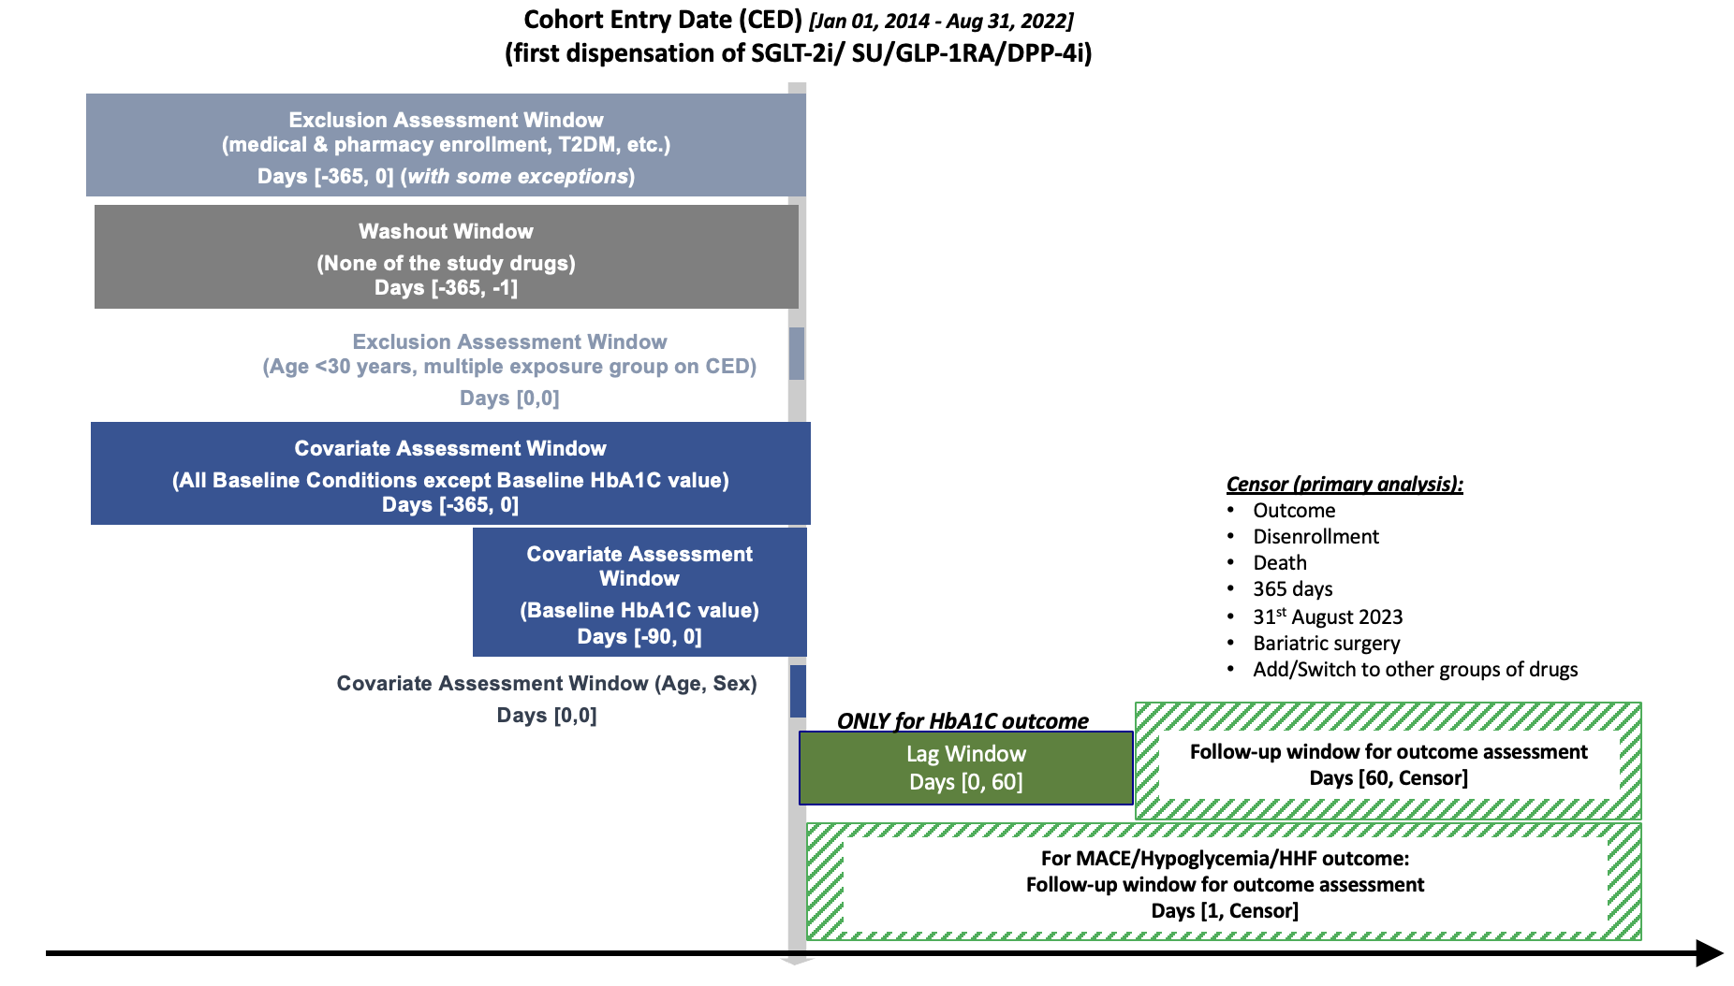
Abbreviations: CED, cohort entry date; DPP-4i, dipeptidyl peptidase-4 inhibitor; GLP-1RA, glucagon-like peptide-1 receptor agonist; HbA1c, hemoglobin A1c; HF, heart failure; IQR inter-quartile range; MACE, major adverse cardiovascular events; SGLT-2i, sodium-glucose cotransporter-2 inhibitor; SU, sulfonylurea; T2DM, type 2 diabetes mellitus

Note: In addition to the criteria depicted in the figure, we required people to have two fills of metformin within 180 days and to be on metformin on CED, and required two HbA1c measurements within 365 days of CED, one of them within 90 days of CED

eFigure 2. Patient Flowchart Diagram
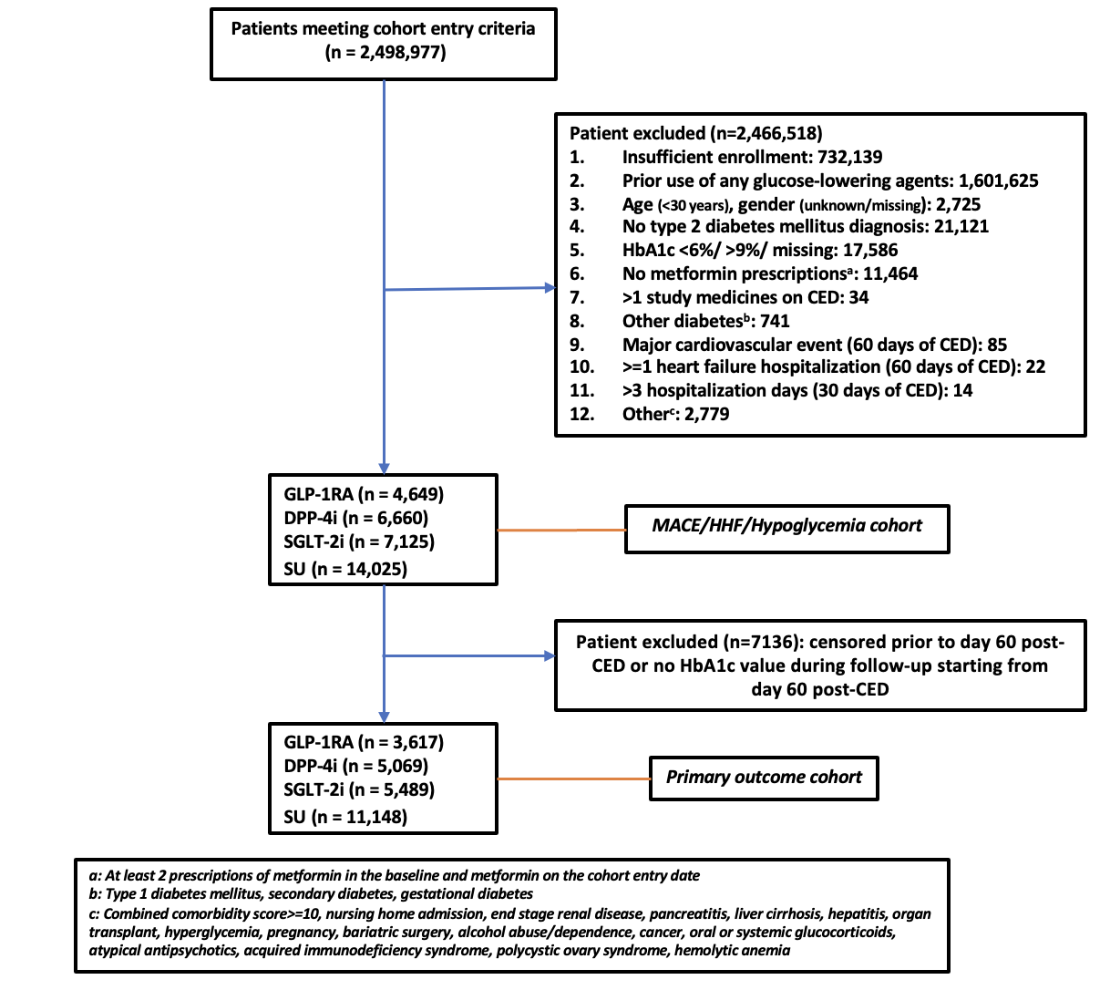
Patient excluded (n = 5,412,079)
- Insufficient enrollment: 732,139
- Prior use of study medicines: 1,599,541
- Prior use of all other glucose lowering agents: 2,084
- Age (<30 years): 2,663
- Gender (unknown or missing): 92
- No Type 2 DM diagnosis: 21,121
- HbA1c <6% or >9%: 9,094
- HbA1c value missing: 8,492
- <2 metformin prescriptions: 9,225
- Not on metformin on cohort entry: 2,239
- Nursing home admission: 580
- Type 1 DM diagnosis: 316
- Major cardiovascular event (60 days): 85
- Secondary or gestational diabetes: 425
- >1 study medicine on CED: 34
- End-stage renal disease: 16
- Pancreatitis (acute or chronic): 31
- Cirrhosis: 53
- Hepatitis (acute): 3
- Organ transplant: 4
- Hyperglycemia (symptomatic): 63
- Pregnancy: 1
- Bariatric surgery: 4
- Alcohol abuse/dependence: 92
- Cancer: 540
- Use of oral/systemic glucocorticoids: 1,341
DPP-4I
(n = 30,391)
Abbreviations: CED, cohort entry date; DPP-4i, dipeptidyl peptidase-4 inhibitor; GLP-1RA, glucagon-like peptide-1 receptor agonist; HbA1c, hemoglobin A1c; HHF, hospitalization for heart failure; MACE, major adverse cardiovascular events; SGLT-2i, sodium-glucose cotransporter-2 inhibitor; SU, sulfonylurea

eFigure 3. Cumulative Hazard Plot for Major Adverse Cardiovascular Events as a Secondary Outcome

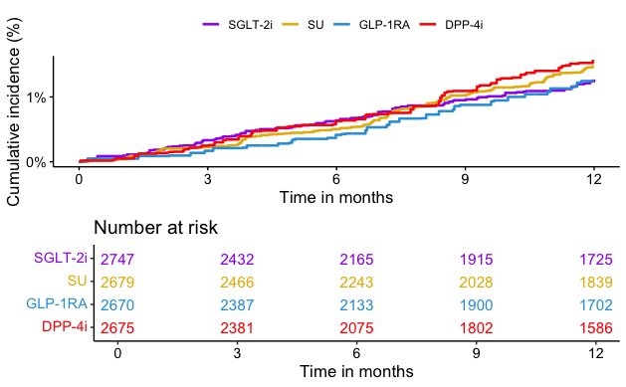
Abbreviations: DPP-4i, dipeptidyl peptidase-4 inhibitor; GLP-1RA, glucagon-like peptide-1 receptor agonist; SGLT-2i, sodium-glucose cotransporter-2 inhibitor; SU, sulfonylurea

eFigure 4. Cumulative Hazard Plot for Hospitalization for Heart Failure (Any Position) as a Secondary Outcome

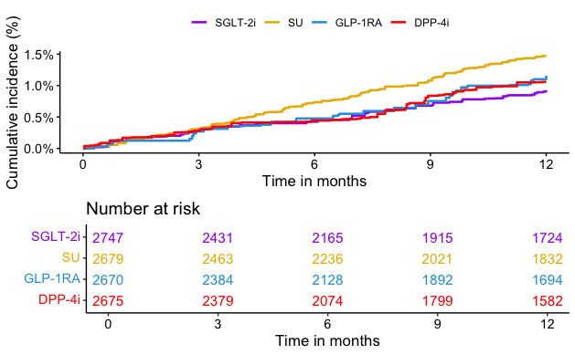
Abbreviations: DPP-4i, dipeptidyl peptidase-4 inhibitor; GLP-1RA, glucagon-like peptide-1 receptor agonist; SGLT-2i, sodium-glucose cotransporter-2 inhibitor; SU, sulfonylurea

eFigure 5. Cumulative Hazard Plot for Hospitalization for Heart Failure (Primary Position) as a Secondary Outcome

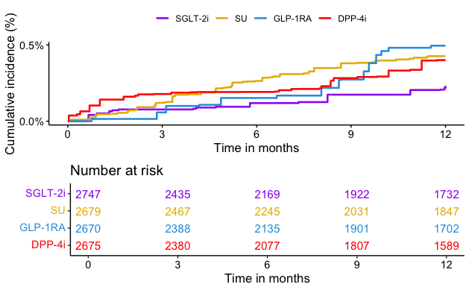
Abbreviations: DPP-4i, dipeptidyl peptidase-4 inhibitor; GLP-1RA, glucagon-like peptide-1 receptor agonist; SGLT-2i, sodium-glucose cotransporter-2 inhibitor; SU, sulfonylurea

eFigures 6A-F. Forest Plots for Subgroup Analysis of the Primary Outcome (HbA1c ≥7.0%)

- Sodium-glucose cotransporter-2 inhibitor (SGLT-2i) vs. sulfonylurea (SU)

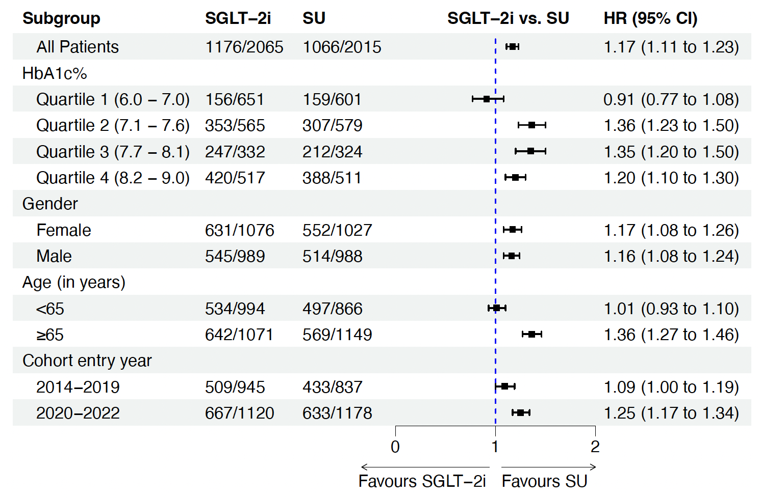

- Sodium-glucose cotransporter-2 inhibitor (SGLT-2i) vs. glucagon-like peptide 1 receptor agonist (GLP-1RA)

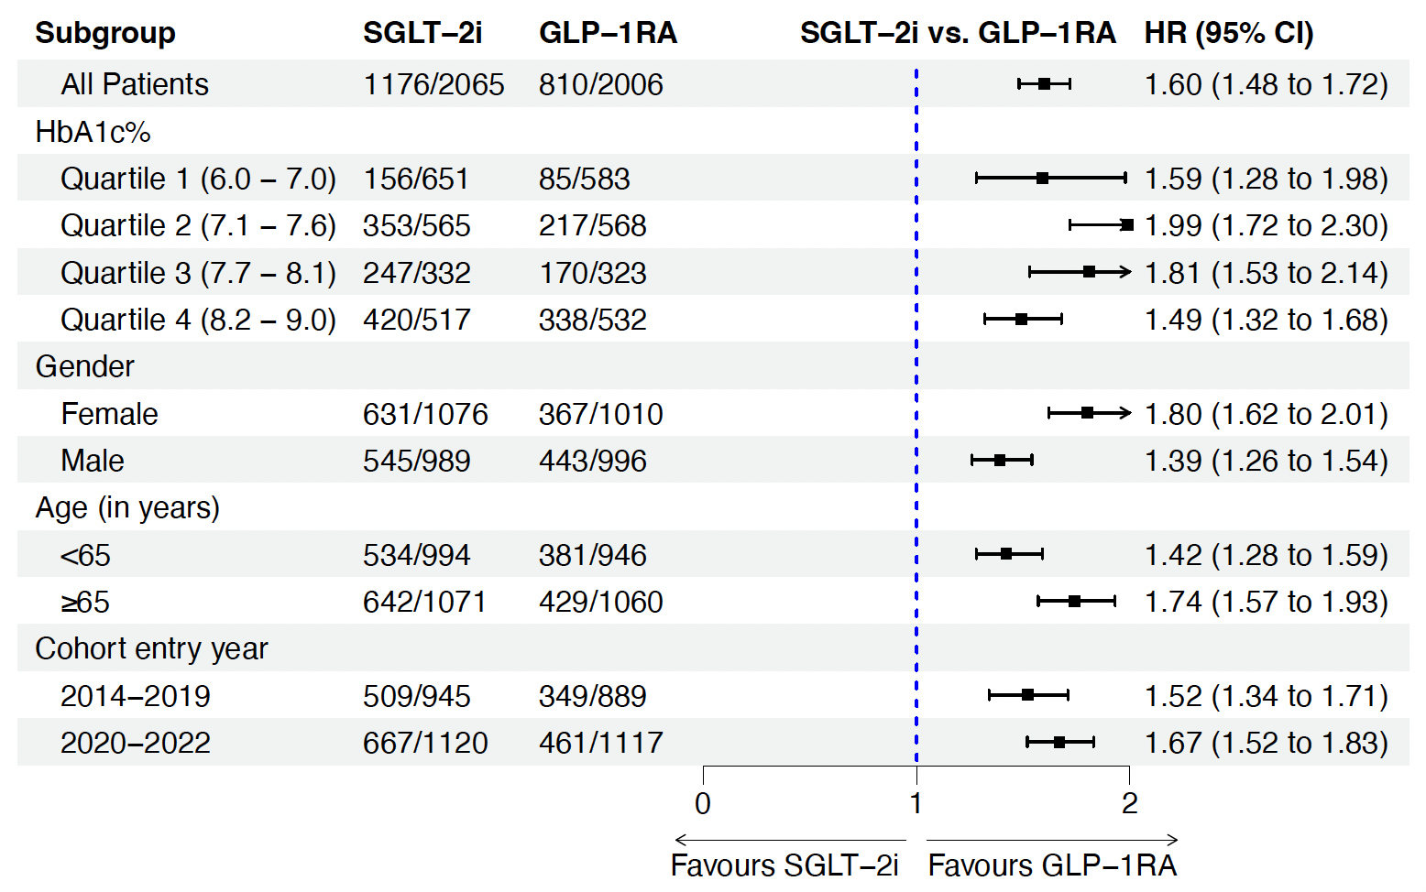

- Sodium-glucose cotransporter-2 inhibitor (SGLT-2i) vs. dipeptidyl peptidase-4 inhibitor (DPP-4i)

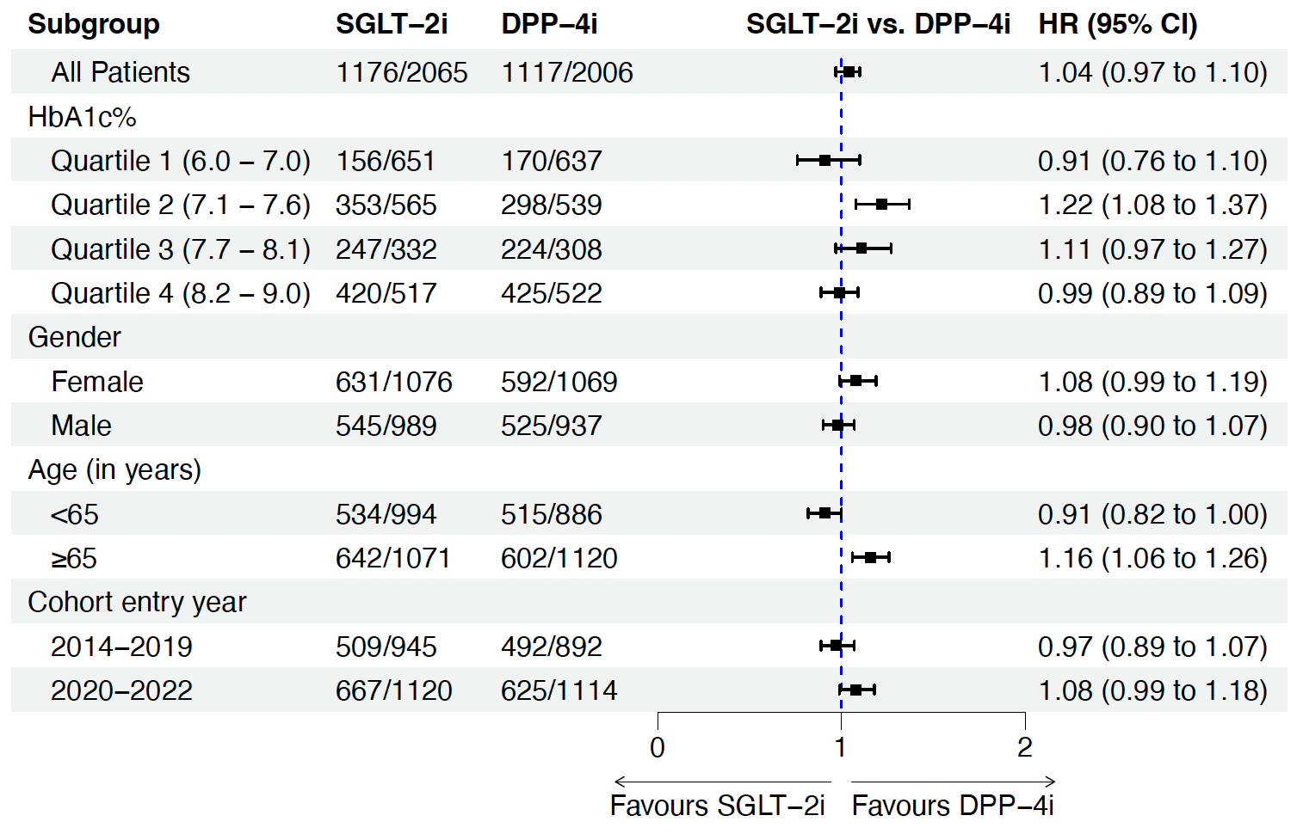

- Glucagon-like peptide 1 receptor agonist (GLP-1RA) vs. sulfonylurea (SU)

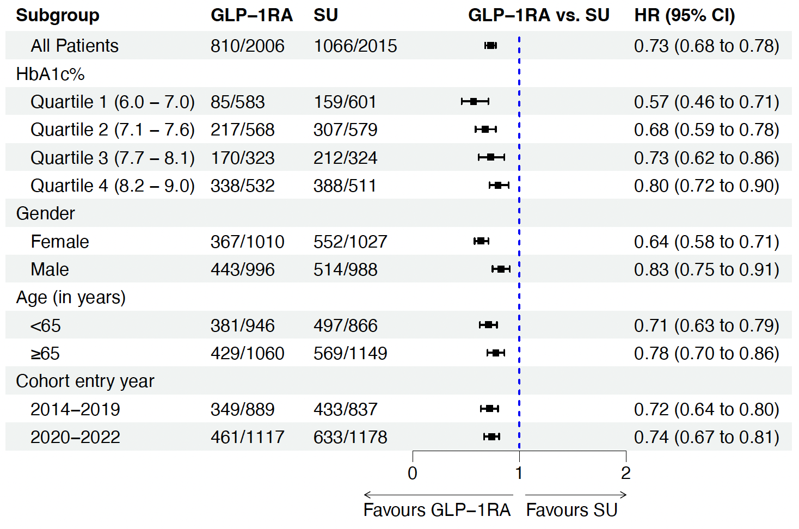

- Dipeptidyl peptidase-4 inhibitor (DPP-4i) vs. sulfonylurea (SU)

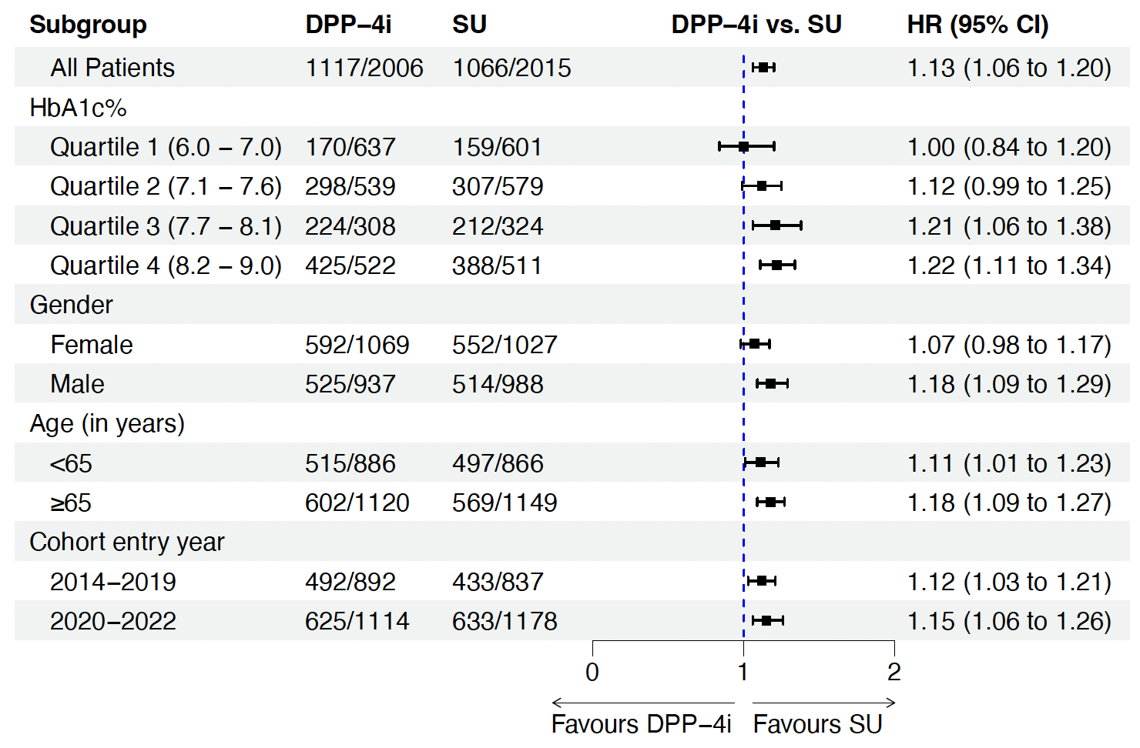

- Glucagon-like peptide 1 receptor agonist (GLP-1RA) vs. dipeptidyl peptidase-4 inhibitor (DPP-4i)

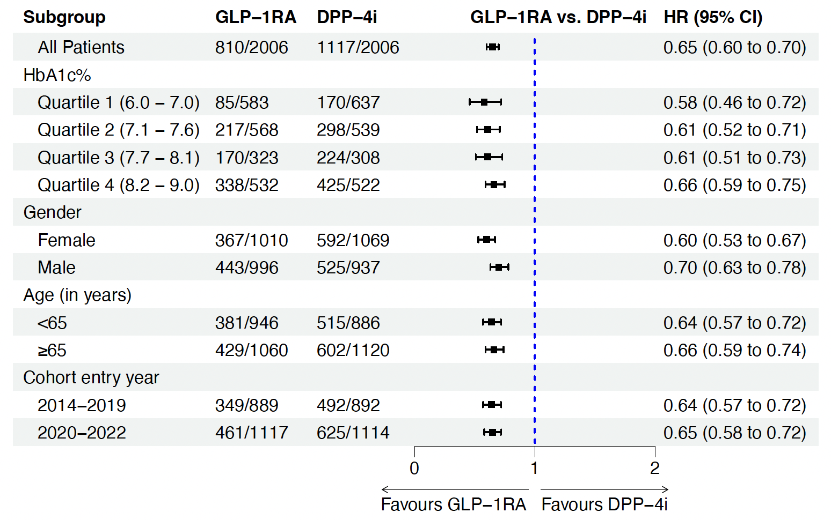
Abbreviations: CI, confidence interval; DPP-4i, dipeptidyl peptidase-4 inhibitor; GLP-1RA, glucagon-like peptide-1 receptor agonist; HbA1c, hemoglobin A1c; HR, hazard ratio; SGLT-2i, sodium-glucose cotransporter-2 inhibitor; SU, sulfonylurea
eFigure 7. Forest Plot Showing Findings of Primary and Sensitivity Analyses for Major Adverse Cardiovascular Events and Hospitalization for Heart Failure Outcome (Any Diagnosis Position)

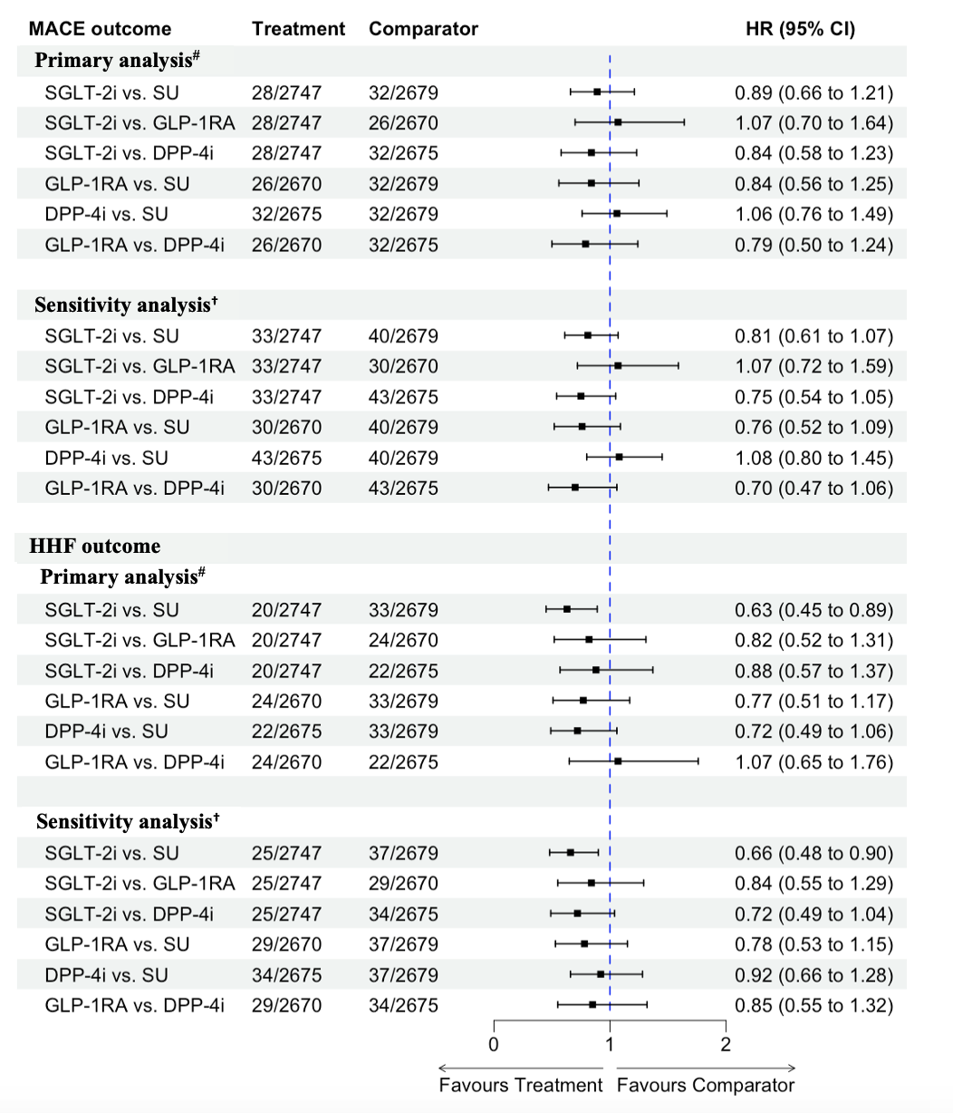
Abbreviations: CI, confidence interval; DPP-4i, dipeptidyl peptidase-4 inhibitor; GLP-1RA, glucagon-like peptide-1 receptor agonist; HbA1c, hemoglobin A1c; HHF, hospitalization for heart failure; HR, hazard ratio; ITT, intention-to-treat; MACE, mace adverse cardiovascular events; SGLT-2i, sodium-glucose cotransporter-2 inhibitor; SU, sulfonylurea
#Modified ITT
†Standard ITT
eFigure 8. Forest Plot for the Primary Outcome (HbA1c ≥7.0%) Among Those with At Least 60 Days of Follow-up: A) Assuming Missing HbA1c Value as a Proxy for the Desired Glycemic Status (HbA1c <7.0%) and B) Missing Outcome Imputation
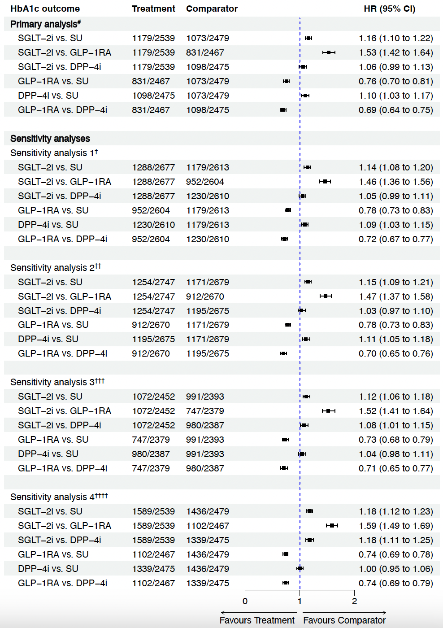
Abbreviations: CI, confidence interval; CPT, current procedural terminology; DPP-4i, dipeptidyl peptidase-4 inhibitor; GLP-1RA, glucagon-like peptide-1 receptor agonist; HbA1c, hemoglobin A1c; HR, hazard ratio; ITT, intention-to-treat; SGLT-2i, sodium-glucose cotransporter-2 inhibitor; SU, sulfonylurea
#Modified ITT
†Standard ITT
††Modified ITT with follow-up starting 1 day after cohort entry
†††Modified ITT with follow-up starting 90 days after cohort entry
††††Modified ITT with missing outcome imputation and follow-up starting 60 days after cohort entry
eFigure 9. Forest Plot for the Outcome of HbA1c Test Ordered Among Those With At Least 60 Days of Follow-upª
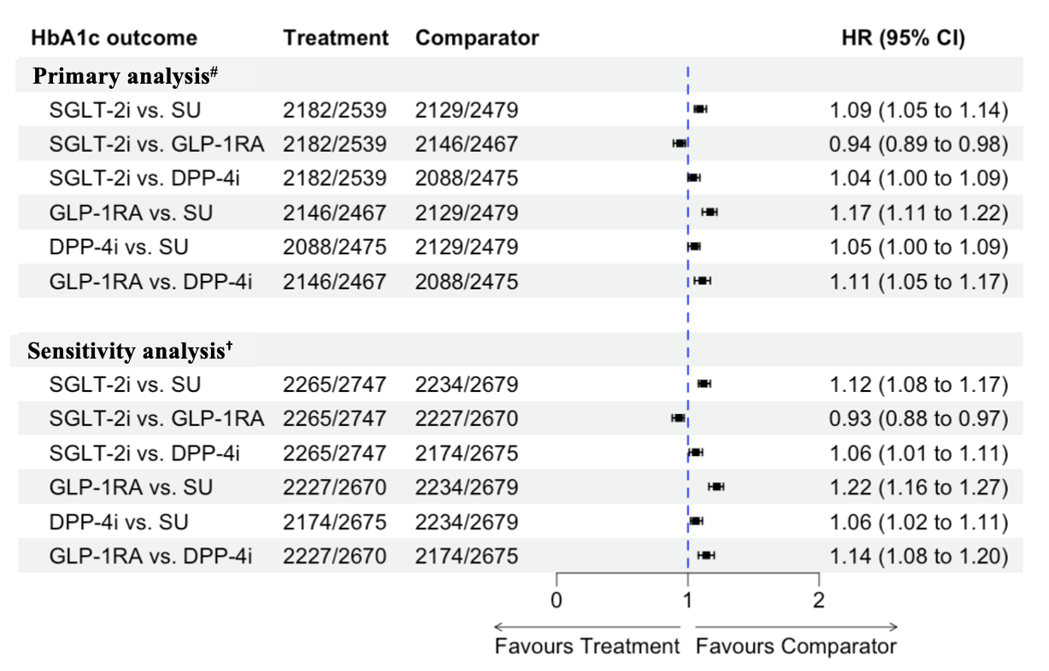
Abbreviations: CI, confidence interval; CPT, current procedural terminology; DPP-4i, dipeptidyl peptidase-4 inhibitor; GLP-1RA, glucagon-like peptide-1 receptor agonist; HbA1c, hemoglobin A1c; HR, hazard ratio; ITT, intention-to-treat; SGLT-2i, sodium-glucose cotransporter-2 inhibitor; SU, sulfonylurea
ªHbA1c test ordered identified using current procedural terminology (CPT) codes
#Modified ITT with test ordered as outcome and follow-up starting 60 days after cohort entry
†Modified ITT with test ordered as outcome and follow-up starting 1 day after cohort entry

eReferences

- Nathan DM, Buse JB, Kahn SE, et al. Rationale and design of the glycemia reduction approaches in diabetes: a comparative effectiveness study (GRADE). Diabetes Care 2013;36:2254–61. doi: 10.2337/dc13-0356
- Gagne JJ, Glynn RJ, Avorn J, Levin R, Schneeweiss S. A combined comorbidity score predicted mortality in elderly patients better than existing scores. J Clin Epidemiol. 2011;64(7):749-759. doi:10.1016/j.jclinepi.2010.10.004
- Kim DH, Schneeweiss S, Glynn RJ, Lipsitz LA, Rockwood K, Avorn J. Measuring frailty in Medicare data: development and validation of a claims-based frailty index. J Gerontol A Biol Sci Med Sci. 2018;73(7):980-987. doi:10.1093/gerona/glx229

