Appendices Table of Contents

Name | Description | Page(s)
Appendix Text 1 | Search strategy | 2
Appendix Table 1 | Description of how subgroups were created | 3-11
Appendix Table 2 | Additional study characteristics | 12-15
Appendix Table 3 | Adapted Newcastle – Ottawa assessment scale for cohort studies | 16
Appendix Table 4 | Quality assessment of included studies according to NOS and AHRQ. | 17-19
Appendix Table 5 | Definitions of immunocompromise used by individual studies | 20
Appendix Figure 1 | Forest plots for all patients, all-cause and COVID-specific mortality | 21
Appendix Figure 2 | Forest plots for all patients, all-cause and COVID-specific hospitalization | 21
Appendix Figure 3 | Forest plots for any mortality, any hospitalization and composite of mortality or hospitalization stratified by age | 22
Appendix Figure 4 | Forest plots for any mortality, any hospitalization and composite of mortality or hospitalization stratified by early versus late stage of omicron | 23
Appendix Figure 5 | Forest plots for any mortality, any hospitalization and composite of mortality or hospitalization stratified by immunocompromise | 24
Appendix Figure 6 | Forest plots for any mortality, any hospitalization and composite of mortality or hospitalization stratified by low vs high risk of outcomes in untreated group | 25
Appendix Figure 7 | Forest plots for any mortality, any hospitalization and composite of mortality or hospitalization stratified by propensity score matching vs other adjustment method | 26
Appendix Figure 8 | Forest plots for any mortality, any hospitalization and composite of mortality or hospitalization stratified by vaccination history | 27
Appendix Figure 9 | Funnel plots for outcomes of mortality, hospitalization and composite of mortality and hospitalization | 30

Appendix Text 1. Search strategy
PubMed search for observational studies
("nirmaltrelvir" OR "nirmatrelvir-ritonavir" OR "nirmatrelvir/ritonavir" OR "Paxlovid" OR "paxlovid")
AND
(“randomized” OR “controlled trial” OR "propensity score" OR "propensity-score" OR "matched" OR "cohort" OR "case-control" OR "case control" OR "case cohort" OR "case-cohort" OR "observational")
AND
("hospitalization" OR "hospital" OR "hospitalized" OR "hospitalized" OR "hospitalization" OR "death" OR "mortality" OR "emergency department" OR "intensive care" OR "ICU").

Cochrane central search
Nirmatrelvir OR paxlovid

Appendix Table 1. Original and combined subgroups.
AuthorYear | PMID | Original subgroup | Combined subgroup name
Aggarwal 2023 | 36780912 | Age18to64 | Age0_18to64
Aggarwal 2023 | 36780912 | AgeOver64 | AgeOver64
Aggarwal 2023 | 36780912 | All | All
Aggarwal 2023 | 36780912 | All | All
Aggarwal 2023 | 36780912 | All | All
Aggarwal 2023 | 36780912 | Comorbid0to1 | Comorbid0to1
Aggarwal 2023 | 36780912 | ComorbidOver1 | ComorbidOver1
Aggarwal 2023 | 36780912 | ImmunocompromisedMild | ImmunocompromisedMild
Aggarwal 2023 | 36780912 | ImmunocompromisedModToSevere | ImmunocompromisedModToSevere
Aggarwal 2023 | 36780912 | ImmunocompromisedNo | ImmunocompromisedNo
Aggarwal 2023 | 36780912 | ImmunocompromisedYes | ImmunocompromisedYes
Aggarwal 2023 | 36780912 | ObeseNo | ObeseNo
Aggarwal 2023 | 36780912 | ObeseYes | ObeseYes
Aggarwal 2023 | 36780912 | OmicronBeforeBA4andBA5 | OmicronBeforeBA4andBA5
Aggarwal 2023 | 36780912 | OmicronDuringBA4andBA5 | OmicronDuringBA4andBA5
Aggarwal 2023 | 36780912 | Vaccinated0 | VaccinatedNo
Aggarwal 2023 | 36780912 | Vaccinated0to2 | VaccinatedDisregard
Aggarwal 2023 | 36780912 | Vaccinated1to2 | VaccinatedDisregard
Aggarwal 2023 | 36780912 | VaccinatedOver2 | VaccinatedBoosted
Aggarwall 2024 | 38500962 | All | All
Al-Obaidi 2023 | 36898600 | Age18to64 | Age0_18to64
Al-Obaidi 2023 | 36898600 | AgeOver64 | AgeOver64
Al-Obaidi 2023 | 36898600 | All | All
Al-Obaidi 2023 | 36898600 | All | All
Al-Obaidi 2023 | 36898600 | All | All
Al-Obaidi 2023 | 36898600 | ImmunocompromisedNo | ImmunocompromisedNo
Al-Obaidi 2023 | 36898600 | ImmunocompromisedYes | ImmunocompromisedYes
Al-Obaidi 2023 | 36898600 | Vaccinated0to1 | VaccinatedNo
Al-Obaidi 2023 | 36898600 | VaccinatedOver2 | VaccinatedBoosted
Arbel 2022 | 36001529 | Age40to64 | Age0_18to64
Arbel 2022 | 36001529 | Age40to64ImmunityNo | Age0to64ImmunityNo
Arbel 2022 | 36001529 | Age40to64ImmunityYes | Age0to64ImmunityYes
Arbel 2022 | 36001529 | AgeOver64 | AgeOver64
Arbel 2022 | 36001529 | AgeOver64ImmunityNo | AgeOver64ImmunityNo
Arbel 2022 | 36001529 | AgeOver64ImmunityYes | AgeOver64ImmunityYes
Bajema 2023 | 37276589 | Age18to64 | Age0_18to64
Bajema 2023 | 37276589 | AgeOver64 | AgeOver64
Bajema 2023 | 37276589 | All | All
Bajema 2023 | 37276589 | All | All
Bajema 2023 | 37276589 | All | All
Bajema 2023 | 37276589 | ImmunocompromisedNo | ImmunocompromisedNo
Bajema 2023 | 37276589 | ImmunocompromisedYes | ImmunocompromisedYes
Bajema 2023 | 37276589 | SymptomsNo | SymptomsNo
Bajema 2023 | 37276589 | SymptomsYes | SymptomsYes
Bajema 2023 | 37276589 | Tx0to1days | Tx0to1days
Bajema 2023 | 37276589 | Tx2to5days | Tx2to5days
Bajema 2023 | 37276589 | VaccinatedNo | VaccinatedNo
Bajema 2023 | 37276589 | VaccinatedYes | VaccinatedPrimaryOrBooster
Bhatia 2025 | 39823513 | Age18to49 | Age18to39_49
Bhatia 2025 | 39823513 | Age50to64 | Age0_18to64
Bhatia 2025 | 39823513 | AgeOver64 | AgeOver64
Bhatia 2025 | 39823513 | All | All
Bhatia 2025 | 39823513 | All | All
Bhatia 2025 | 39823513 | All | All
Bhatia 2025 | 39823513 | Vaccinated0 | VaccinatedNo
Bhatia 2025 | 39823513 | VaccinatedOver1 | VaccinatedPrimaryOrBooster
Butt 2024 | 37711076 | Age18to60 | Age0_18to64
Butt 2024 | 37711076 | AgeOver60 | AgeOver64
Butt 2024 | 37711076 | All | All
Butt 2024 | 37711076 | Black | Black
Butt 2024 | 37711076 | Cancer | Cancer
Butt 2024 | 37711076 | CardiovascularYes | CardiovascularYes
Butt 2024 | 37711076 | ChronicKidneyDisease | ChronicKidneyDisease
Butt 2024 | 37711076 | ChronicLungDisease | ChronicLungDisease
Butt 2024 | 37711076 | DiabetesYes | DiabetesYes
Butt 2024 | 37711076 | Female | Female
Butt 2024 | 37711076 | Male | Male
Butt 2024 | 37711076 | ObeseYes | ObeseYes
Butt 2024 | 37711076 | OtherUnknownRace | OtherUnknownRace
Butt 2024 | 37711076 | SymptomsNo | SymptomsNo
Butt 2024 | 37711076 | SymptomsYes | SymptomsYes
Butt 2024 | 37711076 | Vaccinated0to1 | VaccinatedNo
Butt 2024 | 37711076 | Vaccinated2 | VaccinatedPrimary
Butt 2024 | 37711076 | Vaccinated3 | VaccinatedBoosted
Butt 2024 | 37711076 | White | White
Cegolon 2023 | 37242504 | All | All
Cullen 2024 | 39649410 | Age12to64 | Age0_18to64
Cullen 2024 | 39649410 | AgeOver64 | AgeOver64
Cullen 2024 | 39649410 | All | All
Cullen 2024 | 39649410 | VaccinatedOver0 | VaccinatedDisregard
Dormuth 2023 | 37782496 | HighRisk | HighRisk
Dormuth 2023 | 37782496 | ImmunocompromisedMod | ImmunocompromisedMod
Dormuth 2023 | 37782496 | ImmunocompromisedSevere | ImmunocompromisedSevere
Dormuth 2023 | 37782496 | ModerateRisk | ModerateRisk
Dryden-Peterson 2023 | 36508742 | Age50to64 | Age0_18to64
Dryden-Peterson 2023 | 36508742 | AgeOver64 | AgeOver64
Dryden-Peterson 2023 | 36508742 | All | All
Dryden-Peterson 2023 | 36508742 | All | All
Dryden-Peterson 2023 | 36508742 | All | All
Dryden-Peterson 2023 | 36508742 | ObeseNo | ObeseNo
Dryden-Peterson 2023 | 36508742 | ObeseYes | ObeseYes
Dryden-Peterson 2023 | 36508742 | Vaccinated0to1 | VaccinatedNo
Dryden-Peterson 2023 | 36508742 | VaccinatedOver1 | VaccinatedPrimaryOrBooster
Evans 2023 | 36773891 | All | All
Faust 2023 | 37387690 | All | All
Faust 2023 | 37387690 | All | All
Faust 2023 | 37387690 | VaccinatedYes | VaccinatedYes
Faust 2023 | 37387690 | VaccinatedYes | VaccinatedYes
Ganatra 2023 | 35986628 | All | All
Ganatra 2023 | 35986628 | All | All
Ganatra 2023 | 35986628 | VaccinatedYes | VaccinatedYes
Ganatra 2023 | 35986628 | VaccinatedYes | VaccinatedYes
Hammond 2022 | 35172054 | Age18to64 | Age0_18to64
Hammond 2022 | 35172054 | AgeOver64 | AgeOver64
Hammond 2022 | 35172054 | All | All
Hammond 2022 | 35172054 | All | All
Hammond 2022 | 35172054 | All | All
Hammond 2022 | 35172054 | Female | Female
Hammond 2022 | 35172054 | Male | Male
Hammond 2022 | 35172054 | ObeseNo | ObeseNo
Hammond 2022 | 35172054 | ObeseYes | ObeseYes
Hammond 2024 | 38598573 | All | All
Hammond 2024 | 38598573 | All | All
Hammond 2024 | 38598573 | All | All
Hansen 2023 | 37398261 | All | All
Hansen 2023 | 37398261 | All | All
Henderson 2024 | 38380946 | All | All
Hsu CK 2024 | 38568820 | All | All
Hsu CK 2024 | 38568820 | All | All
Hsu CK 2024 | 38568820 | All | All
Huh 2024 | 39497563 | All | All
Jorda 2025 | 39505067 | All | All
Jorda 2025 | 39505067 | All | All
Kabore 2023 | 37149726 | Age0to69 | Age0_18to64
Kabore 2023 | 37149726 | AgeOver69 | AgeOver64
Kabore 2023 | 37149726 | All | All
Kabore 2023 | 37149726 | ImmunocompromisedYes | ImmunocompromisedYes
Kabore 2023 | 37149726 | Vaccinated0to1 | VaccinatedNo
Kabore 2023 | 37149726 | VaccinatedOver1 | VaccinatedPrimaryOrBooster
Kim 2023 | 37431541 | AgeOver59 | AgeOver64
Kim 2023 | 37431541 | AgeOver69 | AgeOver64
Kim 2023 | 37431541 | AgeOver79 | AgeOver64
Kim 2023 | 37431541 | All | All
Kim 2023 | 37431541 | Vaccinated0 | VaccinatedNo
Kim 2023 | 37431541 | VaccinatedOver0 | VaccinatedDisregard
Kim 2024 | 38621766 | AgeOver59 | AgeOver64
Kim 2024 | 38621766 | AgeOver69 | AgeOver64
Kim 2024 | 38621766 | AgeOver79 | AgeOver64
Kim 2024 | 38621766 | All | All
Kim 2024 | 38621766 | Vaccinated0 | VaccinatedNo
Kim 2024 | 38621766 | VaccinatedOver0 | VaccinatedPrimaryOrBooster
Kuo, 2025 | 40988922 | Age18to64 | Age0_18to64
Kuo, 2025 | 40988922 | Age18to64 | Age0_18to64
Kuo, 2025 | 40988922 | Age18to64 | Age0_18to64
Kuo, 2025 | 40988922 | AgeOver64 | AgeOver64
Kuo, 2025 | 40988922 | AgeOver64 | AgeOver64
Kuo, 2025 | 40988922 | AgeOver64 | AgeOver64
Kuo, 2025 | 40988922 | All | All
Kuo, 2025 | 40988922 | All | All
Kuo, 2025 | 40988922 | All | All
Kuo, 2025 | 40988922 | Vaccinated1to2 | VaccinatedDisregard
Kuo, 2025 | 40988922 | Vaccinated1to2 | VaccinatedDisregard
Kuo, 2025 | 40988922 | Vaccinated1to2 | VaccinatedDisregard
Kuo, 2025 | 40988922 | Vaccinated3up | VaccinatedBoosted
Kuo, 2025 | 40988922 | Vaccinated3up | VaccinatedBoosted
Kuo, 2025 | 40988922 | Vaccinated3up | VaccinatedBoosted
Kuo, 2025 | 40988922 | VaccinatedNo | VaccinatedNo
Kuo, 2025 | 40988922 | VaccinatedNo | VaccinatedNo
Kuo, 2025 | 40988922 | VaccinatedNo | VaccinatedNo
Kwok 2023 | 36992319 | All | All
Kwok 2023 | 36992319 | All | All
Lewnard 2023 | 36933565 | All | All
Lewnard 2023 | 36933565 | VaccinatedOver1 | VaccinatedPrimaryOrBooster
Lewnard, 2023 | 36933565 | VaccinatedOver2 | VaccinatedBoosted
Lin 2023 | 37733342 | Age12To64 | Age0_18to64
Lin 2023 | 37733342 | Age12To64 | Age0_18to64
Lin 2023 | 37733342 | AgeOver64 | AgeOver64
Lin 2023 | 37733342 | AgeOver64 | AgeOver64
Lin 2023 | 37733342 | All | All
Lin 2023 | 37733342 | All | All
Lin 2023 | 37733342 | CardiovascularNo | CardiovascularNo
Lin 2023 | 37733342 | CardiovascularNo | CardiovascularNo
Lin 2023 | 37733342 | CardiovascularYes | CardiovascularYes
Lin 2023 | 37733342 | CardiovascularYes | CardiovascularYes
Lin 2023 | 37733342 | DiabetesNo | DiabetesNo
Lin 2023 | 37733342 | DiabetesNo | DiabetesNo
Lin 2023 | 37733342 | DiabetesYes | DiabetesYes
Lin 2023 | 37733342 | DiabetesYes | DiabetesYes
Lin 2023 | 37733342 | ImmunocompromisedNo | ImmunocompromisedNo
Lin 2023 | 37733342 | ImmunocompromisedNo | ImmunocompromisedNo
Lin 2023 | 37733342 | ImmunocompromisedYes | ImmunocompromisedYes
Lin 2023 | 37733342 | ImmunocompromisedYes | ImmunocompromisedYes
Lin 2023 | 37733342 | NonWhite | NonWhite
Lin 2023 | 37733342 | NonWhite | NonWhite
Lin 2023 | 37733342 | ObeseNo | ObeseNo
Lin 2023 | 37733342 | ObeseNo | ObeseNo
Lin 2023 | 37733342 | ObeseYes | ObeseYes
Lin 2023 | 37733342 | ObeseYes | ObeseYes
Lin 2023 | 37733342 | Vaccinated0to2 | VaccinatedDisregard
Lin 2023 | 37733342 | Vaccinated0to2 | VaccinatedDisregard
Lin 2023 | 37733342 | VaccinatedOver2 | VaccinatedBoosted
Lin 2023 | 37733342 | VaccinatedOver2 | VaccinatedBoosted
Lin 2023 | 37733342 | White | White
Lin 2023 | 37733342 | White | White
Low 2023 | 37567557 | Age18to39 | Age18to39_49
Low 2023 | 37567557 | Age40to59 | Age0_18to64
Low 2023 | 37567557 | AgeOver59 | AgeOver64
Low 2023 | 37567557 | All | All
Low 2023 | 37567557 | Female | Female
Low 2023 | 37567557 | Male | Male
Lui 2023 | 37204790 | All | All
Lui 2023 | 37204790 | All | All
Lui 2023 | 37204790 | All | All
Ma 2023 | 37103932 | All | All
Paraskevis 2023 | 37565522 | All | All
Paraskevis 2023 | 37565522 | All | All
Park 2022 | 36617550 | All | All
Park 2022 | 36617550 | Vaccinated2 | VaccinatedPrimary
Park 2022 | 36617550 | Vaccinated3 | VaccinatedBoosted
Rajme-López 2024 | 38545451 | All | All
Rodriguez-Leal 2025 | 40412101 | All | All
Rodriguez-Leal 2025 | 40412101 | ImmunocompromisedYes | ImmunocompromisedYes
Saheb Sharif-Askari 2024 | 39472619 | All | All
Schilling 2024 | 37778363 | All | All
Schwartz 2023 | 36781188 | Age18to69 | Age0_18to64
Schwartz 2023 | 36781188 | Age18to69 | Age0_18to64
Schwartz 2023 | 36781188 | AgeOver69 | AgeOver64
Schwartz 2023 | 36781188 | AgeOver69 | AgeOver64
Schwartz 2023 | 36781188 | All | All
Schwartz 2023 | 36781188 | All | All
Schwartz 2023 | 36781188 | HighRisk | HighRisk
Schwartz 2023 | 36781188 | HighRisk | HighRisk
Schwartz 2023 | 36781188 | StandardRisk | StandardRisk
Schwartz 2023 | 36781188 | StandardRisk | StandardRisk
Schwartz 2023 | 36781188 | Vaccinated0 | VaccinatedNo
Schwartz 2023 | 36781188 | Vaccinated0 | VaccinatedNo
Schwartz 2023 | 36781188 | Vaccinated1to2 | VaccinatedDisregard
Schwartz 2023 | 36781188 | Vaccinated1to2 | VaccinatedDisregard
Schwartz 2023 | 36781188 | VaccinatedOver2 | VaccinatedBoosted
Schwartz 2023 | 36781188 | VaccinatedOver2 | VaccinatedBoosted
Shah 2023 | 36454693 | Age18to49 | Age18to39_49
Shah 2023 | 36454693 | Age18to49Vax0 | Age18to49Vax0
Shah 2023 | 36454693 | Age18to49Vax2 | Age18to49Vax2
Shah 2023 | 36454693 | Age18to49VaxOver2 | Age18to49VaxOver2
Shah 2023 | 36454693 | Age50to64 | Age0_18to64
Shah 2023 | 36454693 | Age50to64Vax0 | Age0to64Vax0
Shah 2023 | 36454693 | Age50to64Vax2 | Age0to64Vax2
Shah 2023 | 36454693 | Age50to64VaxOver2 | Age0to64VaxOver2
Shah 2023 | 36454693 | AgeOver64 | AgeOver64
Shah 2023 | 36454693 | AgeOver64Vax0 | AgeOver64Vax0
Shah 2023 | 36454693 | AgeOver64Vax2 | AgeOver64Vax2
Shah 2023 | 36454693 | AgeOver64VaxOver2 | AgeOver64VaxOver2
Shah 2023 | 36454693 | All | All
Shah 2023 | 36454693 | ImmunocompromisedNo | ImmunocompromisedNo
Shah 2023 | 36454693 | ImmunocompromisedYes | ImmunocompromisedYes
Shah 2023 | 36454693 | Vaccinated0 | VaccinatedNo
Shah 2023 | 36454693 | Vaccinated2 | VaccinatedPrimary
Shah 2023 | 36454693 | VaccinatedOver2 | VaccinatedBoosted
Shiau 2024 | 38702925 | All | All
Shiau 2024 | 38702925 | All | All
Shiau 2024 | 38702925 | All | All
Tsai 2023 | 37322616 | AgeOver64 | AgeOver64
Tsai 2023 | 37322616 | AgeOver64 | AgeOver64
Tsai 2023 | 37322616 | AgeOver64 | AgeOver64
Tsai 2023 | 37322616 | All | All
Tsai 2023 | 37322616 | All | All
Tsai 2023 | 37322616 | All | All
Van Heer 2023 | 37927380 | AgeOver69 | AgeOver64
Van Heer 2023 | 37927380 | AgeOver69 | AgeOver64
Van Heer 2023 | 37927380 | All | All
Van Heer 2023 | 37927380 | All | All
Wai 2023 | 36212676 | All | All
Wee 2023 | 37331509 | AgeOver59 | AgeOver64
Wee, 2023 | 37331509 | All | All
Wee, 2023 | 37331509 | ImmunocompromisedYes | ImmunocompromisedYes
Wei 2025 | 39964106 | All | All
Wei 2025 | 39964106 | All | All
Wong 2022 | 36216007 | All | All
Wong 2022 | 36216007 | All | All
Wu JY 2023b | 37769748 | Age18to40 | Age18to39_49
Wu JY 2023b | 37769748 | Age41to64 | Age0_18to64
Wu JY 2023b | 37769748 | Age41to64 | Age0_18to64
Wu JY 2023b | 37769748 | AgeOver64 | AgeOver64
Wu JY 2023b | 37769748 | AgeOver64 | AgeOver64
Wu JY 2023b | 37769748 | All | All
Wu JY 2023b | 37769748 | All | All
Wu JY 2023b | 37769748 | Female | Female
Wu JY 2023b | 37769748 | Male | Male
Wu JY 2023b | 37769748 | Male | Male
Wu JY 2023b | 37769748 | VaccinatedNo | VaccinatedNo
Wu JY 2023b | 37769748 | VaccinatedNo | VaccinatedNo
Wu JY 2023b | 37769748 | VaccinatedYes | VaccinatedYes
Xie 2023 | 37041016 | Age18to65 | Age0_18to64
Xie 2023 | 37041016 | AgeOver65 | AgeOver64
Xie 2023 | 37041016 | Black | Black
Xie 2023 | 37041016 | Female | Female
Xie 2023 | 37041016 | Male | Male
Xie 2023 | 37041016 | NoPrevInfection | NoPrevInfection
Xie 2023 | 37041016 | PrevInfection | PrevInfection
Xie 2023 | 37041016 | Vaccinated0 | VaccinatedNo
Xie 2023 | 37041016 | Vaccinated1to2 | VaccinatedDisregard
Xie 2023 | 37041016 | VaccinatedOver2 | VaccinatedBoosted
Xie 2023 | 37041016 | White | White
Yan 2024 | 38864601 | Age18to49 | Age18to39_49
Yan 2024 | 38864601 | Age50to64 | Age0_18to64
Yan 2024 | 38864601 | Age65to74 | AgeOver64
Yan 2024 | 38864601 | AgeOver74 | AgeOver64
Yan 2024 | 38864601 | All | All
Yan 2024 | 38864601 | All | All
Yan 2024 | 38864601 | All | All
Yan 2024 | 38864601 | ImmunocompromisedNo | ImmunocompromisedNo
Yan 2024 | 38864601 | ImmunocompromisedYes | ImmunocompromisedYes
Yan 2024 | 38864601 | Risk1of4 | Risk1of4
Yan 2024 | 38864601 | Risk2of4 | Risk2of4
Yan 2024 | 38864601 | Risk3of4 | Risk3of4
Yan 2024 | 38864601 | Risk4of4 | Risk4of4
Yan 2024 | 38864601 | Vaccinated2 | VaccinatedPrimary
Yan 2024 | 38864601 | VaccinatedNo | VaccinatedNo
Yan 2024 | 38864601 | VaccinatedOver2 | VaccinatedBoosted
Yip 2024 | 36031408 | Age18to69 | Age0_18to64
Yip 2024 | 36031408 | AgeOver69 | AgeOver64
Yip 2024 | 36031408 | All | All
Yip 2024 | 36031408 | Highrisk | HighRisk

Appendix Table 2. Additional study characteristics
Author, year | Adjustment method | Variables adjusted for | Outcomes reported | Vaccination
Aggarwal, 2023 | PSM | Age, sex, insurance, obesity, immunocompromise, number of comorbidities, number of vaccinations, and omicron subvariant. | Hospitalization  Death | 2 doses: 15% treated, 16% controls  3+ doses: 61% treated, 58% controls
Aggarwal, 2024 | LR and IPTW | Age, sex, race/ethnicity, comorbidities, immunocompromise, obesity, insurance, vaccination. | Hospitalization | None: 18%  1 dose: 4%  2 doses: 14.4%  3+ doses: 64%
Al-Obaidi, 2023 | PSM | Age, BMI, vaccination, diabetes, comorbidities. | Hospitalization  Death  Hospitalization or death | 3+ doses: 42%
Arbel, 2022 | Cox | Age, sex and comorbidities. | Hospitalization | Vaccinated (2+) or previous infection: 78%
Bajema, 2023 | PSM | Age, sex, race, region, vaccination, symptom number, substance use, comorbidities, health encounters. | Hospitalization  Death  Hospitalization or death | None: 17%  1 dose: 4%  2 doses: 28%  3+ doses: 51%
Bhatia, 2025 | IPCW | Age, sex, race/ethnicity, comorbidities, risk factors for severe COVID, hospitalizations in previous year. | Hospitalization  Death  Hospitalization or death | NR
Butt, 2024 | IPTW | Age, sex, race, BMI, vaccination, and comorbidities | Hospitalization or death | None or 1: 25%  2 doses: 26%  3+ doses: 49%
Cegelon, 2023 | LR | Age, sex, vaccination, Charlson index and immunosuppression. |  | 0 doses: 18%  1-2 doses: 17%  3+ doses: 65%
Cullen, 2024 | PSM | Age, sex, race, ethnicity, region, insurance type, cohort entry month, healthcare utilization, COVID-19 vaccination status, number of past SARS-CoV-2 infections, and comorbidities. | Hospitalization | Any: 67%
Dormuth, 2023 | PSM | Age, sex, and propensity score. | Hospitalization or death | Group 1: 90% 3 or more  Group 2: 80% 3 or more  Group 3: 83% 3 or more  Group 4: 62% 3 or more
Dryden-Peterson 2023 | IPTW | Age, vaccination, comorbidities, neighorhood depreivation, and race/ethnicity. | Hospitalization  Death  Hospitalization or death | 0: 8%  1: 2%  2: 25%  3+: 66%
Evans 2023 | Coxl | Age, sex, comorbidities, vaccination and social deprivation. | Hospitalization or death | Treated: 2% 0, 62% 1 to 3, 36% 4+  Control: 4% 0, 78% 1 to 3, 18% 4+
Faust, 2023 | PSM | Age, sex, race, BMI, comorbidities, medications, lab values | Hospitalization  Death | 100% vaccinated
Ganatra, 2023 | PSM | Age, sex, race, BMI, comorbidities, medications, lab values | Hospitalization  Death | NR
Hammond, 2022 | NA | NA | Hospitalization  Death  Hospitalization or death
Hammond, 2024 | NA | NA | Hospitalization  Death  Hospitalization or death | Vaccinated (2+): 57%
Hansen, 2023 | IPTW | Age, sex, race, BMI, comorbidities, risk factors for severe COVID, and deprivation by zip code. | Hospitalization  Death | Treated: 40% 0, 21% 1 to 2, 39% 3+  Control: 60% 0, 23% 1 to 2, 17% 3+
Henderson, 2024 | Cox | Age, sex, race, ethnicity, comorbidities, vaccination and SES | Hospitalization | 0: 44%  1 to 2: 32%  3+: 24%
Hsu CK 2024 | PSM | Age, sex, ethnicty, lifestyle factors, and comorbidities. | Hospitalization or death | NR
Huh, 2024 | PSM | Age, sex, comorbidities, vaccination, infection date, and previous COVID-19 infections | Death | <2: 4.9%  2: 5.7%  3+: 88.8%
Jorda, 2025 | PSM | Age, sex, immunization, symptoms, education, income, and comorbidities. | Hospitalization  Death | 2+ doses in last 6 months: 55%
Kabore, 2023 | PSM | Age, sex, region of residence, vaccination, and comorbidities | Hospitalization | 0 or 1: 56%  2: 5%  3: 21%  4+: 18%
Kim, 2023 | LR | Age, sex, vaccination and comorbidities | Death | Vaccinated: 96%
Kim, 2024 | PSM | Age, sex, vaccination and comorbidities | Death | Vaccinated: 95%
Kuo, 2025 | Cox | Age, sex, vaccination, risk factors for severe COVID-19, comorbidity index, outpatient visits, and recent hospital admission. | Hospitalization  Death  Hospitalization or death | Treated: 11.4% 0 to 1, 7.7% 2, and 81% 3+  Control: 7.7% 0 to 1, 11.1% 2, and 81% 3+
Kwok, 2023 | LR | Age, sex, respiratory disease, eGFR, and number of comorbidities. | Hospitalization  Death | Vaccinated: 0%
Lewnard, 2023 | Cox | Age, sex, days of symptoms, comorbidities, vaccination, BMI, and healthcare utilization. |  | Treated: 6.1% 0 to 1, 13.3% 2, 80.6% 3+  Control: 14.9% 0 to 1, 25% 2, 60.1% 3+
Lin 2023 | Cox | Age, sex, race, comorbidities, vaccination. | Death  Hospitalization or death | Treated: 75%  Control: 50%
Low 2023 | PSM | Age, sex, days of illness, vaccination, and comorbidities. | Hospitalization | Vaccinated (2+): 98%
Lui 2023 | PSM | Age, sex, comorbidities, Charlson score, vaccination, and medication use. | Hospitalization  Death  Hospitalization or death | Vaccination (3+): 67%
Ma 2023 | PSM | Age, sex, comorbidities, previous hospitalizations, laboratory tests. | Hospitalization | Vaccination: 21%
Paraskevis, 2023 | LR | Age, previous infection, vaccination, time since last vaccination. | Hospitalization  Death | Treated: 90% 2+  Controls: 85% 2+
Park, 2022 | PSM | Age, sex, vaccination, treatments | Death | NR
Rajme-López, 2024 | PSM | Age, sex, BMI, and comorbidities. | Hospitalization or death | Vaccination: 93%
Rodriguez-Leal, 2025 | Cox | Sex, age, immunosuppression, recent hospitalization, Charlson index, dialysis, hypertension, overweight, vaccination, previous COVID-19, and days of symptoms. | Hospitalization or death | 2 doses: 10%  3 doses: 67%  4 doses:16%
Saheb Sharif-Askari, 204 | Cox | Age, sex, race/ethnicity, comorbidities, vaccination. | Hospitalization | 2+ doses: 45% treated, 48% control
Schilling, 2024 | RCT | NA | Hospitalization | 2+ doses: 45% treated, 61% controls
Schwartz, 2023 | PSM | Age, sex, vaccination, comorbidities, long term care residence, and risk level. | Hospitalization or death  Death | 2+ doses: 93%
Shah, 2023 | Cox | Age, sex, race/ethnicity, social vulnerabilities, comorbidities, vaccination, previous infection | Hospitalization | Treated: 15% 0, 19% 2, 60% 3+  Control: 28% 0, 23% 2, 42% 3+
Shiau, 2024 | PSM | Age, sex, race/ethnicity, smoking, comorbidities, BMI and FEV1 predicted | Hospitalization or death | NR
Tsai 2023 | PSM | Age, sex, race, comorbitities, obesity | Hospitalization  Death  Hospitalization or death | NR
Van Heer, 2023 | LR | Sex, vaccination, previous hospitalization, and socioeconomic status |  | 1-2 doses: 6%  3 doses: 24%  4 doses: 70%
Wai, 2023 | Cox | Age, sex, previous health, ethnicity, socioeconomic status, comorbidities. |  | NR
Wee, 2023 | LR | Age, sex, ethnicity, housing, comorbidities, vaccination, previous infections. |  | 3+ doses: 95%
Wei 2025 | PSM | Age, sex, comorbidities, vaccination, medications, date, residence, healthcare utilization |  | 2+ doses: 85%
Wong 2022 | PSM | Age, sex, date, comorbidities, vaccination |  | 2+ doses: 33%
Wu JY 2023b | PSM | Age, sex, race, body mass index, comorbidities, labs |  | NR
Xie 2023 | PSM | Age, sex, race, deprivation, comorbidities, vaccination, medications, healthcare utilization |  | 0 doses: 76763  1-2 doses: 84620  2+ doses: 94905
Yan, 2024 | PSM | Exact matching (age, vaccination, Charlson) and propensity score matching (sex, race, comorbidities) |  | 0 to 1 doses: 16%  2 doses: 23%  3+ doses: 61%
Yip 2024 | PSM | Age, sex, comorbidities, vaccination, hospitalizations |  | 2+ doses: 56%
IPCW = inverse probability of censoring weights; PSM = propensity score matching; LR = logistic regression; IPTW = inverse probability treatment weighting; Cox = Cox regression

Appendix Table 3. Adapted Newcastle – Ottawa assessment scale for cohort studies.
DOMAIN | EXPANATION | CRITERIA | Possible maximum # of stars
Selection | Representativeness of exposed cohort | One star = The cohort was truly representative of the average population of interest, i.e. community-dwelling adults with COVID-19 without further selection  One star = The cohort was somewhat representative of the average population of interest  No star = selected group of users, e.g. nurses, volunteers etc.  No star = no description of the derivation of the cohort | 4
Selection | Selection of the non-exposed cohort | One star = Drawn from the same community of the exposed cohort  No star = Drawn from a different source or no description | 4
Selection | Ascertainment of exposure | One star = secure record (electronic healthcare records)  One star = structured interview  No star = written self-report or no description | 4
Selection | Demonstration that outcome of interest not present at start of study | One star = yes, i.e. participants with the outcome were excluded from study  No star = no | 4
Comparability | Comparability of cohorts on the basis of design or analysis | One star = yes, i.e. study controls for at least age  One star = plus another factor (e.g. comorbidity) | 2
Outcome | Assessment of outcome | One star = independent blind assessment  One star = record linkage  No star = none of the above | 3
Outcome | Was follow-up long enough for outcomes to occur? | One star = yes, at least 30 days of follow-up  No star = less than 30 days of follow-up | 3
Outcome | Adequacy of follow-up of cohorts | One star = complete follow-up (all subjects accounted for) or at least 80% (lost to follow-up unlikely to introduce bias) or random loss  No star = follow-up below the treshold or no adequate description | 3

Appendix Table 4. Quality assessment of included studies according to NOS and AHRQ.
 |  | Newcastle Ottawa scale (NOS) assessment |  |  |  | AHRQ assessment
 |  | Selection | Comparability | Outcome/Exposure | Overall
Author,Year | PMID | (#) stars | (#) stars | (#) stars | (#) stars
Aggarwal, 2023 | 36780912 | 4 | 1 | 3 | 9 | Good
Aggarwal, 2024 | 38500962 | 4 | 1 | 3 | 9 | Good
Al-Obaidi, 2023 | 36898600 | 4 | 1 | 3 | 9 | Good
Arbel, 2022 | 36001529 | 4 | 1 | 3 | 9 | Good
Bajema, 2023 | 37276589 | 4 | 1 | 3 | 9 | Good
Bhatia, 2025 | 39823513 | 4 | 1 | 3 | 9 | Good
Butt, 2024 | 37711076 | 4 | 1 | 3 | 9 | Good
Cegelon, 2023 | 37242504 | 3 | 1 | 2 | 7 | Fair
Cullen, 2024 | 39649410 | 4 | 1 | 3 | 9 | Good
Dormuth, 2023 | 37782496 | 3 | 1 | 3 | 8 | Fair
Dryden-Peterson 2023 | 36508742 | 3 | 1 | 3 | 8 | Fair
Evans 2023 | 36773891 | 4 | 1 | 3 | 9 | Good
Faust, 2023 | 37387690 | 3 | 1 | 3 | 8 | Fair
Ganatra, 2023 | 35986628 | 3 | 1 | 3 | 8 | Fair
Hansen, 2023 | 37398261 | 4 | 1 | 3 | 9 | Good
Henderson, 2024 | 38380946 | 4 | 1 | 3 | 9 | Good
Hsu CK 2024 | 38568820 | 4 | 1 | 3 | 9 | Good
Huh, 2024 | 39497563 | 4 | 1 | 3 | 9 | Good
Jorda, 2025 | 39505067 | 4 | 1 | 3 | 9 | Good
Kabore, 2023 | 37149726 | 4 | 1 | 3 | 9 | Good
Kim, 2023 | 37431541 | 4 | 1 | 3 | 9 | Good
Kim, 2024 | 38621766 | 4 | 1 | 3 | 9 | Good
Kuo, 2025 | 40988922 | 4 | 1 | 3 | 9 | Good
Kwok, 2023 | 36992319 | 3 | 1 | 3 | 8 | Fair
Lewnard, 2023 | 36933565 | 4 | 1 | 3 | 9 | Good
Lin 2023 | 37733342 | 4 | 1 | 3 | 9 | Good
Low 2023 | 37567557 | 4 | 1 | 3 | 9 | Good
Lui 2023 | 37204790 | 3 | 1 | 3 | 8 | Fair
Ma 2023 | 37103932 | 3 | 1 | 3 | 8 | Fair
Paraskevis, 2023 | 37565522 | 3 | 1 | 3 | 8 | Fair
Park, 2022 | 36617550 | 3 | 1 | 1 | 6 | Poor
Rajme-López, 2024 | 38545451 | 3 | 1 | 3 | 8 | Fair
Rodriguez-Leal, 2025 | 40412101 | 3 | 1 | 3 | 8 | Fair
Saheb Sharif-Askari, 204 | 39472619 | 4 | 1 | 3 | 9 | Good
Schwartz, 2023 | 36781188 | 4 | 1 | 3 | 9 | Good
Shah, 2023 | 36454693 | 4 | 1 | 3 | 9 | Good
Shiau, 2024 | 38702925 | 3 | 1 | 3 | 8 | Fair
Tsai 2023 | 37322616 | 3 | 1 | 3 | 8 | Fair
Van Heer, 2023 | 37927380 | 3 | 1 | 3 | 8 | Fair
Wai, 2023 | 36212676 | 4 | 1 | 3 | 9 | Good
Wee, 2023 | 37331509 | 3 | 1 | 3 | 8 | Fair
Wei 2025 | 39964106 | 4 | 1 | 3 | 9 | Good
Wong 2022 | 36216007 | 4 | 1 | 3 | 9 | Good
Wu JY 2023b | 37769748 | 3 | 1 | 3 | 8 | Fair
Xie 2023 | 37041016 | 3 | 1 | 3 | 8 | Fair
Yan, 2024 | 38864601 | 3 | 1 | 3 | 8 | Fair
Yip 2024 | 36031408 | 4 | 1 | 3 | 9 | Good

Appendix Table 5. Definitions of immunocompromised used by individual studies. This table provides a summary, for a more granular explanation typically covering 2 pages or more for each study readers should review the appendices noted in the table.
Study | Definition
Any hospitalization
Aggarwal, 2023 | Appendix 1, pg 10: Use of any of the following medications: TNF-alpha inhibitors, azathioprine, mycophenolate, systemic corticosteroids, alemtuzumab, azathioprine plus mTORi or calcineurin inhibitor, belatacept, eculizumab, rituximab, cyclophosphamide, thymoglobulin, calcineurin inhibitor alone and any of over 20 chemotherapy agents.
Kabore, 2023 | Appendix B: Leukemia, lymphoma, multiple myeloma, other hematologic cancer, solid organ transplant, and use of anti-B cell therapy, systemic corticosteroids, cyclophosphamide
Shah, 2023 | Suppl Table 2: Immunocompromise was defined using ICD-10 codes (adapted from https:// academic.oup.com/cid/article/73/11/e4353/6060064), primarily organ or stem cell transplant, immunodeficiency, connective tissue disorder) or immunocompromising medication (adapted from https://www.atsjournals.org/doi/10.1513/ AnnalsATS.201507-415BC) including chemotherapy, chronic steroid use, HIV, or radiation therapy prescribed during the past 6 months.
Wee, 2023 | Suppl MMC3: Presence of solid malignancy, hematologic malignancy, rheumatologic or inflammatory disorders, other intrinsic immune condition or immunodeficiency, or organ or stem cell transplant.
Any hospitalization or death
Dormuth, 2023 | Appendix 1, eTable 1: solid organ transplant, malignant hematologic condition, stem cell transplant, anti-CD20 agents, severe primary immunodeficiency, cancer treatment, significantly immunosuppressive drugs, advanced HIV, moderate primary immunodeficiency, renal conditions.
Al-Obaidi, 2023 | Table 3: Immunocompromised, status includes malignancy, lymphoproliferative disorders, and hematopoietic stem cell transplants, solid organ transplants, and patients with HIV.
Bajema, 2023 | Supp Table 3: Use of one of over 200 immunosuppressant drugs, largely chemotherapeutic agents
Lin, 2023 | eTable 2: Human immunodeficiency virus, pneumocystosis, malignant neoplasm associated with transplanted organ, other malignant immunoproliferative diseases; full list at https://www.qualityindicators.ahrq.gov/Downloads/Modules/PSI/V60-ICD10/TechSpecs/PSI_Appendix_I.pdf
Rodriguez-Leal, 2025 | Page 3: Solid or hematological transplant, renal replacement therapy, primary immunosuppression, active treatment with myelotoxic drugs, onco-hematological patients with either neutropenia or lymphopenia, human immunodeficiency virus infection with adult immunodepression syndrome stage or immunosuppressive treatment with corticosteroids, methotrexate,  or biologic drugs such as rituximab)
Yan, 2024 | Not reported in manuscript or supplemental materials

Appendix Figure 1. Forest plots for all patients, all-cause mortality and COVID-specific mortality
All-cause mortality  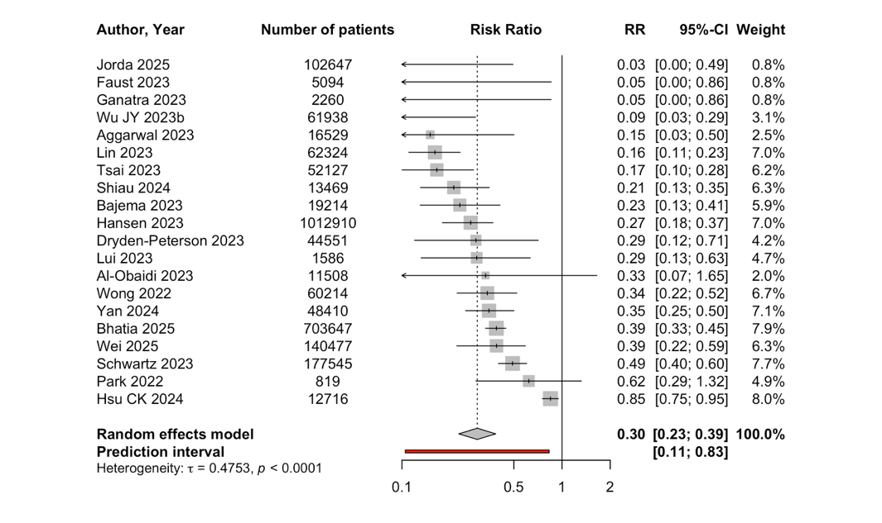 | COVID-specific mortality  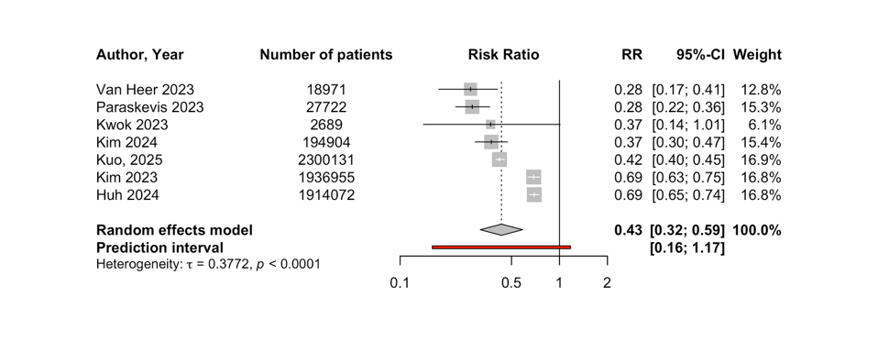

Appendix Figure 2. Forest plots for all patients, all-cause hospitalization and COVID-specific hospitalization
All-cause hospitalization  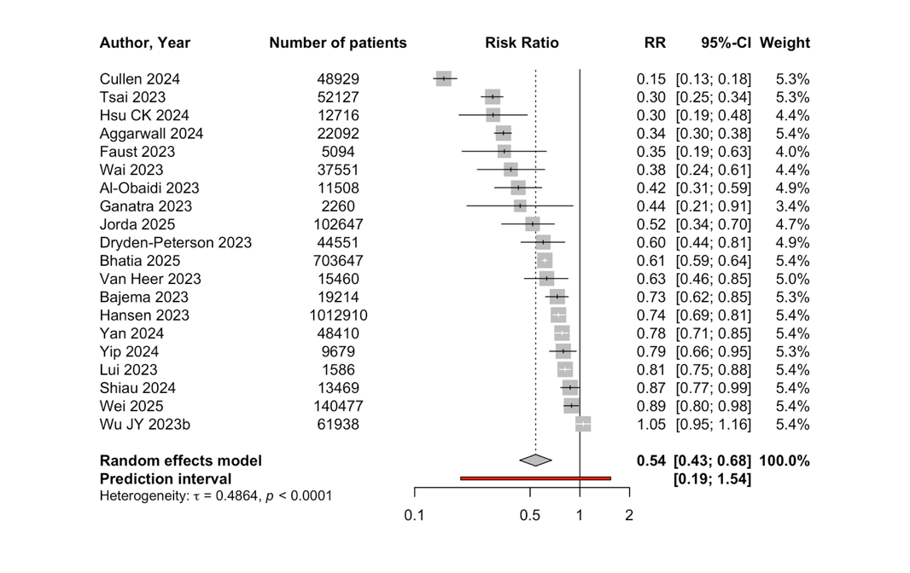 | COVID-specific hospitalization  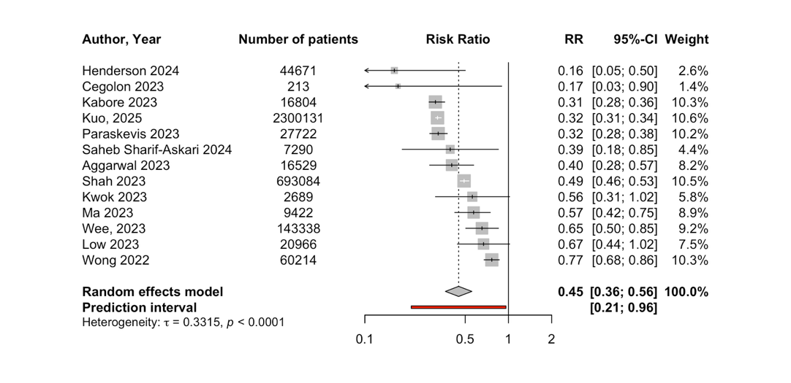
Appendix Figure 3. Forest plots for any mortality, any hospitalization and composite of mortality or hospitalization stratified by age
Mortality by age  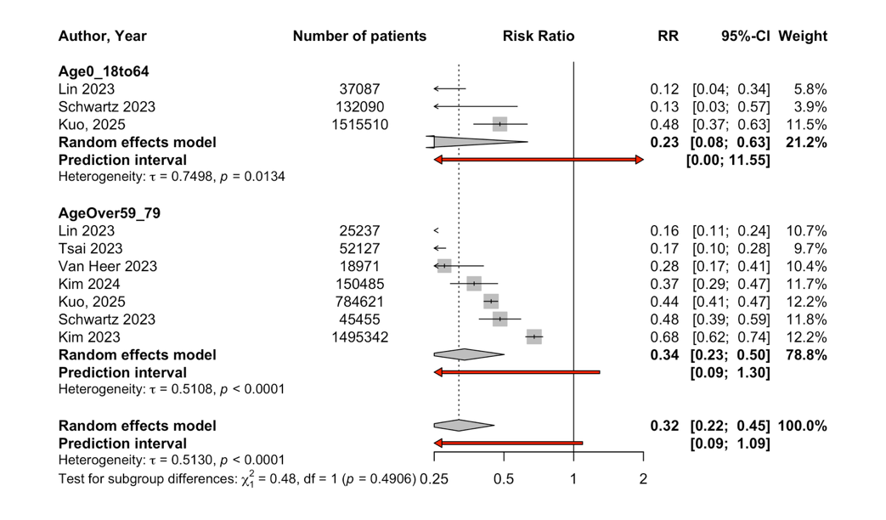  Mortality or hospitalization by age  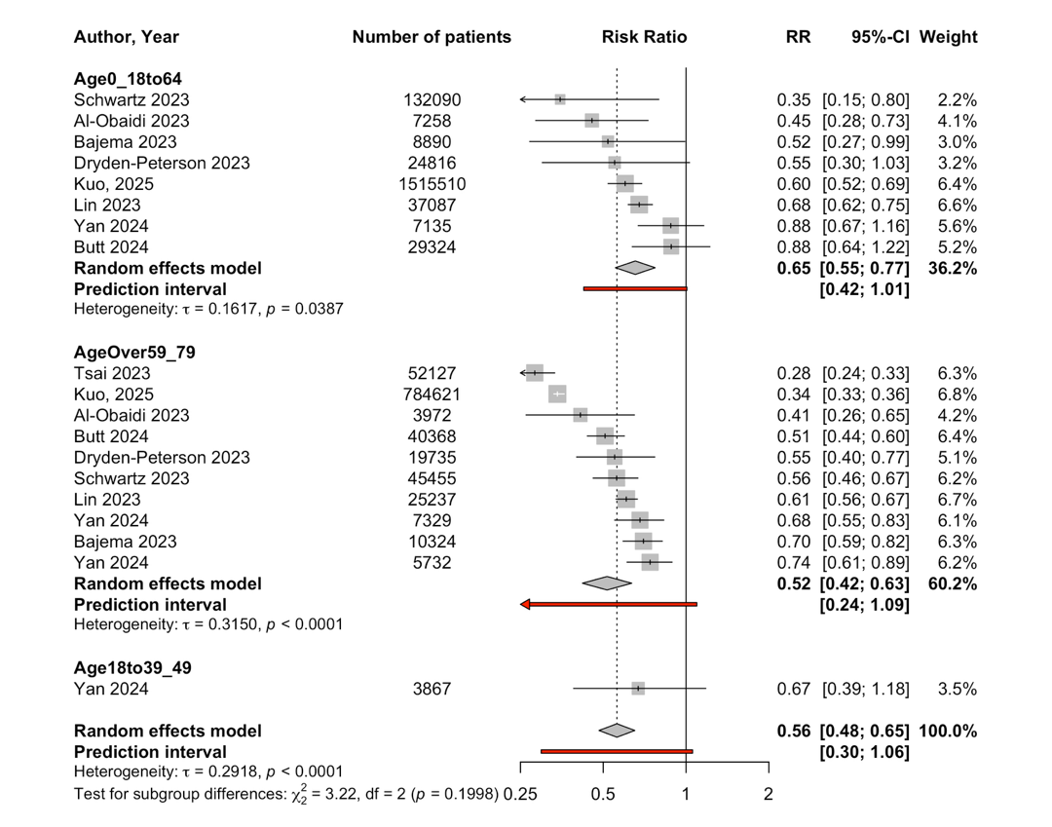 | Hospitalization by age  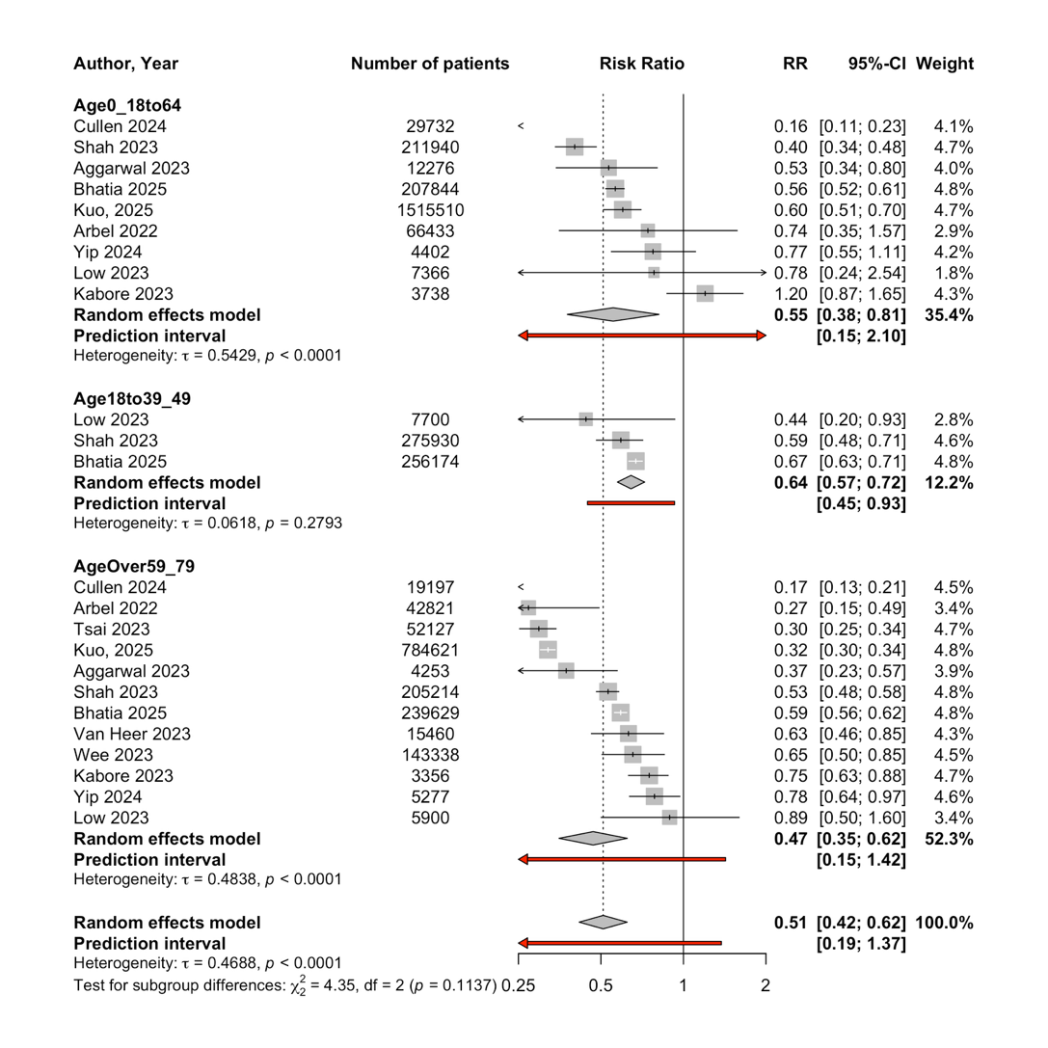
Appendix Figure 4. Forest plots for any mortality, any hospitalization and composite of mortality or hospitalization stratified by early vs late omicron
Mortality by early vs late omicron  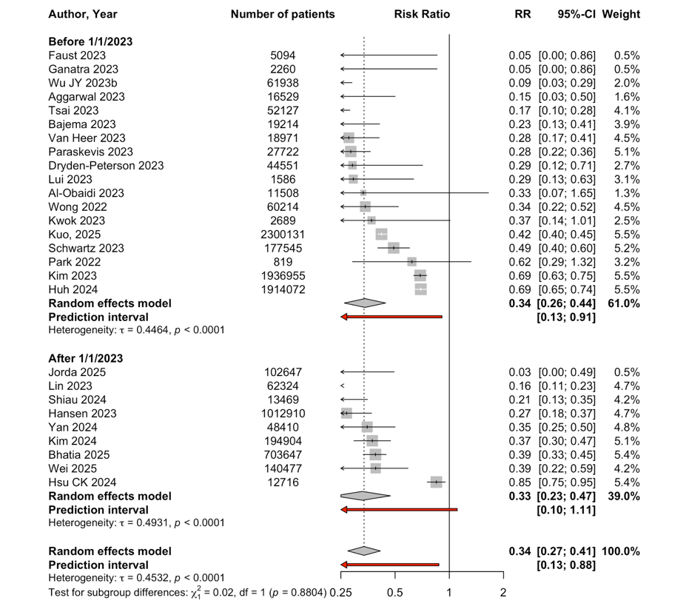  Mortality or hospitalization by early vs late omicron  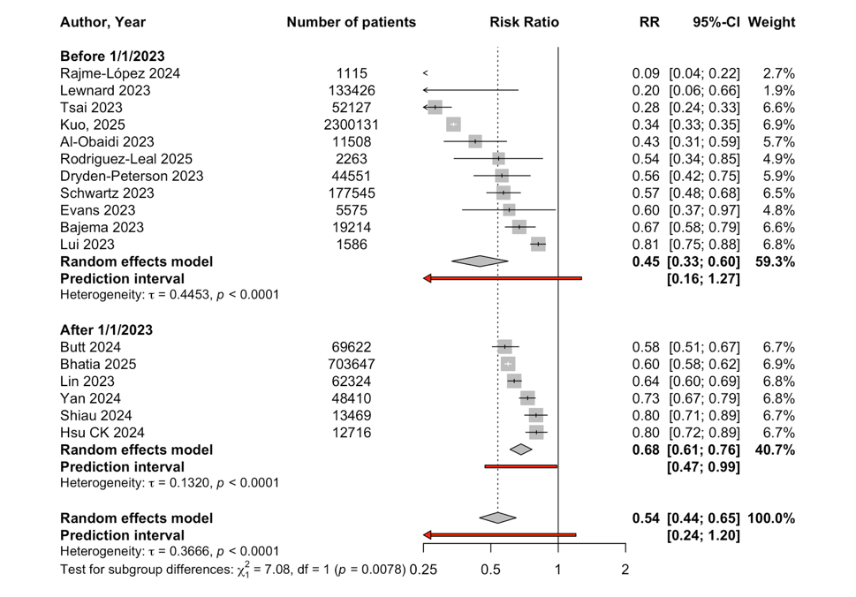 | Hospitalization by early vs late omicron  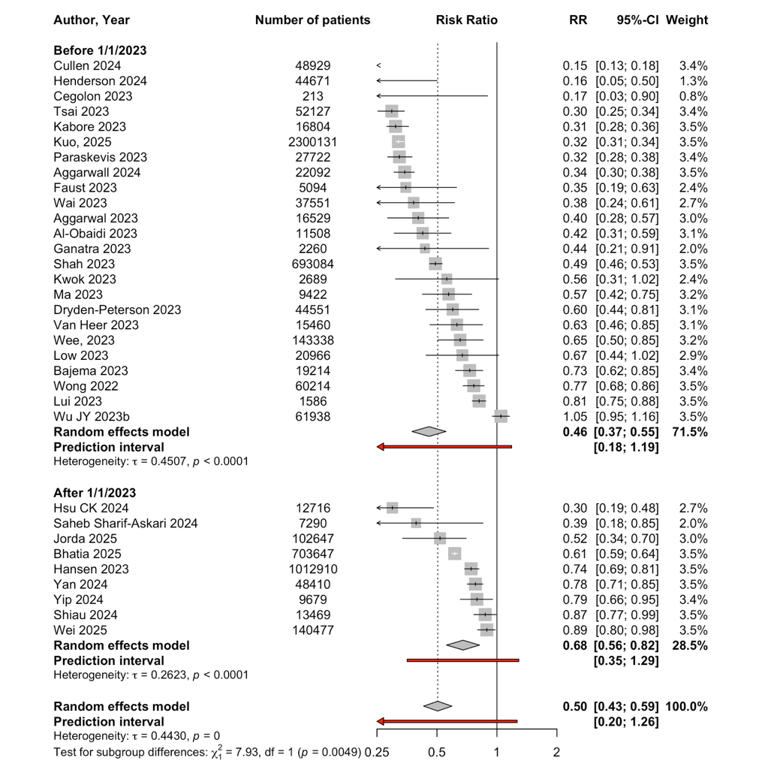
Appendix Figure 5. Forest plots for any mortality, any hospitalization and composite of mortality or hospitalization stratified by immunocompromise
Mortality by immunocompromise  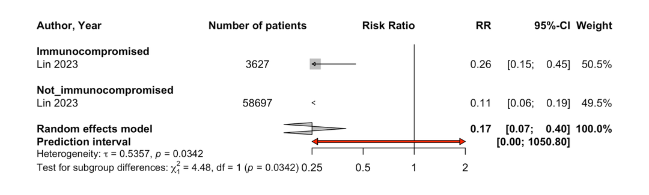  Mortality or hospitalization by immunocompromise  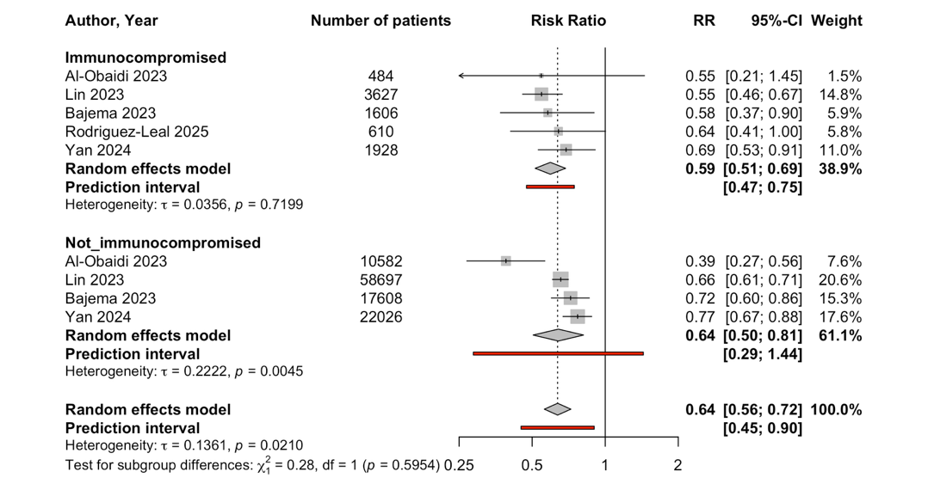 | Hospitalization by immunocompromise  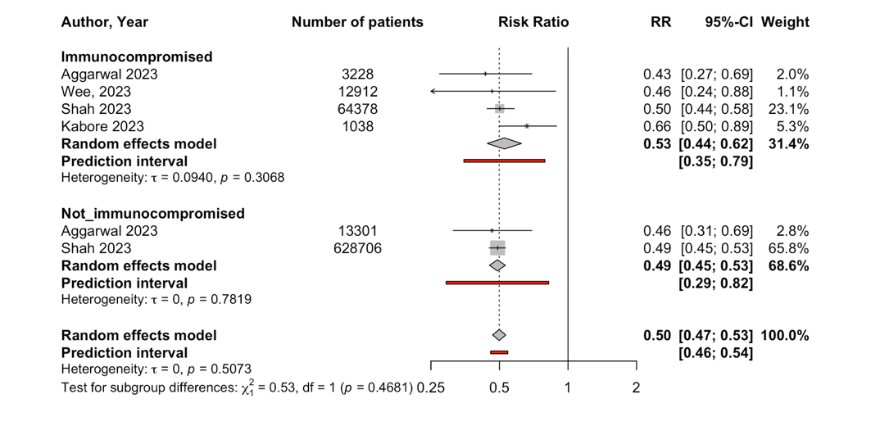

Appendix Figure 6. Forest plots for any mortality, any hospitalization and composite of mortality or hospitalization stratified by low vs high risk
Mortality by low vs high risk  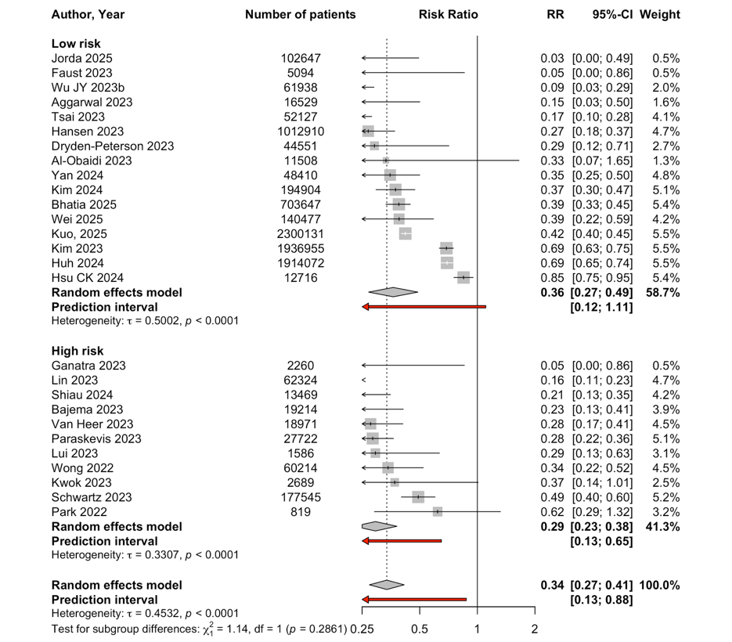  Mortality or hospitalization by low vs high risk  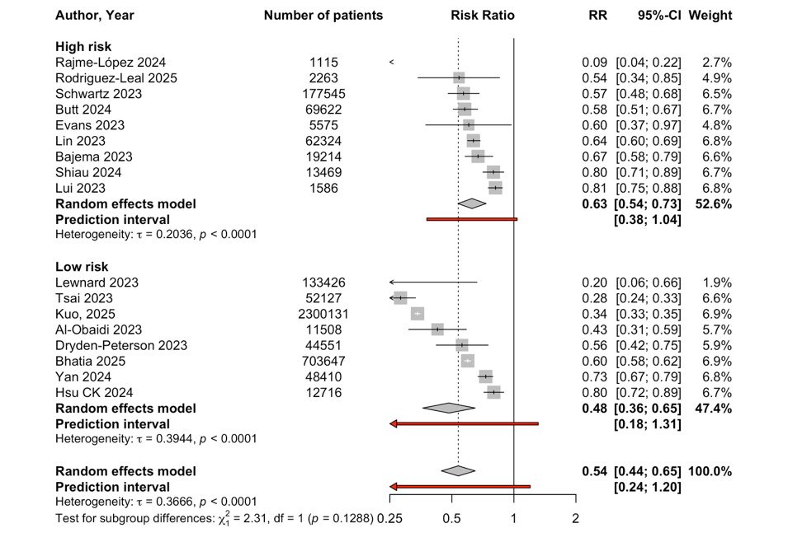 | Hospitalization by low vs high risk  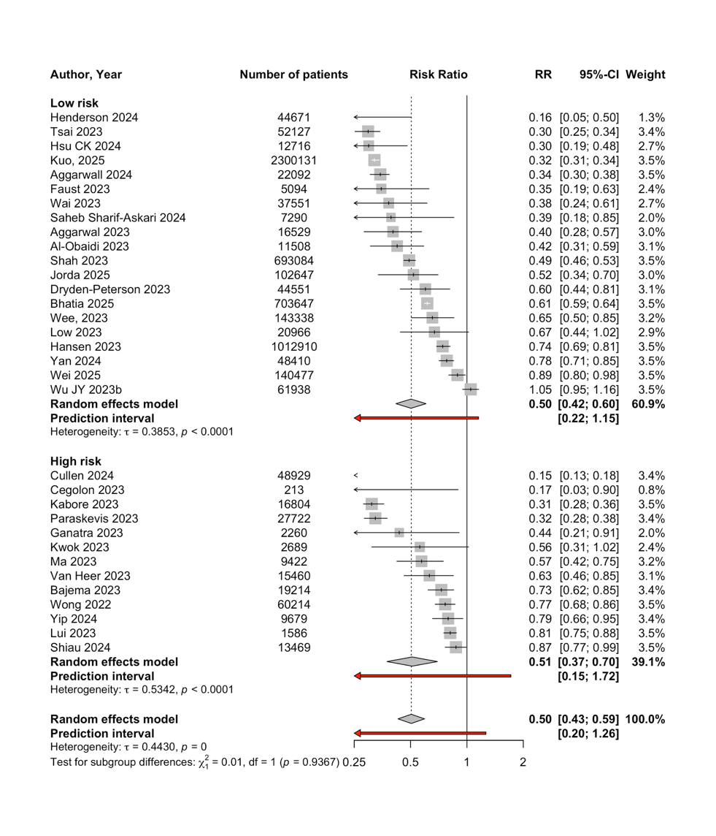
Appendix Figure 7. Forest plots for any mortality, any hospitalization and composite of mortality or hospitalization stratified by PSM vs other method
Mortality by PSM vs other method  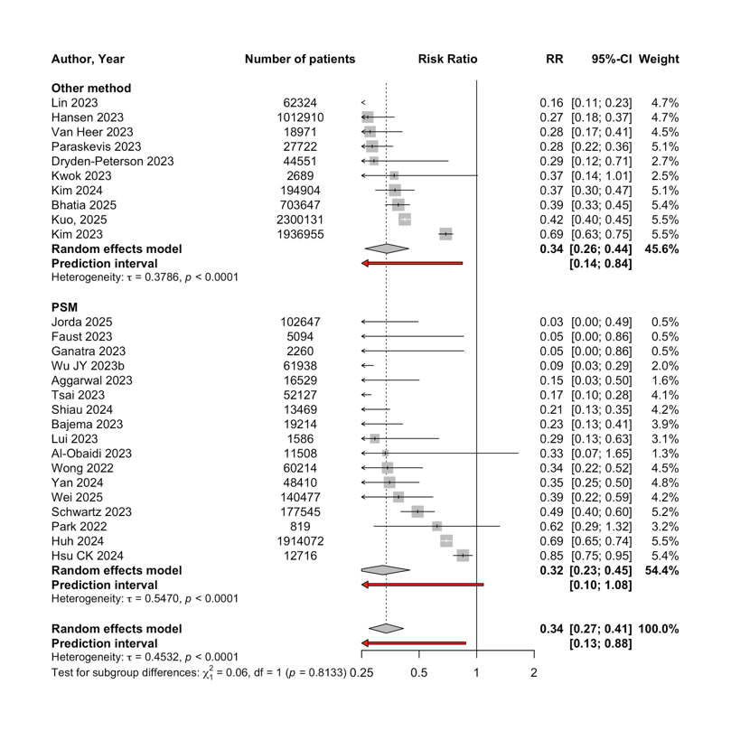 | Hospitalization by PSM vs other method  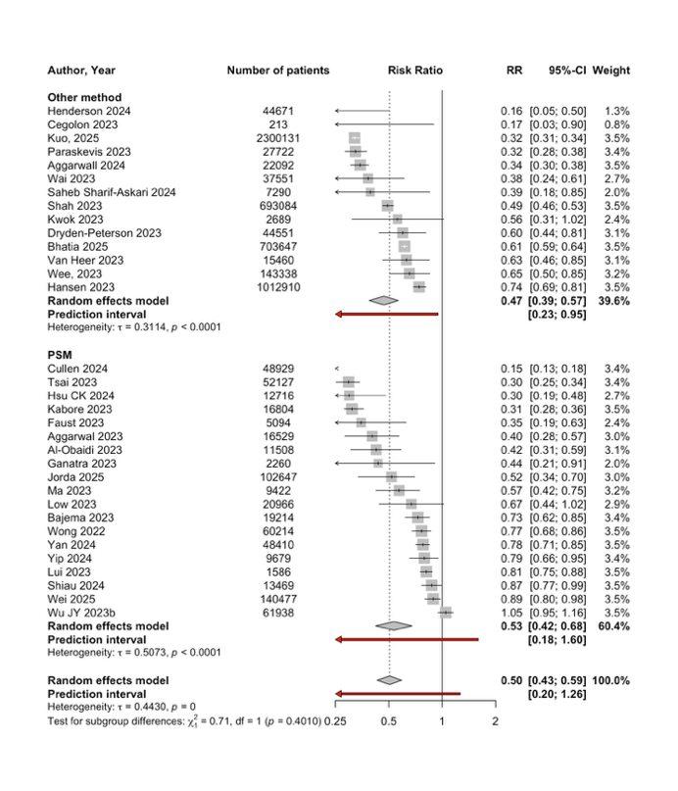 | Mortality or hospitalization by PSM vs other method  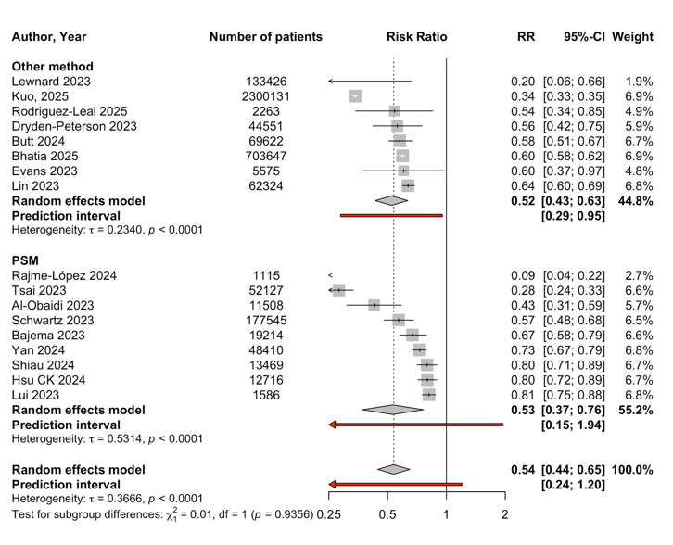

Appendix Figure 8. Forest plots for any mortality, any hospitalization and composite of mortality or hospitalization stratified by vaccination
Mortality by vaccination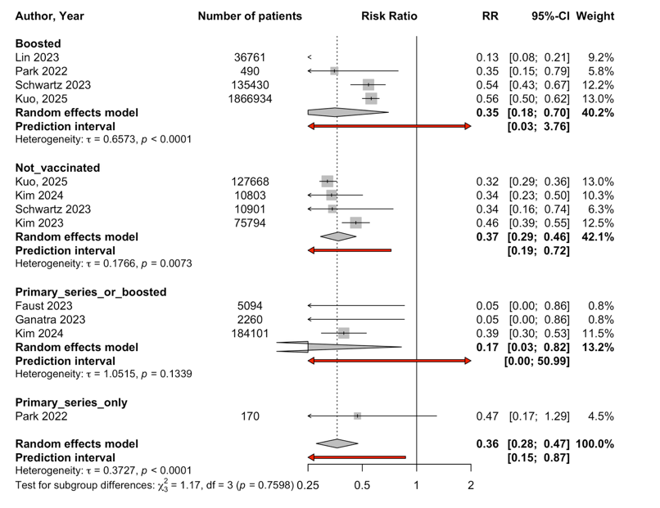  Mortality or hospitalization by vaccination  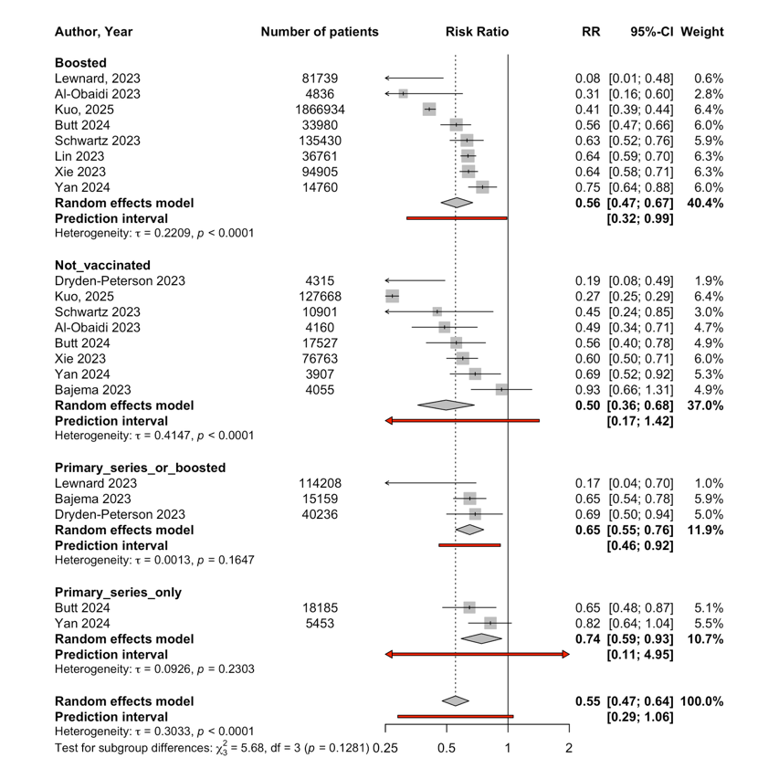 | Hospitalization by vaccination  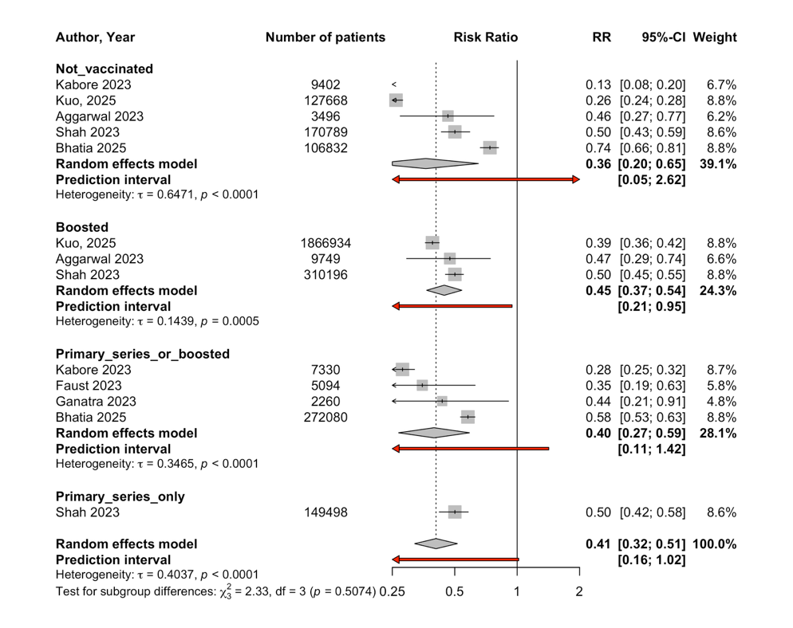

Appendix Figure 9. Scatter plots with fitted regression lines and 95% Cis for hospitalization rate in the control group versus relative risk and mortality rate in the control group versus relative risk.
Hospitalization rate in control groups versus relative risk
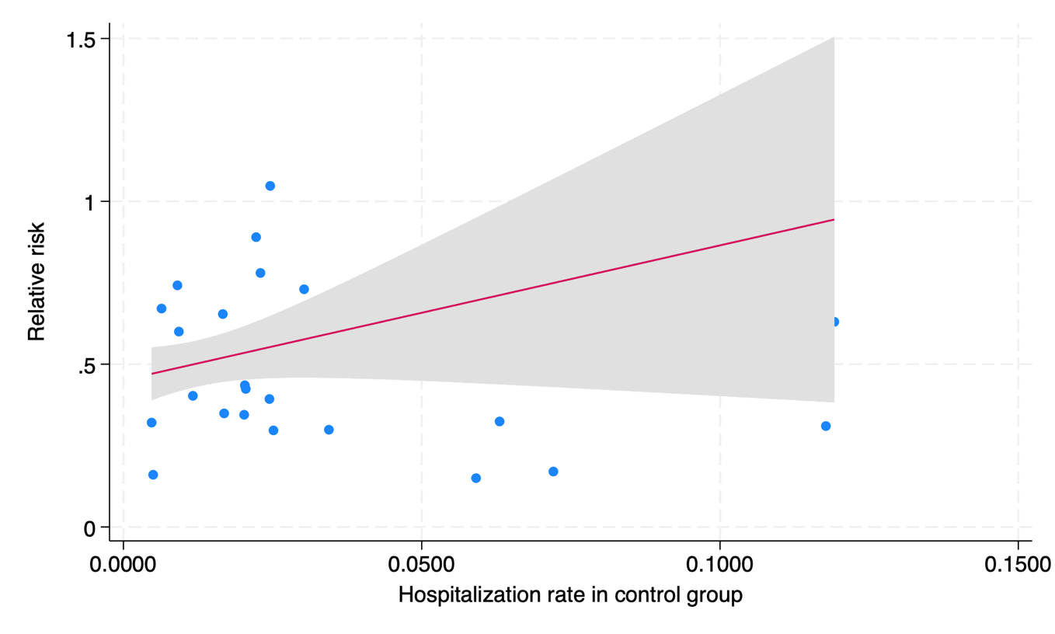

Mortality rate in control groups versus relative risk
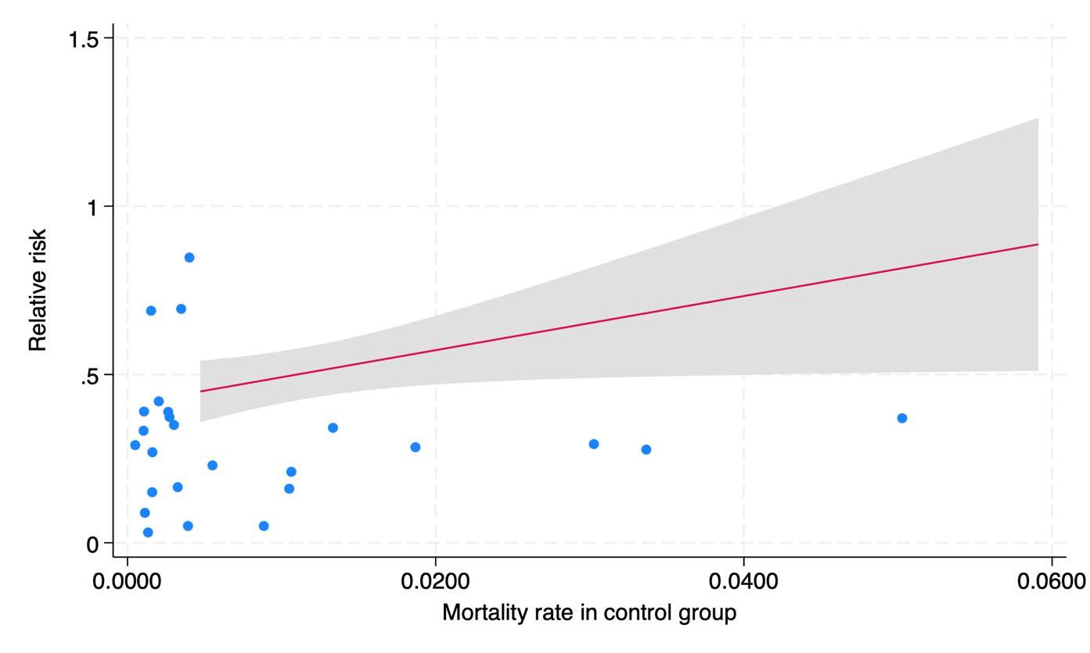

Appendix Figure 10. Funnel plots for outcomes of mortality, hospitalization and composite of mortality and hospitalization
Mortality  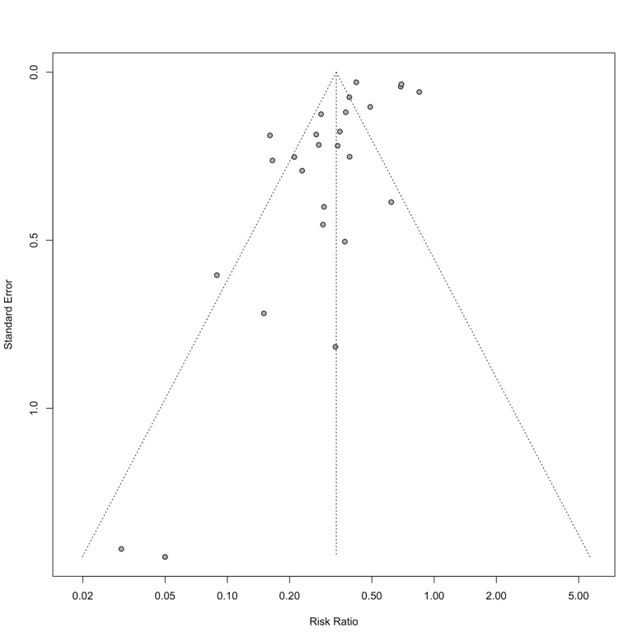 | Hospitalization  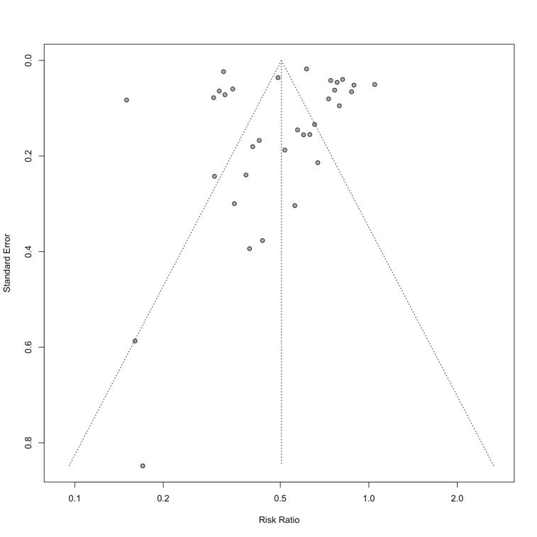
Mortality or hospitalization
