Supplemental Appendix

Table 1: International Classification of Disease-10 codes to identify opioid use disorder

Figure 1: Unadjusted trends in number of emergency department visits and discharges before medically advised

Figure 2: Trends in outcomes adjusted for seasonality

Table 2: Sensitivity analysis with exclusion of a comparison hospital

Table 3: Sensitivity analysis with exclusion of March-December 2020 for COVID-19 pandemic

Table 1: International Classification of Disease-10 codes to identify opioid-related disorders

Category | ICD-10 Codes | Description
Opioid Poisoning/Overdose | T40.0X* | Poisoning by opium
Opioid Poisoning/Overdose | T40.1X* | Poisoning by heroin
Opioid Poisoning/Overdose | T40.2X* | Poisoning by other opioids (e.g., morphine, codeine)
Opioid Poisoning/Overdose | T40.3X* | Poisoning by methadone
Opioid Poisoning/Overdose | T40.4* | Poisoning by synthetic narcotics (e.g., fentanyl, tramadol)
Opioid Poisoning/Overdose | T40.6* | Poisoning by other/unspecified narcotics
Opioid-Related Disorders | F11.1* | Opioid abuse (with/without complications)
Opioid-Related Disorders | F11.2* | Opioid dependence (with/without complications)
Opioid-Related Disorders | F11.9* | Opioid use, unspecified (with/without complications)

Figure 1: Unadjusted trends in number of emergency department visits within 6 months of discharge and discharges before medically advised

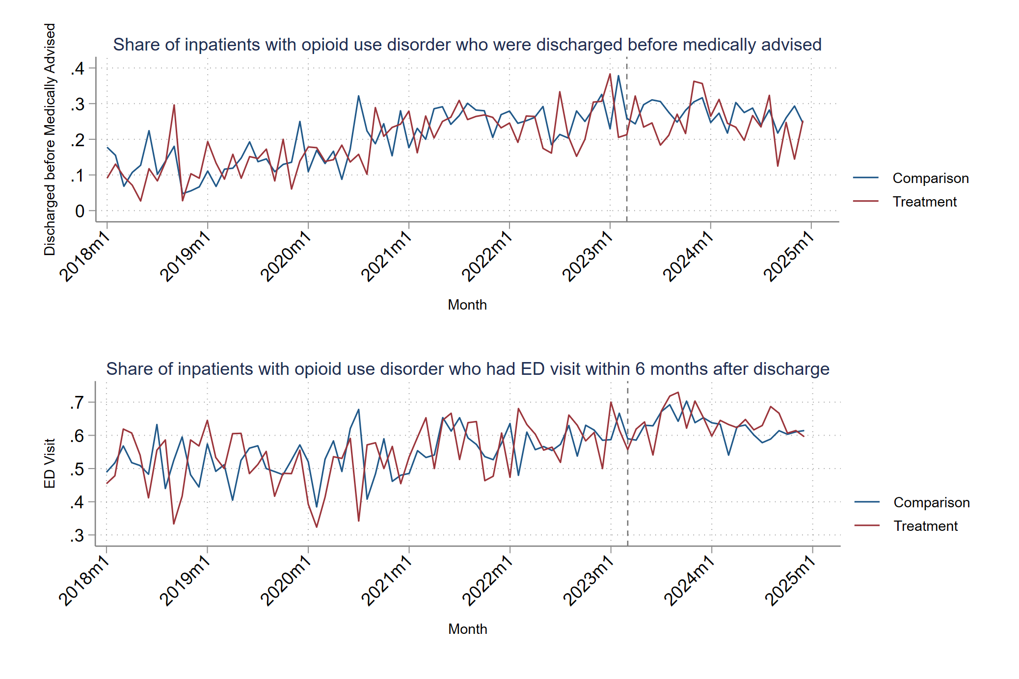
Notes: Individuals in the comparison group include patients with an ICD-10 diagnosis corresponding to opioid use disorder who were admitted to the three hospitals in the health system that did not implement an addiction consult service at any point during the study period. Individuals in the treatment group reflected patients with opioid use disorder treated at the hospital that implemented an addiction consult service at any point during the study period.
Figure 2: Trends in outcomes adjusted for covariates

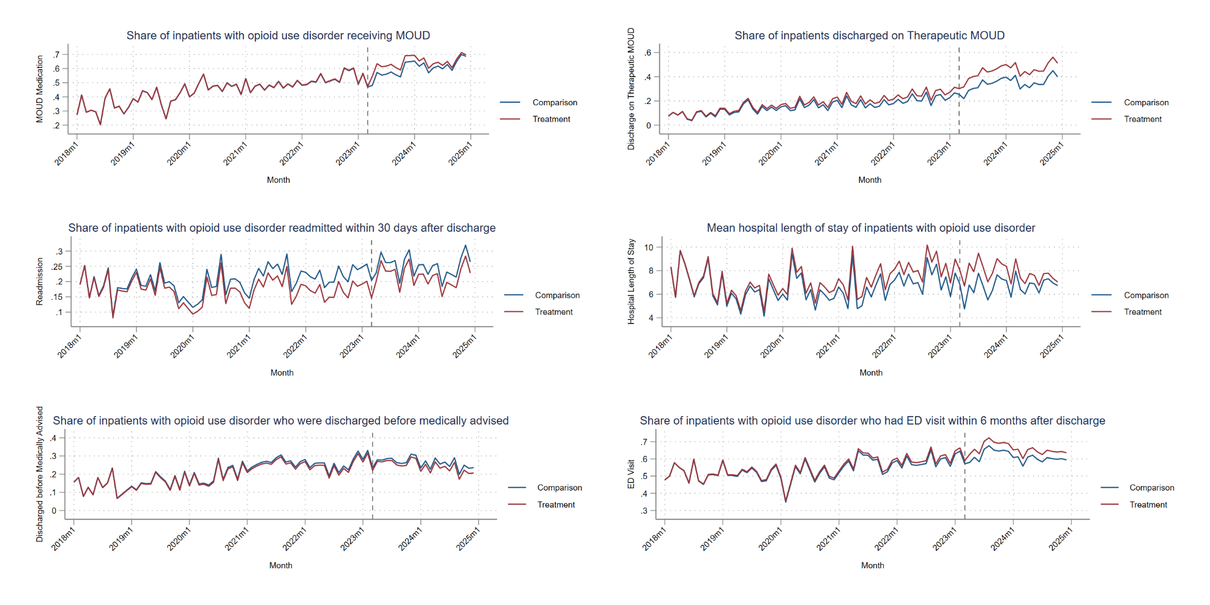

Notes: Individuals in the comparison group include patients with an ICD-10 diagnosis corresponding to opioid use disorder who were admitted to the three hospitals in the health system that did not implement an addiction consult service at any point during the study period. Individuals in the treatment group reflected patients with opioid use disorder treated at the hospital that implemented an addiction consult service at any point during the study period. MOUD=medication for opioid use disorder.

Table 2: Sensitivity analysis with exclusion of a comparison hospital

 | Unadjusted | Adjusted
Readmission within 30 days of discharge  (percentage points) | -0.02  [-0.07,0.03] | -0.01  [-0.05,0.04]
Length of stay  (days) | 0.24  [-0.65,1.12] | 0.25  [-0.60,1.10]
MOUD receipt  (percentage points) | 0.08*  [0.02,0.14] | 0.05*  [0.00,0.10]
Discharge on therapeutic MOUD  (percentage points) | 0.12***  [0.08,0.16] | 0.10***  [0.06,0.14]
Discharge before medically advised  (percentage points) | 0.01  [-0.03,0.06] | 0  [-0.04,0.04]
Emergency department visit within 6 months of discharge  (visits) | 0.02  [-0.03,0.07] | 0.03  [-0.01,0.08]

Notes: This table depicts regression estimates that correspond to differential changes in outcomes between patients with OUD admitted to the hospital with an ACS (“treatment”) relative to patients with OUD admitted to the other hospitals without ACS (“comparison”), before and after the ACS was implemented in July 2023. All models include hospital- and year-fixed effects. Adjusted models additionally controlled for age, sex, race, insurance type, Charlson Comorbidity Index score, and the presence of serious injection-related infections. 95% confidence intervals are presented in brackets.
*p-value<0.05
***p-value<0.001

Table 3: Sensitivity analysis with exclusion of March-December 2020 for COVID-19 pandemic

 | Unadjusted | Adjusted
Readmission within 30 days of discharge  (percentage points) | -0.01  [-0.05,0.03] | 0  [-0.04,0.04]
Length of stay  (days) | 0.33  [-0.58,1.23] | 0.30  [-0.57,1.17]
MOUD receipt  (percentage points) | 0.05*  [0.00,0.12] | 0.03  [-0.01,0.07]
Discharge on therapeutic MOUD  (percentage points) | 0.09***  [0.05,0.14] | 0.08***  [0.04,0.12]
Discharge before medically advised  (percentage points) | 0  [-0.04,0.04] | -0.01  [-0.05,0.03]
Emergency department visit within 6 months of discharge  (visits) | 0.02  [-0.03,0.06] | 0.03  [-0.01,0.07]

Notes: This table depicts regression estimates that correspond to differential changes in outcomes between patients with OUD admitted to the hospital with an ACS (“treatment”) relative to patients with OUD admitted to the other hospitals without ACS (“comparison”), before and after the ACS was implemented in July 2023. All models include hospital- and year-fixed effects. Adjusted models additionally controlled for age, sex, race, insurance type, Charlson Comorbidity Index score, and the presence of serious injection-related infections. 95% confidence intervals are presented in brackets.
*p-value<0.05
***p-value<0.001

