Supplementary Online Content

eFigure 1 Cohort Inclusion Flowchart for the Study Sample
eTable 1. Medications of Interest Considered in the Study
eTable 2. ICD-9-CM, ICD-10-CM, or Procedure Codes for Disease Conditions and Service Care Considered in the Study
eTable 3. Definition of Study Outcomes
eTable 4. Study Covariates, Definitions, and Measurement Sources and Windows
eTable 5. Duration of Follow-Up and Reasons for Censoring
eTable 6. Percentages of Participants by Time-Varying Characteristics During Follow-Up
eTable 7: Baseline Clinical and Demographic Characteristics of the HRS-Medicare Study Participants for Cross-Validation Splits, Stratified by Those With or Without Outcomes of OD or OUD.
eTable 8. Coefficients of Variables Predicting Time to First OUD or OD From Full, BS-, and Lasso-Cox models Using the Cause-specific vs Sub-distribution Hazard
eMethod 1. Imputation Approach for Missing Data on HRS-Assessed Covariates at Baseline and Follow-Up
eMethod 2. Development of Prediction Methods for the First OUD or OD and Sources of R Packages Used in Analyses
eFigure 1. Cohort Inclusion Flowchart for the Study Sample
eFigure 2. Receiver Operating Characteristic Curves for Each Training and Testing Split Across All Years (1 to 8), by Type of Prediction Model

eTable 1. Medications of Interest Considered in the Study
Medication Class | Individual Medication
Opioids | butorphanol, codeine, dihydrocodeine, fentanyl, hydrocodone, hydromorphone, levorphanol, meperidine, methadone, morphine, nalbuphine, opium, oxycodone, oxymorphone, pentazocine, remifentanil, sufentanil, tramadol.  *Excluding injectable opioids used primarily for inpatients, rectal dosage forms that are rarely used, opioids used as cold medicines (eg, promethazine/codeine syrup) to suppress cough, and buprenorphine in sublingual form and combined buprenorphine-naloxone products, which are used for addiction treatment.
Nonopioids
Analgesics and antipyretics | acetaminophen, salicylamide, sodium thiosalicylate, ziconotide
NSAIDs | celecoxib, diclofenac potassium/sodium, etodolac, fenoprofen, flurbiprofen, ibuprofen, indomethacin, ketoprofen, ketorolac, meclofenamate, mefenamic acid, meloxicam, nabumetone, naproxen, oxaprozin, piroxicam, sulindac, tolmetin
Salicylates | Aspirin, diflunisal, choline magnesium trisalicylate, magnesium salicylate, and salsalate
Adjuvant analgesics
SNRI antidepressants | Duloxetine, venlafaxine, desvenlafaxine, Milnacipran, levomilnacipran
Tricyclic antidepressants | amitriptyline, clomipramine, imipramine, doxepin, trimipramine, amoxapine, maprotiline, nortriptyline, desipramine, protriptyline,
Anticonvulsants (for pain treatment) | carbamazepine, fosphenytoin, gabapentin, lacosamide, lamotrigine, levetiracetam, oxcarbazepine, phenytoin, pregabalin, topiramate, and valproate
Skeletal muscle relaxants | baclofen, carisoprodol, chlorzoxazone, cyclobenzaprine, dantrolene, diazepam, metaxalone, methocarbamol, orphenadrine, tizanidine
Other CNS Medications
Benzodiazepines | alprazolam, estazolam, lorazepam, oxazepam, temazepam, triazolam, midazolam, chlordiazepoxide, clobazam, clonazepam, clorazepate, diazepam, prazepam, flurazepam, quazepam.
Antipsychotics | acetophenazine, chlorpromazine, droperidol, fluphenazine, haloperidol, loxapine, mesoridazine, molindone, perphenazine, pimozide, prochlorperazine, thioridazine, thiothixene, trifluoperazine, aripiprazole, asenapine, brexpiprazole, cariprazine, clozapine, iloperidone, fanapt, lurasidone, olanzapine, paliperidone, primavaserin, quetiapine, risperidone, ziprasidone.
Sedative-hypnotics | buspirone, meprobamate, eszopiclone, zaleplon, zolpidem, suvorexant, hydroxyzine, diphenhydramine, ramelteon, tasimelteon, amobarbital, butabarbital, pentobarbital, secobarbital, phenobarbital, mephobarbital, chloral hydrate, lemborexant
Antidepressants (excluding drugs for pain treatment) | mirtazapine, bupropion, isocarboxazid, phenelzine, tranylcypromine, selegiline, rasagiline, nefazodone, trazodone, citalopram, escitalopram, fluoxetine, fluvoxamine, paroxetine, sertraline, vilazodone, vortioxetine, maprotiline
Anticonvulsants (excluding those for pain treatment) | acetazolamide, brivaracetam, cenobamate, eslicarbazepine acetate, ethadione, ethotoin, ethosuximide, ezogabine, felbamate, fenfluramine, mephenytoin, methohexital, methsuximide, magnesium sulfate, perampanel, paramethadione, phenobarbital, primidone, rufinamide, stiripentol, sultiame, tiagabine, trimethadione, vigabatrin, zonisamide
Abbreviations: CNS, central nervous system; NSAID, nonsteroidal anti-inflammatory; SNRI, serotonin and norepinephrine reuptake inhibitor.

eTable 2. ICD-9-CM, ICD-10-CM, or Procedure Codes for Disease Conditions and Service Care Considered in the Study
Disease, Condition, or Service Care | ICD-9-CM, ICD-10-CM, or Procedure Code | Algorithm
Chronic pain
Musculoskeletal | 274.x, 710.x-729.x (exclude 723.4, 724.3, 724.4, 729.1, 729.2), A18.01-A18.02, A52.16, D48.1, E08.61x, E09.61x, E10.61x, E11.61x, E13.61x, M00-M02, M04.02-M04.09, M05-M19, M1A, M20.10, M21.61-M21.62, M22-M25, M32-M36, M43.2-M43.8X9, M45-M48, M49.80, M50, M51, M53, M54, M60.0-M60.2, M61-M63, M65-M67, M70-M72, M75-M77, M79, M96.1, M99.2-M99.7, N20.0, Q68.6, R25.2, R26.2, R29.8x | At least 1 inpatient, SNF, HHA, HOP, or carrier claim with disease code in any diagnostic position
Neuropathic | 053.1x, 249.6, 250.6, 307.89, 336.x, 337.x, 338.0, 340, 350.x, 351.x, 352.1, 353.x-355.x, 357.1, 357.2-357.4, 357.8, 357.9, 723.4, 724.3, 724.4, 729.1, 729.2,  A52.15, B02 (exclude B02.1), EXX.4, EXX.610, EXX.65 (where X in “08”-“13”), E10.4, F45.42, G13.0, G13.1, G32.0, G35, G50- G52.1, G54-G59, G61.8, G61.9, G62.8, G62.9, G63-G65, G89.0, G90.0, G90.5, G95, G99.0-G99.2, M05.5, M54.13-M54.18, M54.3, M54.4, M60.8, M60.9, M79.1, M79.2, M79.7
Idiopathic | 338.2, 338.4, 780.96, G89, R52
Clinical condition
Cancer | CCS11-CCS43 | HCUP CCS for ICD-9-CM or ICD-10-CM
Mental disorder | Anxiety disorders (CCS 651), mood disorders (CCS 657), schizophrenia and other psychotic disorders (CCS 659) | HCUP CCS for ICD-9-CM or ICD-10-CM
Diabetes | Diabetes mellitus without complication (CCS 49), diabetes mellitus with complications (CCS 50) | HCUP CCS for ICD-9-CM or ICD-10-CM
Cardiovascular disease | Heart valve disorders (CCS 96), coronary atherosclerosis and other heart disease (CCS 101), pulmonary heart disease (CCS 103), cardiac dysrhythmias (CCS 106), congestive heart failure; nonhypertensive (CCS 108), acute cerebrovascular disease (CCS 109), occlusion or stenosis of precerebral arteries (CCS 110), other and ill-defined cerebrovascular disease (CCS 111), peripheral and visceral atherosclerosis (CCS 114) | HCUP CCS for ICD-9-CM or ICD-10-CM
Hypertension | essential hypertension (CCS 98), hypertension with complications, and secondary hypertension (CCS 99) | HCUP CCS for ICD-9-CM or ICD-10-CM
Pulmonary condition | Pneumonia (except that caused by tuberculosis or sexually transmitted disease) (CCS 122), acute bronchitis (CCS 125), other upper respiratory infections (CCS 126), chronic obstructive pulmonary disease and bronchiectasis (CCS 127), asthma (CCS 128), pleurisy; pneumothorax; pulmonary collapse (CCS 130), respiratory failure; insufficiency; arrest (CCS 131), other lower respiratory disease (CCS 133) | HCUP CCS for ICD-9-CM or ICD-10-CM
Kidney disease | Nephritis; nephritis; renal sclerosis (CCS 156), acute and unspecified renal failure (CCS 157), chronic kidney disease (CCS 158), other diseases of kidney and ureters (CCS 161) | HCUP CCS for ICD-9-CM or ICD-10-CM
Gastrointestinal tract disorder | Gastrointestinal hemorrhage (CCS 153), other gastrointestinal disorders (CCS 155), digestive congenital anomalies (CCS 214) | HCUP CCS for ICD-9-CM or ICD-10-CM
Liver disease | Liver diseases (CCS 151) | HCUP CCS for ICD-9-CM or ICD-10-CM
Neurodegenerative disorder | Parkinson disease (CCS 79), other hereditary and degenerative nervous system conditions (CCS 81) | HCUP CCS for ICD-9-CM or ICD-10-CM
Substance use disorder | Chronic Condition Data Warehouse, Drug Use Disorder Algorithm¹ | At least 1 inpatient, SNF, HHA, HOP, carrier, or DME claim with disease code
Procedures
Physical therapy | 20550-20552, 20560, 20561, 28899, 20999, 62281, 62324, 62325, 64405, 64408, 64415, 64417, 64418, 64420, 64421, 64425, 64430, 64435, 64445-64451, 64461-64463, 64505, 64510, 64517, 64520, 64530, 64620, 64632, 64660, 64999, 64450, 76881, 76882, 76942, 76999, 90901, 90912, 90913, 92506, 97001-97004, 97010, 97012, 97016, 97018, 97022, 97024, 97026, 97028, 97032-97036, 97039, 97110, 97112, 97113, 97116, 97124, 97139, 97140, 97150, 97530, 97542, 97597, 97598, 97760, 97799, 97610, 97161-97168, 97810, 97811, 97813, 97814, G0281, G0282, G0283, G0329, 0019T | At least 1 inpatient, SNF, HHA, HOP, carrier, or DME claim with disease code
Abbreviations: ADRD, Alzheimer disease and related dementias; BPSD, behavioral and psychological symptoms of dementia; CCS, Clinical Classification Software; DME, Durable Medical Equipment; HCUP, Healthcare Cost and Utilization Project; HHA, home health agency; HOP, hospital outpatient; ICD-9-CM and ICD-10-CM, International Classification of Diseases, Ninth or Tenth Revision, Clinical Modification; SNF, skilled nursing facility.
¹https://www2.ccwdata.org/web/guest/condition-categories-other
eTable 3. Definition of Study Outcomes
Disease, Condition, or Service Care | ICD-9-CM, ICD-10-CM, or Procedure Code
Opioid use disorder | Opioid misuse (ICD-9-CM and ICD-10-CM)  305.50 (Opioid abuse – unspecified)  305.51 (Opioid abuse – continuous)  305.52 (Opioid abuse – episodic)  F11.xx, excluding codes that indicated “in remission” or “subsequent encounter to identify an incident event.”  Opioid dependence (ICD-9-CM and ICD-10-CM)  304.00 (Opioid type dependence – unspecified)  304.01 (Opioid type dependence – continuous)  304.02 (Opioid type dependence – episodic)  304.70 (Combinations of opioid type drug with any other – unspecified)  304.71 (Combinations of opioid type drug with any other – continuous)  304.72 (Combinations of opioid type drug with any other – episodic)  F11.2* (opioid dependence, excluding F11.21 [in remission])  F11.9* (opioid use, excluding F11.91 [in remission])
Opioid overdose | Opioid poisoning (ICD-9-CM and ICD-10-CM):  965.00 (Poisoning – opium (alkaloids), unspecified)  965.01 (Poisoning – heroin)  965.02 (Poisoning – methadone)  965.09 (Poisoning – opiates and related narcotics, other)  E850.0 (Accidental poisoning by heroin)  E850.1 (Accidental poisoning by methadone)  E850.2 (Accidental poisoning by other opiates and related narcotics)  T400X1- T400X5, T401X1-T401X4, T402X1-T403X5, T404X1-T404X5, T40601-T40605, T40691-T40695, excluding codes that indicated “in remission” or “subsequent encounter to identify an incident event”)
Injection drug-use related infection
Phlebitis | ICD-9-CM: 451.1*, 451.2*, 451.8*, 451.9*  ICD-10-CM: I80.1*, I80.2*, I80.3*, I80.8*, I80.9*
Abscess and/or cellulitis | ICD-9-CM: 324.1, 324.9, 680, 681, 682, 683  ICD-10-CM: G06.1, G06.2, L02.01, L02.1* L02.2*, L02.3*, L02.4*, L02.91, L03.0*, L03.1*, L03.21*, L03.3*, L03.8*, L03.9*, L98.3
Hepatitis C | ICD-9-CM: 070.41, 070.44, 070.51, 070.54, 070.70, 070.71, V02.62  ICD-10-CM: B17.1, B18.2, Z22.52
Infectious arthritis | ICD-9-CM: 711.0*  ICD-10-CM: M00
Infectious endocarditis | ICD-9-CM: 421*, 424.9*  ICD-10-CM: I33.0, I33.9, I38, I39
Inpatient detox/rehabilitation treatment center | Revenue Code: 0116, 0126, 0136, 0146, 0156, 0118, 0128, 0138, 0158  ICD-9-CM procedure codes: 94.45, 94.46, 94.6*,  ICD-10-CM procedure codes: HZ*
Emergency department visit | Revenue Code: 0450-0452, 0456, 0459, 0981
Abbreviations: ICD-9-CM and ICD-10-CM, International Classification of Diseases, Ninth or Tenth Revision, Clinical Modification;
eTable 4. Study Covariates, Definitions, and Measurement Sources and Windows
Covariate | Measurement | Measurement window | Data source
Demographic characteristic
Age | Classified into 3 groups: 65-74, 75-84, and ≥85 years | On index HRS | Medicare Beneficiary Summary File
Sex | Male or female | On index HRS | Medicare Beneficiary Summary File
Race and ethnicity | Measured based on the Medicare–Research Triangle Institute race code and classified into 3 groups: Black, White, and other (including Asian, Pacific Islander, and Native American or Hispanic individuals) | On index HRS | Medicare Beneficiary Summary File
US geographic region | Northeast, Midwest, West, and South | On index HRS | Medicare Beneficiary Summary File
Dual eligibility status | Dual eligible beneficiaries were defined as having full or partial eligibility in both Medicare and Medicaid in any month; otherwise, nondual beneficiaries | 12 mo before index HRS | Medicare Beneficiary Summary File
Marital status | Classified into married/partnered, separated/divorced, or widowed/never married | On index HRS and each HRS thereafter in follow-up | HRS
Socioeconomic variable
Educational level | Classified into <high school, high school or equivalent, or ≥college | On index HRS | HRS
Household income | Classified into ≤$14,000, $14,001-$26,000, $26,001-$50,000, and ≥$50,001 | On index HRS and each HRS thereafter in follow-up | HRS
Health indicator
Self-rated health status | Classified into poor/good, very good, or excellent | On index HRS and each HRS thereafter in follow-up | HRS
Body mass index | Calculated as weight in kilograms divided by the square of height in meters and categorized as underweight (<18.5), normal (18.5-24.9), overweight (25.0-29.9), or obese (≥30) | On index HRS and each HRS thereafter in follow-up | HRS
Ever smoker | Yes vs no | On index HRS and each HRS thereafter in follow-up | HRS
Ever consumed alcohol | Yes vs no | On index HRS and each HRS thereafter in follow-up | HRS
Depression | Measured using the Center for Epidemiologic Studies Depression-8 (CESD-8) score; classified into depression (CESD-8 score >4) vs no depression (CESD-8 score ≤4) | On index HRS and each HRS thereafter in follow-up | HRS
Any physical impairment | Physical impairment was considered having difficulty in performing 7 ADLs, including picking up a dime, dressing, walking, bathing, eating, getting in/out bed, and using the toilet; classified into impairment (ADL ≥3) vs no impairment (ADL ≤2). | On index HRS and each HRS thereafter in follow-up | HRS
Any physical dependence | Physical dependence was considered having difficulty in performing 5 instrumental ADLs, including preparing meals, shopping, making phone calls, taking medications, and managing money; classified into dependence (instrumental ADL ≥1) vs no dependence (instrumental ADL=0) | On index HRS and each HRS thereafter in follow-up | HRS
Pain intensity | Pain intensity was measured by HRS participants' responses to 2 pain-related questions in each biennial wave: “Are you often troubled with pain?” and “How bad is the pain most of the time: mild, moderate, or severe?”  Patients who reported having moderate or severe pain were classified as having uncontrolled pain; otherwise, controlled pain. | On index HRS and each HRS thereafter in follow-up | HRS
Type of chronic pain conditions
Musculoskeletal pain | Presence or absence of diagnosis | 12 mo before cohort entry and 12 mo before each HRS-survey in follow-up | Medicare Parts A and B
Neuropathic pain | Presence or absence of diagnosis | 12 mo before cohort entry and 12 mo before each HRS-survey in follow-up | Medicare Parts A and B
Idiopathic pain | Presence or absence of diagnosis | 12 mo before cohort entry and 12 mo before each HRS-survey in follow-up | Medicare Parts A and B
Clinical condition
Diabetes | Presence or absence of diagnosis | 12 mo before cohort entry | Medicare Parts A and B
Cardiovascular disease | Presence or absence of diagnosis | 12 mo before cohort entry | Medicare Parts A and B
Stroke | Presence or absence of diagnosis | 12 mo before cohort entry | Medicare Parts A and B
Hypertension | Presence or absence of diagnosis | 12 mo before cohort entry | Medicare Parts A and B
Pulmonary condition | Presence or absence of diagnosis | 12 mo before cohort entry | Medicare Parts A and B
Kidney disease | Presence or absence of diagnosis | 12 mo before cohort entry | Medicare Parts A and B
Liver disease | Presence or absence of diagnosis | 12 mo before cohort entry | Medicare Parts A and B
Gastrointestinal tract disease | Presence or absence of diagnosis | 12 mo before cohort entry | Medicare Parts A and B
Cancer | Presence or absence of diagnosis | 12 mo before cohort entry and 12 mo before each HRS-survey in follow-up | Medicare Parts A and B
Fall injury | Presence or absence of diagnosis | 12 mo before cohort entry and 12 mo before each HRS-survey in follow-up | Medicare Parts A and B
Urinary incontinence | Presence or absence of diagnosis | 12 mo before cohort entry and 12 mo before each HRS-survey in follow-up | Medicare Parts A and B
Seizure | Presence or absence of diagnosis | 12 mo before cohort entry and 12 mo before each HRS-survey in follow-up | Medicare Parts A and B
Neurodegenerative diseases | Presence or absence of diagnosis | 12 mo before cohort entry | Medicare Parts A and B
Substance use disorder | Presence or absence of diagnosis | 12 mo before cohort entry and 12 mo before each HRS-survey in follow-up | Medicare Parts A and B
Mental health disorder | Presence or absence of diagnosis | 12 mo before cohort entry and 12 mo before each HRS-survey in follow-up | Medicare Parts A and B
Total number of comorbidities | Sum of the number of AHRQ CCS categories excluding the aforementioned pain and clinical conditions | 12 mo before cohort entry and 12 mo before each HRS-survey in follow-up | Medicare Parts A and B
Pain management
Receipt of physical therapy | Presence or absence of CPT codes | 12 mo before cohort entry and 12 mo before each HRS-survey in follow-up | Medicare Parts A and B
Use of prescription nonopioids | Yes vs no | 12 mo before cohort entry | Medicare Part D
Use of adjuvant analgesics | Yes vs no | 12 mo before cohort entry | Medicare Part D
Use of long-acting opioids | Yes vs no | 12 mo before cohort entry | Medicare Part D
Opioid dosage | Classified as < 20, 20-50, >50 MME/day | 12 mo before cohort entry | Medicare Part D
Use of opioids for ≥90 days | Yes vs no | 12 mo before cohort entry | Medicare Part D
Duration of opioid use | Mean (SD) | 12 mo before cohort entry | Medicare Part D
Medication utilization
Use of other CNS medications | Yes vs no | 12 mo before cohort entry | Medicare Part D
Polypharmacy (use of ≥5 medications) | Yes vs no | 12 mo before cohort entry | Medicare Part D
Abbreviations: ADL, activities of daily living; AHRQ CCS, Agency for Healthcare Research and Quality Clinical Classifications Software; CNS, central nervous system; CPT, Current Procedural Terminology; HRS, Health and Retirement Study; MME, morphine milligram equivalents.

eTable 5. Percentages of Participants by Time-Varying Characteristics During Follow-Up

 | Time since index date, year
 | 0 | 2 | 4 | 6 | 8 | 10 | 12
Overall sample (No.) | 4190 | 3092 | 2335 | 1663 | 1032 | 584 | 291
 | Participants, No. (%) ª
By time-varying characteristics
Marital status ^{b}
Married or partnered | 2123 (50.7) | 1621(52.4) | 1266 (54.2) | 924 (55.7) | 577 (55.9) | 331 (56.7) | 164 (56.4)
Separated or divorced | 562 (13.4) | 412 (13.3) | 307 (13.2) | 207 (12.5) | 137 (13.3) | 77 (13.2) | 37 (12.7)
Widowed or never married | 1505 (35.9) | 1059 (34.3) | 762 (32.6) | 532 (32.0) | 318 (30.8) | 176 (30.1) | 90 (30.9)
Household income status ^{b}
≤14,000 | 1027 (24.5) | 718 (23.2) | 529 (22.7) | 388 (23.3) | 253 (24.5) | 149 (25.5) | 83 (28.5)
14,001-26,000 | 1096 (26.2) | 807 (26.1) | 598 (25.6) | 427 (25.7) | 267 (25.9) | 138 (23.6) | 59 (20.3)
26,001-50,000 | 1032 (24.6) | 768 (24.8) | 588 (25.2) | 409 (24.6) | 245 (23.7) | 139 (23.8) | 67 (23.0)
≥50,001 | 1035 (24.7) | 799 (25.8) | 620 (26.6) | 439 (26.4) | 267 (25.9) | 158 (27.1) | 82 (28.2)
Self-reported health status ^{b}
Poor or fair | 2006 (47.9) | 1343(43.4) | 968 (41.5) | 642 (38.6) | 389 (37.7) | 212 (36.3) | 110 (37.8)
Good | 1292 (30.8) | 1025 (33.2) | 784 (33.6) | 563 (33.9) | 357 (34.6) | 210 (36.0) | 107 (36.8)
Very good or excellent | 892 (21.3) | 724 (23.4) | 583 (25.0) | 458 (27.5) | 286 (27.7) | 162 (27.7) | 74 (25.4)
Body mass index ^{b}
Underweight or normal weight | 1250 (29.8) | 830 (26.8) | 588 (25.2) | 389 (23.4) | 229 (22.2) | 130 (22.3) | 56 (19.2)
Overweight | 1487 (35.5) | 1106 (35.8) | 840 (36.0) | 604 (36.3) | 371 (36.0) | 222 (38.0) | 123 (42.3)
Obesity | 1453 (34.7) | 1156 (38.4) | 907 (38.8) | 670(40.3) | 432 (42.9) | 232 (39.7) | 112 (38.5)
Ever Smoker ^{b} | 2425 (57.9) | 1768 (57.2) | 1315 (56.3) | 912 (54.8) | 549 (53.2) | 297 (50.9) | 137 (47.1)
Ever consumed alcohol ^{b} | 1609 (38.4) | 1247 (40.3) | 955 (40.9) | 682 (41.0) | 414 (40.1) | 228 (39.0) | 111 (38.1)
Any physical impairment ^{b} | 736 (17.6) | 390 (12.6) | 243 (10.4) | 150 (9.0) | 76 (7.4) | 41 (7.0) | 12 (4.1)
Any physical dependence ^{b} | 1432 (32.0) | 805 (26.0) | 526 (22.5) | 343 (20.6) | 177 (17.2) | 89 (15.2) | 29 (10.0)
Uncontrolled pain ^{b} | 1881 (44.9) | 1377 (44.5) | 1012 (43.4) | 698 (41.9) | 409 (39.6) | 238 (40.8) | 113 (38.8)
Pain Management ^{c}
Use of nonpharmacologic therapy for pain management | 1206 (28.8) | 899 (29.1) | 697 (29.9) | 513 (30.9) | 329 (31.9) | 191 (32.7) | 104 (35.7)
Use of adjuvant analgesic | 1477 (35.3) | 1082 (35.0) | 811 (34.7) | 556 (33.4) | 354 (34.3) | 200 (34.3) | 103 (35.4)
Use of nonopioid | 2791 (66.6) | 2068 (66.9) | 1609 (68.9) | 1171 (70.4) | 748 (72.5) | 445 (76.2) | 232 (79.7)
Opioid dosage, MME/d
<20 | 2117 (50.5) | 1562 (50.5) | 1134 (48.6) | 787 (47.3) | 471 (45.6) | 248 (42.5) | 125 (43.0)
20-50 | 1489 (35.4) | 1080 (34.9) | 836 (35.8) | 595 (35.8) | 358 (34.7) | 200 (34.3) | 103 (35.4)
>50 | 584 (13.9) | 450 (14.6) | 365 (15.6) | 281 (16.9) | 203 (19.7) | 136 (23.3) | 63 (21.7)
Use of long-acting opioid | 191 (4.6) | 124 (4.0) | 85 (3.6) | 55 (3.3) | 26 (2.5) | 15 (2.6) | N/R^{d}
Duration of opioid use,  Mean (SD), d | 54.4 (93.0) | 53.01 (91.5) | 50.4 (88.1) | 48.2 (86.1) | 45.6 (83.3) | 45.0 (82.8) | 47.3 (85.0)
Type of chronic pain diagnosis ^{c}
Musculoskeletal | 4035 (96.3) | 2985 (96.5) | 2265 (97.0) | 1619 (97.4) | 1004 (97.3) | 570 (97.6) | 284 (97.6)
Neuropathic | 1520 (36.3) | 1109 (35.9) | 820 (35.1) | 560 (33.7) | 360 (34.9) | 202 (34.6) | 105 (36.1)
Idiopathic | 546 (13.0) | 337 (10.9) | 188 (8.1) | 91 (5.5) | 40 (3.9) | NR^{d} | NR^{d}
Mental health disorders ^{c} | 973 (23.2) | 651 (21.1) | 460 (19.7) | 303 (18.2) | 177 (17.2) | 90 (15.4) | 38 (13.1)
Substance use disorder ^{c} | 142 (3.4) | 77 (2.5) | 41 (1.8) | 24 (1.4) | NR^{d} | NR^{d} | NR^{d}
Cancer ^{c} | 975 (23.3) | 668 (21.6) | 491 (21.0) | 353 (21.2) | 214 (20.7) | 113 (19.4) | 58 (19.9)
Fall ^{c} | 632 (15.1) | 423 (13.7) | 289 (12.4) | 196 (11.8) | 124 (12.0) | 68 (11.6) | 39 (13.4)
Urinary incontinence ^{c} | 892 (21.3) | 606 (19.6) | 441 (18.9) | 320 (19.2) | 196 (19.0) | 123 (21.1) | 63 (21.7)
Seizure ^{c} | 102 (2.4) | 68 (2.2) | 46 (2.0) | 34 (2.0) | 25 (2.4) | NR^{d} | NR^{d}
Total number of comorbidities, Mean (SD) ^{c} | 17.6 (12.8) | 16.8 (12.1) | 16.4 (11.3) | 16.0 (10.6) | 16.0 (10.3) | 15.7 (10.5) | 15.6 (9.8)
Abbreviations: MME, morphine milligram equivalent; NR, not reported; SD, standard deviation

ª Denominator is the overall sample size of a given 2-year interval in the follow-up.
^{b} These time-varying variables were derived from the HRS survey and were updated biennially
^{c} These time-varying variables were derived from claims data and were updated annually.
^{d} Fewer than 11 participants were censored due to discontinued Medicare enrollment. This data is not reported for consistency with the Centers for Medicare and Medicaid Services cell suppression policy.

eTable 6. Duration of Follow-Up and Reasons for Censoring
 | Follow-up, mean (SD) median, y |  | Censoring reason, No. (%) of Participants
 |  |  | Death | Discontinued Medicare  enrollment | Study end
Overall sample (n=4190) | 6.1 (4.0) 5.6 | 2093 (50.0) |  | NAª | 1978 (47.2)
Abbreviations: OUD, opioid use disorder; OD, opioid overdose; NA, not available
ª Fewer than 11 participants were censored due to discontinued Medicare enrollment. This data is not reported for consistency with the Centers for Medicare and Medicaid Services cell suppression policy.

eTable 7. Baseline Clinical and Demographic Characteristics of the HRS-Medicare Study Participants for Cross-Validation Splits, Stratified by Those With or Without Outcomes of OD or OUD
Selected Characteristics | Split 1 |  |  |  | Split 2 |  |  |  | Split 3
Selected Characteristics | Training |  | Testing |  | Training |  | Testing |  | Training |  | Testing
Selected Characteristics | Without OD/OUD  (n=2666) | With OD/OUD  (n=127) | Without OD/OUD  (n=1343) | With OD/OUD  (n=54) | Without OD/OUD  (n=2671) | With OD/OUD  (n=122) | Without OD/OUD  (n=1338) | With OD/OUD  (n=59) | Without OD/OUD  (n=2681) | With OD/OUD  (n=113) | Without OD/OUD  (n=1328) | With OD/OUD  (n=68)
Age, y
mean, (SD) | 76.2 (7.8) | 72.4 (6.2) | 76.0 (7.9) | 72.0 (6.0) | 76.0 (7.8) | 72.2 (6.1) | 76.5 (7.8) | 72.4 (6.3) | 76.2 (7.8) | 72.2(6.1) | 75.9 (7.8) | 72.4(6.2)
65-74 | 1250(46.9) | 88 (69.3) | 669(49.8) | 36 (66.7) | 1319(49.4) | 80 (65.6) | 600(44.8) | 44 (74.6) | 1269 (47.3) | 80 (70.8) | 650(49.0) | 44 (64.7)
≥75 | 1416 (53.1) | 39 (30.7) | 674 50.2) | 18 (33.3) | 1352 (50.6) | 42 (34.4) | 738(55.2) | 15 (25.4) | 1,412 (52.7) | 33 (29.2) | 678(51.1) | 24 (35.3)
Sex
Male | 939 (35.2) | 37 (29.1) | 461(34.3) | 15 (27.8) | 939 (35.2) | 35 (28.7) | 461(34.5) | 17 (28.8) | 922 (34.4) | 32 (28.3) | 478(36.0) | 20 (29.4)
Female | 1727 (64.8) | 90 (70.9) | 882(65.7) | 39 (72.2) | 1732 (64.8) | 87 (71.3) | 877(65.6) | 42 (71.2) | 1759 (65.6) | 81 (71.7) | 850(64.0) | 48 (70.6)
Dual Medicare-Medicaid eligibility (yes) | 736 (27.6) | 46 (36.2) | 371(27.6) | 18 (33.3) | 740 (27.7) | 44 (36.1) | 367(27.4) | 20 (33.9) | 738 (27.5) | 38 (33.6) | 369(27.8) | 26 (38.2)
Marital Status
Married or partnered | 1371 (51.4) | 61 (48.0) | 665(49.5) | 26 (48.2) | 1,366 (51.1) | 56 (45.9) | 670(50.1) | 31 (52.5) | 1335 (49.8) | 57 (50.4) | 701(52.8) | 30 (44.1)
Separated or divorced | 338 (12.7) | 28 (22.1) | 184(13.7) | 12 (22.2) | 353 (13.2) | 28 (23.0) | 169(12.6) | 12 (20.3) | 353 (13.2) | 24 (21.2) | 169(12.7) | 16 (23.5)
Widowed or never married | 957 (35.9) | 38 (29.9) | 494(36.8) | 16 (29.6) | 952 (35.6) | 38 (31.2) | 499(37.3) | 16 (27.1) | 993 (37.0) | 32 (28.3) | 458 (34.5) | 22 (32.4)
Body mass index
Underweight/  Normal weight | 796 (29.9) | 30 (23.6) | 408(30.4) | 16 (29.6) | 774 (29.0) | 33 (27.1) | 430(32.1) | 13 (22.0) | 838 (31.3) | 29 (25.7) | 366 (27.6) | 17 (25.0)
Overweight | 964 (36.2) | 41 (32.3) | 467(34.8) | 15 (27.8) | 968 (36.2) | 33 (27.1) | 463(34.6) | 23 (39.0) | 930 (34.7) | 38 (33.6) | 501 (37.7) | 18 (26.5)
Obesity | 906 (34.0) | 56 (44.1) | 468(34.9) | 23 (42.6) | 929 (34.8) | 56 (45.9) | 445(33.3) | 23 (39.0) | 913 (34.1) | 46 (40.7) | 461 (34.7) | 33 (48.5)
Ever Smoker | 1519 (57.0) | 80 (63.0) | 785(58.5) | 41 (75.9) | 1531 (57.3) | 85 (69.7) | 773(57.8) | 36 (61.0) | 1558 (58.1) | 77 (68.1) | 746 (56.2) | 44 (64.7)
Ever consumed alcohol | 1050(39.4) | 47 (37.0) | 493(36.7) | 19 (35.2) | 1042 (39.0) | 37 (30.3) | 501(37.4) | 29 (49.2) | 994(37.1) | 48 (42.5) | 549(41.3) | 18 (26.5)
Abbreviations: HRS, Health and Retirement Study; OUD, opioid use disorder; OD, opioid overdose.
eTable 8. Coefficients of Variables Predicting Time to First OUD or OD From Full, BS-, and Lasso-Cox models Using the Cause-specific vs Sub-distribution Hazard
 | Full Cox Model |  |  |  | BS Cox Model |  |  |  | Lasso Cox Model
 | Cause-Specific Hazard ^{b} |  | Sub-distribution Hazard ^{b} |  | Cause-Specific Hazard ^{b} |  | Sub-distribution Hazard ^{b} |  | Cause-Specific Hazard ^{b} | Sub-distribution Hazard ^{b}
Variables ª | Coefficients | p-value | Coefficients | p-value | Coefficients | p-value | Coefficients | p-value | Coefficients | Coefficients
Uncontrolled pain | .921 | <.001 | .883 | <.001 | .939 | <.001 | .858 | <.001 | .709 | .655
Duration of opioid use | .006 | <.001 | .005 | <.001 | .006 | <.001 | .005 | <.001 | .005 | .005
Marital Status (separated or divorced) | .684 | .003 | .739 | .001 | .514 | .011 | .496 | .014 | .345 | .359
Having neurodegenerative disorders | -.684 | .003 | -.630 | .005 | -.618 | .006 | -.602 | .008 | -.321 | -.201
Receiving opioid dose at >50 MME/daily | .398 | .087 | .623 | .005 |  |  | .581 | .006 | .214 | .372
Use of other CNS medications | .599 | .003 | .565 | .005 | .569 | .002 | .516 | .006 | .358 | .294
Total number of comorbidities | .033 | .004 | .028 | .010 | .033 | <.001 | .027 | <.001 | .018 | .012
US region (West) | .706 | .018 | .676 | .020 | .708 | .015 | .666 | .019 | .389 | .385
Receipt of polypharmacy | -.614 | .073 | -.692 | .039 | -.561 | .096 | -.662 | .45
Household income ($26,001-$50,000) | .372 | .156 | .500 | .059
Household income (≥$50,001) | .419 | .171 | .559 | .068
Every consumed alcohol | .272 | .120 | .299 | .077 | .295 | .067 | .336 | .035 | .142 | .168
Use of long-acting opioids | .233 | .328 | .384 | .097 | .430 | .048 | .429 | .047 | .331 | .401
Seizure disorder | .402 | .198 | .483 | .114 | .499 | .099 | .524 | .077 | .244 | .151
Stroke | -.352 | .144 | -.350 | .148 | -.334 | .161 | -.330 | .173 | -.054
Self-reported health status (very good or excellent) | .367 | .138 | .339 | .152
Age (75-84 years) | -.296 | .104 | -.252 | .166 | -.287 | .103 | -.286 | .100 | -.086 | -.016
Any ED visit | .294 | .173 | .300 | .176 |  |  |  |  | .089 | .092
Substance use disorders | .252 | .244 | .295 | .178 | .359 | .081 | .354 | .082 | .293 | .317
Body mass index (obese) | .534 | .407 | .748 | .234 |  |  |  |  |  | .051
Use of non-opioids | -.334 | .129 | -.242 | .252 | -.330 | .117 |  |  | -.028
Household income ($14,001-$26,000) | .219 | .322 | .256 | .256
Race/ethnicity (Blacks) | .181 | .458 | .273 | .283
Pulmonary condition | -.217 | .310 | -.212 | .330
Age ($≥$85 years) | -.443 | .230 | -.348 | .348 | -.502 | .141 | -.486 | .151 | -.098
Body mass index (overweight) | .457 | .474 | 0.575 | .355
Marital status (widowed or never married) | .232 | .269 | 0.168 | .432 | .090 | .610 | -.028 | .872
Use of adjuvant analgesics | .115 | .533 | 0.138 | .437
Body mass index (normal weight) | .422 | .506 | 0.473 | .444
Female sex | -.086 | .648 | -0.134 | .476
Opioid dosage between 20-50 MME/daily | .027 | .884 | 0.121 | .494 |  |  | .101 | .556
Urinary incontinence | -.104 | .565 | -0.102 | .570
Self-reported health status (good) | .072 | .707 | .099 | .599
US region (Northcentral) | .247 | .422 | .152 | .615 | .222 | .454 | .179 | .536
Any physical dependence | .218 | .263 | .090 | .640 |  |  |  |  | .043
Diabetes | .037 | .827 | .069 | .677
Ever smoker | .091 | .583 | .068 | .686
Kidney disease | .118 | .521 | -.072 | .700 |  |  |  |  | .020
US region (South) | .169 | .559 | .107 | .705 | .157 | .575 | .081 | .764
Liver disease | -.119 | .594 | -.075 | .730
Fall injury | .089 | .618 | .059 | .738
Musculoskeletal pain | -.327 | .238 | -.092 | .743
hypertension | .063 | .802 | .079 | .768
Cancer | .072 | .687 | -.053 | .776
Gastrointestinal disorder | -.107 | .548 | -.050 | .780
Race/ethnicity (Other) | .008 | .975 | .075 | .784
Cardiovascular disease | .089 | .690 | .061 | .787
Idiopathic pain | .221 | .211 | .040 | .819 |  |  |  |  | .241 | .106
Education level (high school or equivalent) | -.053 | .792 | -.045 | .828
Any hospitalization | -.084 | .661 | -.040 | .830
Use of nonpharmacological therapy for pain management | -.019 | .910 | .029 | .867
Medicare-Medicaid dual eligibility | -.002 | .994 | .036 | .871
Any physical impairment | .181 | .364 | .025 | .902 |  |  |  |  | .051
Mental health | -.045 | .809 | -.019 | .917
Neuropathic pain | -.008 | .965 | .005 | .977
Education level (≥college) | .012 | .963 | -.005 | .986
Abbreviations: BS, backward selection; CNS, central nervous system; ED, emergency department; LASSO, least absolute shrinkage and selection operator;
MME, morphine milligram equivalent.
ª Variables are ranked by P-value and coefficients.
^{b} Death was censored in the model of cause-specific hazard but treated as a competing event in the model of sub-distribution hazard.
eMethod 1: Imputation Approach for Missing Data on HRS-Assessed Covariates at Baseline and Follow-Up

In our study sample, we observed low percentages of participants who had missing data on the HRS-assessed covariates (<1.3% at baseline and ≤1.0% during follow-up)(see the table below). Because all eligible participants continued to be followed up for detecting OUD or OD after HRS discontinuation, 911 participants dropped out of HRS before the end of their follow-up period. To handle the missing data on HRS-assessed time-varying covariates between dropout from HRS and the end of follow-up, we carried over the values from the last HRS survey during the follow-up. When the carried-over value was not available, we used a multiple imputation method to impute the data missing for HRS-assessed variables using observed values of other variables (including age, sex, US region, comorbidities, and dual Medicare-Medicaid eligibility). We performed 5 imputations and calculated the mean of the variable estimates to create a final imputed variable for each missing response. We used the same approach to impute missing data on HRS-assessed covariates at baseline.

Variable | Baseline, n (%) | Follow-up, n (%)
 | 4190 residents (100%) | 9140 HRS waves (100%)
BMI | 55 (1.3) | 97 (1.1)
Depression | 341 (8.1) | 735 (8.0)
Ever smoke | 27 (0.6) | 53 (0.6)
Activities of daily living | 4 (0.1) | 20 (0.2)
Instrumental activities of daily living | 4 (0.1) | 23 (0.3)
Marital status | 4 (0.1) | 9 (0.10)
Self-reported health status | 7 (0.2) | 17 (0.2)
Abbreviations: BMI, body mass index; HRS, Health and Retirement Study;

eMethod 2: Development of Prediction Methods for the first OUD or OD and Sources of R Packages Used in Analyses

The full Cox model was fitted via the coxph function in the R package survival. The BS Cox model was performed using stepwise variable elimination via the step function in R with the Akaike information criterion to identify a subset of important variables in the full Cox model. The LASSO Cox model, which incorporated both baseline and time-varying covariates, was fitted using the glmnetsurvcv and glmnetsurv functions in the R package glmnetpostsurv, with optimal penalty parameters selected based on the log-likelihood using 10-fold cross-validation on the training data. The SRF model, which incorporated both baseline and time-varying covariates, was fitted using the ltrcrrf function in the R package LTRCforests. Because SRF requires extensive computer memory for constructing forests during model training with large datasets, we set the tuning parameters step factor to 3 and nTree to 50. The following table details the sources of R Packages used in the analyses for each model.
Usage | Package | Source
Cox proportional hazards regression | survival | https://www.rdocumentation.org/packages/survival/versions/3.8-3
Backwards selection (step function) | stats | https://www.rdocumentation.org/packages/stats/versions/3.6.2
LASSO regression for Cox model | glmnetpostsurv | https://rdrr.io/github/CYGUBICKO/glmnetpostsurv/
Survival random forest | LTRCforests | https://www.rdocumentation.org/packages/LTRCforests/versions/0.7.0
AUC/ROC curve with sensitivity and specificity | risksetROC | https://www.rdocumentation.org/packages/risksetROC/versions/1.0.4.1
Variable importance | vimp | https://www.rdocumentation.org/packages/vimp/versions/2.3.5
Abbreviations: AUC, area under the curve; LASSO, least absolute shrinkage and selection operator; ROC, receiver operating characteristic
2955 Excluded due to having no HRS data between 2008 and 2020 or death before January 1, 2008
19,626 HRS participants ≥65 y of age who consented to linkage of their Medicare data from January 1, 2006, to December 31, 2021

16,671 With pain measures in an HRS wave between 2008 and 2020

12,124 Excluded 1 y before the first observed HRS (index) wave
- 5368 Without a diagnosis of chronic pain
- 6159 Without opioid prescription
- 558 With <1 y of enrollment in Medicare Parts A, B, and D
- 39 With a diagnosis of OUD or OD or receiving medication treatment for OUD

357 Excluded without receipt of opioid prescription during follow-up

4190 Eligible participants

eFigure 1. Cohort Inclusion Flowchart for the Study Sample
HRS represents Health and Retirement Study; OD, opioid overdose; OUD, opioid use disorder.
2A Full Cox model  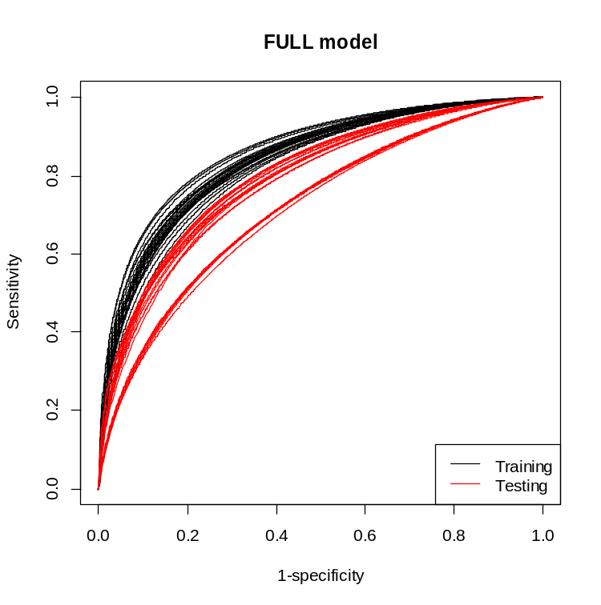 | 2B BS Cox model  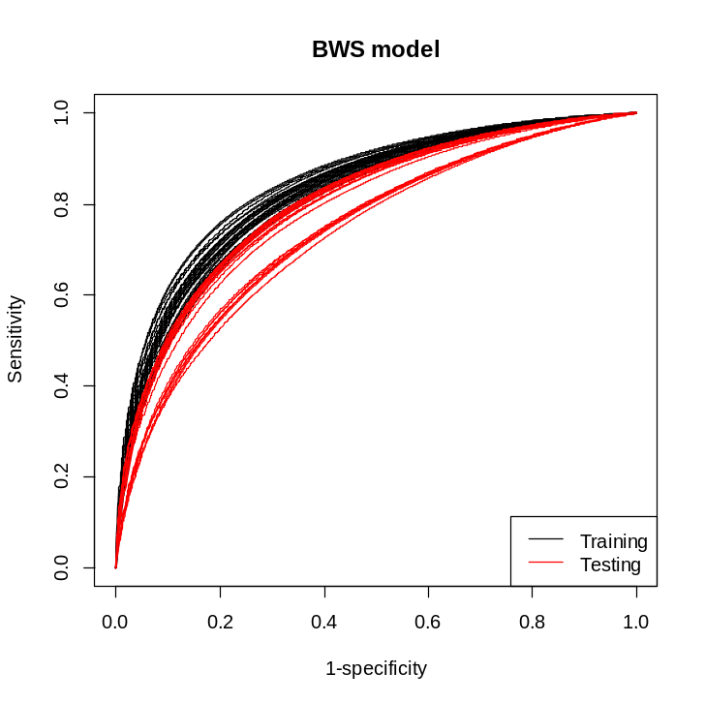
2C LASSO Cox model  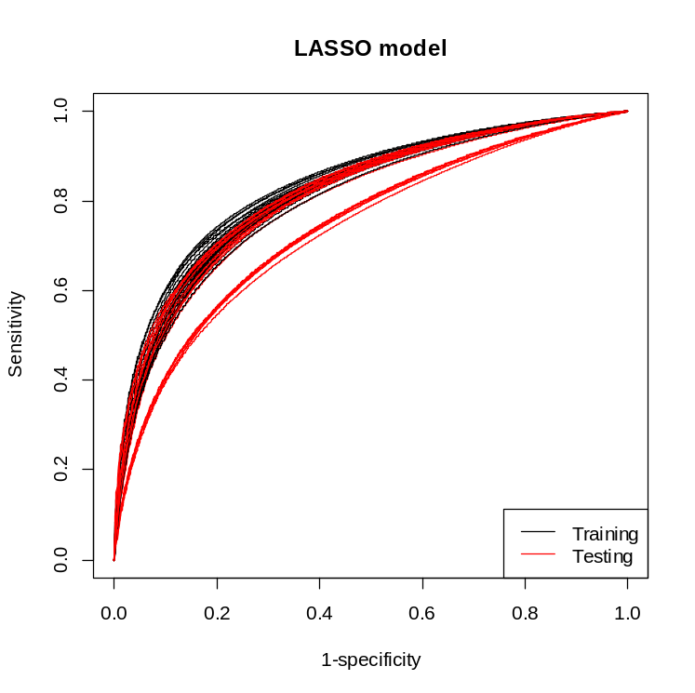 | 2D SRF model  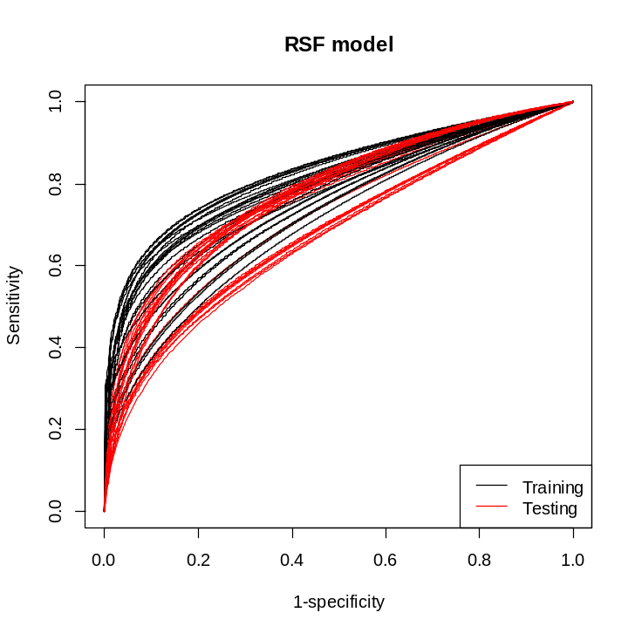

eFigure 2. Receiver Operating Characteristic Curves for Each Training and Testing Split Across All Years (1 to 8), by Type of Prediction Model
BS represents backward selection; LASSO, least absolute shrinkage and selection operator; and SRF, survival random forest.

