Supplemental Figure 1: Level of attrition analysis of respondents from 2015-16 to 2021-23 surveys.*
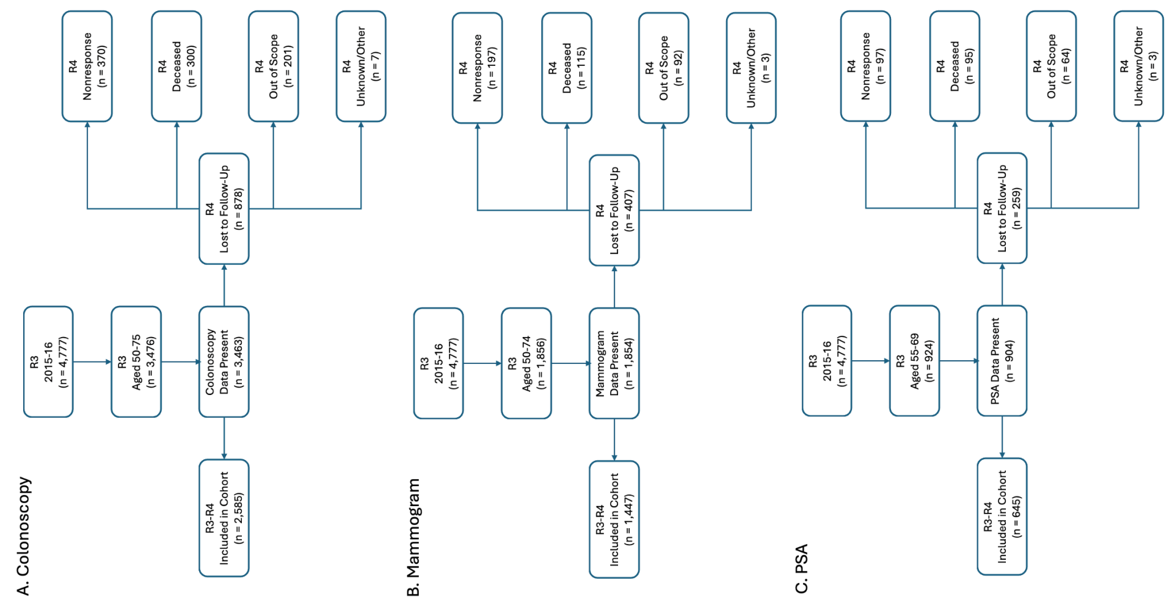
*Nonresponse category includes those who refused to be interviewed and those who could not be interviewed during the field period. Out of scope category includes those who were outside of the United States at the time or were living in a nursing home.

Supplementary Table 1: Attrition analysis comparing cancer screening rates in 2015-16 between the longitudinal cohort respondents included in analysis and the respondents lost to follow-up by 2021-23.
 | Colonoscopy (%) |  |  | Mammogram (%) |  |  | PSA Testing (%)
 | Cohort (N = 2,585) | Lost (N = 878) | Difference in % | Cohort (N = 1,447) | Lost (N = 407 | Difference in % | Cohort (N = 645) | Lost (N = 259) | Difference in %
Overall | 14.4 | 14.0 | -0.4 | 56.1 | 43.9 | -12.2 | 46.7 | 34.6 | -12.1

