eTable 1. Analytical sample size of survey respondents and glucagon-like peptide-1 receptor agonist prescriptions, by year
Year | Number of survey respondents |  | Number of prescriptions
Year | Unweighted | Weighted | Unweighted | Weighted
2013 | 68 | 891,225 | 326 | 4,219,007
2014 | 74 | 983,196 | 364 | 4,639,863
2015 | 93 | 1,110,983 | 459 | 6,298,765
2016 | 117 | 1,167,736 | 550 | 5,690,410
2017 | 162 | 1,641,459 | 732 | 7,630,648
2018 | 206 | 2,115,140 | 1,062 | 10,813,303
2019 | 260 | 2,754,283 | 1,259 | 12,855,728
2020 | 301 | 3,341,848 | 1,552 | 16,430,436
2021 | 451 | 4,416,658 | 2,166 | 20,928,394
2022 | 485 | 5,945,258 | 2,301 | 27,924,720
2023 | 580 | 9,051,092 | 2,963 | 44,892,616
Total | 2,797 | 33,418,878 | 13,734 | 162,323,890

eTable 2. Sample characteristics of survey respondents who use glucagon-like peptide-1 receptor agonists
Characteristics | Weighted frequency, % (95% CI)
Age
18–34 | 5.40 (3.96–6.84)
35–49 | 16.00 (14.08–17.91)
50–64 | 43.39 (40.49–46.30)
65 or older | 35.21 (32.41–38.01)
Sex
Male | 46.79 (43.80–49.78)
Female | 53.21 (50.22–56.20)
Race and ethnicity
Non-Hispanic White | 68.55 (65.34–71.76)
Non-Hispanic Black | 13.36 (10.67–16.05)
Non-Hispanic Asian | 2.30 (1.52–3.08)
Non-Hispanic Other | 3.63 (2.51–4.76)
Hispanic | 12.16 (10.02–14.30)
U.S. Census Region
Northeast | 17.54 (14.65–20.43)
Midwest | 21.84 (18.89–24.79)
South | 43.91 (39.72–48.09)
West | 16.72 (13.73–19.71)
Insurance type
Any Private | 68.13 (65.45–70.81)
Public Only | 30.22 (27.68–32.77)
Uninsured | 1.65 (0.81–2.49)
Poverty-to-income ratio
<200% | 25.58 (23.38–27.78)
200-399% | 27.17 (25.05–29.29)
≥400% | 47.25 (44.58–49.91)

eTable 3. Prevalence of glucagon-like peptide-1 receptor agonist users, 2013-2023
Year | Weighted count of all U.S. adult survey respondents | Weighted count of all GLP-1 users | Weighted prevalence of GLP-1 users (%)
2013 | 154,412,299.00 | 891,225.00 | 0.58 (0.41–0.74)
2014 | 159,017,611.00 | 983,196.00 | 0.62 (0.42–0.81)
2015 | 160,919,215.00 | 1,110,983.00 | 0.69 (0.51–0.87)
2016 | 159,170,662.00 | 1,167,736.00 | 0.73 (0.55–0.92)
2017 | 159,205,747.00 | 1,641,459.00 | 1.03 (0.84–1.22)
2018 | 161,457,768.00 | 2,115,140.00 | 1.31 (1.09–1.54)
2019 | 161,306,710.00 | 2,754,283.00 | 1.71 (1.47–1.95)
2020 | 158,391,869.00 | 3,341,848.00 | 2.11 (1.83–2.38)
2021 | 157,992,797.00 | 4,416,658.00 | 2.8 (2.47–3.12)
2022 | 162,117,103.00 | 5,945,258.00 | 3.67 (3.23–4.1)
2023 | 167,201,971.00 | 9,051,092.00 | 5.41 (4.89–5.94)

eTable 4. Total spending on glucagon-like peptide-1 receptor agonists by drug and year, 2013-2023
Year | Total spending, $
Year | All GLP-1 RAs | Liraglutide | Exenatide | Dulaglutide | Semaglutide | Tirzepatide | Other
2013 | 4,372,906,648 | 2,807,463,289 | 1,565,443,360 | — | — | — | —
2014 | 4,253,269,454 | 2,827,443,100 | 1,425,826,353 | — | — | — | —
2015 | 8,085,188,226 | 3,917,331,832 | 1,337,939,172 | — | — | — | 2,829,917,221
2016 | 8,349,097,014 | 4,855,103,097 | 1,401,913,802 | — | — | — | 2,092,080,114
2017 | 10,200,402,128 | 5,291,378,326 | 1,774,800,166 | 3,134,223,636 | — | — | —
2018 | 16,283,885,550 | 7,449,737,169 | 1,629,210,397 | 6,533,250,491 | 671,687,493 | — | —
2019 | 18,341,360,814 | 7,153,353,344 | 1,639,272,252 | 6,885,936,902 | 2,662,798,315 | — | —
2020 | 23,666,904,149 | 5,125,339,941 | — | 10,872,983,026 | 7,668,581,182 | — | —
2021 | 32,410,459,680 | 4,961,579,940 | — | 17,226,684,468 | 10,222,195,273 | — | —
2022 | 44,570,601,148 | 9,096,356,707 | — | 16,368,450,914 | 17,760,934,583 | — | 1,344,858,944
2023 | 64,856,457,966 | 3,385,317,171 | — | 16,811,339,981 | 35,530,966,718 | 9,119,783,000 | 9,051,095
Total | 235,390,532,777 | 56,870,403,916 | 10,774,405,504 | 77,832,869,418 | 74,517,163,565 | 9,119,783,000 | 6,275,907,374
Abbreviations: Glucagon-like peptide-1 receptor agonists=GLP-1 RAs

eTable 5. Log-linear trends in total spending on glucagon-like peptide-1 receptor agonists, 2013–2023
Characteristics | Full sample |  | GLP-1 users with ≥2 fills/year
Characteristics | Average annual percentage change (95% CI) | P value | Average annual percentage change (95% CI) | P value
Overall | 31.02 (27.64–34.48) | <.001 | 31.03 (27.60–34.55) | <.001
GLP-1 agent
Dulaglutide | 32.09 (17.31–48.74) | .002 | 32.59 (17.22–49.98) | .002
Exenatide | 2.49 (-2.13–7.32) | .229 | 2.16 (-2.48–7.03) | .290
Liraglutide | 6.31 (-1.40–14.61) | .099 | 6.37 (-1.31–14.64) | .095
Semaglutide | 109.13 (63.63–167.27) | .001 | 109.75 (63.47–169.14) | .001
Other | -38.50 (-84.55–144.76) | .269 | -9.24 (-35.92–28.55) | .175
Age
18–34 | 48.11 (26.78–73.02) | <.001 | 48.18 (25.86–74.46) | <.001
35–49 | 33.37 (22.51–45.20) | <.001 | 33.34 (22.26–45.44) | <.001
50–64 | 32.65 (23.66–42.30) | <.001 | 32.76 (23.65–42.54) | <.001
65 or older | 28.03 (24.09–32.10) | <.001 | 27.92 (23.98–31.98) | <.001
Sex
Male | 29.72 (23.29–36.50) | <.001 | 29.78 (23.24–36.65) | <.001
Female | 33.13 (28.40–38.04) | <.001 | 33.12 (28.34–38.07) | <.001
Race and ethnicity
Non-Hispanic White | 28.22 (23.34–33.29) | <.001 | 28.22 (23.32–33.32) | <.001
Non-Hispanic Black | 47.31 (36.55–58.91) | <.001 | 47.77 (36.90–59.50) | <.001
Non-Hispanic Asian | 37.56 (-5.18–99.57) | .084 | 37.18 (5.49–78.40) | .024
Other | 69.23 (29.31–121.48) | .002 | 68.04 (27.43–121.60) | .002
Hispanic | 34.68 (24.49–45.72) | <.001 | 34.68 (24.35–45.87) | <.001
U.S. Census Region
Northeast | 36.64 (26.64–47.44) | <.001 | 36.54 (26.56–47.31) | <.001
Midwest | 36.58 (29.34–44.22) | <.001 | 36.86 (29.55–44.57) | <.001
South | 26.55 (22.97–30.23) | <.001 | 26.48 (22.61–30.46) | <.001
West | 32.34 (22.29–43.21) | <.001 | 32.39 (22.28–43.34) | <.001
Insurance
Any Private | 28.42 (22.95–34.14) | <.001 | 28.48 (22.93–34.29) | <.001
Public Only | 37.41 (30.35–44.86) | <.001 | 37.45 (29.96–45.38) | <.001
Uninsured | 29.88 (-0.29–69.19) | .052 | 30.07 (-2.35–73.25) | .067
Income Relative to Federal Poverty Line
<200% | 35.25 (28.46–42.40) | <.001 | 35.20 (28.42–42.34) | <.001
200–399% | 28.71 (19.47–38.67) | <.001 | 28.83 (19.44–38.96) | <.001
≥400% | 30.23 (25.51–35.13) | <.001 | 30.22 (25.49–35.13) | <.001

eTable 6. Sensitivity analysis (restricted to ≥2 fills/year) of median out-of-pocket spending per capita on glucagon-like peptide-1 receptor agonists overall and by age, sex, race and ethnicity, U.S. Census Region, and insurance type, 2013-2023
Characteristics | Out-of-pocket spending per capita, median $ [IQR]
Characteristics | Full sample | 2013–2016 | 2017–2019 | 2020–2023
Overall | 2,070 [668–5,476] | 3,789 [1,410–11,963] | 2,456 [873–6,528] | 1,755 [556–4,532]
Age
18–34 | 954 [278–2,828] | 1,716 [0–3,789] | 500 [278–3,472] | 987 [279–2,750]
35–49 | 1,438 [380–4,216] | 2,815 [1,242–5,035] | 1,520 [663–3,872] | 1,174 [226–3,648]
50–64 | 2,016 [710–5,131] | 3,468 [1,452–11,963] | 2,520 [996–6,265] | 1,728 [574–4,172]
65 or older | 2,750 [888–8,160] | 7,708 [1,410–14,130] | 3,358 [1,010–8,328] | 2,487 [777–5,960]
Sex
Male | 2,292 [714–6,234] | 3,648 [1,444–13,885] | 2,920 [1,028–7,728] | 1,991 [594–4,875]
Female | 1,920 [638–5,028] | 4,186 [1,410–10,125] | 2,235 [720–5,610] | 1,630 [500–4,185]
Race and ethnicity
Non-Hispanic White | 2,680 [832–6,595] | 4,284 [1,542–12,166] | 3,248 [1,095–7,898] | 2,217 [685–5,476]
Non-Hispanic Black | 1,285 [440–3,476] | 4,347 [1,386–15,453] | 1,512 [380–3,616] | 1,209 [390–3,084]
Non-Hispanic Asian | 1,200 [258–3,872] | — | 708 [396–2,628] | 1,200 [183–6,234]
Non-Hispanic Other | 1,410 [625–3,996] | 2,108 [1,350–11,576] | 1,530 [885–8,460] | 1,002 [416–3,710]
Hispanic | 1,057 [343–2,920] | 1,794 [684–4,812] | 1,050 [426–2,742] | 1,034 [228–2,968]
U.S. Census Region
Northeast | 1,680 [646–4,584] | 2,108 [1,146–12,288] | 2,366 [688–6,057] | 1,666 [564–3,690]
Midwest | 2,560 [842–7,147] | 5,526 [1,652–12,166] | 2,574 [1,156–6,528] | 2,270 [725–5,440]
South | 2,196 [702–5,345] | 4,308 [1,404–14,890] | 2,607 [996–6,470] | 1,808 [560–4,408]
West | 1,545 [356–5,250] | 2,362 [927–9,051] | 1,744 [468–7,704] | 1,320 [192–4,316]
Insurance type
Any Private | 2,541 [966–6,088] | 3,789 [1,472–11,544] | 3,300 [1,200–7,898] | 2,200 [774–4,971]
Public Only | 1,028 [188–4,298] | 4,380 [792–12,166] | 1,095 [186–3,871] | 850 [132–3,570]
Uninsured | 3,608 [750–9,980] | 3,325 [1,452–12,408] | 2,170 [1,156–4,812] | 3,635 [750–9,980]
Income Relative to Federal Poverty Line
<200% | 888 [165–2,928] | 2,000 [792–10,716] | 1,160 [195–3,400] | 640 [96–2,400]
200-399% | 2,196 [732–5,859] | 5,035 [1,652–12,288] | 2,814 [764–7,064] | 1,920 [654–4,839]
≥400% | 2,816 [1,134–6,579] | 4,348 [1,545–12,166] | 3,616 [1,410–7,952] | 2,576 [948–5,571]

eTable 7. Log-linear trends in median out-of-pocket spending per capita on glucagon-like peptide-1 receptor agonists, 2013–2023
Characteristics | Full sample |  | GLP-1 users with ≥2 fills/year
Characteristics | Average annual percentage change (95% CI) | P value | Average annual percentage change (95% CI) | P value
Overall | -6.94 (-11.37 to -2.28) | .009 | -8.14 (-12.44 to -3.63) | .003
GLP-1 agent
Dulaglutide | -12.42 (-15.67 to -9.03) | <.001 | -9.13 (-14.35 to -3.61) | .009
Exenatide | -8.30 (-29.04 to 18.50) | .425 | -6.40 (-37.56 to 40.31) | .692
Liraglutide | -14.46 (-24.48 to -3.11) | .020 | -13.74 (-19.47 to -7.61) | <.001
Semaglutide | 10.77 (-15.99 to 46.06) | .362 | -0.60 (-13.32 to 13.97) | .908
Other | -22.50 (-33.07 to -10.27) | .017 | -22.13 (-65.12 to 73.83) | .158
Age
18 to 34 | 7.23 (-33.22 to 72.18) | .743 | -17.93 (-36.96 to 6.83) | .122
35 to 49 | -13.01 (-22.36 to -2.53) | .022 | -10.93 (-20.05 to -0.77) | .038
50 to 64 | -5.27 (-13.30 to 3.49) | .200 | -5.96 (-14.60 to 3.54) | .183
65 or older | -13.60 (-18.72 to -8.15) | <.001 | -13.73 (-17.72 to -9.55) | <.001
Sex
Male | -8.90 (-14.67 to -2.73) | .010 | -8.47 (-14.36 to -2.18) | .015
Female | -8.08 (-16.22 to 0.86) | .070 | -7.39 (-14.23 to 0.01) | .050
Race and ethnicity
Non-Hispanic White | -5.75 (-11.59 to 0.48) | .066 | -6.17 (-10.85 to -1.23) | .020
Non-Hispanic Black | -8.39 (-20.87 to 6.06) | .209 | -10.90 (-25.69 to 6.83) | .184
Non-Hispanic Asian | -1.57 (-25.16 to 29.47) | .899 | 8.74 (-19.88 to 47.57) | .545
Other | -6.94 (-29.95 to 23.63) | .581 | -8.32 (-31.86 to 23.35) | .524
Hispanic | -4.31 (-13.72 to 6.12) | .361 | -8.86 (-15.32 to -1.91) | .019
U.S. Census Region
Northeast | -3.07 (-10.13 to 4.54) | .374 | -5.21 (-12.20 to 2.33) | .148
Midwest | -3.29 (-11.90 to 6.17) | .439 | -6.02 (-15.90 to 5.02) | .238
South | -11.17 (-14.92 to -7.25) | <.001 | -11.83 (-16.80 to -6.55) | <.001
West | -12.67 (-20.56 to -4.01) | .010 | -10.31 (-19.13 to -0.54) | .041
Insurance
Any Private | -4.63 (-11.18 to 2.41) | .166 | -5.68 (-11.04 to 0.01) | .050
Public Only | -18.48 (-28.35 to -7.25) | .006 | -20.43 (-30.97 to -8.28) | .005
Uninsured | -23.24 (-45.17 to 7.46) | .107 | -3.22 (-30.26 to 34.29) | .823
Income Relative to Federal Poverty Line
<200% | -9.60 (-16.60 to -2.00) | .020 | -7.53 (-16.03 to 1.82) | .099
200 to 399% | -15.48 (-20.54 to -10.10) | <.001 | -13.40 (-17.02 to -9.62) | <.001
≥400% | -4.02 (-9.93 to 2.28) | .178 | -6.83 (-13.85 to 0.76) | .071

eTable 8. Sensitivity analysis (restricted to ≥2 fills/year) of mean out-of-pocket burden on glucagon-like peptide-1 receptor agonists overall and by age, sex, race and ethnicity, U.S. Census Region, and insurance type, 2013-2023
Characteristics | Out-of-pocket burden, % (95% CI)
Characteristics | Full sample | 2013–2016 | 2017–2019 | 2020–2023
Overall | 8.22 (6.51–10.06) | 14.17 (11.59–17.53) | 9.05 (7.01–11.54) | 6.98 (5.52–8.53)
Age
18–34 | 2.85 (1.91–3.79) | 7.38 (2.07–12.69) | 2.42 (0.92–3.91) | 2.63 (1.66–3.61)
35–49 | 6.04 (4.56–7.53) | 9.17 (6.01–12.34) | 8.38 (4.41–12.35) | 4.91 (3.35–6.47)
50–64 | 7.47 (6.27–8.68) | 13.73 (9.98–17.48) | 8.38 (6.16–10.60) | 6.13 (4.77–7.49)
65 or older | 10.88 (9.18–12.59) | 18.28 (11.23–25.33) | 10.63 (7.64–13.63) | 9.77 (7.82–11.71)
Sex
Male | 7.95 (6.82–9.09) | 12.94 (8.22–17.65) | 8.67 (6.56–10.78) | 7.04 (5.83–8.24)
Female | 8.46 (7.25–9.68) | 15.10 (11.75–18.46) | 9.35 (6.95–11.76) | 6.93 (5.50–8.35)
Race and ethnicity
Non-Hispanic White | 8.90 (7.72–10.08) | 14.80 (11.62–17.98) | 9.66 (7.55–11.76) | 7.47 (6.10–8.84)
Non-Hispanic Black | 6.71 (5.16–8.26) | 13.24 (6.29–20.19) | 9.50 (4.76–14.24) | 5.60 (4.18–7.01)
Non-Hispanic Asian | 4.07 (1.70–6.44) | 2.32 (0.98–3.65) | 2.88 (0.43–5.33) | 4.37 (1.56–7.18)
Non-Hispanic Other | 7.04 (4.33–9.75) | 13.27 (4.97–21.57) | 8.98 (4.72–13.25) | 5.61 (2.38–8.84)
Hispanic | 7.04 (5.32–8.76) | 11.56 (6.32–16.81) | 4.82 (2.15–7.49) | 6.96 (4.86–9.05)
U.S. Census Region
Northeast | 7.05 (5.39–8.70) | 16.87 (11.00–22.73) | 6.93 (4.12–9.73) | 5.88 (4.25–7.51)
Midwest | 10.09 (7.91–12.26) | 15.19 (10.53–19.84) | 9.27 (6.70–11.84) | 9.35 (6.59–12.11)
South | 8.05 (6.63–9.46) | 14.23 (9.62–18.84) | 9.21 (6.88–11.53) | 6.64 (5.10–8.18)
West | 7.39 (5.49–9.30) | 10.26 (4.63–15.89) | 10.40 (4.20–16.60) | 5.95 (4.25–7.65)
Insurance type
Any Private | 7.27 (6.37–8.17) | 13.53 (10.65–16.40) | 8.71 (6.72–10.71) | 5.68 (4.76–6.59)
Public Only | 10.07 (8.39–11.75) | 16.80 (10.09–23.51) | 9.31 (6.90–11.72) | 9.43 (7.47–11.39)
Uninsured | 18.55 (4.56–32.55) | 10.38 (2.38–18.38) | 26.20 (2.14–50.26) | 19.04 (0.00–38.96)
Income Relative to Federal Poverty Line
<200% | 12.55 (10.60–14.51) | 20.35 (14.22–26.47) | 11.56 (8.10–15.01) | 11.68 (9.35–14.00)
200-399% | 9.58 (7.76–11.40) | 16.53 (11.52–21.54) | 10.60 (7.94–13.25) | 8.08 (5.71–10.45)
≥400% | 5.49 (4.59–6.38) | 10.69 (7.51–13.87) | 6.74 (4.27–9.22) | 4.24 (3.44–5.03)

eTable 9. Log-linear trends in mean out-of-pocket burden on glucagon-like peptide-1 receptor agonists, 2013–2023
Characteristics | Full sample |  | GLP-1 users with ≥2 fills/year
Characteristics | Average annual percentage change (95% CI) | P value | Average annual percentage change (95% CI) | P value
Overall | -8.43 (-11.64 to -5.09) | <.001 | -8.99 (-12.35 to -5.50) | <.001
GLP-1 agent
Dulaglutide | -2.97 (-9.04 to 3.51) | .284 | -4.67 (-10.37 to 1.39) | .103
Exenatide | -17.76 (-31.65 to -1.04) | .042 | -16.91 (-33.61 to 3.99) | .087
Liraglutide | -8.29 (-13.43 to -2.83) | .008 | -8.30 (-12.55 to -3.85) | .003
Semaglutide | 8.37 (-11.44 to 32.61) | .331 | 5.19 (-10.23 to 23.24) | .426
Other | -36.71 (-61.58 to 4.26) | .059 | -26.88 (-45.44 to -2.02) | .047
Age
18 to 34 | -1.36 (-17.83 to 18.41) | .869 | -2.11 (-17.58 to 16.25) | .785
35 to 49 | -9.16 (-16.99 to -0.59) | .039 | -8.93 (-17.55 to 0.59) | .062
50 to 64 | -7.94 (-13.27 to -2.29) | .012 | -9.90 (-14.95 to -4.56) | .003
65 or older | -8.54 (-12.20 to -4.73) | <.001 | -8.18 (-12.82 to -3.29) | .005
Sex
Male | -7.53 (-10.79 to -4.15) | <.001 | -8.60 (-12.11 to -4.95) | <.001
Female | -9.05 (-13.43 to -4.46) | .002 | -9.17 (-13.73 to -4.37) | .002
Race and ethnicity
Non-Hispanic White | -8.21 (-11.68 to -4.61) | <.001 | -8.72 (-12.24 to -5.05) | <.001
Non-Hispanic Black | -6.49 (-14.46 to 2.23) | .123 | -7.85 (-15.90 to 0.97) | .074
Non-Hispanic Asian | 4.12 (-20.29 to 36.02) | .740 | 6.23 (-12.36 to 28.77) | .489
Other/Mixed | -0.11 (-22.97 to 29.52) | .992 | -0.87 (-23.97 to 29.23) | .942
Hispanic | -6.64 (-16.19 to 3.99) | .183 | -7.37 (-16.30 to 2.52) | .122
U.S. Census Region
Northeast | -3.83 (-9.25 to 1.92) | .163 | -5.00 (-10.86 to 1.24) | .102
Midwest | -12.25 (-20.79 to -2.79) | .018 | -12.55 (-20.88 to -3.35) | .014
South | -9.31 (-11.01 to -7.58) | <.001 | -9.83 (-11.59 to -8.02) | <.001
West | -5.62 (-14.22 to 3.84) | .204 | -5.93 (-13.93 to 2.81) | .154
Insurance
Any Private | -10.35 (-14.74 to -5.74) | <.001 | -11.06 (-15.57 to -6.31) | <.001
Public Only | -6.42 (-12.00 to -0.48) | .037 | -6.59 (-12.47 to -0.32) | .042
Uninsured | 5.74 (-23.50 to 46.14) | .696 | 10.82 (-19.23 to 52.05) | .467
Income Relative to Federal Poverty Line
<200% | -7.26 (-11.09 to -3.27) | .003 | -7.57 (-11.91 to -3.01) | .005
200 to 399% | -6.52 (-12.54 to -0.08) | .048 | -7.27 (-13.04 to -1.11) | .026
≥400% | -11.37 (-16.97 to -5.40) | .002 | -11.78 (-17.79 to -5.32) | .003

eTable 10. Sensitivity analysis (restricted to ≥2 fills/year) of mean high out-of-pocket burden on glucagon-like peptide-1 receptor agonists overall and by age, sex, race and ethnicity, U.S. Census Region, and insurance type, 2013-2023
Characteristics | High out-of-pocket burden, % (95% CI)
Characteristics | Full sample | 2013–2016 | 2017–2019 | 2020–2023
Overall | 21.56 (17.54–25.49) | 39.97 (32.2–49.1) | 25.68 (20.4–32.8) | 17.31 (13.53–21.52)
Age
18–34 | 4.91 (0.45–9.36) | 22.50 (0.00–48.51) | 1.32 (0.00–4.01) | 4.43 (0.00–9.31)
35–49 | 16.91 (11.45–22.36) | 24.81 (13.85–35.77) | 26.72 (11.71–41.73) | 13.22 (7.39–19.05)
50–64 | 19.08 (15.79–22.37) | 39.97 (30.09–49.84) | 22.47 (16.24–28.69) | 14.51 (10.86–18.15)
65 or older | 29.08 (24.92–33.23) | 50.36 (35.56–65.16) | 31.22 (23.32–39.13) | 24.95 (20.26–29.65)
Sex
Male | 21.04 (17.97–24.11) | 34.81 (23.93–45.68) | 26.08 (19.48–32.68) | 17.76 (14.42–21.09)
Female | 22.04 (18.74–25.33) | 43.90 (34.98–52.82) | 25.37 (18.59–32.14) | 16.87 (13.22–20.53)
Race and ethnicity
Non-Hispanic White | 23.36 (20.20–26.51) | 42.43 (34.50–50.36) | 28.07 (22.36–33.78) | 18.08 (14.73–21.42)
Non-Hispanic Black | 17.69 (12.77–22.61) | 31.90 (19.75–44.06) | 22.27 (8.16–36.37) | 15.53 (10.48–20.59)
Non-Hispanic Asian | 13.47 (3.29–23.65) | 0.00 (0.00–0.00) | 14.62 (0.00–41.73) | 14.66 (2.82–26.50)
Non-Hispanic Other | 21.85 (11.48–32.23) | 50.20 (7.51–92.90) | 33.67 (13.29–54.06) | 14.01 (3.71–24.31)
Hispanic | 16.58 (11.33–21.84) | 30.01 (13.76–46.27) | 7.65 (1.11–14.19) | 16.84 (10.30–23.38)
U.S. Census Region
Northeast | 17.31 (13.16–21.45) | 38.26 (28.32–48.20) | 19.98 (8.29–31.66) | 14.13 (9.47–18.79)
Midwest | 27.29 (21.81–32.76) | 45.23 (33.00–57.45) | 24.98 (16.88–33.07) | 24.53 (17.87–31.19)
South | 21.07 (17.04–25.11) | 39.85 (28.77–50.94) | 27.53 (20.12–34.94) | 16.03 (11.86–20.19)
West | 19.68 (13.97–25.39) | 33.95 (15.35–52.55) | 27.65 (14.32–40.99) | 14.63 (10.01–19.24)
Insurance type
Any Private | 19.54 (16.79–22.28) | 37.54 (29.98–45.11) | 25.33 (19.74–30.92) | 14.50 (11.62–17.38)
Public Only | 25.90 (21.82–29.98) | 48.51 (32.78–64.24) | 26.00 (18.61–33.38) | 23.09 (18.36–27.82)
Uninsured | 35.71 (15.31–56.11) | 41.36 (0.00–91.21) | 42.74 (0.00–86.07) | 33.11 (6.47–59.76)
Income Relative to Federal Poverty Line
<200% | 32.10 (27.30–36.90) | 45.76 (32.78–58.74) | 34.11 (24.33–43.89) | 29.52 (24.05–35.00)
200-399% | 26.57 (21.80–31.34) | 49.73 (34.43–65.03) | 33.26 (24.01–42.51) | 20.55 (15.12–25.99)
≥400% | 14.02 (11.24–16.81) | 33.08 (23.84–42.32) | 16.41 (10.41–22.42) | 9.98 (7.35–12.61)

eTable 11. Sensitivity analysis (threshold of 20%) of mean high out-of-pocket burden on glucagon-like peptide-1 receptor agonists overall and by age, sex, race and ethnicity, U.S. Census Region, and insurance type, 2013-2023
Characteristics | High out-of-pocket burden, % (95% CI)
Characteristics | Full sample | 2013–2016 | 2017–2019 | 2020–2023
Overall | 9.18 (5.64–12.72) | 18.36 (14.78–21.94) | 9.23 (7.43–11.03) | 7.56 (6.09–9.03)
Age
18–34 | 0.83 (0.00–2.45) | 13.46 (0.00–33.70) | 0.00 (0.00–0.00) | 0.00 (0.00–0.00)
35–49 | 7.00 (3.68–10.32) | 11.28 (2.28–20.27) | 9.55 (2.75–16.36) | 5.51 (1.48–9.53)
50–64 | 7.81 (5.74–9.87) | 16.93 (9.32–24.54) | 7.30 (3.68–10.92) | 6.16 (3.92–8.40)
65 or older | 13.23 (10.43–16.04) | 25.18 (11.83–38.54) | 12.06 (6.31–17.80) | 11.72 (8.65–14.79)
Sex
Male | 8.91 (6.85–10.96) | 16.76 (7.91–25.61) | 7.03 (3.52–10.55) | 8.13 (5.93–10.32)
Female | 9.43 (7.38–11.47) | 19.64 (11.76–27.51) | 11.01 (6.54–15.47) | 7.03 (4.68–9.38)
Race and ethnicity
Non-Hispanic White | 9.98 (8.05–11.90) | 18.69 (12.59–24.78) | 9.81 (5.95–13.66) | 8.21 (6.01–10.40)
Non-Hispanic Black | 7.81 (4.91–10.72) | 17.63 (7.28–27.97) | 11.51 (4.67–18.36) | 6.14 (2.95–9.34)
Non-Hispanic Asian | 3.95 (0.00–9.33) | 0.00 (0.00–0.00) | 0.00 (0.00–0.00) | 4.85 (0.00–11.36)
Non-Hispanic Other | 9.81 (3.46–16.17) | 13.87 (0.00–39.41) | 11.92 (1.59–22.26) | 8.37 (0.37–16.37)
Hispanic | 6.90 (3.83–9.96) | 19.68 (8.99–30.37) | 2.77 (0.00–5.95) | 6.21 (2.42–10.00)
U.S. Census Region
Northeast | 7.67 (4.95–10.39) | 23.00 (10.50–35.49) | 3.95 (0.32–7.59) | 6.70 (3.88–9.51)
Midwest | 13.07 (8.90–17.25) | 19.37 (8.98–29.77) | 11.44 (6.10–16.77) | 12.20 (7.03–17.36)
South | 8.53 (6.48–10.58) | 18.83 (11.87–25.80) | 9.15 (4.65–13.65) | 6.53 (4.28–8.78)
West | 7.34 (3.96–10.72) | 11.71 (1.91–21.51) | 11.38 (0.73–22.02) | 5.28 (2.00–8.57)
Insurance type
Any Private | 8.12 (6.43–9.80) | 18.93 (13.23–24.63) | 8.58 (4.94–12.21) | 5.85 (4.04–7.67)
Public Only | 11.13 (8.51–13.75) | 17.54 (7.40–27.67) | 9.95 (5.59–14.30) | 10.62 (7.49–13.76)
Uninsured | 20.50 (5.35–35.65) | 5.37 (0.00–16.34) | 42.74 (0.00–86.07) | 20.59 (0.95–40.23)
Income Relative to Federal Poverty Line
<200% | 16.57 (13.30–19.85) | 28.87 (18.09–39.65) | 12.55 (6.69–18.40) | 15.91 (11.87–19.95)
200-399% | 10.89 (8.00–13.78) | 21.35 (10.32–32.38) | 12.49 (7.11–17.86) | 8.54 (5.09–11.99)
≥400% | 4.74 (3.17–6.31) | 12.82 (6.33–19.31) | 5.57 (1.39–9.75) | 3.01 (1.58–4.43)

eTable 12. Log-linear trends in mean high out-of-pocket burden on glucagon-like peptide-1 receptor agonists, 2013–2023
Characteristics | Full sample |  | GLP-1 users with ≥2 fills/year
Characteristics | Average annual percentage change (95% CI) | P value | Average annual percentage change (95% CI) | P value
Overall | -9.59 (-12.53 to -6.54) | <.001 | -10.22 (-13.30 to -7.03) | <.001
GLP-1 agent
Dulaglutide | -4.80 (-10.43 to 1.18) | .093 | -5.33 (-10.98 to 0.68) | .071
Exenatide | -16.55 (-36.59 to 9.84) | .151 | -14.51 (-36.20 to 14.55) | .227
Liraglutide | -6.85 (-10.77 to -2.75) | .005 | -7.06 (-11.35 to -2.58) | .007
Semaglutide | 15.96 (-9.71 to 48.92) | .176 | 12.44 (-11.93 to 43.57) | .253
Other | -33.56 (-61.20 to 13.76) | .066 | -33.64 (-53.78 to -4.71) | .044
Age
18 to 34 | -13.02 (-62.13 to 99.77) | .545 | -16.81 (-69.43 to 126.39) | .512
35 to 49 | -7.22 (-19.75 to 7.28) | .273 | -6.89 (-19.83 to 8.13) | .308
50 to 64 | -9.89 (-16.58 to -2.66) | .014 | -11.98 (-18.04 to -5.47) | .003
65 or older | -9.02 (-12.12 to -5.81) | <.001 | -8.72 (-12.48 to -4.80) | <.001
Sex
Male | -7.33 (-11.62 to -2.83) | .005 | -8.61 (-12.77 to -4.25) | .002
Female | -11.08 (-15.01 to -6.97) | <.001 | -11.19 (-15.11 to -7.08) | <.001
Race and ethnicity
Non-Hispanic White | -9.79 (-13.51 to -5.90) | <.001 | -10.37 (-14.09 to -6.49) | <.001
Non-Hispanic Black | -6.04 (-12.33 to 0.70) | .072 | -7.91 (-14.69 to -0.60) | .037
Non-Hispanic Asian | -6.12 (-50.27 to 77.24) | .711 | -8.72 (-59.82 to 107.37) | .679
Other/Mixed | -22.96 (-32.56 to -11.99) | .002 | -22.63 (-31.82 to -12.20) | .002
Hispanic | -6.55 (-18.52 to 7.19) | .293 | -7.19 (-18.08 to 5.15) | .209
U.S. Census Region
Northeast | -12.65 (-19.90 to -4.74) | .006 | -12.76 (-19.77 to -5.13) | .005
Midwest | -3.52 (-11.57 to 5.26) | .376 | -5.03 (-13.27 to 3.99) | .231
South | -11.04 (-13.75 to -8.24) | <.001 | -11.67 (-14.18 to -9.09) | <.001
West | -7.47 (-16.61 to 2.68) | .126 | -7.64 (-15.98 to 1.54) | .090
Insurance
Any Private | -11.36 (-15.16 to -7.39) | <.001 | -12.17 (-16.09 to -8.06) | <.001
Public Only | -7.01 (-12.40 to -1.29) | .022 | -7.20 (-13.45 to -0.49) | .039
Uninsured | -7.23 (-25.63 to 15.71) | .438 | -2.56 (-21.64 to 21.18) | .781
Income Relative to Federal Poverty Line
<200% | -6.32 (-9.21 to -3.34) | .001 | -6.55 (-9.35 to -3.67) | <.001
200 to 399% | -7.34 (-13.90 to -0.28) | .043 | -8.62 (-14.26 to -2.61) | .011
≥400% | -13.89 (-20.21 to -7.07) | .002 | -14.23 (-20.81 to -7.09) | .002

eTable 13. Comparison of glucagon-like peptide-1 receptor agonist total spending estimates from a prior study and the current study
Year | Tsipas et al. (2025)¹ total spending estimates | Current study total spending estimates | Absolute difference | Relative difference
All GLP-1 RA spending
2018 | 13.66 | 16.28 | 2.62 | 19.18%
2019 | 18.51 | 18.34 | 0.17 | 0.92%
2020 | 24.67 | 23.67 | 1.00 | 4.05%
2021 | 31.79 | 32.41 | 0.62 | 1.95%
2022 | 44.18 | 44.57 | 0.39 | 0.88%
2023 | 71.66 | 64.86 | 6.80 | 9.49%
Total | 204.47 | 200.13 | 4.34 | 2.12%
Liraglutide
2018 | 6.00 | 7.45 | 1.45 | 24.17
2019 | 6.15 | 7.15 | 1.00 | 16.26
2020 | 5.84 | 5.13 | 0.71 | 12.16
2021 | 5.16 | 4.96 | 0.20 | 3.88
2022 | 4.37 | 9.10 | 4.73 | 108.24
2023 | 3.51 | 3.39 | 0.12 | 3.42
Total | 31.03 | 37.17 | 6.14 | 19.79
Exenatide
2018 | 1.66 | 1.63 | 0.03 | 1.81
2019 | 1.61 | 1.64 | 0.03 | 1.86
2020 | — | — | — | —
2021 | — | — | — | —
2022 | — | — | — | —
2023 | — | — | — | —
Total | 3.27 | 3.27 | 0.00 | 0.00
Dulaglutide
2018 | 5.60 | 6.53 | 0.93 | 16.61
2019 | 7.99 | 6.89 | 1.10 | 13.77
2020 | 10.63 | 10.87 | 0.24 | 2.26
2021 | 13.76 | 17.23 | 3.47 | 25.22
2022 | 16.54 | 16.37 | 0.17 | 1.03
2023 | 17.57 | 16.81 | 0.76 | 4.33
Total | 72.09 | 74.70 | 2.61 | 3.62
Semaglutide
2018 | 0.41 | 0.67 | 0.26 | 63.41
2019 | 2.76 | 2.66 | 0.10 | 3.62
2020 | 6.7 | 7.67 | 0.97 | 14.48
2021 | 11.81 | 10.22 | 1.59 | 13.46
2022 | 20.02 | 17.76 | 2.26 | 11.29
2023 | 37.66 | 35.53 | 2.13 | 5.66
Total | 79.36 | 74.52 | 4.84 | 6.10
Tirzepatide
2018 | — | — | — | —
2019 | — | — | — | —
2020 | — | — | — | —
2021 | — | — | — | —
2022 | — | — | — | —
2023 | 12.42 | 9.12 | 3.30 | 26.57
Total | 12.42 | 9.12 | 3.30 | 26.57

¹Tsipas S, Khan T, Loustalot F, Myftari K, Wozniak G. Spending on Glucagon-Like Peptide-1 Receptor Agonists Among US Adults. JAMA Netw Open. 2025 Apr 1;8(4):e252964. doi: 10.1001/jamanetworkopen.2025.2964. PMID: 40172891; PMCID: PMC11966331.
Note: We did not include the “other” category from our MEPS-based comparison because Tsipas et al. did not report an equivalent category.

eFigure 1. Histogram of total annual spending on glucagon-like peptide-1 receptor agonists per user-year
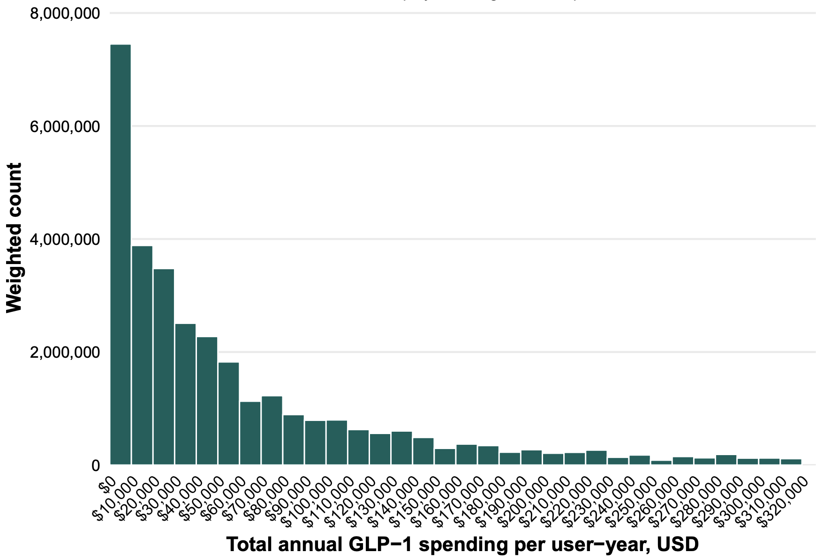

eFigure 2. Histogram of total annual out-of-pocket spending on glucagon-like peptide-1 receptor agonists per user-year
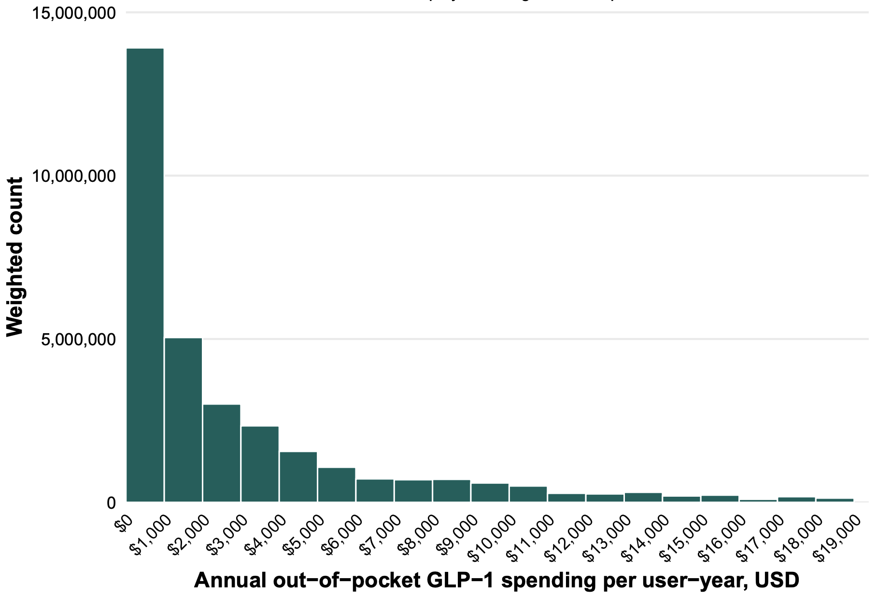
eFigure 3. Histogram of total annual out-of-pocket burden on glucagon-like peptide-1 receptor agonists
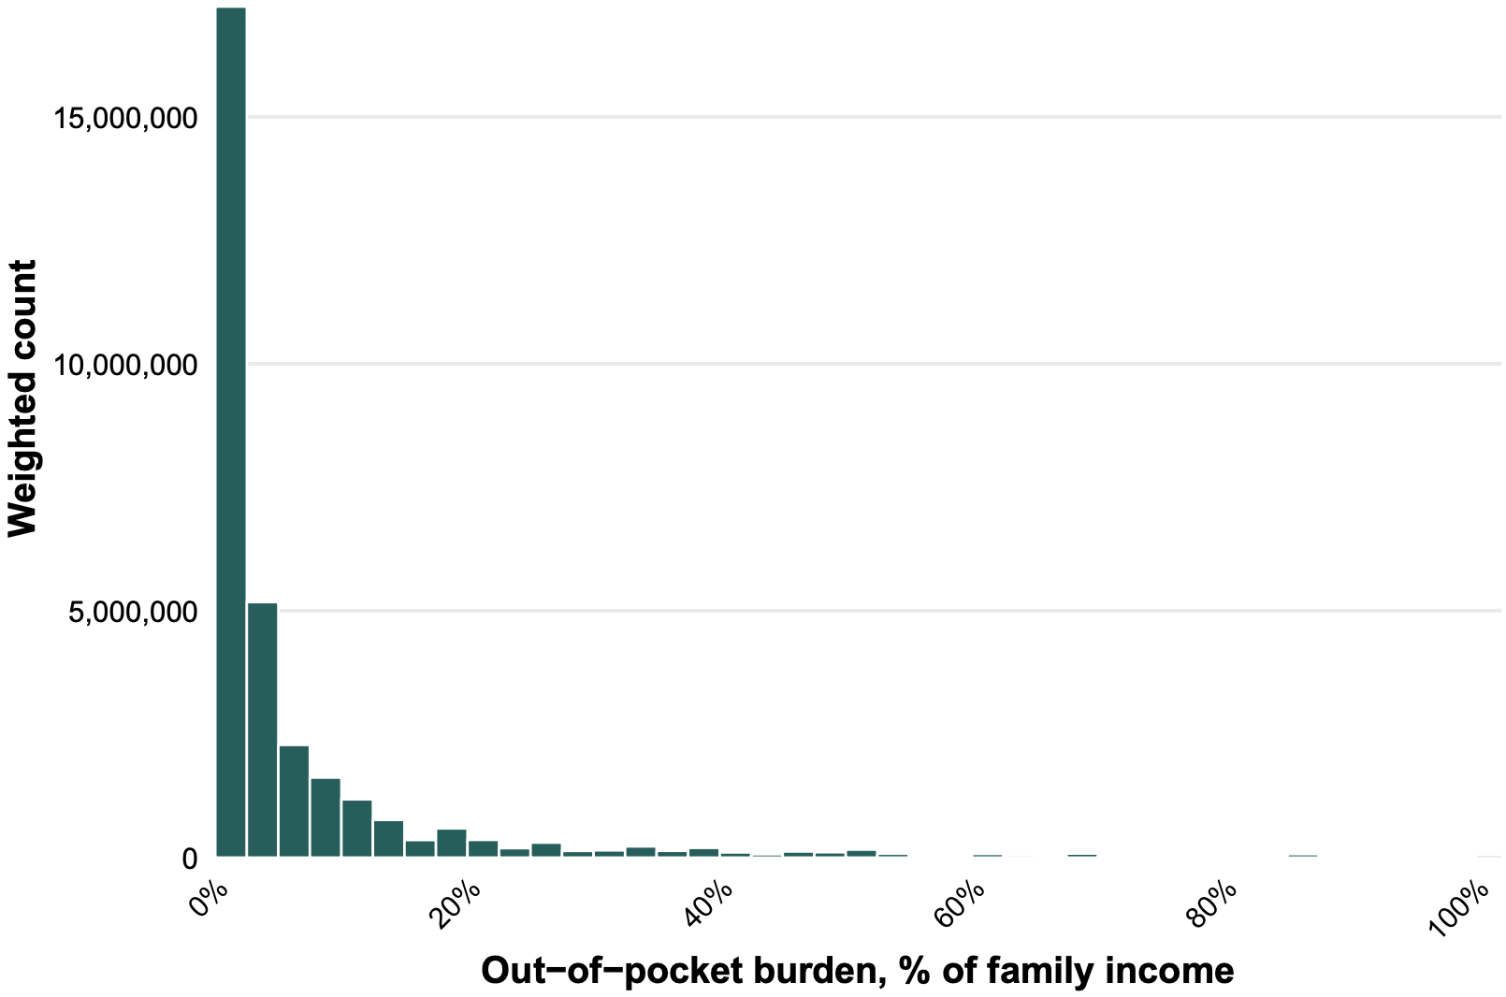

eFigure 4. Histogram of total annual high out-of-pocket burden on glucagon-like peptide-1 receptor agonists
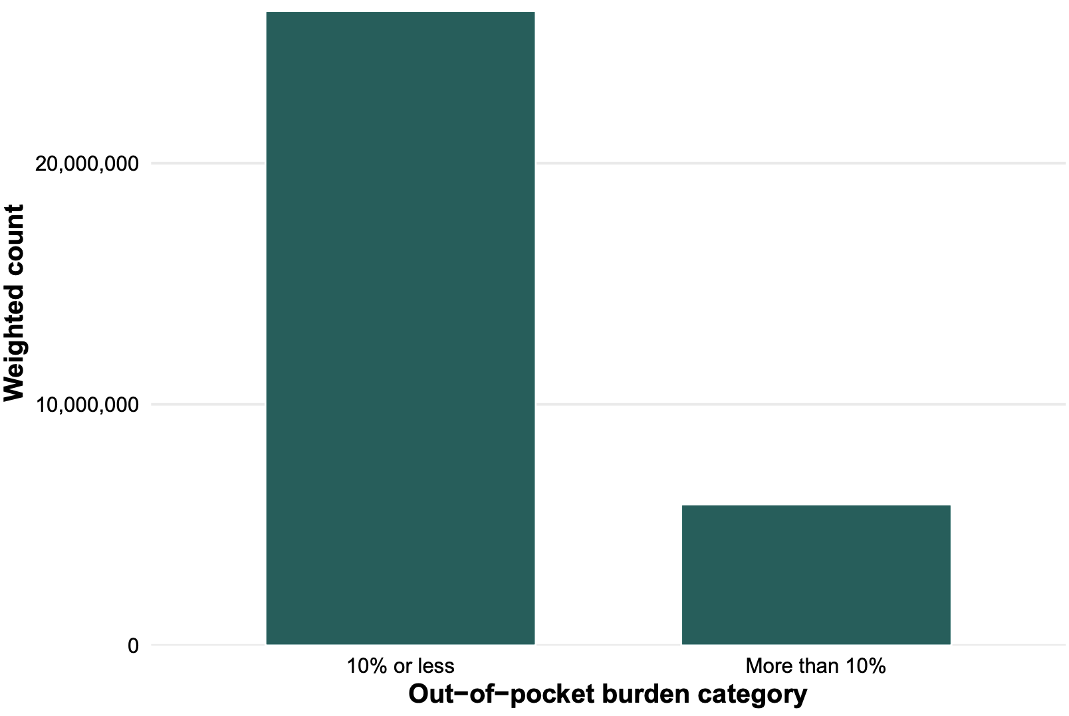
eFigure 5. Prevalence of glucagon-like peptide-1 receptor agonist users, 2013-2023
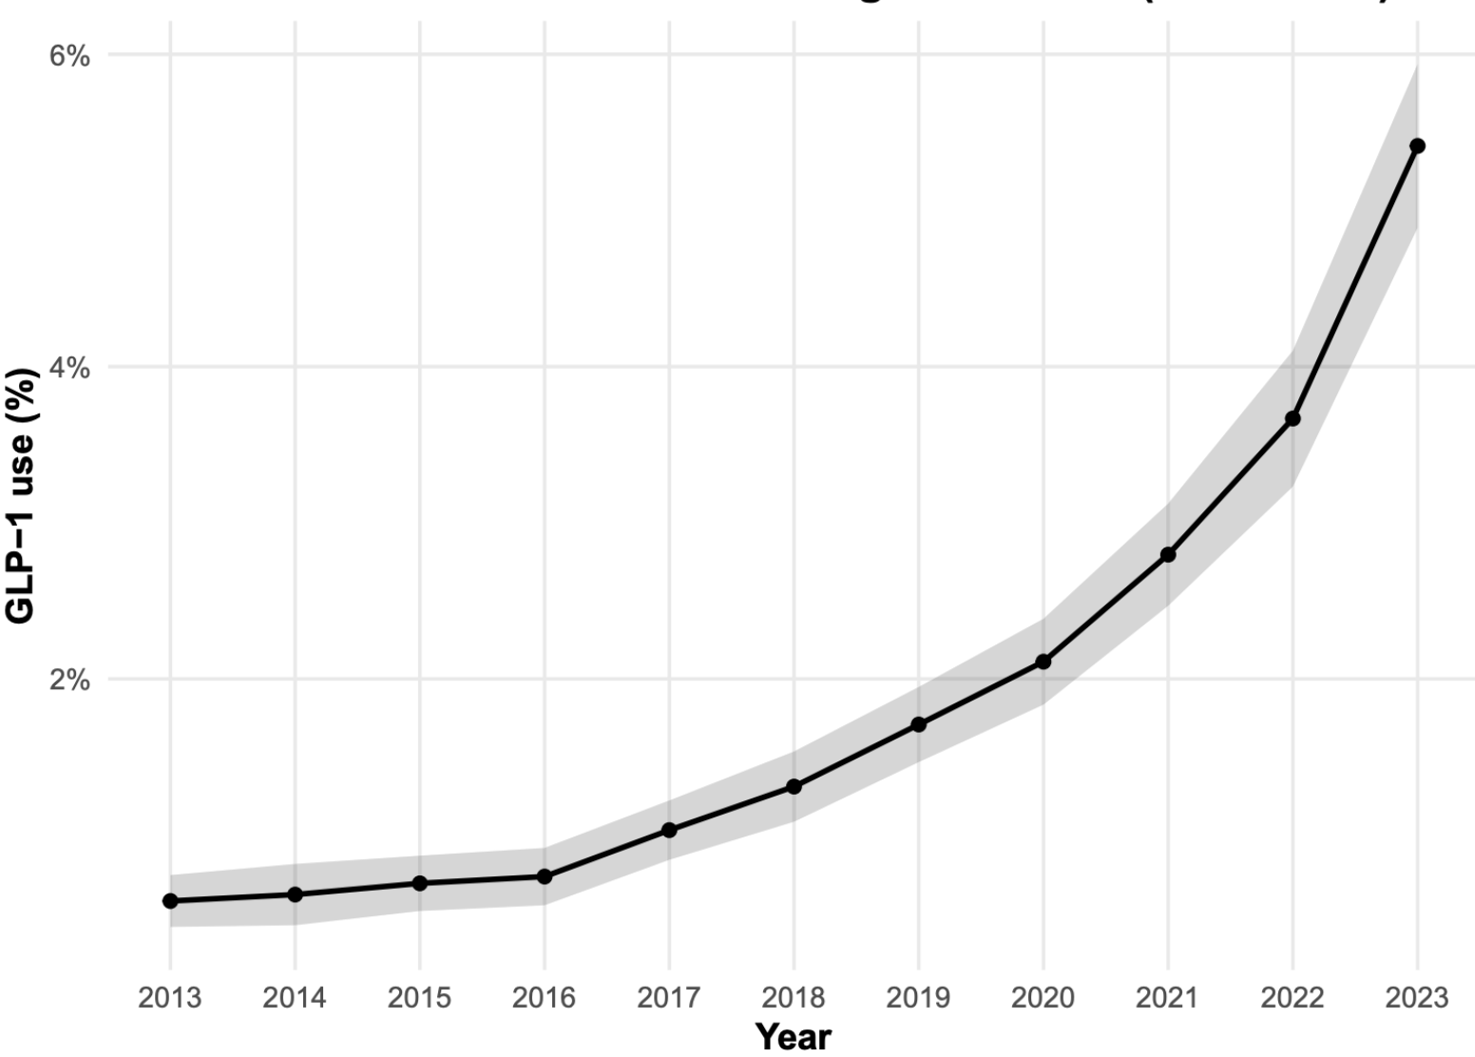
eFigure 6. Median out-of-pocket spending per capita on glucagon-like peptide-1 receptor agonists by drug and year, 2013-2023
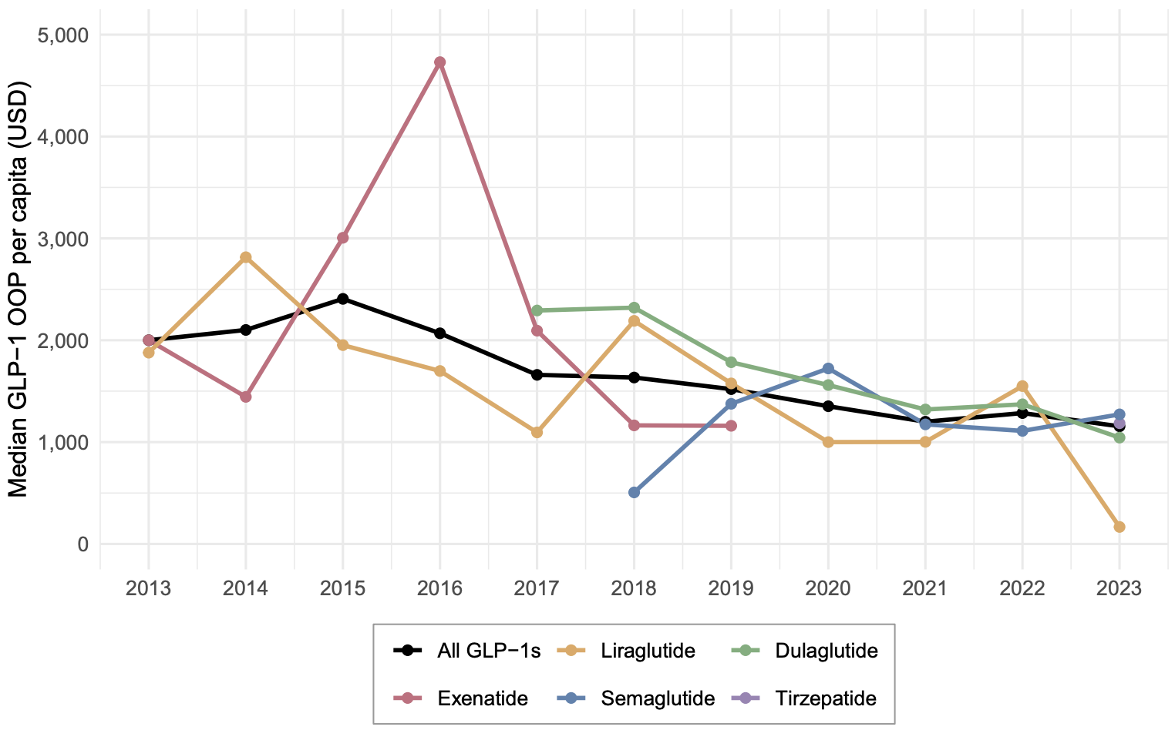

eFigure 7. Mean out-of-pocket burden on glucagon-like peptide-1 receptor agonists by drug and year, 2013-2023
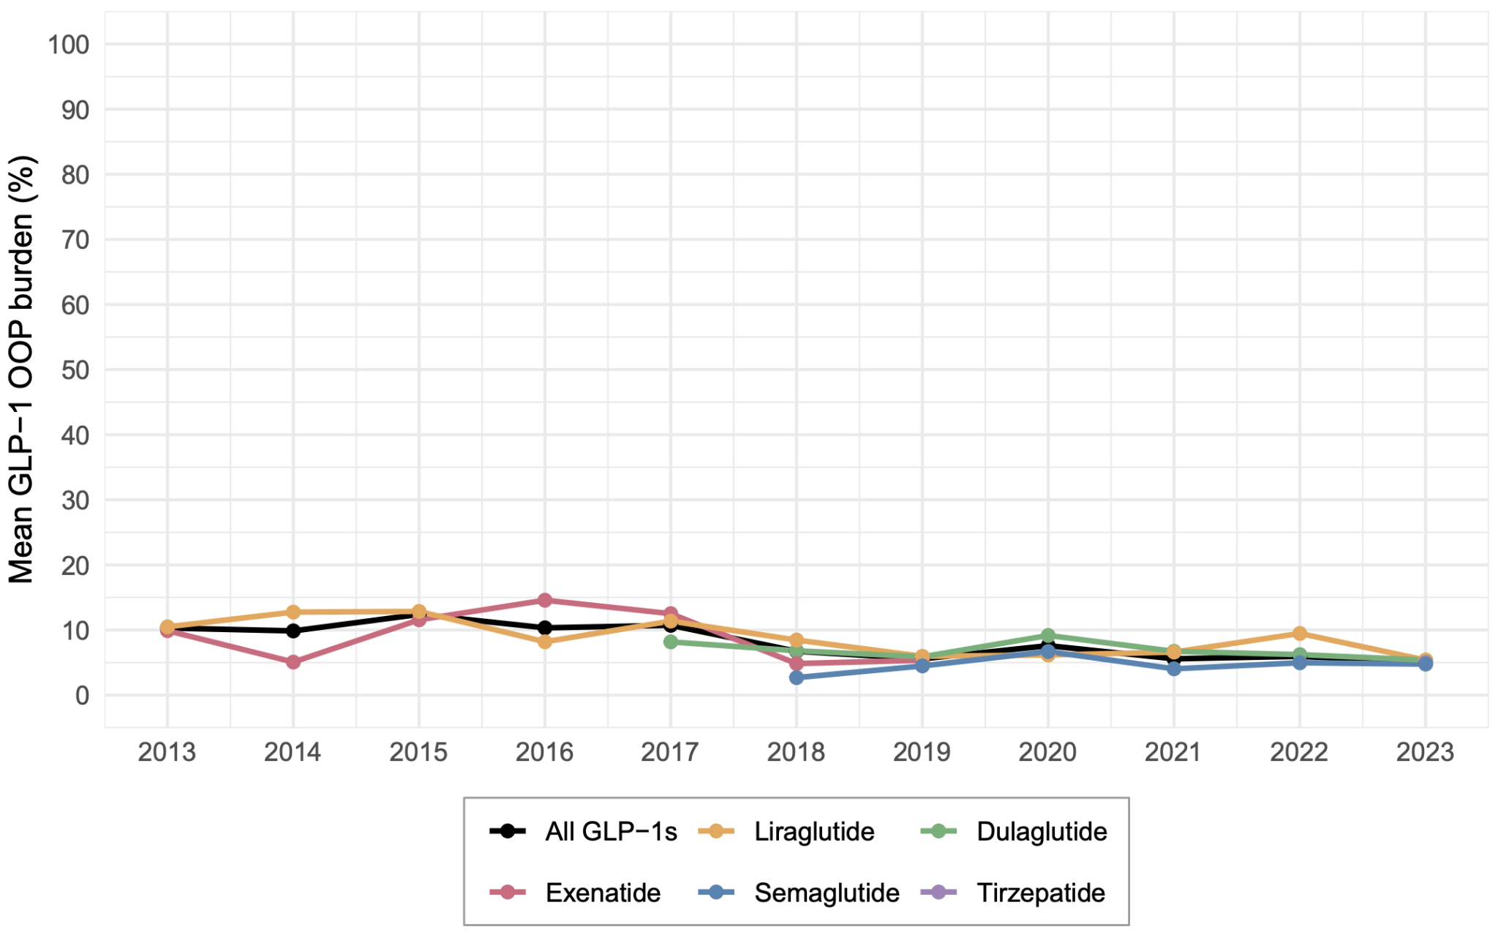

eFigure 8. Mean high out-of-pocket burden on glucagon-like peptide-1 receptor agonists by drug and year, 2013-2023
