Supplementary methods:
Our primary event-study model specification was as follows:
$$\begin{aligned}Y=∂_{1}e+∂_{2}e*\left(InfectionYear=2021\right)+β_{e}\left(e>2\right)+α_{c}+θ_{q}+X_{i}+ϵ_{itc} \#1\end{aligned}$$
Here, $i$ represents individuals, $α_{c}$ represents month of COVID-19 infection fixed effects (FE), $θ_{q}$ represents quarter-year FE, and $X_{i}$ are a set of invidual-level covariates that include region FE, Elixhauser score FE, age group FE, sex (female/male), and CBSA (yes or no/unknown).
The primary coefficients of interest are a linear trend in event time ($e$), the interaction between $e$ and a binary indicator if the individual had their infection in 2021 (vs 2020), and then a set of post-infection event time fixed effects ($β_{e})$. For all individuals we excluded the months $-1≤e≤1$, as the purpose of our study was to estimate the impact of COVID-19 infection on longer-term health utilization outcomes.
We ran all these models separately for individuals who were and were not hospitalized for their COVID-19 infection. We estimated all models using ordinary least squares and reported heteroskedasticity—robust standard errors clustered at the individual level.
For the outcome of any filled prescription, we limited our analysis only to individuals with continuous prescription drug coverage for the 12 months before and after their COVID-19 infection.
As an sensitivity analysis, we also estimated the below fully flexible event-study specification:
$$\begin{aligned}Y=α_{c}+β_{e}+θ_{q}+X_{i}+ϵ_{itc} \#2\end{aligned}$$
Again, here $i$ represents individuals, $α_{c}$ represents month of COVID-19 infection fixed effects, $θ_{q}$ represents quarter-year fixed effects, and $X_{i}$ are a set of invidual-level covariates that include region FE, Elixhauser score FE, age group FE, sex, CBSA (yes or no/unknown). $β_{e}$ are now a full set of pre- and post-infection event time fixed effects, and each event-study coefficient now represents the change in each outcome relative to the reference period, which is $e=-2$, two months before the month of COVID infection. We again exclude the months $-1≤e≤1$ for all individuals. The full set of pre- and post-infection event -study coefficients from this alternative specification are shown graphically in eFigure 1.
As a second sensitivity analysis, we estimated a version of Equation 1 above excluding the interaction term between $e$ and the dummy variable for having an infection in 2021 (vs 2020):
$$\begin{aligned}Y=∂_{1}e+β_{e}\left(e>2\right)+α_{c}+θ_{q}+X_{i}+ϵ_{itc} \#3\end{aligned}$$
Results from this specification are displayed in eTables 3 and 4 and were mostly similar. However, they did vary slightly for the outcomes for which the interaction term was statistically significant in our primary model specification, and we thus prefer Equation 1 as our primary specification.

In a third sensitivity analysis, we widened our washout window and excluded months -2, -1, 0, +1 and +2 from our models, which were run using Equation 1. Results from this sensitivity analysis are displayed in eFigure 8 and were very similar to our primary specification.
In a final sensitivity analysis, we tested the assumption of linear pre-infection trends by comparing model fit between linear and quadratic pre-infection trends. This was done using only the pre-infection data from months -12 to -2. On these data, for each outcome and subgroup (hospitalized vs not hospitalized), we calculated the Bayesian Information Criterion for two models: 1) a model using a linear trend in pre-infection months, year of infection FE, interaction terms between year of infection FE and the linear trend, and all of the covariates including in our primary specification, and 2) the same model as previous, plus a quadratic trend in pre-infection months and the interaction between that quadratic trend and year of infection FE. For all outcomes for the hospitalized subgroup and four out of six outcomes for the non-hospitalized subgroup, the BIC was lower for the simpler model with only a linear trend, indicating that the model with linear trends was a better fit for the pre-infection data.
For two outcomes in the non-hospitalized subgroup, outpatient visits and any prescription, the BIC was lower for the model with quadratic trends, and so for those two outcomes we ran an alternative quadratic specification given in Equation 4 below:
$$\begin{aligned}Y=∂_{1}e+∂_{2}e*\left(InfectionYear=2021\right)+∂_{1}e^{2}+∂_{2}e^{2}*\left(InfectionYear=2021\right) \\ +β_{e}\left(e>2\right)+α_{c}+θ_{q}+X_{i}+ϵ_{itc} \#4\end{aligned}$$
This model contains all the terms included in Equation 1 above, and then also includes a quadratic trends in month relative to infection ($e^{2}$) and its interaction with year of infection FE.
eFigure 1: Event-study coefficients from fully flexible event-study specification (Equation 2)
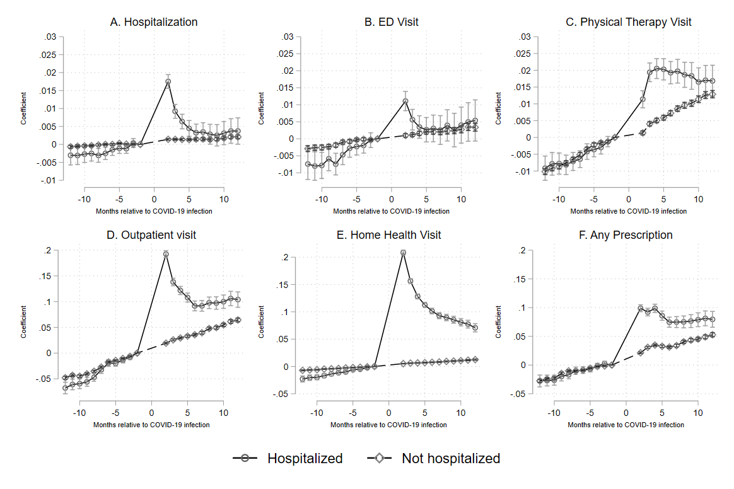

eTable 1: Criteria for identifying utilization in Marketscan claims
Event | Inclusions
COVID-19 Diagnosis | ICD-10 Dx Codes: U071 or J1282
ED Visits | Revenue codes: 450-459  CPT codes: 99281-99285  Place of service: Emergency Department
Outpatient Office Visits | CPT codes: 99202-99205, 99212-99215, 99385-99386, 99395- 99396, 99441-99443, 99495-99496, G0438, G0349, G0402
Outpatient Physical Therapy | CPT codes:  Physical rehabilitation evaluation/re-evaluation: 97001-97002  Supervised modalities: 97010, 97012, 97016, 97018, 97022, 97024, 97026, 97028  Constant attendance modalities: 97032-97036, 97039  Therapeutic procedures: 97110, 97112-97113, 97116, 97124, 97139-97140, 97150,  97530, 97532-97533, 97535, 97537, 97542, 97545  Active wound care management: 97597-97598, 97602, 97605-97606  Test or measurement: 97750, 97755  Orthotic management or prosthetic management: 97760, 97761, 97762  Other unlisted rehabilitation procedures: 97799
Home Health Visits | CPT codes: 99500-99602, 99341-99350  HCPCS codes: S9122-S9124, T1001-T1004, T1030-T1031  Place of service: Patient Home

eTable 2: Alternative prescription medication use outcome results
 | (1) | (2)
 | Hospitalized | Non-hospitalized
Pre-infection average monthly rate of utilization (SE) | 1.96 (0.029) | 1.15 (0.015)
Pre-infection linear trend | 0.036*** | 0.021***
 | (0.030-0.043) | (0.020-0.022)
Pre-infection linear trend*Diagnosis in 2021 | 0.0036* | 0.0014***
Pre-infection linear trend*Diagnosis in 2021 | (0.00066-0.0066) | (0.0010-0.0019)
Post-infection month 2 | 0.46*** | 0.017***
 | (0.43-0.48) | (0.012-0.021)
Post-infection month 3 | 0.34*** | 0.044***
 | (0.31-0.37) | (0.039-0.048)
Post-infection month 4 | 0.36*** | 0.046***
 | (0.33-0.39) | (0.041-0.051)
Post-infection month 5 | 0.29*** | 0.037***
 | (0.26-0.32) | (0.031-0.042)
Post-infection month 6 | 0.22*** | 0.025***
 | (0.19-0.26) | (0.019-0.031)
Post-infection month 7 | 0.24*** | 0.029***
 | (0.20-0.28) | (0.023-0.035)
Post-infection month 8 | 0.23*** | 0.044***
 | (0.18-0.27) | (0.037-0.051)
Post-infection month 9 | 0.22*** | 0.040***
 | (0.18-0.26) | (0.033-0.047)
Post-infection month 10 | 0.22*** | 0.043***
 | (0.17-0.26) | (0.035-0.051)
Post-infection month 11 | 0.23*** | 0.052***
 | (0.18-0.28) | (0.044-0.061)
Post-infection month 12 | 0.22*** | 0.058***
 | (0.16-0.27) | (0.049-0.067)
Observations | 1117490 | 17586580
Notes: This table reports the results of Equation 1 run on the alternative prescription medication outcome, defined as the monthly count of total filled prescriptions, for both the hospitalized and non-hospitalized cohorts. * p<0.05 ** p<0.01 *** p<0.001

eTable 3: Sensitivity analysis using Equation 3 - Changes in healthcare utilization post-COVID-19 infection among hospitalized patients
 | (1) | (2) | (3) | (4) | (5) | (6)
 | Hospitalization | ED Visit | Outpatient visit | Physical Therapy Visit | Home Health Visit | Any Prescription
Pre-infection average monthly rate of utilization (SE) | 0.011 (0.0008) | 0.035 (0.002) | 0.347 (0.009) | 0.039 (0.002) | 0.075 (0.003) | 0.552 (0.005)
Pre-infection linear trend | 0.00035** | 0.00088*** | 0.0072*** | 0.00090*** | 0.0023*** | 0.0033***
 | (0.000087-0.00061) | (0.00045-0.0013) | (0.0061-0.0082) | (0.00054-0.0013) | (0.0018-0.0029) | (0.0023-0.0043)
Post-infection month 2 | 0.016*** | 0.0076*** | 0.16*** | 0.0086*** | 0.20*** | 0.082***
 | (0.015-0.018) | (0.0053-0.0099) | (0.16-0.17) | (0.0060-0.011) | (0.20-0.20) | (0.077-0.087)
Post-infection month 3 | 0.0076*** | 0.0012 | 0.10*** | 0.016*** | 0.14*** | 0.072***
 | (0.0060-0.0091) | (-0.0011-0.0035) | (0.096-0.11) | (0.013-0.019) | (0.14-0.15) | (0.067-0.077)
Post-infection month 4 | 0.0044*** | -0.0018 | 0.078*** | 0.016*** | 0.11*** | 0.075***
 | (0.0029-0.0059) | (-0.0042-0.00056) | (0.072-0.084) | (0.013-0.019) | (0.11-0.12) | (0.070-0.081)
Post-infection month 5 | 0.0021** | -0.0035** | 0.057*** | 0.015*** | 0.096*** | 0.059***
 | (0.00056-0.0037) | (-0.0061--0.0010) | (0.051-0.063) | (0.012-0.018) | (0.092-0.10) | (0.054-0.065)
Post-infection month 6 | 0.00057 | -0.0040** | 0.033*** | 0.013*** | 0.083*** | 0.045***
 | (-0.0010-0.0022) | (-0.0067--0.0014) | (0.027-0.040) | (0.0095-0.016) | (0.078-0.087) | (0.039-0.051)
Post-infection month 7 | 0.00043 | -0.0054*** | 0.026*** | 0.012*** | 0.072*** | 0.042***
 | (-0.0012-0.0021) | (-0.0082--0.0026) | (0.020-0.033) | (0.0089-0.016) | (0.067-0.077) | (0.035-0.048)
Post-infection month 8 | -0.00056 | -0.0049** | 0.025*** | 0.010*** | 0.066*** | 0.039***
 | (-0.0023-0.0012) | (-0.0078--0.0019) | (0.018-0.032) | (0.0067-0.014) | (0.061-0.071) | (0.032-0.045)
Post-infection month 9 | -0.0012 | -0.0072*** | 0.018*** | 0.0092*** | 0.060*** | 0.037***
 | (-0.0030-0.00066) | (-0.010--0.0041) | (0.010-0.025) | (0.0053-0.013) | (0.054-0.065) | (0.030-0.044)
Post-infection month 10 | -0.00095 | -0.0066*** | 0.013** | 0.0065** | 0.053*** | 0.036***
 | (-0.0029-0.0010) | (-0.0099--0.0033) | (0.0051-0.021) | (0.0023-0.011) | (0.047-0.059) | (0.028-0.043)
Post-infection month 11 | -0.00069 | -0.0065*** | 0.012** | 0.0061** | 0.047*** | 0.035***
 | (-0.0027-0.0014) | (-0.0100--0.0031) | (0.0037-0.020) | (0.0017-0.011) | (0.041-0.053) | (0.027-0.043)
Post-infection month 12 | -0.0010 | -0.0070*** | 0.0028 | 0.0050* | 0.038*** | 0.030***
 | (-0.0032-0.0011) | (-0.011--0.0033) | (-0.0061-0.012) | (0.00035-0.0097) | (0.032-0.045) | (0.022-0.038)
Observations | 1190134 | 1190134 | 1190134 | 1190134 | 1190134 | 1117490
Notes: Each column reports the results of Equation 3 for individals hospitalized for their COVID-19 infections. The first row in each column provides the averagely monthly rate of utilization for each outcome in the pre-infection period to provide context to the magnitude of the event-study coefficients. The second row reports the coefficient on the linear event time trend for that outcome, and then the subsequent rows report the coefficients on the event time fixed effects for post-infection months 2 through 12. All models also included a set of month of index infection fixed effects, a set of quarter-year calendar fixed effects, and a set of individual time-invariant covariates that include region FE, Elixhauser score FE, age group FE, sex (female/male), and CBSA (yes or no/unknown). Standard errors are robust and clustered at the individual level. * p<0.05 ** p<0.01 *** p<0.001

eTable 4: Sensitivity analysis using Equation 3 - Changes in healthcare utilization post-COVID-19 infection among non-hospitalized patients
 | (1) | (2) | (3) | (4) | (5) | (6)
 | Hospitalization | ED Visit | Outpatient visit | Physical Therapy Visit | Home Health Visit | Any Prescription
Pre-infection average monthly rate of utilization (SE) | 0.004 (0.0001) | 0.020 (0.0006) | 0.289 (0.008) | 0.037 (0.001) | 0.027 (0.0006) | 0.435 (0.005)
Pre-infection linear trend | 0.000071*** | 0.00032*** | 0.0051*** | 0.0011*** | 0.00073*** | 0.0028***
 | (0.000033-0.00011) | (0.00024-0.00041) | (0.0048-0.0053) | (0.00098-0.0011) | (0.00064-0.00081) | (0.0025-0.0030)
Post-infection month 2 | 0.00091*** | -0.00061** | -0.00028 | -0.0032*** | 0.0022*** | 0.0080***
 | (0.00071-0.0011) | (-0.0010--0.00019) | (-0.0016-0.0010) | (-0.0038--0.0026) | (0.0017-0.0026) | (0.0068-0.0092)
Post-infection month 3 | 0.00083*** | -0.00072** | 0.0011 | -0.0015*** | 0.0024*** | 0.015***
 | (0.00062-0.0010) | (-0.0012--0.00028) | (-0.00030-0.0024) | (-0.0022--0.00091) | (0.0019-0.0029) | (0.013-0.016)
Post-infection month 4 | 0.00073*** | -0.00063** | -0.00040 | -0.0016*** | 0.0021*** | 0.016***
 | (0.00051-0.00095) | (-0.0011--0.00017) | (-0.0018-0.0010) | (-0.0023--0.00091) | (0.0016-0.0026) | (0.014-0.017)
Post-infection month 5 | 0.00060*** | -0.00053* | -0.0019* | -0.0019*** | 0.0018*** | 0.011***
 | (0.00037-0.00083) | (-0.0010--0.000044) | (-0.0034--0.00041) | (-0.0026--0.0011) | (0.0012-0.0024) | (0.0095-0.012)
Post-infection month 6 | 0.00067*** | -0.00082** | -0.0043*** | -0.0016*** | 0.0018*** | 0.0068***
 | (0.00043-0.00091) | (-0.0013--0.00030) | (-0.0059--0.0028) | (-0.0023--0.00076) | (0.0012-0.0024) | (0.0053-0.0083)
Post-infection month 7 | 0.00063*** | -0.0012*** | -0.0056*** | -0.0013** | 0.0017*** | 0.0065***
 | (0.00037-0.00088) | (-0.0017--0.00066) | (-0.0072--0.0039) | (-0.0021--0.00044) | (0.00099-0.0023) | (0.0049-0.0082)
Post-infection month 8 | 0.00040** | -0.0012*** | -0.0024** | -0.0013** | 0.0019*** | 0.010***
 | (0.00014-0.00067) | (-0.0018--0.00067) | (-0.0042--0.00069) | (-0.0022--0.00045) | (0.0012-0.0026) | (0.0087-0.012)
Post-infection month 9 | 0.00044** | -0.0014*** | -0.0058*** | -0.0018*** | 0.0019*** | 0.011***
 | (0.00016-0.00071) | (-0.0020--0.00084) | (-0.0076--0.0039) | (-0.0028--0.00086) | (0.0011-0.0027) | (0.0087-0.012)
Post-infection month 10 | 0.00068*** | -0.0014*** | -0.0054*** | -0.0017** | 0.0019*** | 0.0096***
 | (0.00039-0.00098) | (-0.0020--0.00077) | (-0.0074--0.0035) | (-0.0027--0.00067) | (0.0011-0.0027) | (0.0077-0.011)
Post-infection month 11 | 0.00094*** | -0.00100** | -0.0040*** | -0.0015** | 0.0020*** | 0.011***
 | (0.00063-0.0013) | (-0.0017--0.00033) | (-0.0061--0.0020) | (-0.0026--0.00043) | (0.0012-0.0029) | (0.0086-0.013)
Post-infection month 12 | 0.00087*** | -0.0014*** | -0.0061*** | -0.0023*** | 0.0023*** | 0.012***
 | (0.00054-0.0012) | (-0.0021--0.00074) | (-0.0083--0.0040) | (-0.0034--0.0012) | (0.0014-0.0032) | (0.0094-0.014)
Observations | 18641942 | 18641942 | 18641942 | 18641942 | 18641942 | 17586580
Notes: Each column reports the results of Equation 3 for individals who were not hospitalized for their COVID-19 infections. The first row in each column provides the averagely monthly rate of utilization for each outcome in the pre-infection period to provide context to the magnitude of the event-study coefficients. The second row reports the coefficient on the linear event time trend for that outcome, and then the subsequent rows report the coefficients on the event time fixed effects for post-infection months 2 through 12. All models also included a set of month of index infection fixed effects, a set of quarter-year calendar fixed effects, and a set of individual time-invariant covariates that include region FE, Elixhauser score FE, age group FE, sex (female/male), and CBSA (yes or no/unknown). Standard errors are robust and clustered at the individual level. * p<0.05 ** p<0.01 *** p<0.001

eFigure 2: Unadjusted rates of hospitalizations by hospitalized vs non-hospitalized cohorts 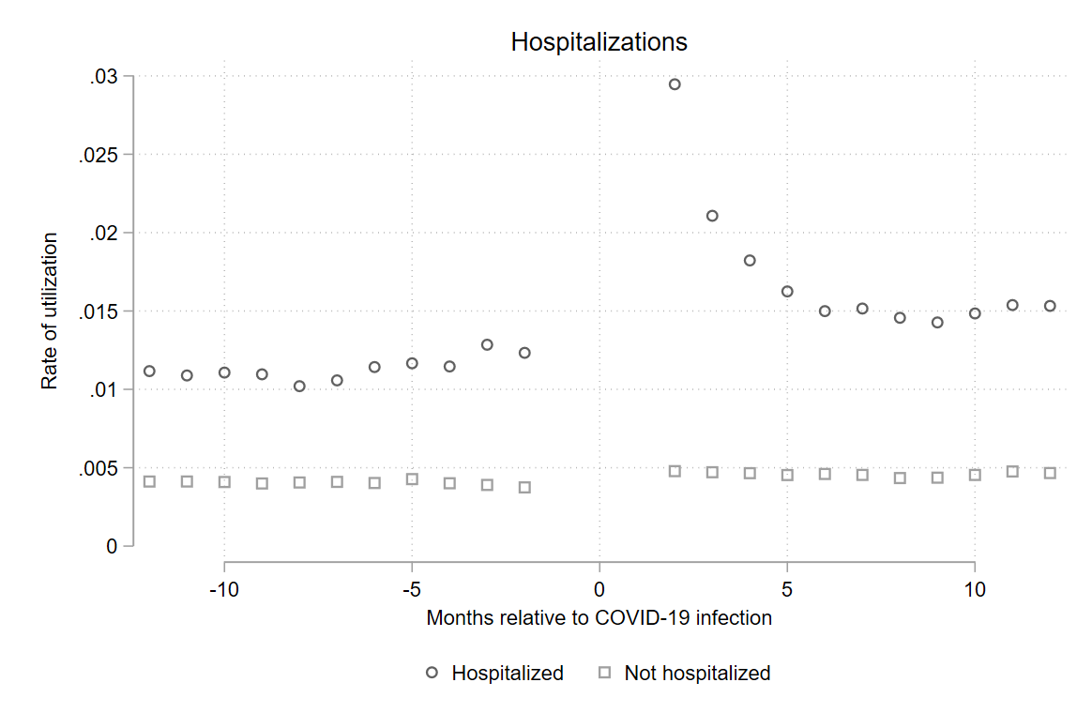
eFigure 3: Unadjusted rates of ED visits by hospitalized vs non-hospitalized cohorts
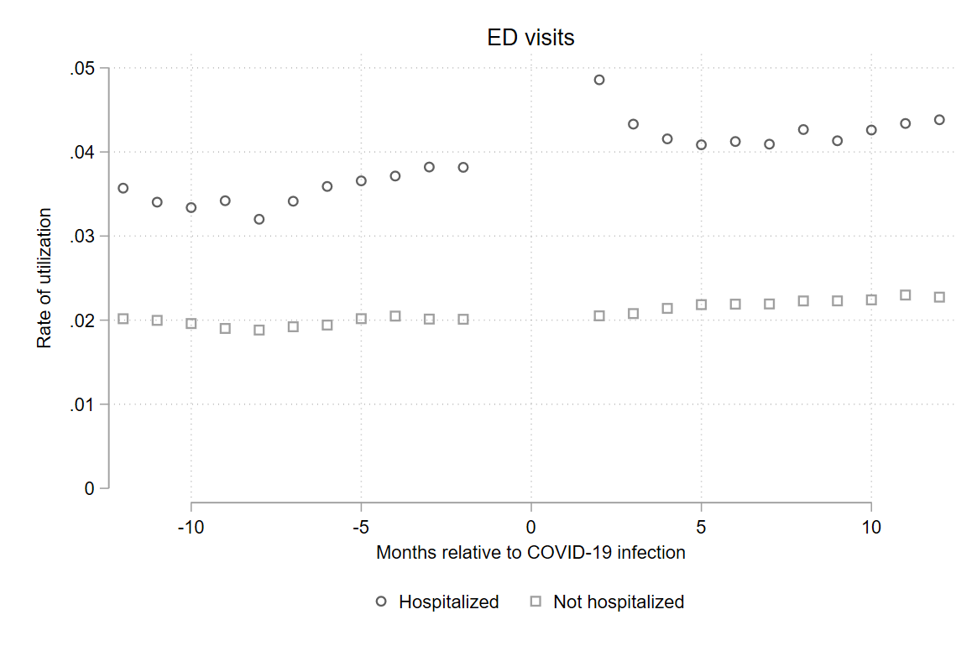

eFigure 4: Unadjusted rates of outpatient visits by hospitalized vs non-hospitalized cohorts
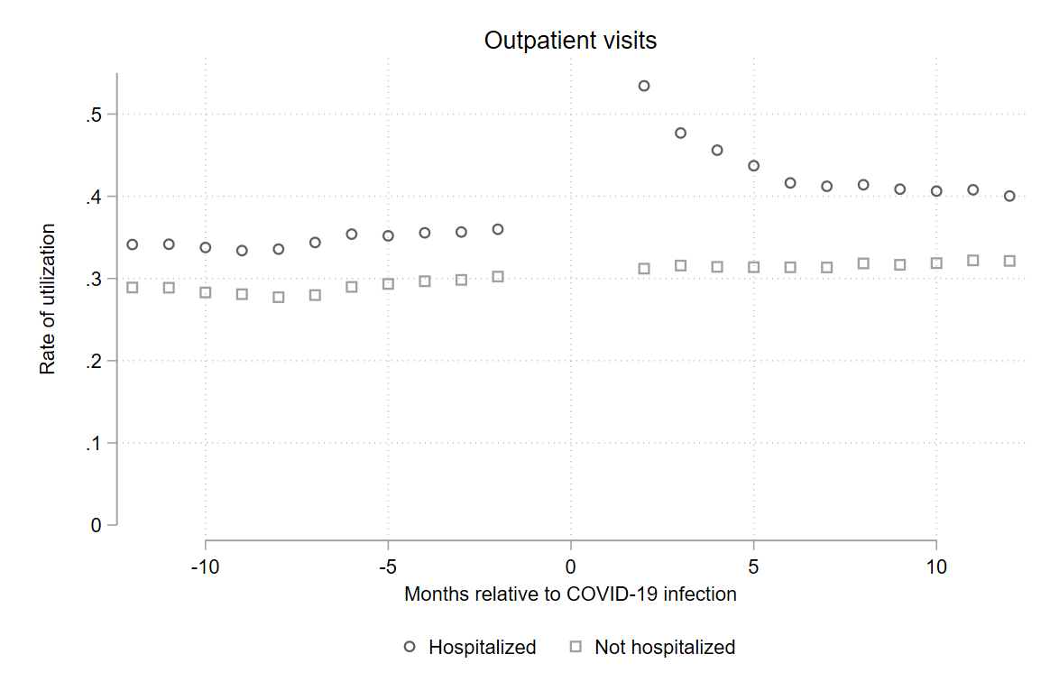
eFigure 5: Unadjusted rates of physical therapy visits by hospitalized vs non-hospitalized cohorts
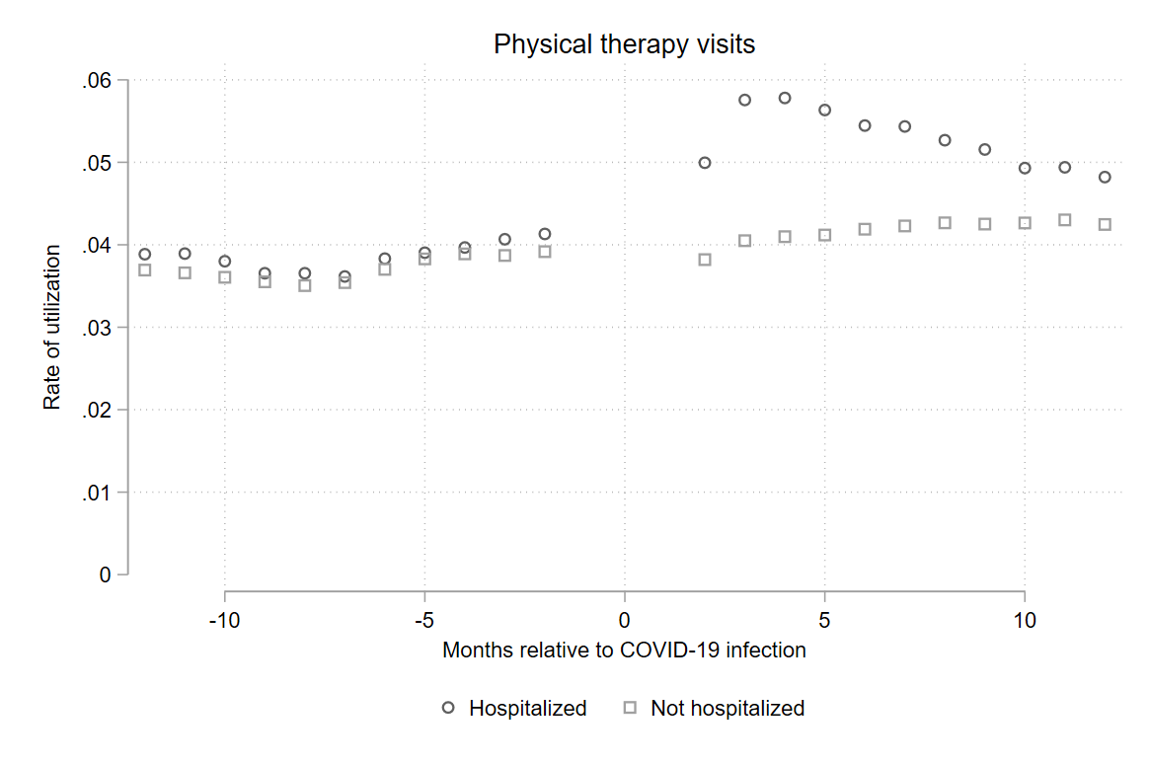

eFigure 6: Unadjusted rates of home health visits by hospitalized vs non-hospitalized cohorts
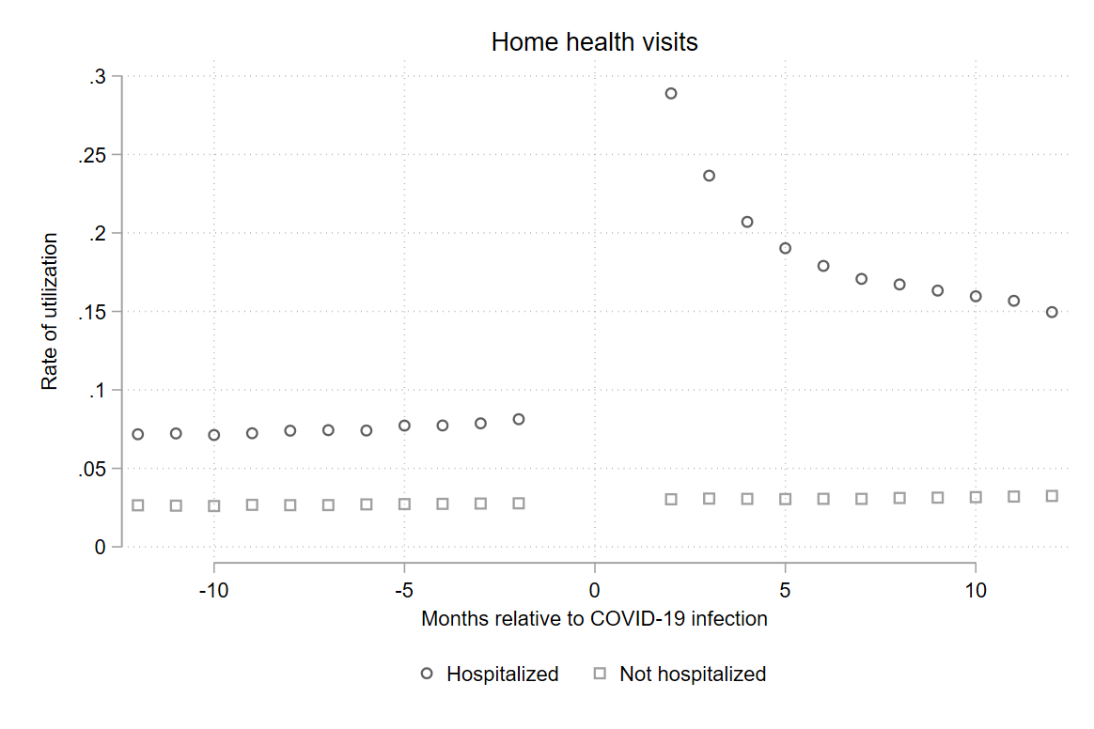
eFigure 7: Unadjusted rates of any filled prescription by hospitalized vs non-hospitalized cohorts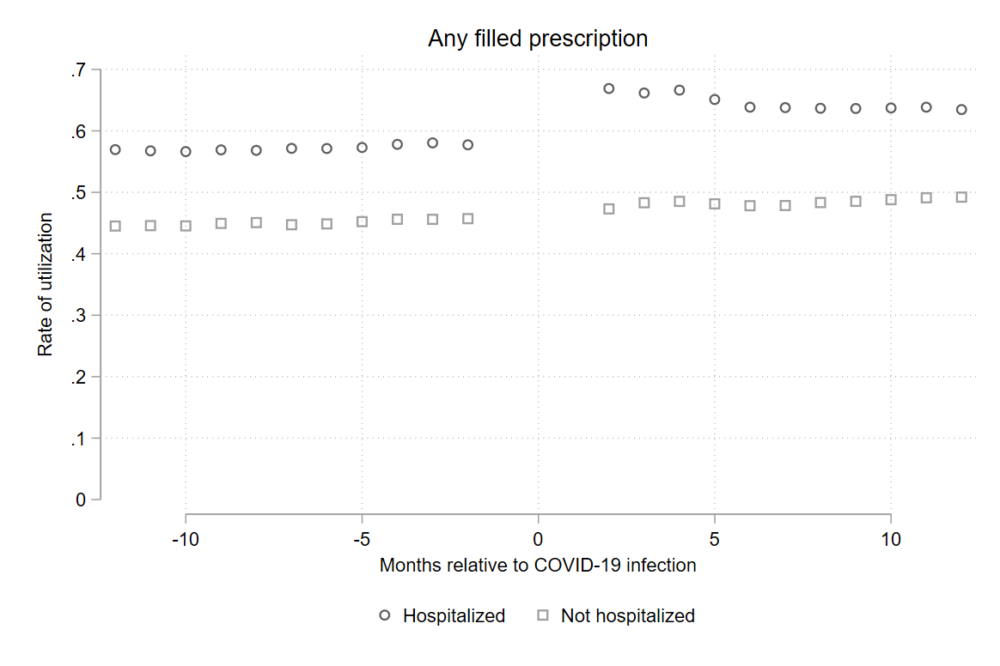

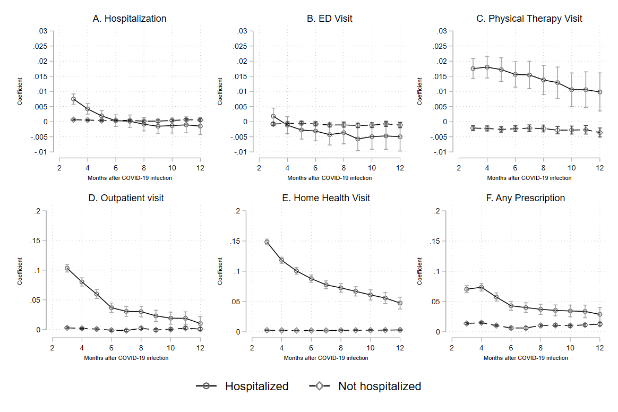
eFigure 8: Sensitivity analysis excluding months -2 and +2 from the analysis
Note: These figures display the event study coefficients from Months 3-12 post-infection, and were run using Equation 1 but excluding months -2 to +2 from the data.

eFigure 9: Sensitivity analysis including quadratic pre-trend (Equation 3)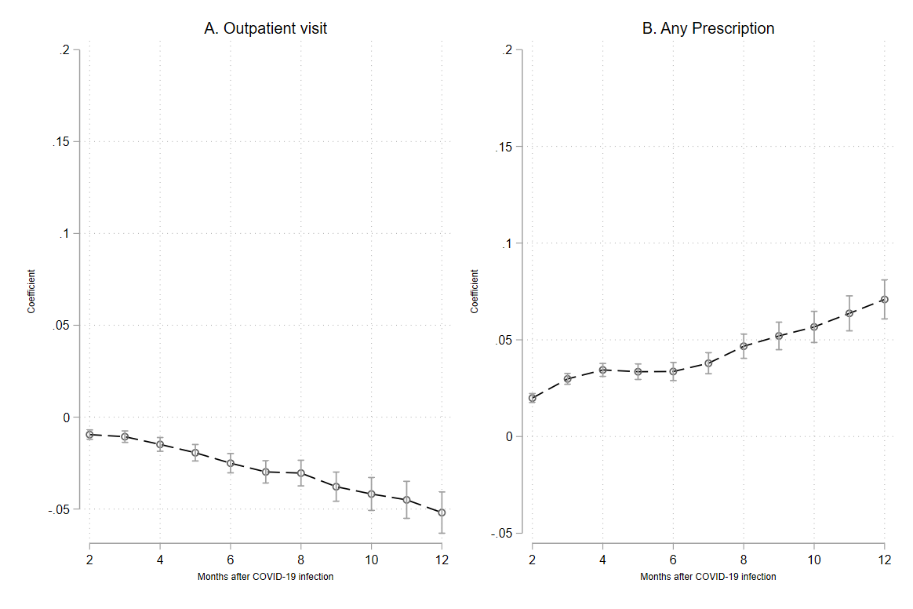
Note: These figures show the post-infection event study coefficients from Equation 4. These models were only run for the outcomes of outpatient visit and any prescription for the non-hospitalized group, as these were the only two models where BIC testing indicated that a quadratic pre-infection trend was a better fit.

