Supplementary Materials

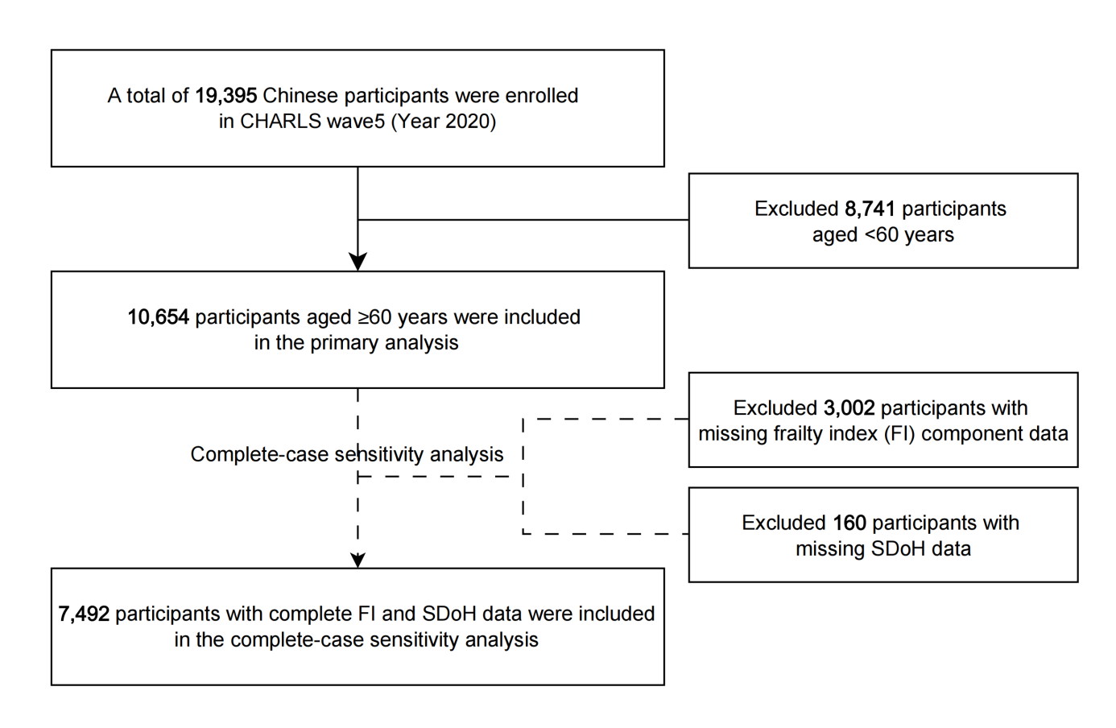

Figure S1. Flowchart for the study sample. China Health and Retirement Longitudinal Study (CHARLS), 2020, the latest wave.

Method S1. Source cohort and eligibility
This study used data from the China Health and Retirement Longitudinal Study (CHARLS) [1], a nationally representative longitudinal survey designed to examine the social, economic, and health conditions of middle-aged and older adults in China.

CHARLS targets community-dwelling Chinese adults aged 45 years or older and their spouses. Institutionalized populations were not included in the sampling frame. The baseline national survey was conducted in 2011-2012 (Wave 1) using a multistage, stratified, probability-proportional-to-size sampling design and covered 150 county-level units and 450 village- or urban community-level primary sampling units across 28 provinces in China, excluding Tibet. The baseline sample included 17,708 respondents from 10,257 households.

CHARLS follows respondents through face-to-face interviews at approximately 2-year intervals. After the baseline survey, follow-up waves were conducted in 2013 (Wave 2), 2015 (Wave 3), 2018 (Wave 4), and 2020 (Wave 5) [2]. The survey collects a wide range of information, including demographic characteristics, socioeconomic conditions, health status, health behaviors, physical functioning, and health care utilization.

CHARLS was approved by the institutional review board at Peking University (IRB00001052-11015), and all participants provided written informed consent before participation.

Table S1. Assessment of SDoH in CHARLS.
Domain | Subdomain | Descriptions | Categories and Coding
Economic Stability | Employment status | The type of work the participants had done in the past year. | 1: Employed in the agricultural sector  2: Employed in the non-agricultural sector  3: Not employed/retired
Economic Stability | Per capita household incomeª | The annual household income per household member. Household income includes earning income, capital income, pension income, and government transfers. | Continuous variable
Economic Stability | Per capita household consumptionª | The annual household consumption per household member. Household consumption includes food, and non-food consumption. | Continuous variable
Education Access and Quality | Education level | The highest level of education participants have attained. | 1: No formal education  2: Primary school  3: Middle school  4: Secondary vocational school and above
Healthcare Access and Quality | Health insurance | The type of health insurance or healthcare plan participants have. | 1: Uninsured  2: Private  3: Public or government
Healthcare Access and Quality | Access to healthcare | Participants’ access to healthcare in the past year. | 1: Inaccessible  2: Accessible
Healthcare Access and Quality | Per capita number of health institutions | The number of health institutions per capita in participant's residence. Health institutions refer to the total count of various types of hospitals, primary healthcare facilities, and specialized public health institutions. | Continuous variable
Neighborhood and  Built Environment | Residence | The area where participants live. | 1: Rural  2: Peri-urban  3: Urban
Neighborhood and  Built Environment | Accommodation stability | Whether participants own or rent their accommodation. | 1: Rent or other arrangement  2: Own home
Neighborhood and  Built Environment | Per capita housing areaª | The construction area of the residence per household member. | Continuous variable
Neighborhood and  Built Environment | Housing qualityª | A composite score of housing conditions [3], including type of accommodation, barrier-free facilities, electricity, water, gas supply, and room temperature. Higher scores indicate better quality. | Continuous variable
Neighborhood and  Built Environment | Air quality (AQI) | The annual average Air Quality Index (AQI) at the city level. Higher values indicate more severe air pollution. | Continuous variable
Neighborhood and  Built Environment | Noise level (Leq, dB(A)) | The area noise level at the participant's residence. Higher values indicate higher noise levels. | Continuous variable
Neighborhood and  Built Environment | Extreme climate (CPRI) | The Climate Physical Risk Index (CPRI) representing extreme climate risk [4]. Higher values indicate greater risk. | Continuous variable
Social and Community  Context | Marriage | The current marital status of participants. | 1: Unmarried, separated, divorced and widowed  2: Married or cohabiting
Social and Community  Context | Living alone | Whether participants live alone. | 1: Yes  2: No
Social and Community  Context | Social participationª | The level of participants’ participation in social activities, such as interacting with friends, playing mahjong, chess, or cards, attending sports or social clubs, engaging in volunteer or community organizations, and attending educational or training courses. | 1: Low social participation  2: High social participation
Note: a. Variables were imputed using multiple imputation.

Table S2. The 30 items used to construct the FI [5-12].
Domain | No | Description of the items (CHARLS) | Cut-off value | Observed deficit present, n/N (%)^{f} | Missing before imputation, n/N (%)^{g}
Comorbidity | 1 | Self-reported physician diagnosed hypertension | Yes = 1, No = 0 | 5329/10638 (50.09) | 16/10654 (0.15)
Comorbidity | 2 | Self-reported physician diagnosed dyslipidemia | Yes = 1, No = 0 | 3235/10637 (30.41) | 17/10654 (0.16)
Comorbidity | 3 | Self-reported physician diagnosed diabetes | Yes = 1, No = 0 | 1960/10636 (18.43) | 18/10654 (0.17)
Comorbidity | 4 | Self-reported physician diagnosed heart diseaseª | Yes = 1, No = 0 | 2944/10636 (27.68) | 18/10654 (0.17)
Comorbidity | 5 | Self-reported physician diagnosed stroke | Yes = 1, No = 0 | 1237/10635 (11.63) | 19/10654 (0.18)
Comorbidity | 6 | Self-reported physician diagnosed cancer | Yes = 1, No = 0 | 332/10,636 (3.12) | 18/10654 (0.17)
Comorbidity | 7 | Self-reported physician diagnosed arthritis | Yes = 1, No = 0 | 4876/10635 (45.85) | 19/10654 (0.18)
Comorbidity | 8 | Self-reported physician diagnosed chronic lung disease | Yes = 1, No = 0 | 2074/10636 (19.50) | 18/10654 (0.17)
Comorbidity | 9 | Self-reported physician diagnosed kidney disease | Yes = 1, No = 0 | 1403/10635 (13.19) | 19/10654 (0.18)
Comorbidity | 10 | Self-reported physician diagnosed gastric disease | Yes = 1, No = 0 | 3628/10635 (34.11) | 19/10654 (0.18)
Comorbidity | 11 | Self-reported physician diagnosed asthma | Yes = 1, No = 0 | 911/10635 (8.57) | 19/10654 (0.18)
Comorbidity | 12 | Self-reported physician diagnosed any emotional, nervous, or psychiatric problems | Yes = 1, No = 0 | 379/10635 (3.56) | 19/10654 (0.18)
Comorbidity | 13 | Self-reported physician diagnosed memory-related disease^{b} | Yes = 1, No = 0 | 956/10635 (8.99) | 19/10654 (0.18)
Self-reported health problems | 14 | Self-reported vision problems | Yes = 1, No = 0 | 295/9457 (3.12) | 1197/10654 (11.24)
Self-reported health problems | 15 | Self-reported hearing problems | Yes = 1, No = 0 | 730/9457 (7.72) | 1197/10654 (11.24)
Self-reported health problems | 16 | Self-reported general health status | Poor or fair = 1,  very good or good = 0 | 7439/9460 (78.64) | 1194/10654 (11.21)
Self-reported health problems | 17 | Self-reported body pain | Somewhat, Quite a Bit, or Very = 1, None or a little = 0 | 3362/10633 (31.62) | 21/10654 (0.20)
ADL/IADL functional disability^{c} | 18 | Difficulty with dressing | Yes = 1, No = 0 | 584/10631 (5.49) | 23/10654 (0.22)
ADL/IADL functional disability^{c} | 19 | Difficulty with bathing or showering | Yes = 1, No = 0 | 843/10631 (7.93) | 23/10654 (0.22)
ADL/IADL functional disability^{c} | 20 | Difficulty with eating | Yes = 1, No = 0 | 300/10631 (2.82) | 23/10654 (0.22)
ADL/IADL functional disability^{c} | 21 | Difficulty with getting in and out of bed | Yes = 1, No = 0 | 399/10631 (3.75) | 23/10654 (0.22)
ADL/IADL functional disability^{c} | 22 | Difficulty with using the toilet | Yes = 1, No = 0 | 429/10630 (4.04) | 24/10654 (0.23)
ADL/IADL functional disability^{c} | 23 | Difficulty with managing money | Yes = 1, No = 0 | 1109/10629 (10.43) | 25/10654 (0.23)
ADL/IADL functional disability^{c} | 24 | Difficulty with taking medications | Yes = 1, No = 0 | 651/10629 (6.12) | 25/10654 (0.23)
ADL/IADL functional disability^{c} | 25 | Difficulty with shopping for groceries | Yes = 1, No = 0 | 1090/10629 (10.25) | 25/10654 (0.23)
ADL/IADL functional disability^{c} | 26 | Difficulty with preparing meals | Yes = 1, No = 0 | 1179/10629 (11.09) | 25/10654 (0.23)
ADL/IADL functional disability^{c} | 27 | Difficulty with doing housework | Yes = 1, No = 0 | 1318/10630 (12.40) | 24/10654 (0.23)
ADL/IADL functional disability^{c} | 28 | Difficulty with controlling urination and defecation | Yes = 1, No = 0 | 296/10630 (2.78) | 24/10654 (0.23)
Depression^{d} | 29 | CESD-10 questionnaire | >10 =1, ≤10 =0 | 3056/9625 (31.75) | 1029/10654 (9.66)
Cognition deficits^{e} | 30 | (memory deficit score + orientation deficit score) / full score | Continuous (0-1) | Not applicable^{h} | 2243/10654 (21.05)
Notes:
a. Heart disease indicated the angina, heart attack, heart failure, or other heart problems.
b. Memory-related disease indicated Alzheimer’s disease or dementia, organic brain senility, or other serious memory impairment.
c. ADL/IADL functional disability was converted into a binary variable when constructing networks to improve interpretability because the summed domain score was highly zero-inflated, with sparse observations across the higher score levels.
d. Depression was evaluated using the 10-item Center for Epidemiologic Studies Depression Scale (CESD-10) [13]. In the CHARLS, CESD-10 was used, and the total score ranged from 0 to 30.
e. Cognition was derived from memory and orientation items in CHARLS. The memory deficit score was the average number of words not recalled in the immediate and delayed word recall tasks (range: 0-10). The orientation deficit score was based on five questions on the day of the week, month, date, year, and season, with one point assigned for each wrong answer (range: 0-5). The cognition deficit score was calculated as (memory deficit score + orientation deficit score) / 15; higher values indicate poorer cognitive function.
f. Percentages for observed deficit prevalence were calculated among participants with non-missing data for the corresponding item.
g. Percentages for missing data were calculated among all age-eligible participants included in the primary analysis (n = 10654).
h. For the cognition item, deficit prevalence was not reported because it was treated as a continuous deficit score ranging from 0 to 1.

Method S2. Standard deficit-accumulation approach proposed by Searle et al. [5]
The frailty index (FI) was developed using the deficit-accumulation framework proposed by Searle et al. Under this approach, frailty is quantified as the proportion of health deficits present in an individual, rather than as a syndrome defined by a single fixed set of criteria. Candidate deficits may include a broad range of age-related health problems, such as symptoms, clinical signs, diseases, and disability-related limitations, provided that they are biologically meaningful, generally increase with age, and do not become almost universal too early in life.

The exact composition of an FI does not need to be identical across studies or datasets; different frailty indices may include different items and even different numbers of deficits, as long as they follow the same underlying principles. Variables used to construct an FI may be continuous, ordinal, or binary. Each deficit is coded on a scale from 0 to 1, where 0 indicates no deficit and 1 indicates that the deficit is fully present. The FI is then calculated by summing the coded deficits and dividing by the total number of included items, so that higher values indicate greater frailty.

According to Searle et al., at least 30 deficits are recommended to ensure stable performance, and an index based on approximately 30 variables has been shown to be sufficiently robust for predicting adverse outcomes. In the present study, FI construction followed these principles and was adapted to the variables available in the CHARLS 2020 dataset.

Method S3. Identification of domain-specific SDoH latent classes
Latent class analysis (LCA) was conducted using MPlus version 8 to identify distinct subgroups within four SDoH domains based on domain-specific indicators: Economic Stability, Health Care Access and Quality, Neighborhood and Built Environment, and Social and Community Context. LCA was not conducted for Education Access and Quality as the domain has a single categorical indicator (educational attainment) which could be used as subgroups directly.

LCA accommodates a wide range of variable types, including continuous, binary, ordinal, and nominal indicators, allowing for flexible and realistic modeling of complex data structures [14]. In this study, some continuous variables were retained in their original form rather than being categorized to preserve data granularity and avoid information loss.

Model fit was evaluated using the following statistical criteria: Akaike Information Criterion (AIC), Bayesian Information Criterion (BIC), sample-size adjusted BIC (aBIC), entropy, the Lo-Mendell-Rubin Likelihood Ratio Test (LMRT), and the Bootstrap Likelihood Ratio Test (BLRT). Lower values of AIC, BIC, and aBIC indicate a better fit [15]. Entropy values range from 0 to 1, with values greater than 0.80 suggesting high classification accuracy [16]. A statistically significant LMRT and BLRT (p < 0.05) supported the selection of a model with k classes over a model with k-1 classes [17].

Table S3. Latent class model fit indices (Economic stability).
Category No. | Free Parameter No. | Loglikelihood | AIC | BIC | aBIC | Entropy | LMR | BLRT | Category Probability | Sample Size
1 | 6 | -39962.285 | 79936.570 | 79980.212 | 79961.145 | - | - | - | - | -
2 | 11 | -36778.736 | 73579.472 | 73659.482 | 73624.526 | 0.845 | <0.0001 | <0.0001 | 0.7246/0.2754 | 7720/2934
3 | 16 | -36446.383 | 72924.767 | 73041.146 | 72990.300 | 0.914 | <0.0001 | <0.0001 | 0.0044/0.2852/0.7104 | 47/3038/7569
4 | 21 | -35832.100 | 71706.200 | 71858.948 | 71792.213 | 0.871 | <0.0001 | <0.0001 | 0.0056/0.6132/0.1426/0.2360 | 60/6533/1519/2542
- Latent class 1: Low economic resources with agricultural employment (72.5%)
- Latent class 2: High economic resources with non-agricultural employment or without employment (e.g. retired) (27.5%)

Table S4. Latent class model fit indices (Healthcare access and quality).
Category No. | Free Parameter No. | Loglikelihood | AIC | BIC | aBIC | Entropy | LMR | BLRT | Category Probability | Sample Size
1 | 5 | -21744.679 | 43499.358 | 43535.726 | 43519.837 | - | - | - | - | -
2 | 10 | -21408.818 | 42837.637 | 42910.374 | 42878.595 | 0.612 | <0.0001 | <0.0001 | 0.4973/0.5027 | 5298/5356
3 | 15 | -20935.737 | 41901.474 | 42010.580 | 41962.912 | 0.828 | <0.0001 | <0.0001 | 0.3026/0.2340/0.4634 | 3224/2493/4937
4 | 20 | -20696.806 | 41433.613 | 41579.087 | 41515.529 | 0.853 | <0.0001 | <0.0001 | 0.2724/0.2324/0.2192/0.2761 | 2902/2476/2335/2941
5 | 25 | -20654.322 | 41358.643 | 41540.486 | 41461.039 | 0.879 | 0.2102 | 1.000 | 0.2218/0.2500/0.0254/0.2324/0.2704 | 2363/2663/271/2476/2881
- Latent class 1: Low perceived healthcare access despite higher per-capita facility density (27.2%)
- Latent class 2: Moderate perceived healthcare access with moderate per-capita facility density (21.9%)
- Latent class 3: Moderate perceived healthcare access with relatively higher per-capita facility density (27.6%)
- Latent class 4: High perceived healthcare access despite lower per-capita facility density (23.2%)

Table S5. Latent class model fit indices (Neighborhood and built environment).
Category No. | Free Parameter No. | Loglikelihood | AIC | BIC | aBIC | Entropy | LMR | BLRT | Category Probability | Sample Size
1 | 13 | -79885.245 | 159796.490 | 159891.048 | 159849.736 | - | - | - | - | -
2 | 22 | -74871.949 | 149787.898 | 149947.919 | 149878.006 | 1.000 | <0.0001 | <0.0001 | 0.5814/0.4186 | 6194/4460
3 | 31 | -74157.104 | 148376.207 | 148601.692 | 148503.178 | 0.867 | <0.0001 | <0.0001 | 0.4160/0.4186/0.1654 | 4432/4460/1762
4 | 40 | -73518.627 | 147117.254 | 147408.202 | 147281.087 | 0.893 | <0.0001 | <0.0001 | 0.1742/0.3056/0.4072/0.1130 | 1856/3256/4338/1204
5 | 49 | -73143.685 | 146385.370 | 146741.780 | 146586.065 | 0.915 | 0.0004 | 0.0005 | 0.4140/0.4168/0.1604/0.0025/0.0062 | 4411/4441/1709/27/66
- Latent class 1: Rural residence with moderate housing conditions and relatively fair air quality (17.4%)
- Latent class 2: Rural residence with moderate housing conditions and relatively good air quality (40.7%)
- Latent class 3: Mixed rural-urban residence with high housing conditions and relatively good air quality (30.6%)
- Latent class 4: Urban residence with high housing conditions and relatively fair air quality (11.3%)

Table S6. Latent class model fit indices (Social and community context).
Category No. | Free Parameter No. | Loglikelihood | AIC | BIC | aBIC | Entropy | LMR | BLRT | Category Probability | Sample Size
1 | 3 | -17611.337 | 35228.675 | 35250.496 | 35240.962 | - | - | - | - | -
2 | 7 | -16074.969 | 32163.938 | 32214.854 | 32192.609 | 0.975 | <0.0001 | <0.0001 | 0.8770/0.1230 | 9344/1310
3 | 11 | -16072.514 | 32167.027 | 32247.038 | 32212.081 | 0.500 | 0.0859 | 0.1154 | 0.1230/0.8770/0.0000 | 1310/9344/0
- Latent class 1: Low social connection (12.3%)
- Latent class 2: High social connection (87.7%)

Table S7. Summary of network analysis parameters, thresholds, and interpretations.
Parameters | Interpretation and threshold
Edge weights | Edge weights reflected the strength of conditional associations. Thicker edges indicated stronger relationships.
Centrality indices | Centrality indices, including strength, closeness, and betweenness [18], identified key and influential nodes. Nodes with higher strength were considered more central.
Bridge strength | Bridge strength, defined as the sum of absolute edge weights linking nodes across communities, was computed using the networktools package [19]. Higher values indicate stronger inter-community connectivity. This analysis was applied to both the domain-level and variable-level integrated networks to identify bridging roles of specific SDoH community and frailty community.
Network accuracy and stability | Accuracy and stability were evaluated using the bootnet package.  Edge-weight accuracy was evaluated using nonparametric bootstrapping with 1,000 resamples to estimate 95% confidence intervals (CIs), where narrower CIs reflect greater precision.  Centrality stability was assessed using case-dropping bootstraps with 1,000 resamples to compute correlation stability (CS) coefficients. A CS coefficient above 0.25 indicates acceptable stability, and values over 0.5 are considered good [20].
Edge-weight difference test and node-strength difference test | Edge-weight and node-strength difference tests were performed to examine whether specific connections and nodes differed significantly.

Frailty Network
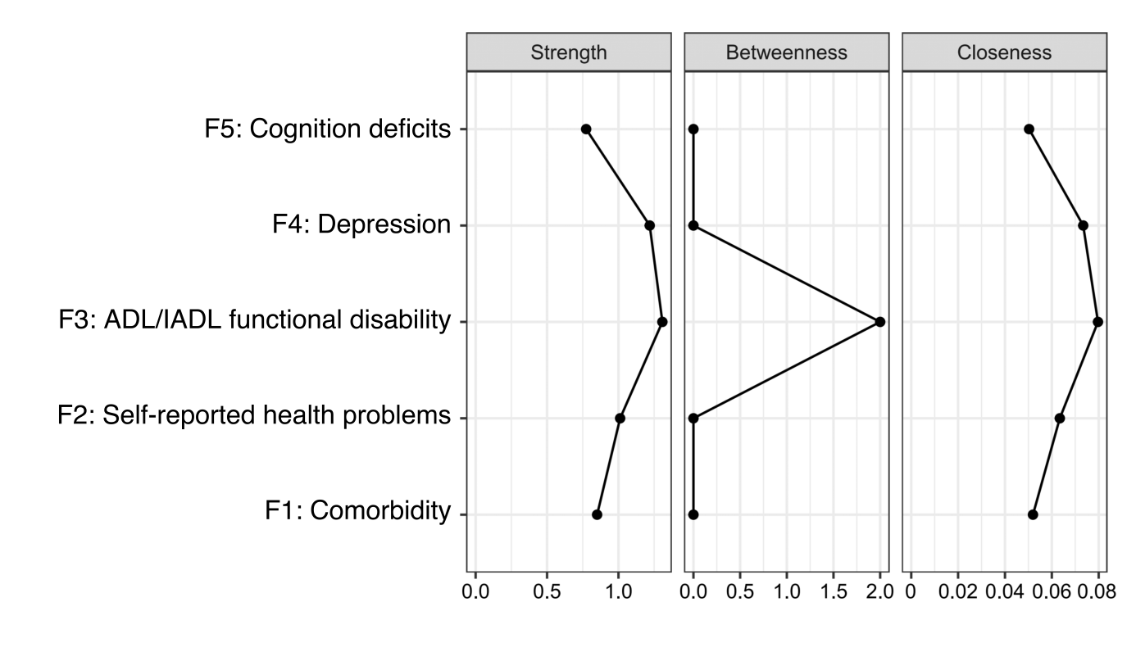

Figure S2. Centrality indices for the frailty network.
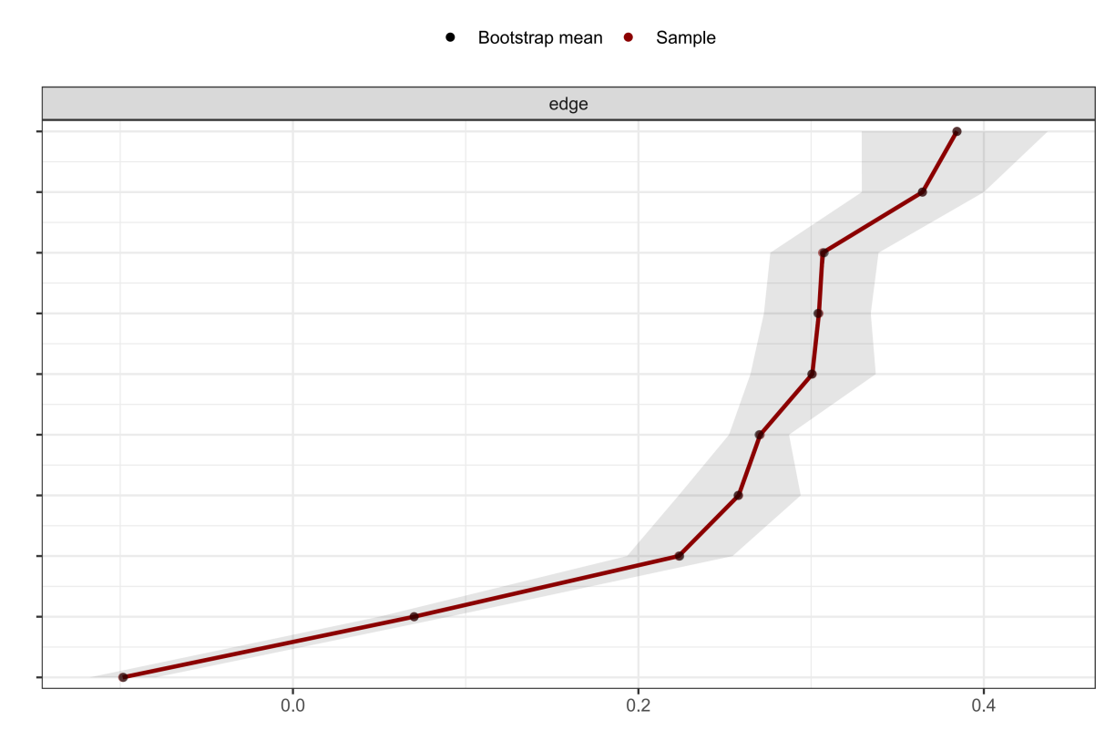
Figure S3. Accuracy analysis of estimated edge weights in the frailty network using bootstrapped confidence intervals. Notes: The vertical axis lists each edge between each pair of nodes, and the horizontal axis indicates the estimated edge weights. The black dots represent the edge weights. The gray shaded areas represent the 95% bootstrapped confidence intervals, indicating the variability and precision of each estimated edge weight. Narrower intervals suggest more stable and reliable associations between domains.
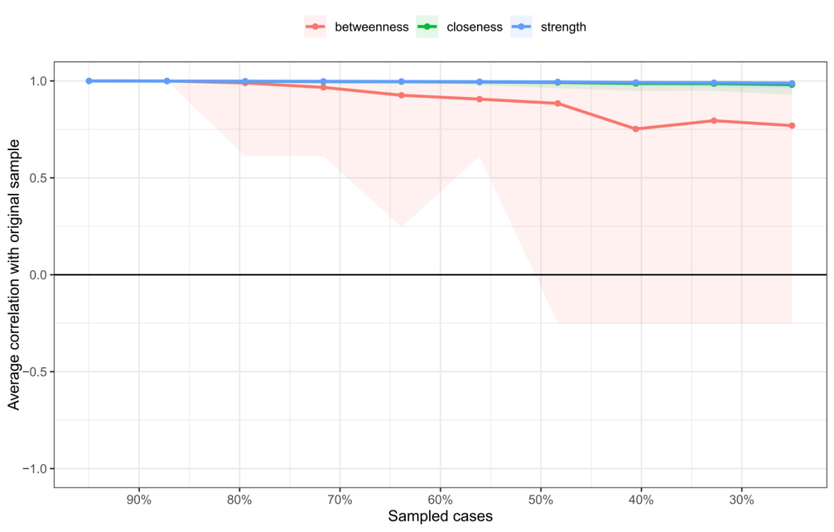
Figure S4. Stability analysis of centrality indices in the frailty network using case-dropping bootstrap. Note: The plot presents the correlation stability (CS) coefficients for three centrality indices: strength (blue), closeness (green), and betweenness (red). The x-axis represents the proportion of cases retained in each bootstrap sample, while the y-axis indicates the average correlation between centrality values in the subset and the full sample. Colored lines show the mean correlations, and shaded areas represent 95% confidence intervals. Dots along the curves indicate the estimated correlation at each sampling proportion. The CS coefficient was 0.75 for strength.

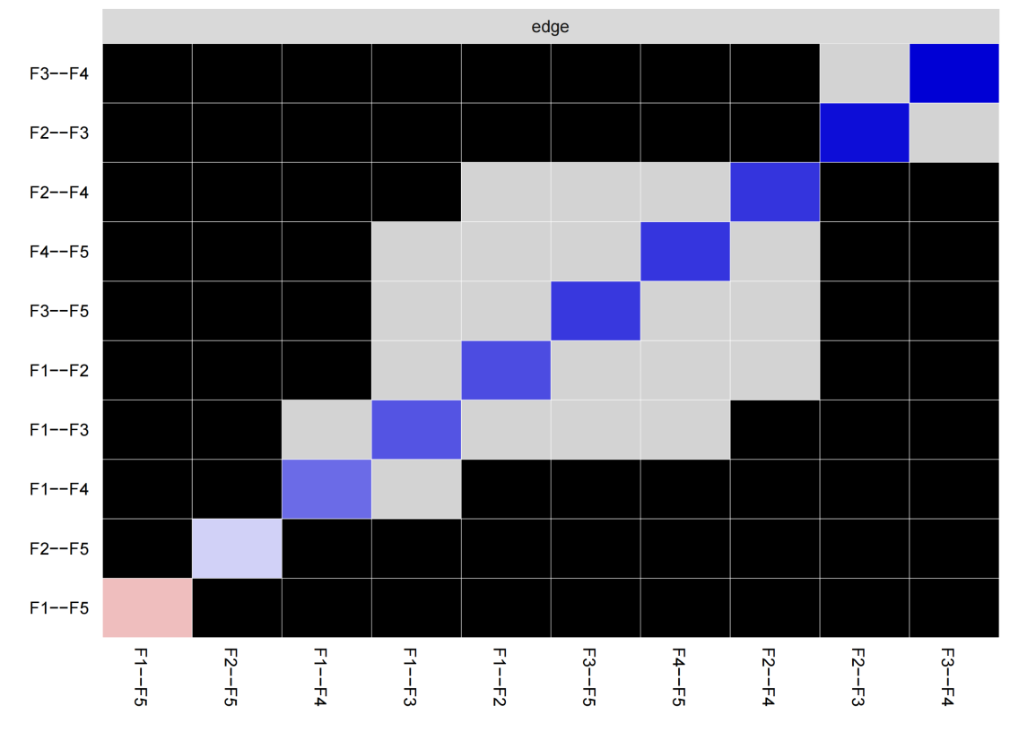
Figure S5. Edge weight difference test for the frailty network. Note: This heatmap presents the results of nonparametric bootstrap difference tests comparing all pairs of edge weights in the frailty network. Each row and column correspond to a specific edge. Black cells indicate statistically significant differences between the corresponding edge weights (p < 0.05), while gray cells indicate non-significant differences. This analysis helps identify whether certain associations are significantly stronger or weaker than others within the network structure.

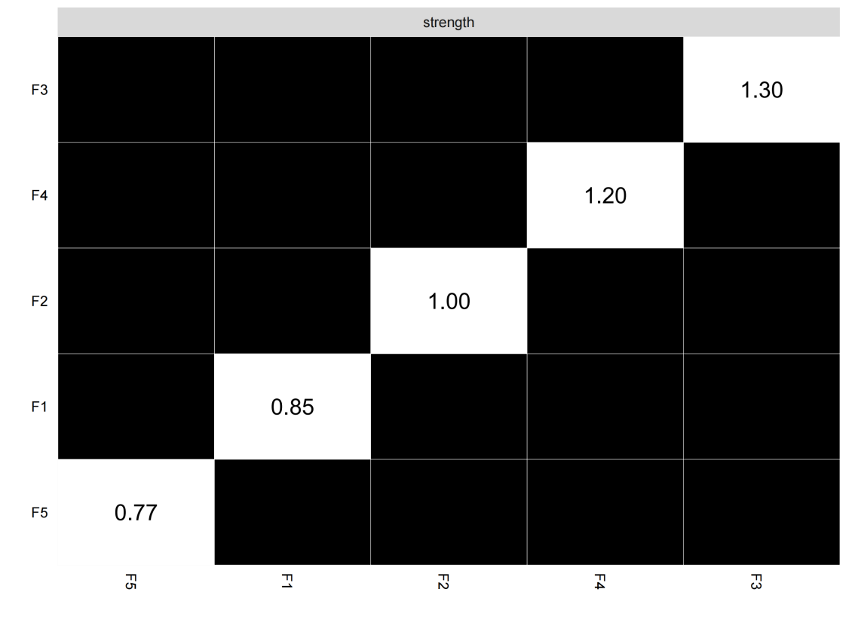
Figure S6. Node strength difference test in the frailty network. Note: This heatmap shows the results of nonparametric bootstrap difference tests comparing node strength centrality values across all nodes in the frailty network. Each row and column corresponds to a node, and each cell represents a pairwise comparison of node strength. Black cells indicate statistically significant differences in node strength between the respective node pair (p < 0.05), while gray cells indicate non-significant differences. This test helps identify which nodes are significantly more central than others in the network.

Domain-level network connecting SDoH with frailty

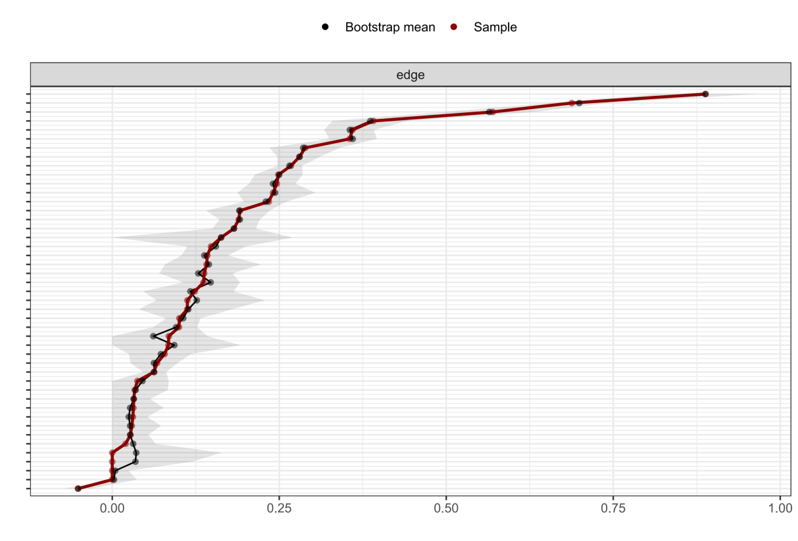
Figure S7. Accuracy analysis of estimated edge weights in the domain-level network using bootstrapped confidence intervals. Notes: The vertical axis lists each edge between each pair of nodes, and the horizontal axis indicates the estimated edge weights. The black dots represent the edge weights. The gray shaded areas represent the 95% bootstrapped confidence intervals, indicating the variability and precision of each estimated edge weight. Narrower intervals suggest more stable and reliable associations between domains.
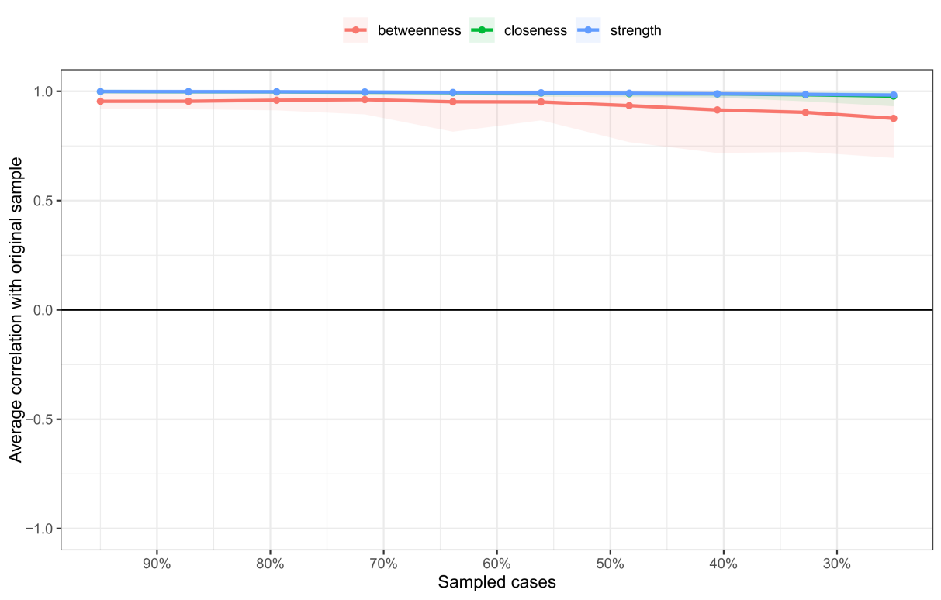
Figure S8. Stability analysis of centrality indices in the domain-level network using case-dropping bootstrap. Note: The plot presents the correlation stability (CS) coefficients for three centrality indices: strength (blue), closeness (green), and betweenness (red). The x-axis represents the proportion of cases retained in each bootstrap sample, while the y-axis indicates the average correlation between centrality values in the subset and the full sample. Colored lines show the mean correlations, and shaded areas represent 95% confidence intervals. Dots along the curves indicate the estimated correlation at each sampling proportion. The CS coefficient was 0.75 for strength.
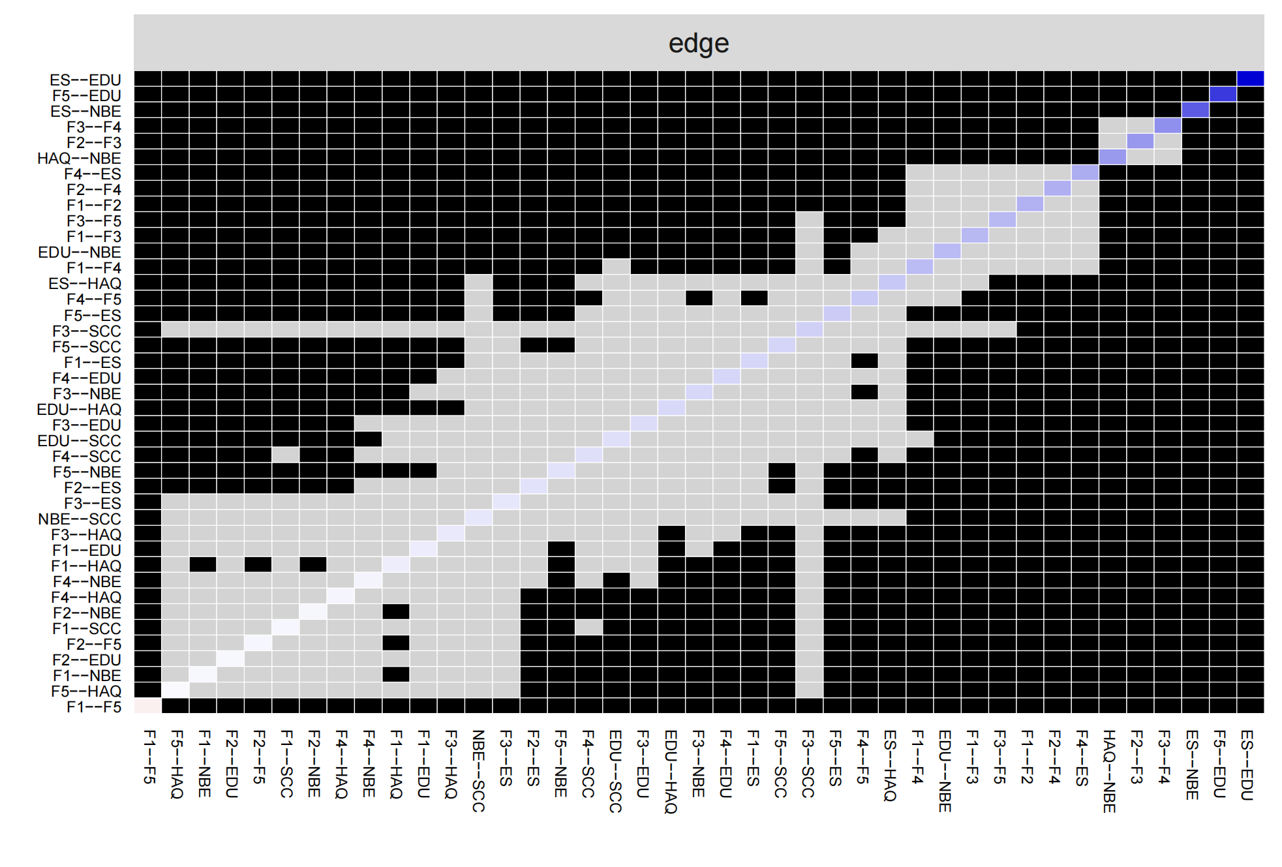
Figure S9. Edge weight difference test for the domain-level network. Note: This heatmap presents the results of nonparametric bootstrap difference tests comparing all pairs of edge weights in the domain-level network. Each row and column correspond to a specific edge. Black cells indicate statistically significant differences between the corresponding edge weights (p < 0.05), while gray cells indicate non-significant differences. This analysis helps identify whether certain associations are significantly stronger or weaker than others within the network structure.

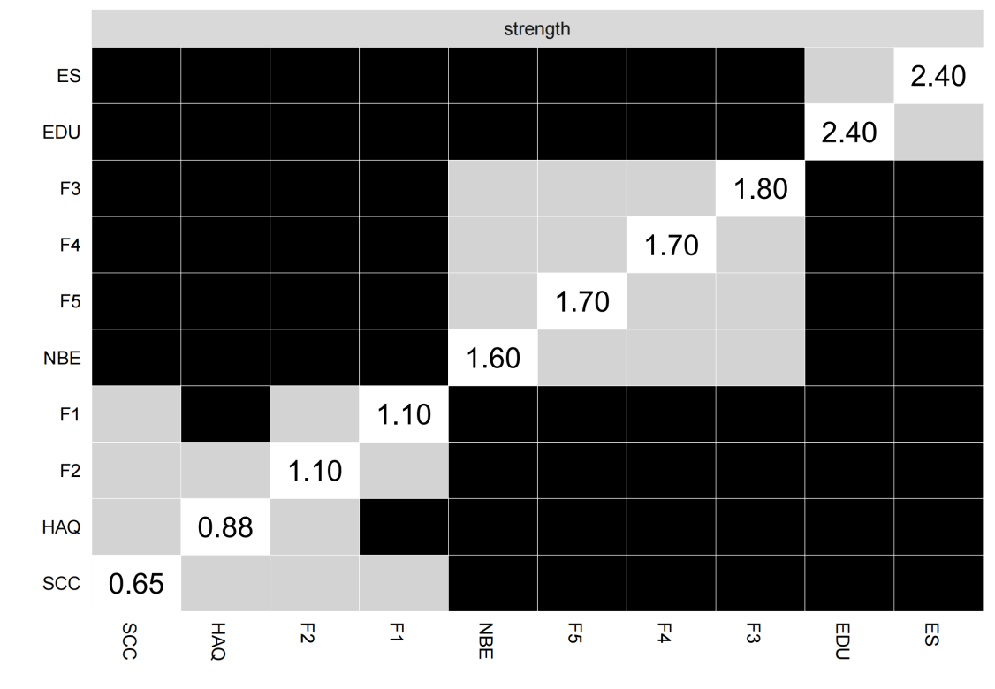
Figure S10. Node strength difference test in the domain-level network. Note: This heatmap shows the results of nonparametric bootstrap difference tests comparing node strength centrality values across all nodes in the domain-level network. Each row and column corresponds to a node, and each cell represents a pairwise comparison of node strength. Black cells indicate statistically significant differences in node strength between the respective node pair (p < 0.05), while gray cells indicate non-significant differences. This test helps identify which nodes are significantly more central than others in the network.

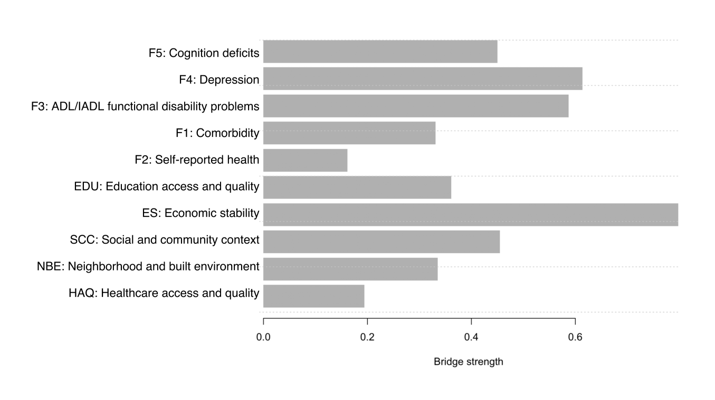
Figure S11. Bridge strength in the domain-level network after removing the edge between Education Access and Quality and cognition deficits. Notes: The edge connecting Education Access and Quality and cognition was set to zero in the estimated weighted adjacency matrix, while all other edge weights and the original community assignment were retained. Bridge strength was then recalculated to evaluate the extent to which the bridging roles of education and cognition were attributable to their direct association.
The integrated network of SDoH and frailty
Table S8. Edge weights for the integrated network of SDoH and frailty.
From | to | Edge weights | Direction
SCC1: Marriage | SCC2: Living alone | 1.813 | Positive
ES1: Employment status | NBE1: Residence | 0.657 | -
F5: Cognition deficits | EDU1: Education level | 0.645 | -
NBE2: Accommodation stability | SCC2: Living alone | 0.495 | Positive
NBE3: Per capita housing area | SCC2: Living alone | 0.457 | -
NBE1: Residence | NBE4: Housing quality | 0.418 | Negative
HAQ3: Per capita number of health institutions | NBE6: Noise level | 0.389 | Negative
F3: ADL/IADL functional disability | F4: Depression | 0.380 | Positive
NBE5: Air quality | NBE7: Extreme climate | 0.359 | Negative
NBE2: Accommodation stability | SCC1: Marriage | 0.342 | Positive
ES1: Employment status | SCC1: Marriage | 0.338 | -
F3: ADL/IADL functional disability | ES1: Employment status | 0.335 | -
F2: Self-reported health problems | F3: ADL/IADL functional disability | 0.328 | Positive
HAQ3: Per capita number of health institutions | NBE5: Air quality | 0.320 | Positive
EDU1: Education level | NBE1: Residence | 0.309 | -
F1: Comorbidity | HAQ2: Access to healthcare | 0.308 | Negative
ES2: Per capita household income | EDU1: Education level | 0.298 | -
EDU1: Education level | SCC1: Marriage | 0.297 | -
NBE1: Residence | NBE3: Per capita housing area | 0.291 | -
F2: Self-reported health problems | F4: Depression | 0.275 | Positive
ES2: Per capita household income | NBE1: Residence | 0.271 | -
F1: Comorbidity | F2: Self-reported health problems | 0.245 | Positive
HAQ3: Per capita number of health institutions | NBE7: Extreme climate | 0.245 | Positive
F3: ADL/IADL functional disability | SCC2: Living alone | 0.237 | Positive
F3: ADL/IADL functional disability | F5: Cognition deficits | 0.204 | Positive
HAQ1: Health insurance | SCC1: Marriage | 0.203 | -
F1: Comorbidity | F4: Depression | 0.202 | Positive
ES3: Per capita household consumption | NBE1: Residence | 0.192 | -
F4: Depression | F5: Cognition deficits | 0.188 | Positive
F1: Comorbidity | F3: ADL/IADL functional disability | 0.183 | Positive
F5: Cognition deficits | SCC1: Marriage | 0.183 | Negative
ES2: Per capita household income | ES3: Per capita household consumption | 0.180 | Positive
NBE2: Accommodation stability | NBE3: Per capita housing area | 0.173 | Positive
NBE1: Residence | SCC2: Living alone | 0.160 | -
NBE4: Housing quality | SCC2: Living alone | 0.160 | Positive
ES3: Per capita household consumption | EDU1: Education level | 0.158 | -
F5: Cognition deficits | NBE1: Residence | 0.143 | -
F4: Depression | EDU1: Education level | 0.141 | -
ES1: Employment status | SCC2: Living alone | 0.140 | -
HAQ3: Per capita number of health institutions | NBE4: Housing quality | 0.136 | Negative
F5: Cognition deficits | SCC3: Social participation | 0.133 | Negative
ES1: Employment status | EDU1: Education level | 0.132 | -
NBE5: Air quality | NBE6: Noise level | 0.132 | Positive
F4: Depression | SCC1: Marriage | 0.129 | Positive
F2: Self-reported health problems | HAQ2: Access to healthcare | 0.121 | Negative
ES1: Employment status | ES2: Per capita household income | 0.121 | -
F3: ADL/IADL functional disability | SCC3: Social participation | 0.120 | Positive
HAQ3: Per capita number of health institutions | NBE1: Residence | 0.106 | -
F3: ADL/IADL functional disability | HAQ2: Access to healthcare | 0.101 | Positive
F5: Cognition deficits | HAQ2: Access to healthcare | 0.101 | Positive
Notes:
Only edge weights with an absolute value ≥0.100 are presented for clarity.
- indicates associations involving categorical variables with three or more levels, for which a specific positive or negative direction cannot be meaningfully interpreted.
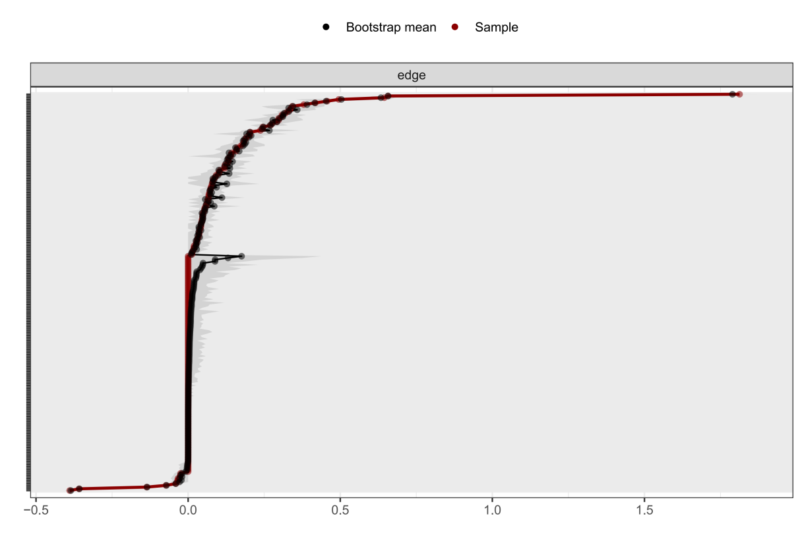
Figure S12. Accuracy analysis of estimated edge weights in the integrated network using bootstrapped confidence intervals. Notes: The vertical axis lists each edge between each pair of nodes, and the horizontal axis indicates the estimated edge weights. The black dots represent the edge weights. The gray shaded areas represent the 95% bootstrapped confidence intervals, indicating the variability and precision of each estimated edge weight. Narrower intervals suggest more stable and reliable associations between domains.

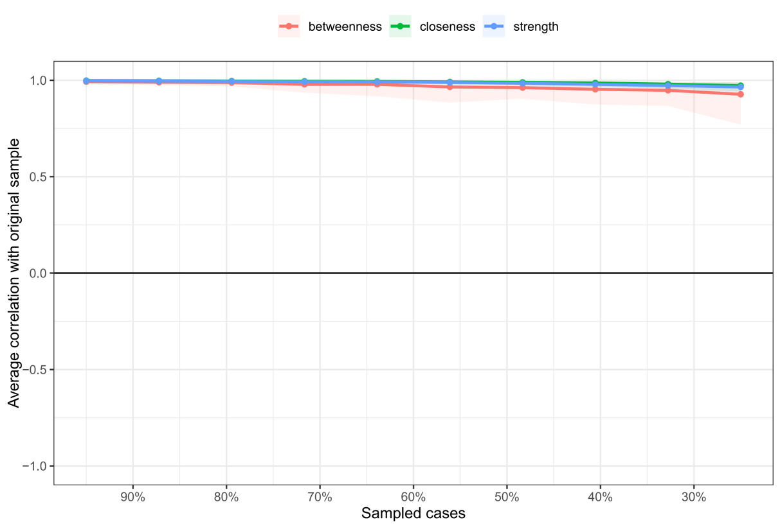
Figure S13. Stability analysis of centrality indices in the integrated network using case-dropping bootstrap. Note: The plot presents the correlation stability (CS) coefficients for three centrality indices: strength (blue), closeness (green), and betweenness (red). The x-axis represents the proportion of cases retained in each bootstrap sample, while the y-axis indicates the average correlation between centrality values in the subset and the full sample. Colored lines show the mean correlations, and shaded areas represent 95% confidence intervals. Dots along the curves indicate the estimated correlation at each sampling proportion. The CS coefficient was 0.75 for strength.

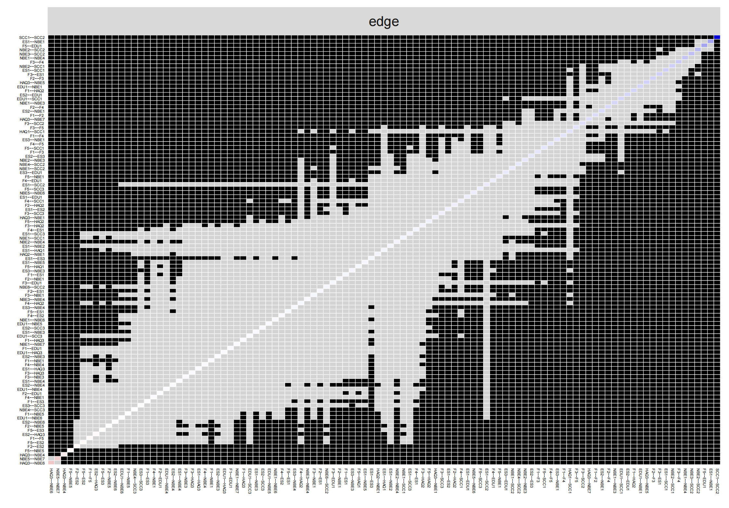
Figure S14. Edge weight difference test for the integrated network. Note: This heatmap presents the results of nonparametric bootstrap difference tests comparing all pairs of edge weights in the domain-level network. Each row and column corresponds to a specific edge. Black cells indicate statistically significant differences between the corresponding edge weights (p < 0.05), while gray cells indicate non-significant differences. This analysis helps identify whether certain associations are significantly stronger or weaker than others within the network structure.
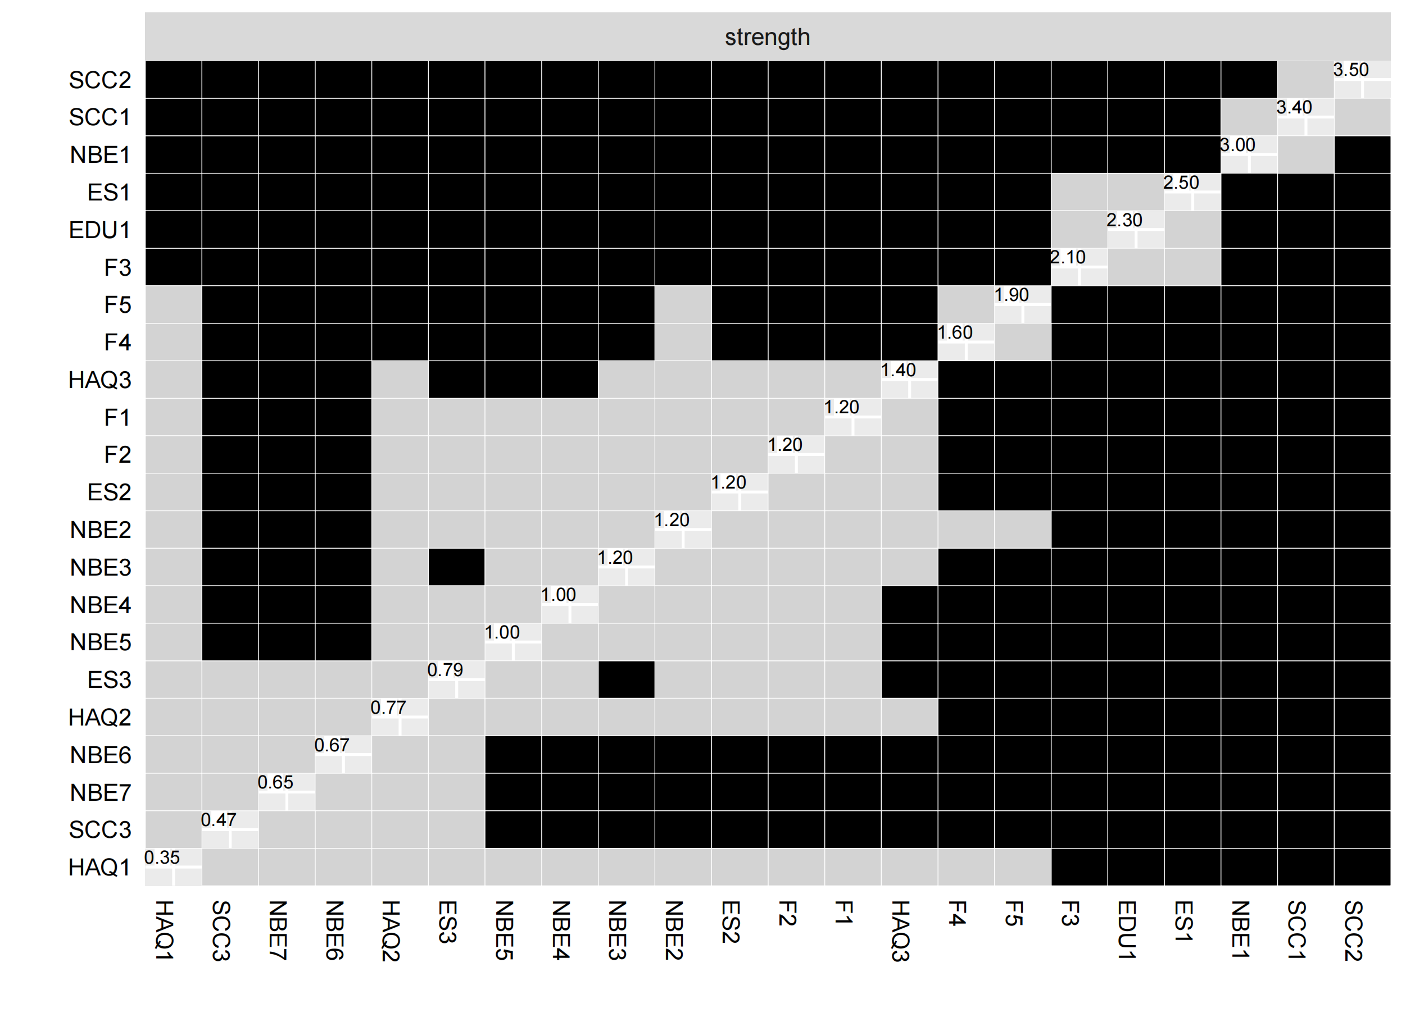

Figure S15. Node strength difference test in the integrated network. Note: This heatmap shows the results of nonparametric bootstrap difference tests comparing node strength centrality values across all nodes in the domain-level network. Each row and column corresponds to a node, and each cell represents a pairwise comparison of node strength. Black cells indicate statistically significant differences in node strength between the respective node pair (p < 0.05), while gray cells indicate non-significant differences. This test helps identify which nodes are significantly more central than others in the network.

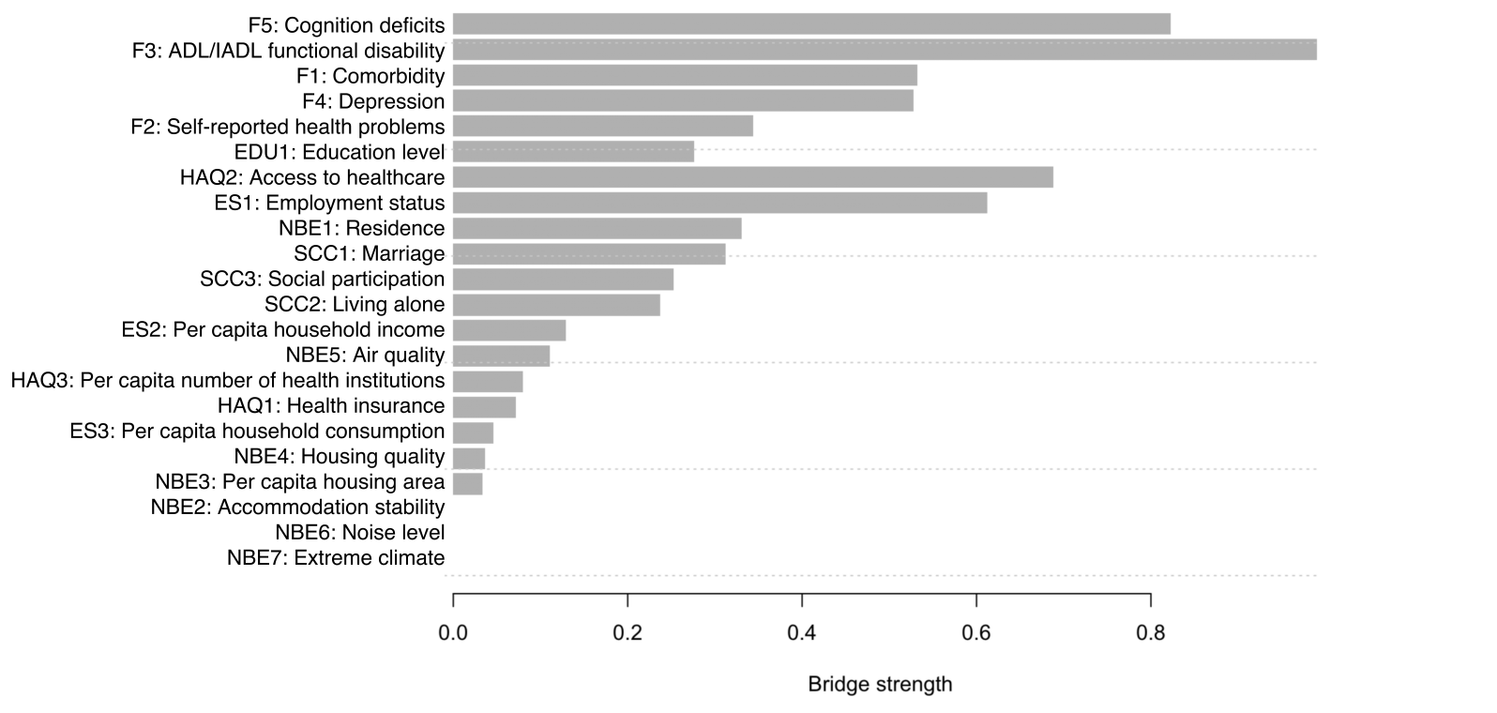
Figure S16. Bridge strength in the integrated variable-level network after removing the the edge between education level and cognition. Notes: The edge connecting education level and cognition was set to zero in the estimated weighted adjacency matrix, while all other edge weights and the original community assignment were retained. Bridge strength was then recalculated to assess whether the bridge strength of education level and cognition was primarily driven by their direct association.

Result S1. SDoH Variables to Frailty Domain Network
To explore associations between specific SDoH variables and frailty domains, subnetworks were constructed for each SDoH domain (Figures S17A-S17E). Details of node centrality measures, accuracy, and stability assessments are presented in Figures S18-S32.

In the Economic Stability subnetwork, the strongest SDoH-frailty association was between employment status and self-reported health problems (edge weight = 0.333). In the Education Access and Quality subnetwork, education level was most strongly associated with cognition deficits (0.802). In the Health Care Access and Quality subnetwork, access to healthcare showed the strongest association, with a negative edge to comorbidity (0.338). In the Neighborhood and Built Environment subnetwork, residence was most strongly associated with cognition deficits (0.256). In the Social and Community Context subnetwork, living alone was most strongly associated with ADL/IADL functional disability (0.348). These findings offer a structural overview of the relationships between individual variables in each SDoH domain and frailty.
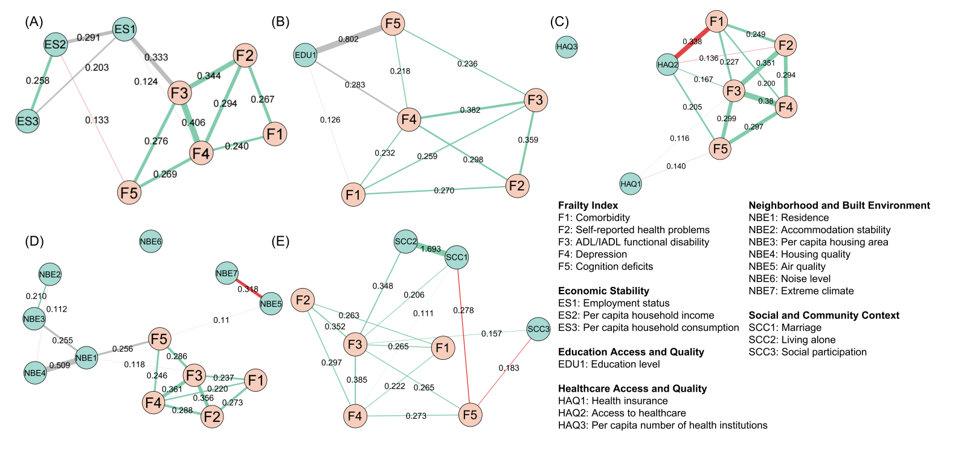
Figure S17. Subnetworks between frailty domains and variables in the specific SDoH domains: (A) Economic Stability; (B) Education Access and Quality; (C) Health Care Access and Quality; (D) Neighborhood and Built Environment; and (E) Social and Community Context. Notes: Thicker edges indicate stronger relationships; only edge weights with an absolute value ≥0.100 are presented for clarity. Positive edges are shown in green, negative edges are shown in red, and the edges connecting categorical variables with more than 2 categories and other variables (both with other categorical variables and with continuous variables) are shown in gray. Higher values in each frailty domain indicate worse conditions. Higher values for each SDoH variable indicate better conditions except air quality, noise level, and extreme climate; higher values for air quality, noise level, and extreme climate indicate worse conditions.

Economic Stability
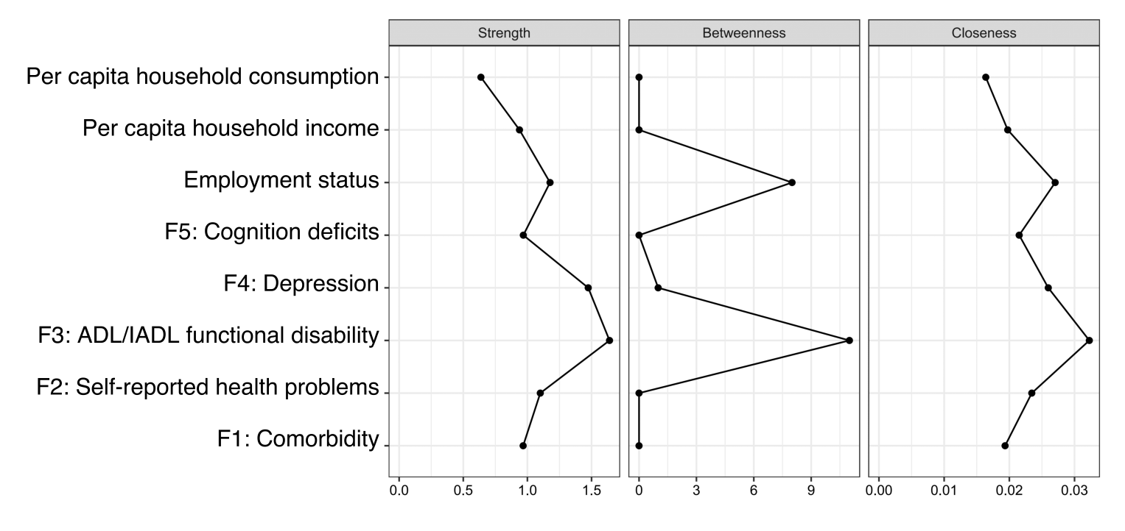

Figure S18. Centrality indices for the network of frailty domains and Economic Stability variables.
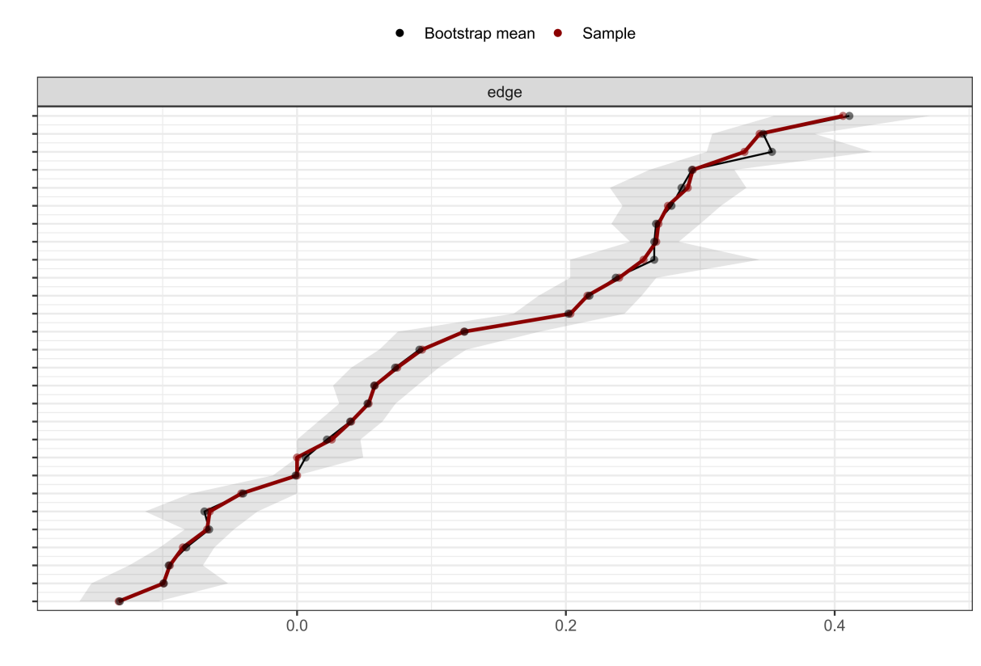
Figure S19. Accuracy analysis of estimated edge weights in the network connecting Economic Stability variables and frailty domains using bootstrapped confidence intervals. Notes: The vertical axis lists each edge between each pair of nodes, and the horizontal axis indicates the estimated edge weights. The black dots represent the edge weights. The gray shaded areas represent the 95% bootstrapped confidence intervals, indicating the variability and precision of each estimated edge weight. Narrower intervals suggest more stable and reliable associations between domains.
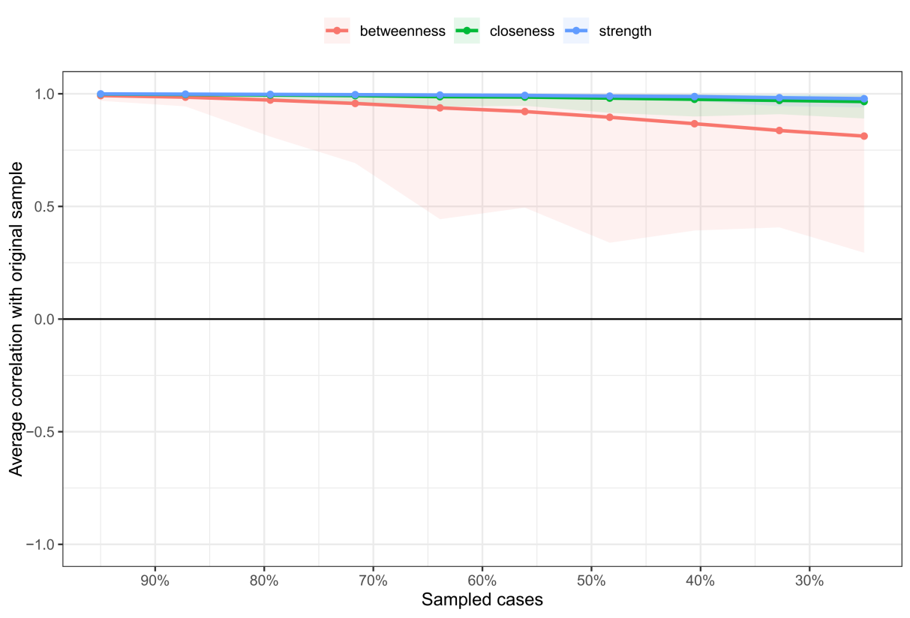
Figure S20. Stability analysis of centrality indices in the network connecting Economic Stability variables and frailty domains using case-dropping bootstrap. Note: The plot presents the correlation stability (CS) coefficients for three centrality indices: strength (blue), closeness (green), and betweenness (red). The x-axis represents the proportion of cases retained in each bootstrap sample, while the y-axis indicates the average correlation between centrality values in the subset and the full sample. Colored lines show the mean correlations, and shaded areas represent 95% confidence intervals. Dots along the curves indicate the estimated correlation at each sampling proportion. The CS coefficient was 0.75 for strength.

Education Access and Quality

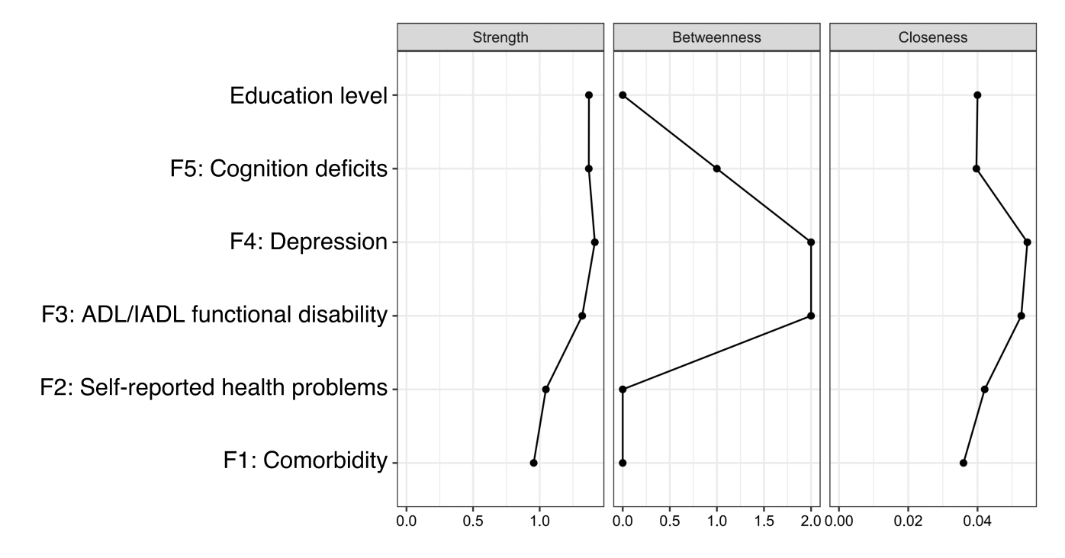

Figure S21. Centrality indices for the network of frailty domains and Education Access and Quality variable.

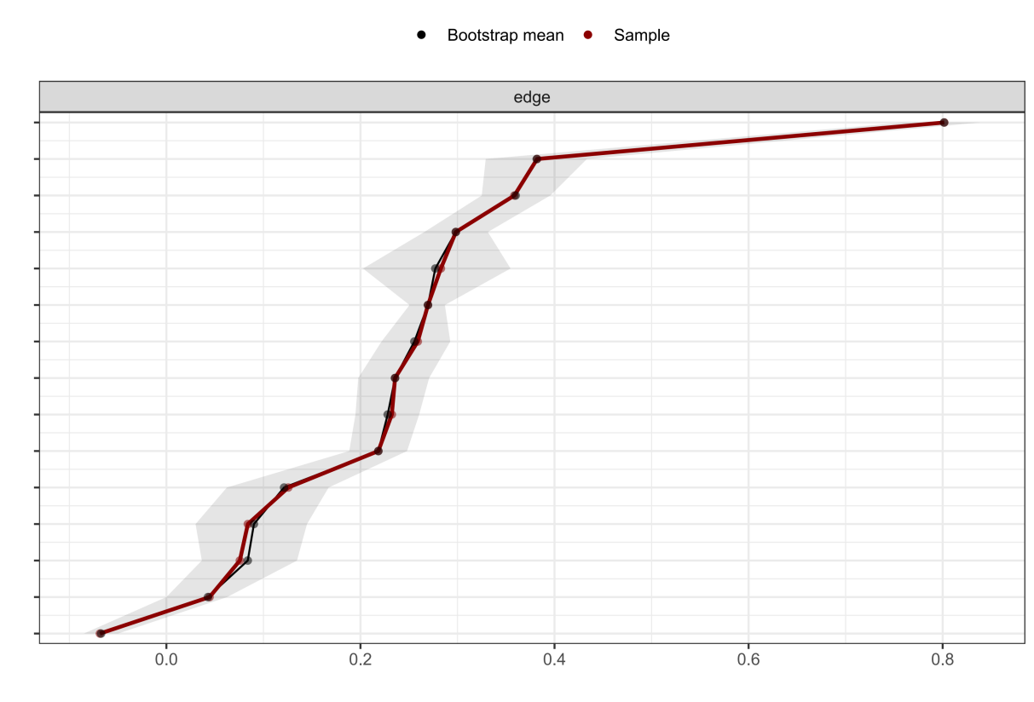
Figure S22. Accuracy analysis of estimated edge weights in the network connecting Education variable and frailty domains using bootstrapped confidence intervals. Notes: The vertical axis lists each edge between each pair of nodes, and the horizontal axis indicates the estimated edge weights. The black dots represent the edge weights. The gray shaded areas represent the 95% bootstrapped confidence intervals, indicating the variability and precision of each estimated edge weight. Narrower intervals suggest more stable and reliable associations between domains.
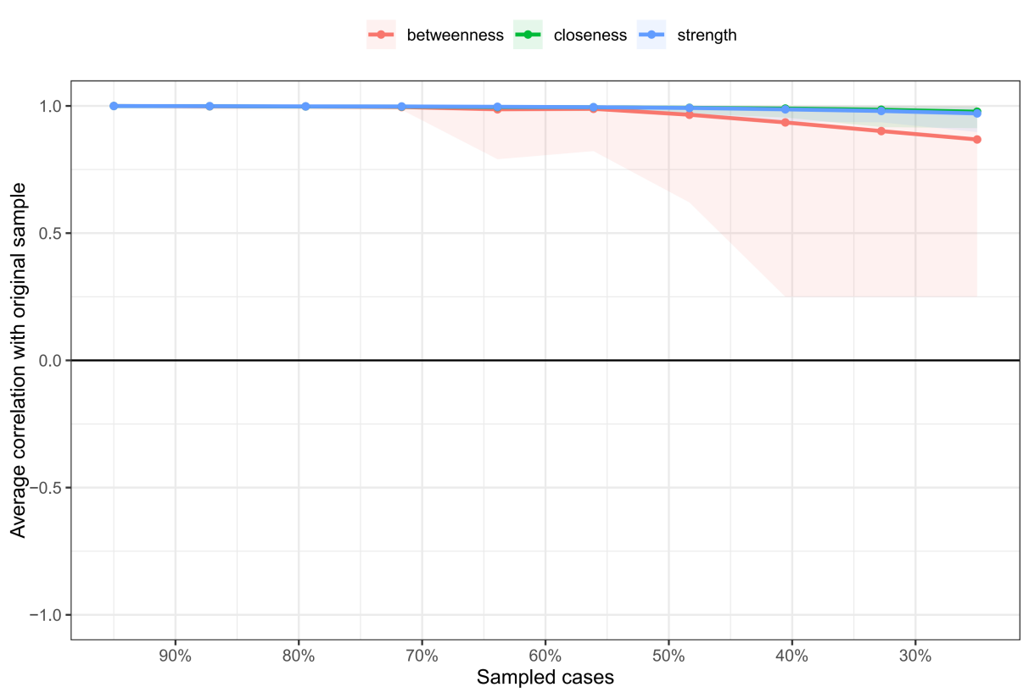
Figure S23. Stability analysis of centrality indices in the network connecting Education variable and frailty domains using case-dropping bootstrap. Note: The plot presents the correlation stability (CS) coefficients for three centrality indices: strength (blue), closeness (green), and betweenness (red). The x-axis represents the proportion of cases retained in each bootstrap sample, while the y-axis indicates the average correlation between centrality values in the subset and the full sample. Colored lines show the mean correlations, and shaded areas represent 95% confidence intervals. Dots along the curves indicate the estimated correlation at each sampling proportion. The CS coefficient was 0.75 for strength.

Healthcare Access and Quality
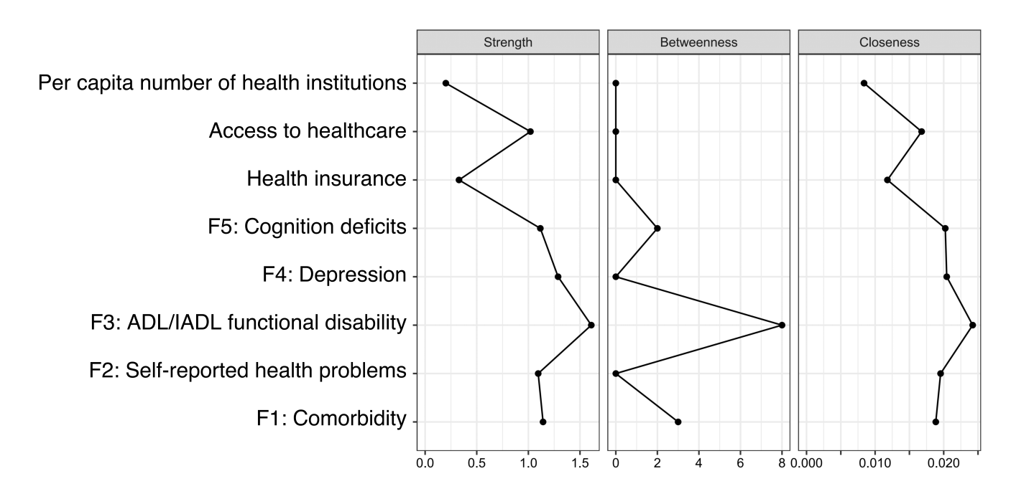

Figure S24. Centrality indices for the network of frailty domains and Healthcare Access and Quality variables.
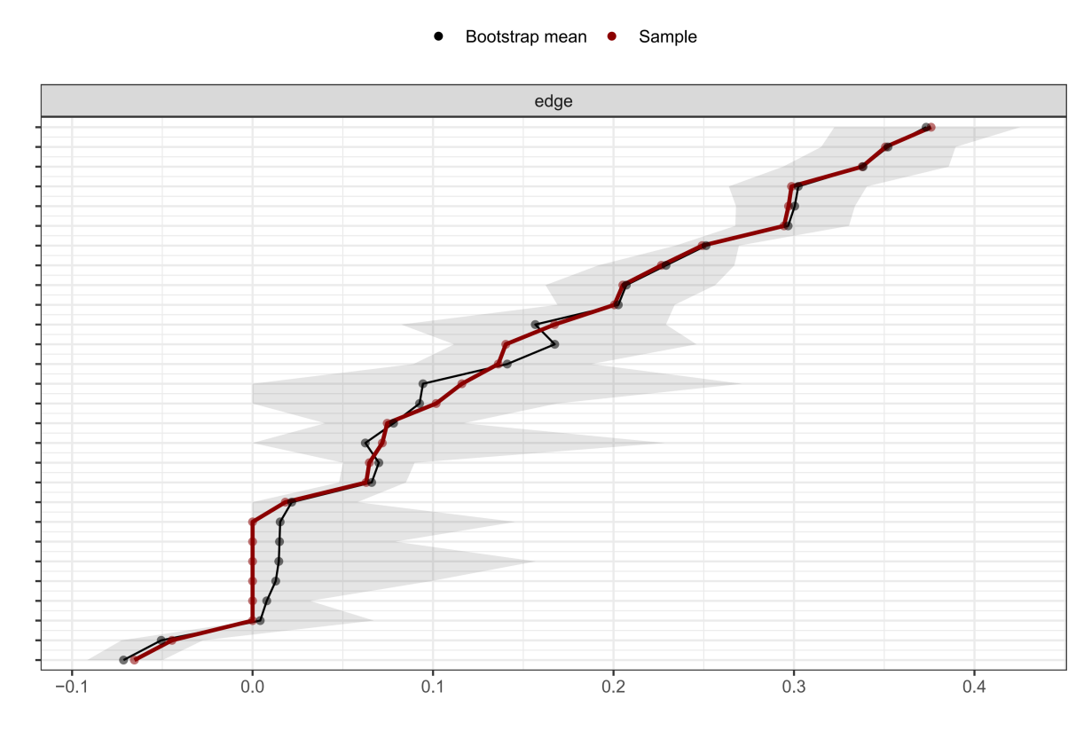
Figure S25. Accuracy analysis of estimated edge weights in the network connecting Healthcare Access and Quality variables and frailty domains using bootstrapped confidence intervals. Notes: The vertical axis lists each edge between each pair of nodes, and the horizontal axis indicates the estimated edge weights. The black dots represent the edge weights. The gray shaded areas represent the 95% bootstrapped confidence intervals, indicating the variability and precision of each estimated edge weight. Narrower intervals suggest more stable and reliable associations between domains.
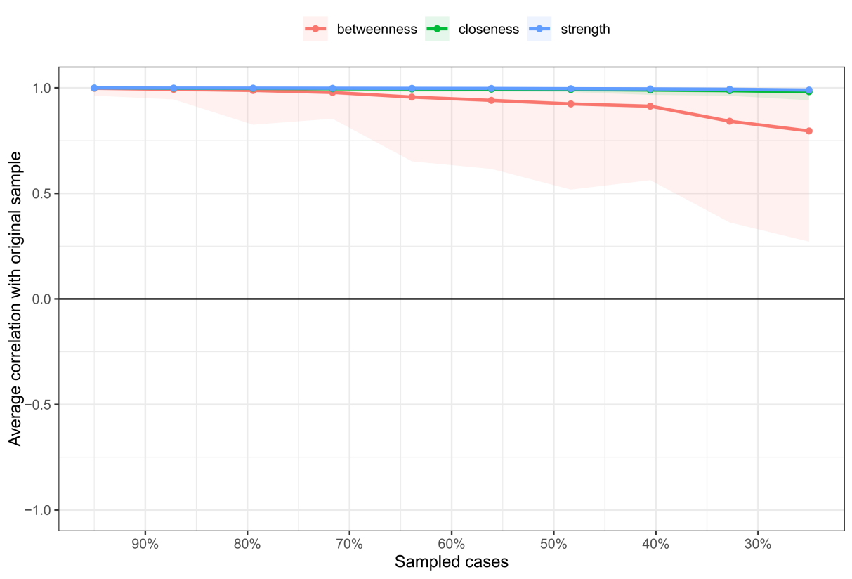
Figure S26. Stability analysis of centrality indices in the network connecting Healthcare Access and Quality variables and frailty domains using case-dropping bootstrap. Note: The plot presents the correlation stability (CS) coefficients for three centrality indices: strength (blue), closeness (green), and betweenness (red). The x-axis represents the proportion of cases retained in each bootstrap sample, while the y-axis indicates the average correlation between centrality values in the subset and the full sample. Colored lines show the mean correlations, and shaded areas represent 95% confidence intervals. Dots along the curves indicate the estimated correlation at each sampling proportion. The CS coefficient was 0.75 for strength.

Neighborhood and Built Environment
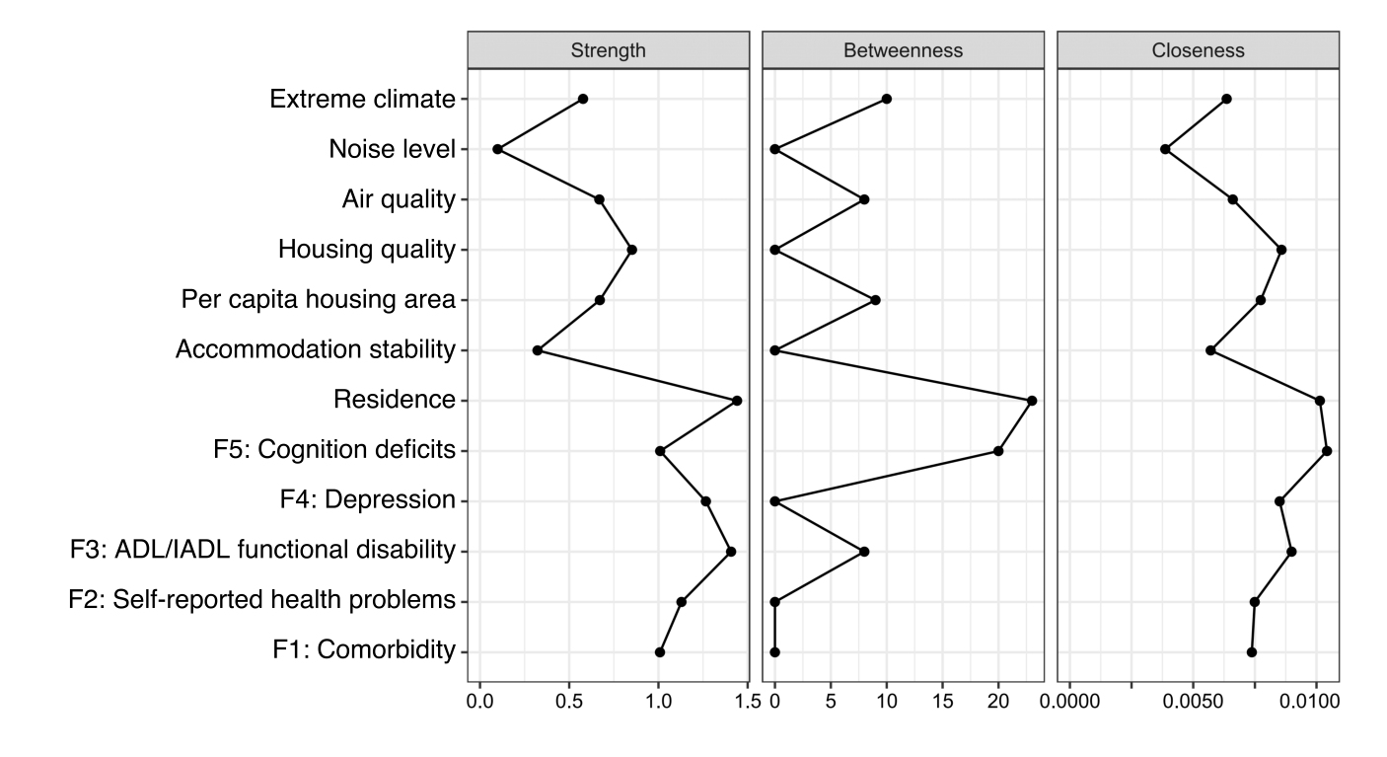
Figure S27. Centrality indices for the network of frailty domains and Neighborhood and Built Environment variables.
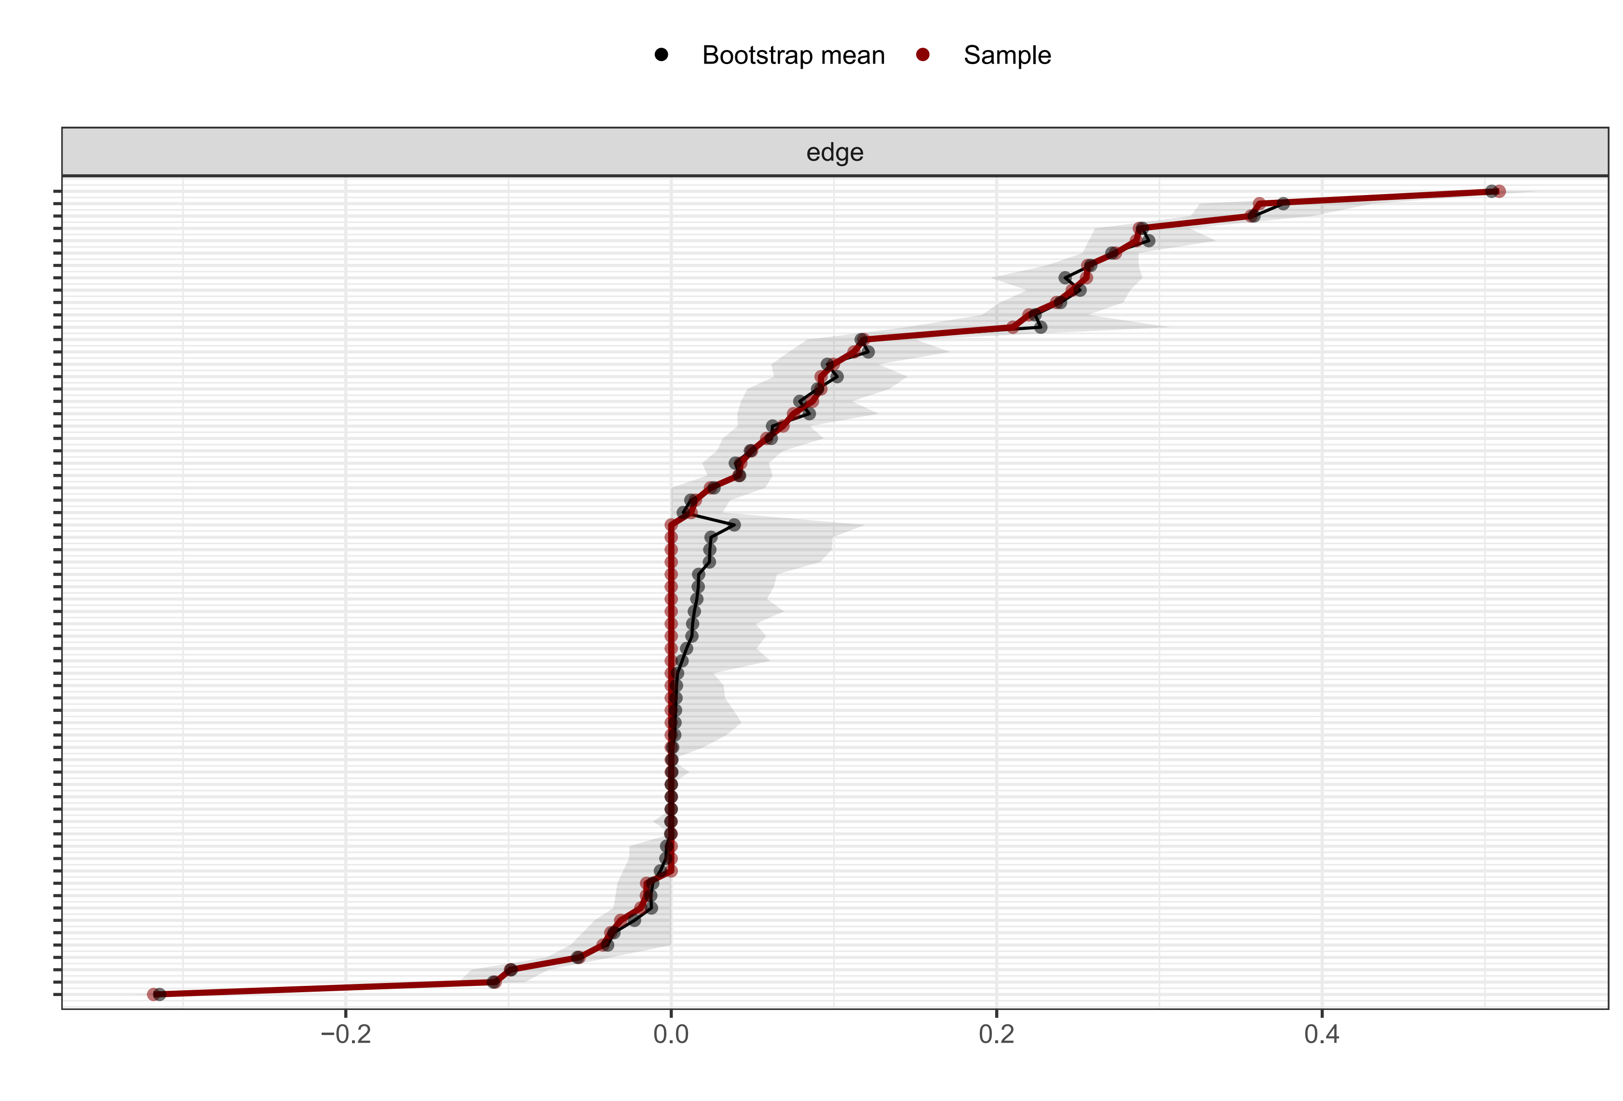
Figure S28. Accuracy analysis of estimated edge weights in the network connecting Neighborhood and Built Environment variables and frailty domains using bootstrapped confidence intervals. Notes: The vertical axis lists each edge between each pair of nodes, and the horizontal axis indicates the estimated edge weights. The black dots represent the edge weights. The gray shaded areas represent the 95% bootstrapped confidence intervals, indicating the variability and precision of each estimated edge weight. Narrower intervals suggest more stable and reliable associations between domains.
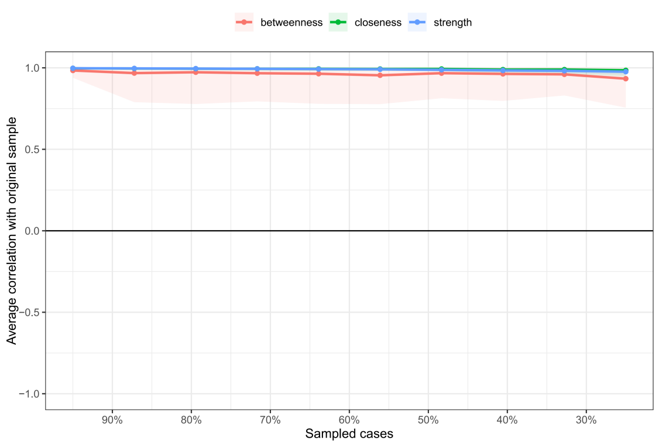
Figure S29. Stability analysis of centrality indices in the network connecting Neighborhood and Built Environment variables and frailty domains using case-dropping bootstrap. Note: The plot presents the correlation stability (CS) coefficients for three centrality indices: strength (blue), closeness (green), and betweenness (red). The x-axis represents the proportion of cases retained in each bootstrap sample, while the y-axis indicates the average correlation between centrality values in the subset and the full sample. Colored lines show the mean correlations, and shaded areas represent 95% confidence intervals. Dots along the curves indicate the estimated correlation at each sampling proportion. The CS coefficient was 0.75 for strength.

Social and Community Context
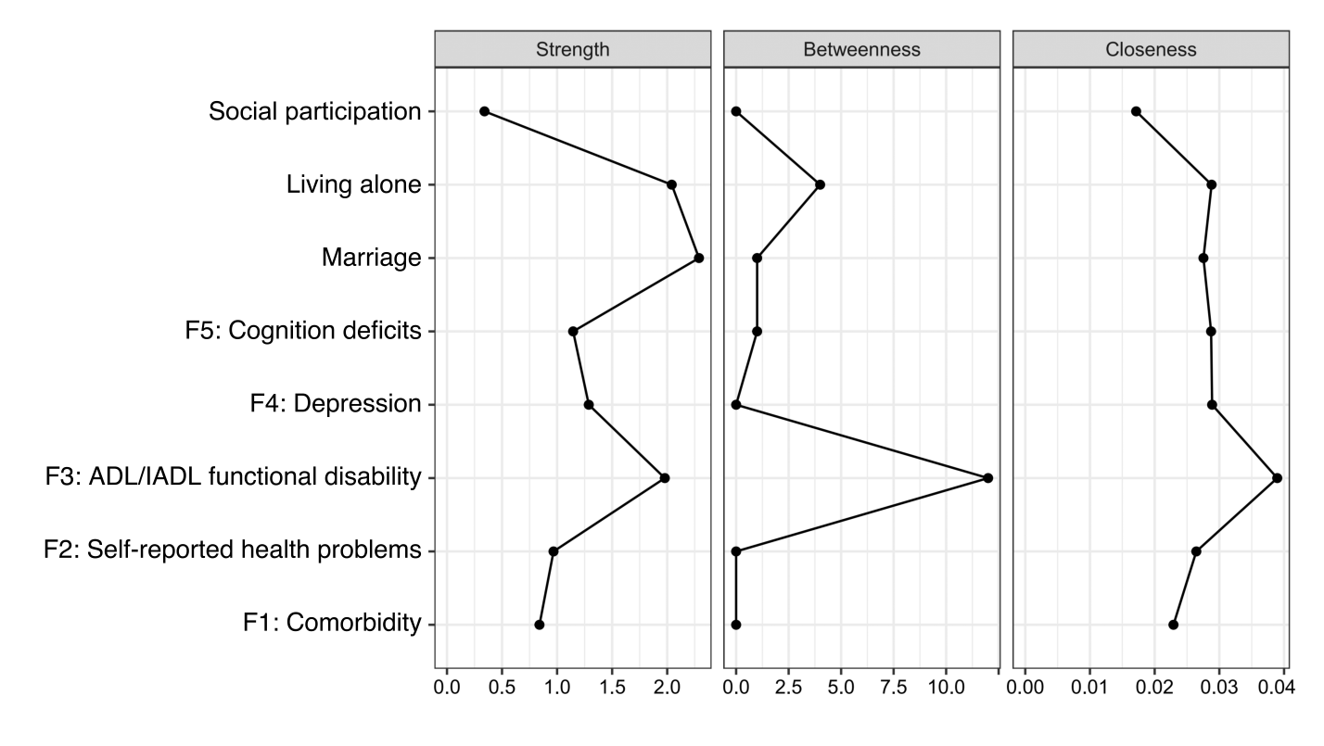

Figure S30. Centrality indices for the network of frailty domains and Social and Community Context variables.
Figure S31. Accuracy analysis of estimated edge weights in the network connecting Social and Community Context variables and frailty domains using bootstrapped confidence intervals. Notes: The vertical axis lists each edge between each pair of nodes, and the horizontal axis indicates the estimated edge weights. The black dots represent the edge weights. The gray shaded areas represent the 95% bootstrapped confidence intervals, indicating the variability and precision of each estimated edge weight. Narrower intervals suggest more stable and reliable associations between domains.
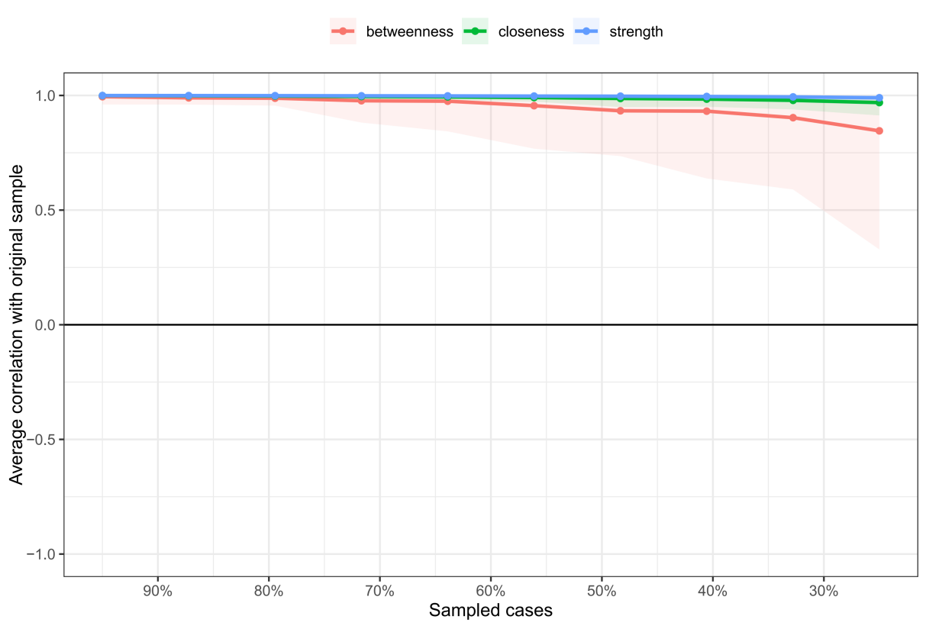
Figure S32. Stability analysis of centrality indices in the network connecting Social and Community Context variables and frailty domains using case-dropping bootstrap. Note: The plot presents the correlation stability (CS) coefficients for three centrality indices: strength (blue), closeness (green), and betweenness (red). The x-axis represents the proportion of cases retained in each bootstrap sample, while the y-axis indicates the average correlation between centrality values in the subset and the full sample. Colored lines show the mean correlations, and shaded areas represent 95% confidence intervals. Dots along the curves indicate the estimated correlation at each sampling proportion. The CS coefficient was 0.75 for strength.

Sensitivity analysis
Table S9. Comparison of characteristics between participants included in the complete-case sensitivity analysis (n = 7492) and those excluded due to missing FI component or SDoH indicator data (n = 3162).
Variables | Included in the complete-case sensitivity analysis  (n = 7492) | Excluded from the complete-case sensitivity analysis  (n = 3162) | Missing in excluded  (n (%)) | χ²/Z | P
Demographics
Age (years)ª | 67.00 (8.00, 63.00-71.00) | 70.00 (13.00, 65.00-78.00) | 0 (0.0) | -23.854 | <0.001^{c}
Gender^{b} |  |  | 0 (0.0) | 76.687 | <0.001^{d}
Male | 3830 (51.1) | 1323 (41.8)
Female | 3662 (48.9) | 1839 (58.2)
Economic Stability
Employment status^{b} |  |  | 0 (0.0) | 202.552 | <0.001^{d}
Employed in the agricultural sector | 3528 (47.1) | 1102 (34.9)
Employed in non-agricultural sector | 654 (8.7) | 187 (5.9)
Not employed/retired | 3310 (44.2) | 1873 (59.2)
Per capita household income (RMB)ª | 10000.00 (28682.50, 3165.00-31847.50) | 5618.00 (15670.12, 2154.88-17825.00) | 378 (12.0) | -15.159 | <0.001^{c}
Per capita household consumption (RMB)ª | 7200.00 (8400.00, 3600.00-12000.00) | 6000.00 (9000.00, 3000.00-12000.00) | 32 (1.0) | -7.249 | <0.001^{c}
Education Access and Quality
Education level^{b} |  |  | 0 (0.0) | 722.976 | <0.001^{d}
No formal education | 1745 (23.3) | 1522 (48.1)
Primary school | 3467 (46.3) | 1194 (37.8)
Middle school | 1940 (25.9) | 352 (11.1)
Secondary vocational school and above | 340 (4.5) | 94 (3.0)
Health Care Access and Quality
Health insurance^{b} |  |  | 0 (0.0) | 68.004 | <0.001^{d}
Uninsured | 318 (4.2) | 255 (8.1)
Private | 98 (1.3) | 56 (1.8)
Public or government | 7076 (94.4) | 2851 (90.2)
Access to healthcare^{b} |  |  | 0 (0.0) | 11.772 | <0.001^{d}
Inaccessible | 843 (11.3) | 285 (9.0)
Accessible | 6649 (88.7) | 2877 (91.0)
Per capita number of health institutionsª | 8.05 (3.83, 5.42-9.25) | 7.12 (3.33, 5.28-8.61) | 0 (0.0) | -8.061 | <0.001^{c}
Neighborhood and built environment
Residence^{b} |  |  | 0 (0.0) | 50.042 | <0.001^{d}
Rural area | 4771 (63.7) | 2227 (70.4)
Peri-urban area | 821 (25.4) | 321 (10.2)
Urban area | 1900 (25.4) | 614 (19.4)
Accommodation stability^{b} |  |  | 0 (0.0) | 26.480 | <0.001^{d}
Rent or other arrangement | 728 (9.7) | 414 (13.1)
Own home | 6764 (90.3) | 2748 (86.9)
Per capita housing area (m²)ª | 48.50 (45.00, 30.00-75.00) | 45.00 (47.46, 26.67-74.13) | 34 (1.1) | -3.550 | <0.001^{c}
Housing qualityª | 4.00 (1.00, 4.00-5.00) | 4.00 (1.00, 4.00-5.00) | 35 (1.1) | -2.360 | 0.018^{c}
Air quality (AQI)ª | 68.25 (28.92, 57.00-85.92) | 65.08 (21.00, 56.33-77.33) | 0 (0.0) | -5.954 | <0.001^{c}
Noise level (Leq, dB(A))ª | 54.60 (1.90, 53.80-55.70) | 54.60 (1.90, 53.80-55.70) | 0 (0.0) | -0.661 | 0.509^{c}
Extreme climate (CPRI)ª | 25.01 (7.71, 22.10-29.81) | 24.96 (7.64, 22.00-29.64) | 0 (0.0) | -1.751 | 0.080^{c}
Social and Community Context
Marriage^{b} |  |  | 0 (0.0) | 276.264 | <0.001^{d}
Unmarried, separated, divorced and widowed | 1441 (19.2) | 1082 (34.2)
Married or cohabiting | 6051 (80.2) | 2080 (65.8)
Living alone^{b} |  |  | 0 (0.0) | 59.326 | <0.001^{d}
Yes | 984 (13.1) | 599 (18.9)
No | 6508 (86.9) | 2563 (81.1)
Social isolation^{b} |  |  | 22 (0.7) | 151.051 | <0.001^{d}
Low social participation | 3924 (52.4) | 2065 (65.3)
High social participation | 3568 (47.6) | 1097 (34.7)
Abbreviation: AQI, Air Quality Index; Leq, A-weighted Equivalent Continuous Sound Level (dB(A)); CPRI, Climate Physical Risk Index; ADL, Activities of Daily Living; IADL, Instrumental Activities of Daily Living.
Continuous variables are presented as median (IQR, Q1-Q3); Categorical variables are presented as counts (percentages).
a. Median (IQR, Q1-Q3).
b. Counts (percentages).
c. Mann-Whitney U test.
d. Chi-square test.
Bold values mean adjusted P < 0.05.

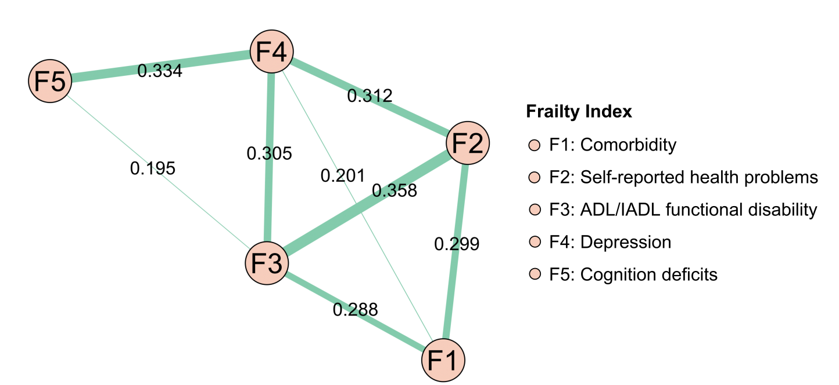

Figure 33. Network structure of five frailty domains in the complete-case sensitivity analysis (n = 7492). Notes: Edge labels indicate edge weights, and thicker edges indicate stronger relationships. All edges shown in this figure are positive and displayed in green. Higher values in each frailty domain indicate worse conditions.

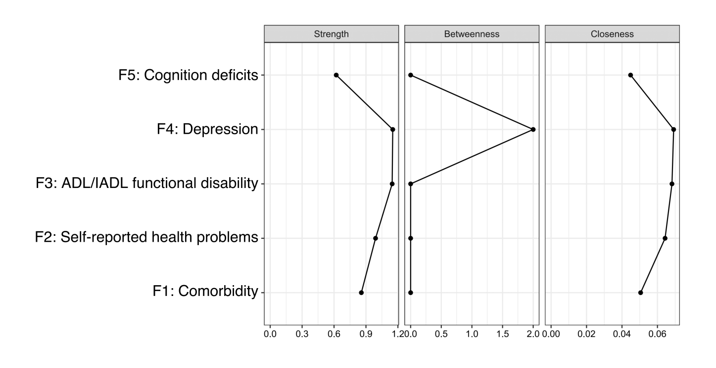

Figure S34. Centrality indices for the frailty domain network, including participants excluded in main analyses.

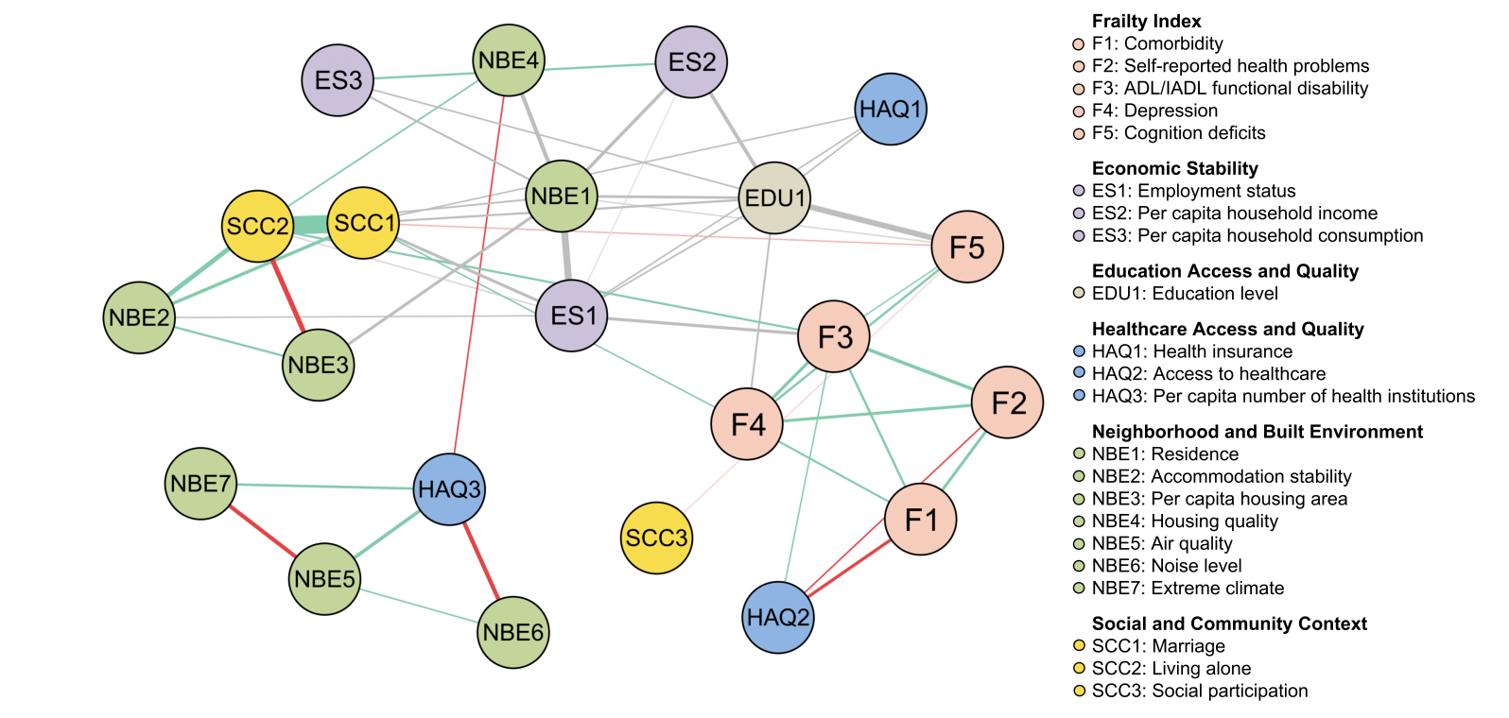
Figure 35. Integrated network structure of SDoH and frailty in the complete-case sensitivity analysis (n = 7492). . Notes: Thicker edges indicate stronger relationships; only edge weights with an absolute value ≥0.100 are presented for clarity. Positive edges are shown in green, negative edges are shown in red, and the edges connecting categorical variables with more than 2 categories and other variables (both with other categorical variables and with continuous variables) are shown in gray. Higher values in each frailty domain indicate worse conditions. Higher values for each SDoH variable indicate better conditions except air quality, noise level, and extreme climate; higher values for air quality, noise level, and extreme climate indicate worse conditions.

Table S10. Edge weights for the integrated network of SDoH and frailty in the complete-case sensitivity analysis.
From | to | Edge weights | Direction
SCC1: Marriage | SCC2: Living alone | 1.797 | Positive
ES1: Employment status | NBE1: Residence | 0.662 | -
F5: Cognition deficits | EDU1: Education level | 0.549 | -
NBE3: Per capita housing area | SCC2: Living alone | 0.466 | Negative
NBE2: Accommodation stability | SCC2: Living alone | 0.446 | Positive
HAQ3: Per capita number of health institutions | NBE6: Noise level | 0.394 | Negative
NBE1: Residence | NBE4: Housing quality | 0.384 | -
NBE5: Air quality | NBE7: Extreme climate | 0.377 | Negative
ES2: Per capita household income | EDU1: Education level | 0.336 | -
HAQ3: Per capita number of health institutions | NBE5: Air quality | 0.324 | Positive
F2: Self-reported health problems | F3: ADL/IADL functional disability | 0.315 | Positive
ES2: Per capita household income | NBE1: Residence | 0.305 | -
NBE2: Accommodation stability | SCC1: Marriage | 0.302 | Positive
F3: ADL/IADL functional disability | F4: Depression | 0.289 | Positive
F1: Comorbidity | HAQ2: Access to healthcare | 0.288 | Negative
F3: ADL/IADL functional disability | ES1: Employment status | 0.282 | -
ES1: Employment status | SCC1: Marriage | 0.276 | -
NBE1: Residence | NBE3: Per capita housing area | 0.276 | -
F1: Comorbidity | F2: Self-reported health problems | 0.273 | Positive
F2: Self-reported health problems | F4: Depression | 0.272 | Positive
EDU1: Education level | NBE1: Residence | 0.237 | -
HAQ3: Per capita number of health institutions | NBE7: Extreme climate | 0.229 | Positive
F4: Depression | F5: Cognition deficits | 0.211 | Positive
F1: Comorbidity | F3: ADL/IADL functional disability | 0.21 | Positive
ES2: Per capita household income | ES3: Per capita household consumption | 0.198 | Positive
NBE2: Accommodation stability | NBE3: Per capita housing area | 0.192 | Positive
EDU1: Education level | SCC1: Marriage | 0.19 | -
F3: ADL/IADL functional disability | SCC2: Living alone | 0.188 | Positive
ES3: Per capita household consumption | NBE1: Residence | 0.182 | -
F1: Comorbidity | F4: Depression | 0.179 | Positive
F4: Depression | EDU1: Education level | 0.162 | -
NBE1: Residence | SCC2: Living alone | 0.156 | -
NBE4: Housing quality | SCC2: Living alone | 0.149 | Positive
ES1: Employment status | EDU1: Education level | 0.147 | -
EDU1: Education level | HAQ1: Health insurance | 0.144 | -
ES3: Per capita household consumption | EDU1: Education level | 0.14 | -
ES1: Employment status | HAQ1: Health insurance | 0.138 | -
HAQ3: Per capita number of health institutions | NBE4: Housing quality | 0.135 | Negative
NBE5: Air quality | NBE6: Noise level | 0.132 | Positive
F2: Self-reported health problems | HAQ2: Access to healthcare | 0.131 | Negative
F4: Depression | SCC1: Marriage | 0.13 | Positive
HAQ1: Health insurance | SCC1: Marriage | 0.13 | -
F3: ADL/IADL functional disability | HAQ2: Access to healthcare | 0.122 | Positive
F3: ADL/IADL functional disability | F5: Cognition deficits | 0.119 | Positive
ES1: Employment status | NBE2: Accommodation stability | 0.119 | -
F5: Cognition deficits | NBE1: Residence | 0.112 | -
ES1: Employment status | SCC2: Living alone | 0.112 | -
F5: Cognition deficits | SCC1: Marriage | 0.108 | Negative
ES1: Employment status | ES2: Per capita household income | 0.108 | -
F5: Cognition deficits | SCC3: Social participation | 0.104 | Negative
Notes:
Only edge weights with an absolute value ≥0.100 are presented for clarity.
- indicates associations involving categorical variables with three or more levels, for which a specific positive or negative direction cannot be meaningfully interpreted.

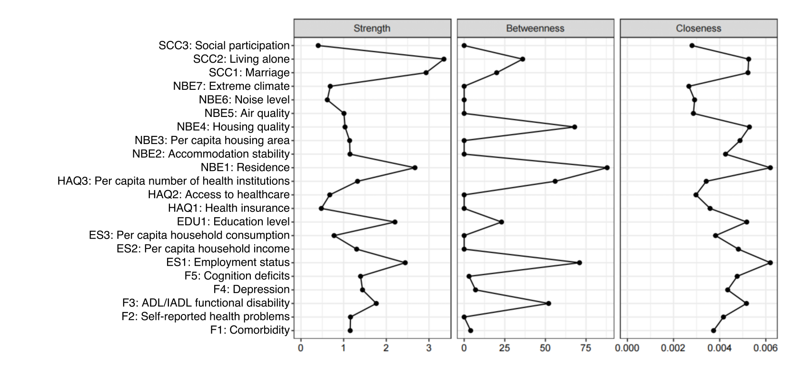

Figure S36. Centrality indices for the integrated network of SDoH and frailty in the complete-case sensitivity analysis.

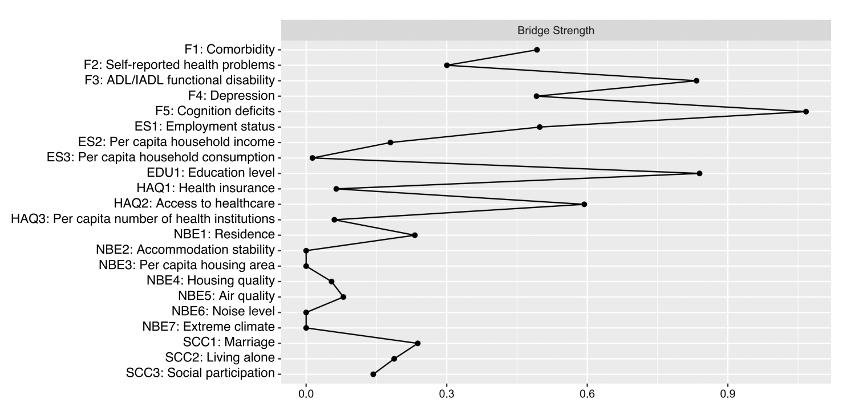

Figure S37. Bridge strength for the integrated network of SDoH and frailty in the complete-case sensitivity analysis.

References
1. Zhao, Y., et al., Cohort profile: the China Health and Retirement Longitudinal Study (CHARLS). Int J Epidemiol, 2014. 43(1): p. 61-8.
2. Zhao, Y., et al., China Health and Retirement Longitudinal Study Wave 5 (2020) User Guide. National School of Development, Peking University, 2023.
3. Yang, Y., et al., The effect of living environmental factors on cardiovascular diseases in Chinese adults: results from a cross-sectional and longitudinal study. Eur J Prev Cardiol, 2023. 30(11): p. 1063-1073.
4. Guo, K., Q. Ji, and D. Zhang, A dataset to measure global climate physical risk. Data Brief, 2024. 54: p. 110502.
5. Searle, S.D., et al., A standard procedure for creating a frailty index. BMC Geriatr, 2008. 8: p. 24.
6. He, D., et al., Frailty is associated with the progression of prediabetes to diabetes and elevated risks of cardiovascular disease and all-cause mortality in individuals with prediabetes and diabetes: Evidence from two prospective cohorts. Diabetes Res Clin Pract, 2022. 194: p. 110145.
7. He, D., et al., Associations of metabolic heterogeneity of obesity with frailty progression: Results from two prospective cohorts. J Cachexia Sarcopenia Muscle, 2023. 14(1): p. 632-641.
8. Li, C., et al., Association of Cystatin C Kidney Function Measures With Long-term Deficit-Accumulation Frailty Trajectories and Physical Function Decline. JAMA Netw Open, 2022. 5(9): p. e2234208.
9. Cao, X., et al., Aging metrics incorporating cognitive and physical function capture mortality risk: results from two prospective cohort studies. BMC Geriatr, 2022. 22(1): p. 378.
10. Xu, W., et al., Sarcopenia and frailty among older Chinese adults: Findings from the CHARLS study. PLoS One, 2024. 19(11): p. e0312879.
11. Yin, W., et al., The Association Between Physical Activity and Frailty: China Health and Retirement Longitudinal Study (CHARLS). Int J Environ Res Public Health, 2025. 22(8).
12. Zhang, K., et al., Association of childhood and adulthood socioeconomic status with frailty index trajectories: Using five-wave panel data from the China Health and Retirement Longitudinal Study (CHARLS). Arch Gerontol Geriatr, 2025. 131: p. 105780.
13. Andresen, E.M., et al., Screening for depression in well older adults: evaluation of a short form of the CES-D (Center for Epidemiologic Studies Depression Scale). Am J Prev Med, 1994. 10(2): p. 77-84.
14. Van Lissa, C.J., M. Garnier-Villarreal, and D. Anadria, Recommended Practices in Latent Class Analysis Using the Open-Source R-Package tidySEM. Structural Equation Modeling: A Multidisciplinary Journal, 2024. 31(3): p. 526-534.
15. Lazarsfeld, P.F., Latent structure analysis. (No Title), 1968.
16. Aflaki, K., S. Vigod, and J.G. Ray, Part II: A step-by-step guide to latent class analysis. Journal of Clinical Epidemiology, 2023. 159: p. 348-351.
17. Nylund, K.L., T. Asparouhov, and B.O. Muthén, Deciding on the number of classes in latent class analysis and growth mixture modeling: A Monte Carlo simulation study. Structural equation modeling: A multidisciplinary Journal, 2007. 14(4): p. 535-569.
18. da Cunha Leme, D.E., A.L. Neri, and A. Fattori, How Do the Factors Associated With Frailty Change With Sex? An Exploratory Network Analysis. J Gerontol A Biol Sci Med Sci, 2022. 77(10): p. 2023-2031.
19. Jones, P.J., R. Ma, and R.J. McNally, Bridge Centrality: A Network Approach to Understanding Comorbidity. Multivariate Behav Res, 2021. 56(2): p. 353-367.
20. Epskamp, S., D. Borsboom, and E.I. Fried, Estimating psychological networks and their accuracy: A tutorial paper. Behav Res Methods, 2018. 50(1): p. 195-212.

