Supplements

Methods

S1. Table – CPT codes used to identify and select ED encounters

S2. Table – CPT codes and modifiers to identify and categorize outpatient follow-up visits

S3. Table – International Classification of Diseases – 10th Edition diagnosis codes to select emergency department encounters for diabetes and hyperglycemia

S4. Figure – Cohort assembly flowchart with inclusion and exclusion criteria

Results

S5. Table – Patient characteristics, by category of follow-up status, without restriction that diagnosis of follow-up visits match the primary diagnosis of the initial emergency department encounter

S6. Figure – Proportion of patients who obtained outpatient follow-up visits (blue), return emergency department encounters prior to follow-up visit (gray), or no follow-up visit (orange) within 30 days, 2016 - 2022

S7. Sensitivity Analyses

Supplement 1. Table – Current Procedure Terminology (CPT) codes used to identify and select emergency department encounters for patient cohort

Step | Criteria | Time frame | CPT Codes
Identify index ED encounter | Identify all facility and/or physician claims for emergency department E/M claims | January 2020 – May 2022 | 99281, 99282, 99283, 99284, 99285
Exclude patients hospitalized from the ED | Exclude patients with same or next-day claims for inpatient admission or observation services | Same day or next day as index ED encounter | Observation: 99217, 99218, 99219, 99220, 99224, 99225, 99226, G0378, 99234, 99235, 99236, 99238, 99239  Inpatient: 99221, 99222, 99223, 99231, 99232, 99233  OR  Inpatient Confinement File*  Check for hospitalization records in the Inpatient Confinement file for the same patient identifier and date, with POS = 21 or 22 (inpatient hospital or outpatient hospital)
Exclude patients with recent use of the ED or hospital | Exclude patients with any ED visits within 30 days prior to the index ED encounter | 30 days prior to the index ED date | 99281, 99282, 99283, 99284, 99285
Exclude patients with recent use of the ED or hospital | Exclude patients with any hospitalization within 30 days prior to the index ED encounter | 30 days prior to the index ED date | 99217, 99218, 99219, 99220, 99221, 99222, 99223, 99231, 99232, 99233, 99234, 99235, 99236  99238, 99239  OR  Inpatient Confinement File, POS 21 or 22
ED, emergency department; E/M, evaluation and management; POS, place of service

*The inpatient confinement file is a separate administrative claims file that aggregates all inpatient claims related to hospital admissions (observation claims are not included n this file). This file contains the same records as the main medical records file that contains all administrative claims but was used in these steps as a secondary check to ensure that no index ED encounters had associated inpatient admissions.

Supplement 2. Table – CPT codes and modifiers to identify and categorize outpatient follow-up visits

In-person (office-based) follow-up visits
Category | Code | Description
Diabetes Specific Code | G0108 | Diabetes management training individual
Diabetes Specific Code | G0109 | Diabetes management training individual/group
One of the following codes
Outpatient Visit E/M Codes | 99201-99205 | Office/outpatient visit, new
Outpatient Visit E/M Codes | 99211-99215 | Office/outpatient visit, established
*Note – we did not include primary care visit codes G0402, G0438, G0439 as these indicate annual wellness visits and/or preventive health visits which typically should occur in-person and are not intended to be post-hospital/ED follow-up visits

Telemedicine follow-up visits
Category | Code | Description
One of the following codes
Outpatient Visit E/M Codes | 99201-99205 | Office/outpatient visit, new
Outpatient Visit E/M Codes | 99211-99215 | Office/outpatient visit, established
AND one of the following
Telemedicine Place of Service (POS) | POS 02 | Telehealth services provided via telecommunications system
Telemedicine Place of Service (POS) | POS 10 | Telehealth provided in the patient's home
CPT Code Modifiers | GT | Interactive audio and video telecommunication system
CPT Code Modifiers | 95 | Synchronous telemedicine (real-time interactive video/audio)
CPT Code Modifiers | 93 | Synchronous telemedicine (real-time interactive audio only)
CPT Code Modifiers | FQ | Real-time audio-only telehealth communication

One of the following codes
Telephone outpatient encounter | 99441-99443 | Telephone E/M service
Telephone outpatient encounter | 98966-98968 | Telephone assessment and management service provided by a qualified non-physician healthcare professional to an established client, parent, or guardian
Virtual Check-In | G2012 | Brief communication technology-based service, e.g. virtual check-in, by a physician or other qualified health care professional who can report evaluation and management services, provided to an established patient, not originating from a related e/m service provided within the previous 7 days nor leading to an e/m service or procedure within the next 24 hours or soonest available appointment; 5-10 minutes of medical discussion.
Virtual Check-In | G2251 | Brief communication technology-based service, e.g. virtual check-in, by a qualified health care professional who cannot report evaluation and management services, provided to an established patient, not originating from a related e/m service provided within the previous 7 days nor leading to a service or procedure within the next 24 hours or soonest available appointment: 5-10 minutes of medical discussion
Virtual Check-In | G2252 | Brief communication technology-based service, e.g. virtual check-in, by a physician or other qualified health care professional who can report evaluation and management services, provided to an established patient, not originating from a related e/m service provided within the previous 7 days nor leading to an e/m service or procedure within the next 24 hours or soonest available appointment; 11-20 minutes of medical discussion.

Supplement 3. Table – International Classification of Diseases – 10th Edition diagnosis codes to select emergency department encounters for diabetes and hyperglycemia

Diabetes mellitus | E109 E1010 E1011 E1021 E1022 E1029 E10311 E10319 E10321 E103211 E103212 E103213 E103219 E10329 E103291 E103292 E103293 E103299 E10331 E103311 E103312 E103313 E103319 E10339 E103391 E103392 E103393 E103399 E10341 E103411 E103412 E103413 E103419 E10349 E103491 E103492 E103493 E103499 E10351 E103511 E103512 E103513 E103519 E10359 E103591 E103592 E103593 E103594 E1036 E1039 E1040 E1041 E1042 E1043 E1044 E1049 E1051 E1052 E1059 E10610 E10618 E10620 E10621 E10622 E10628 E10630 E10638 E10641 E10649 E1065 E1069 E108 E14311 E14319 E14321 E14321 E14322 E14323 E14329 E14329 | Type 1 diabetes mellitus with X complication
Diabetes mellitus | E119 E1100 E1101 E1121 E1122 E1129 E11311 E11319 E11321 E11321 E11322 E11323 E11329 E11329 E113291 E113292 E113293 E113299 E11331 E113311 E113312 E113313 E113319 E11339 E113391 E113392 E113393 E113399 E11341 E113411 E113412 E113413 E113419 E11349 E113491 E113492 E113493 E113499 E11351 E113511 E113512 E113513 E113519 E11359 E113591 E113592 E113593 E113599 E1136 E1139 E1140 E1141 E1142 E1143 E1144 E1149 E1151 E1152 E1159 E11610 E11618 E11620 E11621 E11622 E11628 E11630 E11638 E11641 E11649 E1165 E1169 E118 E1142 | Type 2 diabetes mellitus with X complication

Supplement 4. Figure – Cohort assembly flowchart with inclusion and exclusion criteria
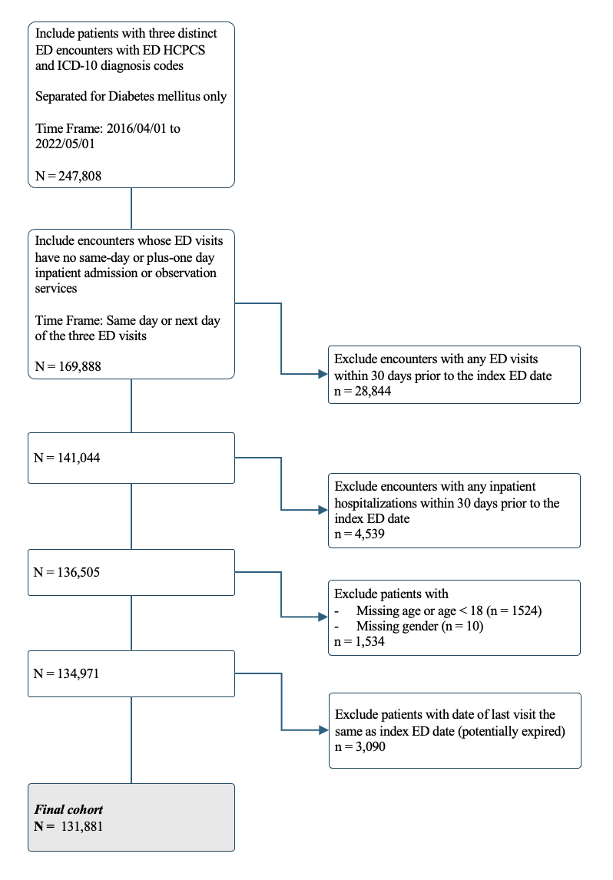
Supplement 5. Table – Patient characteristics, by category of follow-up status, without restriction that diagnosis of follow-up visits match primary diagnosis of the initial emergency department encounter

Patient characteristics |  | Hazard Ratio (95% CI)
 |  | Outpatient clinic visit  (main outcome) | P | ED visit before clinic visit (competing outcome) | P
Age, tens of years |  | 1.03 (1.02, 1.03) | <.0001 | 0.91 (0.90, 0.93) | <.0001
Sex | Male | reference |  | reference
 | Female | 1.00 (0.99, 1.01) | 0.9276 | 1.00 (0.97, 1.03) | 0.98
Race and ethnicity | Non-Hispanic White | reference |  | reference
 | Non-Hispanic Black | 0.92 (0.91, 0.94) | <.0001 | 1.09 (1.04, 1.14) | <.0001
 | Hispanic | 0.98 (0.96, 1.00) | 0.0191 | 0.93 (0.88, 0.98) | 0.01
Region | Northeast | reference |  | reference
 | South | 0.99 (0.96, 1.01) | 0.2153 | 1.07 (1.00, 1.13) | 0.04
 | Midwest | 1.01 (0.98, 1.04) | 0.5096 | 0.97 (0.91, 1.04) | 0.43
 | West | 1.03 (1.01, 1.06) | 0.0175 | 0.98 (0.91, 1.05) | 0.57
Insurance | Medicare | reference |  | reference
 | Commercial | 1.05 (1.02, 1.07) | <.0001 | 0.73 (0.69, 0.77) | <.0001
 | Medicare LIS | 0.94 (0.93, 0.96) | <.0001 | 1.26 (1.21, 1.31) | <.0001
Education | High school diploma or less | 0.96 (0.94, 0.97) | <.0001 | 1.10 (1.06, 1.15) | <.0001
 | Some college | reference | 0.0887 | reference
 | Bachelor’s degree or more | 0.98 (0.95, 1.00) | <.0001 | 0.93 (0.86, 1.00) | 0.05
Billing level of index ED encounter | Level 1-2 | reference |  | reference
 | Level 3 | 1.08 (1.04, 1.12) | 0.0001 | 1.04 (0.94, 1.15) | 0.44
 | Level 4 | 1.10 (1.06, 1.14) | <.0001 | 1.13 (1.03, 1.24) | 0.01
 | Level 5 | 1.07 (1.03, 1.11) | 0.0001 | 1.19 (1.08, 1.31) | 0.00
Index ED encounter diagnosis | Type 1 diabetes | 0.79 (0.76, 0.81) | <.0001 | 0.99 (0.92, 1.07) | 0.82
Outpatient clinic visits in prior 6 months | None | 0.80 (0.78, 0.82) | <.0001 | 1.37 (1.29, 1.45) | <.0001
 | 1 | reference | <.0001 | reference
 | 2 | 1.10 (1.07, 1.13) | <.0001 | 0.90 (0.84, 0.96) | 0.002
 | ≥3 | 1.56 (1.53, 1.60) | <.0001 | 0.74 (0.70, 0.78) | <.0001
Elixhauser co-morbidity index, (HR) |  | 0.999 (1.00, 1.00) | 0.0002 | 1.03 (1.02, 1.03) | <.0001
Year | 2016 (Q3 — Q4) | reference | <.0001 | reference | <.0001
 | 2017 | 1.06 (1.03, 1.09) | 0.0155 | 0.88 (0.83, 0.94) | 0.0001
 | 2018 | 1.03 (1.01, 1.06) | 0.0002 | 0.96 (0.90, 1.02) | 0.17
 | 2019 | 1.05 (1.02, 1.08) | <.0001 | 0.85 (0.80, 0.91) | <.0001
 | 2020 | 1.09 (1.06, 1.12) | <.0001 | 0.86 (0.81, 0.92) | <.0001
 | 2021 | 1.09 (1.07, 1.12) | <.0001 | 0.88 (0.83, 0.94) | <.0001
 | 2022 (Q1 – Q2) | 1.15 (1.12, 1.19) | <.0001 | 0.97 (0.90, 1.06) | 0.51

Supplement 6. Figure – Proportion of patients who obtained outpatient follow-up visits (blue), return emergency department encounters prior to follow-up visit (gray), or no follow-up visit (orange) within 30 days, 2016 – 2022

Supplement 7. Sensitivity Analyses

S7A. Table – Patient characteristics with hazard ratios for obtaining outpatient follow-up visits within 30 days, without competing outcome included in model

Patient characteristics |  | Hazard Ratio (95% CI)
 |  | Outpatient clinic visit | P value
Age, years (%) |  | 1.05 (1.04, 1.05) | <.0001
Sex | Male | Reference | ...
 | Female | 0.96 (0.95, 0.98) | <.0001
Race and ethnicity | Non-Hispanic White | Reference | ...
 | Non-Hispanic Black | 0.97 (0.95, 0.99) | 0.007
 | Hispanic | 1.03 (1.01, 1.06) | 0.005
 | Other / unknown | 0.99 (0.95, 1.04) | 0.74
Region | Northeast | Reference | ...
 | South | 0.96 (0.93, 0.98) | 0.002
 | Midwest | 1.01 (0.98, 1.04) | 0.65
 | West | 1.05 (1.01, 1.08) | 0.006
Insurance | Medicare | Reference | ...
 | Commercial | 1.11 (1.08, 1.14) | <.0001
 | Medicare LIS | 0.95 (0.93, 0.97) | <.0001
Education | High school diploma or less | 0.99 (0.97, 1.01) | 0.16
 | Some college | Reference | ...
 | Bachelor’s degree or more | 0.94 (0.91, 0.97) | 0.0002
 | Unknown | 0.99 (0.95, 1.04) | 0.75
Billing level of index ED encounter | Level 1-2 | Reference | …
 | Level 3 | 1.12 (1.07, 1.17) | <.0001
 | Level 4 | 1.15 (1.10, 1.20) | <.0001
 | Level 5 | 1.08 (1.03, 1.12) | 0.001
Index ED encounter diagnosis | Type 1 diabetes | 0.69 (0.66, 0.71) | <.0001
 | Type 2 diabetes | Reference | ...
Outpatient clinic visits in prior 6 months | None | 0.86 (0.83, 0.88) | <.0001
 | 1 | Reference | ...
 | 2 | 1.06 (1.03, 1.10) | 0.0006
 | ≥3 | 1.32 (1.29, 1.36) | <.0001
Elixhauser co-morbidity index, (HR) |  | 0.99 (0.99, 0.99) | <.0001
Year | 2016 (Q3 — Q4) | Reference | ...
 | 2017 | 1.05 (1.02, 1.09) | 0.001
 | 2018 | 1.05 (1.02, 1.08) | 0.002
 | 2019 | 1.07 (1.04, 1.10) | <.0001
 | 2020 | 1.09 (1.06, 1.13) | <.0001
 | 2021 | 1.09 (1.06, 1.12) | <.0001
 | 2022 (Q1 – Q2) | 1.16 (1.11, 1.21) | <.0001

S7B. Figure – Cumulative incidence function for diabetes follow-up visits within 30 days, without competing outcome included in model

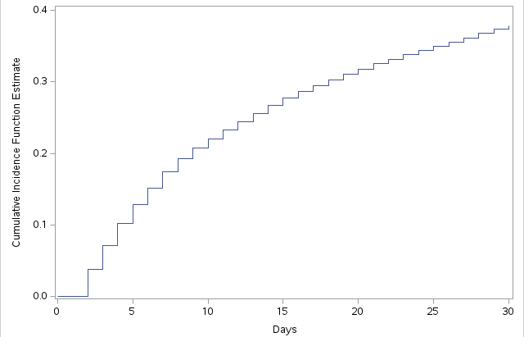

S7C. Table – Patient characteristics with hazard ratios for obtaining outpatient follow-up visits within 30 days (primary outcome) and return hospital admissions prior to outpatient follow-up visit (alternative competing outcome)

Patient characteristics |  | Hazard Ratio (95% CI)
 |  | Outpatient clinic visit (main outcome) | P value | Readmission before clinic visit (competing outcome) | P value
Age, years |  | 1.05 (1.04, 1.05) | <0.0001 | 1.02 (1.00, 1.04) | 0.11
Sex | Male | Reference | ... | Reference | ...
 | Female | 0.96 (0.95, 0.98) | <.0001 | 0.91 (0.87, 0.95) | <.0001
Race and ethnicity | Non-Hispanic White | Reference | ... | Reference | ...
 | Non-Hispanic Black | 0.97 (0.95, 0.99) | 0.007 | 0.98 (0.92, 1.03) | 0.42
 | Hispanic | 1.04 (1.01, 1.06) | 0.0047 | 0.81 (0.76, 0.87) | <.0001
Region | Northeast | Reference | ... | Reference | ...
 | South | 0.96 (0.93, 0.98) | 0.002 | 0.95 (0.88, 1.03) | 0.20
 | Midwest | 1.01 (0.98, 1.04) | 0.65 | 0.90 (0.83, 0.98) | 0.02
 | West | 1.05 (1.01, 1.08) | 0.006 | 0.78 (0.71, 0.86) | <.0001
Insurance | Medicare | Reference | ... | Reference | ...
 | Commercial | 1.11 (1.08, 1.14) | <.0001 | 0.70 (0.65, 0.76) | <.0001
 | Medicare LIS | 0.95 (0.93, 0.97) | <.0001 | 1.16 (1.10, 1.22) | <.0001
Education | High school diploma or less | 0.99 (0.97, 1.01) | 0.15 | 1.05 (1.00, 1.10) | 0.06
 | Some college | Reference | ... | Reference | ...
 | Bachelor’s degree or more | 0.94 (0.91, 0.97) | 0.0002 | 1.05 (0.96, 1.15) | 0.33
Billing level of index ED encounter | Level 1-2 | Reference | … | Reference | …
 | Level 3 | 1.12 (1.07, 1.17) | <.0001 | 1.10 (0.96, 1.26) | 0.17
 | Level 4 | 1.15 (1.10, 1.20) | <.0001 | 1.25 (1.10, 1.42) | 0.00
 | Level 5 | 1.08 (1.03, 1.12) | 0.001 | 1.44 (1.26, 1.64) | <.0001
Index ED encounter diagnosis | Type 1 diabetes | 0.69 (0.66, 0.71) | <.0001 | 1.09 (0.99, 1.19) | 0.08
 | Type 2 diabetes | Reference | ... | Reference | ...
Outpatient clinic visits in prior 6 months | None | 0.86 (0.83, 0.88) | <.0001 | 1.27 (1.17, 1.38) | <.0001
 | 1 | Reference | ... | Reference | ...
 | 2 | 1.06 (1.03, 1.10) | 0.0005 | 0.83 (0.76, 0.91) | <.0001
 | ≥3 | 1.32 (1.29, 1.36) | <.0001 | 0.78 (0.72, 0.83) | <.0001
Elixhauser co-morbidity index, (HR) |  | 0.99 (0.99, 0.99) | <.0001 | 1.04 (1.04, 1.04) | <.0001
Year | 2016 (Q3 — Q4) | Reference | ... | Reference | ...
 | 2017 | 1.05 (1.02, 1.09) | 0.0008 | 0.96 (0.88, 1.04) | 0.32
 | 2018 | 1.05 (1.02, 1.08) | 0.002 | 0.98 (0.90, 1.06) | 0.56
 | 2019 | 1.07 (1.04, 1.10) | <.0001 | 0.94 (0.86, 1.02) | 0.11
 | 2020 | 1.09 (1.06,1.13) | <.0001 | 0.93 (0.85, 1.01) | 0.09
 | 2021 | 1.09 (1.06, 1.12) | <.0001 | 0.96 (0.89, 1.04) | 0.34
 | 2022 (Q1 – Q2) | 1.16 (1.11, 1.20) | <.0001 | 1.00 (0.90, 1.12) | 0.96

S7D. Figure – Cumulative incidence functions for diabetes follow-up visits (blue) and return hospital admissions (red) over 30 days following emergency department encounter

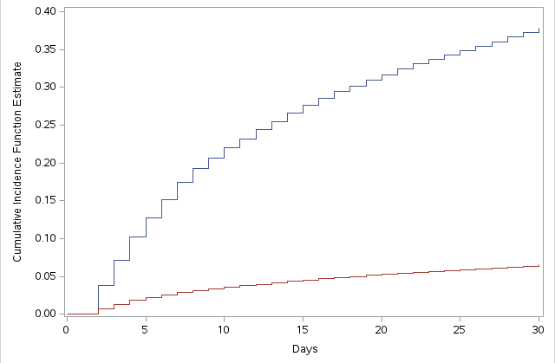

S7E. Table – Patient characteristics for individuals with recorded claims beyond 30 days from the index ED encounter

 |  | All patients  (n = 126488) | Follow-Up Visit within 30d  (n = 58593) | No Follow-Up Visit within 30d  (n = 51935) | Return ED visit within 30d, prior to follow-up visit  (n = 15960)
Age, years, mean (SD) |  | 63.21 (15.24) | 64.21 (14.31) | 62.12 (16.18) | 63.13 (15.18)
Sex, n (%) | Female
 | Male | 60948 (48.2) | 28370 (48.4) | 25098 (48.3) | 7480 (46.9)
Race and ethnicity, n (%) | Non-Hispanic White | 66116 (52.3) | 31068 (53.0) | 27086 (52.2) | 7962 (49.9)
 | Non-Hispanic Black | 29564 (23.4) | 13215 (22.6) | 12138 (23.4) | 4211 (26.4)
 | Hispanic | 19159 (15.1) | 9078 (15.5) | 7891 (15.2) | 2190 (13.7)
 | Asian | 2178 (1.7) | 1044 (1.8) | 917 (1.8) | 217 (1.4)
 | Other/unknown | 9471 (7.5) | 4188 (7.1) | 3903 (7.5) | 1380 (8.6)
Region, n (%) | Northeast
 | South | 11359 (9.0) | 5372 (9.2) | 4597 (8.9) | 1390 (8.7)
 | Midwest | 71271 (56.3) | 32271 (55.1) | 29427 (56.7) | 9573 (60.0)
 | West | 24176 (19.1) | 11330 (19.3) | 10069 (19.4) | 2777 (17.4)
Insurance, n (%) | Commercial | 35455 (28.0) | 15732 (26.8) | 16314 (31.4) | 3409 (21.4)
 | Medicare Advantage | 53477 (42.3) | 25976 (44.3) | 21129 (40.7) | 6372 (39.9)
 | Medicare Advantage + LIS | 37500 (29.6) | 16852 (28.8) | 14476 (27.9) | 6172 (38.7)
Annual Household Income, n (%) | < $40k | 7518 (5.9) | 3079 (5.3) | 3278 (6.3) | 1161 (7.3)
 | $40k – $74k | 87566 (69.2) | 40839 (69.7) | 35370 (68.1) | 11357 (71.2)
 | $75k – $99k | 11479 (9.1) | 5541 (9.5) | 4810 (9.3) | 1128 (7.1)
 | > $100k | 12048 (9.5) | 5657 (9.7) | 5281 (10.2) | 1110 (7.0)
Education, n (%) | High school diploma or less | 50979 (40.3) | 23408 (40.0) | 20677 (39.8) | 6894 (43.2)
 | Some college | 57687 (45.6) | 27188 (46.4) | 23717 (45.7) | 6782 (42.5)
 | Bachelor’s degree or more | 8837 (7.0) | 4003 (6.8) | 3878 (7.5) | 956 (6.0)
 | Unknown | 8985 (7.1) | 3994 (6.8) | 3663 (7.1) | 1328 (8.3)
Billing level of index ED encounter, n (%) | Level 1-2 | 4831 (3.8) | 2104 (3.6) | 2170 (4.2) | 557 (3.5)
 | Level 3 | 26263 (20.8) | 12215 (20.8) | 10952 (21.1) | 3096 (19.4)
 | Level 4 | 54708 (43.3) | 25773 (44.0) | 22054 (42.5) | 6881 (43.1)
 | Level 5 | 40686 (32.2) | 18501 (31.6) | 16759 (32.3) | 5426 (34.0)
Index ED encounter diagnosis, n (%) | Type 1 diabetes | 7938 (6.3) | 2764 (4.7) | 4191 (8.1) | 983 (6.2)
 | Type 2 diabetes | 118541 (93.7) | 55827 (95.3) | 47739 (91.9) | 14975 (93.8)
Outpatient visits in prior 6 months, n (%) | None | 19451 (15.4) | 7183 (12.3) | 9598 (18.5) | 2670 (16.7)
 | 1 | 15988 (12.6) | 6634 (11.3) | 7473 (14.4) | 1881 (11.8)
 | 2 | 15176 (12.0) | 6602 (11.3) | 6856 (13.2) | 1718 (10.8)
 | ≥3 | 75873 (60.0) | 38174 (65.2) | 28008 (53.9) | 9691 (60.7)
ED visits in prior 6 months, n (%) | None | 86934 (68.7) | 41421 (70.7) | 36683 (70.6) | 8830 (55.3)
 | 1 | 23441 (18.5) | 10608 (18.1) | 9463 (18.2) | 3370 (21.1)
 | 2 | 8985 (7.1) | 3865 (6.6) | 3412 (6.6) | 1708 (10.7)
 | ≥3 | 7128 (5.6) | 2699 (4.6) | 2377 (4.6) | 2052 (12.9)
Hospitalization in prior 6 months, n (%) | None | 106172 (83.9) | 49750 (84.9) | 44483 (85.7) | 11939 (74.8)
 | 1 | 9001 (7.1) | 3896 (6.6) | 3527 (6.8) | 1578 (9.9)
 | 2 | 5734 (4.5) | 2556 (4.4) | 2114 (4.1) | 1064 (6.7)
 | ≥3 | 5581 (4.4) | 2391 (4.1) | 1811 (3.5) | 1379 (8.6)
Hospitalization requiring intensive care admission in prior 6 months, n (%) |  | 2218 (1.8) | 922 (1.6) | 819 (1.6) | 477 (3.0)
Elixhauser co-morbidity index, mean (SD) |  | 8.76 (9.38) | 8.91 (9.19) | 7.91 (8.92) | 11.01 (11.00)
Elixhauser co-morbidities, n (%) | Hypertension | 85440 (67.5) | 41168 (70.3) | 32967 (63.5) | 11305 (70.8)
 | Obesity | 30496 (24.1) | 15314 (26.1) | 11086 (21.3) | 4096 (25.7)
 | Chronic kidney disease | 27453 (21.7) | 13604 (23.2) | 9730 (18.7) | 4119 (25.8)
 | Cerebrovascular disease | 11260 (8.9) | 5127 (8.8) | 4294 (8.3) | 1839 (11.5)
 | Heart failure | 16556 (13.1) | 7813 (13.3) | 5957 (11.5) | 2786 (17.5)
Year, n (%) | 2016 (Q3 — Q4) | 14775 (11.7) | 6467 (11.0) | 6288 (12.1) | 2020 (12.7)
 | 2017 | 21941 (17.3) | 10036 (17.1) | 9185 (17.7) | 2720 (17.0)
 | 2018 | 21500 (17.0) | 9939 (17.0) | 8852 (17.0) | 2709 (17.0)
 | 2019 | 21937 (17.3) | 10232 (17.5) | 9089 (17.5) | 2616 (16.4)
 | 2020 | 18755 (14.8) | 8775 (15.0) | 7663 (14.8) | 2317 (14.5)
 | 2021 | 20929 (16.5) | 9896 (16.9) | 8364 (16.1) | 2669 (16.7)
 | 2022 (Q1 – Q2) | 6651 (5.3) | 3248 (5.5) | 2494 (4.8) | 909 (5.7)

