Online Appendix: “Preferences for rent control: Between political geography and political economy”

9 Rental market data management
This section describes the data curation and data management procedure for the aggregation of RWI-GEO-RED housing ads to median market rents at the level of electoral districts:
- I select all rental objects (rental houses and rental apartments) that were advertised between January 1, 2020, and June 30, 2021 (the most recent inclusions in the data).
- Mapping these objects onto electoral district boundaries requires georeferencing at the level of either INSPIRE 1sqkm grid cells or municipal boundaries (Gemeinden). Therefore, I drop all ads that are not georeferenced at either of these two levels (roughly 4%).
- To compute base rents per square meter, I need valid information on apartment size (in square meters) and total base rents. Therefore, I apply the data curating procedure described below. This curating procedure results in the omission of merely 0.06% of all ads. The final sample consists of 2,284,595 rental objects. I excluded those ads that:
  - do not have information on apartment size
  - do not have information on total base rents
  - report unrealistic apartment sizes (below 10 sqm, the majority of which reports the minimum value of 1 sqm)
  - report unrealistic base rents of EUR 100/sqm or more
- To map rental objects onto electoral districts, I use geo-information on ads’ location in INSPIRE 1sqkm grid cells and municipalities. Information on municipalities uniquely identifies the electoral district for ads situated in municipalities that are fully nested in electoral districts. This is not the case, however, for large urban municipalities that are split into multiple electoral districts. Therefore, I proceed as follows to assign ads to electoral districts:
  - I determine which electoral district entails the centroid of a given INSPIRE 1sqkm grid cell.
  - Where information on grid cells is missing, I use information on the municipality, which I link to electoral districts using the official correspondence sheet of municipalities to electoral districts (Wahlkreise und zugeordnete Gemeinden) provided by the Federal Election Commissioner (Bundeswahlleiter). For municipalities that are fully nested within an electoral district, this results in the unique assignment to that district. For municipalities that entail multiple districts, the ad is multiply assigned to each electoral district within the municipality.
- Lastly, I take the median value of the base rent per square meter within each electoral district.

10 Convergence Diagnostics ($\hat{R}$)
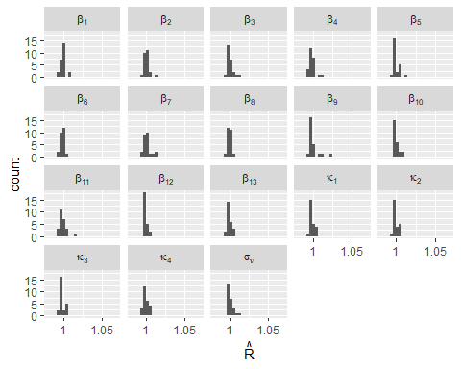
Figure 10.1: Gelman Rubin Convergence Diagnostic, Model 1 (H1). R-hat values for all model parameters, estimated for sets of two chains across M=25 imputations.
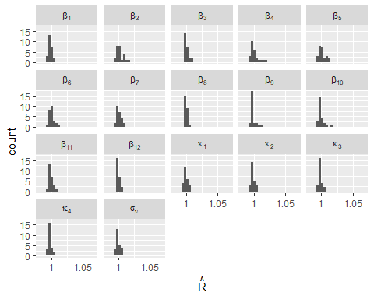
Figure 10.2: Gelman Rubin Convergence Diagnostic, Model 2 (H2). R-hat values for all model parameters, estimated for sets of two chains across M=25 imputations.
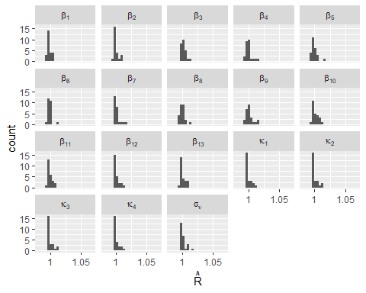
Figure 10.3: Gelman Rubin Convergence Diagnostic, Model 3 (H3). R-hat values for all model parameters, estimated for sets of two chains across M=25 imputations.

11 Robustness Checks

11.1 Alternative model specifications

11.1.1 Hierarchical linear regression
The outcome variable in these analyses is a five-point scale ranging from 1 (strongly oppose the introduction of national rent cap) to 5 (strongly support the introduction of national rent cap). This means that the scale was reversed for better interpretability.
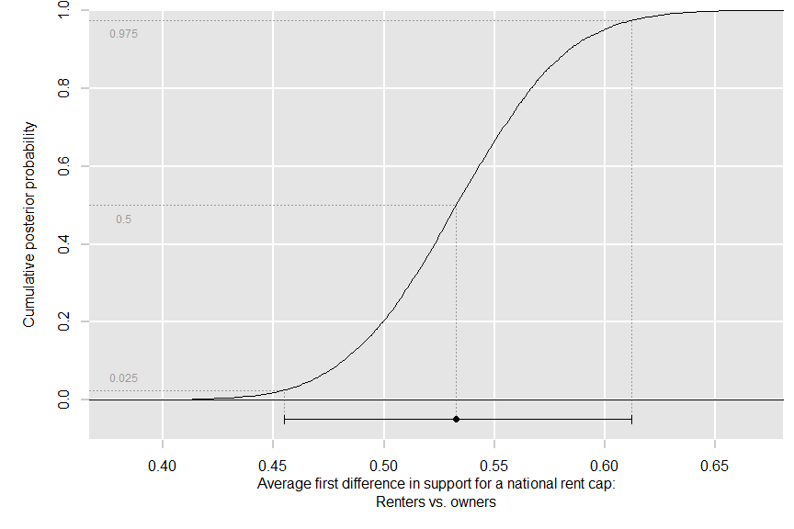
Figure 11.1: Average first difference in support for a national rent cap between renters and owners. Upper: Cumulative posterior probability. Lower: Posterior median and 95% credible interval.
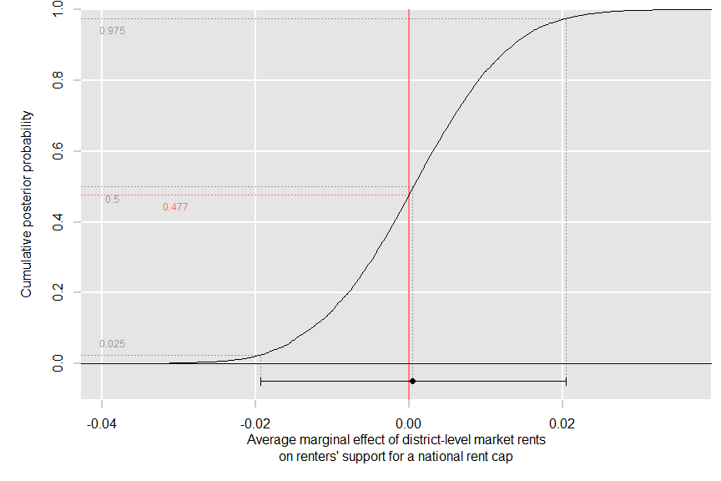
Figure 11.2: Average marginal effect of district-level market rents on renters’ support for a national rent cap. Upper: Cumulative posterior probability. Lower: Posterior median and 95% credible interval.
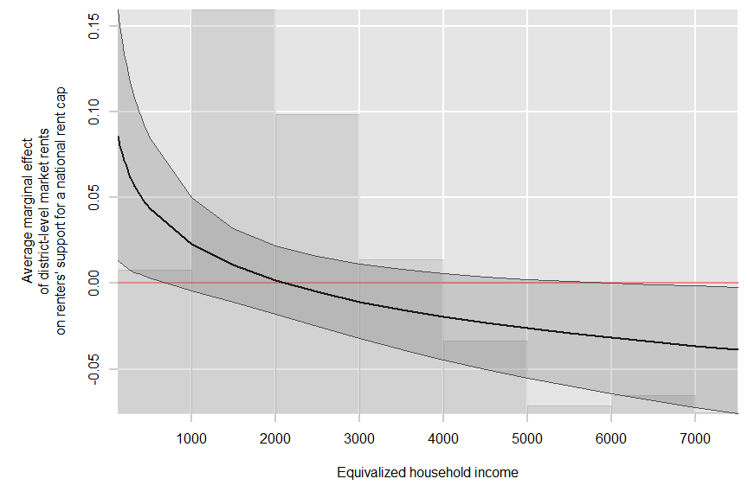
Figure 11.3: Conditional average marginal effect of district-level market rents on renters’ support for a national rent cap by equivalized household income. Posterior median and 95% credible interval.

11.1.2 Hierarchical logistic regression: Binary support of national rent cap
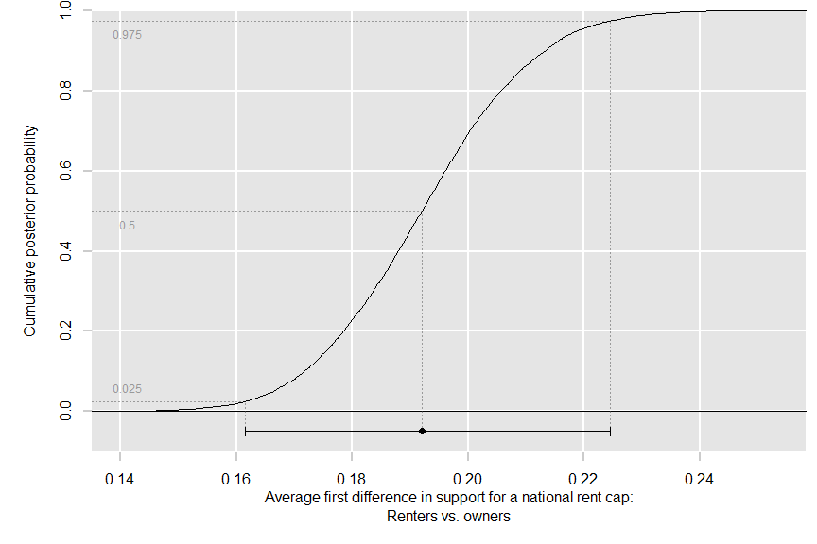
Figure 11.4: Average first difference in support for a national rent cap between renters and owners. Upper: Cumulative posterior probability. Lower: Posterior median and 95% credible interval.
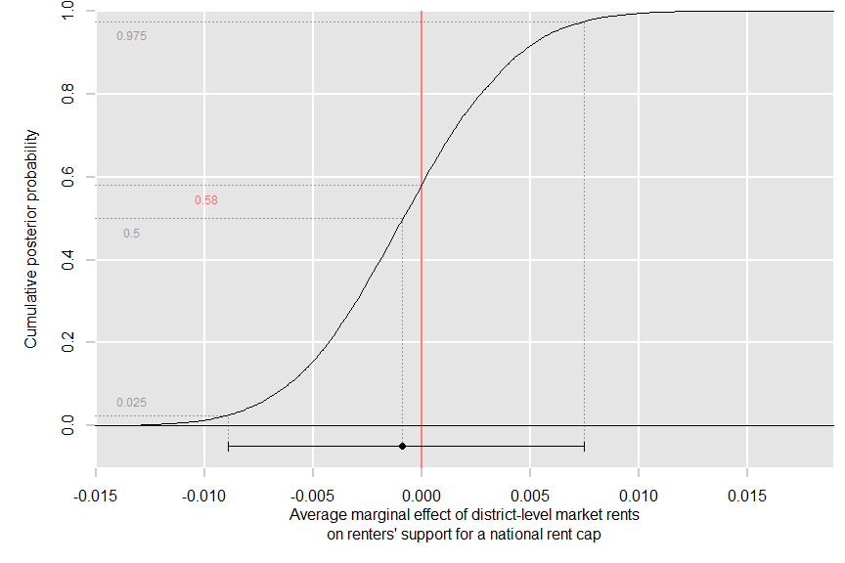
Figure 11.5: Average marginal effect of district-level market rents on renters’ support for a national rent cap. Upper: Cumulative posterior probability. Lower: Posterior median and 95% credible interval.
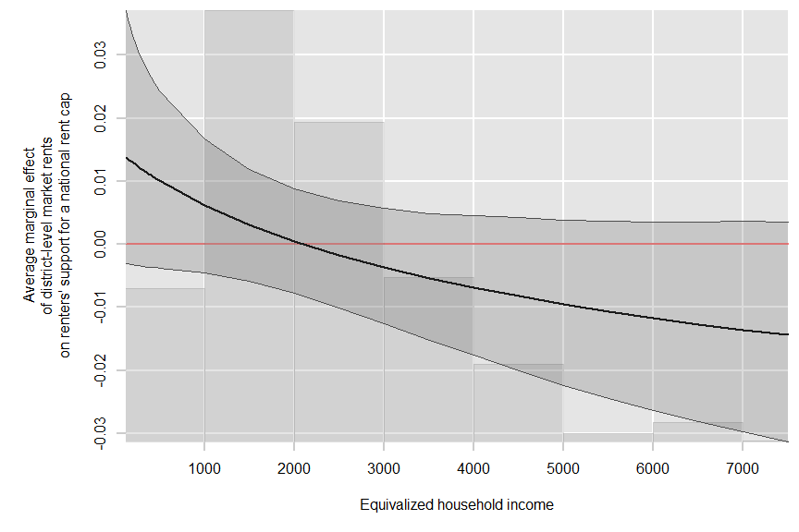
Figure 11.6: Conditional average marginal effect of district-level market rents on renters’ support for a national rent cap by equivalized household income. Posterior median and 95% credible interval.

11.2 Additional covariates

11.2.1 Place of residence (rural/suburban/urban)
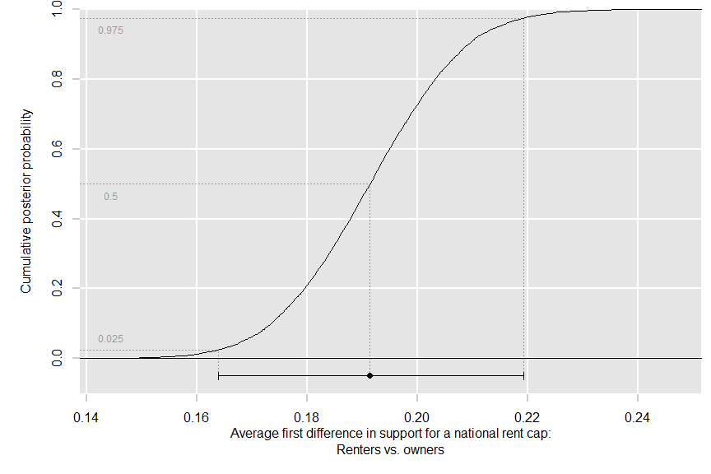
Figure 11.7: Average first difference in support for a national rent cap between renters and owners. Upper: Cumulative posterior probability. Lower: Posterior median and 95% credible interval.
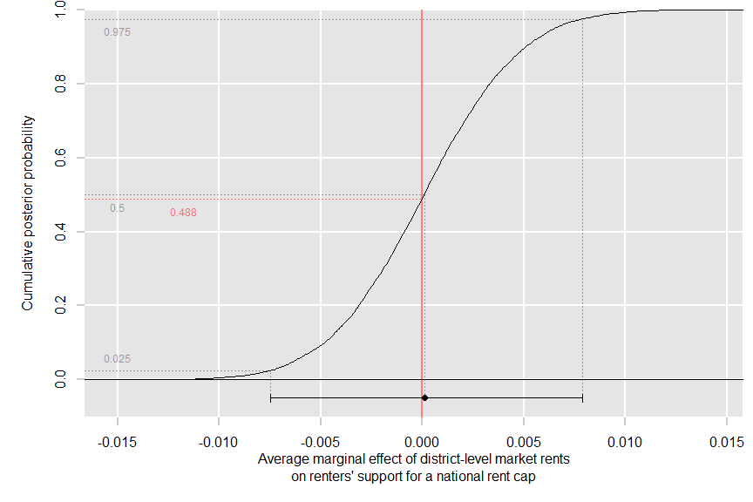
Figure 11.8: Average marginal effect of district-level market rents on renters’ support for a national rent cap. Upper: Cumulative posterior probability. Lower: Posterior median and 95% credible interval.
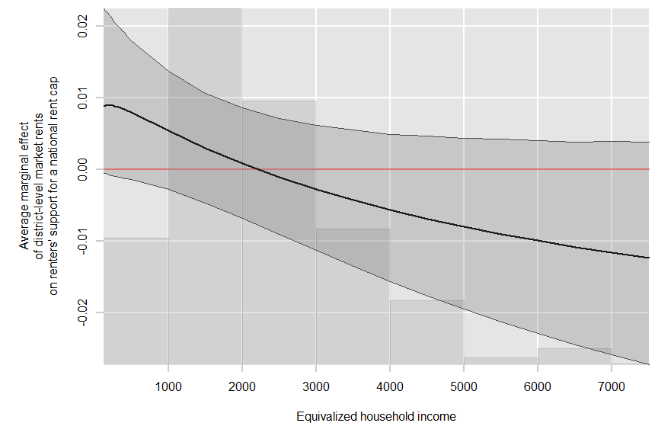
Figure 11.9: Conditional average marginal effect of district-level market rents on renters’ support for a national rent cap by equivalized household income. Posterior median and 95% credible interval.

11.2.2 Left-right ideology
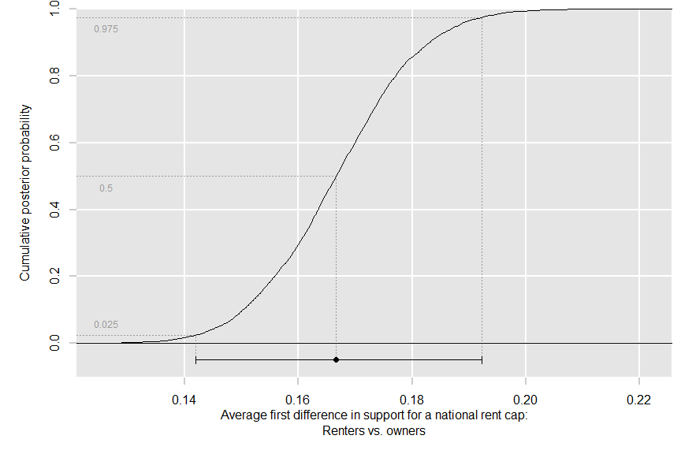
Figure 11.10: Average first difference in support for a national rent cap between renters and owners. Upper: Cumulative posterior probability. Lower: Posterior median and 95% credible interval.
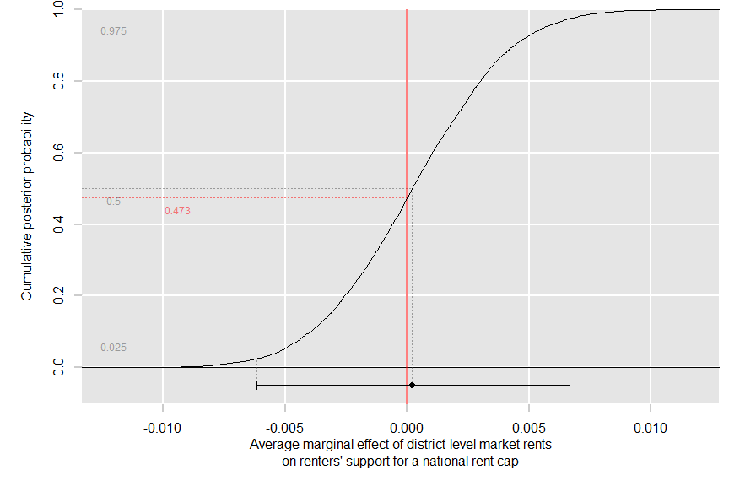
Figure 11.11: Average marginal effect of district-level market rents on renters’ support for a national rent cap. Upper: Cumulative posterior probability. Lower: Posterior median and 95% credible interval.
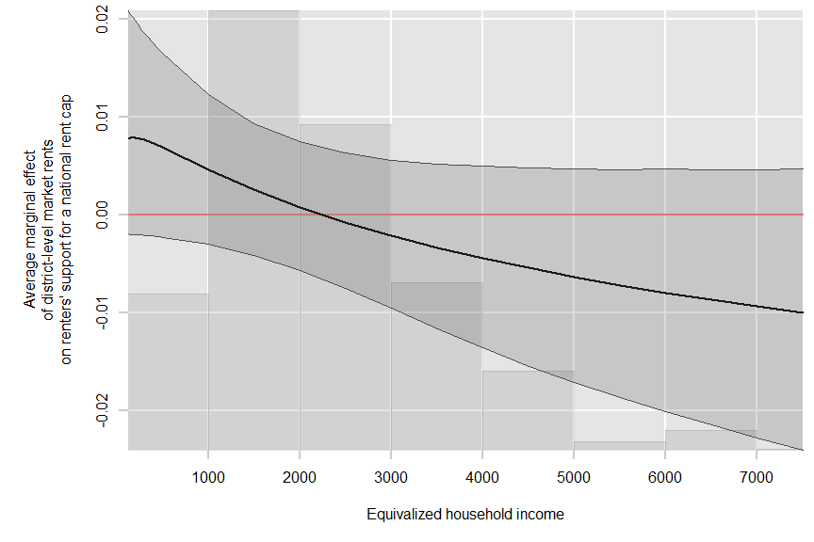
Figure 11.12: Conditional average marginal effect of district-level market rents on renters’ support for a national rent cap by equivalized household income. Posterior median and 95% credible interval.

11.2.3 Preferences for taxation and redistribution
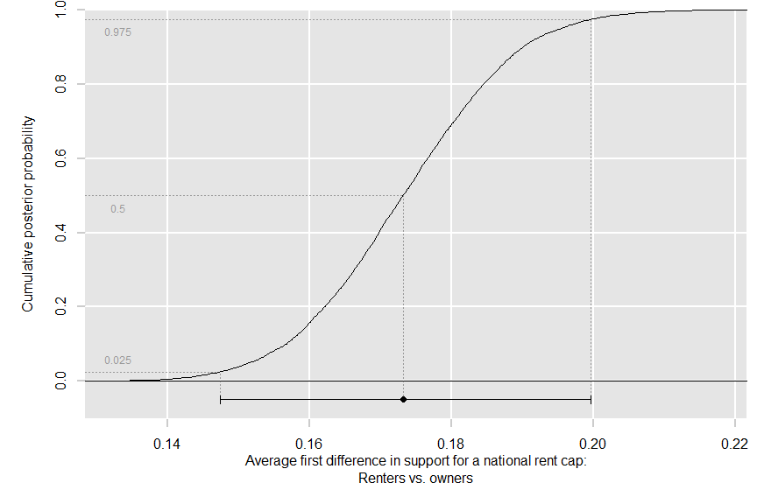
Figure 11.13: Average first difference in support for a national rent cap between renters and owners. Upper: Cumulative posterior probability. Lower: Posterior median and 95% credible interval.
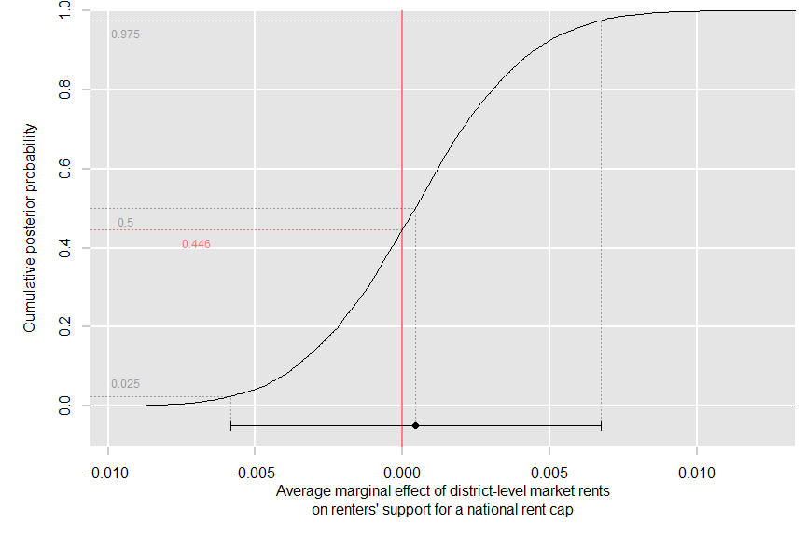
Figure 11.14: Average marginal effect of district-level market rents on renters’ support for a national rent cap. Upper: Cumulative posterior probability. Lower: Posterior median and 95% credible interval.
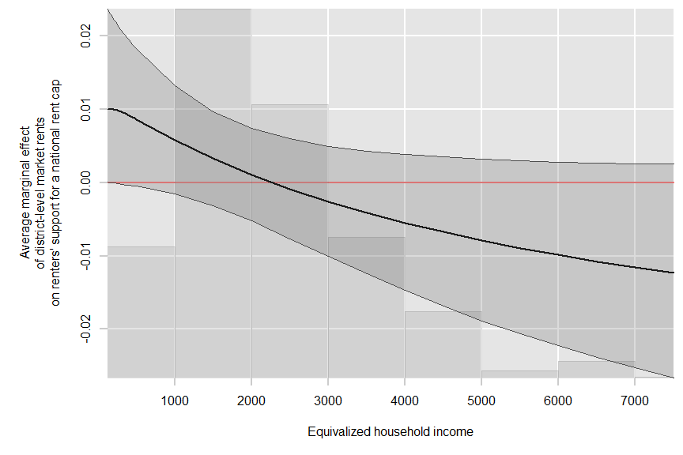
Figure 11.15: Conditional average marginal effect of district-level market rents on renters’ support for a national rent cap by equivalized household income. Posterior median and 95% credible interval.

11.2.4 Party identification
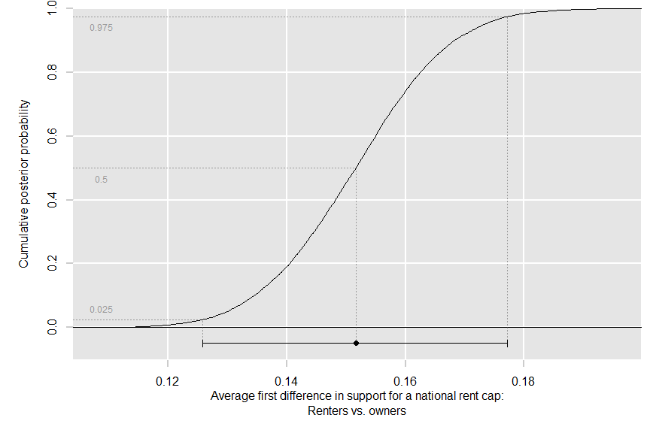
Figure 11.16: Average first difference in support for a national rent cap between renters and owners. Upper: Cumulative posterior probability. Lower: Posterior median and 95% credible interval.
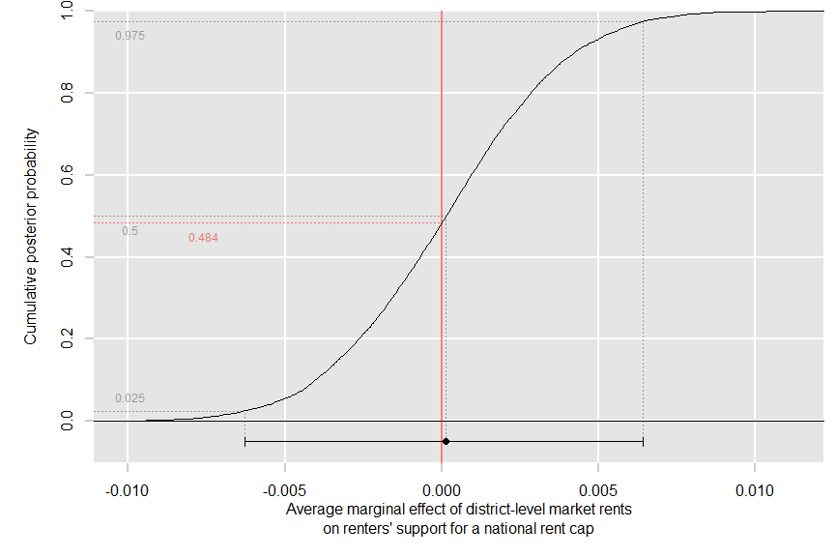
Figure 11.17: Average marginal effect of district-level market rents on renters’ support for a national rent cap. Upper: Cumulative posterior probability. Lower: Posterior median and 95% credible interval.
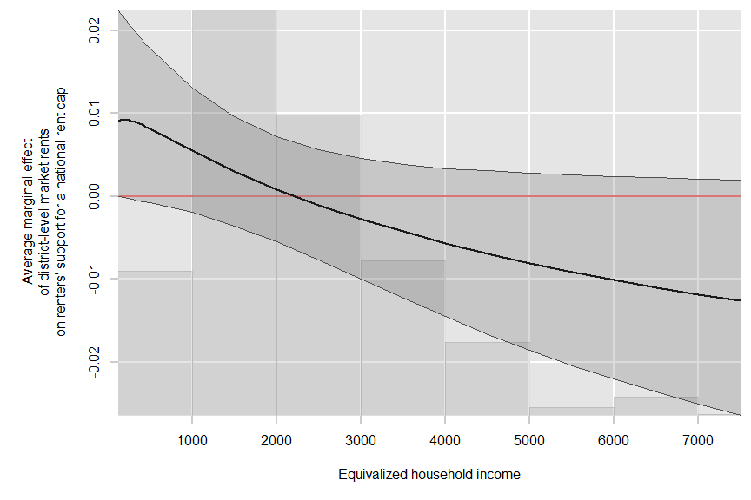
Figure 11.18: Conditional average marginal effect of district-level market rents on renters’ support for a national rent cap by equivalized household income. Posterior median and 95% credible interval.

11.3 Tertile-binned equivalized household income
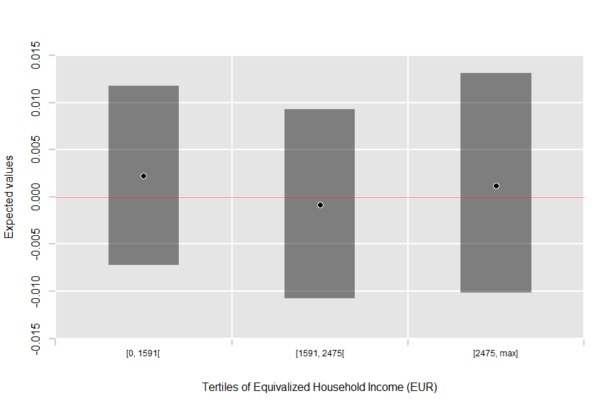
Figure 11.19: Conditional average marginal effects of district-level market rents on renters’ support for a national rent cap by tertile-binned equivalized household income. Posterior medians and 95% credible intervals.

12 Exploratory Analyses

12.1 Bivariate relationships (no covariate adjustment)
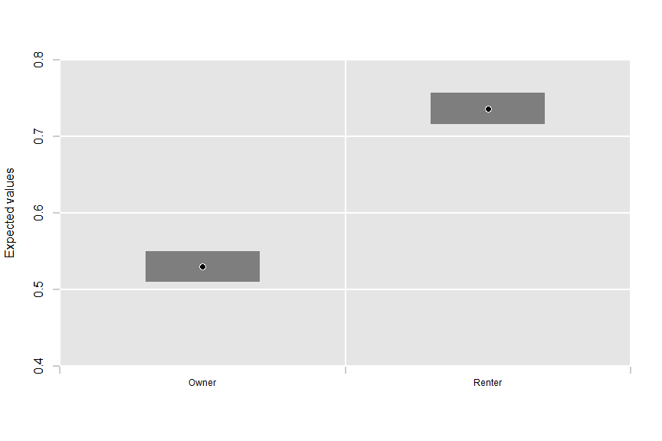
Figure 12.1: Unadjusted expected values of support for a national rent cap among renters and homeowners. Posterior median and 95% credible interval.
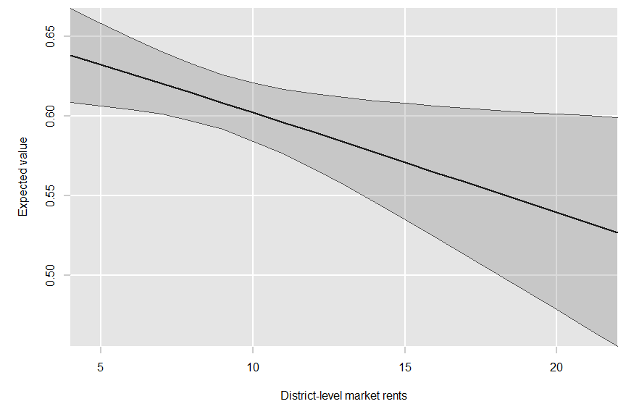
Figure 12.2: Unadjusted expected values of support for a national rent cap as a function of district-level market rents. Posterior median and 95% credible interval.
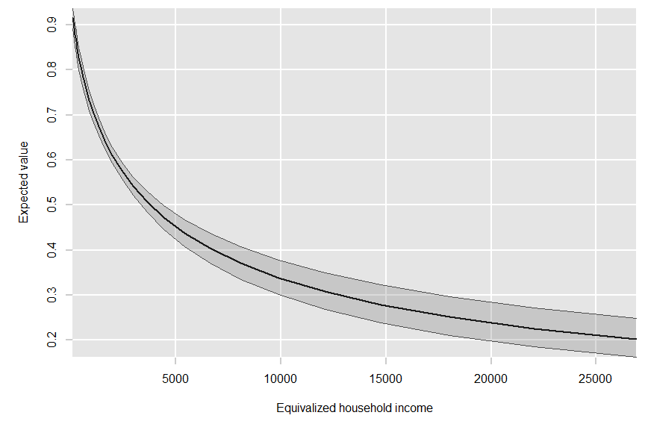
Figure 12.3: Unadjusted expected values of support for a national rent cap as a function of equivalized household income. Posterior median and 95% credible interval.
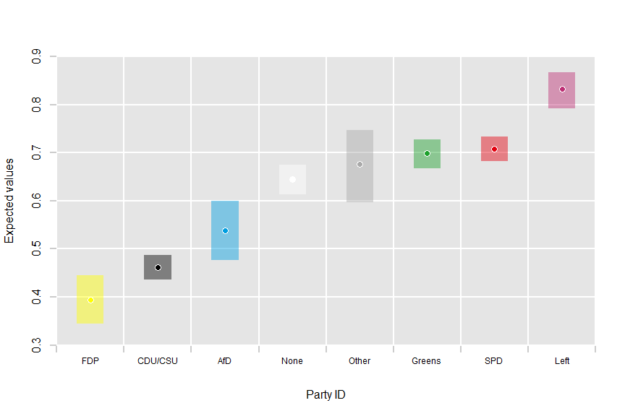
Figure 12.4: Unadjusted expected values of support for a national rent cap by party identification. Posterior median and 95% credible interval.
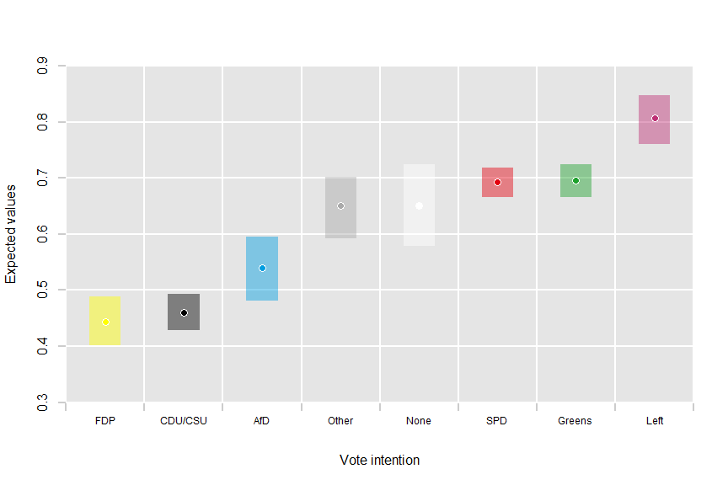
Figure 12.5: Unadjusted expected values of support for a national rent cap by respondents’ vote intention prior to the 2021 German Federal Election. Posterior median and 95% credible interval.

12.2 Effects of market rents for homeowners
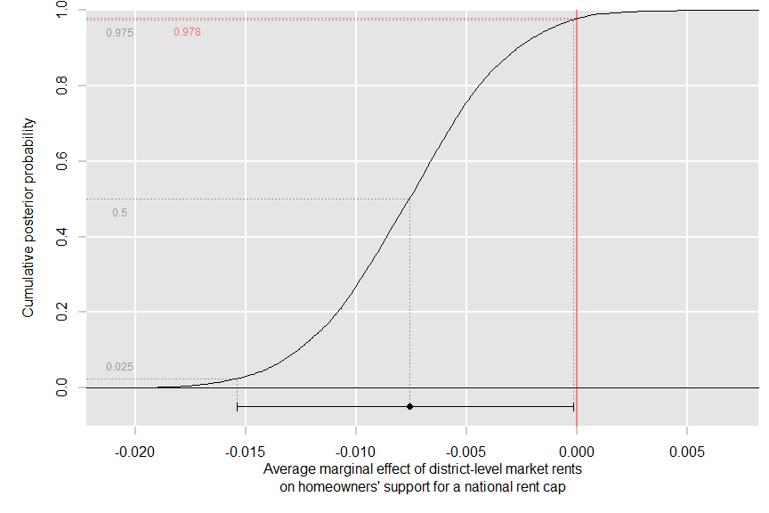
Figure 12.6: Average marginal effect of district-level market rents on homeowners’ support for a national rent cap. Upper: Cumulative posterior probability. Lower: Posterior median and 95% credible interval.
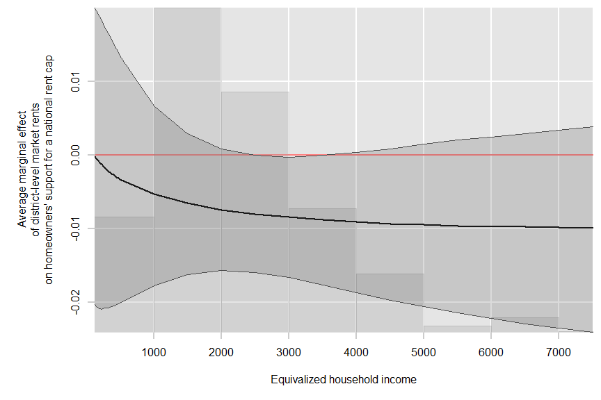
Figure 12.7: Conditional average marginal effect of district-level market rents on homeowners’ support for a national rent cap by equivalized household income. Posterior median and 95% credible interval.

12.3 Effect of log equivalized household income for renters
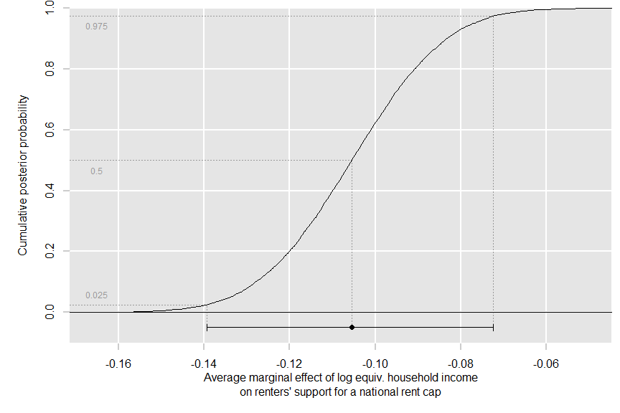
Figure 12.8: Average marginal effect of log.equivalized household income on renters’ support for a national rent cap. Upper: Cumulative posterior probability. Lower: Posterior median and 95% credible interval.
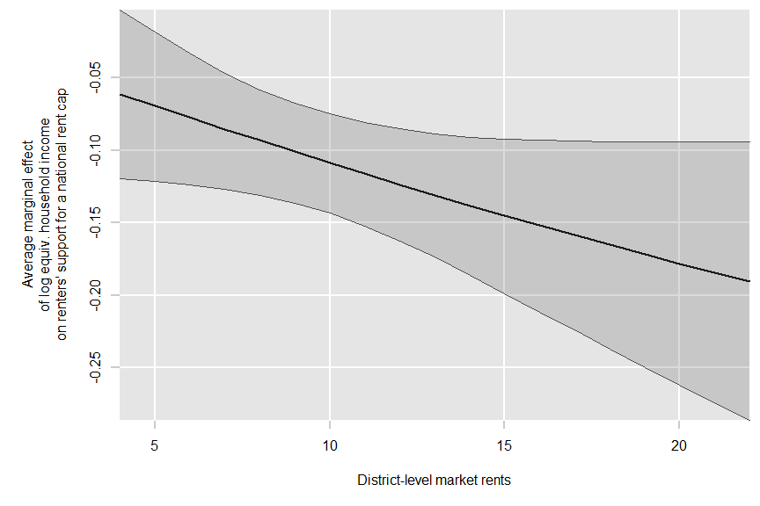
Figure 12.9: Conditional average marginal effect of log. equivalized household income on renters’ support for a national rent cap by district-level market rents. Posterior median and 95% credible interval.

