Online Appendix for

Reconsidering the Relationship between Anti-Immigration Attitudes and Preferences for the AfD Using Implicit Attitudes Measures
by
Manuel Kleinert, Justus-Liebig-University, Giessen
published in
Politische Vierteljahresschrift

Cognitive Dissonance
In order to develop cognitive dissonance citizens need to have the general knowledge, which party suits which attitudes. In the case of this study, it is assumed that citizens are aware that strong anti-immigration attitudes are generally seen as compatible with the AfD. To provide an empirical check of this premise, a brief analysis of two waves of the GLES Panel was conducted. This panel is a representative sample of the German population and collected every one to six months. Among all waves of the GLES Panel, these two were chosen because they are (1) the closest to the field phase of this study (September 2021 (wave 19) and May 2023 (wave 24), with the survey of this study conducted in Spring 2022) and (2) include the variable of interest (kpXX_1110i). This particular item that asked the respondents, how they would place each major German party on a migration policy scale. This scale ranged from 1 “[this party] wants to ease migration” to 7 “[this party] wants to restrict migration”. When asked about the programmatic position of the AfD, an overwhelming majority of 90.5% (in 2021) and 91.4% (in 2023) opted for either the most extreme value or the second highest with more than 80 percent choosing the endpoint of the scale in both instances. As this is panel data, it was also possible to estimate how stable these judgments are within persons between 2021 and 2023. 79.8% do not change their view at all and 91.1% only within one point on the scale. To allow better judgment of these values, it was also analysed how homogenous the respondents judge the connection between the Green Party and the question whether this party gives priority to fighting climate change over economic growth. 79.7% (2021) and 75.6% (2023) chose one of the two options closest to priority for fighting climate change and 54.7% do not change their opinion within these two years (81.7% within one scale point). It is inferred from these results that the public association between anti-immigration policies and the AfD is considerably strong and might be the most pronounced association between a policy position and a party in German politics today. Citizens can therefore be expected to generally be aware of the strong association between anti-immigration stances and the AfD and the aforementioned premise is therefore met.

Explicit Measurements

AfD sympathy
Wording for this item was adopted from the GLES Short-term Campaign Panel (GLES 2019) and read: ‘In general, what do you think of the following parties?’ This was asked as a matrix question listing all parties currently represented in the Bundestag. Answers were given on an 11-point scale ranging from +5’I think a great deal of this party’ and -5’I don´t think much of this party’.

Anti-immigration attitudes
The aim in operationalising anti-immigration attitudes was to be precise, comprehensive and comparable with previous research in this area, so that findings can inform each other. However, there is considerable variation in how the concept is measured. Some scholars focus on migrants who have already immigrated (e.g. 'Foreigners living in Germany should adapt to German culture', used in Schmitt-Beck 2017, Bieber et al. 2018), some on future immigration ('Should immigration be restricted?', used in Klein et al. 2018), and some only on refugees (Goerres et al. 2018; Tutic and Grehl 2021). Ultimately, wording for this item was taken from a GLES Short-term Campaign Panel (GLES 2019). The full item battery reads as follows:

‘To what extend do you agree or disagree with the following statements:
a) Immigrants are generally good for Germany´s economy. (mig_eco)
b) German culture is harmed by immigrants. (mig_cul)
c) Immigrants increase crime rates in Germany. (mig_cri)
d) The next question´s topic is about future migration to Germany. What is your opinion, should it be easier or more difficult for foreigners to come and live here?’ (mig_com)

 | Stand. Est. (Std.Err.) | p
 | Factor Loadings
Index of explicit AIA
mig_eco | 1.00
mig_cul | 1.42 (0.08) | .000
mig_cri | 1.21 (0.07) | .000
mig_com | 1.09 (0.07) | .000
 | Residual Variances
mig_eco | 0.50 (0.05) | .000
mig_cul | 0.36 (0.05) | .000
mig_cri | 0.46 (0.05) | .000
mig_com | 0.50 (0.05) | .000
 | Latent Variances
Index of explicit AIA | 0.76 (0.09) | .000
 | Fit Indices
χ² | 13.05 (2) | .001
RMSEA | 0.126
CFI | 0.987
TLI | 0.961
Table A1: Confirmatory Factor Analysis of the Index of explicit anti-immigration attitudes (AIA).

Answers were given on a 5-point scale ranging from 1'strongly agree' to 5'strongly disagree' with correspondingly labelled steps in between. For the last item, the scale ranged from 1'Immigration for foreigners should be made easier' to 5'Immigration for foreigners should be made more difficult'. An equally weighted index of the four items was computed, with the first item inverted from the original scale to reflect the same attitudinal direction as the other three. Table A1 reports a confirmatory factor analysis of this index. All items contribute significantly to the estimated factor. The comparative fit index (CFI) and the Tucker-Lewis index (TLI) indicate a good fit, while the RMSEA is not meaningful in interpreting the fit of the model due to limited degrees of freedom (Kenny et al. 2015).

Implicit Measurements
Table A2 lists all the primes used in the SC-IATs. Initially, these sets also included the term “Migrant” (migrant) and “Der Flügel” (the wing – a well-known branch of the party). After a pre-test of the survey with 41 participants, the error rate leading to exclusion from the analysis (with more than 20% errors; Karpinski and Steinman 2006) was relatively high in both IATs, at around 29% (migration) and 32% (AfD). In total, 42% of all respondents would have to be dropped if these rates were to persist in the main phase. To reduce this rate, three possible sources of error were investigated: a) The complexity and speed of the tests might be too difficult, especially for older participants or those with lower levels of education. b) The tests might be too long and monotonous, leading to higher error rates, especially towards the end of each IAT and in the second compared to the first. c) Individual items might be responsible and raise error rates disproportionately.

A possible age and education bias (a) was not supported by the data. Respondents who passed both IATs showed only marginal differences on these two variables (categorised age variable: 4.73 vs. 4.76; education variable: 6.24 vs. 6.33) compared to those who made too many errors on one or both tests. Issue b), regarding the length of the test, was examined using the average correct answers on each trial for each of the four setups (Migration - positive, Migration - negative, AfD - positive, AfD - negative). These setups are considered as separate cases here (rather than a pooled analysis of all trials) because switching from one setup to the other always led to a temporal decrease in correct responses in both SC-IATs, showing that respondents had to adapt to each setup separately. Although there was considerable variation in the percentage of correct answers over the course of each test, there was a positive trend in each of the four parts, meaning that participants got better as the test progressed. In fact, even within each setting, the percentage of correct answers increased from quarter to quarter. Even in the last quarter of the last set (trials 168-192), when fatigue might be expected, the correct answers reached the highest level of all the quarters. Therefore, the data implies a clear training effect and no changes in the length of the tests necessary. Finally, c) it was tested whether some items had significantly higher error rates than others. Indeed, within the migration-SC-IAT, the item 'Migrant' produced an error rate of 28%, while all other items were between 23 and 25%. This is somewhat surprising as this is the item that is linguistically closest to 'migration'. However, it may have been too close, causing confusion, and it was the only foreign word, which may at least partially explain this result. Similarly, for the AfD-SC-IAT, the item ‘Der Flügel’ (the wing – a well-known branch of the party) was incorrectly sorted by 23% of all respondents while the other items had error rates below 20%. Some participants also indicated in the comments that they did not know this label. Therefore, for the main data collection phase both items (‘Migrant’ and ‘Der Flügel’) were dropped, meaning that the other items appeared more often instead. Note that this is a departure from the pre-registered report, which also included these terms. However, this decision appears justified as it does not change the overall nature of the tests, but makes them more feasible and therefore accessible to respondents, thereby increasing their validity. In addition, the introductory texts before the SC-IATs were shortened and refined. They now explicitly stated that it is more important to answer correctly than to answer quickly. With these adjustments, the error rates fell from 42% to 30% (22% for both separately). These failure rates are comparable to those in the relevant literature, which often uses a relaxed criterion and only deletes participants with a failure rate above 30% instead of the 20%-threshold applied in this study (Bos et al. 2018; Maier et al. 2022). Cases from the pre-tests were removed before all analyses presented in the article. All participants included in the final dataset were exposed to the primes listed in Table A2. English translations of the items are for informational purposes only and were not used in the IAT.

Migration | migration |  | AfD | AfD
Einwanderer | immigrant(s) |  | Alternative für Deutschland | Alternative for Germany
Zuwanderer | immigrant(s) |  | Deutschland. Aber normal. | Germany. But normal.
Flüchtling | refugee(s) |  | Alexander Gauland | Alexander Gauland
Asylbewerber | asylum seeker(s) |  | Alice Weidel | Alice Weigel
Ausländer | foreigner(s) |  | Tino Chrupalla | Tino Chrupalla
Gut | good |  | Schlecht | bad
Glücklich | happy |  | Qual | torture
Frieden | peace |  | Verletzt | hurt
Vergnügen | pleasure |  | Misserfolg | failure
Prachtvoll | magnificent |  | Böse | evil
Liebe | love |  | Übel | plague
Lachen | laugh |  | Schrecklich | terrible
Freude | Joy |  | Grausam | cruel
Wundervoll | wonderful |  | Scheußlich | Awful

Table A2: Primes used in the SC-IATs. Primes of the migration and AfD table were used in their respective SC-IAT, ‘good’ and ‘bad’ primes were used in both SC-IAT.

In blocks 1 and 2 of each SC-IAT, the category of interest (migration, AfD) shared the correct response key with the category 'positive', whereas in blocks 3 and 4 it shared the correct response key with the category 'negative'. The first and third block served as practice blocks (24 trials each), the second and fourth block (72 trials each) were used to calculate the so-called 'D-score'. Before calculating the D-scores, non-responses and trials with responses faster than 350 ms were excluded. Errors were counted as the block average plus a penalty of 400ms. Participants with an error rate greater than 20% were excluded. After these adjustments, D-scores were calculated as the mean response time of the block in which the substantial term (migration/AfD) shared a key with the positive category, minus the mean of the block in which it shared a key with the negative category, divided by the standard deviation of all correct trials in both blocks.

Additional Descriptive Analyses

Sample
Initial quotas for entry to the survey followed stratification according to gender and age, in the general population (Statistisches Bundesamt 2022c, 2022d). However, different dropout rates across the gender-age combinations made it necessary to oversample some groups. Missings due to non-response to survey questions were rare and relatively proportionate across gender and age groups. Most missings were due to error rates on the SC-IAT above the 20% cut-off. Although there was no linear relationship between age and error rates, some age-gender combinations had disproportionately high error rates. Men in their 50s and women in their 60s had particularly high failure rates of over 40% of all cases collected. To compensate for these missing cases a second phase of data collection was conducted. The entire data collection phase therefore started with a pre-test on 12-14 April 2022, continued with a main collection phase between 20th and 24th April, and a further collection phase between 23rd and 25th May 2022, in order to fill in the gaps in the intended quotation resulting from the above-mentioned deletion process. Figure A1 shows the intended quotation, the total number of cases collected and the actual valid cases, broken down by gender and age.

From the total sample, approximately 33% of all cases had to be dropped, leaving us with 181 male and 188 female respondents. Due to the described oversampling of certain age-gender combinations, the final data set is now relatively close to the initial quotation, allowing for limited generalisation with respect to gender and age. Other socio-demographic variables are also similar to the general population statistics: Within the sample, 61.5% were employed, compared to about 65% in the general population over 18 years (Statistisches Bundesamt 2022b). The education variable used slightly different categories, therefore its values are not entirely comparable to public statistics. The sample has a slight overrepresentation of highly educated, with a rate of 29.5% reporting a higher education degree, compared to about 23% in the general population over 18 years (Statistisches Bundesamt 2022a).
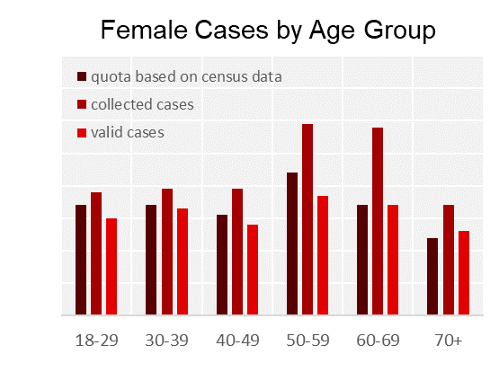
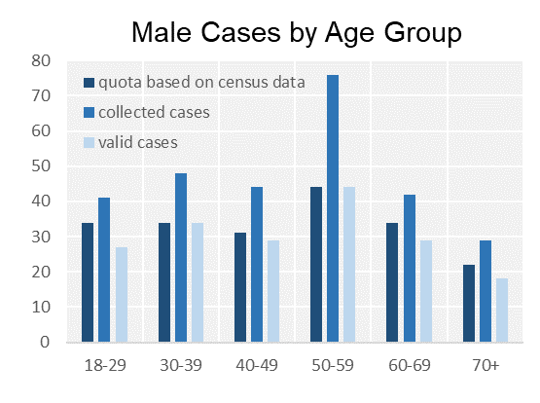
Fig. A1: Quotations, collected and valid cases of male and female participants, split by age groups. Individuals under the age of 18 were excluded from participation and two valid cases of individuals reporting a non-binary gender were dropped.

Universality of the SC-IAT (Extension)
In addition to the findings presented in Figure 3 of the publication, the universality of the SC-IATs in this study with regard to gender and working status was also tested (Figure A2). The results show that men have slightly lower explicit and implicit anti-immigration attitudes, while the pattern is mixed when it comes to AfD sympathy. Respondents who reported being part of the active labour force had slightly lower explicit anti-immigration attitudes and sympathy for the AfD, but lower implicit sympathy for the party. However, these differences are relatively small and should therefore not be over-interpreted.
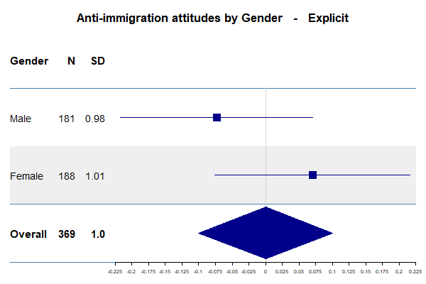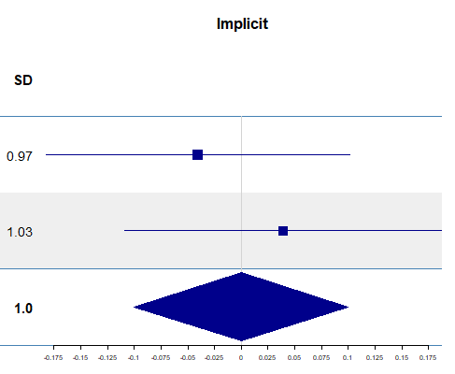
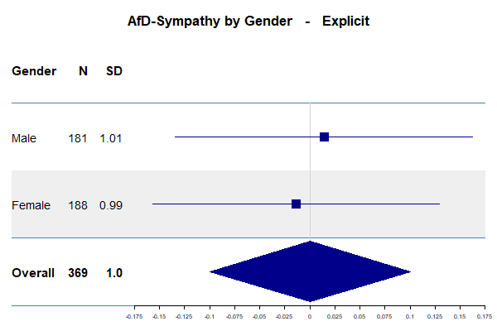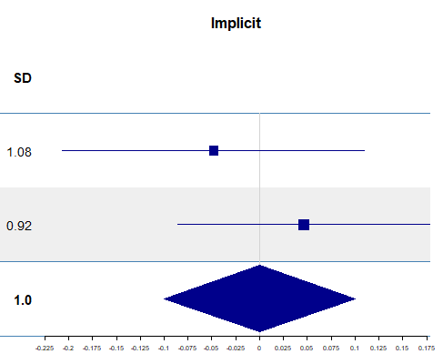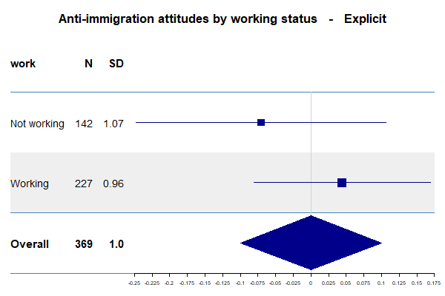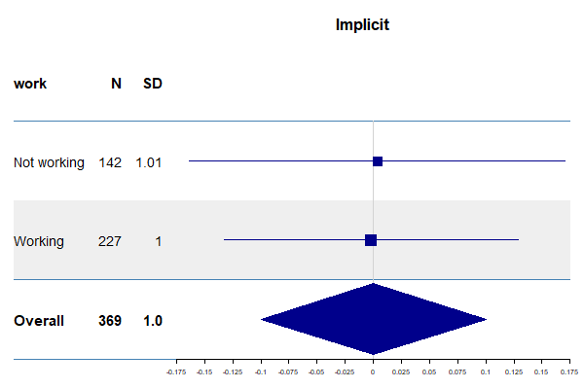
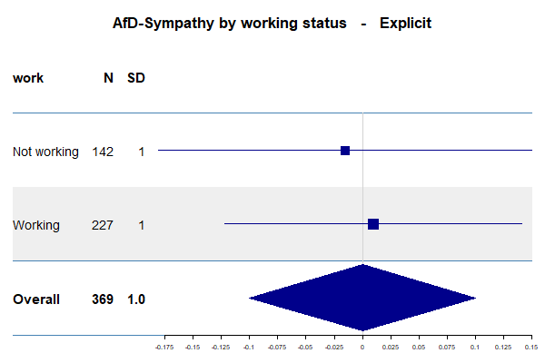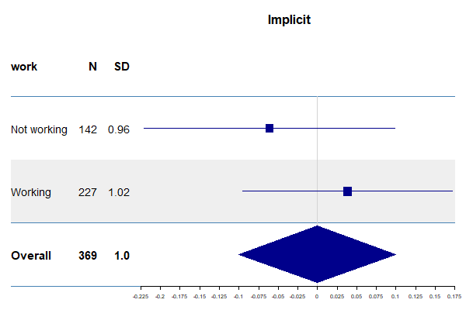
Fig. A2: Descriptive statistics for AIA and AfD Sympathy split by means of collection (implicit vs explicit) and gender or working status.

References
Bieber, Ina; Roßteutscher, Sigrid; Scherer, Philipp (2018): Die Metamorphosen der AfD-Wählerschaft: Von einer euroskeptischen Protestpartei zu einer (r)echten Alternative? In Politische Vierteljahresschrift 59 (3), pp. 433–461. https://doi.org/10.1007/s11615-018-0103-y.
Bos, Linda; Sheets, Penelope; Boomgaarden, Hajo G. (2018): The Role of Implicit Attitudes in Populist Radical-Right Support. In Political Psychology 39 (1), pp. 69–87. https://doi.org/10.1111/pops.12401.
GLES (2019): Wahlkampf-Panel (GLES 2017). With assistance of Sigrid Roßteutscher, Rüdiger Schmitt-Beck, Harald Schoen, Bernhard Weßels, Christof Wolf, Maria Preißinger et al. (ZA6804 Datenfile Version 7.0.0).
GLES (2023a): GLES Panel 2016-2021, Wellen 1-21. With assistance of Marc Debus, Thorsten Faas, Sigrid Roßteutscher, Rüdiger Schmitt-Beck, Harald Schoen, Bernhard Weßels et al. (ZA6838 Datenfile Version 6.0.0).
GLES (2023b): GLES Panel 2023, Welle 24. With assistance of Harald Schoen, Joss Roßmann, Hannah Bucher, Maximilian Etzel, Sebastian Fenzl, Jan Marquardt et al. (ZA7730 Datenfile Version 1.0.0).
Goerres, Achim; Spies, Dennis C.; Kumlin, Staffan (2018): The Electoral Supporter Base of the Alternative for Germany. In Swiss Political Science Review 24 (3), pp. 246–269. https://doi.org/10.1111/spsr.12306.
Karpinski, Andrew; Steinman, Ross B. (2006): The single category implicit association test as a measure of implicit social cognition. In Journal of personality and social psychology 91 (1), pp. 16–32. https://doi.org/10.1037/0022-3514.91.1.16.
Kenny, David A.; Kaniskan, Burcu; McCoach, D. Betsy (2015): The Performance of RMSEA in Models With Small Degrees of Freedom. In Sociological Methods & Research 44 (3), pp. 486–507. https://doi.org/10.1177/0049124114543236.
Klein, Markus; Heckert, Fabian; Peper, Yannic (2018): Rechtspopulismus oder rechter Verdruss? In KZfSS Kölner Zeitschrift für Soziologie und Sozialpsychologie 70 (3), pp. 391–417. https://doi.org/10.1007/s11577-018-0564-4.
Maier, Michaela; Welzenbach-Vogel, Ines C.; Christner, Clara; Tillman, Erik R.; Zinkernagel, Axel; Schmitt, Manfred (2022): Implicit and explicit populist and anti-immigrant attitudes and their explanatory power for populist radical-right party support. In Acta Politica. https://doi.org/10.1057/s41269-022-00255-6.
Statistisches Bundesamt (2022a): Bevölkerung im Alter von 15 Jahren und mehr nach allgemeinen und beruflichen Bildungsabschlüssen nach Jahren. Available online at https://www.destatis.de/DE/Themen/Gesellschaft-Umwelt/Bildung-Forschung-Kultur/Bildungsstand/Tabellen/bildungsabschluss.html. Accessed at 18 July 2023.
Statistisches Bundesamt (2022b): Arbeitsmarkt. Available online at https://www.destatis.de/DE/Themen/Wirtschaft/Konjunkturindikatoren/Arbeitsmarkt/karb811_x13a.html. Accessed at 18 July 2023.
Statistisches Bundesamt (2022c): Bevölkerung nach Altersgruppen (ab 2011). Available online at https://www.destatis.de/DE/Themen/Gesellschaft-Umwelt/Bevoelkerung/Bevoelkerungsstand/Tabellen/liste-altersgruppen.html#474508. Accessed at 18 July 2023.
Statistisches Bundesamt (2022d): Bevölkerung nach Nationalität und Geschlecht. Available online at https://www.destatis.de/DE/Themen/Gesellschaft-Umwelt/Bevoelkerung/Bevoelkerungsstand/Tabellen/deutsche-nichtdeutsche-bevoelkerung-nach-geschlecht-deutschland.html. Accessed at 18 July 2023.
Tutić, Andreas; Grehl, Sascha (2021): Implizite Einstellungen, explizite Einstellungen und die Affinität zur AfD. In KZfSS Kölner Zeitschrift für Soziologie und Sozialpsychologie 73 (3), pp. 389–417. https://doi.org/10.1007/s11577-021-00803-6.

