Supplemental Materials:
Teachers’ and Students’ Perceptions of Students’ Ability and Importance Value in Math and Reading: A Latent Difference Score Analysis of Intra-Individual Cross-Domain Differences

Supplement S1. Items Measuring Students’ Ability Self-Concept
Supplement S2. Descriptive Statistics and Observed Correlations for all Demographic, Math-Related and Reading-Related Variables
Supplement S3. Overview of Model Fits
Supplement S4. Tests of Measurement Invariance Across Subjects and Gender
Supplement S5. Successive Models Predicting Latent Difference Scores and Reading Scores by Student Characteristics
Supplement S6. Figure Model without Control Variables
Supplement S7. Frequencies of the Mean Plausible Values for all Latent Difference Scores
Supplement S8. Gender-Specific Latent Means and Variances of Perceptions of Importance and Ability in Reading and of the Latent Difference Scores
Supplement S9. Mplus Syntax of the Final Latent Difference Score Model Including All Hypothesized Predictors

Supplement S.1

Table S.1
Items Measuring Students’ Ability Self-Concept
Item wording | Response Scale
How good at math [reading] are you? | 1 = not very good  7 = very good
If you were to list all the students from best to worst in math [reading], where are you? | 1 = one of the worst 7 = one of the best
How well do you expect to do in math [reading] this year? | 1 = not well  7 = very well
How good would you be at learning something new in math [reading]? | 1 = not very good  7 = very good

Supplement S.2

Table S.2
Descriptive Statistics and Observed Correlations for all Manifest Demographic, Math- and Reading-Related Variables
Variable |  | 1. | 2. | 3. | 4. | 5. | 6. | 7. | 8. | 9. | 10. | 11. | 12. | 13. | 14. | 15.
1. | Grade level 3 vs. 6 | --
2. | Grade level 4 vs. 6 | −.44*** | --
3. | Student gender | .01 | .02 | --
4. | Parental education | −.06 | .05 | −.05 | --
5. | Cognitive ability | .14** | .11* | .14** | .13* | --
6. | Prior math grade | −.04 | .16** | .01 | .02 | .28*** | --
7. | Prior reading grade | .13* | .13* | −.10† | −.02 | .32*** | .55*** | --
8. | Math ability self-concept (S) | .13* | −.01 | .22** | .04 | .21*** | .24*** | .16** | --
9 | Reading ability self-concept (S) | .13* | −.05 | −.08† | .11* | .27*** | .06 | .24*** | .07 | --
10. | Math importance (S) | .01 | .04 | −.01 | −.04 | −.07 | .03 | .03 | .33*** | .04 | --
11. | Reading importance (S) | .05 | −.01 | −.06 | −.05 | −.02 | .00 | .07 | −.01 | .31*** | .40*** | --
12. | Math ability (T) | .01 | −.04 | .09† | .24*** | .33*** | .45*** | .35*** | .42*** | .11* | .03 | −.08 | --
13. | Reading ability (T) | .01 | −.02 | −.04 | .22*** | .38*** | .36*** | .44*** | .21*** | .34*** | −.01 | .02 | .73 *** | --
14. | Math importance (T) | .04 | −.06 | −.03 | .14** | .22*** | .34*** | .30*** | .32*** | .08† | .04 | −.01 | .72*** | .54*** | --
15. | Reading importance (T) | .02 | −.01 | −.15** | .17** | .21*** | .31*** | .30*** | .27*** | .16** | .03 | .06 | .62*** | .64*** | .85*** | --
 | N | 469 | 469 | 469 | 345 | 468 | 310 | 319 | 467 | 467 | 467 | 465 | 462 | 463 | 455 | 458
 | M | 0.32 | 0.30 | 0.47 | 4.70 | 114.44 | 11.72 | 12.24 | 5.45 | 5.56 | 5.91 | 5.82 | 5.00 | 5.04 | 5.40 | 5.40
 | SD | 0.47 | 0.46 | 0.50 | 1.74 | 15.73 | 2.09 | 1.89 | 1.09 | 1.14 | 1.52 | 1.41 | 1.31 | 1.30 | 1.45 | 1.38
Note. S = student-rated; T = teacher-rated. Student gender: 1 = male, 0 = female. Prior school grade and prior subject interest refer to the data collection at the end of the previous school year (t-1). † p <.10, * p < .05, ** p < .01, *** p < .001

Supplement S.3

Table S.3
Overview of Model Fits
Model |  | Model fit indices
Model | χ² | df | CFI | TLI | RMSEA | SRMR
Fullmodel including all control variables | 274.896 | 137 | .961 | .934 | .046 | .042
Model without control variables | 150.376 | 81 | .977 | .965 | .043 | .048
Model without control variables  (only males) | 131.301 | 81 | .965 | .948 | .053 | .059
Model without control variables  (only females) | 130.724 | 81 | .974 | .961 | .050 | .055
Note. n_{female}= 248. n_{male} = 221. CFI = comparative fit index, TLI = Tucker-Lewis index, RMSEA = root mean square error of approximation, SRMR = standardized root mean square residual.

Supplement S.4

Table S.4.1
Tests of Measurement Invariance Across Subjects
Models | χ² | df | CFI | TLI | RMSEA | SRMR | ΔCFI | ΔRMSEA
Freely estimated parameters ^{abc} | 151.349 | 74 | .976 | .961 | .047 | .045 | — | —
Fixed factor loadings | 155.644 | 77 | .976 | .961 | .047 | .048 | .000 | .000
Fixed factor loadings and item intercepts^{d} | 158.431 | 80 | .975 | .963 | .046 | .048 | −.001 | −.001
Note. ª One factor loading per construct was fixed at 1.0 for model identification purposes. ^{b} The first and second indicator of students’ self-concept of ability were allowed to correlate as they focus on current abilities whereas the other two indicators reflect future expectancies. ^{c} The estimated residual variance of one indicator of teachers’ perceived student ability was negative and close to zero in some models and was thus fixed to zero. ^{d} Testing invariance in a model including only students’ self-concept indicated that the intercept of one indicator of students’ self-concept had to be estimated freely across the two subjects (partial strong measurement invariance). Thus, we used this restriction in all models. However, we repeated all analyses with the intercept fixed across the subjects and our results did not change substantially. See also Fig. 1 for an overview of the final measurement model. CFI = comparative fit index, TLI = Tucker-Lewis index, RMSEA = root mean square error of approximation, SRMR = standardized root mean square residual.

Table S4.2
Tests of Measurement Invariance Across Gender
Models | χ² | df | CFI | TLI | RMSEA | SRMR | ΔCFI | ΔRMSEA
Freely estimated parameters ^{ab} | 248.439 | 148 | .971 | .952 | .054 | .052 | — | —
Fixed factor loadings | 267.672 | 156 | .967 | .950 | .055 | .059 | −.004 | .001
Fixed factor loadings and item intercepts | 276.981 | 164 | .967 | .951 | .054 | .061 | −.004 | .000
Note. ª One factor loading per construct was fixed at 1.0 for model identification purposes. ^{b} The model had the same restrictions as seen in Fig. 1. CFI = comparative fit index, TLI = Tucker-Lewis index, RMSEA = root mean square error of approximation, SRMR = standardized root mean square residual.

Supplemental S.5

Table S.5
Successive Models Predicting Latent Difference Scores and Reading Scores by Student Characteristics
Predictors | M1 |  | M2 |  | M3 |  | M4 |  | M5 |  | M6 |  | M7 |  | M8
ΔMath-Reading
Self-Concept of Ability (S)
Grade level 3 vs 6 | .03 | (.06) |  |  |  |  |  |  |  |  |  |  |  |  | .09 | (.07)
Grade level 4 vs 6 | .05 | (.06) |  |  |  |  |  |  |  |  |  |  |  |  | .08 | (.06)
Student gender (male) |  |  | .23*** | (.04) |  |  |  |  |  |  |  |  |  |  | .20*** | (.05)
Parental education |  |  |  |  | −.06 | (.06) |  |  |  |  |  |  |  |  | −.05 | (.06)
Cognitive ability |  |  |  |  |  |  | −.05 | (.05) |  |  |  |  |  |  | −.08 | (.06)
Prior math grade |  |  |  |  |  |  |  |  | .14* | (.06) |  |  | .23** | (.08) | .24** | (.08)
Prior reading grade |  |  |  |  |  |  |  |  |  |  | −.06 | (.08) | −.24* | (.09) | −.23** | (.09)
R² | .00 | (.01) | .05 | (.02) | .00 | (.01) | .00 | (.01) | .02 | (.02) | .00 | (.01) | .05 | (.04) | .11 | (.04)
ΔMath-Reading Importance (S)
Grade level 3 vs 6 | −.02 | (.05) |  |  |  |  |  |  |  |  |  |  |  |  | .01 | (.05)
Grade level 4 vs 6 | .03 | (.05) |  |  |  |  |  |  |  |  |  |  |  |  | .05 | (.05)
Student gender (male) |  |  | .04 | (.05) |  |  |  |  |  |  |  |  |  |  | .03 | (.05)
Parental education |  |  |  |  | .01 | (.05) |  |  |  |  |  |  |  |  | .02 | (.05)
Cognitive ability |  |  |  |  |  |  | −.05 | (.04) |  |  |  |  |  |  | −.06 | (.05)
Prior math grade |  |  |  |  |  |  |  |  | .03 | (.06) |  |  | .07 | (.07) | .09 | (.07)
Prior reading grade |  |  |  |  |  |  |  |  |  |  | −.04 | (.05) | −.09 | (.06) | −.10 | (.07)
R² | .00 | (.00) | .00 | (.00) | .00 | (.00) | .00 | (.00) | .00 | (.00) | .00 | (.00) | .01 | (.01) | .02 | (.01)
ΔMath-Reading
Ability (T)
Grade level 3 vs 6 | −.01 | (.08) |  |  |  |  |  |  |  |  |  |  |  |  | .04 | (.09)
Grade level 4 vs 6 | −.06 | (.08) |  |  |  |  |  |  |  |  |  |  |  |  | −.03 | (.08)
Student gender (male) |  |  | .19*** | (.05) |  |  |  |  |  |  |  |  |  |  | .17** | (.05)
Parental education |  |  |  |  | .04 | (.05) |  |  |  |  |  |  |  |  | .06 | (.04)
Cognitive ability |  |  |  |  |  |  | −.06 | (.06) |  |  |  |  |  |  | −.08 | (.06)
Prior math grade |  |  |  |  |  |  |  |  | .13 | (.09) |  |  | .27* | (.04) | .25* | (.11)
Prior reading grade |  |  |  |  |  |  |  |  |  |  | −.09 | (.09) | −.27** | (.04) | −.23* | (.10)
R² | .00 | (.01) | .04 | (.02) | .00 | (.00) | .00 | (.01) | .02 | (.02) | .01 | (.02) | .06 | (.05) | .11 | (.04)
ΔMath-Reading Importance (T)
Grade level 3 vs 6 | .01 | (.08) |  |  |  |  |  |  |  |  |  |  |  |  | .02 | (.07)
Grade level 4 vs 6 | −.09 | (.06) |  |  |  |  |  |  |  |  |  |  |  |  | −.09 | (.06)
Student gender (male) |  |  | .20*** | (.06) |  |  |  |  |  |  |  |  |  |  | .19** | (.06)
Parental education |  |  |  |  | −.03 | (.06) |  |  |  |  |  |  |  |  | −.02 | (.06)
Cognitive ability |  |  |  |  |  |  | .02 | (.05) |  |  |  |  |  |  | −.01 | (.06)
Prior math grade |  |  |  |  |  |  |  |  | .10 | (.06) |  |  | .13† | (.11) | .14† | (.07)
Prior reading grade |  |  |  |  |  |  |  |  |  |  | .04 | (.06) | −.09 | (.10) | −.08 | (.09)
R² | .01 | (.01) | .04 | (.02) | .00 | (.00) | .00 | (.00) | .01 | (.01) | .00 | (.00) | .01 | (.02) | .06 | (.02)
Table continues on next page.

Table S.5 – continued from previous page
Predictors | M1 |  | M2 |  | M3 |  | M4 |  | M5 |  | M6 |  | M7 |  | M8
Reading Self-Concept (S)
Grade level 3 vs 6 | .15* | (.07) |  |  |  |  |  |  |  |  |  |  |  |  | .04 | (.07)
Grade level 4 vs 6 | .02 | (.06) |  |  |  |  |  |  |  |  |  |  |  |  | −.08 | (.07)
Student gender (male) |  |  | −.09* | (.04) |  |  |  |  |  |  |  |  |  |  | −.07 | (.04)
Parental education |  |  |  |  | .12* | (.05) |  |  |  |  |  |  |  |  | .11* | (.06)
Cognitive ability |  |  |  |  |  |  | .28*** | (.05) |  |  |  |  |  |  | .22*** | (.06)
Prior math grade |  |  |  |  |  |  |  |  | .06 | (.07) |  |  | −.13 | (.08) | −.14† | (.08)
Prior reading grade |  |  |  |  |  |  |  |  |  |  | .25*** | (.07) | .37*** | (.08) | .30*** | (.07)
R² | .02 | (.02) | .01 | (.01) | .02 | (.01) | .08 | (.03) | .00 | (.01) | .07 | (.04) | .10 | (.04) | .17 | (.04)
Reading Importance (S)
Grade level 3 vs 6 | .05 | (.06) |  |  |  |  |  |  |  |  |  |  |  |  | .03 | (.05)
Grade level 4 vs 6 | .02 | (.05) |  |  |  |  |  |  |  |  |  |  |  |  | .00 | (.05)
Student gender (male) |  |  | −.06 | (.05) |  |  |  |  |  |  |  |  |  |  | −.04 | (.05)
Parental education |  |  |  |  | −.04 | (.06) |  |  |  |  |  |  |  |  | −.03 | (.06)
Cognitive ability |  |  |  |  |  |  | −.01 | (.06) |  |  |  |  |  |  | −.04 | (.06)
Prior math grade |  |  |  |  |  |  |  |  | .00 | (.01) |  |  | .07 | (.06) | −.07 | (.06)
Prior reading grade |  |  |  |  |  |  |  |  |  |  | .07† | (.04) | −.12* | (.06) | .14* | (.06)
R² | .00 | (.00) | .00 | (.00) | .00 | (.00) | .00 | (.00) | .00 | (.00) | .00 | (.00) | .01 | (.01) | .02 | (.01)
Reading Ability (T)
Grade level 3 vs 6 | .00 | (.07) |  |  |  |  |  |  |  |  |  |  |  |  | −.10 | (.07)
Grade level 4 vs 6 | −.02 | (.07) |  |  |  |  |  |  |  |  |  |  |  |  | −.16* | (.07)
Student gender (male) |  |  | −.05 | (.05) |  |  |  |  |  |  |  |  |  |  | −.02 | (.05)
Parental education |  |  |  |  | .21*** | (.05) |  |  |  |  |  |  |  |  | .20*** | (.05)
Cognitive ability |  |  |  |  |  |  | .32*** | (.05) |  |  |  |  |  |  | .18** | (.06)
Prior math grade |  |  |  |  |  |  |  |  | .38*** | (.06) |  |  | .16* | (.07) | .14† | (.08)
Prior reading grade |  |  |  |  |  |  |  |  |  |  | .42*** | (.06) | .34*** | (.08) | .34*** | (.07)
R² | .00 | (.00) | .00 | (.01) | .05 | (.02) | .10 | (.03) | .15 | (.05) | .17 | (.05) | .21 | (.06) | .30 | (.06)
Reading Importance (T)
Grade level 3 vs 6 | .02 | (.07) |  |  |  |  |  |  |  |  |  |  |  |  | −.05 | (.06)
Grade level 4 vs 6 | −.01 | (.07) |  |  |  |  |  |  |  |  |  |  |  |  | −.11† | (.07)
Student gender (male) |  |  | −.14** | (.04) |  |  |  |  |  |  |  |  |  |  | −.13* | (.04)
Parental education |  |  |  |  | .18** | (.05) |  |  |  |  |  |  |  |  | .16** | (.05)
Cognitive ability |  |  |  |  |  |  | .21*** | (.04) |  |  |  |  |  |  | .12* | (.05)
Prior math grade |  |  |  |  |  |  |  |  | .31*** | (.06) |  |  | .14* | (.07) | .13† | (.07)
Prior reading grade |  |  |  |  |  |  |  |  |  |  | .30*** | (.06) | .23*** | (.07) | .21** | (.08)
R² | .00 | (.00) | .02 | (.01) | .03 | (.02) | .05 | (.02) | .10 | (.04) | .09 | (.04) | .11 | (.04) | .18 | (.04)
Note. Standardized path coefficients; standard errors in parentheses. S = student-rated. T = teacher-rated. † p <.10, * p < .05, ** p < .01, *** p < .001

Supplement S.6

Figure S.6
Latent Difference Score Model Without Predictors
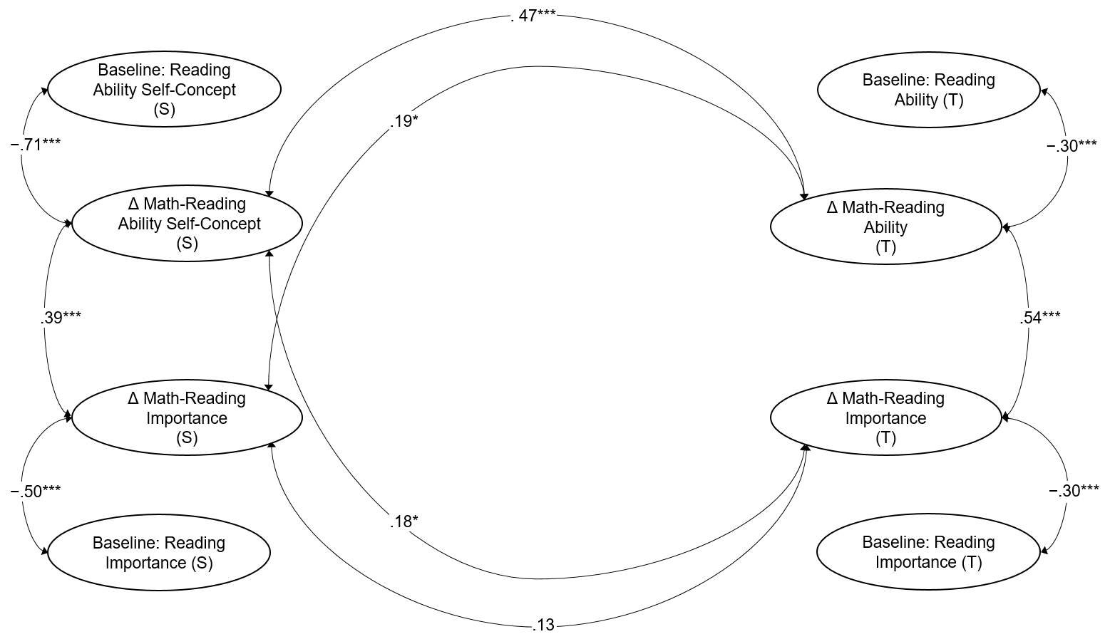
Note. Correlations between the latent variables (all reading and difference scores) are also included in the model but are not shown in the figure for simplification. S = student-rated; T = teacher-rated.

Supplement S.7

Figure S.7.1
Frequencies of the Mean Plausible Values for all Latent Difference Scores

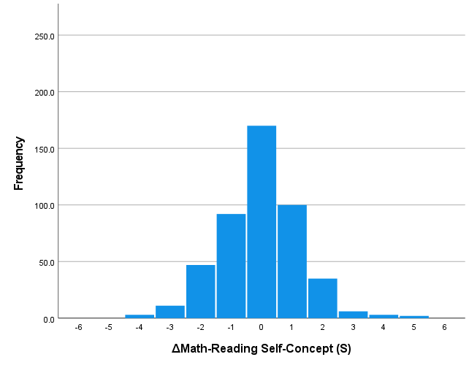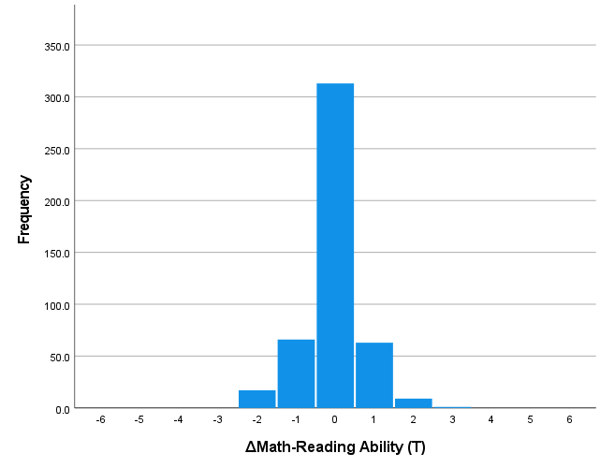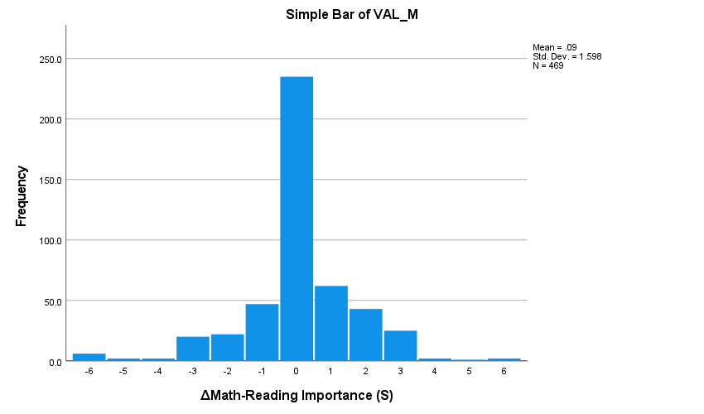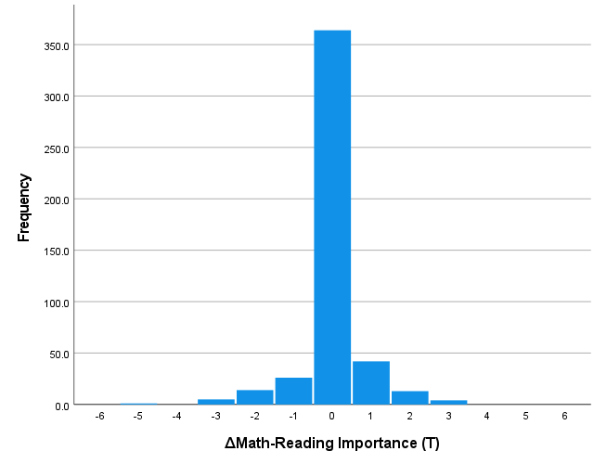

Note. Plausible values were generated for each latent difference score using Bayesian estimation. S = student-rated; T = teacher-rated.

Figure S.7.2
Mean Plausible Values for all Latent Difference Scores per Student separated by Gender
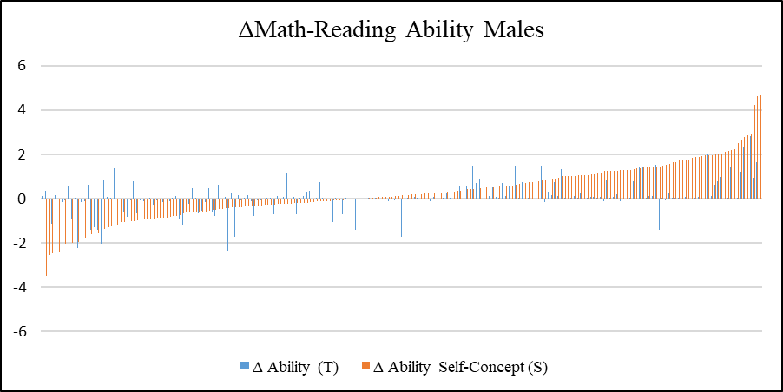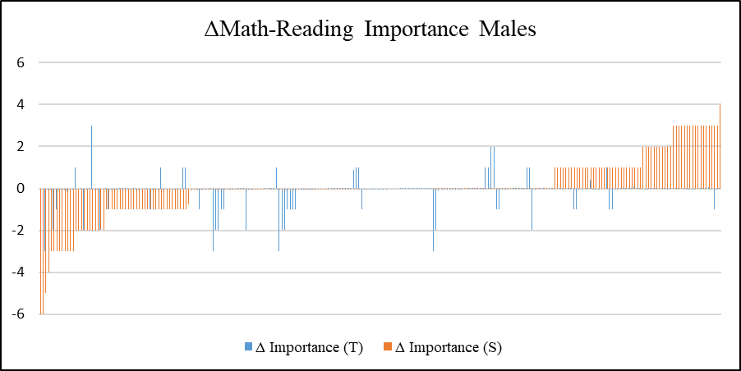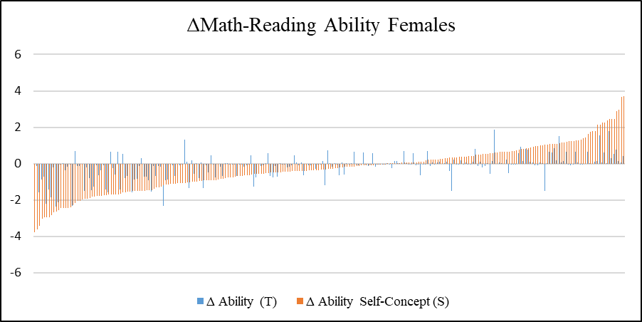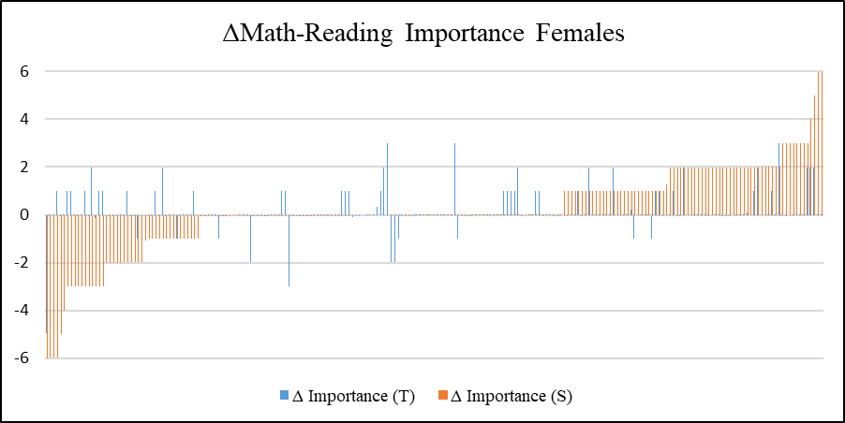
Note. Plausible values were generated for each latent difference score using Bayesian estimation. S = student-rated; T = teacher-rated.

Supplement S.8

Table S.8
Gender-Specific Latent Means and Variances of Perceptions of Students’ Importance and Ability in Reading and of the Latent Difference Scores and Amount of Students With Significant Differences Between the Subjects
 | Student |  |  |  |  |  |  | Teacher |  |  |  |  |  |  |  |  |  | Student |  |  |  |  |  | Teacher
Variable | Reading |  |  | ΔMath-Reading |  |  |  | Reading |  |  |  |  | ΔMath-Reading |  |  |  |  | ΔMath-Reading |  |  |  |  |  | ΔMath-Reading
Variable | M | σ² |  | M | σ² |  |  |  | M | σ² |  |  |  | M | σ² |  |  |  | Read>Math |  | Math>Read |  |  | Read>Math |  |  | Math>Read
 |  |  |  |  |  |  |  |  |  |  |  |  |  |  |  |  |  |  | M | % sign. | M | % sign. |  | M | % sign. |  | M | % sign.
Male students
Self-concept/  Ability | 5.52 | 1.05*** |  | 0.29** | 1.72*** |  |  |  | 5.02 | 1.15*** |  |  |  | 0.10 | 0.47*** |  |  |  | −0.82 | 11% | 1.10 | 24% |  | −0.37 |  | 12% | 0.44 | 20%
Importance | 5.73 | 2.21*** |  | 0.16 | 3.10*** |  |  |  | 5.18 | 2.19*** |  |  |  | 0.18* | 0.67*** |  |  |  | −1.20 | 20% | 1.13 | 33% |  | −0.32 |  | 5% | 0.46 | 19%
Female students
Self-concept/  Ability | 5.71 | 1.17*** |  | −0.39*** | 2.17*** |  |  |  | 5.04 | 1.22*** |  |  |  | −0.17* | 0.55*** |  |  |  | −1.09 | 23% | 0.88 | 11% |  | −0.48 |  | 23% | 0.34 | 14%
Importance | 5.90 | 1.75*** |  | 0.03 | 2.09*** |  |  |  | 5.58 | 1.55*** |  |  |  | −0.13* | 0.52*** |  |  |  | −0.86 | 22% | 1.04 | 25% |  | −0.46 |  | 13% | 0.22 | 7%
Note. Plausible values were generated for each latent difference score using Bayesian estimation to determine means and the amount of students with significant differences in students’ and teachers’ perception across the subjects separately for negative and positive difference scores. Read = reading. Sign. = significant.

Supplement S.9

TITLE: Mplus Syntax of the Final Latent Difference Score Model Including All Hypothesized Predictors
DATA: file = ldm.dat;
VARIABLE:
NAMES =
kidid Tmr teachw4
SCAm1 SCAm2 SCAm3 SCAm4
SCAr1 SCAr2 SCAr3 SCAr4
IMPm IMPr
Tabm1 Tabm2 Tabr1 Tabr2
Timpm Timpr
grade3 grade4 sex pareduc sIQ m3grd2a r3grd2a;

MISSING = all(-999,-888);
IDVARIABLE = kidid;
USEOBSERVATIONS = (Tmr == 1); ! selecting teachers that teach both reading and math;
CLUSTER = teachw4; ! cluster = students with the same teacher in wave 4;
USEVARIABLES =
SCAm1 SCAm2 SCAm3 SCAm4
SCAr1 SCAr2 SCAr3 SCAr4
IMPm IMPr
Tabm1 Tabm2 Tabr1 Tabr2
Timpm Timpr
grade3 grade4 sex pareduc sIQ m3grd2a r3grd2a;

MODEL:
! 1. LATENT MEASUREMENT MODEL: Specification of latent variables for each perspective
! (Student and teacher) and construct (self-concept/ability and importance) separately;
! S = Students’ ratings; T = Teachers’ ratings; m = math; r = reading;
! SCA = Self-concept of ability; I = Importance; AB = Ability;

! Self-concept: students’ ratings;
SCAm BY SCAm1@1;
SCAm BY SCAm2 (s1);
SCAm BY SCAm3 (s2);
SCAm BY SCAm4 (s3);

SCAr BY SCAr1@1;
SCAr BY SCAr2 (s1);
SCAr BY SCAr3 (s2);
SCAr BY SCAr4 (s3);
! For model identification: set one intercept to zero for each subject;
[SCAm1@0 SCAr1@0];
! Partial strong factorial invariance =
! Intercepts of observed variables equal across subjects (except for one item);
[SCAm2 SCAr2] (s4);
[SCAm3 SCAr3] (s5);
[SCAm4 SCAr4];
! Additional parameters: covariance between the residual variances of parallel items across subjects;
SCAm1 WITH SCAr1;
SCAm2 WITH SCAr2;
SCAm3 WITH SCAr3;
SCAm4 WITH SCAr4;
! Additional parameters: covariance between the residual variances of parallel items within a subject;
SCAr1 WITH SCAr2;
SCAm1 WITH SCAm2;

! Importance: students’ ratings;
Sim BY IMPm@1;
SIr BY IMPr@1;
! For model identification: set residual variance and intercept of one observed indicator to zero for each subject;
IMPm@0 IMPr@0;
[IMPm@0 IMPr@0];

! Ability: teachers’ ratings;
TABm BY Tabm1@1;
TABm BY Tabm2 (t1);

TABr BY Tabr1@1;
TABr BY Tabr2 (t1);
! For model identification: set one intercept for each subject to zero
[TABr1@0 TABm1@0];
! The residual variance of one indicator was negative and close to zero in some models and was thus fixed to zero;
TABr2@0;
! Strong measurement invariance: intercepts of observed variables equal across subjects
[TABm2 TABr2] (t2);

! Additional parameters: covariance between the residual variances of parallel items across subject;
TABm1 WITH TABr1;

! Importance: teachers’ ratings;
TIm BY Timpm@1;
TIr BY Timpr@1;
! For model identification: set residual variance and intercept of one observed indicator to zero for each subject;
Timpm@0 Timpr@0;
[Timpm@0 Timpr@0];

! 2. LATENT DIFFERENCE SCORE (LDS) MODEL
! define difference scores;
SCA BY;
SI BY;
TAB BY;
TI BY;

! Specify LDS through perfect regression from math on reading plus difference score (residual variance @0; reading = baseline);
SCAm ON SCAr@1 SCA@1;
SIm ON SIr@1 SI@1;
TABm ON TABr@1 TAB@1;
TIm ON TIr@1 TI@1;

SCAm@0 SIm@0 TABm@0 TIm@0;

! Freely estimating the means of all reading scores and difference scores;
[SCAr SCA];
[SIr SI];
[TABr TAB];
[TIr TI];

! Covariances between all difference scores;
SCA WITH SI TAB TI;
SI WITH TAB TI;
TAB WITH TI;

! Covariances between all reading scores;
SCAr WITH SIr TABr TIr;
SIr WITH TABr TIr;
TABr WITH TIr;

! Covariances between reading scores (baseline) and difference scores;
SCA WITH SCAr SIr TABr TIr;
SI WITH SCAr SIr TABr TIr;
Tab WITH SCAr SIr TABr TIr;
TI WITH SCAr SIr TABr TIr;

! Regressing difference scores on student characteristics;

SCA ON grade3 grade4 sex pareduc sIQ m3grd2a r3grd2a;
SI ON grade3 grade4 sex pareduc sIQ m3grd2a r3grd2a;
TAB ON grade3 grade4 sex pareduc sIQ m3grd2a r3grd2a;
TI ON grade3 grade4 sex pareduc sIQ m3grd2a r3grd2a;

! Regressing reading scores on student characteristics;

SCAr ON grade3 grade4 sex pareduc sIQ m3grd2a r3grd2a;
SIr ON grade3 grade4 sex pareduc sIQ m3grd2a r3grd2a;
TABr ON grade3 grade4 sex pareduc sIQ m3grd2a r3grd2a;
TIr ON grade3 grade4 sex pareduc sIQ m3grd2a r3grd2a;

! Covariances between all student characteristics;

grade3 WITH grade4 pareduc sex sIQ m3grd2a r3grd2a;
grade4 WITH pareduc sex sIQ m3grd2a r3grd2a;
pareduc WITH sex sIQ m3grd2a r3grd2a;
sex WITH sIQ m3grd2a r3grd2a;
sIQ WITH m3grd2a r3grd2a;
r3grd2a WITH m3grd2a;

ANALYSIS:
estimator = MLR;
model = nocovariances;
type = complex;

OUTPUT:
stdyx;
tech4;
sampstat;
svalues;
modindices(3.84);

