Effectiveness of interventions in teacher education: Synthesis of reviews (2010–2024)
Stichwort Wirksamkeit von Interventionen in der Lehrkräftebildung: Synthese von Reviews (2010–2024)

Supplementary Material

Table S1 Overview of included meta-analyses
Meta-analysis | Intervention | Outcomes | n_{studies}
Ma et al. (2023) | Blended teaching vs. traditional teaching | Teachers’ academic performance (K)  Anxiety (A)  Attitude (A)  Self-efficacy for teaching (A) | 15
Ning et al. (2022) | Teacher education interventions | Teachers’ technological pedagogical content knowledge (K) | 59
Wilson (2023) | Technology integration courses | Pedagogical beliefs on teaching and learning with technology:  Attitudes (A)  Beliefs (A) | 39
Wilson et al. (2020) | Technology integration courses | Technology-related knowledge (K) | 38
Brock & Carter (2017) | Trainings to foster evidence-based practices (dealing with students with disabilities) | Implementation fidelity of evidence-based practices (B) | 12
Dignath et al. (2022) | Training and interventions about inclusive education | Beliefs about inclusive education:  Cognitive appraisals  Emotional appraisals  Self-efficacy | 22
Basma and Savage (2023) | Teacher professional development | Students’ reading achievement (S) | 14
Didion et al. (2020) | Teacher professional development | Reading outcomes (S) | 28
Ansyari et al. (2022) | Data use (professional development interventions) | Student outcomes (S) | 17
Zhang et al. (2023) | Interventions aiming at promoting teachers’ STEM perceptions | Teachers‘ perceptions about STEM:  STEM knowledge (K)  STEM instruction (B)  STEM learning (S) | 23
Zhou et al. (2023) | Teacher professional development training | STEM teacher self-efficacy (A) | 21
Oliveira et al. (2021) | Social and Emotional Skills Interventions to prevent/reduce burnout | Teacher burnout (A) | 13
Kraft et al. (2018) | Teacher coaching | Teacher instruction (B)  Student achievement (S) | 60
Smith and Sheridan (2019) | Teacher-training programs | Knowledge about family engagement (K)  Attitudes toward family engagement (A)  Family engagement practices (B) | 39
Note. (K) = knowledge, (A) = attitudes/beliefs/affect, (B) = behavior, (S) = student achievement

Investigation of publication bias
Method
The risk of bias in the results due to publication bias was assessed through visual inspection of funnel plots. Additionally, the Fail-Safe-N method following Orwin (1983) was used to determine how many unpublished meta-analyses with null effects would be necessary to reduce the observed effect size to g = 0.10.
Results
For all conducted meta-analyses, asymmetries in the distribution are evident (see Figures S1–S5). Particularly, it is clear from the overall effect that studies with lower precision or smaller sample sizes report higher effect sizes compared to studies with higher precision. This could suggest that meta-analyses with relatively low precision, which report smaller effect sizes, may not be published or may not appear in peer-reviewed journals.
In contrast, the Fail-Safe-N analysis suggests a relative stability of the results. To reduce the effect size to g = 0.10, between 7 and 60 unpublished meta-analyses with null effects would be required (overall: 60; knowledge: 39; beliefs/attitudes/affect: 21; behavior/instruction/practice: 27; student learning: 7).
References
Orwin, R. G. (1983). A fail-safe n for effect size in meta-analysis. Journal of Educational Statistics, 8, 157-159. https://doi.org/10.3102/10769986008002157

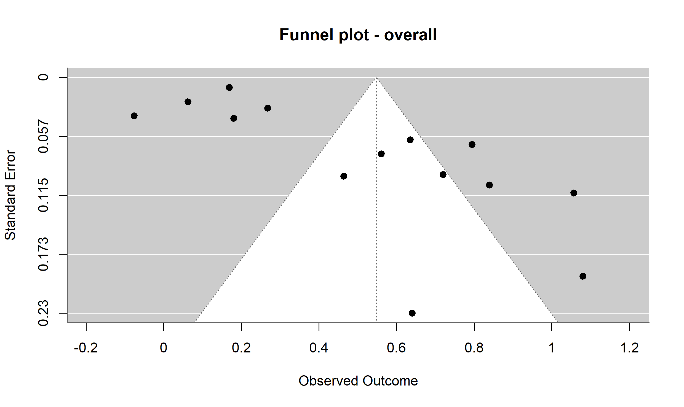
Figure S1: Funnel plot of the overall effect
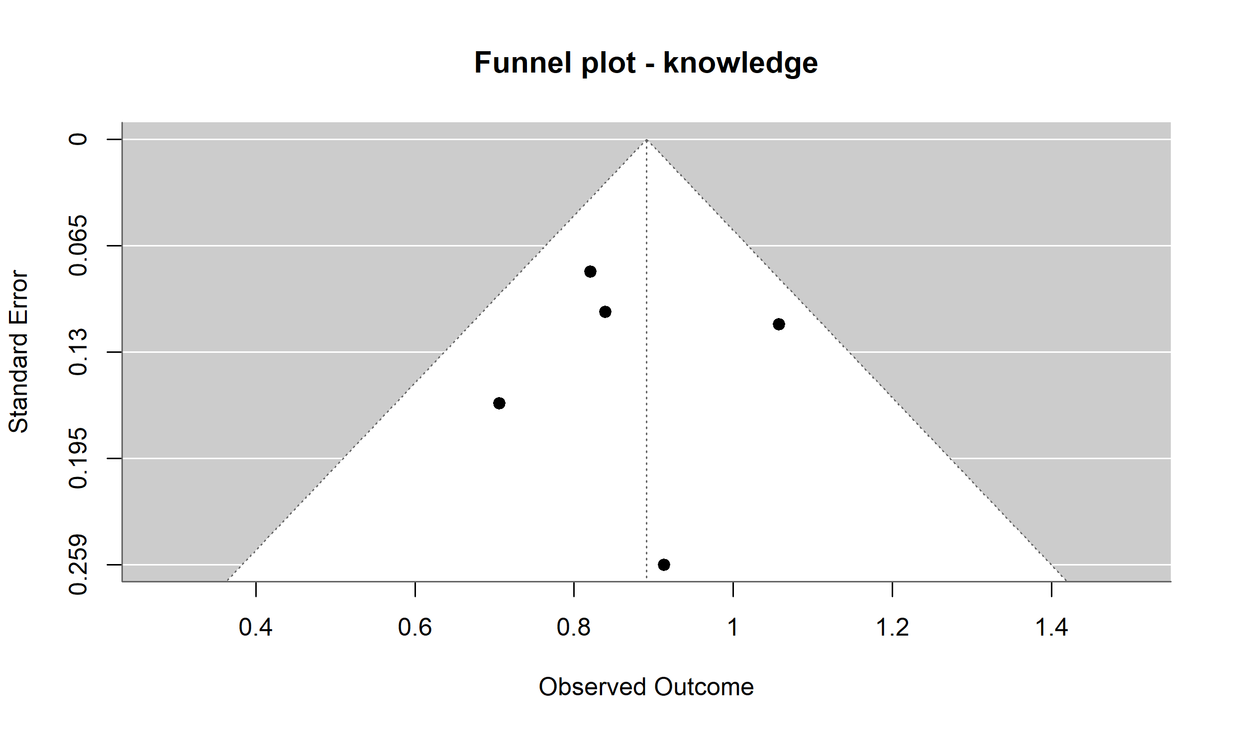
Figure S2: Funnel plot of intervention effects on knowledge

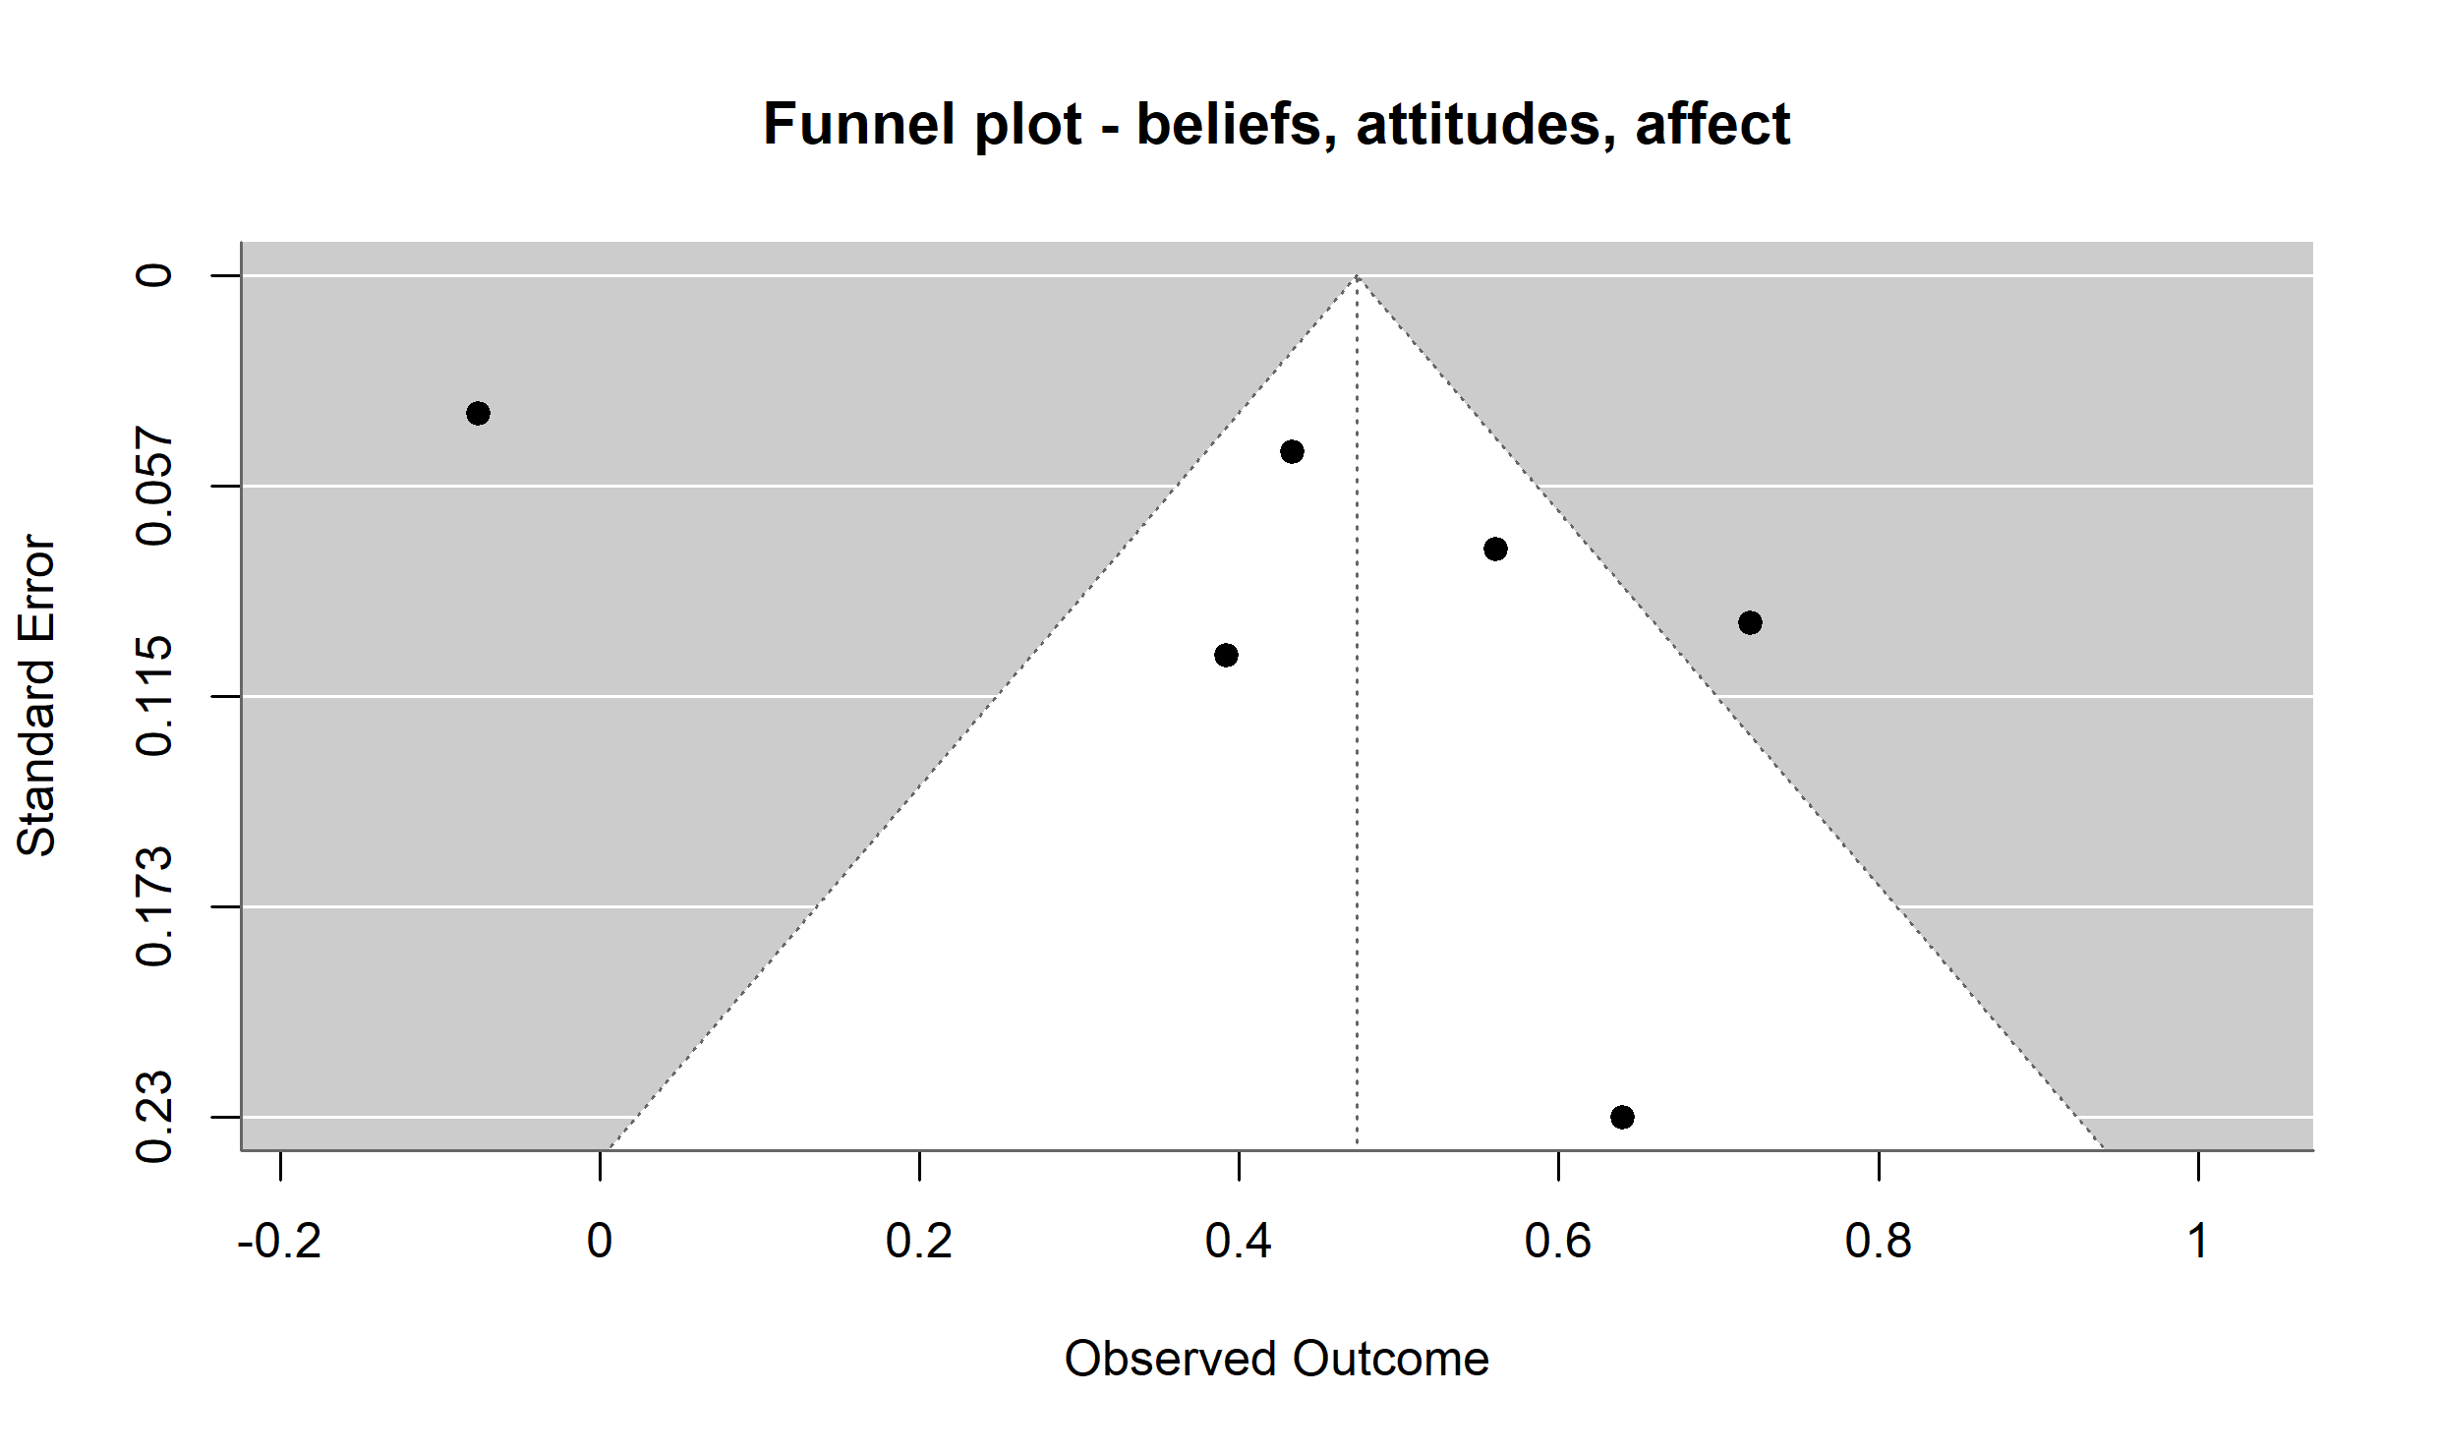
Figure S3: Funnel plot of intervention effects on beliefs, attitudes, and affect

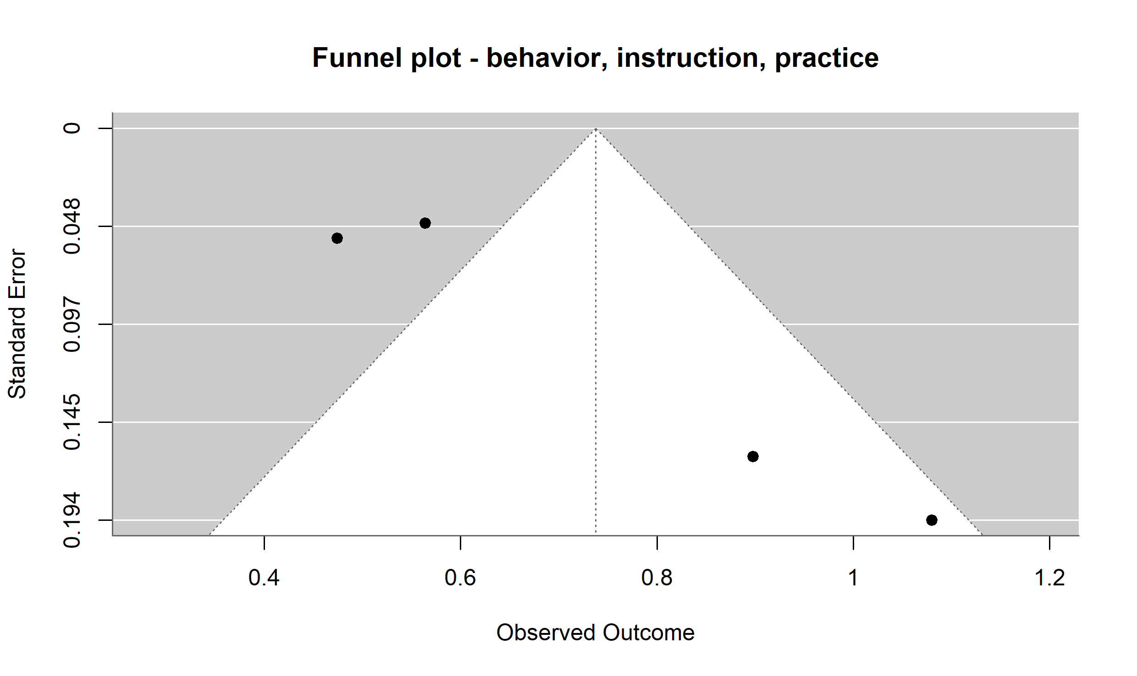
Figure S4: Funnel plot of intervention effects on behavior, instructional quality, and practice

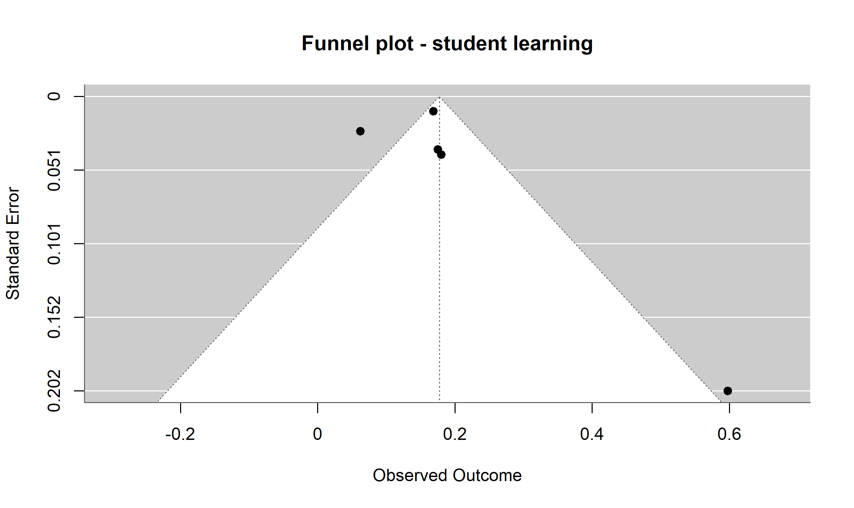
Figure S5: Funnel plot of intervention effects on student learning

