Appendix
Table A1: Comparison of the weighted sample of SITCO with official statistics of student population
Gender (in %) | Official Statistics 2020¹ | SITCO 2020
Male | 51 | 52
Female | 49 | 48
Total (N) | 2,891,049 | 25,726
Subject group (in %) | Official Statistics 2020¹ | SITCO 2020
Humanities | 12 | 14
Sports Science | 1 | 1
Law, Economics, and Social Sciences | 37 | 35
Mathematics, Natural Sciences | 11 | 13
Human Medicine, Health Sciences | 6 | 4
Agricultural, Forestry and Nutritional Sciences | 2 | 2
Engineering | 27 | 27
Art, Art History | 3 | 3
Total (N) | 2,891,049 | 25,726
Study degree (in %) | Official Statistics 2020² | SITCO 2020 | SiD 2021
BA | 50 | 55 | 57
MA | 28 | 28 | 28
Other | 22 | 17 | 15
Total (N) | 476,913 | 25,726 | 177,277
¹ Source: https://www.hrk.de/fileadmin/redaktion/hrk/02-Dokumente/02-03-Studium/02-03-01-Studium-Studienreform/HRK_Statistik_BA_MA_UEbrige_WiSe_2020_21_finale.pdf
² Source: https://www.destatis.de/DE/Presse/Pressemitteilungen/2021/09/PD21_414_213.html
The discrepancies with the official statistics regarding study degree (BA) may be due to the fact that the official data refer only to the degrees of the graduation cohort, not to all enrolled students. Comparisons with nationwide representative data of the Student Survey in Germany (SiD), which also includes enrolled students, show very similar results to our data.

Table A2: Digital teaching formats and dropout intentions among students with children (main model presented in Tab. 1, including missing values in the control variables)
 | (1) | (2) | (3) | (4)
Digital teaching formats
Courses with uploaded videos | -0.05* | -0.03 | -0.04 | -0.02
Courses with learning materials | -0.01 | -0.01 | 0.00 | -0.00
Courses with assignments | 0.01 | 0.00 | 0.01 | 0.00
Courses with interactive features | -0.08*** | -0.08** | -0.06** | -0.06*
Mechanism behind DT
Digital teaching allows flexibility |  | -0.09*** |  | -0.08***
Contact with students became easier |  |  | -0.04 | -0.03
Communication with lecturers became easier |  |  | -0.16*** | -0.14***
Control variables
First-generation student (ref. missing)
No | 0.12 | 0.16 | 0.08 | 0.11
Yes | 0.20 | 0.21 | 0.16 | 0.17
Study degree (ref. missing)
BA | -0.01 | -0.05 | -0.10 | -0.12
MA | -0.10 | -0.12 | -0.20 | -0.20
State examination | -0.21 | -0.23 | -0.31 | -0.31
Diploma | 0.34 | 0.34 | 0.34 | 0.34
Other degree | -0.29 | -0.38 | -0.29 | -0.38
Gender (ref. missing)
Male | 0.06 | 0.05 | 0.20 | 0.18
Female | 0.06 | 0.08 | 0.22 | 0.22
Diverse | 0.99* | 1.03* | 1.11* | 1.14*
Other | 0.46 | 0.46 | 0.51 | 0.50
Field of study (ref. missing)
Humanities | -0.07 | -0.05 | -0.04 | -0.03
Social Sciences | -0.02 | -0.01 | -0.03 | -0.01
Sport Sciences | -0.41 | -0.40 | -0.41 | -0.40
Law | 0.17 | 0.21 | 0.23 | 0.25
Business and Economics | 0.02 | 0.03 | 0.04 | 0.04
Informatics | -0.14 | -0.10 | -0.07 | -0.05
Natural Sciences | 0.30⁺ | 0.29⁺ | 0.31⁺ | 0.30⁺
Medicine | -0.01 | 0.00 | 0.05 | 0.05
Agricultural, Forestry and Food Sciences | 0.02 | 0.02 | 0.06 | 0.05
Engineering | -0.02 | -0.03 | -0.01 | -0.01
Art Studies | -0.03 | 0.01 | -0.04 | -0.00
Study semester (ref. missing)
2 | -0.32⁺ | -0.31⁺ | -0.27⁺ | -0.27⁺
3–4 | -0.32* | -0.31* | -0.30⁺ | -0.29⁺
5–6 | -0.22 | -0.21 | -0.23 | -0.22
7–8 | -0.28⁺ | -0.29⁺ | -0.26 | -0.27
9–10 | -0.39* | -0.40* | -0.37* | -0.38*
11–12 | -0.18 | -0.17 | -0.13 | -0.13
13–14 | -0.17 | -0.17 | -0.18 | -0.18
>15 | -0.11 | -0.11 | -0.10 | -0.10
Limited financial support of parents (ref. missing)
1: does not apply at all | 0.04 | 0.17⁺ | 0.05 | 0.15
2 | 0.11 | 0.22 | 0.11 | 0.21
3 | 0.13 | 0.23* | 0.13 | 0.21⁺
4 | 0.05 | 0.17 | 0.05 | 0.15
5: fully applies | 0.23** | 0.33*** | 0.20* | 0.29***
Job loss (ref. missing)
no | 0.01 | 0.18 | -0.02 | 0.13
yes | 0.15 | 0.29 | 0.13 | 0.24
Grade for previous semester (ref. missing)
I have no grades | 0.06 | 0.05 | 0.04 | 0.03
1 (best) | -0.18 | -0.18 | -0.19 | -0.19
2 | -0.11 | -0.14 | -0.13 | -0.15
3 | -0.12 | -0.13 | -0.13 | -0.14
4 | -0.28 | -0.26 | -0.29 | -0.27
5 (worst) | 1.80* | 1.81** | 1.77* | 1.79**
Grade for current semester (ref. missing)
I have no grades | 0.05 | 0.05 | 0.06 | 0.06
1 (best) | -0.16 | -0.14 | -0.14 | -0.13
2 | -0.05 | -0.03 | -0.04 | -0.02
3 | 0.11 | 0.13 | 0.12 | 0.14
4 | -0.06 | -0.13 | -0.15 | -0.20
5 (worst) | -1.05⁺ | -1.03⁺ | -1.02⁺ | -1.00⁺
Constant | 2.01 | 1.99 | 2.29 | 2.24
Observations | 1,571 | 1,571 | 1,571 | 1,571
AIC | 4848 | 4818 | 4813 | 4792
BIC | 5138 | 5113 | 5113 | 5097
+ p < 0.10. * p < 0.05. ** p < .01. *** p < .001. OLS regression models. We use the original Likert scale (1–5) for digital teaching formats and mechanism behind them. Source: SITCO survey 2020.

Table A3: Descriptions of the analytical sample of students with children
 | mean | sd | min | max
Dropout intention | 1.60 | 1.2 | 1 | 5
First-generation student | 0.51 |  | 0 | 1
Gender
Male | 0.46 |  | 0 | 1
Female | 0.54 |  | 0 | 1
Other | 0.00 |  | 0 | 1
Limited financial support from parents | 3.32 | 1.7 | 1 | 5
Job loss | 0.18 |  | 0 | 1
Study semester | 8.32 | 4.5 | 2 | 15
Grade for previous semester | 2.05 | 0.7 | 1 | 5
Grade for current semester | 2.15 | 0.7 | 1 | 5
Study degree
BA | 0.50 |  | 0 | 1
MA | 0.35 |  | 0 | 1
State exam. | 0.12 |  | 0 | 1
Diploma | 0.01 |  | 0 | 1
Other | 0.02 |  | 0 | 1
Field of study
Humanities | 0.19 |  | 0 | 1
Social Sciences | 0.34 |  | 0 | 1
Sport Sciences | 0.01 |  | 0 | 1
Law | 0.04 |  | 0 | 1
Business and Economics | 0.09 |  | 0 | 1
Informatics | 0.07 |  | 0 | 1
Natural Sciences | 0.08 |  | 0 | 1
Medicine | 0.04 |  | 0 | 1
Agricultural, Forestry and Food Sciences | 0.02 |  | 0 | 1
Engineering | 0.11 |  | 0 | 1
Art Studies | 0.02 |  | 0 | 1
Observations | 989
Weighted data of the analytical sample. Source: SITCO survey 2020

Figure A1: Dropout intentions among students with children (in %)
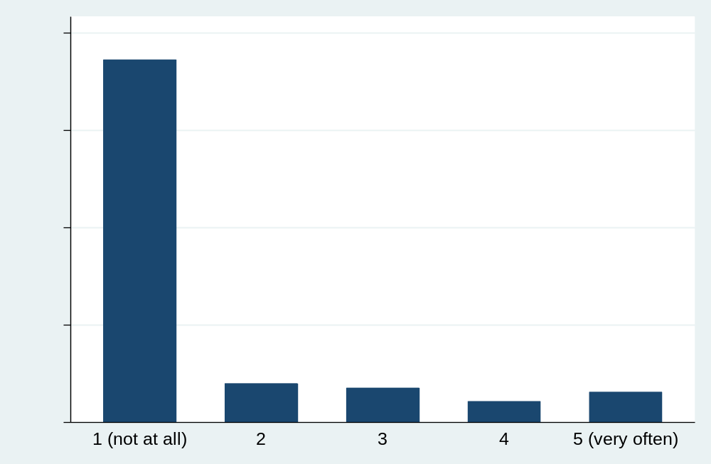
Weighted data of the analytical sample. Question wording: To what extent are you currently thinking about giving up your studies altogether? 1: not at all - 5: very often. Source: SITCO survey 2020.

Table A4: Descriptive results on students with children compared to students without children
 | Students with children |  | Students without children
Dropout intention (mean) | 1.60 |  | 1.45 | ***
Psychological burdens
Felt stressed in recent weeks | 73 |  | 69 | **
Felt overloaded in recent weeks | 70 |  | 57 | ***
Digital teaching formats
Interactive features (min. 50% courses) | 81 |  | 81 | ns
Uploaded videos (min. 50% courses) | 40 |  | 51 | ***
Learning materials (min. 50% courses) | 62 |  | 57 | ***
Assignments (min. 50% courses) | 57 |  | 52 | **
Mechanism behind digital teaching
Digital teaching is more flexible | 79 |  | 82 | ns
Contact with students got easier | 15 |  | 12 | **
Communication with lecturers got easier | 40 |  | 38 | ns
N | 989 |  | 15,700
Weighted data of the analytical sample. Source: SITCO survey 2020

Table A5: Explaining the higher dropout intention of students with children (compared to students without children)
 | (1) | (2) | (3) | (4) | (5) | (6)
Students with children (ref. without children) | 0.12*** | 0.12*** | 0.12*** | 0.09* | 0.06⁺ | 0.05
Students with children (ref. without children) | (0.03) | (0.03) | (0.03) | (0.03) | (0.03) | (0.03)
Sociodemography
First-generation students |  | 0.04** | 0.03* | -0.03⁺ | 0.03⁺ | -0.01
 |  | (0.02) | (0.02) | (0.02) | (0.02) | (0.02)
Gender (ref. male)
Female |  | -0.04* | -0.03 | -0.03⁺ | -0.09*** | -0.09***
 |  | (0.02) | (0.02) | (0.02) | (0.02) | (0.02)
Diverse |  | 0.58*** | 0.58*** | 0.53*** | 0.46*** | 0.43***
 |  | (0.09) | (0.09) | (0.09) | (0.08) | (0.08)
Other |  | 0.20 | 0.18 | 0.18 | 0.16 | 0.16
 |  | (0.13) | (0.12) | (0.12) | (0.12) | (0.12)
Academic characteristics
Intended degree (ref. BA)
MA |  | -0.05* | -0.01 | -0.01 | -0.01 | -0.01
 |  | (0.02) | (0.02) | (0.02) | (0.02) | (0.02)
State exam. |  | -0.08** | -0.12*** | -0.10*** | -0.13*** | -0.12***
 |  | (0.03) | (0.03) | (0.03) | (0.03) | (0.03)
Diploma |  | -0.04 | -0.08 | -0.08 | -0.07 | -0.07
 |  | (0.11) | (0.11) | (0.10) | (0.10) | (0.10)
Other |  | -0.04 | -0.11 | -0.10 | -0.08 | -0.07
 |  | (0.10) | (0.10) | (0.10) | (0.09) | (0.09)
Field of study (ref. Humanities)
Social Sciences |  | -0.08** | -0.08** | -0.06* | -0.06* | -0.05*
 |  | (0.03) | (0.03) | (0.03) | (0.03) | (0.03)
Sport Sciences |  | -0.23** | -0.27*** | -0.28*** | -0.19* | -0.20**
 |  | (0.08) | (0.08) | (0.08) | (0.08) | (0.08)
Law |  | -0.07 | -0.18*** | -0.15*** | -0.11** | -0.09*
 |  | (0.04) | (0.04) | (0.04) | (0.04) | (0.04)
Business and Economics |  | -0.16*** | -0.20*** | -0.16*** | -0.16*** | -0.14***
 |  | (0.03) | (0.03) | (0.03) | (0.03) | (0.03)
Informatics |  | -0.02 | -0.05 | -0.01 | -0.03 | -0.00
 |  | (0.04) | (0.04) | (0.04) | (0.04) | (0.04)
Natural Sciences |  | -0.09** | -0.13*** | -0.08** | -0.10*** | -0.07*
 |  | (0.03) | (0.03) | (0.03) | (0.03) | (0.03)
Medicine |  | -0.21*** | -0.25*** | -0.20*** | -0.14** | -0.11*
 |  | (0.05) | (0.05) | (0.05) | (0.04) | (0.04)
Agricultural, Forestry and Food Sciences |  | 0.03 | -0.01 | 0.01 | 0.04 | 0.06
Agricultural, Forestry and Food Sciences |  | (0.06) | (0.06) | (0.06) | (0.06) | (0.06)
Engineering |  | -0.13*** | -0.18*** | -0.14*** | -0.16*** | -0.12***
 |  | (0.03) | (0.03) | (0.03) | (0.03) | (0.03)
Arts Studies |  | -0.10* | -0.09⁺ | -0.10* | -0.06 | -0.07
 |  | (0.05) | (0.05) | (0.05) | (0.05) | (0.05)
Study semester |  | -0.00 | 0.00 | -0.01 | 0.00 | 0.00
 |  | (0.00) | (0.00) | (0.00) | (0.00) | (0.00)
Grade for previous semester (ref. I did not receive grades)
1 (best) |  |  | -0.22*** | -0.20*** | -0.22*** | -0.21***
 |  |  | (0.03) | (0.03) | (0.03) | (0.03)
2 |  |  | -0.17*** | -0.16*** | -0.17*** | -0.16***
 |  |  | (0.02) | (0.02) | (0.02) | (0.02)
3 |  |  | -0.06* | -0.06* | -0.07** | -0.07**
 |  |  | (0.03) | (0.03) | (0.03) | (0.03)
4 |  |  | 0.08 | 0.09 | 0.08 | 0.08
 |  |  | (0.06) | (0.06) | (0.06) | (0.06)
5 (worse) |  |  | 0.26 | 0.25 | 0.28⁺ | 0.27
 |  |  | (0.17) | (0.17) | (0.17) | (0.17)
Grade for current semester (ref. I did not receive grades)
1 (best) |  |  | -0.16*** | -0.14*** | -0.11*** | -0.11***
 |  |  | (0.03) | (0.03) | (0.03) | (0.03)
2 |  |  | -0.09*** | -0.08*** | -0.06** | -0.06**
 |  |  | (0.02) | (0.02) | (0.02) | (0.02)
3 |  |  | 0.10*** | 0.10*** | 0.11*** | 0.11***
 |  |  | (0.03) | (0.03) | (0.03) | (0.03)
4 |  |  | 0.22** | 0.20* | 0.20** | 0.19*
 |  |  | (0.08) | (0.08) | (0.08) | (0.08)
5 (worse) |  |  | 0.93*** | 0.92*** | 0.82*** | 0.82***
 |  |  | (0.17) | (0.17) | (0.17) | (0.17)
Financial difficulties
Financial support from parents was limited during the pandemic |  |  |  | 0.07*** |  | 0.05***
 |  |  |  | (0.01) |  | (0.01)
I lost my job during the pandemic |  |  |  | 0.13*** |  | 0.11***
 |  |  |  | (0.02) |  | (0.02)
Psychological burdens
Felt overloaded in recent weeks |  |  |  |  | 0.15*** | 0.14***
 |  |  |  |  | (0.01) | (0.01)
Felt stressed in recent weeks |  |  |  |  | 0.07*** | 0.07***
 |  |  |  |  | (0.01) | (0.01)
Constant | 1.45 | 1.56 | 1.72 | 1.53 | 0.90 | 0.81
Observations | 16,689 | 16,689 | 16,689 | 16,689 | 16,689 | 16,689
AIC | 47595 | 47486 | 47160 | 46924 | 46263 | 46137
BIC | 47610 | 47648 | 47399 | 47179 | 46517 | 46406
+ p < 0.10. * p < 0.05. ** p < .01. *** p < .001. Standard errors in parentheses. OLS regression models. Source: SITCO survey 2020.

Table A6: Digital teaching formats and dropout intention (main models presented in Tab. 1, including control variables and coefficients for students without children)
 | Students with children |  |  |  | Students without children
 | (1) | (2) | (3) | (4) | (5) | (6) | (7) | (8)
Digital teaching formats
Courses with uploaded videos | -0.06* | -0.02 | -0.05 | -0.02 | -0.02** | -0.00 | -0.02* | 0.00
 | (0.03) | (0.03) | (0.03) | (0.03) | (0.01) | (0.01) | (0.01) | (0.01)
Courses with learning materials | -0.01 | -0.01 | -0.00 | -0.00 | -0.01 | -0.01 | -0.01 | -0.01
 | (0.03) | (0.03) | (0.03) | (0.03) | (0.01) | (0.01) | (0.01) | (0.01)
Courses with assignments | -0.01 | -0.03 | -0.01 | -0.02 | 0.01* | 0.01⁺ | 0.01* | 0.01⁺
 | (0.03) | (0.03) | (0.03) | (0.03) | (0.01) | (0.01) | (0.01) | (0.01)
Courses with interactive features | -0.07* | -0.06⁺ | -0.06⁺ | -0.05 | -0.06*** | -0.05*** | -0.04*** | -0.04***
 | (0.03) | (0.03) | (0.03) | (0.03) | (0.01) | (0.01) | (0.01) | (0.01)
Mechanism behind DT
Digital teaching allows flexibility |  | -0.18*** |  | -0.16*** |  | -0.10*** |  | -0.09***
 |  | (0.03) |  | (0.03) |  | (0.01) |  | (0.01)
Contact with students became easier |  |  | -0.07 | -0.05 |  |  | -0.05*** | -0.04***
Contact with students became easier |  |  | (0.05) | (0.05) |  |  | (0.01) | (0.01)
Communication with lecturers became easier |  |  | -0.13*** | -0.09* |  |  | -0.09*** | -0.07***
Communication with lecturers became easier |  |  | (0.04) | (0.04) |  |  | (0.01) | (0.01)
Control variables
First-generation student | 0.11 | 0.09 | 0.11 | 0.10 | -0.03⁺ | -0.03⁺ | -0.02 | -0.02
 | (0.08) | (0.07) | (0.08) | (0.07) | (0.02) | (0.02) | (0.02) | (0.02)
Study degree (ref. BA)
MA | -0.09 | -0.08 | -0.08 | -0.07 | 0.01 | 0.00 | 0.01 | 0.00
 | (0.09) | (0.08) | (0.09) | (0.08) | (0.02) | (0.02) | (0.02) | (0.02)
State exam. | -0.24⁺ | -0.24⁺ | -0.24⁺ | -0.24⁺ | -0.11*** | -0.10*** | -0.10*** | -0.10***
 | (0.14) | (0.13) | (0.14) | (0.13) | (0.03) | (0.03) | (0.03) | (0.03)
Diploma | 0.54 | 0.59⁺ | 0.65⁺ | 0.67⁺ | -0.15 | -0.17 | -0.16 | -0.17
 | (0.37) | (0.36) | (0.37) | (0.36) | (0.11) | (0.11) | (0.11) | (0.11)
Other | -0.32 | -0.46 | -0.26 | -0.39 | -0.08 | -0.10 | -0.06 | -0.08
 | (0.33) | (0.33) | (0.33) | (0.33) | (0.10) | (0.10) | (0.10) | (0.10)
Gender (ref. male)
Female | -0.08 | -0.03 | -0.03 | -0.00 | -0.03⁺ | -0.02 | -0.03 | -0.02
 | (0.09) | (0.08) | (0.09) | (0.08) | (0.02) | (0.02) | (0.02) | (0.02)
Diverse | 2.08*** | 2.12*** | 2.06*** | 2.10*** | 0.47*** | 0.46*** | 0.45*** | 0.44***
 | (0.51) | (0.50) | (0.51) | (0.50) | (0.09) | (0.08) | (0.09) | (0.08)
Other | 0.62 | 0.56 | 0.66 | 0.60 | 0.15 | 0.16 | 0.15 | 0.16
 | (0.65) | (0.63) | (0.64) | (0.63) | (0.12) | (0.12) | (0.12) | (0.12)
Field of study (ref. Humanities)
Social Sciences | 0.08 | 0.06 | 0.04 | 0.04 | -0.06* | -0.05* | -0.07* | -0.06*
 | (0.11) | (0.11) | (0.11) | (0.11) | (0.03) | (0.03) | (0.03) | (0.03)
Sport Sciences | -0.46 | -0.44 | -0.52 | -0.49 | -0.29*** | -0.28*** | -0.28*** | -0.27***
 | (0.47) | (0.46) | (0.46) | (0.45) | (0.08) | (0.08) | (0.08) | (0.08)
Law | 0.19 | 0.26 | 0.22 | 0.27 | -0.14** | -0.14** | -0.14** | -0.15***
 | (0.20) | (0.20) | (0.20) | (0.20) | (0.04) | (0.04) | (0.04) | (0.04)
Business and Economics | 0.12 | 0.15 | 0.13 | 0.15 | -0.17*** | -0.15*** | -0.16*** | -0.15***
 | (0.16) | (0.16) | (0.16) | (0.16) | (0.03) | (0.03) | (0.03) | (0.03)
Informatics | -0.04 | -0.01 | 0.01 | 0.02 | 0.02 | 0.05 | 0.04 | 0.06
 | (0.17) | (0.17) | (0.17) | (0.17) | (0.04) | (0.04) | (0.04) | (0.04)
Natural Sciences | 0.47** | 0.41* | 0.44** | 0.40* | -0.10*** | -0.09** | -0.10** | -0.09**
 | (0.17) | (0.17) | (0.17) | (0.17) | (0.03) | (0.03) | (0.03) | (0.03)
Medicine | 0.10 | 0.09 | 0.11 | 0.11 | -0.19*** | -0.17*** | -0.19*** | -0.17***
 | (0.21) | (0.21) | (0.21) | (0.21) | (0.05) | (0.05) | (0.05) | (0.05)
Agricultural, Forestry and Food Sciences | 0.07 | -0.01 | 0.01 | -0.04 | 0.00 | 0.02 | 0.02 | 0.03
Agricultural, Forestry and Food Sciences | (0.27) | (0.26) | (0.27) | (0.26) | (0.06) | (0.06) | (0.06) | (0.06)
Engineering | 0.07 | 0.05 | 0.08 | 0.06 | -0.14*** | -0.13*** | -0.14*** | -0.13***
 | (0.16) | (0.15) | (0.16) | (0.15) | (0.03) | (0.03) | (0.03) | (0.03)
Art Studies | 0.15 | 0.14 | 0.11 | 0.11 | -0.10* | -0.10* | -0.09⁺ | -0.09⁺
 | (0.29) | (0.29) | (0.29) | (0.28) | (0.05) | (0.05) | (0.05) | (0.05)
Grade previous semester (ref. no grade)
1 | -0.33* | -0.35** | -0.30* | -0.32* | -0.19*** | -0.20*** | -0.20*** | -0.21***
 | (0.14) | (0.13) | (0.13) | (0.13) | (0.03) | (0.03) | (0.03) | (0.03)
2 | -0.29** | -0.32** | -0.29** | -0.32** | -0.15*** | -0.16*** | -0.16*** | -0.17***
 | (0.10) | (0.10) | (0.10) | (0.10) | (0.02) | (0.02) | (0.02) | (0.02)
3 | -0.22⁺ | -0.23⁺ | -0.20 | -0.22⁺ | -0.05⁺ | -0.06* | -0.06* | -0.06*
 | (0.13) | (0.13) | (0.13) | (0.13) | (0.03) | (0.03) | (0.03) | (0.03)
4 | -0.70* | -0.62* | -0.65* | -0.60* | 0.16* | 0.16* | 0.15* | 0.15*
 | (0.30) | (0.30) | (0.30) | (0.30) | (0.07) | (0.06) | (0.06) | (0.06)
5 | 1.35 | 1.32 | 1.24 | 1.25 | 0.23 | 0.17 | 0.25 | 0.19
 | (1.20) | (1.18) | (1.19) | (1.17) | (0.17) | (0.17) | (0.17) | (0.17)
Grade current semester (ref. no grade)
1 | -0.30* | -0.25⁺ | -0.29* | -0.25⁺ | -0.13*** | -0.12*** | -0.12*** | -0.12***
 | (0.15) | (0.15) | (0.15) | (0.15) | (0.03) | (0.03) | (0.03) | (0.03)
2 | -0.06 | -0.05 | -0.05 | -0.05 | -0.08*** | -0.07*** | -0.07*** | -0.07***
 | (0.10) | (0.09) | (0.10) | (0.09) | (0.02) | (0.02) | (0.02) | (0.02)
3 | 0.10 | 0.12 | 0.10 | 0.12 | 0.10*** | 0.10*** | 0.11*** | 0.11***
 | (0.12) | (0.12) | (0.12) | (0.12) | (0.03) | (0.03) | (0.03) | (0.03)
4 | -0.27 | -0.40 | -0.37 | -0.46 | 0.20* | 0.20** | 0.21** | 0.21**
 | (0.44) | (0.43) | (0.44) | (0.43) | (0.08) | (0.08) | (0.08) | (0.08)
5 | -0.85 | -1.32 | -0.65 | -1.14 | 0.96*** | 0.99*** | 0.96*** | 0.99***
 | (1.13) | (1.11) | (1.12) | (1.11) | (0.17) | (0.17) | (0.17) | (0.17)
Study semester | 0.03 | 0.03 | 0.02 | 0.02 | -0.01⁺ | -0.01 | -0.01⁺ | -0.01
 | (0.02) | (0.02) | (0.02) | (0.02) | (0.00) | (0.00) | (0.00) | (0.00)
Limited financial support from parents | 0.03 | 0.02 | 0.02 | 0.02 | 0.07*** | 0.06*** | 0.06*** | 0.06***
 | (0.02) | (0.02) | (0.02) | (0.02) | (0.01) | (0.01) | (0.01) | (0.01)
Job loss | 0.25* | 0.26** | 0.26** | 0.26** | 0.11*** | 0.11*** | 0.11*** | 0.10***
 | (0.10) | (0.10) | (0.10) | (0.10) | (0.02) | (0.02) | (0.02) | (0.02)
Constant | 2.03 | 2.59 | 2.33 | 2.74 | 1.80 | 2.10 | 1.99 | 2.22
Observations | 989 | 989 | 989 | 989 | 15,700 | 15,700 | 15,700 | 15,700
AIC | 2885 | 2841 | 2869 | 2836 | 44330 | 44063 | 44144 | 43944
BIC | 3059 | 3021 | 3053 | 3024 | 44606 | 44346 | 44435 | 44243
+ p < 0.10. * p < 0.05. ** p < .01. *** p < .001. Standard errors in parentheses. OLS regression models. We used the original Likert scale (1–5) for all items of digital teaching formats and their mechanisms. Source: SITCO survey 2020.

Figure A2: Courses with asynchronous features (uploaded videos) and dropout intentions among students with and without children
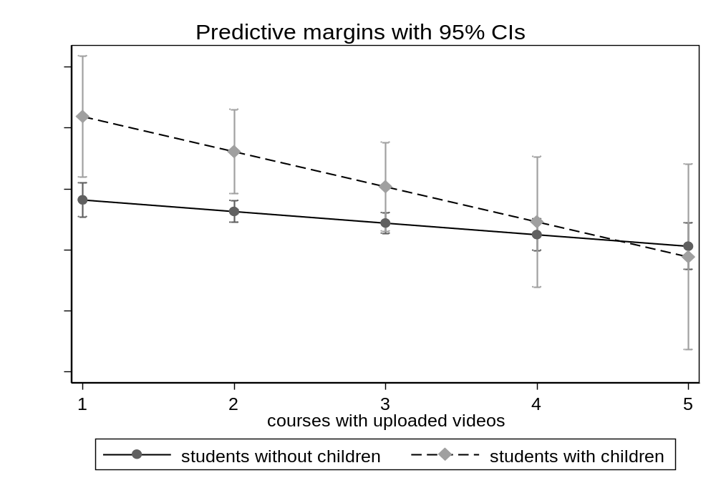
Predicted probabilities. Controlled for gender, first-generation students, financial support from parents, job loss, study degree, study semester, field of study, grade for current semester, grade for previous semester, and other digital teaching features (learning materials, assignments, interactive features). For regression models, see Table A7. Source: SITCO survey 2020.

Figure A3: Courses with asynchronous features (learning materials) and dropout intentions among students with and without children
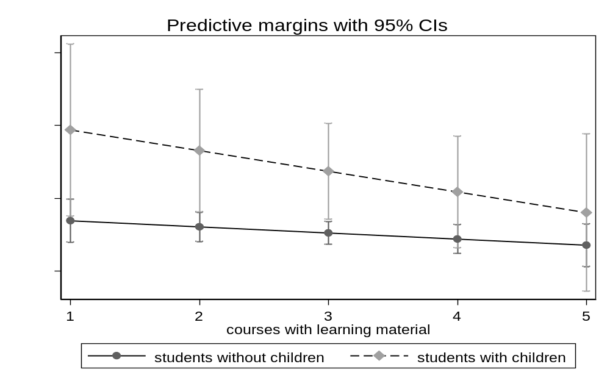
Predicted probabilities. Controlled for gender, first-generation students, financial support from parents, job loss, study degree, study semester, field of study, grade for current semester, grade for previous semester, other digital teaching features (uploaded videos, assignments, interactive features). For regression models, see Table A7. Source: SITCO survey 2020.
Figure A4: Courses with asynchronous features (assignments) and dropout intentions among students with and without children
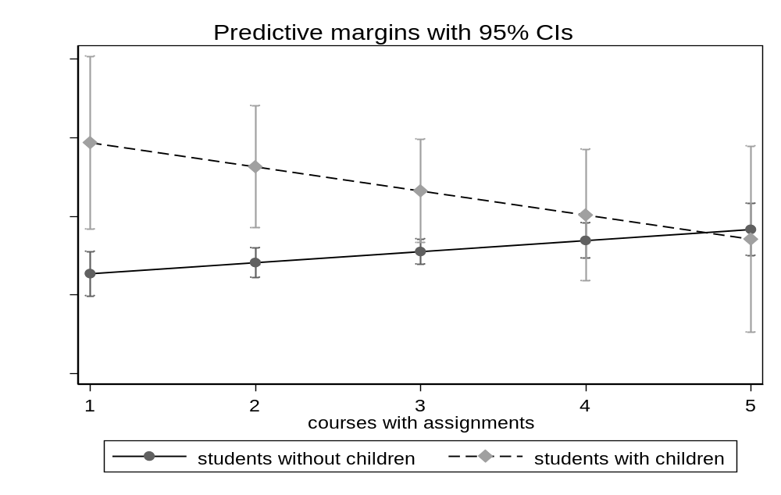
Predicted probabilities. Controlled for gender, first-generation students, financial support from parents, job loss, study degree, study semester, field of study, grade for current semester, grade for previous semester, and other digital teaching features (uploaded videos, learning materials, interactive features). For regression models, see Table A7. Source: SITCO survey 2020.

Figure A5: Courses with synchronous interactive features and dropout intentions among students with and without children
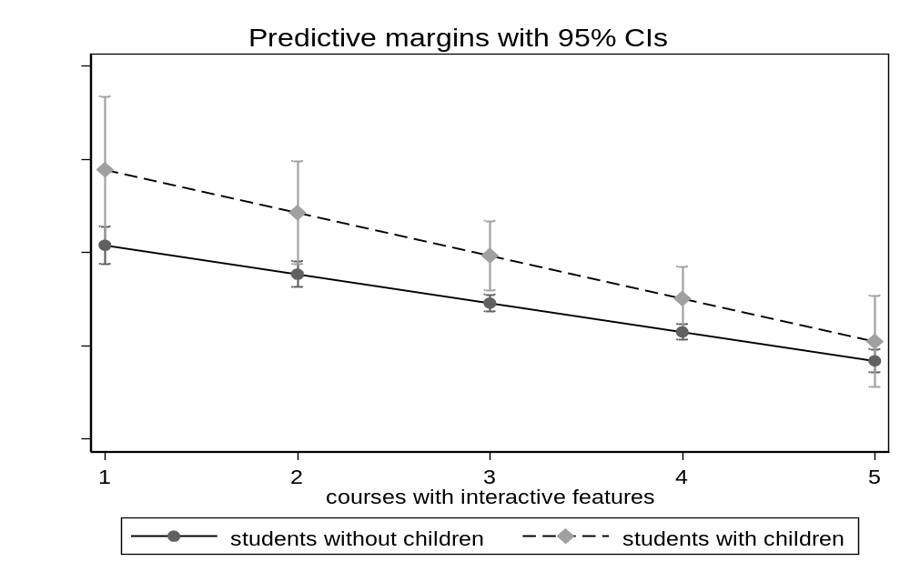
Predicted probabilities. Controlled for gender, first-generation students, financial support from parents, job loss, study degree, study semester, field of study, grade for current semester, grade for previous semester, and other digital teaching features (uploaded videos, learning materials, assignments). For regression models, see Table A7. Source: SITCO survey 2020.
Table A7: Interaction terms of digital features with students with and without children (presented in Fig. A2–A5)
 | (1) | (2) | (3) | (4)
Students with children (ref. students without children) | 0.19⁺ | 0.18* | 0.14⁺ | 0.21**
Students with children (ref. students without children) | (0.11) | (0.08) | (0.08) | (0.08)
Digital teaching formats
Courses with interactive features | -0.06*** | -0.06*** | -0.06*** | -0.06***
Courses with interactive features | (0.01) | (0.01) | (0.01) | (0.01)
Courses with uploaded videos | -0.02** | -0.02** | -0.02** | -0.02**
Courses with uploaded videos | (0.01) | (0.01) | (0.01) | (0.01)
Courses with learning materials | -0.01 | -0.01 | -0.01 | -0.01
Courses with learning materials | (0.01) | (0.01) | (0.01) | (0.01)
Courses with assignments | 0.01⁺ | 0.01⁺ | 0.01⁺ | 0.01*
Courses with assignments | (0.01) | (0.01) | (0.01) | (0.01)
Interaction effects students with children #
# Courses with interactive features | -0.03
# Courses with interactive features | (0.03)
# Courses with uploaded videos |  | -0.04
# Courses with uploaded videos |  | (0.03)
# Courses with learning materials |  |  | -0.02
# Courses with learning materials |  |  | (0.02)
# Courses with assignments |  |  |  | -0.04⁺
# Courses with assignments |  |  |  | (0.02)
Constant | 1.81 | 1.81 | 1.81 | 1.81
Observations | 16,689 | 16,689 | 16,689 | 16,689
AIC | 46477 | 46476 | 46477 | 46475
BIC | 46770 | 46769 | 46770 | 46767
+ p < 0.10. * p < 0.05. ** p < .01. *** p < .001. Standard errors in parentheses. OLS regression models. We use the original Likert scale (1–5) for all items of digital teaching formats. Controlled for first-generation students, financial support from parents, job loss, study degree, study semester, field of study, grade for current semester, and grade for previous semester. Source: SITCO survey 2020.

The interaction terms in the overall model of Table A7 are not significant but show relatively low standard errors. Further significance tests with marginal effects provide detailed information on the extent to which dropout intentions differ among students with and without children within the usage of digital features.
Regarding courses with uploaded videos (M2), students with and without children differ significantly at low levels of usage of uploaded videos: when less than half of the courses provide uploaded videos (categories 1 and 2), the estimated difference in dropout intentions among students with children is higher by 0.14 (for category 1) and 0.10 (for category 2) points than among students without children; these differences are statistically significant (p = 0.009 and 0.007, respectively). When at least half of the courses offer uploaded videos (categories 3–5), the difference is no longer statistically significant (p > 0.10). In other words, when at least half of the courses provide uploaded videos, students with children do not show higher dropout intentions than students without children.
Similar results can be seen in analyses of courses with learning materials (M3) or assignments (M4), although the dropout intention among students with children is not significantly higher when more than half of attended courses offer these features (categories 4–5).
Regarding interactive features (M1): students with children showed significantly higher dropout intentions (0.16, 0.13, 0.10 and 0.07, p < 0.05) when the availability of interactive features was provided in most but not all the courses (categories 1-4). Only when these asynchronous features were provided in all courses (5) was the difference in dropout intentions no longer significantly higher (p > 0.10).
Table A8: Digital teaching formats and dropout intentions of studying mothers and fathers
 | (1) | (2) | (3) | (4) | (5) | (6)
Mother (ref. father) | 0.01 | -0.15 | -0.11 | -0.11 | -0.02 | -0.09
 | (0.24) | (0.26) | (0.18) | (0.18) | (0.19) | (0.18)
Digital teaching formats
Courses with interactive features | -0.09** | -0.10⁺ | -0.09** | -0.09** | -0.09** | -0.09**
Courses with interactive features | (0.03) | (0.06) | (0.03) | (0.03) | (0.03) | (0.03)
Courses with uploaded videos | -0.07* | -0.07* | -0.08 | -0.08 | -0.07* | -0.07*
Courses with uploaded videos | (0.03) | (0.03) | (0.05) | (0.05) | (0.03) | (0.03)
Courses with learning materials | 0.00 | 0.00 | 0.00 | 0.00 | 0.01 | 0.00
Courses with learning materials | (0.03) | (0.03) | (0.03) | (0.03) | (0.05) | (0.03)
Courses with assignments | -0.02 | -0.02 | -0.02 | -0.02 | -0.02 | -0.02
Courses with assignments | (0.03) | (0.03) | (0.03) | (0.03) | (0.03) | (0.05)
Interaction effects mother #
# Courses with interactive features |  | 0.02
# Courses with interactive features |  | (0.07)
# Courses with uploaded videos |  |  | 0.01 | 0.01
# Courses with uploaded videos |  |  | (0.07) | (0.07)
# Courses with learning materials |  |  |  |  | -0.02
# Courses with learning materials |  |  |  |  | (0.06)
# Courses with assignments |  |  |  |  |  | 0.01
# Courses with assignments |  |  |  |  |  | (0.06)
Constant | 1.89 | 2.00 | 1.97 | 1.97 | 1.91 | 1.96
Observations | 989 | 989 | 989 | 989 | 989 | 989
AIC | 2799 | 2799 | 2799 | 2799 | 2799 | 2799
BIC | 2972 | 2972 | 2972 | 2972 | 2972 | 2972
+ p < 0.10. * p < 0.05. ** p < .01. *** p < .001. Standard errors in parentheses. OLS regression models. We used the original Likert scale (1–5) for all items of digital teaching formats. Controlled for gender, first-generation students, financial support from parents, job loss, study degree, study semester, field of study, grade for current semester, and grade for previous semester. Source: SITCO survey 2020.

The interaction terms in the overall model of Table A8 are not statistically significant and show relatively high standard errors. Additional significance tests using marginal effects, which examine whether studying mothers and fathers differ in their dropout intentions across the offer of courses with digital features, also show no significant differences in any category of the courses (1=none, 2, 3=around half, 4, 5=all courses; p > 0.5). In other words, the dropout intentions among studying mothers and fathers do not differ depending on the digital features offered.

Figure A6: Courses with asynchronous features (assignments) and dropout intentions among studying mothers and fathers
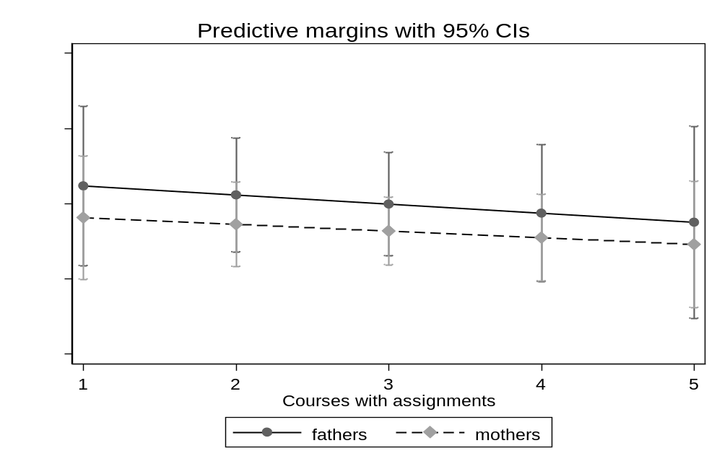
Predicted probabilities. Controlled for first-generation students, financial support from parents, job loss, study degree, study semester, field of study, grade for current semester, grade for previous semester, and other digital teaching features (uploaded videos, learning materials, interactive features). For regression models, see Table A8. Source: SITCO survey 2020.

Figure A7: Courses with asynchronous features (learning materials) and dropout intentions among studying mothers and fathers
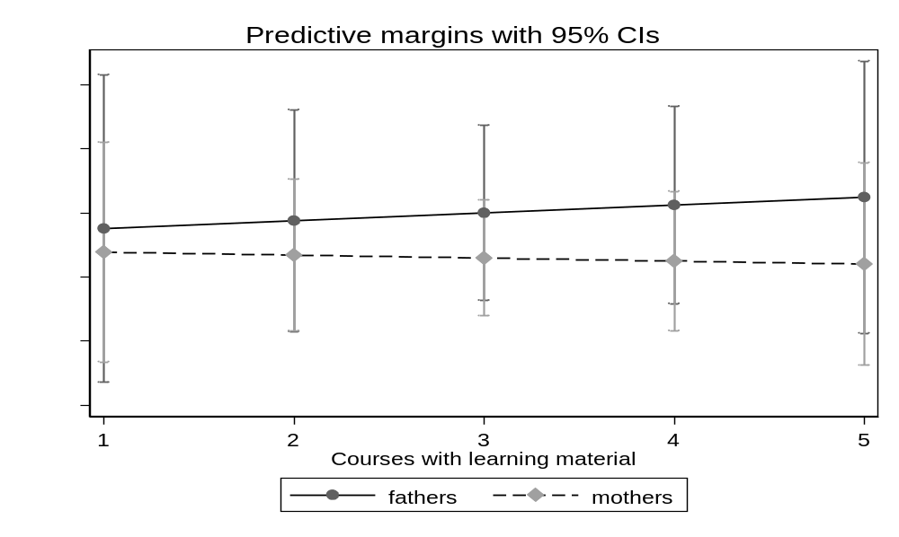
Predicted probabilities. Controlled for first-generation students, financial support from parents, job loss, study degree, study semester, field of study, grade for current semester, grade for previous semester, and other digital teaching features (uploaded videos, assignments, interactive features). For regression models, see Table A8. Source: SITCO survey 2020.

