Supporting Information for “How do climate-related uncertainties influence 2 °C and 1.5 °C pathways?”

Xuanming SU¹, Hideo SHIOGAMA², Katsumasa TANAKA², Shinichiro FUJIMORI^{1,3}, Tomoko HASEGAWA^{1,4}, Yasuaki HIJIOKA¹, Kiyoshi TAKAHASHI¹ and Jingyu LIU¹

- Center for Social and Environmental Systems Research, National Institute for Environmental Studies (NIES), Tsukuba, Japan
- Center for Global Environmental Research, National Institute for Environmental Studies (NIES), Tsukuba, Japan
- Energy Program, International Institute for Applied Systems Analysis (IIASA), Laxenburg A-2361, Austria
- Ecosystem Services and Management Program, International Institute for Applied Systems Analysis (IIASA), Laxenburg A-2361, Austria

Estimating parameters for use in the simple climate model
Carbon cycle parameters adopted from MAGICC 6.0
For the carbon cycle parameters that are consistent with MAGICC 6.0, we extract them directly from the definitions used in MAGICC 6.0 (Meinshausen 2011a & 2011b), as shown in Table S1.
CO₂ fertilization parameters
We use both the logarithmic and rectangular hyperbolic forms to simulate the CO₂ fertilization effects, based on the approach used in MAGICC 6.0. Here, the logarithmic description is defined as
(1)
where β is the CO₂ fertilization factor, $C_{{CO}_{2}}(t)$ is the atmospheric CO₂ concentration in year t, $C_{{CO}_{2}}^{0}$ denotes the pre-industrial CO₂ concentration (278 ppm), and β_{log} is the fertilization coefficient.

The rectangular hyperbolic description is given by Eq. (2-4):
(2)
$β_{sig−b}= \frac{\left(680−C_{b}\right)−β_{sig−r} \left(340−C_{b}\right)}{\left(β_{sig−r}−1\right) \left(680−C_{b}\right) \left(340−C_{b}\right)}$ (3)
(4)
where β_{sig(t)} is the effective CO₂ fertilization factor at time t, and C_{b} denotes the concentration at which the NPP is zero, which is taken to be 31 ppm [_{Gifford}, 1993].

Therefore, the CO₂ fertilization coefficient (β_{fert}) is given by
$β_{fert}(t)=(2−β_{m})β_{log}(t)+(β_{m}−1)β_{sig}(t)$ (5)
where β_{m} is the allocation coefficient between the two descriptions of the CO₂ fertilization effects; its value is taken to be 1.100486, following MAGICC 6.0 [_{Meinshausen et al.} 2011a & 2011b].

Using all 4 RCPs [Vuuren et al. 2011; Thomson et al. 2011; Masui et al. 2011; Riahi et al. 2011] and their extensions reported in Meinshausen et al. [2011c], we re-estimated β and β_{m} by minimizing

$\sum_{1765}^{2100}{{\left(β_{fert}\left(t\right)-β_{fert}^{mgc6}(t)\right)}^{2}}$ (6)

where $β_{fert}^{mgc6}(t)$ is the CO₂ fertilization coefficient obtained from the output of MAGICC 6.0. The average results for the 4 RCPs are shown in Table S2, and the CO₂ concentrations are shown in Figure S1.
Regrowth parameters
In contrast to MAGICC 6.0, the regrowth ($G_{i}\left(t\right), i∈[P, H,S]$; P, H and S stand for the plant pool, the detritus pool and the soil pool, respectively) is here defined to be linearly related to a relaxation time ($τ_{i}(t)$), where a_{i} and b_{i} are parameters that are estimated based on the outputs of MAGICC 6.0 using the 4 RCPs.
$G_{P}(t)=a_{P}+b_{P}τ_{P}(t)$ (7)

$G_{H}(t)=a_{H}+b_{H}τ_{H}(t)$ (8)

$G_{S}(t)=a_{S}+b_{S}τ_{S}(t)$ (9)
We estimate a_{i} and b_{i} by minimizing Eq. (10-12), which are shown below.

$\sum_{1765}^{2100}{{\left(G_{P}\left(t\right)-G_{P}^{mgc6}(t)\right)}^{2}}$ (10)

$\sum_{1765}^{2100}{{\left(G_{H}\left(t\right)-G_{H}^{mgc6}(t)\right)}^{2}}$ (11)

$\sum_{1765}^{2100}{{\left(G_{S}\left(t\right)-G_{S}^{mgc6}(t)\right)}^{2}}$ (12)

where $G_{P}^{mgc6}(t)$, $G_{H}^{mgc6}(t)$ and $G_{S}^{mgc6}(t)$ are outputs from MAGICC 6.0. Here, we estimate the regrowth parameters for each RCP scenario separately and average the values to produce the final estimates. The results can be found in Table S3.
Climate parameters
A two-box module is constructed, following DICE-2013R. We estimate the GMT above the preindustrial level, T_{AT} (t), as

$T_{AT}\left(t\right)=T_{AT}\left(t-1\right)+ξ_{1}\{f^{e}\left(t\right)-ξ_{2}T_{AT}\left(t-1\right)-ξ_{3}[T_{AT}\left(t-1\right)-T_{LO}\left(t-1\right)]\}$ (13)

We also estimate the temperature increase in the deep ocean, T_{LO} (t), by

$T_{LO}\left(t\right)=T_{LO}\left(t-1\right)+ξ_{4}(T_{AT}\left(t-1\right)-T_{LO}\left(t-1\right))$ (14)

where $f^{e}\left(t\right)$ is the total effective radiative forcing. The parameter $ξ_{2}$ can be calculated directly using the assumptions regarding the climate sensitivity made in MAGICC 6.0 (t_{2xco2}) and the forcing coefficient of doubling the CO₂ concentration (f_{co22x}) (Su et al. 2017), and the parameters $ξ_{1}$, $ξ_{3}$ and $ξ_{4}$ can be estimated by minimizing

$\sum_{1765}^{2100}{{\left(T_{AT}\left(t\right)-T_{AT}^{mgc6}(t)\right)}^{2}}$ (15)

where $T_{AT}^{mgc6}(t)$ represents output from MAGICC 6.0. Similarly, we estimate the climate parameters for each RCP scenario separately and average the values to produce the final estimates that can be found in Table S4. The temperature increases above the pre-industrial level are shown in Figure S2.

Table S1: Carbon cycle parameters adopted from the model emulation exercise using MAGICC 6.0 (Meinshausen 2011a & 2011b)
No. | Parameter in SCM4OPT* | Parameter in MAGICC 6.0 | BERN | CCSM1 | CLIMBER | FRCGC | HADLEY | IPSAL | LLNL | MPI | UMD2 | UVIC
1 | σ_{NPP} | CO2_FEEDBACKFACTOR_GPP** | 0.0107 | 0.0088 | 0.0380 | 0.0244 | -0.0032 | -0.0552 | -0.0004 | -0.0302 | -0.0307 | -0.0217
2 | σ_{rsp} | CO2_FEEDBACKFACTOR_RESPIRATION | 0.0685 | -0.0161 | 0.0984 | -0.2000 | 0.1923 | -0.2000 | -0.0079 | -0.0242 | 0.0182 | 0.0057
3 | σ_{H} | CO2_FEEDBACKFACTOR_DETRITUS | -0.1358 | -0.2798 | -0.2632 | 0.3995 | -0.0308 | -0.0958 | -0.2223 | -0.0576 | -0.3000 | -0.1809
4 | σ_{S} | CO2_FEEDBACKFACTOR_SOIL | 0.1541 | 0.1522 | 0.2300 | 0.2236 | 0.0386 | 0.0912 | 0.2183 | 0.0680 | 0.1973 | 0.1056
5 | ρ_{ocn} | OCEANCC_SCALE_IMPULSERESPONSE | 0.9493 | 1.6773 | 2.8733 | 1.1199 | 2.7146 | 0.0100 | 1.3745 | 1.2261 | 0.5673 | 1.7369
6 | κ | OCEANCC_SCALE_GASXCHANGE | 0.2040 | 0.1653 | 0.1610 | 0.2222 | 0.0532 | 0.0716 | 0.1606 | 0.2307 | 0.1606 | 0.2072
7 | α_{T} | OCEANCC_TEMPFEEDBACK | 0.0846 | 0.1172 | 0.1162 | 0.0609 | 0.1386 | -1.2489 | 0.0933 | 0.0692 | -0.0429 | 0.1012
8 | γ_{ocn} | OCEANCC_CONVLTN2INT_YRSAGO | 10.0000 | 10.0000 | 10.0000 | 10.0000 | 10.0000 | 10.0000 | 10.0000 | 10.0000 | 10.0000 | 10.0000
9 | P₀ | CO2_PLANTPOOL_INITIAL | 884.8584 | 870.4989 | 919.3811 | 484.2099 | 494.5423 | 547.8515 | 735.3877 | 351.4974 | 493.4998 | 621.1054
10 | H₀ | CO2_DETRITUSPOOL_INITIAL | 92.7738 | 56.7203 | 94.5397 | 32.6689 | 61.2050 | 66.4868 | 103.1582 | 72.1718 | 70.4359 | 52.2373
11 | S₀ | CO2_SOILPOOL_INITIAL | 1681.5250 | 1028.0560 | 1713.5320 | 592.1234 | 1109.3410 | 1205.0740 | 1869.7420 | 1308.1130 | 1276.6500 | 946.8014
12 | F⁰_{NPP} | CO2_GPP_INITIAL | 66.2716 | 66.5843 | 64.4433 | 48.1558 | 61.0000 | 57.4992 | 66.8000 | 53.2807 | 53.0013 | 61.8993
13 | F⁰_{rsp} | CO2_RESPIRATION_INITIAL | 12.2603 | 12.3181 | 11.9220 | 8.9088 | 11.2850 | 10.6374 | 12.3580 | 9.8569 | 9.8052 | 11.4514
14 | Ρ_{p2d} | CO2_FRACTION_PLANT_2_DETRITUS | 0.9989 | 0.9990 | 0.9825 | 0.9990 | 0.3806 | 0.9990 | 0.9990 | 0.9989 | 0.9990 | 0.9990
15 | δ_{d2s} | CO2_FRACTION_DETRITUS_2_SOIL | 0.0010 | 0.0010 | 0.0010 | 0.0618 | 0.0010 | 0.0010 | 0.0010 | 0.0010 | 0.0010 | 0.0010
16 | ν_{P} | CO2_FRACTION_GPP_2_PLANT | 0.4483 | 0.4848 | 0.4517 | 0.6597 | 1.0000 | 0.8654 | 0.5740 | 0.2183 | 0.8853 | 0.6914
17 | ν_{H} | CO2_FRACTION_GPP_2_DETRITUS | 0.3998 | 0.3472 | 0.4069 | 0.2265 | 0.0000 | 0.0000 | 0.3098 | 0.5732 | 0.0000 | 0.0000
18 | δ_{P} | CO2_FRACTION_DEFOREST_PLANT | 0.7000 | 0.7000 | 0.7000 | 0.7000 | 0.7000 | 0.7000 | 0.7000 | 0.7000 | 0.7000 | 0.7000
19 | δ_{H} | CO2_FRACTION_DEFOREST_DETRITUS | 0.0500 | 0.0500 | 0.0500 | 0.0500 | 0.0500 | 0.0500 | 0.0500 | 0.0500 | 0.0500 | 0.0500
20 | C_{b} | CO2_GIFFORD_CONC_FOR_ZERONPP | 80.0000 | 80.0000 | 80.0000 | 80.0000 | 80.0000 | 80.0000 | 80.0000 | 80.0000 | 80.0000 | 80.0000
21 | ψ | CO2_NORGRWTH_FRAC_DEFO | 0.5000 | 0.5000 | 0.5000 | 0.5000 | 0.5000 | 0.5000 | 0.5000 | 0.5000 | 0.5000 | 0.5000
22 | ρ_{fert} | CO2_FERTILIZATION_SCALE | 1.0413 | 1.0288 | 1.0275 | 1.0173 | 1.0254 | 1.0414 | 1.0666 | 1.0678 | 1.0137 | 1.0286
* See Eq. (21-47) in Su et al. (2017) for definitions.
** Only the remaining part of GPP, namely the NPP, is simulated in MAGICC 6.0.

Table S2: Parameters for fertilization factors used in this study, compared to MAGICC 6.0 (Meinshausen 2011a & 2011b)
Model | No. | Parameter in SCM4OPT | Parameter in MAGICC 6.0 | BERN | CCSM1 | CLIMBER | FRCGC | HADLEY | IPSAL | LLNL | MPI | UMD2 | UVIC
SCM4OPT | 23 | β | CO2_FERTILIZATION_FACTOR | 0.67 | 0.46 | 0.54 | 0.27 | 0.59 | 0.81 | 1.10 | 1.13 | 0.17 | 0.59
SCM4OPT | 24 | β_{m} | CO2_FERTILIZATION_METHOD | 1.44 | 2.00 | 2.00 | 2.00 | 2.00 | 1.25 | 1.00 | 1.01 | 1.63 | 2.00
MAGICC 6.0 | 23 | β | CO2_FERTILIZATION_FACTOR | 0.65 | 0.44 | 0.52 | 0.26 | 0.57 | 0.75 | 1.03 | 1.05 | 0.17 | 0.57
MAGICC 6.0 | 24 | β_{m} | CO2_FERTILIZATION_METHOD | 1.10 | 1.81 | 1.95 | 2.00 | 2.00 | 2.00 | 1.00 | 1.00 | 1.44 | 1.95

Table S3: Regrowth parameters for the terrestrial carbon cycle
No. | Parameter in SCM4OPT | BERN | CCSM1 | CLIMBER | FRCGC | HADLEY | IPSAL | LLNL | MPI | UMD2 | UVIC
25 | a_{P} | 19.7771 | 22.9832 | 19.3980 | 28.7760 | 60.7883 | 47.2993 | 29.9792 | 2.3368 | 45.5161 | 37.4072
26 | b_{P} | -0.3905 | -0.5279 | -0.3632 | -1.3647 | -6.1372 | -3.3897 | -1.0616 | -0.0119 | -3.4380 | -1.8931
27 | a_{H} | -0.4158 | -0.2964 | 1.1276 | -15.7508 | -25.0270 | -57.5299 | -27.8943 | 15.1559 | -67.8580 | -25.6812
28 | b_{H} | 0.1988 | 0.2248 | -0.5132 | 16.3593 | 7.7586 | 33.8908 | 12.6311 | -6.7886 | 35.8033 | 15.4324
29 | a_{S} | 10.0668 | 11.3337 | 7.7320 | 5.2590 | -206.1458 | 7.6043 | 7.6311 | 11.2316 | 5.8719 | 19.2061
30 | b_{S} | -0.0607 | -0.1240 | -0.0427 | -0.0674 | 5.7298 | -0.0494 | -0.0320 | -0.0957 | -0.0283 | -0.3889

Table S4: Climate parameters adopted from the model emulation exercise using MAGICC 6.0 (indicated by *) (Meinshausen 2011a & 2011b) and the tuned parameters used in the climate equations
No. | 31 | 32 | 33 | 34 | 35
Parameter in SCM4OPT | t_{2xco2} | f_{co22x} | ξ₁ | ξ₃ | ξ₄
Parameter in MAGICC 6.0 | CORE_CLIMATESENSITIVITY* | CORE_DELQ2XCO2* | - | - | -
CCCMA_CGCM3_1_T47 | 2.9747 | 3.32 | 0.0692 | 0.3905 | 0.0034
CNRM_CM3 | 2.9828 | 3.48 | 0.0692 | 0.3993 | 0.0024
CSIRO_MK3_0 | 2.2352 | 3.47 | 0.0413 | 0.4639 | 0.0013
GFDL_CM2_0 | 2.3059 | 3.50 | 0.0578 | 0.9000 | 0.0491
GFDL_CM2_1 | 2.2820 | 3.50 | 0.0383 | 0.1867 | 0.0047
GISS_MODEL_E_H | 2.5368 | 4.06 | 0.0692 | 0.4134 | 0.0014
GISS_MODEL_E_R | 2.2569 | 4.06 | 0.0309 | 0.8677 | 0.0529
IAP_FGOALS1_0_G | 2.4223 | 3.71 | 0.0526 | 0.8170 | 0.2285
INMCM3_0 | 2.3515 | 3.71 | 0.0734 | 0.3307 | 0.0028
IPSL_CM4 | 4.1475 | 3.48 | 0.0512 | 0.5111 | 0.0032
MEDIUM_CMIP3_ECS3 | 3.0000 | 3.71 | 0.0535 | 0.3993 | 0.0022
MIROC3_2_HIRES | 5.7344 | 3.14 | 0.0480 | 0.3324 | 0.0031
MIROC3_2_MEDRES | 3.9961 | 3.09 | 0.0424 | 0.3955 | 0.0018
MIUB_ECHO_G | 2.6256 | 3.71 | 0.0795 | 0.3054 | 0.0029
MPI_ECHAM5 | 3.2292 | 4.01 | 0.0238 | 0.0000 | 0.7764
MRI_CGCM2_3_2A | 2.4761 | 3.47 | 0.0625 | 0.3552 | 0.0021
NCAR_CCSM3_0 | 2.1365 | 3.95 | 0.0408 | 0.8549 | 0.0868
NCAR_PCM1 | 1.8957 | 3.71 | 0.0817 | 0.4887 | 0.0031
UKMO_HADCM3 | 3.2074 | 3.81 | 0.0608 | 0.4147 | 0.0035
UKMO_HADGEM1 | 2.9983 | 3.78 | 0.1018 | 0.8720 | 0.0223

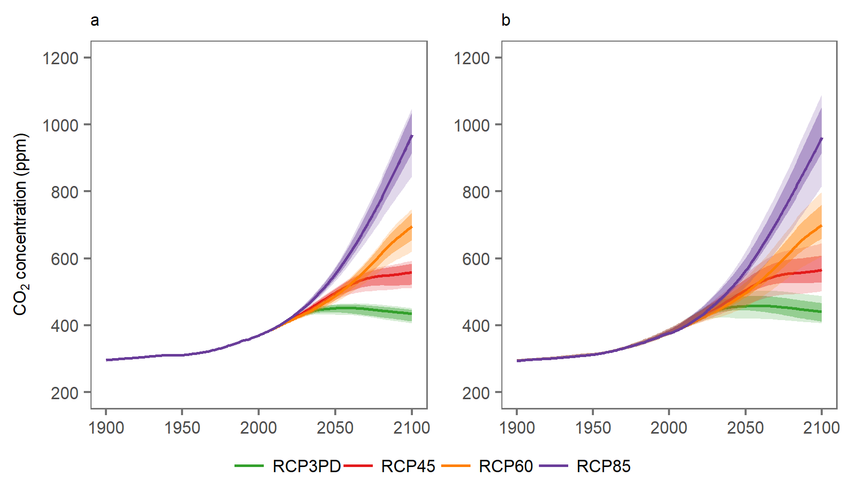
Figure S1: A comparison of the CO₂ concentrations obtained using MAGICC 6.0 (a) and SCM4OPT (b) under the 4 RCPs. The outer ranges indicate the 17th and 83rd percentiles; the inner ranges indicate the 25th and 75th percentiles; and the solid-colored lines indicate the 50th percentile.

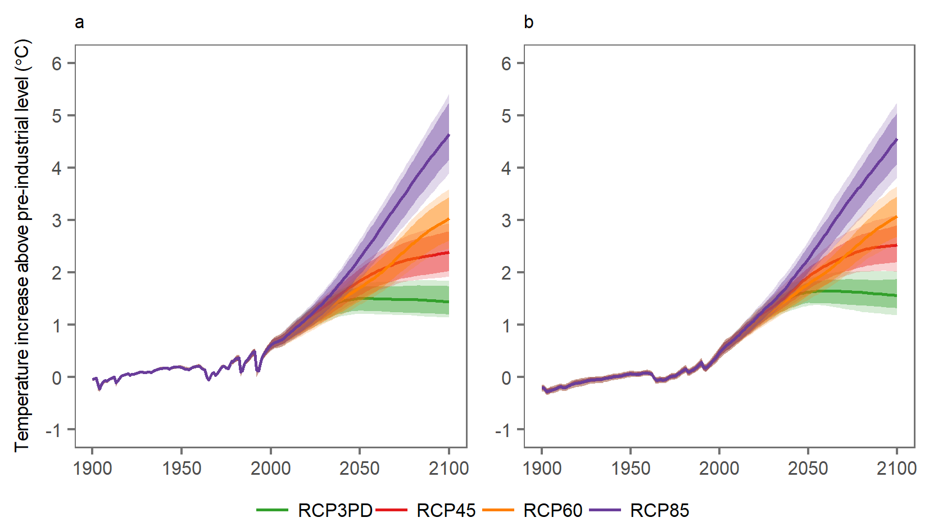
Figure S2: A comparison of temperature increases above the pre-industrial level between MAGICC 6.0 (a) and SCM4OPT (b) under the 4 RCPs. The outer ranges indicate the 17th and 83rd percentiles; the inner ranges indicate the 25th and 75th percentiles; and the solid-colored lines indicate the 50th percentile.

Uncertainty pathways for CO₂ emissions, GHG emissions, CO₂ concentrations and temperature increases
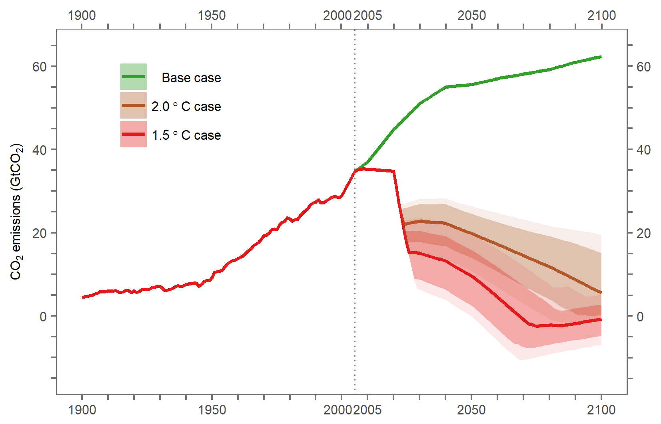
Figure S3: CO₂ emissions from 1900 to 2100 for the base case, the 2 °C case and the 1.5 °C case. Historical data (1900-2004) are based on the historical emissions assumptions used in the RCPs (http://www.iiasa.ac.at/web-apps/tnt/RcpDb/).

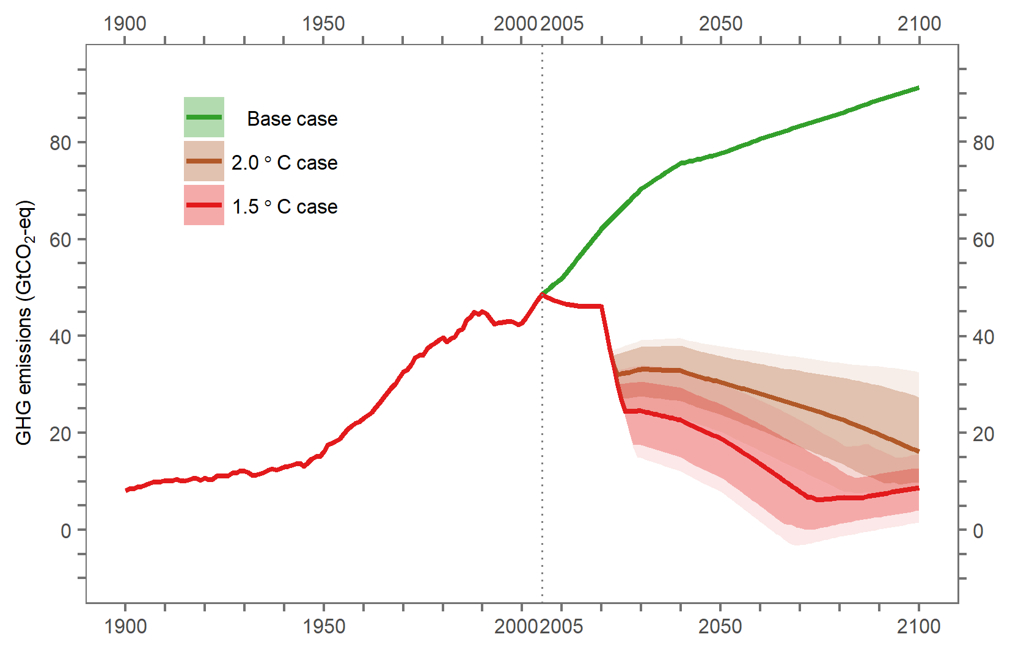
Figure S4: GHG emissions from 1900 to 2100 for the base case, the 2 °C case and the 1.5 °C case. Historical data (1900-2004) are based on the historical emissions assumptions used in the RCPs (http://www.iiasa.ac.at/web-apps/tnt/RcpDb/).

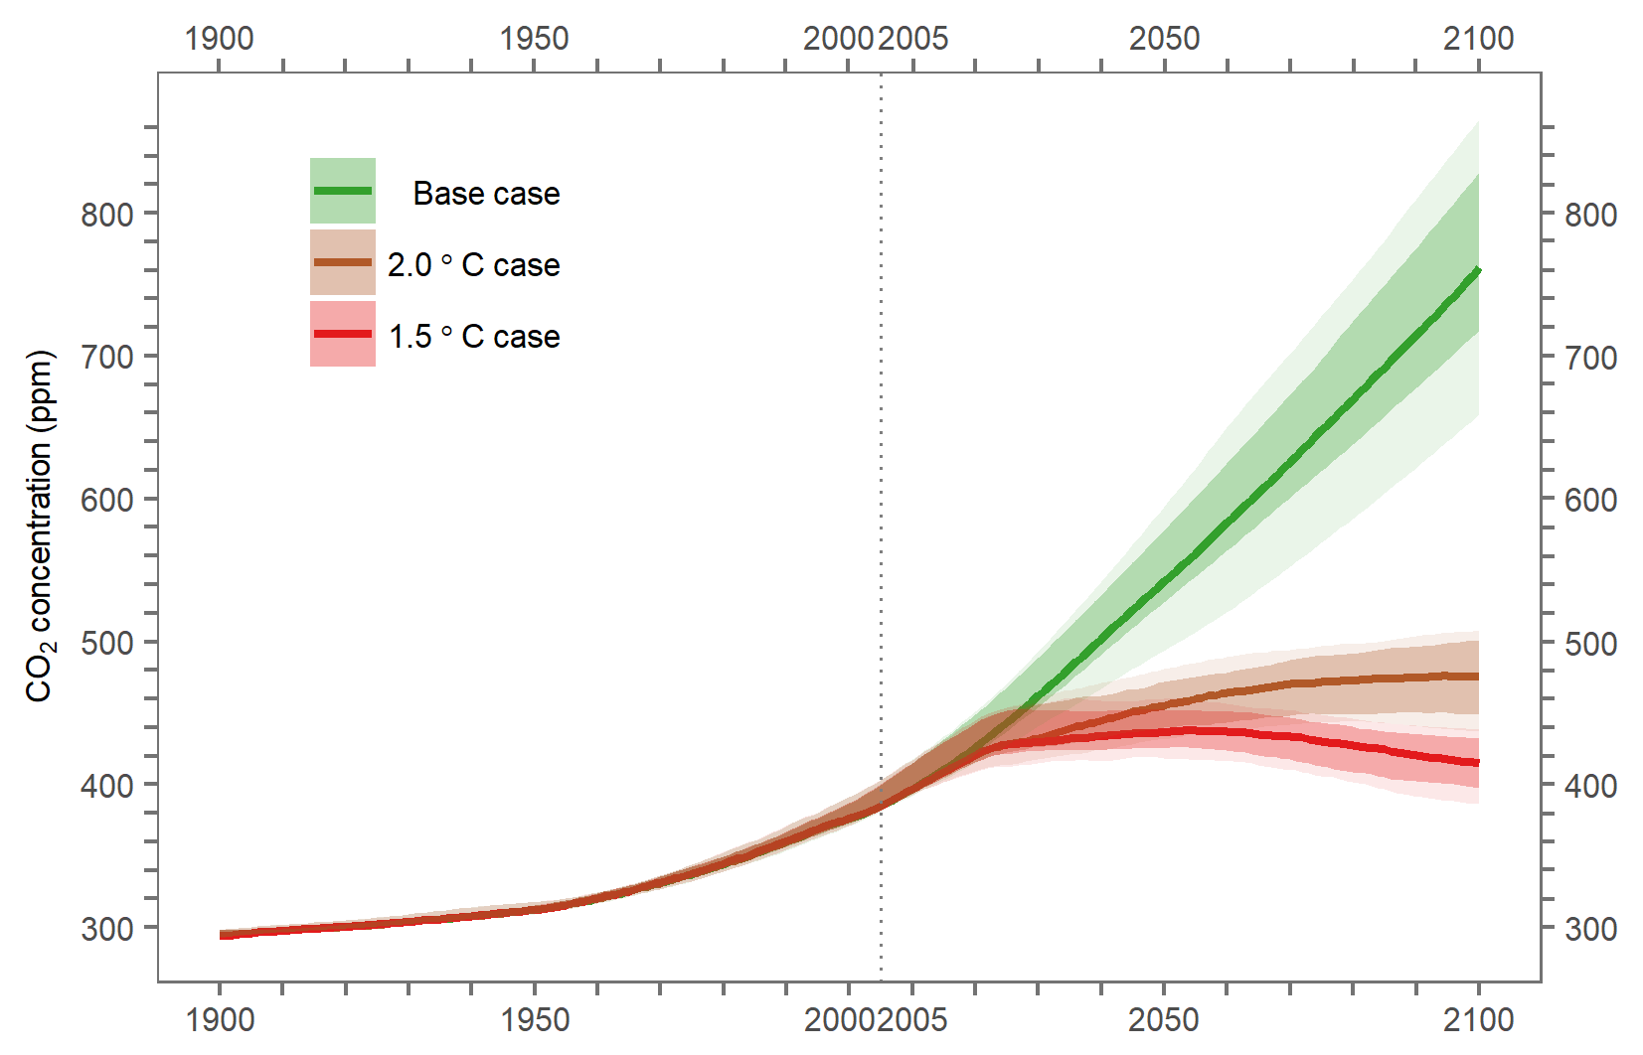
Figure S5: CO₂ concentrations from 1900 to 2100 for the base case, the 2 °C case and the 1.5 °C case. Historical data (1900-2004) are calculated based on the historical emissions assumptions used in the RCPs (http://www.iiasa.ac.at/web-apps/tnt/RcpDb/).

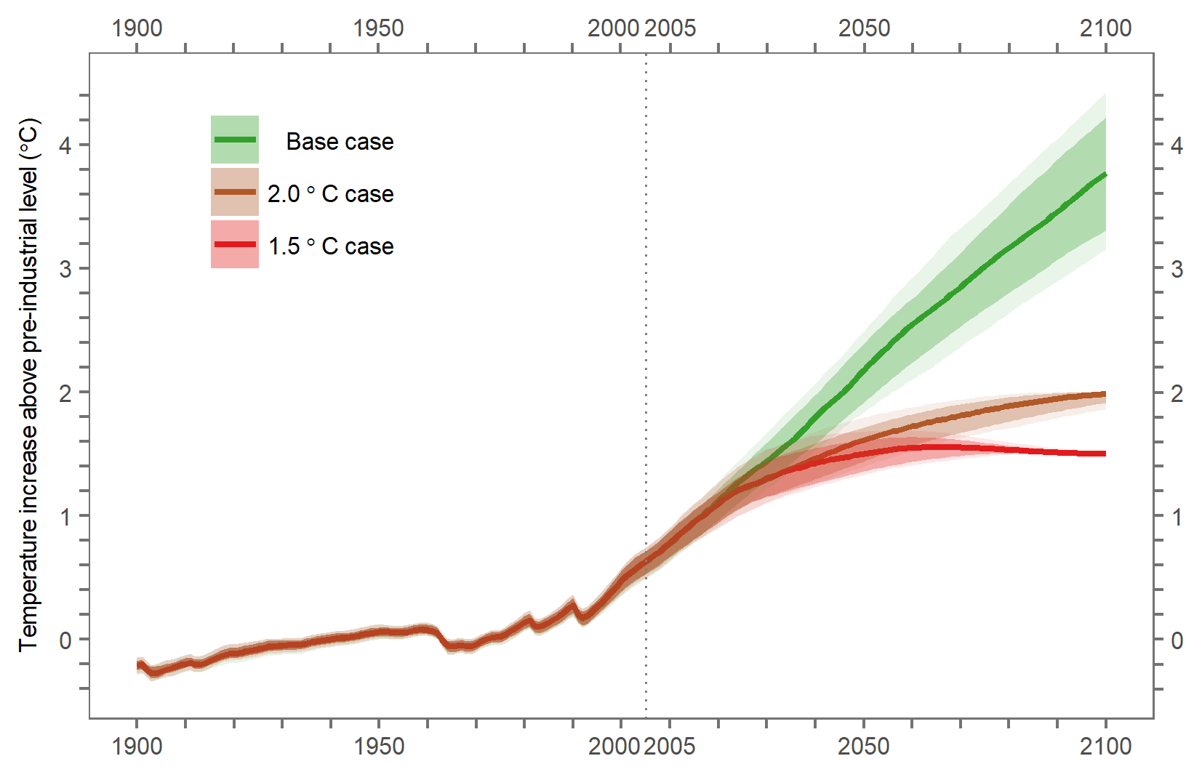
Figure S6: Temperature increase above the pre-industrial level from 1900 to 2100 for the base case, the 2 °C case and the 1.5 °C case. Historical data (1900-2004) are calculated based on the historical emissions assumptions used in the RCPs (http://www.iiasa.ac.at/web-apps/tnt/RcpDb/). The temperature increase is constrained to be below 2 °C or 1.5 °C after 2100 for the 2 °C and the 1.5 °C case, respectively.

References

Giffor RM (1993) Implications of CO₂ Effects on Vegetation for the Global Carbon Budget. Springer Berlin Heidelberg, Berlin, Heidelberg, pp 159-199. DOI 10.1007/978-3642-84608-3_7

Masui T, Matsumoto K, Hijioka Y, Kinoshita T, Nozawa T, Ishiwatari S, Kato E, Shukla PR, Yamagata Y, Kainuma M (2011) An emission pathway for stabilization at 6 Wm⁻² radiative forcing. Clim. Change 109(1-2): 59-76. DOI 10.1007/s10584-011-0150-5

Meinshausen M, Raper SCB, Wigley TML (2011a) Emulating coupled atmosphere-ocean and carbon cycle models with a simpler model, MAGICC6 - Part 1: Model description and calibration. Atmospheric Chemistry and Physics 11(4): 1417-1456. DOI 10.5194/acp-11-1417-2011

Meinshausen M, Wigley TML, Raper SCB (2011b) Emulating atmosphere-ocean and carbon cycle models with a simpler model, MAGICC6 - Part 2: Applications. Atmospheric Chemistry and Physics 11(4): 1457-1471. DOI 10.5194/acp-11-1457-2011

Meinshausen M, Smith SJ, Calvin K, Daniel JS, Kainuma MLT, Lamarque JF, Matsumoto K, Montzka SA, Raper SCB., Riahi K, Thomson A, Velders GJM, van Vuuren DP (2011c) The RCP greenhouse gas concentrations and their extensions from 1765 to 2300. Climatic Change 109(1): 213-241. DOI 10.1007/s10584-0110156-z

Riahi K, Rao S, Krey V, Cho C, Chirkov V, Fischer G, Kindermann G, Nakicenovic N, Rafaj P (2011) RCP 8.5 – A scenario of comparatively high greenhouse gas emissions. Clim. Change 109(1-2): 33-57. DOI 10.1007/s10584-011-0149-y

Su X, Takahashi K, Fujimori S, Hasegawa T, Tanaka K, Kato E, Shiogama H, Masui T, Emori S (2017) Emission pathways to achieve 2.0°C and 1.5°C climate targets. Earth's Future 5: 592-604. DOI 10.1002/2016EF000492

Thomson A, Calvin K, Smith S, Kyle GP, Volke A, Patel P, … Edmonds J (2011) RCP4.5: A pathway for stabilization of radiative forcing by 2100. Clim. Change 109(1-2): 77-94. DOI 10.1007/s10584-011-0151-4

Vuuren D, Stehfest E, Elzen MJ, Kram T, Vliet J, Deetman S, … Ruijven B (2011) RCP2.6: Exploring the possibility to keep global mean temperature increase below 2°C. Clim. Change 109(1-2): 95-116. DOI 10.1007/s10584-011-0152-3

