Supplementary Information. Success of Transdisciplinary Research for Sustainable Land Use - individual Perceptions and Assessments

- The following quotes are referenced in section 3:
QNo. | Quote
Q1 | “Is there an added value? That is a difficult question. I think, generally, Yes, there is. [hesitates] I am pondering because the answer to that question is not very satisfying.”
Q2 | “It is vague; it is difficult too....”
Q3 | “I cannot exactly quantify the share from the project: 80 %, 20 %, 30 %, 70 %,… well, you see, I can’t tell. As an example, short rotation coppices have been implemented, we provided economical and feasibility studies and so on, and I would really state, that the project holds a big share. Still, this formal implementation happened after the end of the project...two, three months after, but the largest share of the way was paved by the project.”
Q4 | “I can hardly assess whether the results are implementable, can be implemented or are even helpful; I don’t know.”
Q5 | “I think it is a very subjective question, too. Partly, you have a couple of objective criteria on hand, but one person recognizes success differently than the other within the same project.”
Q6 | “Everyone who speaks about that project sees how great it is and what results we achieved, and considering the area of conflict and the difficulty of inter- and transdisciplinary challenges, we have accomplished a lot, didn’t we?”
Q7 | “Of course, you have different senses depending on the project phase you’re in. You (either) think the whole project is miserable, or you experience moments of joy, oah, that’s super, that is a super result.”

- Sample Characteristics:
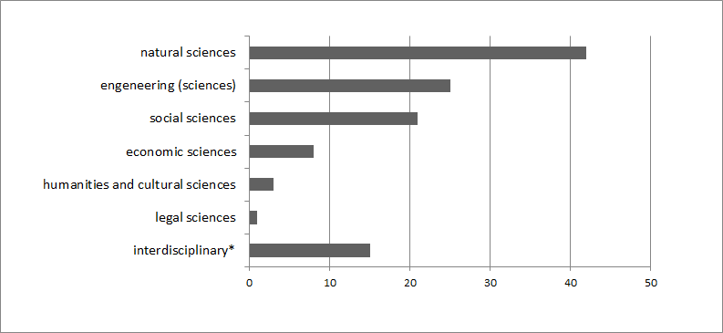
Figure 1.Disciplinary background of participating scientists (number of assignments). * scientists who belong to natural sciences or engineering and one of the other disciplines were classified as ‘interdisciplinary’

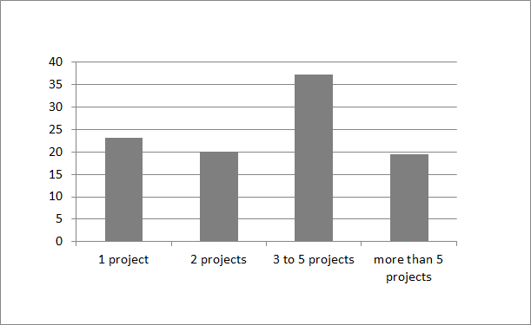
Figure 2. Project experience of respondents. Question: In how many transdisciplinary research projects have you already participated?

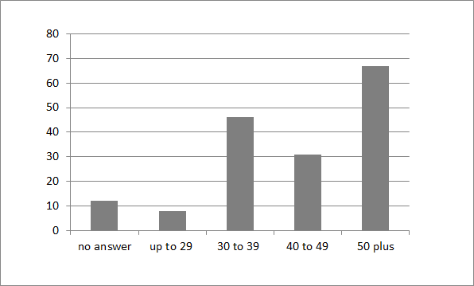
Figure 3. Age of respondents. Question: Which age group are you in?

