Electronic Supplementary Materials

TITLE:
Demand-side decarbonization and electrification: EMF 35 JMIP study

Authors:
Shogo Sakamoto^{1*}, Yu Nagai², Masahiro Sugiyama³, Shinichiro Fujimori^{4,5}, Etsushi Kato⁶, Ryoichi Komiyama⁷, Yuhji Matsuo⁸, Ken Oshiro⁴, Diego Silva Herran^{5,9}

1: Environmental Science Research Laboratory, Central Research Institute of Electric Power Industry
2: Socio-economic Research Center, Central Research Institute of Electric Power Industry
3: Institute for Future Initiatives, The University of Tokyo
4: Graduate School of Engineering, Kyoto University
5: National Institute for Environmental Studies
6: Institute of Applied Energy
7: School of Engineering, The University of Tokyo
8: Institute of Energy Economics, Japan
9: Institute for Global Environmental Strategies (IGES)

*: Corresponding Author：sakshogo@criepi.denken.or.jp
Phone: +81-70-6999-2966
Fax: +81-4-7183-2966

Supplementary Tables

Table ESM1 Technologies in the Industry sector by models¹ (Ju et al. 2021²)
Sub sector | Technology | AIM/Enduse | AIM/Hub | IEEJ | TIMES-Japan
Steel | Electric arc furnace | X | X | X | X
Steel | Hydrogen reduction |  |  | X | X
Steel | CCS | X | X | X | X
Cement | CCS | X | X | X | X
Chemicals | Hydrogen |  |  | X | X
Chemicals | CCS |  | X
Pulp and paper | Biomass for energy | X | X | X | X
1 In DNE21, demand sector is not modeled separately.
2 Ju, Y., Sugiyama, M., Kato, E. et al. Industrial decarbonization under Japan’s national mitigation scenarios: a multi-model analysis. Sustain Sci (2021). https://doi.org/10.1007/s11625-021-00905-2

Table ESM2 Technologies in the Residential sector by models¹
Service | Technology | AIM/Enduse | AIM/Hub² | IEEJ | TIMES-Japan
Lighting | Incandescent lamp | X |  | X
Lighting | Fluorescent light | X
Lighting | LED light | X |  | X
Lighting | Generic technology |  |  |  | X
Cooking | Electric kitchen | X |  | X | X
Cooking | Gas kitchen | X |  | X | X
Hot water | Electric water heater | X |  |  | X
Hot water | Heat pump | X |  | X | X
Hot water | Gas water heater | X |  | X | X
Hot water | Oil water heater | X |  | X | X
Hot water | Fuel cell | X
Hot water | Low temperature heat |  |  |  | X
Hot water | Solar water heater | X |  | X | X
Space cooling | Air conditioner | X |  | X | X
Space cooling | Heat pump |  |  |  | X
Space cooling | Solar |  |  |  | X
Space heating | Air conditioner | X |  | X | X
Space heating | Electric heater | X |  |  | X
Space heating | Heat pump |  |  |  | X
Space heating | Gas stove | X |  | X | X
Space heating | Oil stove | X |  | X | X
Space heating | Coal stove
Space heating | Biomass stove | X
Space heating | Low temperature heat |  |  |  | X
Space heating | Solar |  |  |  | X
1 In DNE21, demand sector is not modeled separately.
2 The version of AIM/Hub used in this study considers energy demand in the residential sector by final energy carriers (energy services are not considered).

Table ESM3 Technologies in the Commercial sector by models¹
Service | Technology | AIM/Enduse | AIM/Hub² | IEEJ | TIMES-Japan
Lighting | Incandescent lamp | X |  | X
Lighting | Fluorescent light | X
Lighting | LED light | X |  | X
Lighting | Generic technology |  |  |  | X
Cooking | Electric kitchen | X |  | X | X
Cooking | Gas kitchen | X |  | X | X
Cooking | Coal kitchen | X |  |  | X
Hot water | Electric water heater | X |  |  | X
Hot water | Heat pump | X |  | X | X
Hot water | Gas water heater | X |  | X | X
Hot water | Oil water heater | X |  | X | X
Hot water | Coal water heater | X |  |  | X
Hot water | District heating | X
Hot water | Low temperature heat |  |  |  | X
Hot water | Solar water heater | X |  | X | X
Space cooling | Air conditioner | X |  | X | X
Space cooling | Heat pump |  |  |  | X
Space cooling | Absorption chiller- heater(gas) | X |  | X | X
Space cooling | Absorption chiller- heater(oil) | X |  | X
Space cooling | District heating | X
Space cooling | Solar |  |  |  | X
Space heating | Air conditioner | X |  | X | X
Space heating | Electric heater | X
Space heating | Heat pump |  |  |  | X
Space heating | Absorption chiller- heater(gas) | X |  | X | X
Space heating | Absorption chiller- heater(oil) | X |  | X
Space heating | Coal stove | X |  |  | X
Space heating | District heating | X |  |  | X
Space heating | Low temperature heat |  |  |  | X
Space heating | Solar |  |  |  | X
1 In DNE21, demand sector is not modeled separately.
2 The version of AIM/Hub used in this study considers energy demand in the commercial sector by final energy carriers (energy services are not considered).

Table ESM4 Technologies in the Transportation sector by models¹
Service | Technology |  | AIM/Enduse | AIM/Hub | IEEJ | TIMES-Japan
Passenger | Vehicle | Petrol | X | X | X | X
Passenger | Vehicle | Hybrid | X |  | X | X
Passenger | Vehicle | Diesel | X |  | X | X
Passenger | Vehicle | Gas | X |  | X | X
Passenger | Vehicle | Gas Hybrid |  |  | X
Passenger | Vehicle | Biofuel | X | X | X | X (biofuel and synthetic fuel)
Passenger | Vehicle | Biofuel hybrid |  |  | X
Passenger | Vehicle | EV | X | X | X | X
Passenger | Vehicle | PHEV | X |  | X
Passenger | Vehicle | Fuel Cell | X |  | X | X
Passenger | Bus | Petrol | X | X | X | X
Passenger | Bus | Hybrid | X |  | X
Passenger | Bus | Diesel | X |  |  | X
Passenger | Bus | Gas | X | X | X | X
Passenger | Bus | Gas Hybrid |  |  | X
Passenger | Bus | Biofuel | X |  | X | X (biofuel and synthetic fuel)
Passenger | Bus | Biofuel hybrid |  |  | X
Passenger | Bus | EV | X | X | X | X
Passenger | Bus | PHEV |  |  | X
Passenger | Bus | Fuel cell | X |  | X | X
Freight | Petrol |  | X |  | X | X
Freight | Diesel |  | X | X | X | X
Freight | Biodiesel |  | X | X | X
Freight | Gas |  | X | X | X | X
Freight | EV |  | X | X | X | X
Freight | Fuel cell |  | X |  |  | X
Railway | Coal |  | X | X
Railway | Diesel |  | X | X |  | X
Railway | Biodiesel |  | X | X
Railway | Electricity |  | X | X | X | X
Aviation | Jet fuel |  | X | X | X | X
Aviation | Biofuel |  | X | X
Aviation | Electricity |  |  | X
Aviation | Hydrogen |  |  |  |  | X
Ship | Oil |  | X | X | X | X
Ship | Gas |  |  |  |  | X
Ship | Biofuel |  | X | X |  | X
Ship | Electricity |  |  | X
1 In DNE21, demand sector is not modeled separately.

Supplementary Figures

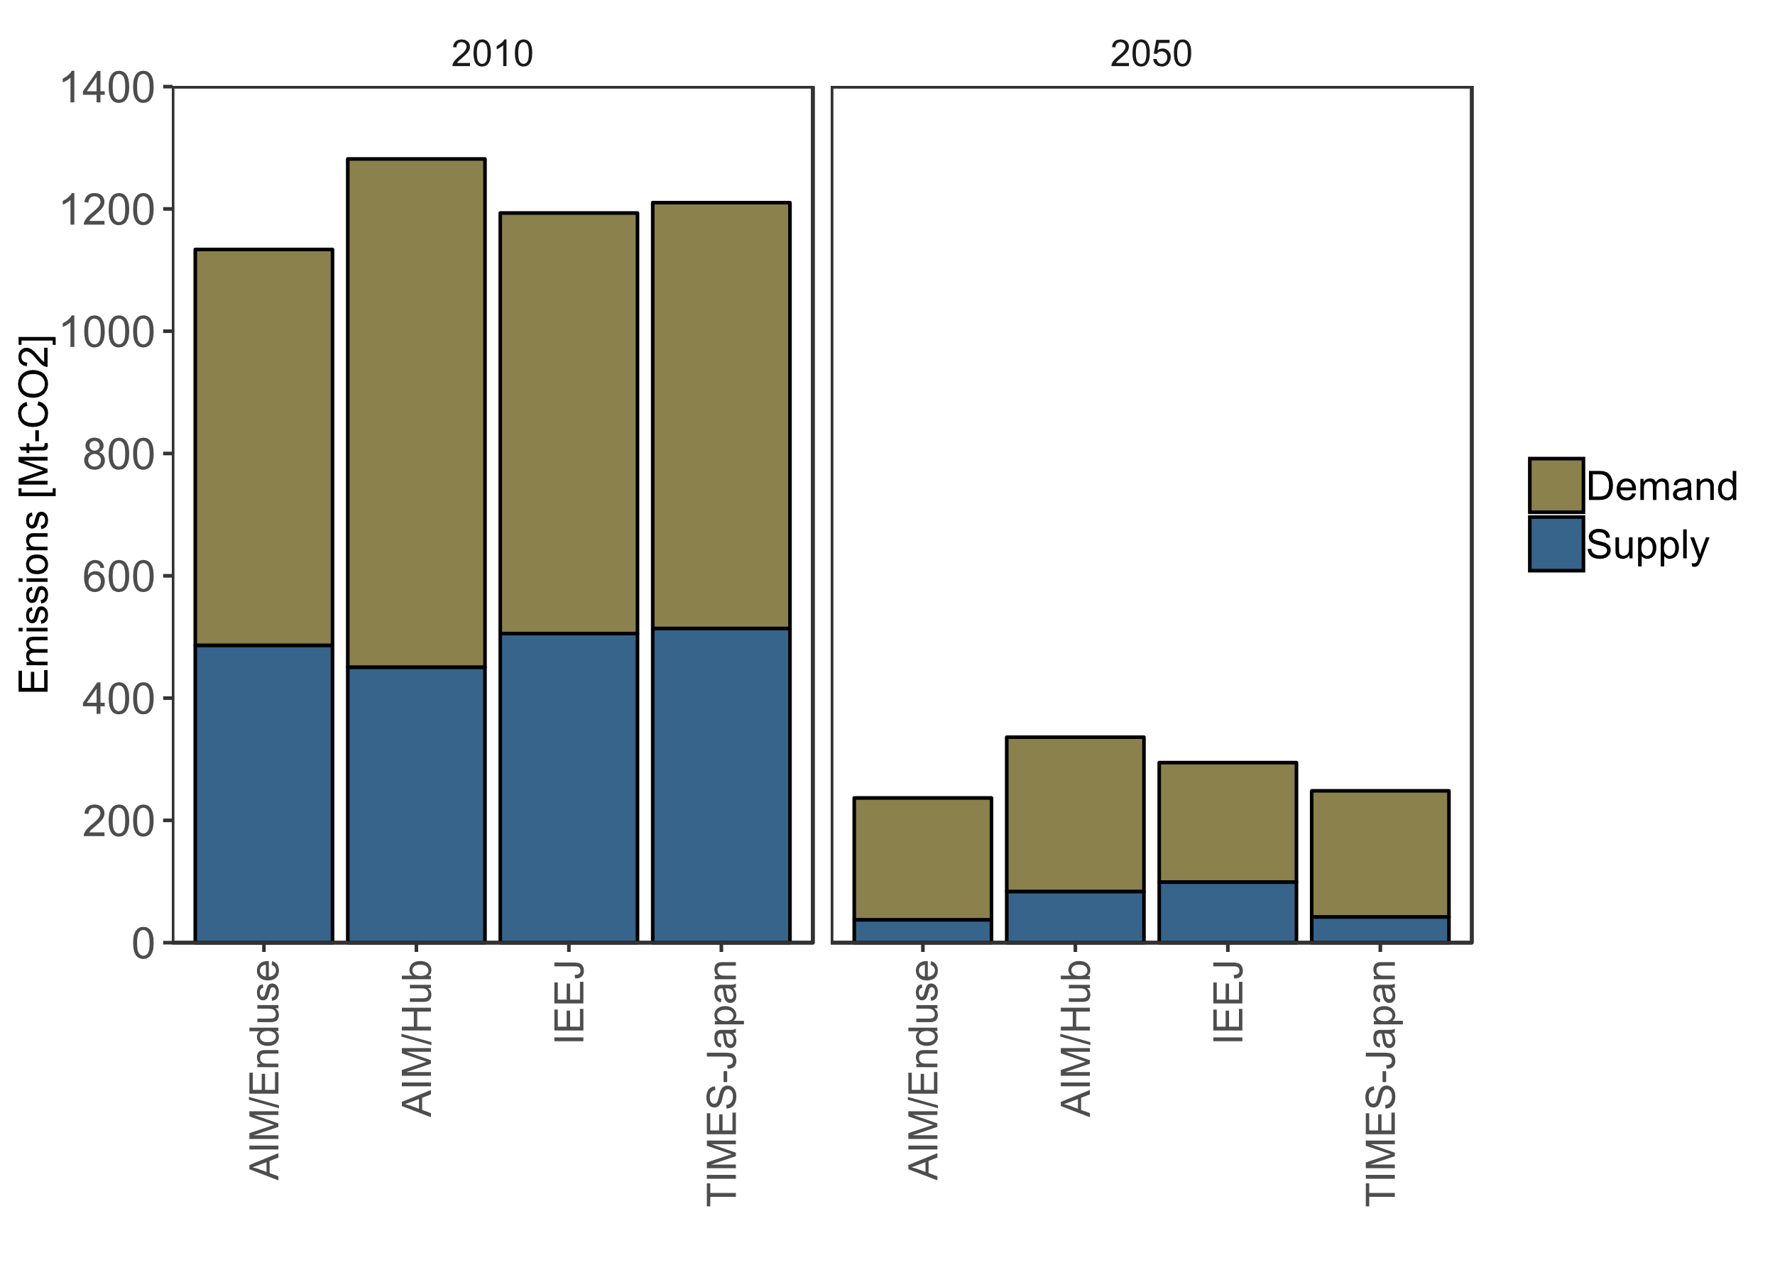
Figure ESM 1. CO2 emissions in 2010 and 2050 in 26by30+80by50_Def. Note: Demand includes CO2 emissions from fuel combustion in industry, residential, commercial, institutional sectors include industrial process and agriculture, forestry, fishing, and transportation sector. Supply includes CO2 emissions energy supply of electricity, gases, heat, liquids, solids and other.

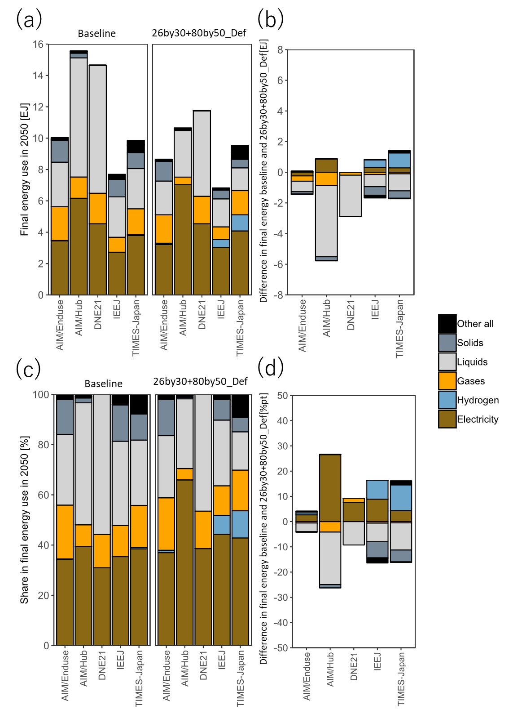
Figure ESM 2. Final energy use in 2050 (Baseline and 26by30+80by50_Def): (a) Final energy use in 2050 in Baseline and 26by30+80by50_Def, (b)Difference in final energy use Baseline and 26by30+80by50_Def, (c)Fuel share in final energy use in 2050 in Baseline and 26by30+80by50_Def, and (d)Difference of fuel share in final energy use Baseline and 26by30+80by50_Def.

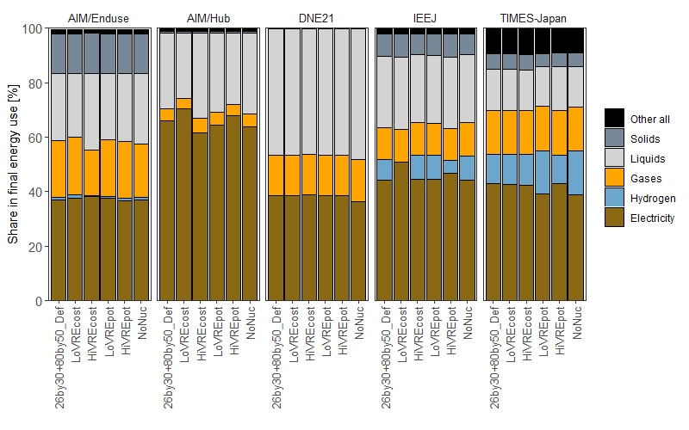
Figure ESM 3. Share of fuels in final energy use in 2050 in VREs and nuclear generation sensitivity scenarios

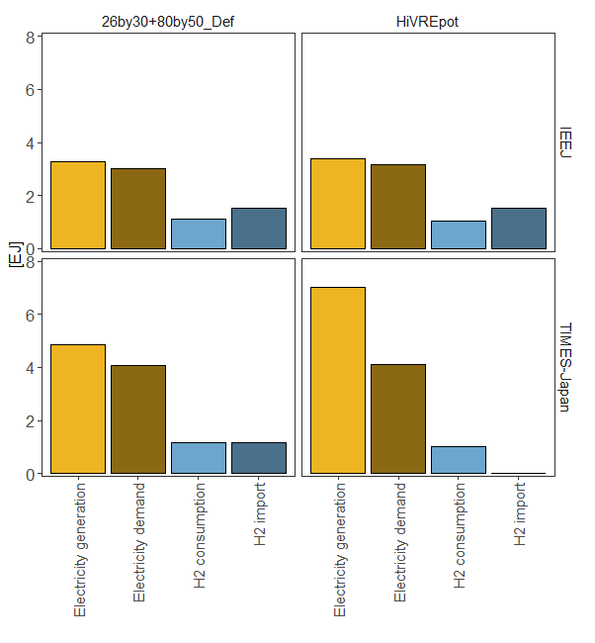
Figure ESM 4. Electricity and hydrogen in 2050 (26by30+80by50_Def & HiVREpot in IEEJ & TIMES-Japan). Note: H2 consumption includes hydrogen which is used to generate electricity and directly at the demand sector.

