Electronic Supplementary Material

Box S1: Training for lead farmers

The main focus of the training to the leader farmers was to provide detail technical knowledge on habitats and ecosystem management to increase fish production based on production of natural feed. The training aimed to build up women’s capacity needed for their active involvement in fish culture.

Overall, the lead farmers attended a series of sessions on techniques, value chains and women’s empowerment. The technical sessions focused on (a) habitat in ponds and its uses, (b) natural feed in pond, (c) fish species’ food and feeding habits, (d) fish species for ecopond, and (e) use of fishing gear. The value chain session focused on value chain actors and the market system. The women’s empowerment sessions focused on (a) women participation and decision-making capacity development, (b) access to resources, (c) control over the use of income, (d) leadership in the Community, and (e) WEAI related information collection and documentation.

A Participatory Action Learning (PAL) approach was adopted with hands-on sessions and tools such as magnifying glasses, aquaria, and microscopes. These were used for the effective learning of women about science on fish culture technologies. There is an important gender dimension on involvement of women in fish culture using this PAL approach. When women achieve knowledge about the science on fish culture technologies, develop their knowledge, skills and build up linkages with the support providers it is expected that there could be improvement in gender relations through their active participation in the activities, increased role in decision-making and development of self-confidence. It could improve their positioning in the households, families and in the communities.

After getting this training from experts, leader farmers assume the role of information disseminators in the communities at a suitable place located within the community called Learning Center (LC). Women farmers meet weekly to learn about the science on fish culture technologies in their ponds. Full women facilitated and women farmer participated session added more involvement of participants and as a way forward of activities leader farmer provided embedded service to the communities. In these sessions, women also shared experiences and knowledge, and even share opinions about other social and gender issues.

Overall, 297 lead farmers were trained in the intervention area. Of these 124 were located in Barguna and 173 in Khulna.

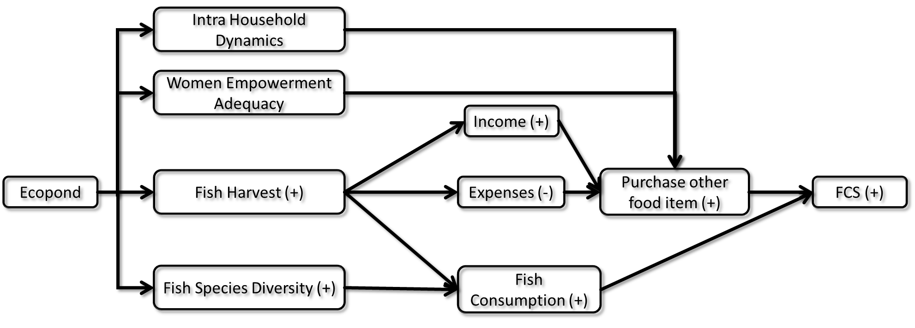
Figure S1 Analytical framework of impacts and impact pathways

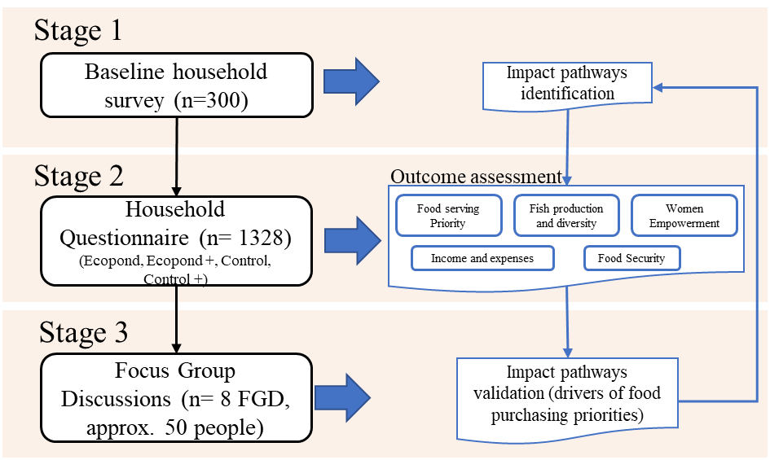
Figure S2 Study flow between impact pathways and outcome assessments

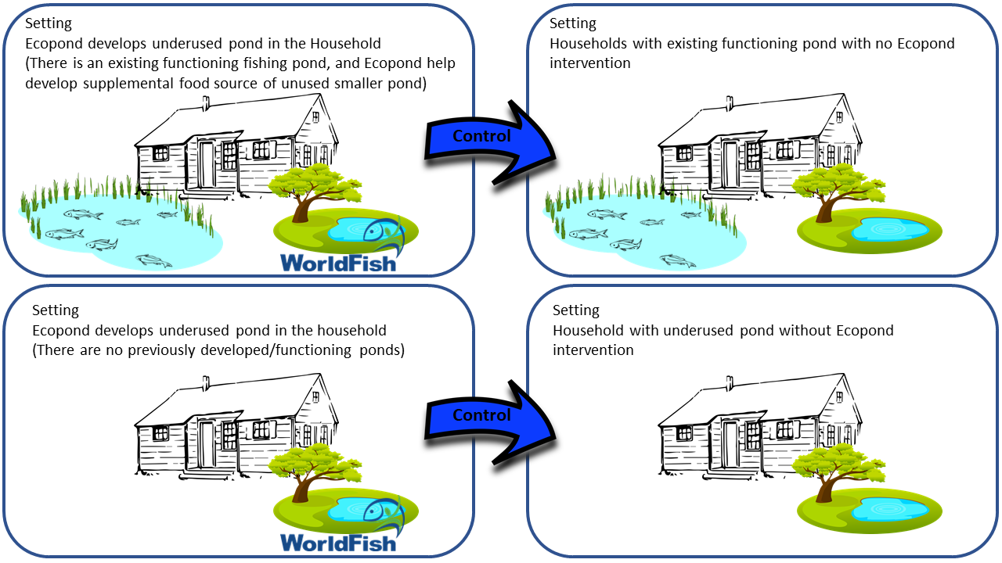
Figure S3 Study groups and comparisons

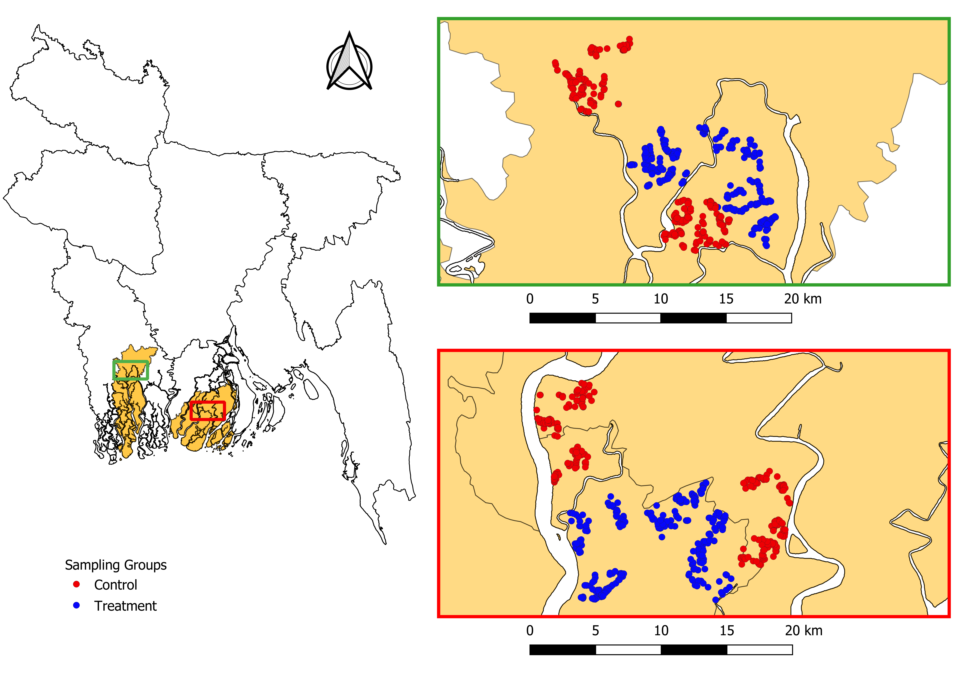Figure S4 Location of study areas
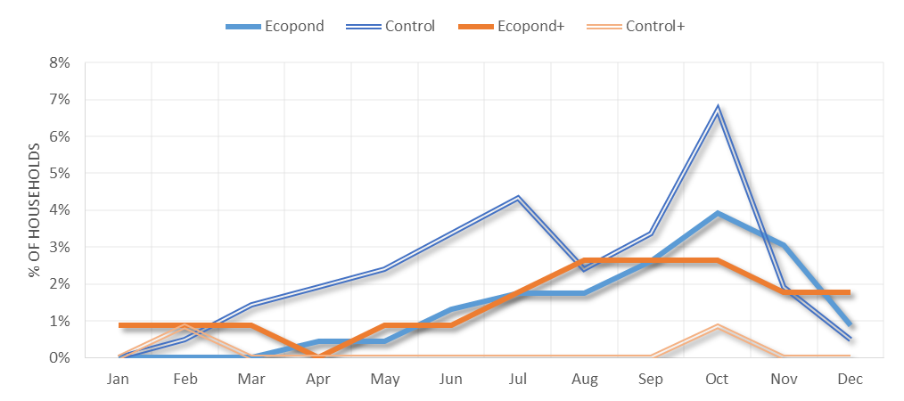
Figure S5 Self-reported months of food insecurity by sampling groups in Study Site 1

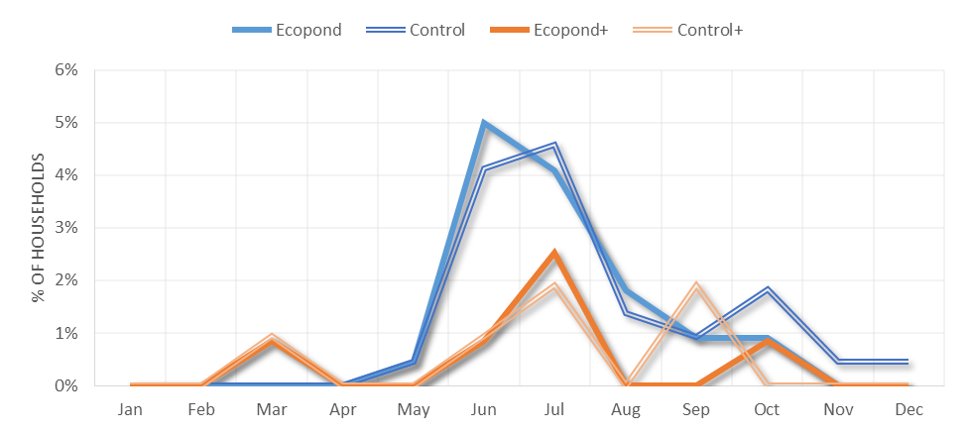
Figure S6 Self-reported months of food insecurity by sampling groups in Study Site 2

Table S1 General characteristics between study sites
 | Study Site 1 |  | Study Site 2
 | Polder 29 | Polder 30 | Polder 43/1A | Polder 43/2F
Environmental Characteristics
Land Type | Medium highland | Medium highland | Medium highland | Medium highland
Land Use | Net cultivable area (NCA): 69%;  Settlements: 23%  Water bodies (river/khals):7%  Road: 1% | Net cultivable area (NCA): 66%;  Settlements: 29%;  Water bodies (river/khals): 4%  Road:1% | Net cultivable area (NCA): 73%;  Settlements: 22%;  Water bodies (river/khals): 4%; Road: 1% | Net cultivable area (NCA): 63%; Settlements: 32%;  Water bodies (river/khals); 4%: Road: 1%
Soil Texture | Clay and clay loam | Clay and clay loam | Clay and clay loam | Clay and clay loam
Soil Salinity | Maximum level in March-April | Maximum level in April-May | - Maximum level in March-April | - Maximum level in April-May
Drainage | Imperfectly drained (i.e. water does not stay on land for more than 15 days at any given moment) | Poorly drained (i.e. the soil remains under water from 15 days – 7-8 months) | Poorly drained (i.e. land is flooded between 0-90 cm deep 15 days to few months) | Poorly drained (i.e. the soil remains under water from 15 days to 7-8 months)
Socioeconomic and demographic characteristics
Religion | 96% of total population is Muslim and the rest is predominately Hindu and a minority Christian | 75% of total population is Hindu and the rest is predominately Muslim and a minority Christian | 96% of total population is Muslim and the rest is predominately Hindu and a minority Christian | 96% of total population is Muslim and the rest is predominately Hindu and a minority Christian
Age structure | The highest proportion of population (28%) is 30-49 years old | The highest proportion of population (38%) is 30-49 years old | The highest proportion of population (25%) is 30-49 years old | The highest proportion of population (25%) is 30-49 years old
Education | Males tend to be more educated than females | Males tend to be more educated than females | Males tend to be more educated than females | Males tend to be more educated than females
Livelihoods | 38.63%: employed; 61%: engaged in household work (mainly agriculture);  0.25%: looking for employment | 30% is employed, 48% is engaged in household work, 1% is looking for work and 21% of total population is not working | 35% is employed, 46% is engaged in household work, only 1% is looking for work and about 18% of total population is not working | 35% of total population is employed, 47% is engaged in household work, only 1%is looking for work and about 18% of total population is not working
Poverty | About 48% of the households in average are in the ‘deficit’ category, 8% are surplus and rests of 44% households are in balance situation | 48% of the households in average are in the ‘deficit’ category, 8% are surplus and rests of 44% households are in balance situation | 66% households are poor | 45% of the households in average are in the ‘deficit’ category, 8% are surplus and rests of 47% households are in balance situation
Institutions and infrastructure | Peripheral roads of the polder are paved and brick soling;  Only one growth center or big market  About 7 hat/bazar (2 of these bazars are open every day of the week). | Some of the peripheral roads of the polder are paved and brick soling; Only one growth center  About 15 markets/bazars. | Most of the peripheral roads of the polder are earthen and brick soling. | Most of the peripheral roads of the polder are earthen and brick soling.  Only one growth centers  About 15 markets/bazars.
Note: Growth Centers are focal points of economic, social and cultural activity in the rural areas of Bangladesh. Rural markets are commonly considered as growth centres in Bangladesh. Source: (CEGIS, 2016).

Table S2 Focus group discussion characteristics
 | Target | Number of participants | Location | Age range | Religion
FGD1 | Women only | 6 | Barguna | 27-50 | Islam (100%)
FGD2 | Women only | 7 | Barguna | 26-50 | Islam (100%)
FGD3 | Women only | 7 | Khulna | 23-55 | Islam (100%)
FGD4 | Women only | 7 | Khulna | 26-60 | Hindu (100%)
FGD5 | Men only | 6 | Barguna | 17-66 | Islam (100%)
FGD6 | Men only | 7 | Barguna | 35-70 | Islam (100%)
FGD7 | Men only | 7 | Khulna | 26-60 | Islam (100%)
FGD8 | Men only | 7 | Khulna | 37-70 | Hindu (100%)

Table S3 Food groups and weights considered for the FCS calculation
Food Groups | Food Items | Weight
Cereals | rice, wheat, maize and other food items made from these cereals (e.g. cake, puffed rice, fatted rice) | 2
Tubers and other root crops | potatoes, sweet potato | 2
Pulses | mungbean, mushur dal, chickpea, groundnut | 3
Vegetables | potato, tomato, brinjal, okra, bitter gourd, cauliflower, cabbage and leafy vegetables | 1
Fruits | mango, banana, watermelon, pineapple, guava | 1
Fish and meat | fish, beef, mutton, poultry, pork, eggs | 4
Milk and milk products | milk, yoghurt, and other dairy products | 4
Sugar | sugar and sugar products | .5
Oil | oil, fat, butter | .5

Table S4 Variables use to determine the propensity score
Variable | Data type | Description
Age | Continuous | Age of the Ecopond training recipient in the household
Education Years | Continuous | Total years of schooling that Ecopond training recipients have
Religion | Dichotomous | Dummy variable identifying main religion in the household determined by the head of the household (Hindu/Muslim)
Main Activity | Dichotomous | Dummy variable to track if any formal/informal paid job is the primary activity of the Ecopond training recipient
Food Insecurity | Ordinal | Number or months within one year that households reports going through food insecurity
Distance | Dichotomous | Dummy variable describing if the distance to the Ecoponds are either close or far from the household

Table S5 Propensity score matching techniques comparison by study site
 | RMI |  |  | Chi2 |  | Matched |  |  | Discarded
 | Before Match | After Match |  | Chi2 |  | Control | Treated |  | Control | Treated
Zone 1 (Ecopond)
Nearest neighbor
Common Support Group | .446 | .421 |  | .023 |  | 202 | 202 |  | 6 | 2
Subclassification | .446 | .438 |  | .614 |  | 208 | 208 |  | 0 | 0
Match Ratio (1:5) | .446 | .428 |  | N/A |  | 208 | 208 |  | 0 | 0
Caliper (.1) | .446 | .409 |  | .953 |  | 193 | 193 |  | 0 | 0
*Caliper (.1); Support Group | .446 | .392 |  | .950 |  | 189 | 189 |  | 6 | 2
Full Matching | .446 | .461 |  | N/A |  | 208 | 229 |  | 0 | 0
Optimal matching | N/A | N/A |  | N/A |  | N/A | N/A |  | N/A | N/A
Zone 1 (Ecopond+)
Nearest neighbor
*Common Support Group | .539 | .475 |  | .972 |  | 99 | 99 |  | 1 | 14
Subclassification | .539 | .531 |  | .531 |  | 113 | 113 |  | 0 | 0
Match Ratio (1:5) | .539 | .535 |  | N/A |  | 116 | 113 |  | 0 | 0
Caliper (.1) | .539 | .511 |  | .985 |  | 90 | 90 |  | 0 | 0
Caliper (.1); Support Group | .539 | .519 |  | .998 |  | 79 | 79 |  | 1 | 14
Full Matching | .539 | .551 |  | N/A |  | 116 | 113 |  | 0 | 0
Optimal matching | .539 | .531 |  | N/A |  | 113 | 113 |  | 0 | 0
Zone 2 (Ecopond)
Nearest neighbor
Common Support Group | .348 | .338 |  | .474 |  | 216 | 216 |  | 1 | 4
Subclassification | .348 | .344 |  | .174 |  | 218 | 218 |  | 0 | 0
Match Ratio (1:5) | .348 | .344 |  | N/A |  | 197 | 172 |  | 0 | 0
*Caliper (.1) | .348 | .281 |  | .994 |  | 192 | 192 |  | 0 | 0
Caliper (.1); Support Group | .348 | .301 |  | .976 |  | 183 | 183 |  | 1 | 4
Full Matching | .348 | .343 |  | N/A |  | 218 | 220 |  | 0 | 0
Optimal matching | N/A | N/A |  | N/A |  | N/A | N/A |  | N/A | N/A
Zone 2 (Ecopond+)
Nearest neighbor
Common Support Group | .436 | .490 |  | .000 |  | 102 | 102 |  | 3 | 1
Subclassification | .410 | .486 |  | .010 |  | 105 | 105 |  | 0 | 0
Match Ratio (1:5) | .410 | .448 |  | N/A |  | 105 | 105 |  | 0 | 0
Caliper (.1) | .410 | .417 |  | .779 |  | 84 | 84 |  | 0 | 0
*Caliper (.1); Support Group | .410 | .376 |  | .893 |  | 85 | 85 |  | 3 | 1
Full Matching | .410 | .422 |  | N/A |  | 105 | 119 |  | 0 | 0
Optimal matching | N/A | N/A |  | N/A |  | N/A | N/A |  | N/A | N/A
Note: RMI = Relative Multivariate Imbalance (lower imbalance after matching is better); * chosen matching technique

Table S6 Total fish production by species across sampling group and study site (kg/year)

 | Sampling Groups |  |  |  | Propensity Score Matching
Sampling Group | Treated | Control | Sig. |  | After Treatment | Before Treatment | Sig.
Study Site 1
Ecopond vs Control
Anabas/Perch | 6.9 | 3.6 | 0.002** |  | 7.3 | 3.5 | 0.003**
Catfish | 8.3 | 17.2 | 0.423 |  | 7.8 | 18.5 | 0.389
Carp | 46.2 | 41.2 | 0.345 |  | 42.1 | 42.1 | 0.998
Indigenous | 18.5 | 13.1 | 0.061 |  | 19.3 | 13.8 | 0.098
Snakehead | 9.8 | 7.1 | 0.054 |  | 10.0 | 7.3 | 0.080
Tilapia | 25.0 | 20.8 | 0.139 |  | 25.1 | 21.4 | 0.264
Other | 7.1 | 41.1 | 0.217 |  | 6.3 | 44.6 | 0.230
Total | 121.6 | 144.0 | 0574 |  | 118.0 | 151.2 | 0.469
Ecopond+ vs Control+
Anabas/Perch | 9.0 | 6.3 | 0.066 |  | 9.2 | 6.5 | 0.138
Catfish | 11.6 | 6.6 | 0.046* |  | 12.4 | 6.8 | 0.046**
Carp | 112.0 | 182.0 | 0.004** |  | 110.4 | 194.8 | 0.001**
Indigenous | 22.5 | 18.7 | 0.242 |  | 20.2 | 20.1 | 0.973
Snakehead | 16.1 | 13.6 | 0.280 |  | 15.9 | 14.2 | 0.486
Tilapia | 55.9 | 56.8 | 0.958 |  | 56.8 | 59.8 | 0.871
Other | 32.2 | 54.8 | 0.078 |  | 33.4 | 61.3 | 0.068
Total | 259.3 | 338.8 | 0.082 |  | 258.4 | 363.5 | 0.032*
Study Site 2
Ecopond vs Control
Anabas/Perch | 3.8 | 1.4 | 0.000*** |  | 3.8 | 1.3 | 0.000***
Catfish | 13.9 | 14.0 | 0.990 |  | 13.6 | 14.4 | 0.753
Carp | 46.8 | 28.8 | 0.001*** |  | 45.7 | 30.2 | 0.005**
Indigenous | 10.5 | 42.5 | 0.221 |  | 10.7 | 24.0 | 0.458
Snakehead | 6.3 | 3.5 | 0.000*** |  | 6.3 | 3.5 | 0.001**
Tilapia | 33.9 | 15.7 | 0.051 |  | 35.5 | 16.3 | 0.062
Other | 41.8 | 20.0 | 0.380 |  | 46.3 | 18.7 | 0.328
Total | 157.1 | 125.9 | 0.493 |  | 162.0 | 108.5 | 0.244
Ecopond+ vs Control+
Anabas/Perch | 6.5 | 5.1 | 0.241 |  | 6.7 | 4.8 | 0.128
Catfish | 33.2 | 31.8 | 0.861 |  | 37.0 | 29.4 | 0.443
Carp | 87.1 | 85.0 | 0.895 |  | 89.6 | 76.7 | 0.452
Indigenous | 19.3 | 19.0 | 0.969 |  | 19.0 | 13.4 | 0.108
Snakehead | 11.7 | 7.0 | 0.011** |  | 13.2 | 7.0 | 0.005**
Tilapia | 54.7 | 45.0 | 0.408 |  | 56.8 | 45.5 | 0.436
Other | 35.5 | 20.8 | 0.174 |  | 39.9 | 21.0 | 0.173
Total | 247.9 | 213.7 | 0.292 |  | 262.2 | 197.7 | 0.087
Note: Fish harvest per unit area does not include fish species harvested from open waters. ***p<0.001; **p<0.01, *p<0.05; 1 decimal = 40.47 m²

Table S7 Total fish production by source across sampling group and study site (kg/year)
 | Sampling Groups |  |  |  | Propensity Score Matching
Sampling Group | Treated | Control | Sig. |  | After Treatment | Before Treatment | Sig.
Study Site 1
Ecopond vs Control
Gher | 0 | 0 | N/A |  | 0 | 0 | N/A
Ecopond//underutilized pond | 89 | 75 | 0.048* |  | 85 | 76 | 0.253
Pond | 0 | 0 | N/A |  | 0 | 0 | N/A
Open Water | 33 | 69 | 0.347 |  | 33 | 75 | 0.358
Total | 122 | 144 | 0.574 |  | 118 | 151 | 0.469
Ecopond+ vs Control+
Gher | 124 | 188 | 0.118 |  | 120 | 210 | 0.049*
Ecopond//underutilized pond | 79 | 62 | 0.094 |  | 82 | 63 | 0.115
Pond | 36 | 68 | 0.014** |  | 38 | 69 | 0.40*
Open Water | 20 | 20 | 0.907 |  | 18 | 21 | 0.616
Total | 259 | 339 | 0.082 |  | 258 | 364 | 0.032*
Study Site 2
Ecopond vs Control
Gher | 0 | 0 | N/A |  | 0 | 0 | N/A
Ecopond//underutilized pond | 135 | 68 | 0.070 |  | 139 | 70 | 0.094
Pond | 0 | 0 | N/A |  | 0 | 0 | N/A
Open Water | 22 | 58 | 0.185 |  | 23 | 39 | 0.420
Total | 157 | 126 | 0.493 |  | 162 | 108 | 0.244
Ecopond+ vs Control+
Gher | 17 | 25 | 0.673 |  | 19 | 27 | 0.696
Ecopond//underutilized pond | 97 | 62 | 0.000*** |  | 101 | 56 | 0.000***
Pond | 113 | 100 | 0.427 |  | 121 | 96 | 0.258
Open Water | 21 | 27 | 0.531 |  | 22 | 18 | 0.595
Total | 248 | 214 | 0.292 |  | 262 | 198 | 0.087
Note: Fish harvest per unit area does not include fish species harvested from open waters; ***p<0.001; **p<0.01, *p<0.05; 1 decimal = 40.47 m²

Table S8 Fish production per unit area by source across sampling group and study site (kg/decimal/year)
 |  | Sampling Groups |  |  |  |  |  | Propensity Score Matching
Sampling Group |  | Treated | Control | Sig. |  |  |  | After Treatment | Before Treatment | Sig.
Study Site 1
Ecopond vs Control
Gher |  | 0.0 | 0.0 | N/A |  |  |  | 0.0 | 0.0 | N/A
Ecopond/underutilized pond |  | 16.2 | 12.8 | 0.005** |  |  |  | 16.1 | 12.8 | 0.015*
Pond |  | 0.0 | 0.0 | N/A |  |  |  | 0.0 | 0.0 | N/A
Total |  | 16.2 | 12.8 | 0.005** |  |  |  | 16.1 | 12.8 | 0.015*
Ecopond+ vs Control+
Gher | 4.4 |  | 4.2 | 0.873 |  | 4.4 |  |  | 4.6 | 0.923
Ecopond/underutilized pond | 15.6 |  | 10.0 | 0.001** |  | 15.4 |  |  | 10.5 | 0.010*
Pond | 5.0 |  | 6.6 | 0.247 |  | 4.9 |  |  | 6.3 | 0.345
Total | 25.0 |  | 20.7 | 0.116 |  | 24.8 |  |  | 21.4 | 0.253
Study Site 2
Ecopond vs Control
Gher | 0.0 |  | 0.0 | N/A |  | 0.0 |  |  | 0.0 | N/A
Ecopond/underutilized pond | 16.9 |  | 11.9 | 0.022* |  | 17.2 |  |  | 12.1 | 0.032*
Pond | 0.0 |  | 0.0 | N/A |  | 0.0 |  |  | 0.0 | N/A
Total | 16.9 |  | 11.9 | 0.022* |  | 17.2 |  |  | 12.1 | 0.032*
Ecopond+ vs Control+
Gher | 0.7 |  | 0.2 | 0.075 |  | 0.8 |  |  | 0.1 | 0.023*
Ecopond//underutilized pond | 14.8 |  | 9.9 | 0.000*** |  | 14.4 |  |  | 9.2 | 0.000***
Pond | 12.3 |  | 10.1 | 0.247 |  | 13.1 |  |  | 9.9 | 0.157
Total | 27.9 |  | 20.2 | 0.002** |  | 28.4 |  |  | 19.3 | 0.001**
Note: Fish harvest per unit area does not include fish species harvested from open waters; ***p<0.001; **p<0.01, *p<0.05; 1 decimal = 40.47 m²

Table S9 Household expenditures across sampling groups, study sites and statistical tests (USD/AE/year)

 | Sampling Groups |  |  |  | Propensity Score Matching
 | Treated | Control | Sig. |  | After Treatment | Before Treatment | Sig.
Study Site 1
Ecopond vs Control
Basic Needs (Health, Education) | 83 | 79 | 0.644 |  | 82 | 81 | 0.866
Fish | 33 | 34 | 0.867 |  | 33 | 35 | 0.841
Other Food Items | 135 | 159 | 0.003** |  | 136 | 162 | 0.003**
Household Improvements | 100 | 109 | 0.740 |  | 103 | 113 | 0.769
Production Inputs | 42 | 37 | 0.382 |  | 38 | 41 | 0.684
Other | 1 | 5 | 0.143 |  | 1 | 5 | 0.147
Total Expenditures | 394 | 423 | 0.402 |  | 394 | 436 | 0.286
Ecopond+ vs Control+
Basic Needs (Health, Education) | 70 | 103 | 0.002** |  | 70 | 98 | 0.008**
Fish | 24 | 32 | 0.120 |  | 23 | 29 | 0.339
Other Food Items | 144 | 185 | 0.001*** |  | 144 | 184 | 0.000***
Household Improvements | 91 | 112 | 0.147 |  | 94 | 113 | 0.265
Production Inputs | 55 | 70 | 0.155 |  | 56 | 72 | 0.198
Other | 7 | 21 | 0.318 |  | 8 | 18 | 0.497
Total Expenditures | 390 | 523 | 0.000*** |  | 395 | 514 | 0.002**
Study Site 2
Ecopond vs Control
Basic Needs (Health, Education) | 114 | 109 | 0.775 |  | 117 | 110 | 0.709
Fish | 71 | 74 | 0.656 |  | 74 | 75 | 0.869
Other Food Items | 177 | 188 | 0.142 |  | 176 | 191 | 0.069
Household Improvements | 105 | 108 | 0.895 |  | 110 | 110 | 0.974
Production Inputs | 48 | 48 | 0.942 |  | 51 | 50 | 0.894
Other | 8 | 9 | 0.898 |  | 8 | 9 | 0.903
Total Expenditures | 524 | 536 | 0.712 |  | 536 | 545 | 0.807
Ecopond+ vs Control+
Basic Needs (Health, Education) | 105 | 112 | 0.655 |  | 104 | 116 | 0.401
Fish | 68 | 88 | 0.039* |  | 64 | 88 | 0.041*
Other Food Items | 185 | 193 | 0.464 |  | 187 | 192 | 0.743
Household Improvements | 100 | 111 | 0.474 |  | 105 | 116 | 0.604
Production Inputs | 67 | 61 | 0.662 |  | 69 | 61 | 0.608
Other | 0 | 1 | 0.311 |  | 0 | 0 | 0.321
Total Expenditures | 525 | 565 | 0.225 |  | 529 | 573 | 0.256
Note: ***p<0.001; **p<0.01, *p<0.05; 1 decimal = 40.47 m²

Table S10 Household fish consumption by fish species across groups, study sites and statistical tests (in Kg/AE/year)
 | Sampling Groups |  |  |  | Propensity Score Matching
Sampling Group | Treated | Control | Sig. |  | After  Treatment | Before  Treatment | Sig.
Study Site 1
Ecopond vs Control
Anabas/Perch | 2.50 | 1.33 | 0.001*** |  | 2.65 | 1.30 |  | 0.001***
Catfish | 4.03 | 3.33 | 0.197 |  | 3.63 | 3.34 |  | 0.610
Carp | 18.50 | 15.66 | 0.082 |  | 18.86 | 15.66 |  | 0.068
Small indigenous fish | 7.13 | 5.04 | 0.004** |  | 7.19 | 5.19 |  | 0.012*
Snakehead | 3.43 | 2.49 | 0.008** |  | 3.45 | 2.51 |  | 0.011*
Tilapia | 15.40 | 11.34 | 0.001*** |  | 15.50 | 11.57 |  | 0.004**
Other | 4.26 | 4.76 | 0.461 |  | 3.67 | 4.85 |  | 0.029*
Total | 55.26 | 43.94 | 0.000*** |  | 54.95 | 44.43 |  | 0.001***
Ecopond+ vs Control+
Anabas/Perch | 3.31 | 1.52 | 0.003** |  | 3.45 | 1.58 |  | 0.008**
Catfish | 5.34 | 2.71 | 0.061 |  | 4.33 | 2.82 |  | 0.106
Carp | 20.19 | 29.40 | 0.004** |  | 20.26 | 29.75 |  | 0.009**
Small indigenous fish | 18.39 | 5.75 | 0.186 |  | 18.46 | 5.84 |  | 0.252
Snakehead | 4.92 | 3.39 | 0.020** |  | 4.78 | 3.47 |  | 0.087
Tilapia | 17.16 | 11.06 | 0.001** |  | 17.43 | 10.67 |  | 0.002**
Other | 6.14 | 5.98 | 0.867 |  | 6.42 | 6.21 |  | 0.853
Total | 75.45 | 59.80 | 0.152 |  | 75.14 | 60.33 |  | 0.248
Study Site 2
Ecopond vs Control
Anabas/Perch | 1.51 | 0.97 | 0.007** |  | 1.49 | 0.98 |  | 0.028*
Catfish | 7.53 | 8.48 | 0.302 |  | 7.27 | 8.77 |  | 0.136
Carp | 15.77 | 14.70 | 0.435 |  | 15.52 | 15.61 |  | 0.947
Small indigenous fish | 5.19 | 4.05 | 0.018* |  | 5.16 | 3.96 |  | 0.025*
Snakehead | 2.07 | 1.49 | 0.011* |  | 2.04 | 1.53 |  | 0.056
Tilapia | 12.22 | 11.46 | 0.377 |  | 12.35 | 12.07 |  | 0.745
Other | 8.72 | 9.71 | 0.303 |  | 8.89 | 9.28 |  | 0.692
Total | 53.01 | 50.86 | 0.365 |  | 52.71 | 52.20 |  | 0.825
Ecopond+ vs Control+
Anabas/Perch | 2.05 | 1.50 | 0.116 |  | 2.11 | 1.36 |  | 0.036*
Catfish | 8.62 | 9.44 | 0.587 |  | 8.46 | 9.65 |  | 0.480
Carp | 19.33 | 18.21 | 0.649 |  | 19.50 | 16.60 |  | 0.294
Small indigenous fish | 7.40 | 5.33 | 0.037* |  | 6.82 | 5.42 |  | 0.222
Snakehead | 3.59 | 2.36 | 0.009** |  | 3.75 | 2.36 |  | 0.004**
Tilapia | 14.90 | 12.05 | 0.040* |  | 15.07 | 12.33 |  | 0.070
Other | 10.63 | 9.63 | 0.503 |  | 10.74 | 9.91 |  | 0.625
Total | 66.53 | 58.53 | 0.080 |  | 66.45 | 57.64 |  | 0.069
Note: Small indigenous fish include mola, darkina, small chingri, punti and other species rich in micronutrients. ***p<0.001; **p<0.01, *p<0.05

Table S11 Self-reported number of months of food insecurity
 | Sampling Groups |  |  |  | Propensity Score Matching
 | Treated | Control | Sig. |  | After Treatment | Before Treatment | Sig.
Study Site 1
Ecopond vs Control | 0.16 | 0.29 | 0.080 |  | 0.12 | 0.13 | 0.928
Ecopond+ vs Control+ | 0.18 | 0.02 | 0.011* |  | 0.02 | 0.02 | 1.000
Study Site 2
Ecopond vs Control | 0.13 | 0.14 | 0.851 |  | 0.11 | 0.08 | 0.405
Ecopond+ vs Control+ | 0.05 | 0.06 | 0.882 |  | 0.04 | 0.04 | 1.000
Note: ***p<0.001; **p<0.01, *p<0.05

Table S12 Serving priority of household members by group and study site
 | Study Site 1 |  |  |  |  | Study Site 2
 | Treatment | Control | Δ | Sig. |  | Treatment | Control | Δ | Sig.
Ecopond vs Control
Infant (up to 2 yrs.) boy | 1.3 | 1.1 | -0.2 | 0.450 |  | 1.0 | 1.0 | 0.0 | 0.007**
Infant (up to 2 yrs.) girl | 1.4 | 1.2 | -0.2 | 0.141 |  | 1.0 | 1.0 | 0.0 | 0.945
Pregnant women | 1.6 | 1.5 | -0.1 | 0.147 |  | 1.5 | 1.6 | 0.1 | 0.083
Lactating women | 1.5 | 1.5 | 0.0 | 0.035* |  | 1.5 | 1.5 | 0.0 | 0.199
Children (3-12 yrs.) boy | 1.4 | 1.4 | 0.0 | 0.530 |  | 1.3 | 1.2 | -0.1 | 0.361
Children (3-12 yrs.) girl | 1.6 | 1.5 | -0.1 | 0.088 |  | 1.6 | 1.4 | -0.2 | 0.279
Elderly (above 65 yrs.) men | 1.7 | 1.7 | 0.0 | 0.129 |  | 1.4 | 1.6 | 0.2 | 0.910
Elderly (above 65 yrs.) women | 1.8 | 1.8 | 0.0 | 0.815 |  | 1.5 | 1.7 | 0.2 | 0.902
Middle age (35-64 yrs.) men | 2.5 | 2.3 | -0.2 | 0.530 |  | 2.4 | 2.6 | 0.2 | 0.232
Middle age (35-64 yrs.) women | 2.9 | 2.6 | -0.3 | 0.639 |  | 2.9 | 2.8 | -0.1 | 0.279
Adolescent boy (13-18 yrs.) | 2.2 | 2.0 | -0.2 | 0.088 |  | 2.0 | 2.1 | 0.1 | 0.077
Adolescent girls (13-18 yrs.) | 2.3 | 2.1 | -0.2 | 0.132 |  | 2.2 | 2.1 | -0.1 | 0.571
Young adult (19-34 yrs.) men | 2.5 | 2.2 | -0.3 | 0.057 |  | 2.3 | 2.5 | 0.2 | 0.065
Young adult (19-34 yr.) women | 2.9 | 2.6 | -0.3 | 0.006** |  | 2.8 | 2.8 | 0.0 | 0.296
Ecopond+ vs Control+
Infant (up to 2 yr.) boy | 1.3 | 1.1 | -0.2 | 0.247 |  | 1.1 | 1.0 | -0.1 | 0.353
Infant (up to 2 yr.) girl | 1.3 | 1.2 | -0.1 | 0.643 |  | 1.2 | 1.2 | 0.0 | 0.716
Pregnant women | 1.5 | 1.6 | 0.1 | 0.734 |  | 1.6 | 1.5 | -0.1 | 0.165
Lactating women | 1.5 | 1.6 | 0.1 | 0.636 |  | 1.6 | 1.6 | 0.0 | 0.347
Children (3-12 yr.) boy | 1.5 | 1.3 | -0.2 | 0.099 |  | 1.3 | 1.4 | 0.1 | 0.695
Children (3-12 yr.) girl | 1.5 | 1.4 | -0.1 | 0.613 |  | 1.3 | 1.4 | 0.1 | 0.161
Elderly (above 65 yrs.) men | 1.8 | 1.8 | 0.0 | 0.773 |  | 1.7 | 1.8 | 0.1 | 0.013*
Elderly (above 65 yrs.) women | 1.8 | 1.8 | 0.0 | 0.302 |  | 1.8 | 1.8 | 0.0 | 0.139
Middle age (35-64 yr.) men | 2.2 | 2.1 | -0.1 | 0.048 |  | 1.9 | 2.1 | 0.2 | 0.000***
Middle age (35-64 yr.) women | 2.4 | 2.4 | 0.0 | 0.212 |  | 2.2 | 2.2 | 0.0 | 0.040*
Adolescent boy (13-18 yr.) | 1.7 | 1.6 | -0.1 | 0.984 |  | 1.6 | 1.7 | 0.1 | 0.631
Adolescent girls (13-18 yr.) | 1.7 | 1.7 | 0.0 | 0.964 |  | 1.8 | 1.7 | -0.1 | 0.944
Young adult (19-34 yrs.) men | 2.0 | 1.9 | -0.1 | 0.452 |  | 1.9 | 1.9 | 0.0 | 0.014*
Young adult (19-34 yr.) women | 2.3 | 2.2 | -0.1 | 0.735 |  | 2.1 | 2.1 | 0.0 | 0.287
Note: (Δ = control average priority – treatment average priority); ***p<0.001; **p<0.01, *p<0.05
Table S13 Proportion of household with empowerment adequacy across WEAI indicators, groups and study sites

 | Study Site 1 |  |  |  | Study Site 2
WEAI Indicators | Treatment  (% of HH) | Control  (% of HH) | Sig. |  | Treatment  (% of HH) | Control  (% of HH) | Sig.
Ecopond vs Control
P1: Input in productive decisions | 93% | 84% | 0.006** |  | 93% | 91% | 0.458
R1: Ownership of assets | 81% | 66% | 0.001*** |  | 67% | 61% | 0.243
R2: Purchase, sale, or transfer of assets | 89% | 82% | 0.041* |  | 85% | 85% | 0.821
R3: Access to and decisions on credit | 45% | 37% | 0.089 |  | 37% | 26% | 0.012*
I1: Control over use of income | 97% | 92% | 0.054 |  | 99% | 98% | 0.723
L1: Group member | 100% | 100% | 1.000 |  | 100% | 94% | 0.000***
L2: Speaking in public | 92% | 96% | 0.054 |  | 96% | 95% | 0.632
T1: Workload | 52% | 46% | 0.262 |  | 46% | 46% | 0.994
T2: Leisure | 86% | 80% | 0.140 |  | 84% | 80% | 0.245
Ecopond+ vs Control+
P1: Input in productive decisions | 87% | 88% | 0.784 |  | 95% | 90% | 0.125
R1: Ownership of assets | 87% | 74% | 0.017* |  | 76% | 55% | 0.001**
R2: Purchase, sale, or transfer of assets | 89% | 90% | 0.946 |  | 87% | 83% | 0.339
R3: Access to and decisions on credit | 31% | 27% | 0.478 |  | 32% | 28% | 0.482
I1: Control over use of income | 97% | 97% | 1.000 |  | 97% | 99% | 0.625
L1: Group member | 100% | 100% | 1.000 |  | 100% | 96% | 0.047*
L2: Speaking in public | 93% | 96% | 0.365 |  | 98% | 98% | 1.000
T1: Workload | 56% | 59% | 0.661 |  | 62% | 36% | 0.000***
T2: Leisure | 78% | 84% | 0.270 |  | 81% | 88% | 0.158
Note: ***p<0.001; **p<0.01, *p<0.05

