The role of indigenous knowledge and local knowledge in water sector adaptation to climate change in Africa: A structured assessment

Supplementary Material - SM

SM 1
Definition of the relevant GAMI codes used in this study. These should be read together with methods and results sections where summary of the sectors, climate hazards, type of responses, climate risk reduction, limits to adaptation and actors are listed.
SM Table 1: The seven sectors identified by GAMI that are crucial for understanding and tracking climate adaptation
Sector | Definition
Terrestrial & freshwater ecosystems | Freshwater, lake, river, watershed, pond, wetland, stream, terrestrial, taiga, tundra, grasslands, forest, tropical, temperate
Ocean & coastal ecosystems | Marine, mangrove, tidal, estuary, lagoon, reef, coral, sea, ocean, benthic, salt, coast
Water and sanitation | Water, hydrology, basin, watershed, flood, drought, landslide, sanitation
Food, fibre, and other ecosystem products | Food, fibre, nutrition, medicine, aquaculture, fisheries, agroforestry, agroecology
Cities, settlements, and key infrastructure | Cities, urban, infrastructure, industry, settlements
Health, well-being, and communities | Health, wellbeing, well-being, wellness, disease, illness, medicine, epidemics, vector, vector borne, vector-borne, cardiovascular, respiratory, allergies, mental health, heat stress, psychosocial, nutrition, asthma, displacement, cultural integrity, migration, cultural heritage, identity, social capital, mobility, conflict, war
Poverty, livelihoods, and sustainable development | Poverty, livelihood, sustainable development, wealth, resilience, justice, equity, discrimination, conflict, diversification

SM Table 2: Description of the climate hazards that were identified in the papers
Hazard | Definition
Sea level rise | Includes coastal flooding and storm surges
Extreme precipitation and inland flooding
Increased frequency and intensity of extreme heat | Includes urban heat island effect
Precipitation variability
Drought
Rising ocean temperature and ocean acidification | Includes loss of coral cover
Loss of Arctic Sea ice
General climate impacts | No specific hazard identified
Other | Other

SM Table 3: Classification of climate adaptation responses
Adaptation response type | Definition
Behavioural/cultural | Enabling, implementing, or undertaking lifestyle and/or behavioural change
Ecosystem-based | Enhancing, protecting, or promoting ecosystem services
Institutional | Enhancing multilevel governance or institutional capabilities
Technological/infrastructure | Enabling, implementing, or undertaking technological innovation or infrastructural development

SM Table 4: Description of the actors identified in the literature assessed
Actor | Definition
International or multinational governance institutions | Global or regional treaty body or agency (e.g., UN institutions/ organizations, EU institutions, Organization of American States, African Union)
Government (national) | Countries officially recognized by the UN
Government (sub-national) | Domestic, sub-national governing unit. Terms include state, province, territory, department, canton, Lander
Government (local) | Terms include municipality, local government, community, urban, urban regions, rural
Private sector (corporations) | Large national or international companies
Private sector (SME) | Small- and medium-enterprises
Civil society (international, multinational, national) | Voluntary civil society organizations. Includes charities, non-profits, faith-based organizations, professional organizations (e.g., labour unions, associations, federations), cultural groups, religious groups, sporting associations, advocacy groups (e.g., NGOs).
Civil society (sub-national or local) | Formal community associations
Individuals or households | Including informal community networks

SM Table 5: Codes used for assessing the reduced risk and limits to adaptation in the literature papers
Category | Question | Instructions | Codes | Definition
Reduced risk | Is there any evidence (implicitly or explicitly) provided that activities successfully reduced risk or vulnerability? | Select one. If yes, describe the approach in the open field. If no write "None" in open field. | Yes | The change must be documented to respond 'yes' for this question. Anticipated or expected reduction is not sufficient for this question. Note that these don't need to be quantitative, but could involve theory of change, narrative justifications of change, or other.
 |  |  | No
 |  |  | Open field | If answered yes, copy relevant text here. If none write "None."
Adaptation limits | Does the article/ document identify and describe constraints or limits to adaptation? | Select one. | Yes | Constraints are defined as: “factors that make it harder to plan and implement adaptation actions.” (IPCC AR5 WG2, Chap. 16, pg. 923).  Constraints can be categorized as:  (1) Economic: existing livelihoods, economic structures, and economic mobility.  (2) Social/cultural: social norms, identity, place attachment, beliefs, worldviews, values, awareness, education, social justice, and social support.  (3) Human capacity: individual, organizational, and societal capabilities to set and achieve adaptation objectives over time including training, education, and skill development.  (4) Governance, Institutions & Policy: existing laws, regulations, procedural requirements, governance scope, effectiveness, institutional arrangements, adaptive capacity, and absorption capacity.  (5) Financial: lack of financial resources.  (6) Information/Awareness/Technology: lack of awareness or access to information or technology.  (7) Physical: presence of physical barriers; and  (8) Biological: temperature, precipitation, salinity, acidity, and intensity and frequency of extreme events including storms, drought, and wind.

SM 2
List of the countries where the 200 articles with evidence of water adaptation responses. These are distributed in 31 African countries. (Include excel file with GAMI coded water adaptation response articles).
Table 6: Expanded list of articles with evidence of water adaptation responses
Country | Number of articles with water adaptation responses | Number of articles with IK and LK evidence
Algeria | 2 | -
Angola | 1 | 1
Benin | 3 | 2
Botswana | 2 | -
Burkina Faso | 7 | 1
Cameroon | 3 | 1
Chad | 1 | 1
Cote d'Ivoire | 1 | 1
Egypt | 1 | -
Ethiopia | 30 | 4
Ghana | 28 | 15
Gambia | 2 | -
Kenya | 26 | 12
Lesotho | 1 | 1
Malawi | 5 | -
Mali | 2 | -
Morocco | 1 | 1
Mozambique | 4 | 1
Namibia | 4 | 1
Niger | 6 | 2
Nigeria | 19 | 4
Rwanda | 1 | -
Senegal | 3 | 1
South Africa | 16 | 5
Sudan | 2 | -
Swaziland | 2 | -
Tanzania | 11 | 3
Tunisia | 4 | -
Uganda | 11 | 3
Zambia | 4 | -
Zimbabwe | 9 | 7

Evidence levels in Literature assessed
Using the IPCC guidelines, we assessed the evidence levels for both the water adaptation responses and the IK and LK (see the methods section - framing of water adaptation responses and IKLK). This was based on the counts each adaptation response is mentioned in the articles per sub-region (southern, east, west, north, and central Africa).

SM Table 7: Evidence levels used to assess the water adaptation responses recorded in the literature assessed
Strong evidence | > 20 counts per adaptation measure in the region
High evidence | 10 - 19 counts per adaptation measure in the region
Medium evidence | 6 - 9 counts per adaptation measure in the region
Low evidence | 1 - 5 counts per adaptation measure in the region
No data | No evidence of specific adaptation measure in the region

SM Table 8: Evidence levels used to assess the influence of IK and LK per adaptation response
Strong evidence | > 10 counts per adaptation measure in the region
High evidence | 6-9 counts per adaptation measure in the region
Medium evidence | 3-5 counts per adaptation measure in the region
Low evidence | 1-2 counts per adaptation measure in the region
No data | No evidence of specific adaptation measure in the region

SM Table 9: Evidence of human adaptation across sectors in Africa in the literature assessed.
Sector | Total number of publications | Water Adaptation responses | IK and LK in water adaptation
Food fibre and other ecosystems | 409 | 146 | 56
Poverty, livelihoods, and sustainable development | 349 | 129 | 59
Health, well-being, and communities | 142 | 47 | 18
Water and sanitation | 92 | 21 | 7
Terrestrial and freshwater ecosystems | 53 | 18 | 6
Cities settlements and key infrastructure | 39 | 11 | 3
Ocean and coastal ecosystems | 25 | 4 | 2
 | n = 570 | n = 200 | n = 73

SM 3
Extension codes were developed on attributes of indigenous and local knowledge for articles with evidence of IK and LK. The attributes of IK and LK were adapted from Petzold et al. 2020.
SM Table 10: Definition of IK and LK attribution used in this review
Attribute | Definition
Factual knowledge about the environment and environmental changes | These were observations, monitoring of weather, land, place, habitat, ecosystem used to adapt to climate change impacts such as droughts, floods, precipitation variability.
Factual knowledge about the use of the environment | These were water management practices, land use, land use change, carrying capacity, resource conservation for climate adaptation.
Governance and social capital | These were social norms, customary rules and institutions, land tenure, networks of reciprocity in communities used to strengthen/ promote the adaptation process.
Cultural values and worldviews | These were moral and ethical statement about the use of the environment, taboos, religious beliefs, folklore knowledge.
Other | This consisted of other practices used by farmers and communities which are relevant for water-climate-adaptation.

SM 4
Geographic distribution of specific water adaptation responses per country are presented in supplementary material 4.
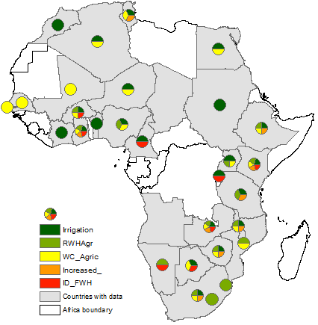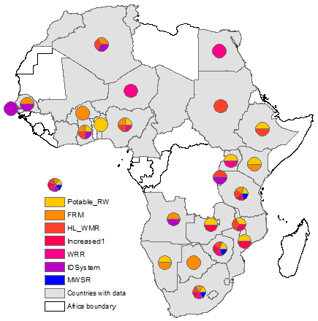
Key: RWHAgric = Rainwater harvesting in agriculture, WC_Agric = water conservation, ID_FWH = Flood water control (harvesting, diverting, drainage) Incresead_= increased groundwater abstraction in agriculture, Potable RW = potable rainwater harvesting, FRM = Flood relief responses, HL_WMR = household level water management and resilience, Increased1= increased groundwater abstraction for domestic water supply, WRR = water recycling, reuse, IDSystem = Improve drainage systems for flood water removal, MWSR = municipal level water supply rationing.

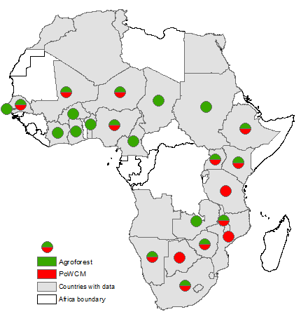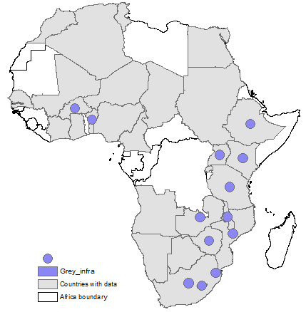
Key: PoWCM = Protection of watersheds and catchment management, Grey_infra = grey inrstructure development

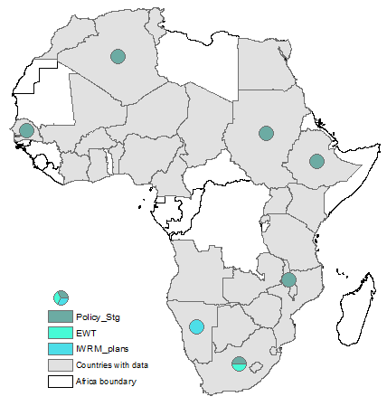
Key: Policy_Stg. = Policy, strategy and enabling conditions responses, EWT = effective water tariffing, IWRM_plans = integrated water resources management plans implementation.
Figure 1. Panel (a) is the distribution of water adaptation responses in agriculture, (b) is the distribution of in domestic & potable water adaptation responses (c) is the distribution of ecosystem-based adaptation responses, (d) is the distribution of grey water adaptation responses and (e) is policy, strategy and enabling environment responses.

SM 5
SM Table 11: List of countries with iNDCs covered in this study and the respective water adaptation targets
Country | Water sector adaptation priorities
Algeria | Integrate the impacts of climate change into sectorial strategies among water management.
Angola | Increase water availability, promote IWRM, water harvesting, construct flood protection barriers along major rivers
Benin | Improve water access, promote water conservation, reduce vulnerability to water stress and floods, promote good water management (IWRM)
Botswana | Improve water supply infrastructure, enhance conjunctive groundwater-surface water use, reduce water loss
Burkina Faso | Implement soil and water conservation strategies, develop master plans for water development and management, development of water reservoirs, combating the silting of water sources, implementation of water-efficient irrigation techniques
Burundi | Develop small- and large-scale irrigation and improve its efficiency, develop, rehabilitate, and manage hydro-agricultural developments
Central African | Improvements on sustainable management of water resources (IWRM), improve potable water supply, improvements on the monitoring of groundwater
Chad | Develop water infrastructure (reservoir), expand irrigation infrastructure, implement IWRM.
Djibouti | Improve access to water.
Egypt | Increase water storage capacity, improve irrigation and drainage, rainwater harvesting, increased use of deep groundwater reservoirs
Eritrea | Implementation of solar powered improved water systems interventions and provide clean and adequate water to all, promote sustainable utilisation.
Ethiopia | Enhance irrigation systems through rainwater harvesting and conservation of water, including improved water use efficiency. Ensure the uninterrupted availability of water services
Gambia | Improve water supply infrastructure (reservoir), implement IWRM,
Ghana | Implement IWRM, strengthen equitable distribution and access to water for the population living in climate change risk communities.
Guinea | Preserve the quality and quantity of water resources, set up a system of hydro-ecological monitoring, use controlled irrigation.
Guinea-Bissau | Capture and storage of rainwater (water retention basins and mini dams) for water management in the dry season
Kenya | Implementing the National Water Master Plan (2014).
Lesotho | Secure village water supply for vulnerable communities, increase irrigation efficiency, increase rainwater and sustainable ground water harvesting, constructing multipurpose dams to enhance water storage, implement IWRM.
Liberia | Protection of water catchments around hydro-power sources, improve irrigation
Malawi | construction of multipurpose dams, implementation of water harvesting technologies, capacity building in integrated water resources management (IWRM), catchment management, promotion of irrigated agriculture
Morocco | Improve irrigation efficiency by adopting localised irrigation systems, desalination, construct water storage facilities, transfer water to other dry regions, improve potable water access.
Mozambique | Improve the capacity for IWRM including building climate resilient hydraulic infrastructures
Namibia | Establishing of irrigation schemes along the perennial rivers of Namibia, improve rural water supply, rationalization of the use of water resources for different economic sectors
Niger | No clear set water sector goals.
Nigeria | Increase use of irrigation systems that use low amounts of water; increase rainwater & sustainable groundwater harvesting for use in agriculture
Rwanda | Increase investment in irrigated agriculture to increase production (irrigation), harness freshwater resources while ensuring food security to its population.
Sierra Leone | No cleat water sector adaptation goals
Somalia | Implement IWRM, construction of large-scale water capture and storage facilities and equitable distribution and access systems,
South Africa | Water Conservation and Demand Management strategy
Sudan | Implement IWRM, water harvesting, increase monitoring and provide hydrological information.
Swaziland | Artificial groundwater recharge, implement IWRM, water harvesting, construct more storage reservoirs, water recycling and reuse
Tanzania | Promote IWRM, wastewater recycling and reuse, exploit and develop groundwater resources
Togo | Protect water resources, improve agriculture water management, rainwater harvesting, improve groundwater management, wastewater reuse.
Tunisia | Wastewater transfer and reuse, improve and secure the water supplies of large urban centres
Uganda | Improving water efficiency, water harvesting and storage, implement IWRM
Zambia | Improve water storage through a network of dams and weirs, adopt and promote IWRM, promote rainwater harvesting
Zimbabwe | Promoting and supporting water harvesting, developing, rehabilitate and maintain surface and groundwater resources, promoting efficient water use practices, improve monitoring, strengthen IWRM

Analysis of iNDCs’ water sector adaptation targets set by African governments.

Fig 2. Summary of the water sector adaptation targets submitted to UNFCCC by African governments. n=36.

References
Berrang-Ford, L. et al., 2021: A systematic global stocktake of evidence on human adaptation to climate change. Nature Climate Change, 11(11), 989-1000. https://doi.org/10.1038/s41558-021-01170-y
Berrang-Ford, L. et al., 2020: "The Global Adaptation Mapping Initiative (GAMI): Part 1 – Introduction and Overview of Methods." Nature Protocol Exchange. https://doi.org/10.21203/rs.3.pex-1240/v1.
Granderson, A.A., 2017: The Role of Traditional Knowledge in Building Adaptive Capacity for Climate Change: Perspectives from Vanuatu. Weather, Climate, and Society, 9(3): 545-561. https://doi.org/10.1175/WCAS-D-16-0094.1
Lesnikowski, A. et al, 2020: "The Global Adaptation Mapping Initiative (GAMI): Part 3 – Coding Protocol." Nature Protocol Exchange. https://doi.org/10.21203/rs.3.pex-1242/v1
Petzold, J., Andrews, N., Ford, J. D., Hedemann, C., & Postigo, J. C., 2020: Indigenous knowledge on climate change adaptation: a global evidence map of academic literature. Environmental Research Letters, 15(11), 113007. https://doi.org/10.1088/1748-9326/abb330.
Williams, P. A., Sikutshwa, L., & Shackleton, S., 2020: Acknowledging Indigenous and Local Knowledge to Facilitate Collaboration in Landscape Approaches - Lessons from a Systematic Review. Land, 9(9), 331. https://doi.org/10.3390/land9090331

