Supplementary material
I) Storyboard instructions for developing the pathway storylines at the second workshop

1) Setting up, setting out  - who are the characters  - the setting  - getting started | 2) Building on boosters/  enablers  - leveraging change  - taking opportunities  - hero/champions
4) We have made it!  - the happy ending!  - what does success look/  feel/ sound/ smell like? | 3) Beating blockers +  barriers  - going over, around or  knocking down

II) Influence diagram
This diagram was created by the researchers after the first workshop based on the workshop transcripts. It highlights how key issues (in capital letters) selected by the groups are influenced by different drivers.
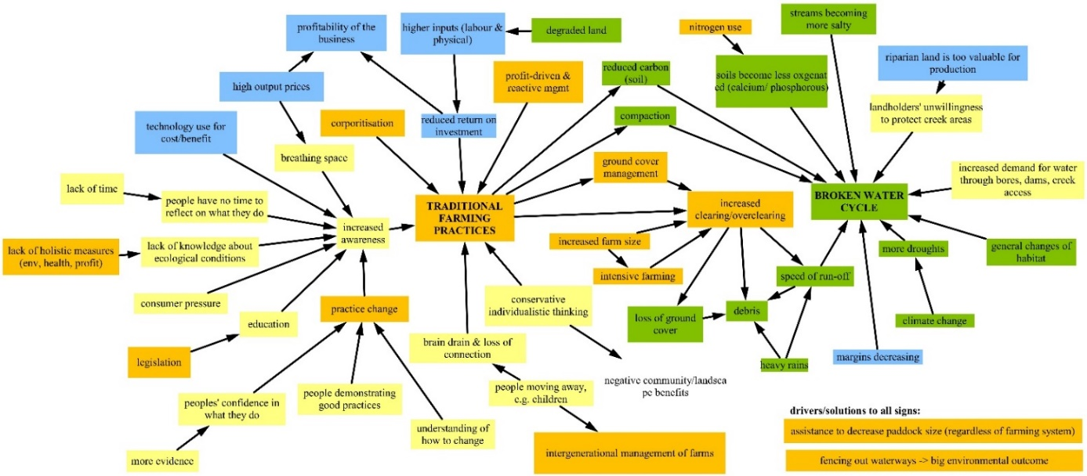
Categories adapted from: Mitchell, M., Lockwood, M., Moore, S.A., Clement, S., 2015. Incorporating governance influences into social-ecological system models: a case study involving biodiversity conservation. Journal of Environmental Planning and Management 58 (11), 1903–1922.

III) Storylines developed at the second workshop
The texts in blue are quotes by participants during the presentation of the respective storyline.
P1) A Utopia of Increased Connections at Multiple Scales

The key issue that this pathway addresses is the disconnect between rural and urban areas. This disconnect can be found at different levels: there is a disconnect locally, within the catchment, and to the cities. The agricultural education in the current education system is insufficient. Further, family farms are increasingly being replaced by bigger farms or corporate ownership and there are fewer people in rural communities. Added together, this has led to less diversity in farming practices and a lack of skilled labour.
However, there are opportunities for change because people in cities are interested in being in touch with where their food is grown. One example is paddock-to-plate marketing and learning from successes of other communities. The underlying understanding is that everyone is a player in agriculture because we all consume food. The internet and technology can make agriculture more accessible and social media platforms provide possible tools for connecting people with agricultural landscapes and to increase the public’s interest in farming. Tourism is another enabler for overcoming the urban-rural divide because people from major cities e.g. Canberra or Sydney come to see canola during the spring, ride rail trails or enjoy local food. Another lever for change can be increased connections with Indigenous heritage, land use and management of the area.
“Welcome to the Cootamundra Show … trying to interest people in agriculture and generally make agriculture … more people-friendly.”
While there are challenges with selling directly to consumers – e.g. a small-scale butchery or supplying a butchery directly versus selling at the sale yards – a range of pros and cons can be identified for all these opportunities.
This ‘utopia’ is about increasing connections at different levels and bringing more people into rural landscapes. This allows people to see, experience and understand our agricultural landscapes better.
“… a nice, happy, friendly world that's a bit of a utopia but the idea is more broadly that people are more connected and understand.”

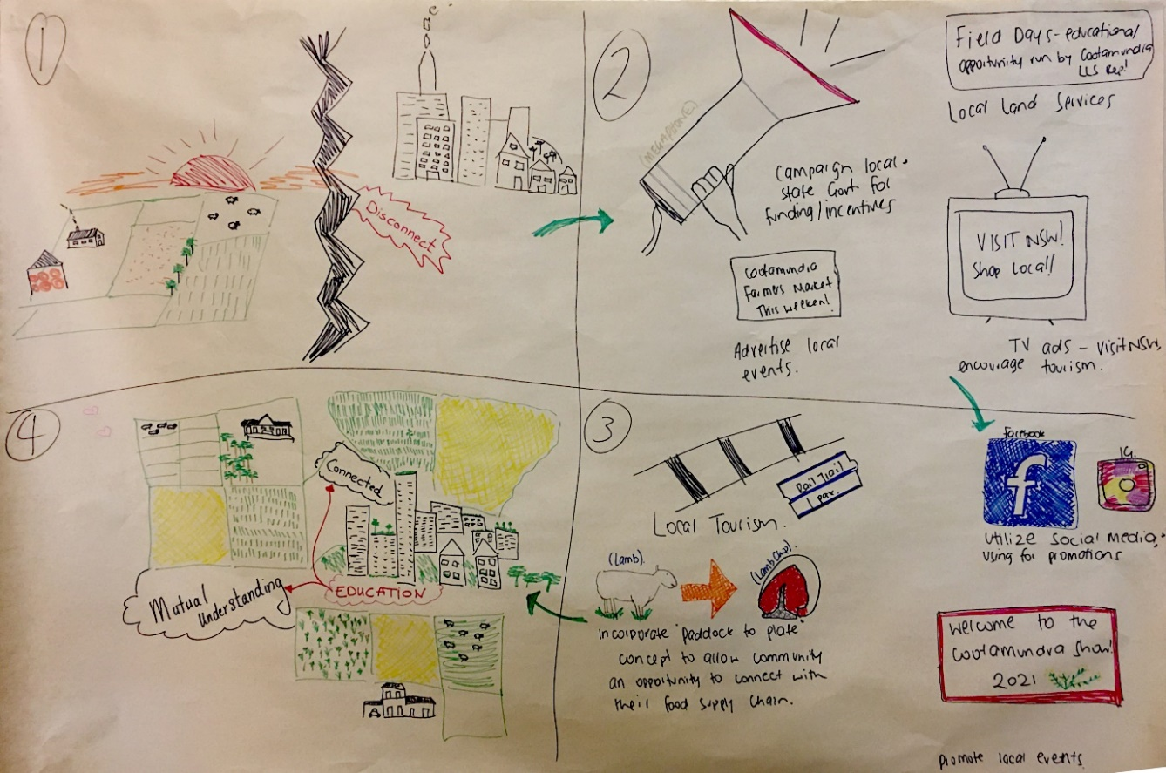

P2) The Power of Grassroots Activities for Change

The key issue that this pathway tackles is the decline in community wellbeing and capacity. Current state and council regulations impact on changes to rural areas including a transition to low impact farming, market access for small and medium farms and bringing additional family members onto the farm.
However, through a shared concern about the declining wellbeing and capacity in the local communities, the Muttama Creek Landcare Group is a possible booster for change. Grassroots initiatives such as ‘kitchen table conversations’, have potential to influence at the local community level, e.g. by lobbying local politicians or councillors. Other enablers are mixed farms bringing back family members, including the next generation, or other interested parties such as free-range egg farmers, pig farmers or those seeking to establish a market garden. There are also existing farmers’ market associations which increase connections and sell local products.
“[At] Muttama Creek Landcare Group … we're concerned about our health and capacity declining.”
In the ‘happy place’, soil health has improved, the rural population has remained stable, the viability of small and medium enterprises has increased and there is improved capacity for ethical semi-intensive agriculture. Over time, the Muttama Creek becomes strong and healthy and many trees can be found in the landscape. Additionally, people are engaging more with the landscape.
“… it takes time, the community, fun, gentleness and persistence …”

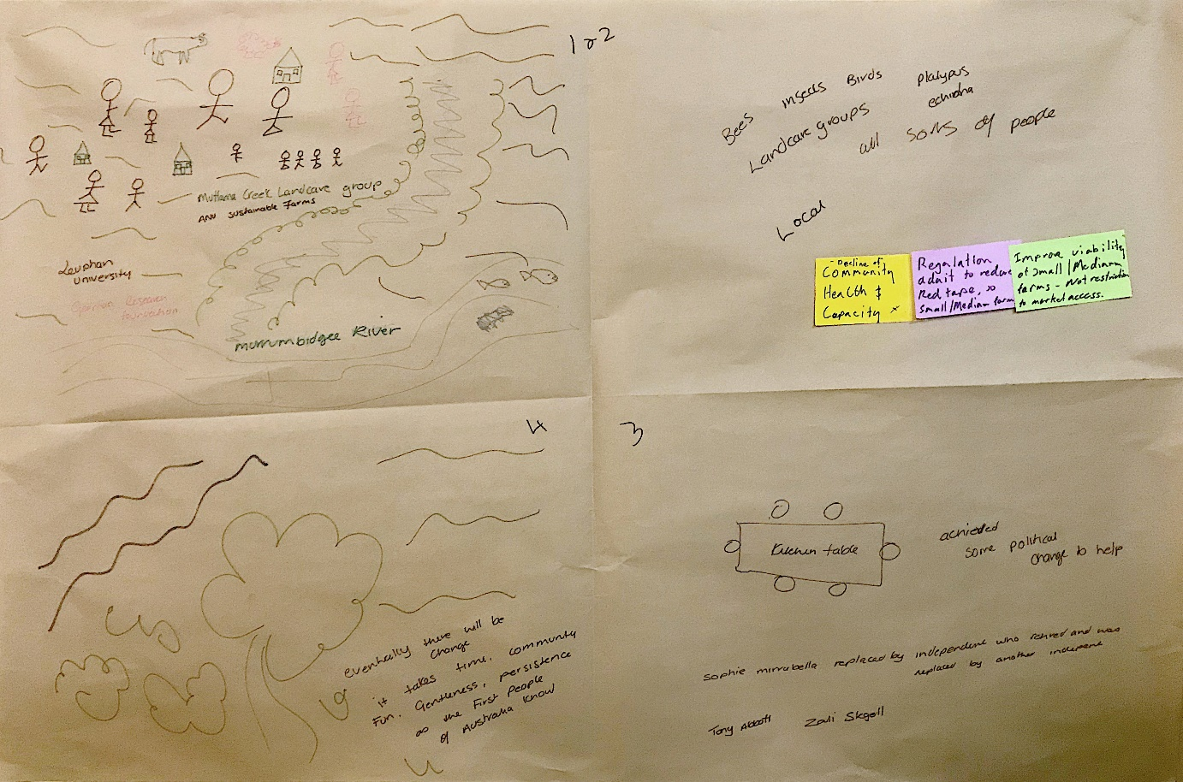

P3) A Vision for a Better Future of the Community and the Environment

This pathway addresses two key issues: First, rural communities are declining and there is a lack of diversity of people in the community. Second, the landscape is showing signs of depletion and exhaustion due to inappropriate cultivation and topsoil loss. There is a large amount of tree loss including remnant dead trees in the landscape due to clearing, lack of regeneration of trees and ringbarking in the past.
“… commodity prices are really good now but it's pretty clear that in the past they haven't been good enough to sustain the landscape, as well as the community, and everything within it.”
Current policies and legislation create a lot of red tape which blocks implementation of many of the good ideas that people have. Additionally, the focus on ‘big dollars’ in agriculture, especially among increasingly bigger and more “corporate” farms, whose focus is solely on production. This can lead to a more pronounced boom-bust cycle. There are more people who are trying to do things differently but they are not very well connected to either markets or others with similar interests. Other barriers for change include the lack of industry support for micro projects, the largely individualistic approach to farming, and farmers’ fear of being exposed to scrutiny. To bring about change, greater self-confidence, improved knowledge, and government support to ‘cross the river’ and do things differently are needed. Even though large parts of the agricultural landscape are in a poor state, old growth trees with hollows can still be found. There is also an increasing number of people in the cities who want to support landholders. This provides opportunities for increasing connections to farmers and farming landscapes. Farm diversification is another possible strategy for the future, for example growing asparagus or farming on a smaller scale. Networking and support for micro projects are also enablers for change. Local initiatives such as the Jugiong hub are starting to grow and create spaces with a ‘city vibe’ that people want to stay in.
As people are starting to do things differently, the landscape is becoming greener with passive solar houses and native gardens emerging. Farmers are selling their products directly to the public and they build partnerships with consumers who value their products and the new production systems they use. Aside from making money through direct sales, farmers earn green dollars e.g. from carbon credits. Farmers are getting paid for sustainable practices and nature conservation. The ‘happy place’ is also characterised by net zero carbon emissions.
“… the dollars are going to this farmer for sustainable practices and conservation.”
In this vision, the rural communities are more bespoke, younger and energised. Connections are vital, for example through the internet. Energy and joyousness characterise this ideal future in which people live in vibrant rural communities and not in isolation. Everyone lives in harmony with the land and is more observant and in touch with their land.
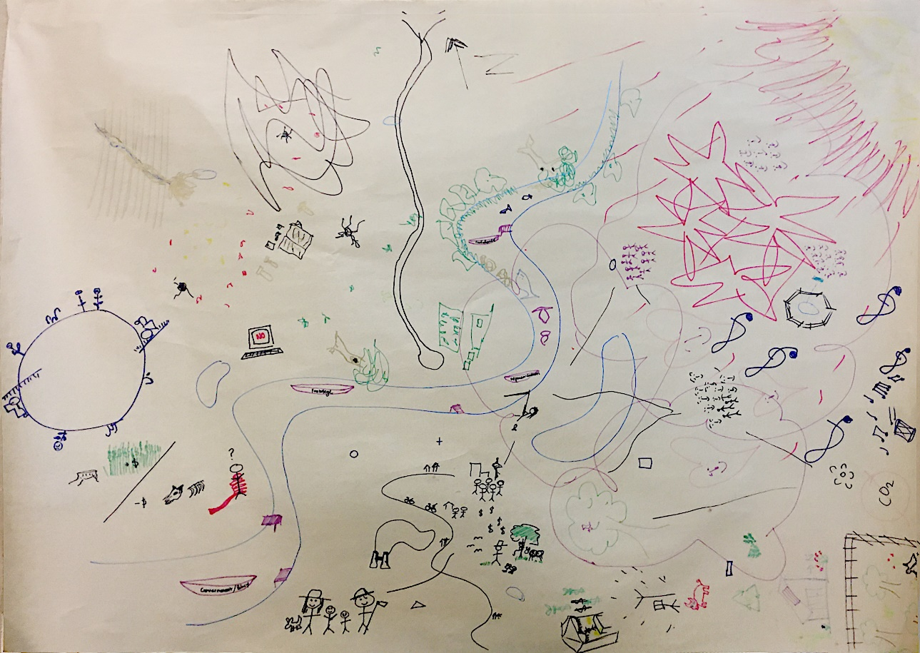

P4) A Multi-Generational Farming Story about Tree Planting

This pathway addresses the key issue of sparse native timber and vulnerable old trees in the landscape. There are several reasons for farmers’ unwillingness to plant more including the short-term loss of return, the lack of time and inflexible funding requirements.
This farming family story starts with a poor old farmer who has sparse vegetation on the hills and nothing along the creek and who can only afford a limited number of children. He also only has one skinny little cow.
The farmer then gets an idea of how to improve his farm and starts implementing it. As a result, shrubbery is growing on his property, the cows are calving, there is water in the creek, as well as wildlife in the water and around the creek. The farmer’s situation is improving and the family is growing. As things progress further, the farmer has the front of the hill planted out, there is understorey, many trees and generally more vegetation on the property.
The key idea behind this farming story is to establish vegetation blocks planted over several generations. This provides the opportunity to have the full range of vegetation which can be used for firewood or left to grow. In this story, the farmer is intrinsically motivated to improve his property but financial incentives also provide an opportunity for change. There are also several examples for community level incentives which motivate farmers to start on-farm improvements. For example, Landcare has in the past initiated activities in the area. Another opportunity could be an organisation similar to BlazeAid which might assist farmers by sending staff to help plant trees and fence off areas.
They might also get involved in farmer education. More education about the value of planting trees and protecting remnant timber – e.g. through farm walks and increased awareness about the benefits of tree lots – also provide opportunities for creating a landscape that has a mix of trees and shrubs.
“… incorporating the city cousins. Come out and share a weekend with us and let's plant some trees and have a camp fire, cook some home-made sausage”
In the ‘happy place’, the farm has had a positive impact throughout the community. The farmer has decided to go with Angus cattle instead of Friesians because the land has become more productive. The farm is a family-oriented enterprise which involves all generations in tree plantings.
“… we're talking about a multi-generational theme happening and … he was planting some trees and then his kids were planting trees and their kids were planting trees …”

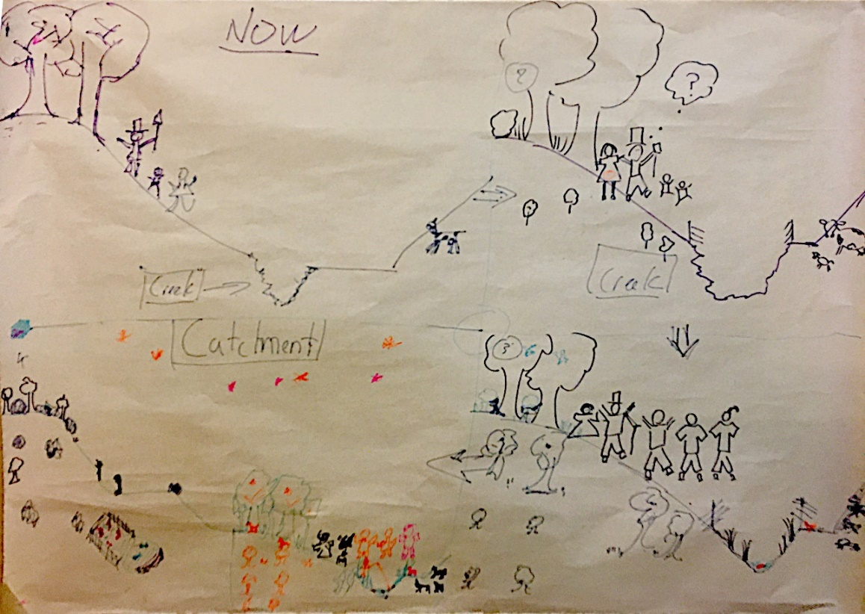

P6) Best Practice Outcomes from Improved Grazing Management

This pathway addresses the interlinked issues of reduced soil health and water quality, loss of biodiversity and lack of regeneration due to set stocking. It builds on existing practices in the mixed farming sphere, in particular rotational grazing instead of set stocking. The key element of this project idea is to promote virtual fences in mixed farming.
One of the enablers of change will be advisors who help farmers with technology, e.g. to work out electronic tags for virtual fencing. Other technologies that this project builds on are solar panels and drones used for feed calculations, stock monitoring and ground cover assessment. In the future, carbon rebates by the NSW government may provide another opportunity to encourage changes to grazing management practices.
However, the technology is still not fully developed and available to everyone. Another barrier for changes to farm management and increased technology in farming are people’s mindsets. Some farmers are set in their ways regarding farming practices and it is very hard to convince them to change.
“… the question mark over this technology for ear tags and things … we're still waiting for that technology to come through when and if it will so that's our blocker at the moment.”
By establishing virtual fences, eventually profitability increases which gives landholders more opportunities to establish regeneration areas, fence off creeks and generally protect areas on their farms. These on-farm technology and management changes also lead to improved environmental outcomes, for example more birds or insects in the landscape.
“… the outcome of that is more … profitability and a better environment, more birds, more bees, more butterflies, happy people.”

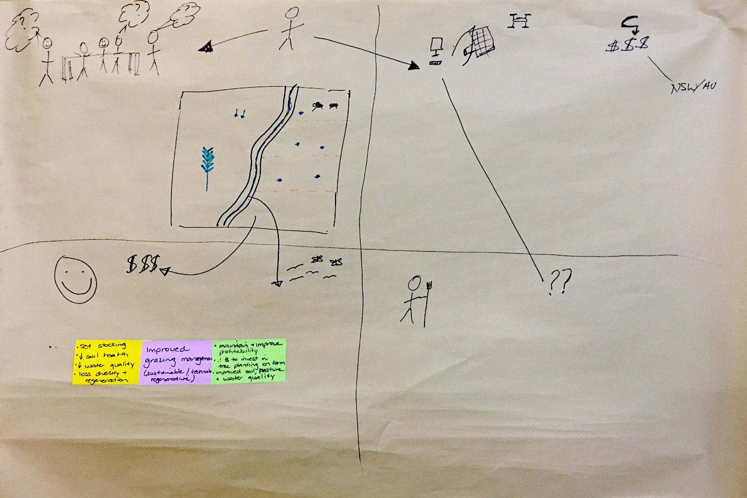

IV) Barriers and enablers discussed by the different groups
The following barriers and enablers are the written outputs of the groups. The group developing P6 did not produce a written output of the barriers and enablers discussed. They were instead derived by the researchers afterwards based on the storyline.
a) Barriers
Governance & Policy; Individual aspects; Market/Industry; Education & knowledge; Collaboration & connections; Farming systems; Technology; Other
P1) Utopia | ● Individualised farming lots  ● Lack of stewardship/ connection to land due to corporate buy outs  ● Broader community disconnect with agriculture & rural Australia  ● Fewer people | ● Less diversity in farming practices – lack of skilled labour  ● Fewer family farms  ● Bigger farms
P2) Grassroots | ● State and council regulation, approval  ● Market access | ● Community awareness
P3) Vision | ● Regulation overburden e.g. OH&S  ● Entrepreneurial risk  ● Individual approach  ● Farmers’ fear of exposure to scrutiny | ● Lack of industry support for micro projects  ● Infrastructure to support value adding
P4) Farming Story | ● Minimum requirements e.g. 30 m  ● Inflexible funding agreements  ● Landholders unwilling to plant due to ↓ grazing land  ● Short term loss of return  ● Set up costs | ● Short term focus  ● Time poor  ● Ageing landholders  ● Bushfire risk  ● Habitat for pests e.g. foxes
P5) Spider Web | ● Regulation – agencies not talking to each other  ● Mindset/ paradigms  ● Fear of change on transition | ● Historical livestock management – set stock: time-controlled grazing  ● Challenge current research model due to complex nature of ecosystem function
P6) Best Practice | ● Some farmers are set in their ways in the community & are seen as knockers  ● Technology is not developed yet (reliable technology needed) | ● Practicability of technology, e.g. scale, terrain

b) Enablers
Governance & Policy; Individual aspects; Markets; Education/knowledge/awareness; Collaboration & connections; Farming systems; Technology; Other
P1) Utopia | ● Using local food to draw people into communities has become more popular  ● Subsidised education during Covid lockdown – can that continue?  ● Learn from successes of other communities that celebrate the supply chain of “paddock to plate”  ● Connecting with Indigenous heritage/land use/management | ● Community shift starting to happen in a positive way – community are becoming more interested – invested in where their food comes from – might lead to more people seeking further education or a job in agriculture?  ● Internet/ technology – making things more accessible  ● Rail trail
P2) Grassroots | ● Changes to regulation and approvals by lobbying politicians, councilors  ● Community education
P3) Vision | ● Present this workshop outcome to government and farmer representative groups  ● Buy from the bush  ● Localised networking & micro project support  ● Representative groups for shared passions | ● Create city vibe  ● Jugiong hub  ● Jazz bar  ● Hub  ● Gundagai Nimbo falls
P4) Farming Story | ● Financial incentives  ● Long term vision for farm + community  ● Ecotourism e.g. sugar pine planting  ● Education -> value of plantings of remnant timber  -> farm walks | ● Correct diverse species -> mix trees/shrubs  ● Promote/educate benefits  ● Community help -> BlazeAid –> old Landcare projects involving people helping each other
P5) Spider Web | ● Both biodiversity and soil carbon projects currently exist -> we just want them to work together better | ● Groundswell revolution  ● Soil carbon markets  ● Climate change impact
P6) Best Practice | ● Carbon rebates through the NSW government  ● Pilot projects in different areas to see how it goes in different landscapes | ● Advisors helping to work out technology  ● Existing technology (electronic tags, virtual fencing, drones)

V) Detailed workshop responses about the five key aspects (Q4.1-4.5) and two open questions (Q5 and 6).

Workshop 1
# | Q4.1 The workshop was effective in accommodating the diversity of goals and perspectives. | Q4.2 The workshop process was effective in dealing with the complexity of the topic. | Q4.3 The workshop provided space for imagination and creativity. | Q4.4 The workshop helped me better understand how I can use future thinking for what I do in the present. | Q4.5 Through the workshop I feel more empowered to bring about a positive future. | Q5 What could be improved about the workshop process? | Q6 What ideas and insights will you take home from this workshop?
1 | 5 | 5 | 5 | 5 | - | - | Confirmation, increased knowledge, go easy when you meet opposition!
2 | 5 | 5 | 5 | 4 | 5 | With Paul* notes on board use more than one letter for words | The nature of progress! General goodwill of people  The value of discussion in groups to grow, [?] + motivation
3 | 4 | 3 | 5 | 3 | 2 | Paul did a great job | Interesting day – there is hope for the future!
4 | 3 | 4 | 4 | 4 | 4 | Speed it up a bit.  3/4 day is easier than whole day! | There is real threat for lack of diversity in farming systems if science-base is lost.
5 | 4 | 4 | 4 | 3 | 3 | It was well done. | We are part of a group who are engaged with the future of farming – how do we engage the rest? And educate city people, many of whom have no connection to the land?
6 | 3 | 5 | 5 | 3 | 3 | - | There are more people concerned about the future of farming, from sustainable perspective than I though.
7 | 5 | 5 | 5 | 4 | 5 | Terrific presentation – balanced + clear | Conscious decision making
8 | 5 | 4 | 5 | 4 | 4 | - | The importance of community & connection
9 | 5 | 5 | 5 | 5 | 5 | Prompter start, earlier finish | Great ideas to promote to friends + neighbours
10 | 5 | 5 | 5 | 5 | 5 | I enjoyed the journey and will be better able to answer after the next session | This has widened my understanding and of concepts of time & prominence.
11 | 4 | 5 | 4 | 4 | 4 | - | Get rid of my friends they hold me back.
12 | 5 | 5 | 5 | 5 | 5 | - | Start small
13 | 4 | 5 | 4 | 4 | 2 | Understand what outcomes will be achieved. | Many varied opinions in the room. A lot of misunderstanding of what can/could be achieved.
14 | 5 | 5 | 5 | 5 | 5 | Blinds on the windows | We need to better understand the barriers preventing change and then find ways to overcome them
15 | 5 | 5 | 5 | 5 | 5 | Set up the night before | Add a ‘where to from here’
16 | 4 | 4 | 5 | 5 | 4 | To develop a plan for the community. E.g. we want workshops, we want to apply for funding | -
17 | 4 | 4 | 5 | 4 | 3 | - | -
18 | 4 | 4 | 4 | 4 | 4 | The hall was a bit noisy and hard to hear at times | A renewed enthusiasm + cooperative
* This refers to Paul Ryan, one of the co-authors, who also facilitated the two workshops.

Workshop 2
# | Q4.1 The workshop was effective in accommodating the diversity of goals and perspectives. | Q4.2 The workshop process was effective in dealing with the complexity of the topic. | Q4.3 The workshop provided space for imagination and creativity. | Q4.4 The workshop helped me better understand how I can use future thinking for what I do in the present. | Q4.5 Through the workshop I feel more empowered to bring about a positive future. | Q5 What could be improved about the workshop process? | Q6 What ideas and insights will you take home from this workshop?
1 | 5 | 5 | 5 | 4 | 5 | Remind, (encourage) people to refrain from talking about themselves all the time! Keep a general perspective in the discussion | Try to engage others who are not here.
2 | 1 | 2 | 4 | 3 | 2 | Not through cropping season | Big Picture things
3 | 5 | 5 | 5 | 5 | 5 | I thought the workshop was well organised & well run on the day. | To open my mind to stimulate change in traditional methods.
4* | 2 | 1 | 1 | 1 | 1 | - | Great venue, fabulous facilitation
5* | 2 | 1 | 1 | 1 | 2 | Great workshop for the community | -
6 | 4 | 4 | 5 | 5 | 5 | N/A | Diversity of ideas around sustainable Agriculture & Biodiversity.
7 | 5 | 5 | 5 | 5 | 5 | - | A different way of thinking about problem solving. The future is bright!
8 | 5 | 5 | 5 | 5 | 5 | I found the acoustics in the hall a little bit difficult more about my hearing then the workshop process. | Although a divergent group from the community, the overall commonality was the strength. The in-depth description of indigenous perspective
9 | 4 | 4 | 5 | 4 | 4 | - | The agricultural and environmental benefits of fence off water courses and tree breaks.
10 | 4 | 4 | 5 | 3 | 2 | Presentations from transformational landholders | -
11 | 4 | 4 | 5 | 4 | 4 | Hard to hear in groups in venue  Not sure all had they say – some dominate | Do the easy things now. What’s stopping you
12 | 5 | 5 | 5 | 5 | 5 | Need to engage the disengaged in other way, maybe circulate survey to, get comment + opinion | Need to communicate widely idea from workshop & engage with existing organisations + government
13* | 1 | 1 | 1 | 1 | 1 | - | Capacity to make small changes to bring people on to rural landscapes.
14 | 4 | 4 | 5 | 4 | 4 | - | The 3 Horizons process is new to me.
15 | 5 | 5 | 5 | 5 | 5 | - | -
16* | 1 | 1 | 1 | 1 | 1 | Very happy with the process. | More confidence in the direction that agriculture is taking in the future. There is hope + a better future is inevitable.  We can but influence the speed of change
17 | 5 | 4 | 5 | 4 | 5 | Have some of the change makers in the room, so we felt that action could come from it | The issues raised here are applicable in many catchments, many people want some change, but nobody wants to change.
18 | 5 | 5 | 5 | 5 | 5 | Sell these ideas to more farmers through their stock + station agents to get farmers onside. | Keep on doing what I have started – it works!
19 | 5 | 5 | 5 | 5 | 5 | Perhaps provide participants that missed a session with a link for audio or a detailed summary to allow them to catch up? | How to engage with the community regarding biodiversity and the avenues I can help facilitate assistance/ engagement as part of my job as a citizen of the area.
20 | 5 | 4 | 5 | 4 | 4 | - | Rural community within Muttama does require improvements and feel a need for this.
21 | 5 | 5 | 5 | 4 | 4 | - | Keep pursuing opportunities to build a brand, market product, connect with community + educate others, + look for ways to bring that to the Landcare Group.
* For these respondents, their strongly negative responses to the Likert scale questions were contradictory to their positive responses to the open-ended questions. We suspect this may have been their mistaken selection of ‘strongly disagree’ and ‘disagree’ instead of ‘strongly agree’ and ‘agree’. Given our resultant uncertainty with the intention of their responses, we have not included their responses as part of the analysis.

