Electronic Supplementary Material

For the article
Identifying mindsets for urban sustainability transformation: Insights from Urban Labs
by Flávia Guerra and M.Danial Syed

Contents
S1 – Survey Questionnaire: pp 2-8
S2 – Means table for comparisons of mindsets indicators across Urban Labs: pp 9-10
S3 – MFA and HCPC graphs: pp 11-12
S4 – Cluster analysis results (plots): pp 13-21

S1. Survey Questionnaire
- DEMOGRAPHICS

Country
- Argentina
- Brazil
- Mexico

City
- Buenos Aires (ARG)
- Recife (BRA)
- Teresina (BRA)
- León (MEX)
- Naucalpan (MEX)

Date
Day: _______ Month: ____________________ Year: 20_____

Organizational affiliation: _______________________________________________________________

Stakeholder category
01. Government department or agency  02. Non-governmental organization (NGO)  03. Community/neighborhood associations  04. Religious or spiritual organization  05. Research institute or university | 06. Private sector  07. International NGO  08. Bilateral or multilateral donor  09. Media  10. Citizen (non-organized)  11. Other, please specify: ________________________

Please tell me how old you are.
______ years old

Can you please tell me what gender do you identify with?
    - Man/male
    - Woman/female
    - Other: Specify

What is the highest level of education you have completed?
(0) None  (1) Primary  (2) Secondary | (3) Bachelors-level  (4) Masters-level  (5) Above Masters-level

For how many years have you lived in [city] now?
    - Less than 1 year
    - More than 1 but less than 5 years
    - More than 5 but less than 10 years
    - 10 years or longer

- MINDSETS

(Perceptions: Climate)
How much have you thought about climate change before today?
(1) Not at all
(2) Very little
(3) Frequently
(4) Very frequently

(Perceptions: Climate)
In your opinion, how important is the problem of climate change in [city]?
- Not a problem at all
- Somewhat unimportant problem
- Somewhat important problem
- Very important problem

(Perceptions: Feasibility/Compatibility)
In your opinion, what are the three most important problems that [city] is facing today?
[Open response]

(Perceptions: Climate)
If you compare the problems you have mentioned in the previous question to the problem of climate change, would you say that the problem of climate change is ‘less important’, ‘just as important’, or ‘more important’ than the problems you have mentioned?
(1) Climate change is less important
(2) Climate change is just as important
(3) Climate change is more important

(Worldviews)
I will now read some statements to you that describe how one can understand the world. For each of these statements, please tell me if you ‘disagree strongly’, ‘disagree somewhat’, ‘agree somewhat’, or ‘agree strongly’.
  - Our world works according to ingrained rules and we cannot really do much to change them. (Fixed/growth mindset)
  - Tackling climate change is only possible when many people and organizations work together. (Communitarian)
  - Guidance and leadership for climate action should mostly come from the government. (Hierarchical)
  - It feels pointless that I should take climate action if no one else does. (Fatalist)
  - A free society can only exist by giving companies the opportunity to prosper. (Individualist)
  - Community organizations and social movements are important drivers of climate action. (Communitarian)
  - Stricter legislation is necessary to make people behave more climate-friendly. (Hierarchical)
  - The future is too uncertain for a person to make serious plans. (Fatalist)
  - If a person acquires wealth, that person should have the right to enjoy it the way he or she wants. (Individualist)

(Emotions, beliefs, perceptions and attitudes)
Please tell me, based on your personal perspective, whether you ‘disagree strongly’, ‘disagree somewhat’, ‘agree somewhat’, or ‘agree strongly’ with each of the following statements.
  - I believe that the danger of climate change has been exaggerated by others. (Emotions: Denial/Acceptance)
  - I feel like climate change does not concern me personally but it concerns people in other parts of the country or in other countries. (Beliefs: Distant/Local)
  - I feel like climate change does not concern me today but it concerns coming generations. (Beliefs: Distant/Local)
  - I think that tackling climate change is primarily the responsibility of countries in North America and Europe. (Beliefs: Responsibility)
  - I am worried about climate change and its consequences. (Emotions: Denial/Acceptance)
  - I believe that reducing the city’s carbon emissions to zero is desirable. (Perceptions: Feasibility/Compatibility)
  - I believe that reducing the city’s carbon emissions to zero is realistic. (Perceptions: Feasibility/Compatibility)
  - I think it is possible to further develop my city while reducing carbon emissions. (Perceptions: Feasibility/Compatibility)
  - I think that poverty and inequality are big problems in my city. (Perceptions: Feasibility/Compatibility)
  - I believe that it is possible to tackle poverty and inequality in my city while reducing carbon emissions. (Perceptions: Feasibility/Compatibility)
  - I think that new technology will address most of the problems caused by climate change without people having to alter their lifestyle. (Attitudes: Lifestyle/Technology)
  - I think that humans have to alter their lifestyle to address the problems caused by climate change. (Attitudes: Lifestyle/Technology)
  - Personally, I believe that I should do more to act on climate change. (Beliefs: Responsibility)
  - I am willing to change my behavior to address climate change. (Attitudes: Lifestyle/Technology)
  - I believe that my city must change its development model to address climate change. (Beliefs: Responsibility)

(Attitudes)
For each of these statements, please tell me whether you ‘disagree strongly’, ‘disagree somewhat’, ‘agree somewhat’, or ‘agree strongly’.
- Urban planning processes in [city] are generally open and participatory. (Attitudes: Participation)
- The municipal government takes climate change seriously when making decisions. (Attitudes: Government)
- The contributions of researchers should be taken into consideration in urban policy. (Attitudes: Participation)
- I am satisfied with climate change action by the national government. (Attitudes: Government)
- I am satisfied with climate change action by the city government. (Attitudes: Government)
- Local communities should participate in urban decision making processes. (Attitudes: Participation)

(Perceptions)
In your opinion, what are the three biggest barriers that prevent your city from taking climate action? Choose up to three of the following options and rank them according to importance.
- Political unwillingness (Political barriers)
- Economic interests (Economic barriers)
- Different political priorities (Political barriers)
- Absence of leadership (Technical barriers)
- Lack of collaboration across institutions (Social barriers)
- Lack of knowledge or capacity (Technical barriers)
- Lack of finances (Economic barriers)
- Citizens do not care (Social barriers)

(Values)
Based on your personal opinion, please rank the following motives to act on climate change from most to least important.
- Economic motives: If I saved or earned money by acting on climate change.
- Social motives: If my community and other people would face fewer climate hazards.
- Ecological motives: If the nature and the planet would be protected.

(Behavior)
During the last 12 months, have you personally done any of the following to tackle climate change?
- Shared information about climate change through media channels (social media, local newspapers, etc.). (Individual)
- Contacted a local politician or a public official to advocate for climate action. (Individual)
- Taken part in a public demonstration, petition or climate strike to demand climate action. (Collective)
- Considered climate change concerns when purchasing certain products. (Individual)
- Changed some habits at home because of climate change concerns (such as the use of energy or water). (Individual)
- Donated money or raised funds for an organization that supports climate action. (Collective)
- Formed or became a member of an organization or group working on climate change. (Collective)
- Voted in a local government election based on candidates’ commitment to fighting climate change. (Individual)
- Other: specify

(New options emerging from free text)
- Provided training or capacity development on climate change topics. (Collective)
- Participated in meetings where climate change issues were discussed. (Collective)
- Contributed to a project or policy addressing climate change issues. (Collective)
- Changed habits outside of the house due to climate change concerns (e.g. mobility patterns, public space interventions). (Individual)
- Considered climate change and/or related topics when making work-related decisions. (Collective)
- Looked for / read credible sources of information to stay up-to-date about climate change. (Individual)

- CAPACITY

How sufficient do you think your knowledge is to personally act on climate change?
(1) Very insufficient
(2) Somewhat insufficient
(3) Somewhat sufficient
(4) More than sufficient

How would you rate your ability to influence or mobilize others to act on climate change?
(1) No or very low influence
(2) Somewhat low influence
(3) Somewhat high influence
(4) Very high influence

Which resources would help you as an individual the most to influence climate action in (city)? Please select and rank the three you consider most important.
- Economic/financial resources
- Community support / Recognition by other actors
- Scientific and technical knowledge
- Exchanging experiences and lessons with others
- Support from the municipality
- Training and capacity development
- Specific personal / individual skills
- TRUST

How trustworthy are the people in [city]?
Would you say people in [city] are generally:
(1) Untrustworthy
(2) Somewhat untrustworthy
(3) Somewhat trustworthy
(4) Very trustworthy

Now about people who live in your neighborhood/area/community.
Would you say people in your neighborhood/area/community are generally:
(1) Untrustworthy
(2) Somewhat untrustworthy
(3) Somewhat trustworthy
(4) Very trustworthy

The next question is about whether you have trust in various institutions in [city]. For each of the institutions, please tell me whether you find them (1) untrustworthy, (2) somewhat untrustworthy, (3) somewhat trustworthy, or (4) very trustworthy.
- Media
- Community/neighborhood associations
- Research institutes / Universities
- NGOs
- Health centers
- Schools
- Private companies
- City administration

- ORGANIZATIONS & NETWORKS

Based on your personal experience and opinion, which are the most important organizations that work on climate change in [city]?
[Open response]

From your experience and observation, how often would you say do actors such as the ones you just mentioned work together to address climate change in [city]?
(1) Never work together
(2) Sometimes work together
(3) Often work together
(4) Almost always work together

How important is climate change as a topic for your organization?
(1) Not important at all
(2) Somewhat unimportant
(3) Somewhat important
(4) Very important

Does your organization actively work on climate change in [city]?
(1) Yes
(2) No

Please tell us which other organizations your organization works with on climate change in [city]?
[Open response]
How often does your organization communicate with each of the organizations you just mentioned?
(1) Never (little or no contact)
(2) Sometimes (1-3 times a year, no active working relationship)
(3) Frequently (about every month)
(4) Very frequently (about every week)

Does your organization work in some kind of network or consortium on climate change in [city]?
(1) Yes
(2) No

How do you rate your organization’s capacity to work on climate change?
(1) No or very low capacity
(2) Somewhat low capacity
(3) Somewhat high capacity
(4) Very high capacity

How do you assess your organization’s power to influence decisions in the city that are important for climate change?
(1) No power
(2) Very low power
(3) Somewhat low power
(4) Somewhat high power
(5) Very high power

Does your organization receive financial or material support for its work on climate change in [city]?
(1) Yes
(2) No

Does your organization receive training or other non-financial support for its work on climate change in [city]?
(1) Yes
(2) No

Which resources would help your organization most to improve its work on climate change? Please select and rank the three you consider most important.
- Economic / financial resources
- Community support
- Scientific and technical knowledge
- Exchanging experiences and lessons with other organizations
- Support from the municipality
- Training and capacity development
- Specific organizational skills

Do the government and researchers work together on climate change in [city]?
(1) Not work together at all
(2) Sometimes work together
(3) Often work together
(4) Almost always work together

As a researcher, have you provided advice to or have you worked with any stakeholders in [city] on climate change in the past three years?
(1) Yes
(2) No

Which actors or organizations in [city] have you provided advice to or have you worked with on climate change?
[Open response]

Have you received advice from or have you worked with any researchers or research organizations on climate change in [city] in the past three years?
(1) Yes
(2) No

Which researchers or research organizations have you received advice from or have you worked with on climate change in [city]?
[Open response]

S2. Means table for comparisons of mindsets indicators across Urban Labs. We include F-statistics and p-values from oneway ANOVA tests for those cases (represented with an asterisk) where the differences in means across Urban Labs were statistically significant at the chosen 5% significance level.
Mindset dimensions | Questions/Statements | Means |  |  |  |  |  | ANOVA
Mindset dimensions | Questions/Statements | UL Buenos Aires | UL Recife | UL Teresina | UL León | UL Naucalpan | Overall | F-statistic | p-value
Beliefs: Distant/Local | I feel like climate change does not concern me personally but it concerns people in other parts of the country or in other countries. | 1.39 | 1.48 | 1.68 | 1.39 | 1.38 | 1.45
Beliefs: Distant/Local | I feel like climate change does not concern me today but it concerns coming generations. | 1.67 | 1.39 | 1.86 | 1.68 | 1.57 | 1.63
Beliefs: Responsibility | I think that tackling climate change is primarily the responsibility of countries in North America and Europe. | 2.52 | 2.24 | 2.32 | 1.71 | 1.9 | 2.2* | 3.87 | 0.01
Beliefs: Responsibility | Personally, I believe that I should do more to act on climate change. | 3.39 | 3.24 | 3.36 | 3.68 | 3.62 | 3.44* | 2.95 | 0.02
Beliefs: Responsibility | I believe that my city must change its development model to address climate change. | 3.53 | 3.61 | 3.55 | 3.75 | 3.86 | 3.63
Emotions | I believe that the danger of climate change has been exaggerated by others. | 1.18 | 1.39 | 1.82 | 1.21 | 1.33 | 1.35* | 4.48 | < 0.01
Emotions | I am worried about climate change and its consequences. | 3.9 | 3.7 | 3.59 | 3.96 | 3.76 | 3.8* | 3.45 | 0.01
Perceptions: Importance of climate change | How much have you thought about climate change before today? | 3.67 | 3.58 | 3.5 | 3.86 | 3.9 | 3.69
Perceptions: Importance of climate change | In your opinion, how important is the problem of climate change? | 3.88 | 3.97 | 3.95 | 3.79 | 3.86 | 3.89
Perceptions: Importance of climate change | Would you say that the problem of climate change is ‘less important’, ‘just as important’, or ‘more important’ than the urban problems mentioned? | 2.23 | 2.21 | 2.23 | 2.14 | 2.19 | 2.2
Perceptions: Feasibility/ Compatibility | I believe that reducing the city’s carbon emissions to zero is desirable. | 3.69 | 3.48 | 3.27 | 3.39 | 3.52 | 3.51
Perceptions: Feasibility/ Compatibility | I believe that reducing the city’s carbon emissions to zero is realistic. | 3.02 | 2.82 | 2.77 | 2.43 | 2.9 | 2.82
Perceptions: Feasibility/ Compatibility | I think it is possible to further develop my city while reducing carbon emissions. | 3.35 | 3.52 | 3.27 | 3.43 | 3.48 | 3.41
Perceptions: Feasibility/ Compatibility | I think that poverty and inequality are big problems in my city. | 3.82 | 3.88 | 3.64 | 3.75 | 3.95 | 3.81
Perceptions: Feasibility/ Compatibility | I believe that it is possible to tackle poverty and inequality in my city while reducing carbon emissions. | 3.65 | 3.64 | 3.36 | 3.46 | 3.43 | 3.54
Attitudes: Government-led climate action | The municipal government takes climate change seriously when making decisions. | 2.29 | 2.3 | 1.91 | 2.21 | 1.81 | 2.16
Attitudes: Government-led climate action | I am satisfied with climate change action by the national government. | 1.94 | 1.24 | 1.59 | 1.39 | 1.57 | 1.59* | 4.75 | < 0.01
Attitudes: Government-led climate action | I am satisfied with climate change action by the city government. | 2.27 | 2.33 | 1.82 | 2.14 | 1.67 | 2.11* | 2.92 | 0.02
Attitudes: Participation | Urban planning processes in [city] are generally open and participatory. | 2.4 | 2.42 | 2.36 | 2.36 | 1.79 | 2.32
Attitudes: Participation | The contributions of researchers should be taken into consideration in urban policy. | 3.96 | 3.7 | 3.45 | 4 | 3.86 | 3.82* | 9.41 | < 0.01
Attitudes: Participation | Local communities should participate in urban decision making processes. | 3.86 | 3.61 | 3.45 | 3.86 | 3.76 | 3.73* | 3.91 | < 0.01
Attitudes: Lifestyle/ Technology | I think that new technology will address most of the problems caused by climate change without people having to alter their lifestyle. | 2.02 | 1.76 | 2.05 | 1.89 | 1.86 | 1.92*
Attitudes: Lifestyle/ Technology | I think that humans have to alter their lifestyle to address the problems caused by climate change. | 3.86 | 3.64 | 3.73 | 3.93 | 3.86 | 3.8* | 3.91 | < 0.01
Attitudes: Lifestyle/ Technology | I am willing to change my behavior to address climate change. | 3.86 | 3.58 | 3.45 | 3.93 | 3.9 | 3.76* | 7.16 | < 0.01
Worldviews | Our world works according to ingrained rules and we cannot really do much to change them. | 1.53 | 1.48 | 1.73 | 1.86 | 1.52 | 1.61
Worldviews | Tackling climate change is only possible when many people and organizations work together. | 3.71 | 3.55 | 3.45 | 3.5 | 3.52 | 3.58
Worldviews | Guidance and leadership for climate action should mostly come from the government. | 2.88 | 2.94 | 3.05 | 2.43 | 2.19 | 2.74* | 4.33 | < 0.01
Worldviews | It feels pointless that I should take climate action if no one else does. | 1.2 | 1.58 | 1.82 | 1.21 | 1.24 | 1.38* | 4.75 | < 0.01
Worldviews | A free society can only exist by giving companies the opportunity to prosper. | 2.31 | 2.45 | 2.82 | 2.68 | 2.95 | 2.57* | 2.63 | 0.04
Worldviews | Community organizations and social movements are important drivers of climate action. | 3.57 | 3.61 | 3.36 | 3.68 | 3.71 | 3.59
Worldviews | Stricter legislation is necessary to make people behave more climate-friendly. | 3.18 | 2.97 | 3.14 | 3.18 | 3.38 | 3.16
Worldviews | The future is too uncertain for a person to make serious plans. | 1.45 | 1.79 | 1.59 | 1.93 | 1.71 | 1.67
Worldviews | If a person acquires wealth, that person should have the right to enjoy it the way he or she wants. | 2.04 | 1.76 | 2.23 | 2.32 | 2.57 | 2.13* | 2.78 | 0.03
Behavior | Individual Climate Action | 3.84 | 3.61 | 2.91 | 4.36 | 4.38 | 3.82* | 7.6 | < 0.01
Behavior | Collective Climate Action | 1.31 | 0.76 | 0.82 | 1.46 | 1.62 | 1.19* | 3.63 | 0.01

S3. MFA and HCPC graphs
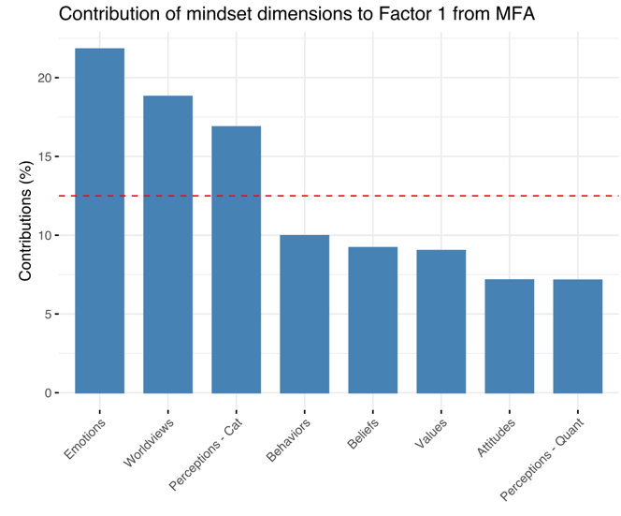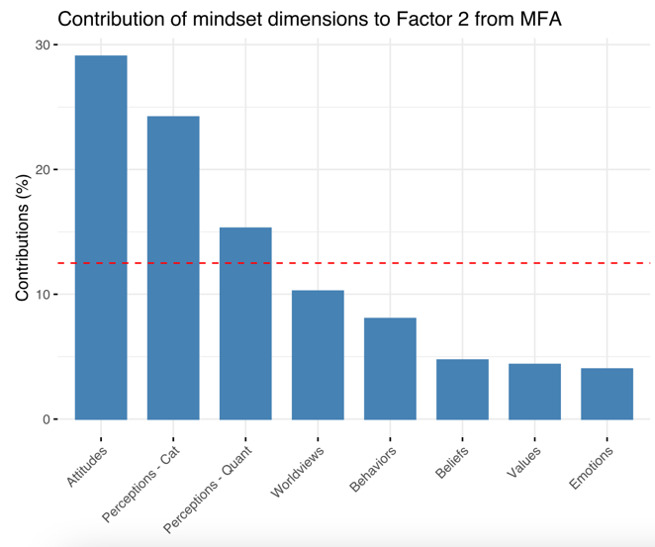
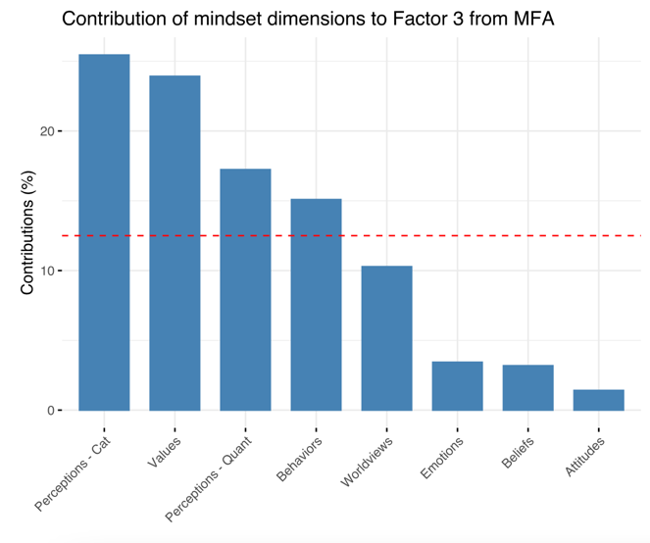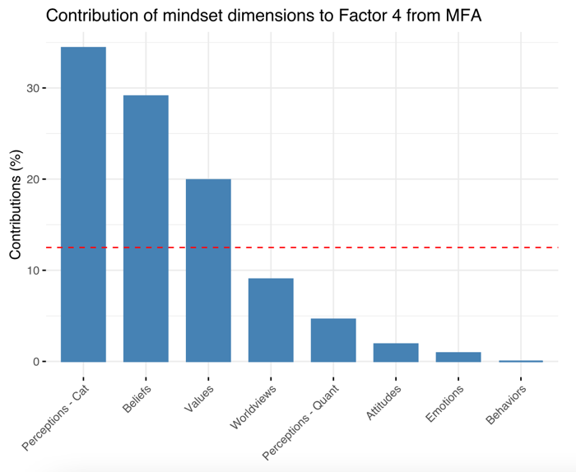
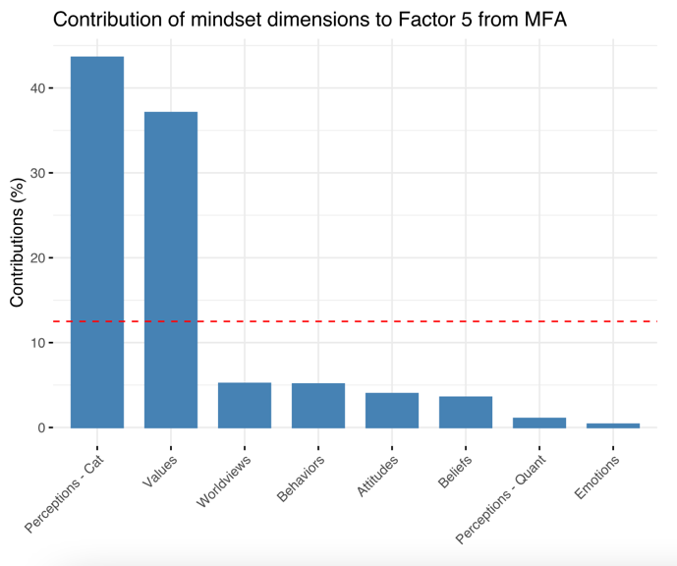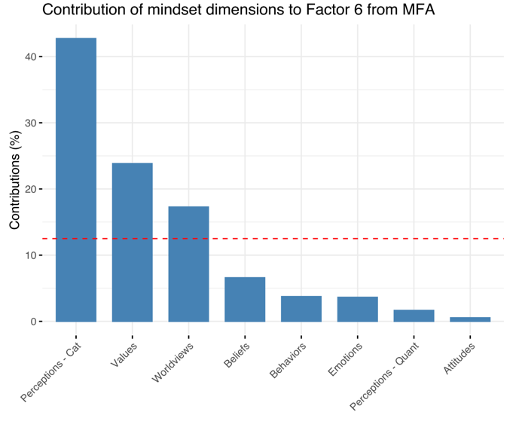

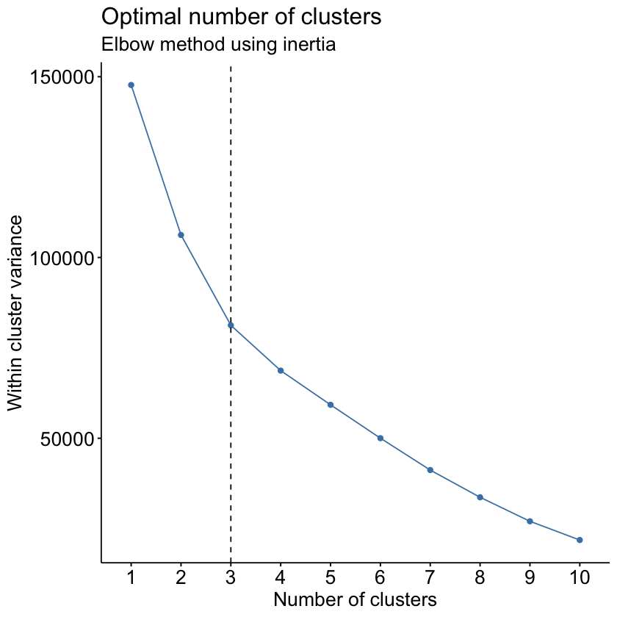

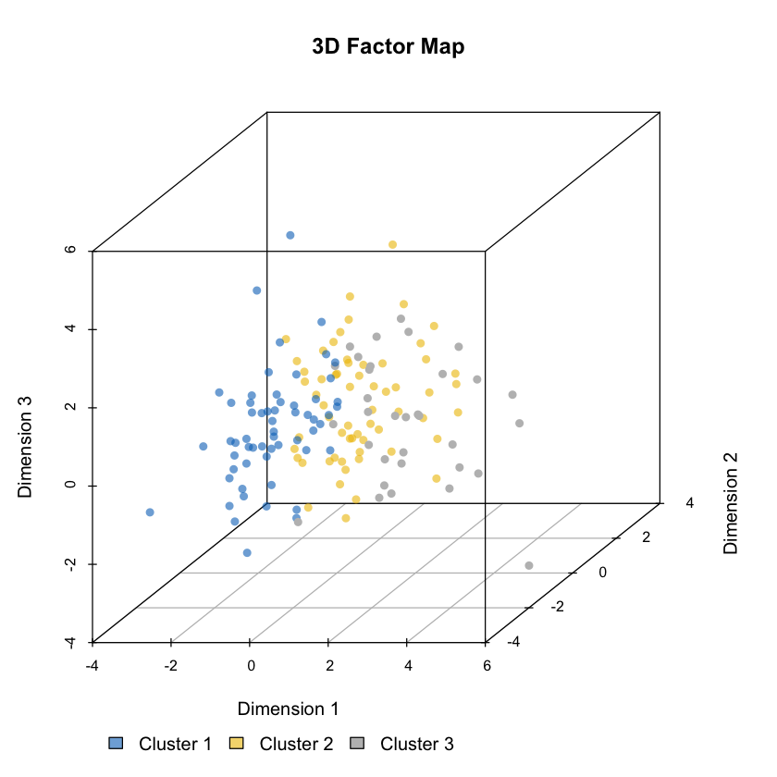

S4. Cluster analysis results (plots)
