Electronic Supplementary Material.

This document lists the documents included for analysis in the public corpus and academic corpus (S1-3) and contains information about where to access detailed results and analyses (S4). Tables and figures in S5-8 provide summaries of corpus linguistic tests that are referenced in the main text.
We encourage readers to engage the main text of the paper to contextualise the tables and images found in this ESM.

S1. DATA OVERVIEW- Data selection and cleaning process, using an adaptation of Haddaway, Macura & Whaley’s (2017) ROSES flow diagram (V1.0)
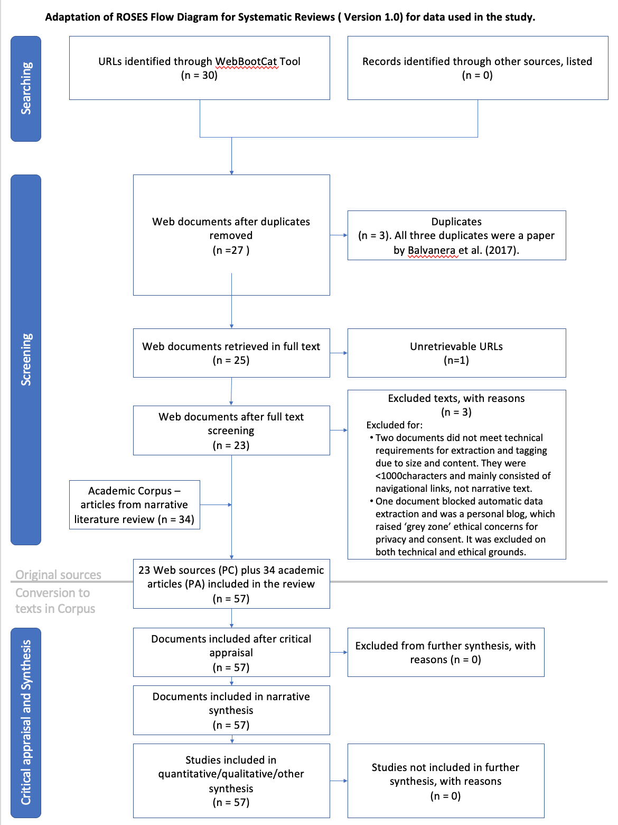
REFERENCE: Haddaway NR, Macura B, Whaley P, and Pullin AS. 2017. ROSES flow diagram for systematic reviews. Version 1.0. DOI: 10.6084/m9.figshare.5897389. Note: ROSES flow diagrams are required for systemic reviews in Sustainability Science. While our study is not a systemic review, the template has been used to summarise our approach to the data selection and cleaning process for the reader.
S2. DATA SOURCES- Documents in the Public Corpus after cleaning (inc. document-level coding).
Doc ID | Reference | Author Group | Region | Dominant Theme | Document type
1 | Lloyd, A and Gray, T. (2014). 'Place-based outdoor learning and environmental sustainability within Australian Primary Schools', Journal of Sustainability Education, October 2014. | Academic | Australia | sustainability education | Research
2 | Past Global Changes (n.d.). Conference listing for 'The Second Conference of the Programme on Ecosystem Change and Society (PECS), Mexico, Oaxaca. PAGES website for the PECS II conference. http://pastglobalchanges.org/calendar/upcoming/127-pages/1694-pecs2-mexico-17 | Academic | Global/Not applicable | sustainability science & practice | Research
3 | Balvanera, P., Daw, T. M., Gardner, T. A., Martín-López, B., Norström, A. V., Ifejika Speranza, C., Spierenburg, M., Bennett, E. M., Farfan, M., Hamann, M., Kittinger, J. N., Luthe, T., Maass, M., Peterson, G. D., & Perez-Verdin, G. (2017). Key features for more successful place-based sustainability research on social-ecological systems: a Programme on Ecosystem Change and Society (PECS) perspective. Ecology and Society, 22(1), Article 14. https://doi.org/10.5751/ES-08826-220114 | Academic | Global/Not applicable | sustainability science & practice | Research
4 | IntechOpen (2022). Book summary: Environmental Change and Sustainability by Steven Silvern and Stephen Young, 2013. Climate Change Books. | Academic | Global/Not applicable | sustainability science & practice | Research
5 | Seto, K. C., Reenberg, A., Boone, C. G., Fragkias, M., Haase, D., Langanke, T., Marcotullio, P., Munroe, D. K., Olah, B., & Simon, D. (2012, 2012/05/15). Urban land teleconnections and sustainability. Proceedings of the National Academy of Sciences, 109(20), 7687-7692. https://doi.org/10.1073/pnas.1117622109 | Academic | Global/Not applicable | sustainability science & practice | Research
6 | Wilbanks, T. J. (2003). Integrating climate change and sustainable development in a place-based context. Climate Policy, 3(sup1), S147-S154. https://doi.org/10.1016/j.clipol.2003.10.013 | Academic | Global/Not applicable | sustainability science & practice | Research
7 | Smith, G (2017). Place-Based Education. Oxford Research Encyclopedia of Education. Retrieved 2022/07/22. https://oxfordre.com/education/view/10.1093/acrefore/9780190264093.001.0001/acrefore-9780190264093-e-95. | Academic | Global/Not applicable | sustainability education | Research
8 | Boyd, D. (2019,). Utilising place-based learning through local contexts to develop agents of change in Early Childhood Education for Sustainability. Education 3-13, 47(8), 983-997. https://doi.org/10.1080/03004279.2018.1551413 | Academic | Global/Not applicable | sustainability education | Research
9 | Vanderbilt University Center for Teaching. (n.d) Teaching Sustainablity'. CFT Teaching Guides. https://cft.vanderbilt.edu/guides-sub-pages/teaching-sustainability/ | Academic | North America | sustainability education | Teaching resources
10 | Semken, S. (2012). The Relevance of Place and Sense of Place to Sustainability. Interdisciplinary Teaching About Earth for a Sustainable Future (InTeGrate) by the Science Educational Resource Center (SERC), Carelton College. https://serc.carleton.edu/integrate/workshops/sustainability2012/essays/semken.html | Academic | North America | sustainability education | Teaching resources
11 | LankellyChase (2017). Historical review of place based approaches. Report Commissioned by the Institute for Voluntary Action Research. https://lankellychase.org.uk/wp-content/uploads/2017/10/Historical-review-of-place-based-approaches.pdf | Consulting | UK | community wellbeing and development | Consulting paper
12 | ChangeLab Solutions (2018). Place-based health disparities: 8 policies that have contributed to place-based health disparities across generations. Change Lab Solutions Blog Page. https://www.changelabsolutions.org/blog/place-based-health-disparities | Consulting | North America | community wellbeing and development | Blog post
13 | Sustainability North Inc. (n.d.). Sustainability that works for business and communities. Sustainability North Homepage. https://www.sustainabilitynorth.ca/ | Consulting | North America | sustainability science & practice | Consulting website
14 | Getting Smart. (2017). What is Place-Based education and why does it matter? Getting Smart, eduInovation & Teton Science Schools. https://www.gettingsmart.com/wp-content/uploads/2017/02/What-is-Place-Based-Education-and-Why-Does-it-Matter-3.pdf | Consulting | North America | sustainability education | Teaching resources
15 | Center for Place-based Learning and Community Engagement (n.d.). Promise of Place. Landing page. https://promiseofplace.org/ | Education advocacy | North America | sustainability education | Teaching resources
16 | Queensland Council of Social Services. (n.d.). Place-Based Approaches. https://www.qcoss.org.au/our-work/place-based-approaches/ | Government | Australia | community wellbeing and development | Policy plan and commentary
17 | Victorian Government (Australia), Department of Environment, Land, Water and Planning (DELWP) (2020). Regional Climate Change Adaptation Strategy- Guidance Note 1: Place-based adaptation concepts and approaches. https://www.climatechange.vic.gov.au/__data/assets/pdf_file/0037/489682/RAS-GN1_Place-based-adaptation-concepts-and-approaches.pdf | Government | Australia | sustainability science & practice | Policy plan and commentary
18 | European Environmental Agency (2017). Perspectives on transitions to sustainability. EEA Report No 25/2017. Publications Office of the European Union, Luxembourg. https://www.eea.europa.eu/publications/perspectives-on-transitions-to-sustainability/file | Government | Europe | sustainability science & practice | Research
19 | New Zealand Government Ministry of Education. (n.d.) Sustainability: environmental education for sustainability. https://tewhariki.tki.org.nz/en/teaching-strategies-and-resources/sustainability/ | Government | New Zealand | sustainability education | Policy plan and commentary
20 | Federal Reserve Bank of Atlanta (2015). The role of place-based initiatives in community development. (online article: march/april 2015). https://www.frbatlanta.org/community-development/publications/partners-update/2015/02/community-development-finance/150323-role-of-place-based-initiatives-in-community-development | Government | North America | community wellbeing and development | Policy plan and commentary
21 | U.S. Department of Housing and Urban Development (2011). Measuring Sustainability. Evidence Matters, Summer 2011. Publication by the Office for Policy Development and Research. HUDUSER. https://www.huduser.gov/portal/periodicals/em/summer11/highlight2.html | Government | North America | community wellbeing and development | Policy plan and commentary
22 | Hallengatte & Hammer (2020). Thinking ahead: for a sustainable recovery from COVID-19 (Coronavirus). Published on World Bank Blogs: Development and a Changing Climate. https://blogs.worldbank.org/climatechange/thinking-ahead-sustainable-recovery-covid-19-coronavirus | Government | World Bank | sustainability science & practice | Blog post
23 | Place-based education. (2021). In Wikipedia. Retrieved 2021-01-04. https://en.wikipedia.org/wiki/Place-based_education | Wiki | Global/Not applicable | sustainability education | General

S3. DATA SOURCES - Documents in the Academic Corpus.
PS sub-corpus

Grenni, S. 2020, 'The inner dimension of sustainability transformation: how sense of place and values can support sustainable place-shaping', Sustainability Science, vol. 15, no. 2, pp. 411-22.
Horlings, L.G., Nieto-Romero, M., Pisters, S. & Soini, K. 2020, 'Operationalising transformative sustainability science through place-based research: the role of researchers', Sustainability Science, vol. 15, no. 2, pp. 467-84.
Horlings, L.G., Roep, D., Mathijs, E. & Marsden, T. 2020, 'Exploring the transformative capacity of place-shaping practices', Sustainability Science, vol. 15, pp. 353-62.
Husain, S.O., Franklin, A. & Roep, D. 2020, 'The political imaginaries of blockchain projects: discerning the expressions of an emerging ecosystem', Sustainability Science, vol. 15, no. 2, pp. 379-94.
Mehmood, A., Marsden, T., Taherzadeh, A., Axinte, L.F. & Rebelo, C. 2020, 'Transformative roles of people and places: learning, experiencing, and regenerative action through social innovation', Sustainability Science, vol. 15, no. 2, pp. 455-66.
Moriggi, A. 2020, 'Exploring enabling resources for place-based social entrepreneurship: a participatory study of Green Care practices in Finland', Sustainability Science, vol. 15, no. 2, pp. 437-53.
Pisters, S.R., Vihinen, H. & Figueiredo, E. 2020, 'Inner change and sustainability initiatives: exploring the narratives from eco-villagers through a place-based transformative learning approach', Sustainability Science, vol. 15, no. 2, pp. 395-409.
Rebelo, C., Mehmood, A. & Marsden, T. 2020, 'Co-created visual narratives and inclusive place branding: a socially responsible approach to residents’ participation and engagement', Sustainability Science, vol. 15, no. 2, pp. 423-35.
Soares da Silva, D. & Horlings, L.G. 2020, 'The role of local energy initiatives in co-producing sustainable places', Sustainability Science, vol. 15, no. 2, pp. 363-77.

SoP sub-corpus

Briggs, L., Stedman, R. & Krasny, M. 2019, 'Place attachment and social–ecological system sustainability examined through the voices of indigenous Guatemalan women', Sustainability Science, vol. 14, no. 3, pp. 655-67.
Enqvist, J.P., Campbell, L.K., Stedman, R.C. & Svendsen, E.S. 2019, 'Place meanings on the urban waterfront: a typology of stewardships', Sustainability Science, vol. 14, no. 3, pp. 589-605.
Ingalls, M.L., Kohout, A. & Stedman, R.C. 2019, 'When places collide: power, conflict and meaning at Malheur', Sustainability Science, vol. 14, no. 3, pp. 625-38.
Marshall, N., Adger, W. N., Benham, C., Brown, K., I Curnock, M., Gurney, G. G., Marshall, P., L Pert, P., & Thiault, L. (2019, 2019/05/01). Reef Grief: investigating the relationship between place meanings and place change on the Great Barrier Reef, Australia. Sustainability Science, 14(3), 579-587.
Masterson, V.A., Enqvist, J.P., Stedman, R.C. & Tengö, M. 2019, 'Sense of place in social–ecological systems: from theory to empirics', Sustainability Science, vol. 14, no. 3, pp. 555-64.
Masterson, V. A., Spierenburg, M., & Tengö, M. (2019, 2019/05/01). The trade-offs of win–win conservation rhetoric: exploring place meanings in community conservation on the Wild Coast, South Africa. Sustainability Science, 14(3), 639-654.
Murphy, A., Enqvist, J. P., & Tengö, M. (2019, 2019/05/01). Place-making to transform urban social–ecological systems: insights from the stewardship of urban lakes in Bangalore, India. Sustainability Science, 14(3), 607-623.
Quinn, T., Bousquet, F., Guerbois, C., Heider, L., & Brown, K. (2019, 2019/05/01). How local water and waterbody meanings shape flood risk perception and risk management preferences. Sustainability Science, 14(3), 565-578.
Verbrugge, L., Buchecker, M., Garcia, X., Gottwald, S., Müller, S., Præstholm, S., & Stahl Olafsson, A. (2019, 2019/05/01). Integrating sense of place in planning and management of multifunctional river landscapes: experiences from five European case studies. Sustainability Science, 14(3), 669-680.

ES sub-corpus
Balvanera, P., Daw, T. M., Gardner, T. A., Martín-López, B., Norström, A. V., Ifejika Speranza, C., . . . Perez-Verdin, G. (2017). Key features for more successful place-based sustainability research on social-ecological systems: a Programme on Ecosystem Change and Society (PECS) perspective. Ecology and Society, 22(1). doi:10.5751/ES-08826-220114
Bouamrane, M., M. Spierenburg, A. Agrawal, A. Boureima, M.-C. Cormier-Salem, M. Etienne, C. Le Page, H. Levrel, and R. Mathevet. 2016. Stakeholder engagement and biodiversity conservation challenges in social-ecological systems: some insights from biosphere reserves in western Africa and France. Ecology and Society 21(4):25.
https://doi.org/10.5751/ES-08812-210425 https://doi.org/10.5751/ES-08812-210425
Carpenter, S. R., E. G. Booth, S. Gillon, C. J. Kucharik, S. Loheide, A. S. Mase, M. Motew, J. Qiu, A. R. Rissman, J. Seifert, E. Soylu, M. Turner, and C. B. Wardropper. 2015. Plausible futures of a social-ecological system: Yahara watershed, Wisconsin, USA. Ecology and Society 20(2): 10. http://dx.doi.org/10.5751/ES-07433-200210
Cundill, G., D. J. Roux, and J. N. Parker. 2015. Nurturing communities of practice for transdisciplinary research. Ecology and Society 20(2): 22. http://dx.doi.org/10.5751/ES-07580-200222
Daw, T. M., C. Hicks, K. Brown, T. Chaigneau, F. Januchowski-Hartley, W. Cheung, S. Rosendo, B. Crona, S. Coulthard, C. Sandbrook, C. Perry, S. Bandeira, N. A. Muthiga, B. Schulte-Herbrüggen, J. Bosire, and T. R. McClanahan. 2016. Elasticity in ecosystem services: exploring the variable relationship between ecosystems and human well-being. Ecology and Society 21(2):11. http://dx.doi.org/10.5751/ES-08173-210211
Förster, J., J. Barkmann, R. Fricke, S. Hotes, M. Kleyer, S. Kobbe, D. Kübler, C. Rumbaur, M. Siegmund-Schultze, R. Seppelt, J. Settele, J. H. Spangenberg, V. Tekken, T. Václavík, and H. Wittmer. 2015. Assessing ecosystem services for informing land-use decisions: a problem-oriented approach. Ecology and Society 20(3):31. http://dx.doi.org/10.5751/ES-07804-200331
García-Llorente, M., I. Iniesta-Arandia, B. A. Willaarts, P. A. Harrison, P. Berry, M. del Mar Bayo, A. J. Castro, C. Montes, and B. Martín-López. 2015. Biophysical and sociocultural factors underlying spatial trade-offs of ecosystem services in semiarid watersheds. Ecology and Society 20(3):39. http://dx.doi.org/10.5751/ES-07785-200339
Hanspach, J., T. Hartel, A. I. Milcu, F. Mikulcak, I. Dorresteijn, J. Loos, H. von Wehrden, T. Kuemmerle, D. Abson, A. Kovács- Hostyánszki, A. Báldi, and J. Fischer. 2014. A holistic approach to studying social-ecological systems and its application to southern Transylvania. Ecology and Society 19(4): 32.
Luthe, T., and R. Wyss. 2016. Resilience to climate change in a cross-scale tourism governance context: a combined quantitative- qualitative network analysis. Ecology and Society 21(1):27. http://dx.doi.org/10.5751/ES-08234-210127
Maass, M., P. Balvanera, P. Bourgeron, M. Equihua, J. Baudry, J. Dick, M. Forsius, L. Halada, K. Krauze, M. Nakaoka, D. E. Orenstein, T. W. Parr, C. L. Redman, R. Rozzi, M. Santos-Reis, A. M. Swemmer, and A. Vădineanu. 2016. Changes in biodiversity and trade-offs among ecosystem services, stakeholders, and components of well-being: the contribution of the International Long- Term Ecological Research network (ILTER) to Programme on Ecosystem Change and Society (PECS). Ecology and Society 21(3):31. http://dx.doi.org/10.5751/ES-08587-210331
Meacham, M., C. Queiroz, A. V. Norström, and G. D. Peterson. 2016. Social-ecological drivers of multiple ecosystem services: what variables explain patterns of ecosystem services across the Norrström drainage basin?. Ecology and Society 21(1):14. http://dx.doi. org/10.5751/ES-08077-210114
Mitchell, M. G. E., E. M. Bennett, A. Gonzalez, M. J. Lechowicz, J. M. Rhemtulla, J. A. Cardille, K. Vanderheyden, G. Poirier-Ghys, D. Renard, S. Delmotte, C. H. Albert, B. Rayfield, M. Dumitru, H.-H. Huang, M. Larouche, K. N. Liss, D. Y. Maguire, K. T. Martins, M. Terrado, C. Ziter, L. Taliana, and K. Dancose. 2015. The Montérégie Connection: linking landscapes, biodiversity, and ecosystem services to improve decision making. Ecology and Society 20(4):15. http://dx.doi.org/10.5751/ES-07927-200415
Norström, A. V., Balvanera, P., Spierenburg, M., & Bouamrane, M. (2017). Programme on Ecosystem Change and Society: Knowledge for sustainable stewardship of social-ecological systems. Ecology and Society, 22(1). doi:10.5751/ES-09010-220147
Oteros-Rozas, E., B. Martín-López, T. Daw, E. L. Bohensky, J. Butler, R. Hill, J. Martin-Ortega, A. Quinlan, F. Ravera, I. Ruiz- Mallén, M. Thyresson, J. Mistry, I. Palomo, G. D. Peterson, T. Plieninger, K. A. Waylen, D. Beach, I. C. Bohnet, M. Hamann, J. Hanspach, K. Hubacek, S. Lavorel and S. Vilardy 2015. Participatory scenario planning in place-based social-ecological research: insights and experiences from 23 case studies. Ecology and Society 20(4):32. http://dx.doi.org/10.5751/ES-07985-200432
Plieninger, T., T. Kizos, C. Bieling, L. Le Dû-Blayo, M.-A. Budniok, M. Bürgi, C. L. Crumley, G. Girod, P. Howard, J. Kolen, T. Kuemmerle, G. Milcinski, H. Palang, K. Trommler, and P. H. Verburg. 2015. Exploring ecosystem-change and society through a landscape lens: recent progress in European landscape research. Ecology and Society 20(2): 5. http://dx.doi.org/10.5751/ ES-07443-200205
Raudsepp-Hearne, C., and G. D. Peterson. 2016. Scale and ecosystem services: how do observation, management, and analysis shift with scale—lessons from Québec. Ecology and Society 21(3):16. http://dx.doi.org/10.5751/ES-08605-210

S4. DETAILED RESULTS & ANALYSES
Detailed results and analysis data have been made available online at the following URL: https://osf.io/y7zmc/?view_only=2f1fc577ec104bfcaafd8dd5c3acf666
Data in the online folder includes in the following:
Topic | File names | Description
Keyness | File_1.1_AC_Keyness_terms.xlsx  File_1.2_AC_Keyness_words.xlsx | Keywords, and keyterms for academic corpus. Includes annotations, thematic coding, and analysis of shared keywords across the AC sub-corpora.
Keyness | File_1.3_PC_keyness.xlsx | All significant keyterms for public corpus, including annotations and thematic coding.
Collocates | File_2.1_AC_word_sketch_Change.xlsx  File_2.2_AC_wrdsketch_SOP_place-based.png  File_2.3_AC_wrdsketch_E&S_place-based_.svg  File_2.4_AC_wrdsketch_PS_place-based.png  File_2.5_PC_Wrdsketch_PC_Change.xlsx  File_2.6_PC_Wrdsketch_PC_place-based.xlsx  File_2.7_PC_Wrdsketch_PC_sustainable.xlsx | Keyterm tables of wordsketches undertaken in the study.
Comparisons | File_3.1_PC_Ed versus AC.xlsx | Keyterms from comparison of the PC’s place-based sustainability education texts to the Academic Corpus.
Comparisons | File_3.2_PC_ST&ED_versus AC.xlsx | Keyterms from comparison of sustainability themed PC texts (i.e. PC’s education and ST sub-corpora) to the Academic Corpus.
Comparisons | File_3.3_SharedKeyterms_AC_ED_ST.xlsx | Identification of shared keyterms between proponents of an environmental view on place-based change (exc. community dev. Themed texts).
Statistical and methodological tests | File_4.1_KEYNESS COMPARISON_AC_REFs versus No REFs in raw txts.xlsx | Results from a comparison of keyterm lists if references were retained or removed in the AC corpora.  We found that this had only minor implications for the findings (adjusting frequency counts of some individual words but not the overarching themes or conclusions) – inclusion of the references was favoured it more fully represents the discursive landscape of academic papers
Statistical and methodological tests | File_4.2_SigEff_Rayson_AC_PC.xlsx | Results of tests using Paul Rayson’s Significance and Effect Calculator. While our study is centred on an interpretive approach to CADS, we used these tests to check H0 values and assess keyness using the %DIFF method as an alternative to Simple Maths. The results of these tests may be useful for (statistically-oriented) methodological research.  The tests showed that the keyterms presented in our paper carry a high confidence against a null hypothesis (i.e. p-values <0.0001). We also found that Bayes Factor Analysis and %DIFF tended to highlight obscure and infrequent strings of text, and were less insightful for our analysis than Simple Maths.
A selection of the outputs (data tables & wordsketch visualisations) from the above analyses are also provided below in S5-S7.

S5_Top 50 Keyterms in the PC texts (inc. thematic coding*).

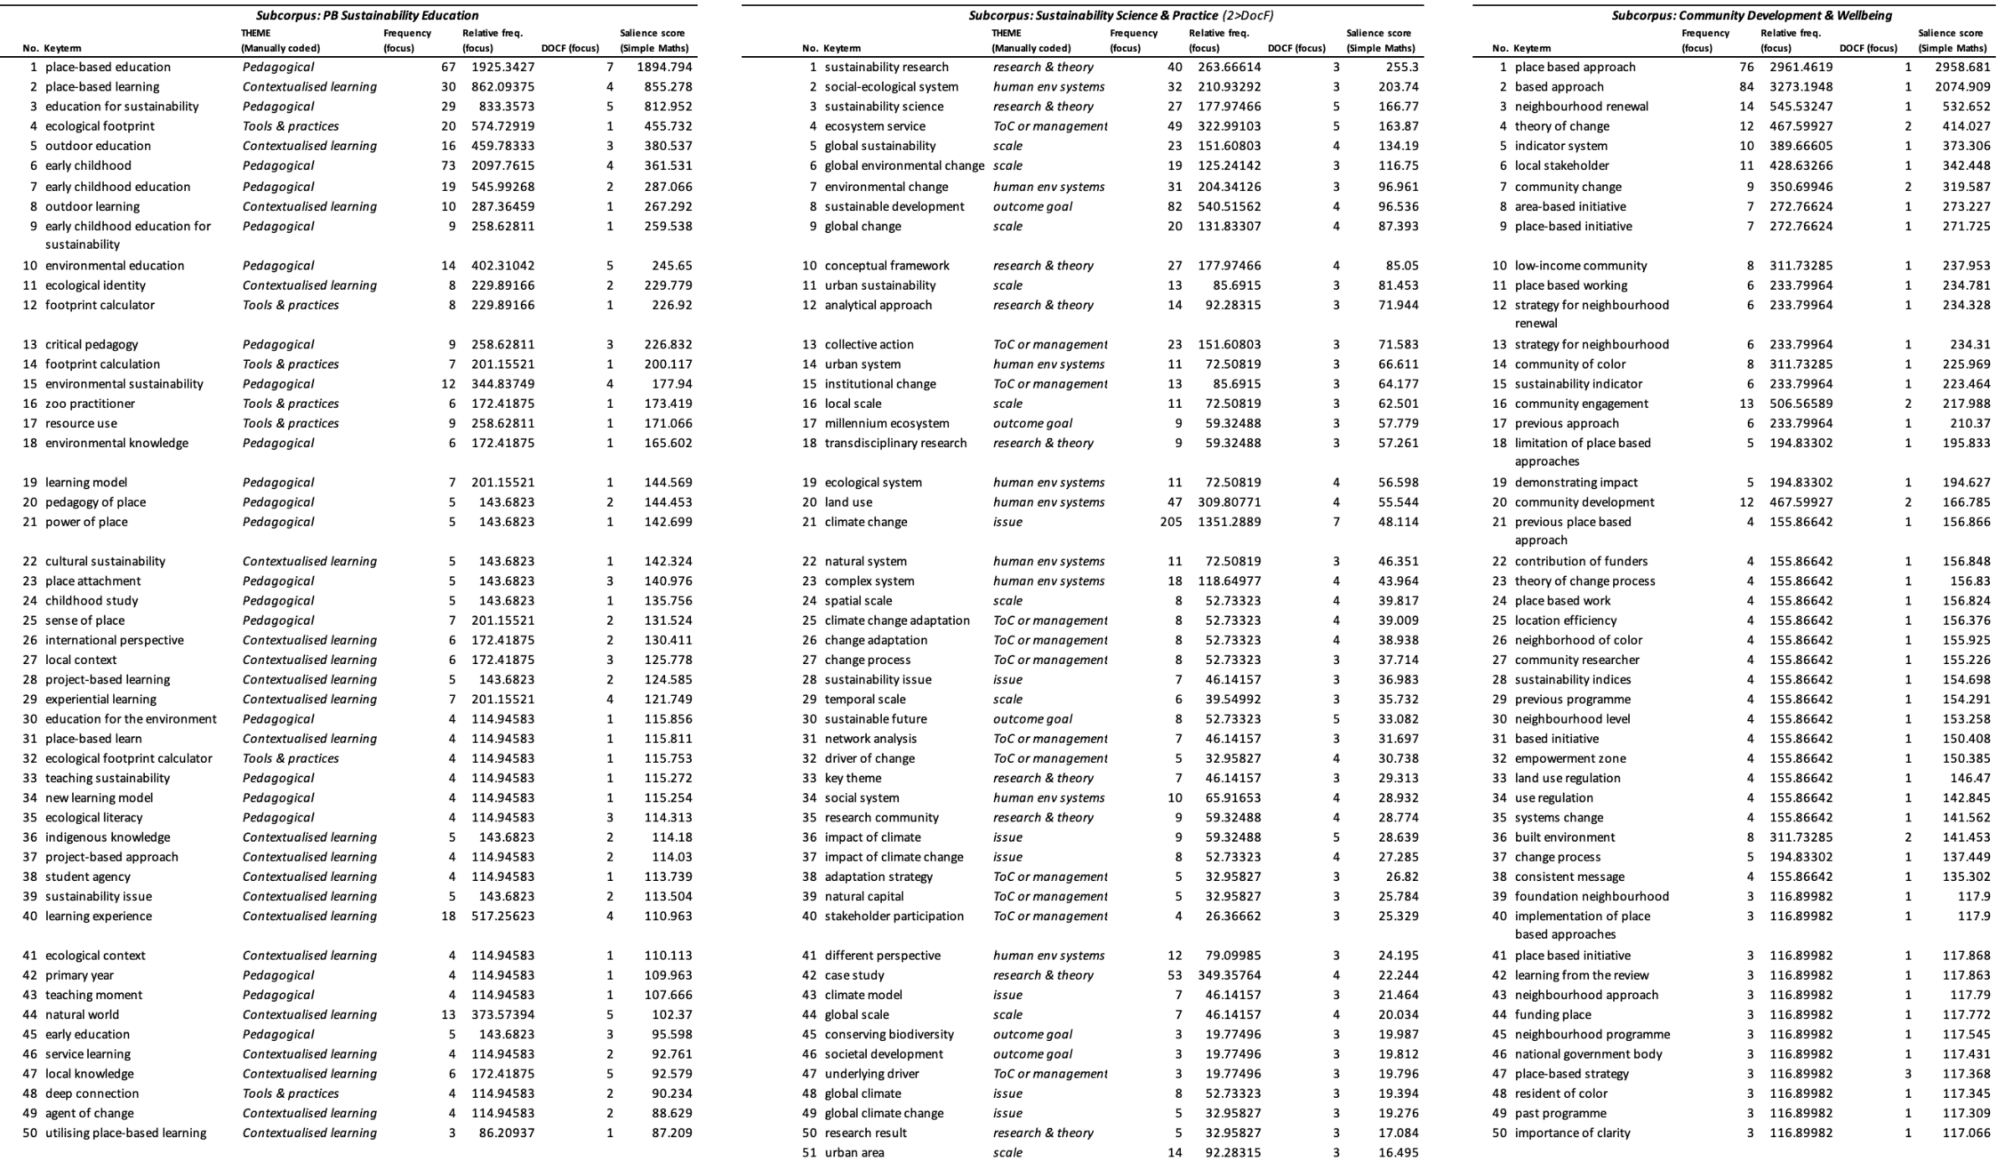
S6_Top 50 keyterms in the AC texts (inc. thematic coding*).
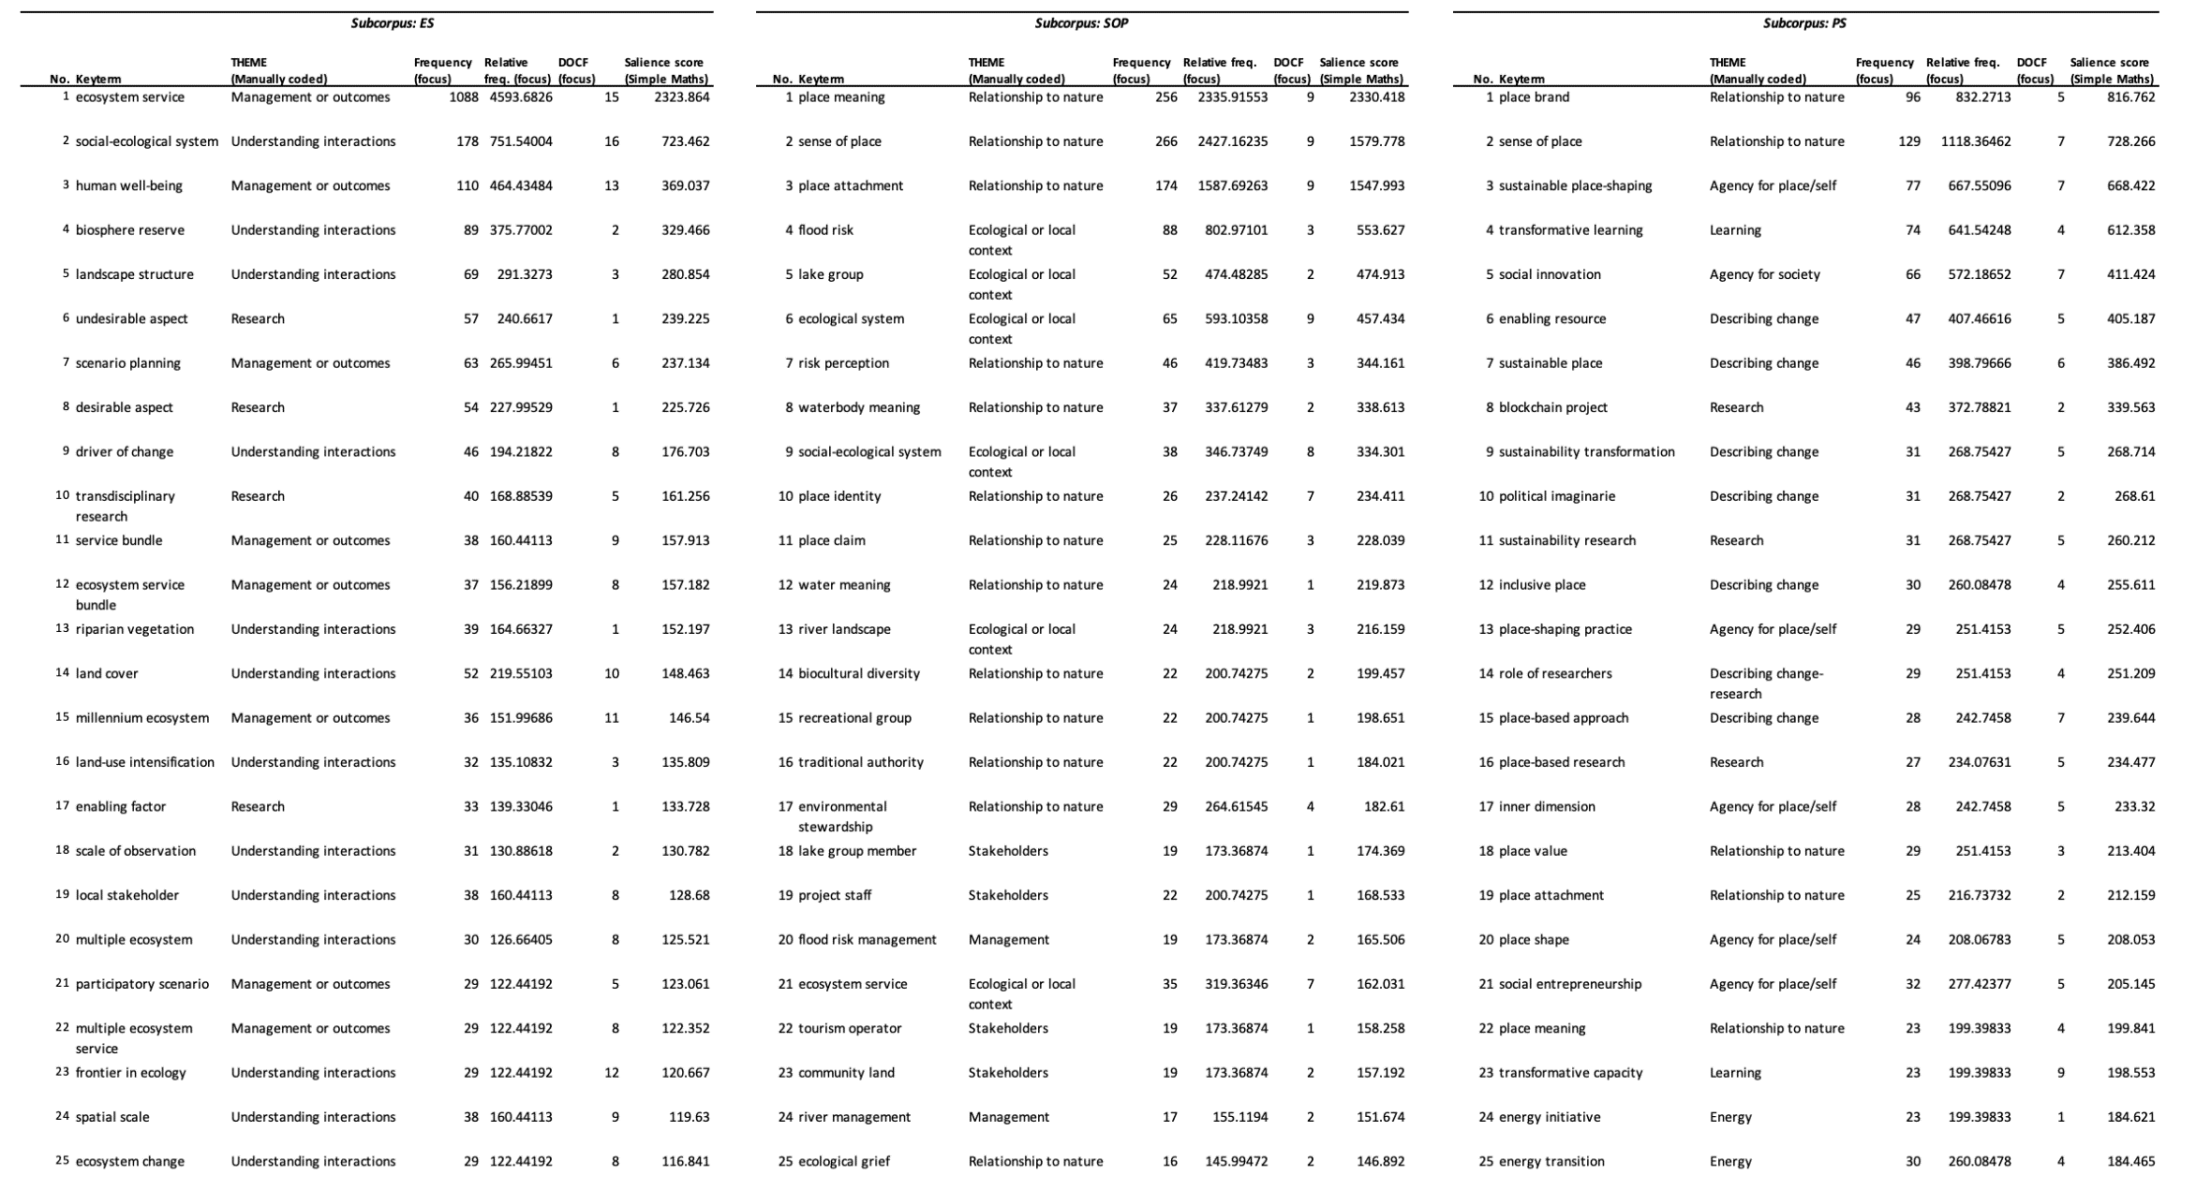

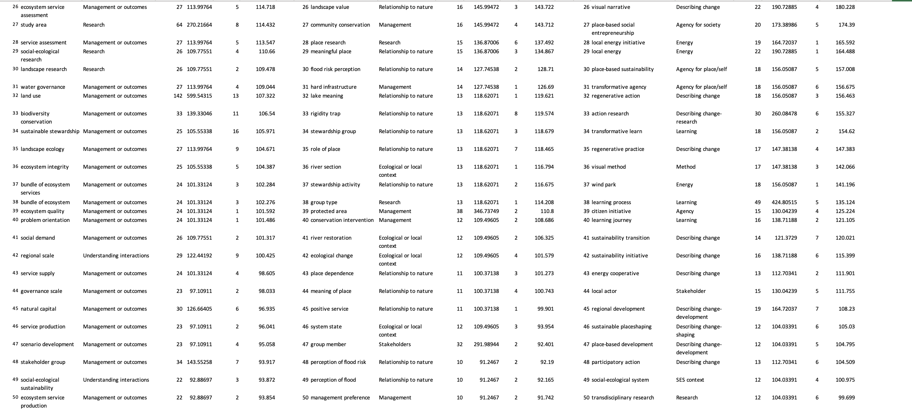

*A note on thematic coding of keyterms reflected in tables S5 & S6.
The themes amongst keyterms were identified by an iterative process of looking at each keyword, offering a description of that word, checking the contextual uses of each keyword in respective concordances (in-text references) and adjusting the categorisation/description if necessary. Looking at descriptions across keywords led to some descriptions being collated as they described similar themes. This is similar in process and epistemological paradigm to the qualitative exploration of texts in traditional discourse analysis, which often adopt (and tailor) the concept of reflexive thematic analysis (Braun & Clarke, 2019), or cycling between descriptive (or In Vivo) coding followed by thematic categorisation (Saldaña, 2021 133-142; 257-267).

References:
- Braun, V., & Clarke, V. (2019). Reflecting on reflexive thematic analysis. Qualitative Research in Sport, Exercise and Health, 11(4), 589-597. doi:10.1080/2159676X.2019.1628806
- Saldaña, J. (2021). The coding manual for qualitative researchers (4th ed.): Sage.

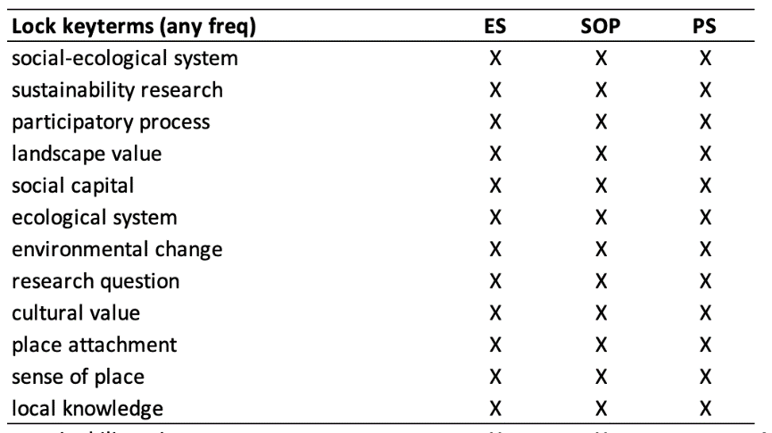
S7_Shared keyterms in AC subcorpora.
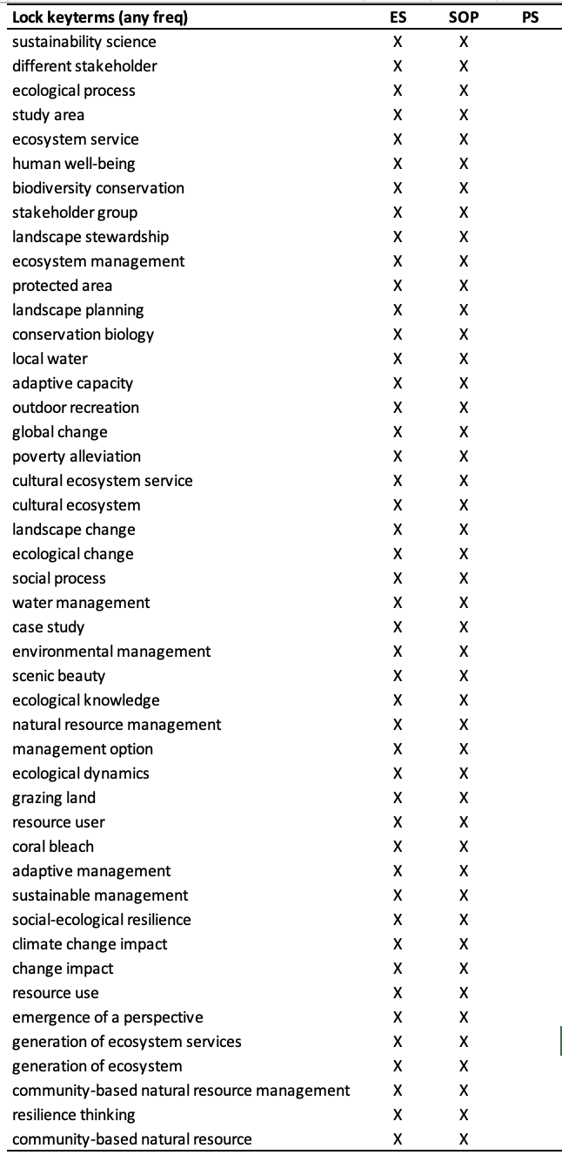
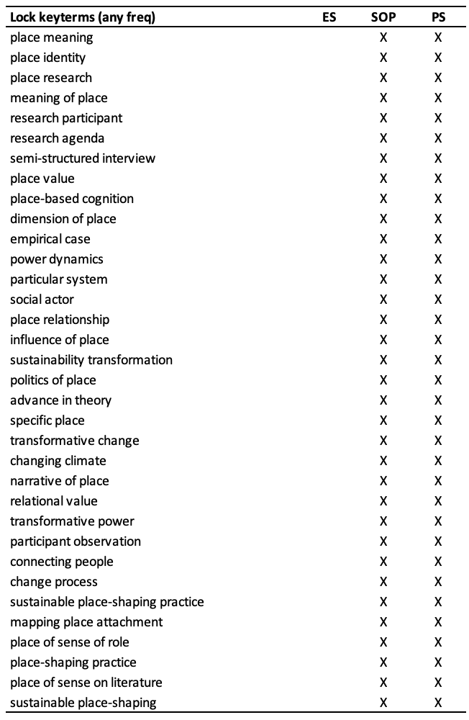

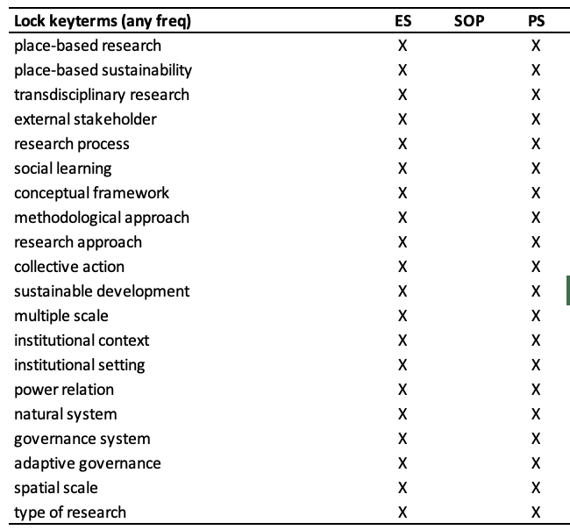

S8_Word Sketches of ‘change’ produced with SketchEngine. Visualisations show (up to) 30 collocates of change and represent comparative frequency (word size), typicality (distance to centre), and grammatical context (colour/descriptive text). Wedge sizes reflect the relative frequency of search term collocates present in the identified grammatical structure.
E&S texts | SOP texts | PS texts
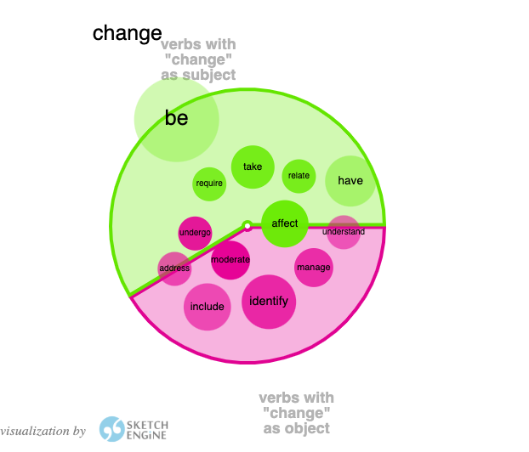 | 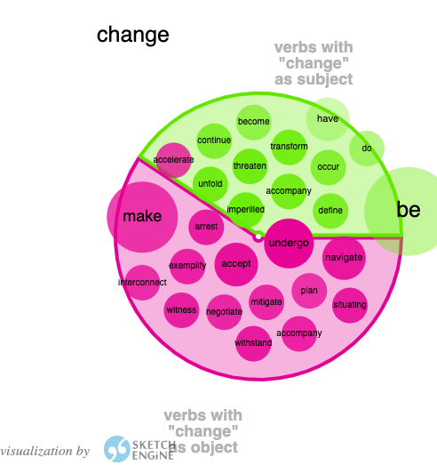 | 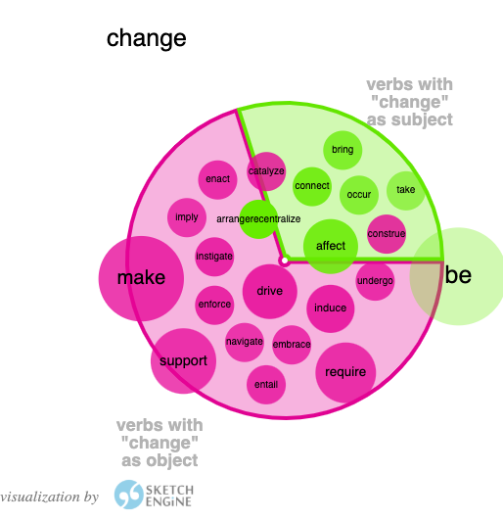
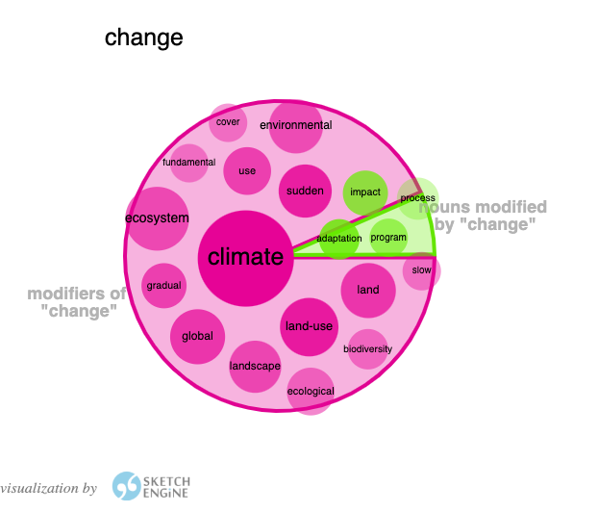 | 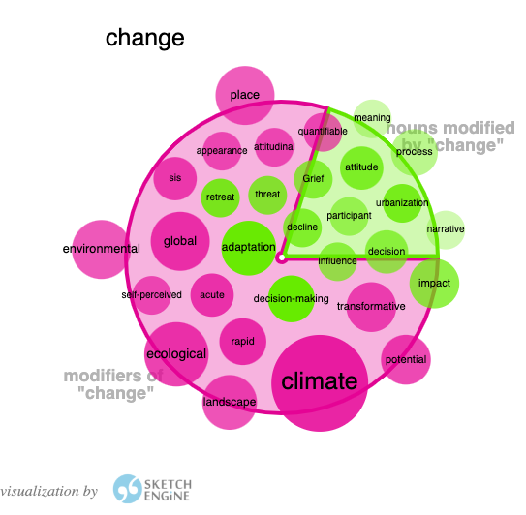 | 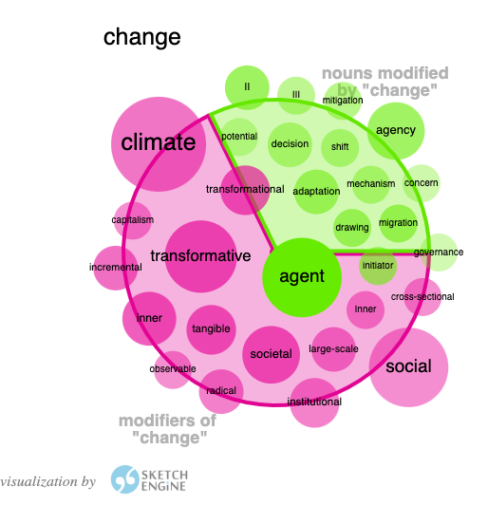
REFERENCE: Adam Kilgarriff, Vojtěch Kovář, Simon Krek, Irena Srdanović, Carole Tiberius. A quantitative evaluation of word sketches. Proceedings of the 14th EURALEX International Congress: 372-79, 2010. http://www.sketchengine.eu

