Electronic Supplementary Material (ESM)

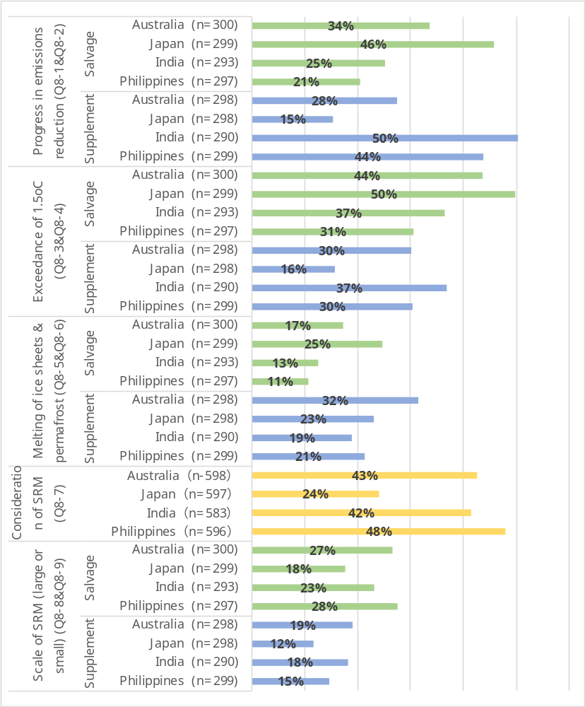

Figure ESM 1. Responses to Q8 comprehension questions. Shares of respondents in choosing correct responses.

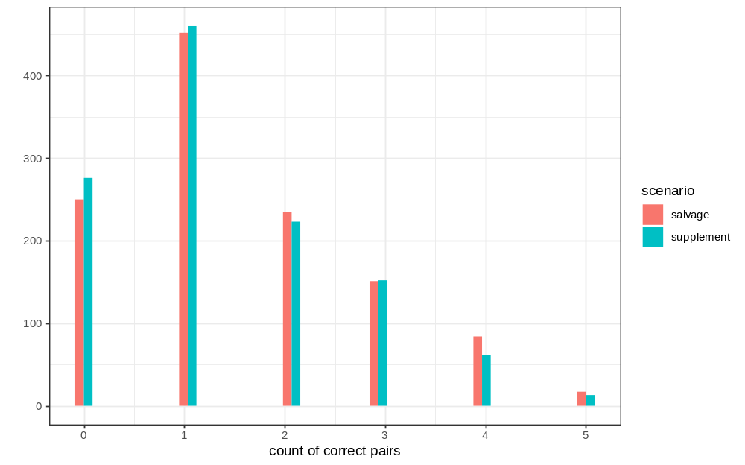
Figure ESM 2. Distribution of the count of correct response pairs to the comprehension questions (Q8’s).

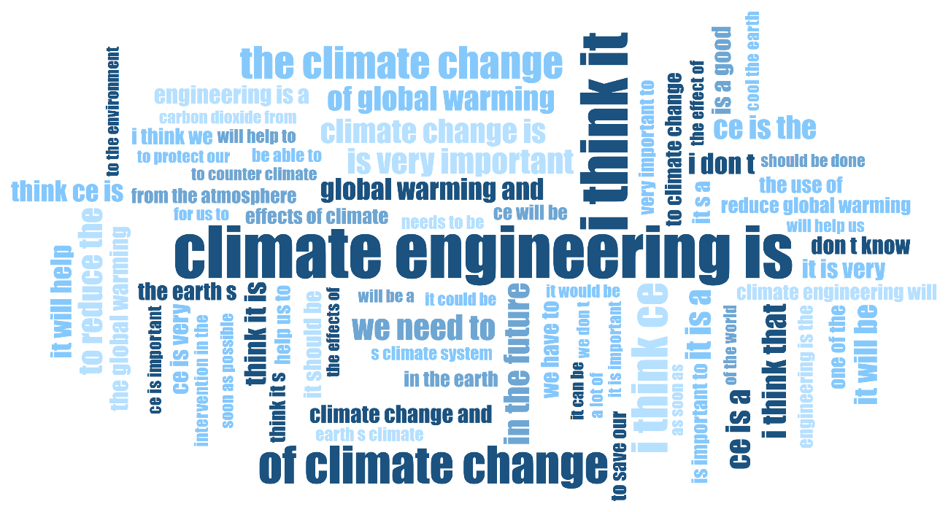
Figure ESM 3. Word cloud (output by MAXQDA) of 3 consecutive words that occur frequently in the answers (free description) to Q14 (respondent’s perception of SRM). Q14 asked respondents to write freely about their perceptions of SRM (or CE in the context of the question) after reading two scenarios. The basic analysis used for the open-ended responses was to identify the most frequently occurring word combinations in a total of 2374 valid responses from the four countries (597 responses from Japan were translated into English by Google Translate). Using the qualitative data analysis software MAXQDA (Rädiker & Kuckartz 2020), a word cloud of three consecutive words that occur frequently in the responses was generated and is shown in Figure ESM 3. The analysis revealed 7 respondents do not have responses when it comes to SRM and 18 misidentified SRM as CO₂ emission reduction or CDR, but these are small numbers compared to the total number of responses.

Rädiker, S., & Kuckartz, U. (2020). Analyzing open-ended survey questions with MAXQDA. Step-by-step. Berlin: MAXQDA Press. https://doi.org/10.36192/978-3-948768027

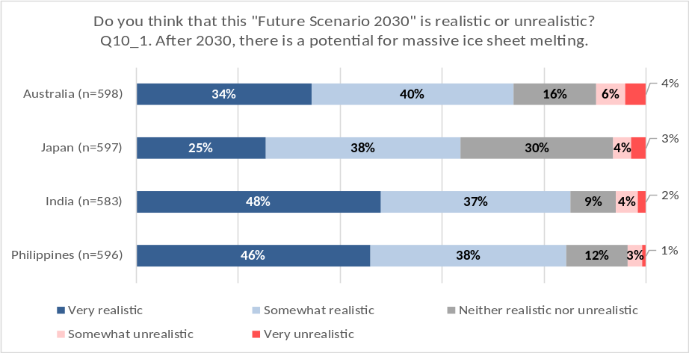
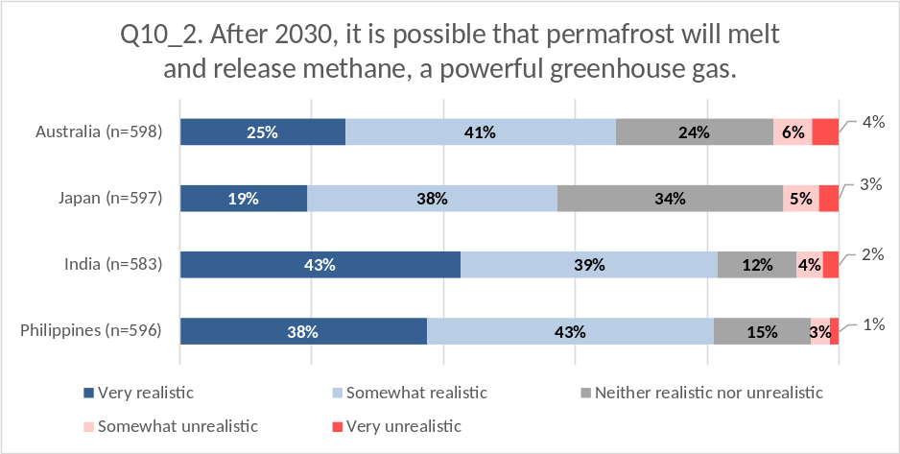
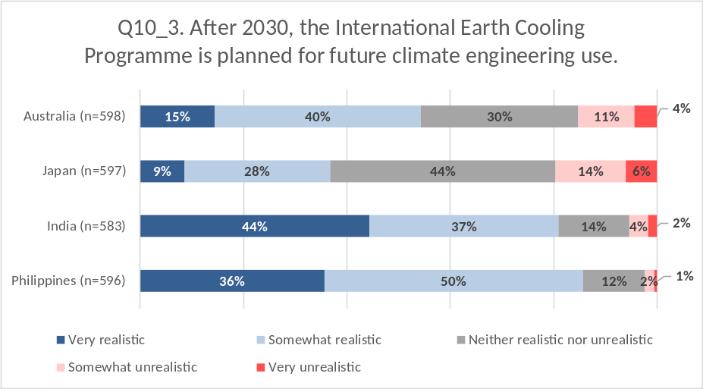
Figure ESM 4. Responses to Q10’s except for Q10_4.

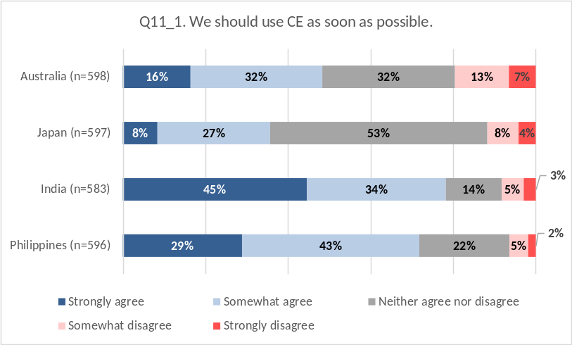
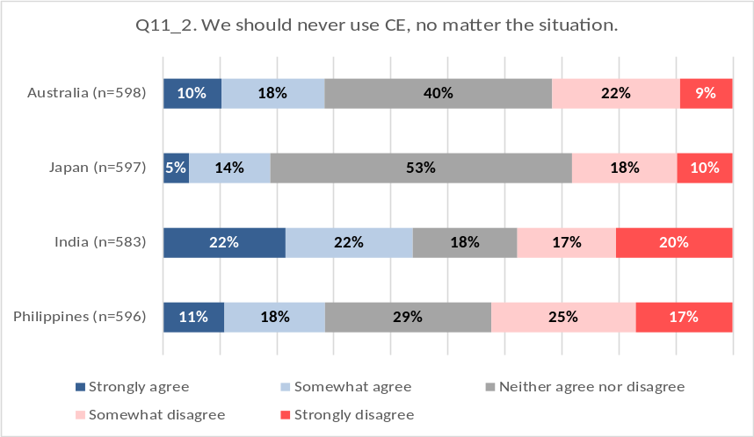
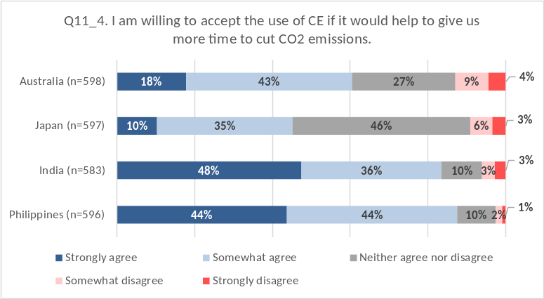

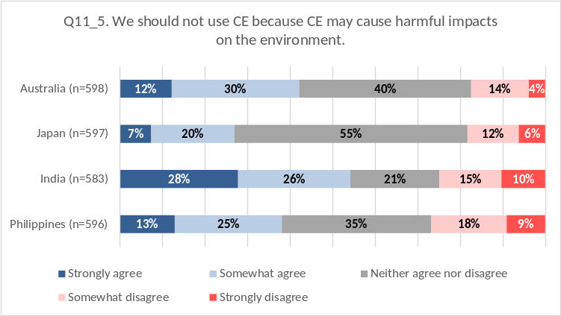

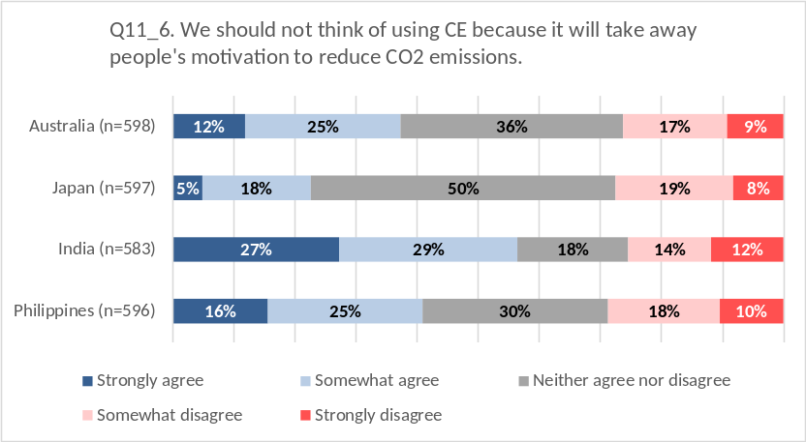
Figure ESM 5. Responses to Q11’s, “Suppose it is the year 2030 and ‘Future Scenario 2030’ has become a reality. What is your opinion of each of the following statements related to the future use of SRM?”, except for Q11_3.

Table ESM 1. As in Table 6 but for Model S3 without and with a comprehension level variable.
 | Dependent variable
 | Support for SRM
Independent variables | Model S3 | Model S3B
Scenario dummy (salvage=1) | 0.056 | 0.056
Correct responses to comprehension questions |  | 0.0003
Education dummy (college or above=1) | 0.062 | 0.062
Gender dummy (female=1) | -0.025 | -0.024
Age | -0.001 | -0.001
Country dummy (India) | 0.016 | 0.016
Country dummy (Japan) | -0.046 | -0.046
Country dummy (Philippines) | 0.032 | 0.033
Risk aversion | -0.033* | -0.033*
Altruistic values | -0.044* | -0.044*
Egoistic values | 0.022 | 0.022
Security values | 0.022 | 0.022
Trust in NGO, researchers, and UN | 0.074*** | 0.074***
Concern about harms from climate change | 0.090* | 0.090*
Belief in the need for further climate action | 0.044* | 0.044*
SRM can be used safely | 0.611*** | 0.611***
SRM can cool fast | 0.163*** | 0.163***
Constant | 1.297*** | 1.296**
Observations | 2261 | 2261
Adjusted R² | 0.563 | 0.563
F Statistic | 0.56 | 0.56
Note: | + p<0.1; * p<0.05; ** p<0.01; *** p<0.001

Table ESM 2. As in Table 7 but for Model S3 without and with a comprehension level variable.
 | Dependent variable
 | Support for SRM
Independent variables | Model O3 | Model O3B
Scenario dummy (salvage=1) | -0.219+ | -0.205+
Correct responses to comprehension questions |  | -0.108**
Education dummy (college or above=1) | -0.028 | -0.016
Gender dummy (female=1) | 0.329** | 0.318**
Age | -0.017*** | -0.017***
Country dummy (India) | -0.022 | -0.043
Country dummy (Japan) | -0.339+ | -0.373*
Country dummy (Philippines) | -0.430* | -0.466*
Risk aversion | -0.024 | -0.026
Altruistic values | 0.003 | 0.006
Egoistic values | 0.294*** | 0.284***
Security values | 0.007 | 0.014
Trust in NGO, researchers, and UN | 0.071* | 0.072*
Concern about harms from climate change | -0.008 | -0.003
Belief in the need for further climate action | -0.069* | -0.068*
SRM can be used safely | -0.272*** | -0.274***
SRM can cool fast | -0.02 | -0.019
Constant | 10.510*** | 10.971***
Observations | 2261 | 2261
Adjusted R² | 0.139 | 0.143
F Statistic | 0.133 | 0.136
Note: | + p<0.1; * p<0.05; ** p<0.01; *** p<0.001

