1. Procedure
Participants in the PC group received the intervention in a closed area of the facility where they could sit on a bench and watch the material in privacy (Figure 1 in manuscript). Before starting the videos, participants in the PC group were familiarized with how to operate the 360° feature on the laptop screen and change the viewing direction using the computer mouse.
Participants in the VR group completed the intervention in an area of the facility where they could stand and watch the material undisturbed (Figure 1 in manuscript). Before starting the VR videos, each participant was given a brief introduction to the VR equipment, including any necessary adjustments to the head straps for comfort, and told that they could change the viewing direction during the VR experience by moving their heads as well as that they could walk around a little in different directions. Finally, efforts were made to adjust the focus of the head-mounted display to ensure the highest possible video quality for each participant. The videos were started externally by the research assistant.
Participants in the UVR group changed into their swimwear in a changing room at the facility. Afterward, they were guided to the pool area (Figure 1 in manuscript). Here, they were instructed to warm up by swimming around, after which they received instruction on the UVR equipment. Before starting the experience, each participant briefly tried on the VR diving mask, snorkel, and floatation belt in order to familiarize themselves with the equipment. Participants were informed that they could move around in the water and look in different directions during the video. They were also given instructions on how to remove water from the snorkel through forceful exhalation if needed. The videos were started externally by the researcher.
2. Video Material
The first video (5 minutes) displays a drift dive from a first-person perspective. Accompanied by calm instrumental music, the viewer encounters marine wildlife such as sea turtles, sharks, and whales, as well as a shipwreck, coral reefs, and various types of algae.
In the second video (5 minutes), the viewer, situated below the surface of the water, is immediately contacted verbally by a fictitious divemaster who verbally instructs the viewer about their pending mission: to locate a whale calf caught in rope. To motivate the viewer to look around, the divemaster mentions that the visuals are recorded and will be used for research. Soon after the whale calf is located, it breaks loose from the rope and the viewer is instructed to follow the calf. The video proceeds through an underwater cave system where the viewer encounters a shipwreck, a kelp forest, and a shiver of sharks. Finally, the video terminates when the whale calf is reunited with its pod (see Figure 2 in the manuscript for a screenshot from the video). In this way, the second video contains a clear narrative storyline.
3. Measures
This table provides the wording for every question asked throughout the three surveys.
Variables | Questions | Options
INS | Please indicate which image below best corresponds to your relationship with NATURE. | 7 pairs of increasingly overlapping circles representing Nature and Self
IOS | Please indicate which image below best corresponds to your relationship with the OCEAN. | 7 pairs of increasingly overlapping circles representing Ocean and Self
BTME  (Self-reported PEB) | How often do you take the following actions to protect the marine environment?  - I conserve energy by turning off lights and electric appliances when not in use.  - I conserve water at home (closing the faucet when brushing teeth and washing dishes, flushing less often, taking short showers, etc.)  - I purchase “environmentally friendly” products (sustainable seafood, phosphate free detergents and soaps, products with recyclable or no packaging, economy size products, etc.)  - I consume content related to marine conservation (articles, books, social media posts, documentaries, etc.).  - I recycle paper, plastic, metal, and/or glass.  - I dispose of used batteries in proper collection containers instead of the waste basket.  - I share content with my network and/or report to authorities or the media about marine environmental problems.  - I collect things that others have thrown on the beach.  - I encourage local officials to build better sewage treatment plans.  - I participate in organized community activities, such as beach clean-ups.  - I participate in campaigns for preventing marine environmental damage, such as protests and demonstrations.  - I am active in an environmental organization that works on marine conservation issues | - Never  - Rarely  - Sometimes  - Often  - Always
BTME (Self-reported intended PEB) | Please select the behavior(s) from the following list that you intend to start doing or improving in the next one month. You can select multiple options.  - Conserve energy by turning off lights and electric appliances when not in use.  - Conserve water at home (closing the faucet when brushing teeth and washing dishes,  flushing less often, taking short showers, etc.).  - Purchase “environmentally friendly” products (sustainable seafood, phosphate free  detergents and soaps, products with recyclable or no packaging, economy size products,  etc.).  - Consume content related to marine conservation (articles, books, social media posts,  documentaries, etc.).  - Recycle paper, plastic, metal, and/or glass.  - Dispose of used batteries in proper collection containers instead of the waste basket.  - Share content with my network and/or report to authorities or the media about marine  environmental problems.  - Collect things that others have thrown on the beach.  - Encourage local officials to build better sewage treatment plans.  - Participate in organized community activities, such as beach clean-ups.  - Participate in campaigns for preventing marine environmental damage, such as protests  and demonstrations.  - Be active in an environmental organization that works on marine conservation issues.  - None at all. | [Multiple choice, selection ranging from 0 to 12]
Physical Presence | Please rate the following statements based on your experience in the ocean experiment.  - The virtual marine environment seemed real to me.  - I had a sense of acting in the virtual marine environment, rather than operating something from outside.  - My experience in the virtual marine environment seemed consistent with my experiences in the real world.  - While I was in the virtual marine environment, I had a sense of “being there”.  - I was completely captivated by the virtual marine world. | - Strongly Disagree  - Disagree  - Neither agree nor disagree  - Agree  - Strongly Agree
Cyber  sickness | How was your physical experience in the ocean experiment?  Select one of the options. | - No problems  - Uneasiness  - Vague dizziness, warmth, headache, stomach awareness, sweating  - Slight dizziness, warmth, headache, stomach awareness, sweating  - Fair dizziness, warmth, headache, stomach awareness, sweating  - Severe dizziness, warmth, headache, stomach awareness, sweating  - Slight nausea; Fair nausea  - Severe nausea  - (Near) retch  - Vomiting
Awe | Please rate the following statements based on your experience in the ocean experiment.  → Time:  - I sensed things momentarily slow down.  - I noticed time slowing.  - I felt my sense of time change.  - I experienced the passage of time differently.  - I had the sense that a moment lasted longer than usual.  → Self-loss:  - I felt that my sense of self was diminished.  - I felt my sense of self shrink.  - I experienced a reduced sense of self.  - I felt my sense of self become somehow smaller.  - I felt small compared to everything else.  → Connectedness  - I had the sense of being connected to everything.  - I felt a sense of communion with all living things.  - I experienced a sense of oneness with all things.  - I felt closely connected to humanity.  - I had a sense of complete connectedness.  - I felt closely connected to the ocean  → Vastness  - I felt that I was in the presence of something grand.  - I experienced something greater than myself.  - I felt in the presence of greatness.  - I perceived something that was much larger than me.  - I perceived vastness.  → Physiological  - I felt my jaw drop.  - I had goosebumps  - I gasped.  - I had chills.  - I felt my eyes widen.  → Accomodation  - I felt challenged to mentally process what I was experiencing  - I found it hard to comprehend the experience in full.  - I felt challenged to understand the experience.  - I struggled to take in all that I was experiencing at once  - I tried to understand the magnitude of what I was experiencing. | - Strongly disagree  - Moderately disagree  - Disagree  - Neither agree nor disagree  - Agree  - Moderately agree  - Strongly Agree
Donation | You will be compensated with a 100 [currency] Amazon gift card. However, you have the option to use your compensation to make a donation to the [name of the foundation kept anonymous for review process], which organizes the annual Nordic Coastal Cleanup Day to reduce ocean pollution and increase proper recycling behaviors. Please choose how much, if any, of your compensation you would like to use for the donation instead.  I would like to donate the following amount (between 0 and 100 [currency]): | Between 0 and 100
Petition | The organization “We Move Europe” is calling everyone to sign a petition that urges the EU to phase out destructive fishing practices (see screenshot below). Are you willing to sign this petition? | - Yes  - No
4. Modification of the Misery Scale
While the Misery Scale was not modified in the survey, upon looking at the data, it was clear that many categories had zero-responses, meaning that they were redundant in the scale. Importantly, zero responses renders the test of the proportional odds assumption unreliable, meaning that a modification was necessary in order to be sure the assumption was met and the statistical analyses were valid. As such, this modification was made in order to ensure robustness in reporting our findings. We modified the scale from 11 levels to 4; "no symptoms (1-2), pre-nausea symptoms (3-6), nausea (7-10), and vomiting (11)".
5. Anecdotal Observations
Anecdotally, participants in the UVR condition exhibited a greater frequency of behaviors indicative of presence compared with the other two intervention groups. For instance, in the second video, upon establishing radio communication with the fictitious divemaster as part of the narrative of the video, the divemaster requests that the viewer give a thumbs up to indicate that the communications system is working. Here, a large number of participants in the UVR condition did a thumbs up in real life, whereas no observations of this behavior was made in the other conditions. We observed this behavior despite the fact that the thumbs up gesture is not the correct physical hand motion in underwater communication for indicating “yes” or “okay”. Furthermore, at one point, the viewer encounters a shiver of sharks and is advised by the divemaster to turn around immediately, which many of the participants in the UVR condition (but not the other conditions) physically did. Although these observations were not systematic, we report them here as they could potentially serve as avenues for future research on behavioral markers of presence.
6. Additional Descriptive Statistics
Variable | Condition
 | PC | VR | UVR
Willingness to sign petition | Yes: 52  No: 8ª | Yes: 47  No: 11ª | Yes: 52  No: 4ª
Self-reported previous PEBs (delayed post-survey) | 2.80 (0.57)^{b} | 2.77 (0.51)^{b} | 2.96 (0.46)^{b}
INS (post-survey) | 5 (2)^{c} | 5 (1)^{c} | 5 (2)^{c}
IOS (delayed post-survey) | 4 (2)^{c} | 4 (2)^{c} | 4 (2)^{c}
INS (delayed post-survey) | 4 (1)^{c} | 4 (1)^{c} | 5 (1)^{c}
ª Frequency
^{b} Mean (SD)
^{c} Median (IQR)

7. Extra Analyses
Visual inspection of a scatter plot indicated that there was no relationship between donation amount and behavioral intentions:
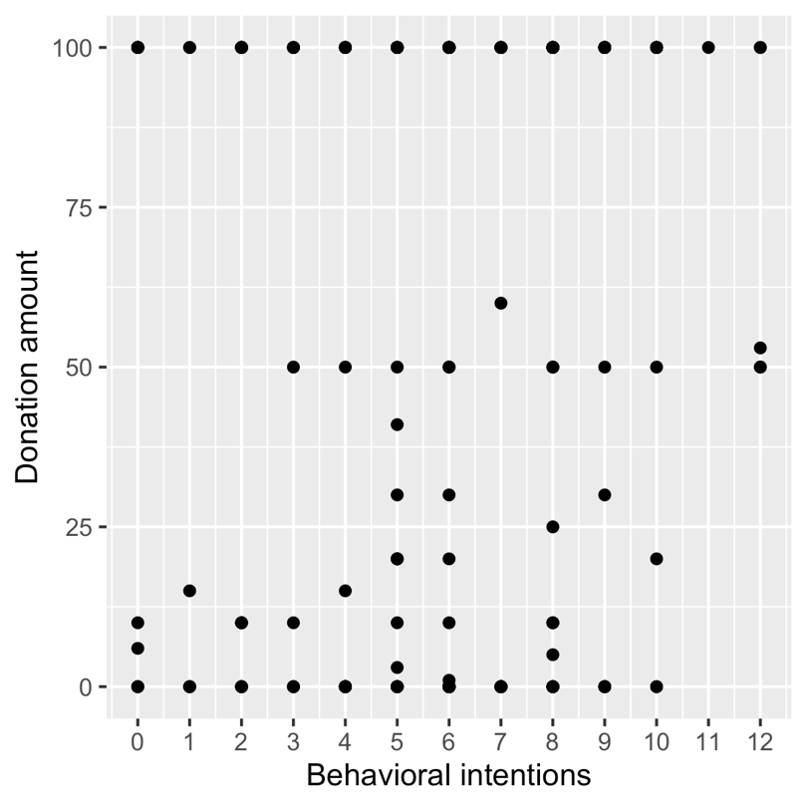
Visual inspection of a scatter plot indicated that there was no relationship between donation amount and ocean connectedness (IOS) measured at the postsurvey:
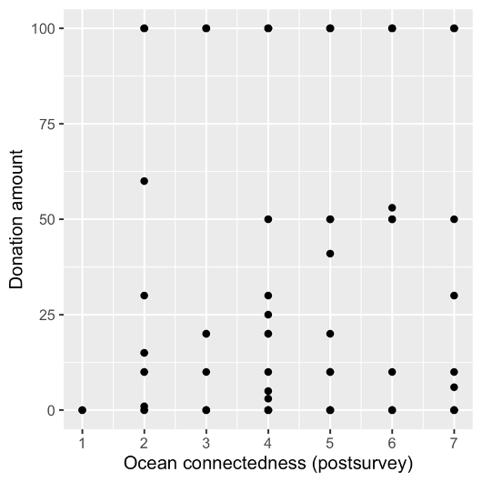

Visual inspection of a scatter plot indicated that there was a relationship between ocean connectedness (IOS) and nature connectedness (INS) measured at the post-survey:
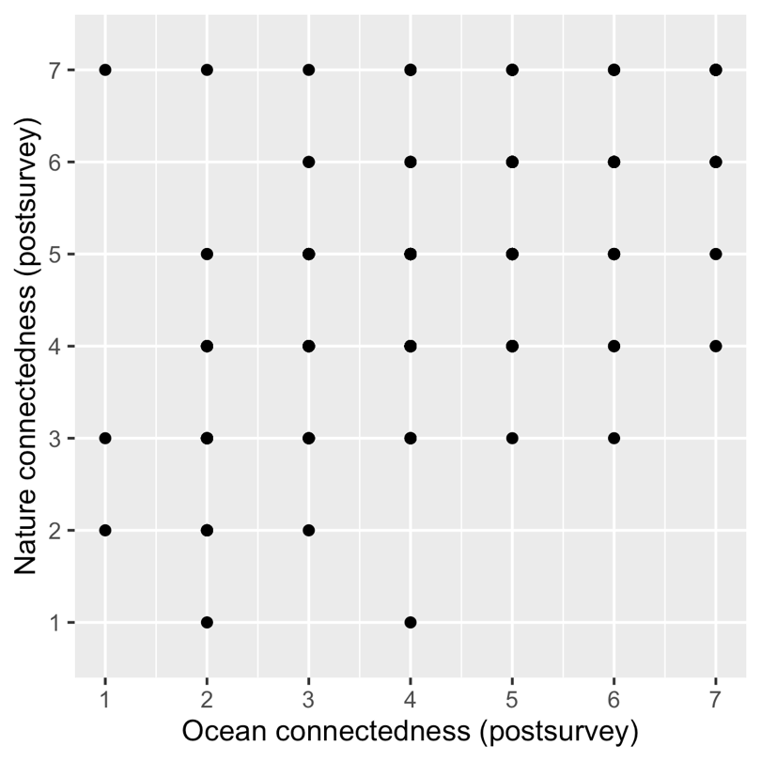
This was corroborated by a Spearman correlation, ρ = 0.54, p < .001.
Regarding the correlation with awe between INS and IOS, we focused specifically on the time and physiological, which were the only dimensions impacted by the intervention, to limit multiple testing.
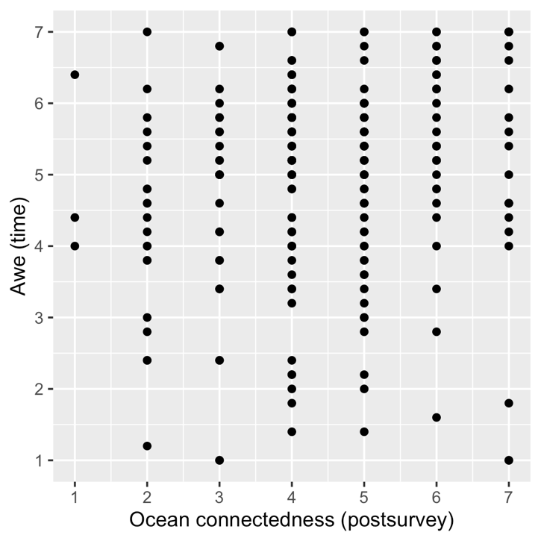
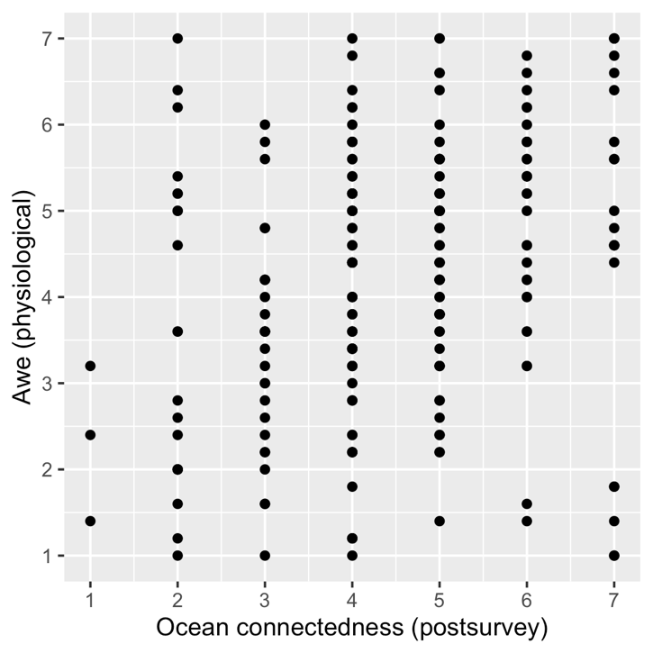
Visual inspection of scatter plots indicated that there was a relationship between ocean connectedness (IOS) and awe time as well as awe physiological:
This was corroborated by Spearman correlations, ρ = 0.18, p < .01 (time); ρ = 0.29, p < .001 (physiological).
Visual inspection of scatter plots indicated that there was a relationship between nature connectedness (INS) and awe time as well as awe physiological:
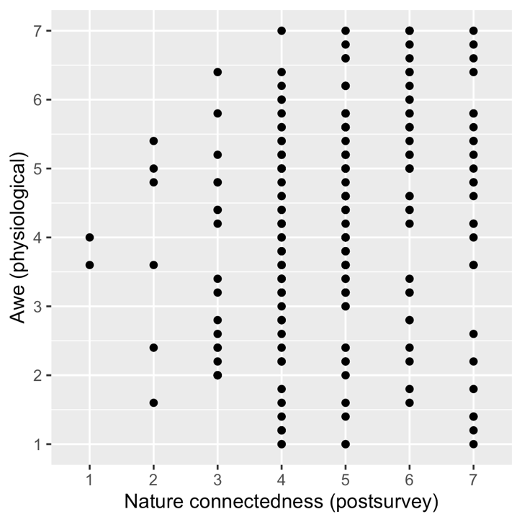
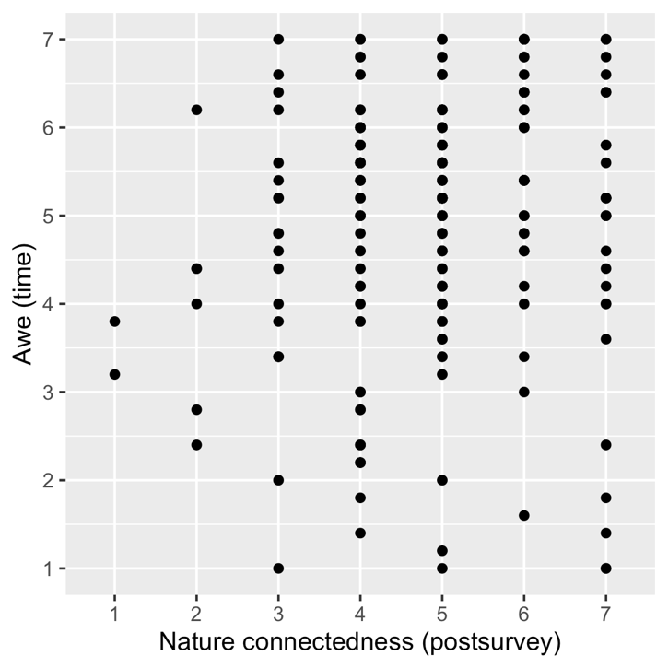
This was corroborated by Spearman correlations, ρ = 0.14, p = .04 (time); ρ = 0.22, p < .01 (physiological).

