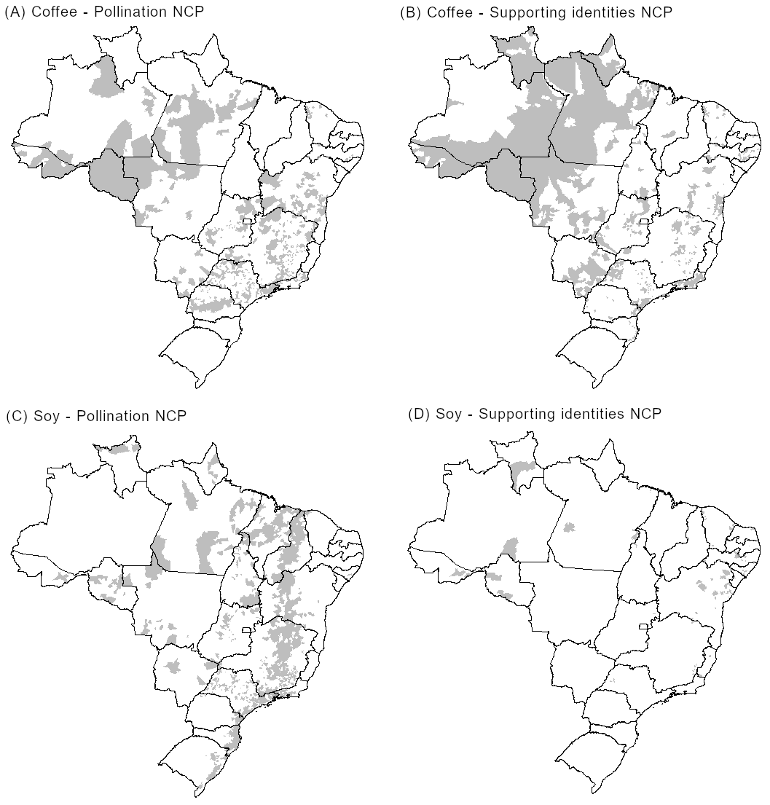
Figure S1. Municipalities excluded from the estimation of nature's contributions to people (NCP) of pollination and supporting identities in the coffee (A and B) and soy (C and D) production systems due to mismatches between spatial data on land use and statistical data on production.
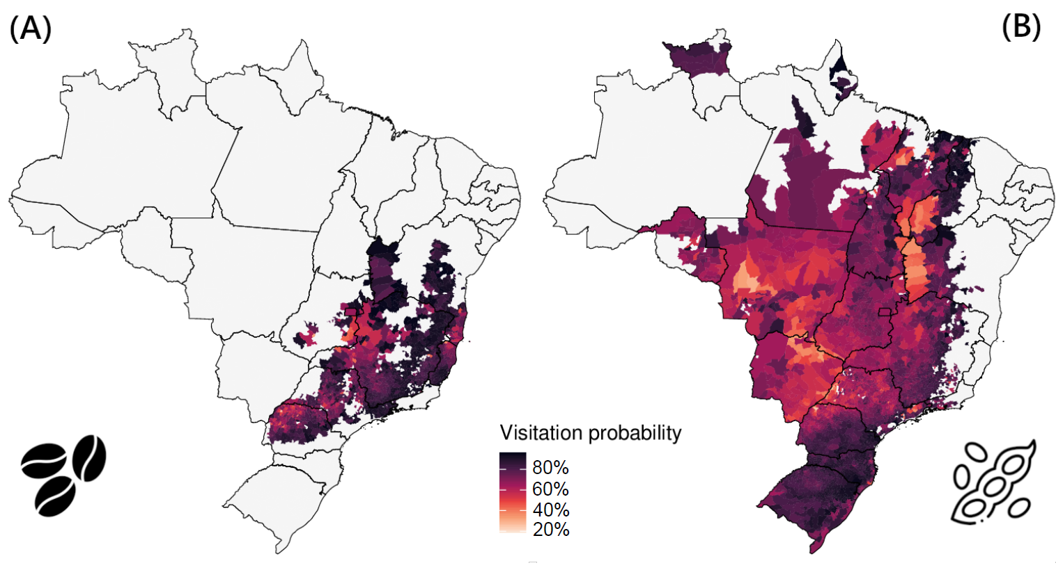
Figure S2. Visitation probability of (A) coffee and (B) soy per producing municipality.

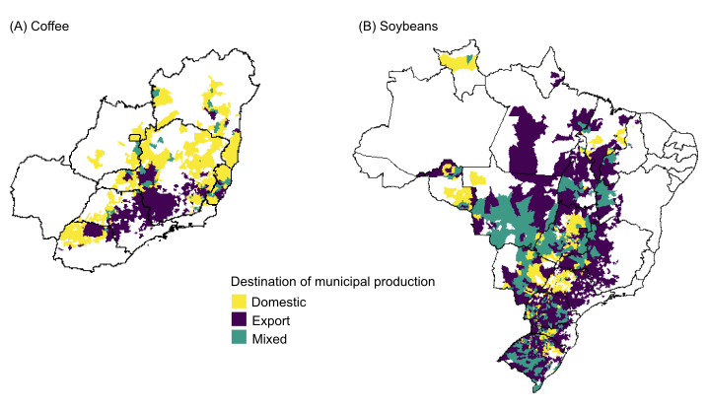
Figure S3. Municipalities producing (A) coffee or (B) soy for the domestic market, for export, or for both.

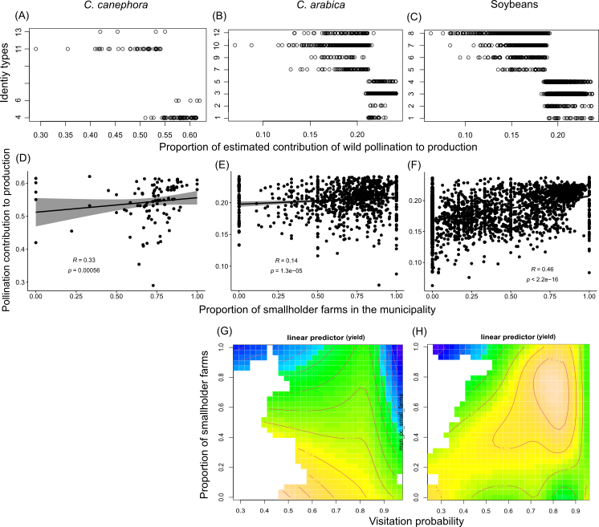
Figure S4. Proportion of the estimated contribution of wild pollination to crop production in the producing municipalities across identity types for (A) C. canephora; (B) C. arabica (B); and (C) soybeans. Spearman’s rank correlation coefficient between the proportion of estimated contribution of wild pollination to crop production and the proportion of smallholder farms in the municipality for (D) C. canephora (R = 0.33, p < 0.001); (E) C. arabica (R = 0.14, p < 0.001); and (F) soybeans (R = 0.46, p < 0.001). Nonlinear interactions between pollinator visitation probability and the proportion of smallholder farms in predicting yield in the producing municipalities for (G) C. arabica and (H) soybeans from Generalized Additive Models.

