Supplementary (SI) 1 (table 1-5): Indicator thematic categorization and data ordination through factor analysis

Table 1:Individual and grouped intended site-level restoration activities and their respective categories
Site-level restoration activity | Active | Agroforestry | Assisted Natural Regeneration (ANR) | Reference
Active silvicultural approaches
Establishment of exotic mono-crop plantations/woodlots | X |  |  | (Atkinson & Bonser, 2020; Buckingham et al., 2018; Shono et al., 2007; MEFCC 2018)
Establishment of a mixed forest with both indigenous and exotic tree species | X
Planting boundary trees along rivers or homesteads | X
Mixing pasture (grazing) with shade trees for animals |  | x
Mixing crops with shade fruit trees. |  | x
Pure passive silvicultural approaches
Land rehabilitation through enclosures/enclosures to enable natural regeneration and species recovery |  |  | X
Forest protection/demarcation and conservation |  |  | X
Management approaches to enhance recovery.
Assisted natural regeneration in protected / enclosures |  |  | X
Enrichment planting (planting trees in forest gaps) |  |  | x
Establishment of soil conservation structures |  |  | x

Table 2.Ecosystem service valued attribute items and their respective thematic categories. NTFP is non-timber forest products
 | Ecosystem service valued attribute groups
Service item | Food | Timber | NTFP | Water provision | Soil erosion control | Micro_ climate | Carbon | Biodiversity | Cultural
Provisioning services
1. Crop | x
2. Timber-poles |  | x
3. Bushmeat |  |  | x
4. Water for home consumption |  |  |  | x
5. Fuelwood |  |  | x
6. Fodder |  |  | x
7. Natural medicine |  |  | x
8. Fibers |  |  | x
9. Ornamental and spices |  |  | x
Regulating and supporting services
10. Make the air we breathe clean |  |  |  |  |  | x
11. Stop strong winds |  |  |  |  |  | x
12. Control floods and mudslides |  |  |  |  | x
13. Shade |  |  |  |  |  | x
14. Absorbing carbon (ካርቦን) from the atmosphere |  |  |  |  |  |  | x
15. Enhancing crop production through pollination |  |  |  |  |  |  |  | x
16. Groundwater recharge and base flow enhancement |  |  |  | x
17. Controlling soil erosion and improving soil fertility |  |  |  |  | x
18. Protect and conserve many kinds of plants and animals |  |  |  |  |  |  |  | x
19. Controlling pests, e.g., Locusts |  |  |  |  |  |  |  | x
Cultural services
20. Beautiful scenery |  |  |  |  |  |  |  |  | x
21. Leisure activities |  |  |  |  |  |  |  |  | x
22. Community Gathering |  |  |  |  |  |  |  |  | x
23. Environmental education |  |  |  |  |  |  |  |  | x
24. Collection of History |  |  |  |  |  |  |  |  | x
25. Preserve traditions |  |  |  |  |  |  |  |  | x
26. Spiritual places |  |  |  |  |  |  |  |  | x
27. Mental and physical therapy |  |  |  |  |  |  |  |  | x
28. Have one's own right |  |  |  |  |  |  |  |  | x
29. For future generations |  |  |  |  |  |  |  |  | x
30. Wild and untouched |  |  |  |  |  |  |  |  | x

Table 3:Latent factor loading on value orientation: Method = principal axis factoring, varimax rotation
Item-statement | Code | KMO | Rotated factor loading
Core Value Orientation |  |  | Altruistic | Egoistic | Biospheric
1.Respect nature and have harmony with other species | VO1 | 0.685 | 0.151 | 0.053 | 0.419
2.Have a safe environment, unity with no conflicts and where people fit in with nature | VO2 | 0.715 | 0.231 | -0.001 | 0.511
3.Protecting the natural environment (forest resources) from destruction | VO3 | 0.712 | 0.231 | 0.073 | 0.372
4.Working and caring for the wellbeing of family and friends | VO4 | 0.765 | 0.531 | 0.022 | 0.265
5.Everyone is treated justly, even people I don’t know | VO5 | 0.715 | 0.599 | 0.164 | 0.167
6.Protecting society’s weak and vulnerable members | VO6 | 0.733 | 0.564 | 0.226 | 0.151
7.Having authority, such as the right to lead or command | VO7 | 0.685 | 0.133 | 0.548 | 0.102
8.Having social status and power and being able to tell others what to do | VO8 | 0.616 | 0.185 | 0.559 | -0.050
9.Having possessions, wealth and money | VO9 | 0.676 | 0.057 | 0.424 | 0.069
10.Maximize the production and utilization of forest and agricultural resources | VO10 | 0.646 | -0.110 | 0.264 | 0.279
Note: KMO = Kaiser–Meyer–Olkin test results using the measure of sampling adequacy. Only factors with KMO greater than 0.55 and single loading (0.45) were used to create latent factors.

Table 4: Factor score loading on beliefs and norms. Method = principal axis factor, varimax rotation
Item-statement | Code | KMO | Rotated factor loading
a)Beliefs: Environmental concern |  |  | Nature | Economic
Maintaining and restoring forest lands for ecological and economic balance is an important basis for rural development | EC1 | 0.637 | 0.548 | -0.360
We must reduce our consumption levels of forest resources to ensure well-being of the present and future generations | EC2 | 0.587 | 0.779 | 0.023
Plants and animals have as much right as humans to exist and should be restored and protected | EC3 | 0.603 | 0.736 | -0.017
Humans have the right to modify the natural environment to suit their economic needs | EC4 | 0.651 | -0.013 | 0.958
b)Norms |  |  | IN (Injuctive Norm) | PN (Personal norms)
I feel personally obliged to protect, conserve, and restore forest landscapes | N1 | 0.714 | 0.214 | 0.557
I feel guilty when I do not act to protect, conserve and restore forest landscapes | N2 | 0.726 | 0.220 | 0.554
People I do represent and important to me think I should act towards protection, conservation and restoration of forest and agricultural landscapes | N3 | 0.603 | 0.751 | 0.319
People I do represent already act towards protection, conservation and restoration of forest and agricultural landscapes | N5 | 0.599 | 0.755 | 0.273
Note: KMO = Kaiser–Meyer–Olkin test results using the measure of sampling adequacy. Only factors with KMO greater than 0.55 and single loading (0.45) were used to create latent factors.

Table 5: Latent factor loading on enabling policy environment for FLR implementation. Method = principal axis factor, varimax rotation
Item-statement | Code | KMO | Rotated factor loading
Enabling policy environment |  |  | Coherence | Clarity | Inclusiveness | Bylaws
Forest restoration pledges, regulatory mechanisms and initiatives #Ethiopia are enacted, adapted and well implemented | EP1 | 0.780 | 0.101 | 0.751 | 0.182 | 0.045
Forest laws, regulations, policies on forest restoration in #Ethiopia are clear and adequate | EP2 | 0.718 | 0.069 | 0.836 | 0.120 | -0.063
Land and tree resource tenure and rights in #Ethiopia especially in your project area is secure and clear | EP3 | 0.689 | 0.139 | 0.820 | 0.005 | -0.107
Benefit sharing mechanism are in place and clear (communities obtains benefits from restored sites) | EP4 | 0.713 | -0.085 | 0.578 | 0.239 | 0.292
All people especially the disadvantaged (poor, less educated) are involved in planning, decision making, implementation and monitoring of forests | EP7 | 0.727 | -0.013 | 0.318 | 0.647 | -0.444
All stakeholders have influence and share control over development and decision in restoration | EP8 | 0.723 | 0.068 | 0.219 | 0.736 | 0.140
State rights are given to communities and households leaving close to restoration sites | EP9 | 0.718 | 0.153 | 0.033 | 0.739 | 0.083
Bi-laws (customary, traditional) are more effective than state policies and should be officially recognized | EP10 | 0.728 | -0.220 | 0.082 | 0.117 | 0.814
Regional laws, policies are in line with federal laws, policies | EP11 | 0.820 | 0.829 | 0.091 | -0.024 | -0.049
Rural land administration and use proclamation, investment proclamation and watershed proclamations are in line with forest development and conservation proclamation | EP12 | 0.799 | 0.819 | 0.013 | 0.187 | -0.012
Rural land administration and use proclamation favors forest land restoration | EP13 | 0.847 | 0.777 | 0.222 | 0.152 | -0.293
Investment proclamation favors forest land restoration | EP14 | 0.815 | 0.763 | 0.155 | 0.104 | -0.272
Watershed proclamation favors forest land restoration | EP15 | 0.763 | 0.846 | -0.094 | -0.035 | 0.071
Note: KMO = Kaiser–Meyer–Olkin test results using the measure of sampling adequacy. Only factors with KMO greater than 0.55 and single loading (0.45) were used to create latent factors.

Supplementary (SI) 2: Extended article results
Table 6:Mean summary of variables for the actor subcategories. That is civil society, executives and users
Variable |  | Executive | Civil society | Users
 | Variable description | (51) | (23) | (195)
ANR | Exclosures with assisted management | 0.54 | 0.50 | 0.29
Active | Pure exotic or mixed plantation species | 0.30 | 0.38 | 0.41
Agroforestry | A mixture of crops or pasture with trees | 0.16 | 0.13 | 0.29
Ecosystem Valued attributes
Food | Crop production importance | 0.04 | 0.04 | 0.04
Timber-pole | Timber, poles importance | 0.12 | 0.15 | 0.19
NTFP | Non-timber forest product | 0.13 | 0.21 | 0.22
Water | Water provision | 0.06 | 0.04 | 0.02
Soil | Soil erosion control | 0.15 | 0.12 | 0.12
Microclimate | Microclimate regulation | 0.13 | 0.08 | 0.11
Carbon | Carbon sequestration | 0.17 | 0.14 | 0.09
Biodiverse | Biodiversity importance | 0.06 | 0.07 | 0.05
Cultural | Cultural and spiritual value | 0.13 | 0.14 | 0.16
Core value orientation
Biospheric | Nature perspective | 0.65 | 0.71 | 0.64
Altruistic | Society perspective | 0.70 | 0.69 | 0.66
Egoistic | Authority and power | 0.65 | 0.62 | 0.64
Beliefs
Nature | Nature protection | 0.70 | 0.72 | 0.66
Economic | Economic development | 0.46 | 0.42 | 0.58
Norms
Injunctive | Societal mandate and approval | 0.68 | 0.58 | 0.64
Personal | Personal mandate and approval | 0.79 | 0.75 | 0.69
Enabling policy environment for FLR implementation
Coherence | Forest and land policies are coherent each other | 0.64 | 0.55 | 0.68
Clarity | Policy clarity and implementation on tenure and restoration | 0.48 | 0.50 | 0.54
Inclusiveness | Policy favorers inclusiveness | 0.52 | 0.44 | 0.57
Bylaws | Effectiveness of customary laws | 0.45 | 0.48 | 0.44

Table 7: Mean summary of variables for the respective stakeholders. Agriadm = Agricultural administration, Forenvadm is Forest and environment administration, Vilcha is Village chairperson, Intengo is International NGOs, Natorg is National NGOs, Resins is Research institutions
Variable |  | Executive |  |  | Civil society |  |  |  | Users
 | Variable description | Agriadm  (12) | Foradm  (19) | Vilcha  (20) | Intngo  (6) | Natorg  (3) | Resins  (7) | Grpld  (7) | Ent  (4) | Church  (18) | School  (21) | Farmer  (152)
ANR | Exclosures with assisted management | 0.59 | 0.59 | 0.45 | 0.55 | 0.41 | 0.39 | 0.61 | 0.28 | 0.24 | 0.31 | 0.3
Active | Pure exotic or mixed plantation species | 0.21 | 0.26 | 0.4 | 0.33 | 0.41 | 0.47 | 0.3 | 0.69 | 0.63 | 0.58 | 0.36
Agroforestry | A mixture of crops or pasture with trees | 0.2 | 0.15 | 0.14 | 0.12 | 0.18 | 0.15 | 0.09 | 0.04 | 0.13 | 0.11 | 0.34
Ecosystem Valued attributes
Food | Crop production importance | 0.07 | 0.04 | 0.01 | 0.04 | 0.08 | 0.05 | 0.00 | 0.08 | 0.03 | 0.03 | 0.04
Timber-pole | Timber, poles importance | 0.11 | 0.11 | 0.13 | 0.14 | 0.08 | 0.21 | 0.13 | 0.30 | 0.32 | 0.23 | 0.16
NTFP | Non-timber forest product | 0.19 | 0.08 | 0.15 | 0.21 | 0.21 | 0.23 | 0.19 | 0.05 | 0.12 | 0.07 | 0.25
Water | Water provision | 0.03 | 0.11 | 0.02 | 0.07 | 0.07 | 0.01 | 0.05 | 0.07 | 0.02 | 0.01 | 0.02
Soil | Soil erosion control | 0.17 | 0.11 | 0.18 | 0.13 | 0.13 | 0.12 | 0.11 | 0.19 | 0.14 | 0.11 | 0.11
Microclimate | Microclimate regulation | 0.14 | 0.15 | 0.11 | 0.07 | 0.09 | 0.06 | 0.12 | 0.04 | 0.11 | 0.14 | 0.11
Carbon | Carbon sequestration | 0.13 | 0.13 | 0.23 | 0.06 | 0.12 | 0.10 | 0.26 | 0.03 | 0.05 | 0.17 | 0.09
Biodiverse | Biodiversity importance | 0.04 | 0.10 | 0.04 | 0.12 | 0.04 | 0.08 | 0.03 | 0.17 | 0.04 | 0.04 | 0.06
Cultural | Cultural and spiritual value | 0.11 | 0.16 | 0.12 | 0.18 | 0.17 | 0.13 | 0.11 | 0.08 | 0.15 | 0.20 | 0.16
Core value orientation
Biospheric | Nature perspective | 0.65 | 0.63 | 0.56 | 0.85 | 0.68 | 0.62 | 0.6 | 0.58 | 0.46 | 0.56 | 0.64
Altruistic | Society perspective | 0.69 | 0.61 | 0.68 | 0.76 | 0.84 | 0.49 | 0.57 | 0.59 | 0.65 | 0.61 | 0.61
Egoistic | Authority and power | 0.66 | 0.6 | 0.65 | 0.34 | 0.65 | 0.72 | 0.72 | 0.69 | 0.53 | 0.65 | 0.64
Beliefs
Nature | Nature protection | 0.66 | 0.72 | 0.65 | 0.77 | 0.77 | 0.54 | 0.65 | 0.73 | 0.58 | 0.6 | 0.6
Economic | Economic development | 0.75 | 0.55 | 0.72 | 0.53 | 0.4 | 0.61 | 0.64 | 0.72 | 0.59 | 0.65 | 0.64
Norms
Injunctive | Societal mandate and approval | 0.74 | 0.5 | 0.69 | 0.53 | 0.39 | 0.42 | 0.67 | 0.67 | 0.53 | 0.61 | 0.62
Personal | Personal mandate and approval | 0.71 | 0.76 | 0.7 | 0.79 | 0.78 | 0.64 | 0.67 | 0.79 | 0.63 | 0.65 | 0.64
Enabling policy environment for FLR implementation
Coherence | Forest and land policies are coherent each other | 0.52 | 0.62 | 0.72 | 0.49 | 0.69 | 0.37 | 0.74 | 0.4 | 0.6 | 0.71 | 0.71
Clarity | Policy clarity and implementation on tenure and restoration | 0.4 | 0.42 | 0.57 | 0.48 | 0.36 | 0.55 | 0.53 | 0.53 | 0.47 | 0.47 | 0.55
Inclusiveness | Policy favorers inclusiveness | 0.55 | 0.49 | 0.5 | 0.32 | 0.29 | 0.5 | 0.49 | 0.32 | 0.44 | 0.46 | 0.58
Bylaws | Effectiveness of customary laws | 0.43 | 0.41 | 0.44 | 0.45 | 0.52 | 0.46 | 0.48 | 0.43 | 0.41 | 0.4 | 0.44
Note: Graphical representation is shown in supplementary 2. Figure1.

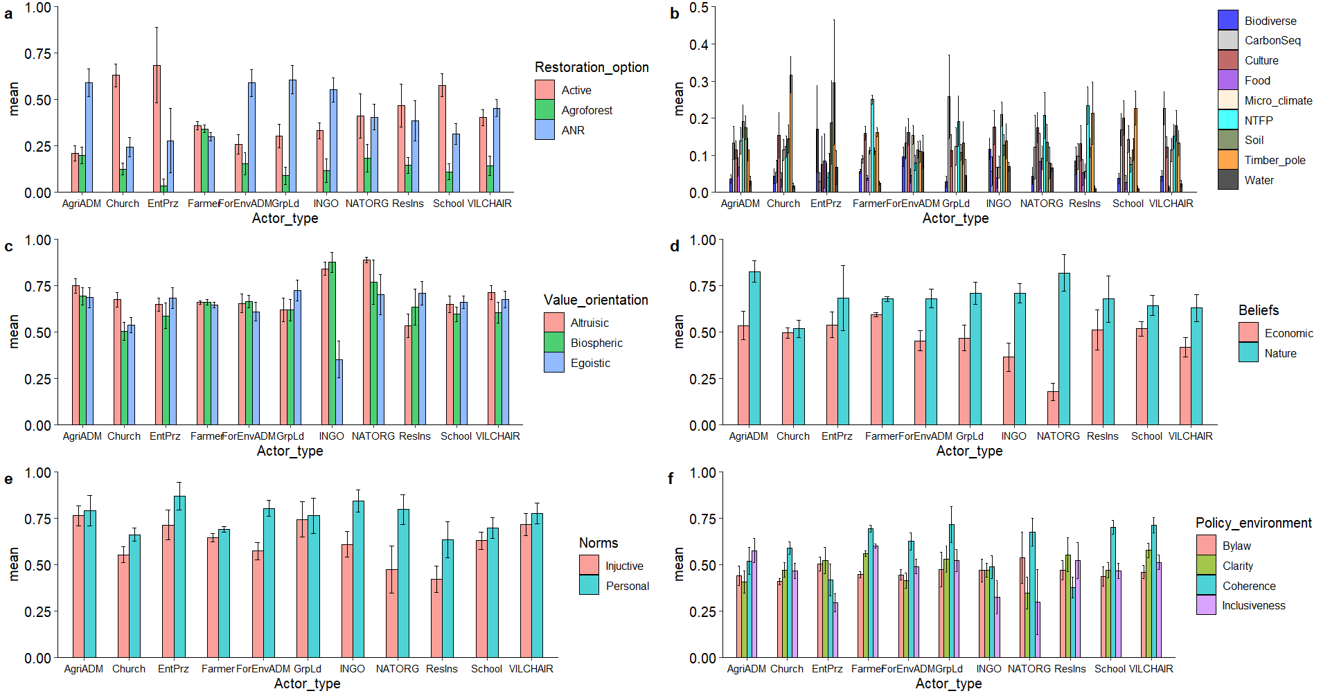
Figure 1: Graphical representation of the mean indices per individual actor type. Note: Agriadm = Agricultural administration, Forenvadm is Forest and environment administration, Vilcha is Village chairperson, Intengo is International NGOs, Natorg is National NGOs, Resins is Research institutions
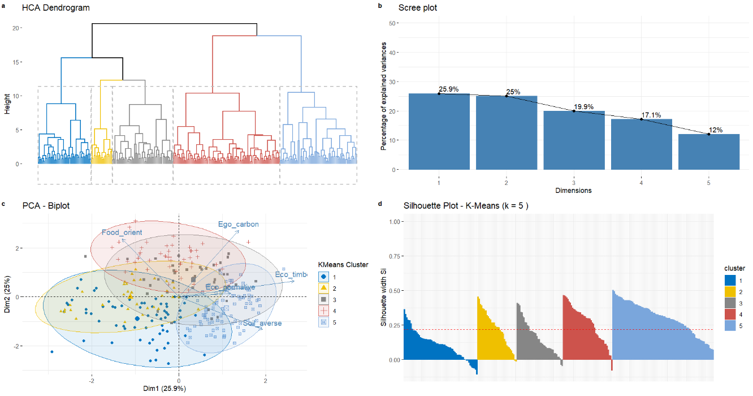
Figure 2: The optimal number of clusters from elbow, silhouette, and gap statistic method and the cluster dendrogram

Table 8: Cluster validation results.
Validation | Measures | Cluster(sizes)
Validation | Measures | 2 | 3 | 4 | 5 | 6
Hierarchical | Connectivity | 5.691 | 14.033 | 18.091 | 44.378 | 44.544
 | Dunn | 0.264 | 0.168 | 0.168 | 0.131 | 0.131
 | Silhouette | 0.387 | 0.212 | 0.085 | 0.097 | 0.091
kmeans | Connectivity | 71.858 | 119.837 | 121.646 | 126.709 | 132.726
 | Dunn | 0.120 | 0.069 | 0.068 | 0.069 | 0.066
 | Silhouette | 0.194 | 0.197 | 0.206 | 0.223 | 0.220
Table 9: Coefficiency parameter estimates of ranked ordered restoration alternatives. Note. Reference is Active restoration strategy. The negative coefficient for ANR and agroforestry means a positive coefficient for active restoration strategy
 | ANR (Assisted Natural Regeneration) |  | Agroforestry
Variables | Coefficient | Standard error | Coefficient | Standard error
Actor subcategory
Executives | 0 | (.) | 0 | (.)
Users | -0.926*** | (0.133) | 0.563*** | (0.146)
civil-society | 0.0954 | (0.195) | 0.0715 | (0.205)
Variable dimensions
Bio_normative | 1.358*** | (0.286) | 1.238*** | (0.317)
Ego_carbon | -0.0100 | (0.389) | -1.271** | (0.407)
Soil_averse | -0.243 | (0.416) | 1.194** | (0.442)
Eco_timber | -2.498*** | (0.313) | -0.274 | (0.313)
Food_orient | -0.132 | (0.353) | 1.919*** | (0.380)
Policy environment
Coherence | 0.266*** | (0.0618) | 0.295*** | (0.0631)
Clarity | -0.284*** | (0.0566) | -0.130* | (0.0566)
Bylaw | 0.00614 | (0.0570) | -0.0971⁺ | (0.0564)
Inclusiveness | 0.0127 | (0.0521) | 0.429*** | (0.0596)
_constant | 1.073** | (0.405) | -2.447*** | (0.444)
lnl2_2 | 0.237***(0.0644)
l2_1 | 0.554***(0.0757)
N | 4092
AIC | 3318.6
BIC | 3482.8
Note: AIC = Akaike information criterion (AIC) and BIC = Bayesian information criterion: Standard errors in parentheses
⁺ p < 0.1, * p < 0.05, ** p < 0.01, *** p < 0.001

