Guidelines interviews with BR management
Please note that the interview guidelines were created and German and have been translated into English using ChatGPT.

Preparatory work
The interviewees are sent a list of the research projects in their biosphere reserve identified in the Periodic Review in advance. They should look at this list and (i) add important research projects that we have forgotten, (ii) indicate which of the research projects they are able to answer questions about their effects, and (iii) evaluate the effects of the projects they can answer questions about for the sustainable development of the biosphere reserve.
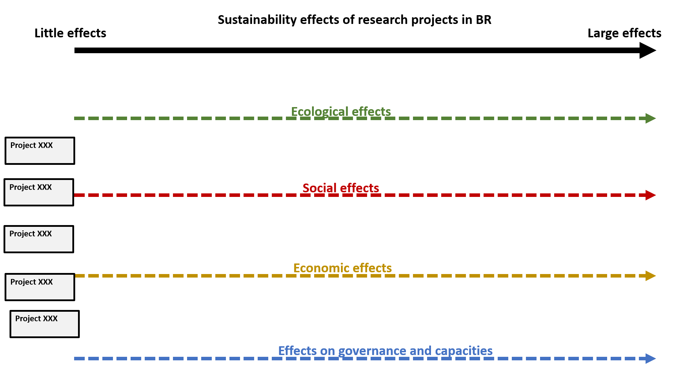
Figure 1: example of diagram to rate effects
Presentation of the preliminary assessments
The interviewee is presented with a diagram on which the research projects are arranged according to the preliminary evaluations. The results of the diagram are briefly described and the interviewee is asked whether this has been understood correctly. Any necessary changes are entered on the diagram.

More detailed descriptions of the effects of major projects
Question 1: In this picture you can see that in your opinion, some projects have had a particularly great effects for sustainable development in and around the biosphere reserve [naming of the X most important projects]. Can you describe to me in more detail how the project activities and results have affected the four dimensions of sustainable development (economic, social, ecological and capacities/skills)?
Question 1.1: Have projects created new networks or strengthened existing ones?
Question 1.2: Have projects questioned strategies and goals with regard to sustainable development in BR?
Question 1.3: Has the way in which decisions are made in the works council changed as a result of certain projects?
Question 1.X: Enquiries if individual dimensions were not addressed

Follow-up question, if some of the most important projects were not dealt with: And how was the whole thing with project XY etc.

More detailed descriptions of the wider impacts of significant projects
Question 2: Every project comes to an end at some point. In your opinion, did some of these projects also have effects beyond the end of the project? These effects cannot be limited to the four dimensions of sustainability in the biosphere reserve. Maybe some projects had made a difference elsewhere? If effects are known, can you briefly describe them in more detail?
Question 2.1: Have activities been followed up or results used elsewhere?
Question 2.2: Has the project contributed to the formation of new networks between actors in and around the works council or even outside the works council or to the strengthening of existing networks even after its official end of the project?
Question 2.3: Even after its official end of the project, has the project contributed to the revision of strategies and goals for the sustainable development of the BR or other BRs?
Question 2.4: Have the projects changed the way in which decisions are made in the works council or in other works councils even after the end of the projects?

Differences in impact between significant and less significant projects
Question 3: Thank you for the detailed explanation of the effects of the projects. As you can see in the picture, some projects have also been classified as less effective for sustainable development. Can you briefly describe to me if they had any effects an if yes what they were?

Reasons why projects have been able to have an impact on BR
Question 4: Why do you think some projects have had more effects in and around the Biosphere Reserve than others?

Question 4.1: In your opinion, what framework conditions are needed for a research project to have an impact in the biosphere reserve?
Question 4.2: does the involvement of practitioners or stakeholders play a role in the The interdependence of science and local actors/population plays a role in the effectiveness of projects? If so, which ones?
Question 4.3: Is the cooperation of different scientific disciplines within a project important? If yes, why=
Question 4.4: Does it matter who determined the research question or the problem dealt with in a project? In other words, whether and how local actors were involved in the development of the research question?

Final Question
Question 5: What kind of research project would you like to see implemented in the Biosphere Reserve in the next few years?

Guidelines interviews with scientists

Part 2: Effects of research projects in the BR
Questions for all research projects in which the scientist was involved

Question W1: In your opinion, did the project activities or the results have effects on the sustainable development of the biosphere reserve or for the management of it?
Question 1.1: Has the project created new networks or strengthened existing ones?
Question 1.2: Did the project question strategies and goals with regard to sustainable development in BR?
Question 1.3: Has the way in which decisions are made in BR changed as a result of the project?
(After) Question 1.4: Do your opinions have this project had an impact beyond the end of the project?

Question W2: In your opinion, what were the factors or obstacles to the project being able to have positive effects on the biospheres?
Question 4.1: In your opinion, what framework conditions are needed for a research project to have an impact in the biosphere reserve?
Question 4.2: Is the cooperation of different scientific disciplines within a project important? If so, why?

Final Question
Question A1.: What kind of research project would you like to see implemented in the Biosphere Reserve in the next few years?

